CH4203: Organic Synthesis Laboratory

Expt. No. 6:

Copper-Catalyzed Click Chemistry of N-tert-butyloxycarbonyl L-prolinyl Azide with 4-Ethynyl toluene

Aim and Objectives:

In this lab, we will learn Click Reaction of an Enantioenriched Azide such as N-tert-butyloxycarbonyl L-prolinyl Azide with a Terminal Alkyne such as 4-ethynyl toluene. The starting material, enantioenriched azide was synthesized from N-tert-butyloxycarbonyl L-prolinol via Mitsunobu reaction using diphenylphosphoryl azide (DPPA).

------------------------------------------------------------------------------------------------------------------------

Reaction Scheme:
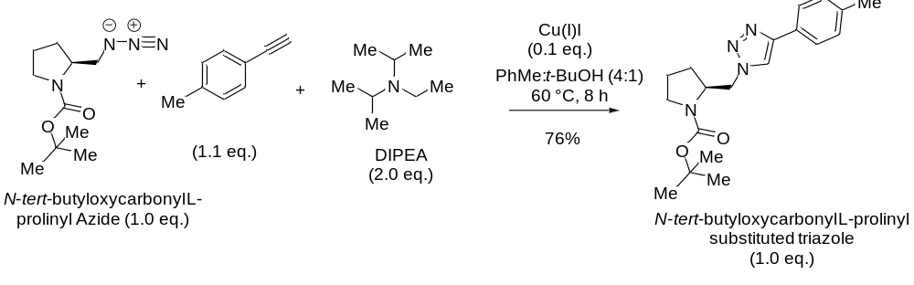Specific Rotation of Azide:
[α]_{D} ^{25.0} = −47.0 (c = 0.6, CHCl₃)

Apparatus Requirement:

Round Bottom (RB) flask; Magnetic bid; Magnetic stirrer; Column chromatography set-up; Measuring cylinder.

Chemicals Requirement:

- N-tert-butyloxycarbonyl L-prolinyl azide
- 4-Ethynyl toluene
- Diisopropyl N-ethyl amine (DIPEA)
- Copper Iodide [Cu(I)I]
- tert-Butanol (solvent)
- Toluene (solvent)

Molecular Wt. and Physical Details of Reagents:
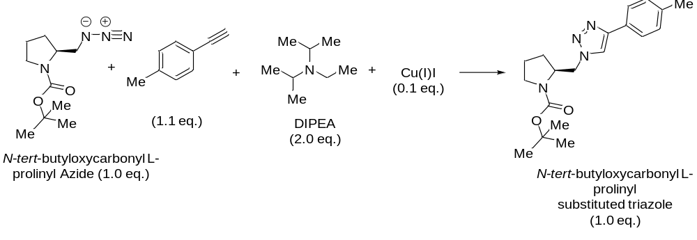equiv.: 1.0 eq. 1.1 eq. 2.0 eq. 0.1 eq.
mmol: 4.42 4.86 8.84 0. 442 4.42
MW: 226.28 116.16 129.25 190.45 342.44
density: NA 0.930 0.742 NA
------------------------------------------------------------------------------------------------------------------------
Amount: 1.0 gm 0.61 ml 1.54 ml 84 mg 1.513 gm
(Theoretical Yield)

Experimental Procedure:

In a round-bottom flask fitted with a stirrer, 1 g (4.42 mmol, 1.0 equiv.) of N-tert-butyloxycarbonyl L-prolinyl azide was taken in 30 mL of tert-butanol and toluene (1:4 ratio).

To this solution was added 1.54 ml (8.84 mmol, 2.0 equiv.) of DIPEA (diisopropyl N-ethyl amine) at 25 °C and stirring was continued for another 5 minutes.

Next, 0.61 ml (4.86 mmol, 1.1 equiv.) of 4-Ethynyl toluene was slowly added to the reaction mixture at 25 °C and stirring was continued for another 10 minutes.

Further, 84 mg (0.442 mmol, 0.1 equiv.) of catalyst Cu(I)I (copper iodide) was added to the reaction mixture at 25 °C.

The reaction mixture was placed in a pre-heated oil bath having 60 °C and stirring was continued for an additional 8 h.

Upon completion of the reaction [as judged by running TLC (Thin Layer Chromatography)], most of the solvents were evaporated under reduced pressure.

Then, 10 g of silica-gel (100-200 mesh) was added to the RB flask and slurry was made (to make it a free-flowing slurry).

The crude Click product N-tert-butyloxycarbonyl L-prolinyl triazole was then purified by Column chromatography by using ethyl acetate and n-hexane as eluents to furnish enantiomerically pure N-tert-butyl L-prolinyl azide as a white solid.

Characterization of Click Product N-tert-butyl L-prolinyl triazole:

The final product was characterized by IR spectra, ¹H NMR spectra, ¹³C NMR spectra, and HRMS spectroscopy.

Results & Observation:

Actual Yield: 1.15 g % of Yield: (Actual Yield / Theoretical Yield) × 100

Theoretical Yield: 1.513 g = (1.15/1.513) × 100

= 76%

Physical State: White solid

Melting Point: 119-121 °C

Specific Rotation: [α]_{D} ^{25.0} = −54.5 (c = 0.5, CHCl₃)

TLC System: R_{f} = 0.42 (30% EtOAc in n-hexane)

IR Frequencies: cm⁻¹

¹H NMR (500 MHz, CDCl₃) δ 7.80 – 7.63 (m, 3H), 7.26 (d, J = 7.7 Hz, 2H), 4.61 (ddt, J = 49.1, 31.3, 15.4 Hz, 2H), 4.22 – 4.11 (m, 1H), 3.30 (t, J = 66.1 Hz, 2H), 2.40 (s, 3H), 1.99 (d, J = 18.9 Hz, 2H), 1.77 (s, 1H), 1.53 (d, J = 2.3 Hz, 9H).

¹³C NMR (126 MHz, CDCl₃) δ 154.2, 149.1, 138.0, 129.5, 125.6, 120.2, 119.7, 80.0, 57.3, 52.8, 51.5, 47.1, 28.5, 24.8, 23.4, 21.3.
------------------------------------------------------------------------------------------------------------------------

Conclusion:

In summary, we have done the Copper-catalysed Click Chemistry of N-tert-butyloxycarbonyl L-prolinyl azide with 4-ethynyl toluene. The active catalyst required for this reaction is Cu(I). The mechanism of this reaction is very interesting and should be taken as home assignment.

The chemical yield was 76%. Further, the compound was characterised by IR spectra, NMR spectra was also checked.

------------------------------------------------------------------------------------------------------------------------

