CH4203: Organic Synthesis Laboratory

Expt. No. 7: Organocatalytic Asymmetric Michael Addition of Cyclohexanone onto β-Nitrostyrene

Aim and Objectives: In this laboratory, we will learn Organocatalytic asymmetric Michael addition of cyclohexanone onto β-nitrostyrene.

The catalyst for this reaction i.e. L-prolinyl triazole will be synthesized from N-tert-butyl L-prolinyl triazole. [The synthesis of N-tert-butyloxycarbonyl L-prolinyl triazole was shown during Click reaction].

Therefore, we will first synthesize the catalyst required for this catalytic enantioselective reaction. Next, we will be doing the asymmetric Michael addition of cyclohexanone onto β-nitrostyrene.

------------------------------------------------------------------------------------------------------------------------

Synthesis of L-prolinyl Triazole Catalyst

Reaction Scheme:

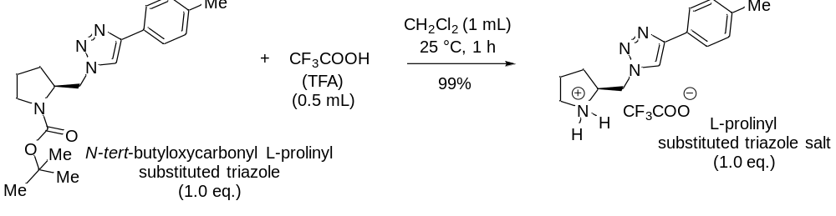

Specific Rotation:
[α]_{D} ^{25.0} = −54.5 (c = 0.5, CHCl₃)

Apparatus Requirement:

Round Bottom (RB) flask; Magnetic bid; Magnetic stirrer; Measuring cylinder.

Chemicals Requirement:

- N-tert-butyloxycarbonyl L-prolinyl triazole (Click product)
- Trifluoroacetic acid (TFA)
- Dichloromethane (Solvent)

Molecular Wt. and Physical Details of Reagents:

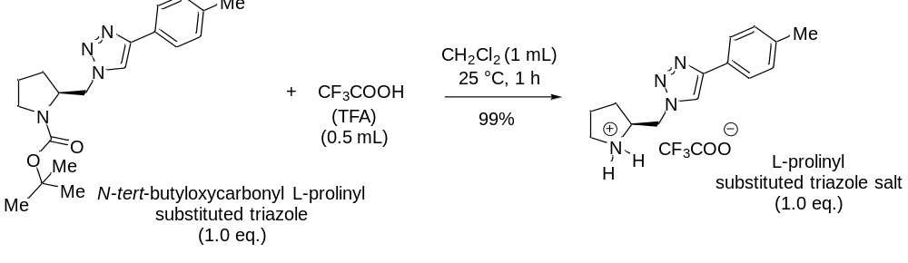 Specific Rotation:
[α]_{D} ^{25.0} = −54.5 (c = 0.5, CHCl₃)

equiv.: 1.0 eq. 1.7 eq. 1 eq.
mmol: 0.292 0.5 0.292
MW: 342.44 114.02 356.35
density: NA 1.487 NA
------------------------------------------------------------------------------------------------------------------------
Amount: 100 mg 0.5 ml 104.05 gm
(Theoretical Yield)

Experimental Procedure for the Synthesis of Organocatalyst, L-prolinyl triazole:

In a round-bottom flask fitted with a stirrer, 100 mg (0.292 mmol, 1.0 equiv.) of N-tert-butyloxycarbonyl L-prolinyl triazole derivative (Click Reaction Product) was taken in 1 mL of dichloromethane.

The RB flask was placed on an ice-bath having temperature at 0 °C.

Next, 0.5 ml (0.5 mmol, 1.7 equiv.) of trifluoroacetic acid was slowly added to the reaction mixture at 0 °C. The stirring was continued for another 1 h.

Upon completion of the reaction [as judged by running TLC (Thin Layer Chromatography)], solvents were evaporated under reduced pressure to furnished TFA salt of L-prolinyl triazole derivative.

------------------------------------------------------------------------------------------------------------------------
Characterization of Organocatalyst, L-prolinyl triazole:

The final product was characterized by IR spectra, ¹H NMR spectra, ¹³C NMR spectra, and HRMS spectroscopy.

Results & Observation:

Actual Yield: 102 mg % of Yield: (Actual Yield / Theoretical Yield) × 100

Theoretical Yield: 104.05 mg = (102/104.05) × 100

= 98%

Physical State: Colourless Gel

Melting Point: Not Solid

Specific Rotation: [α]_{D} ^{25.0} = +44.2 (c = 0.7, CH₃OH)

TLC System: R_{f} = 0.3 (10% MeOH in dichloromethane)

IR Frequencies: XX cm⁻¹

Characterization using NMR Techniques:

¹H NMR (500 MHz, CDCl₃) δ 9.46 (s, 1H, broad, N-H), 9.09 (s, 1H, broad, N-H), 8.12 (s, 1H), 7.46 (d, 2H, J = 9 Hz), 7.19 (d, 2H, J = 9 Hz), 4.90 (d, 2H, J = 6.0 Hz), 4.31 (s, 1H), 3.45 (d, 2H, J = 5 Hz), 2.32-2.34 (m, 1H), 2.32 (s, 3H), 2.15 (m, 2H), 1.90 (br, s, 1H).

¹³C NMR (126 MHz, CDCl₃) δ 147.28, 140.13, 129.89, 125.88, 124.07, 122.49, 59.52, 50.88, 46.24, 27.84, 23.15, 21.14.

Conclusion:

In summary, we have synthesized L-prolinyl triazole derivative (Organocatalyst for Asymmetric Michael Reaction) from N-tert-butyloxy carbonyl L-prolinyl triazole derivative.

The synthesis of N-tert-butyloxycarbonyl L-prolinyl triazole derivative was shown during Click reaction experiment. The mechanism of this reaction is very interesting and should be taken as home assignment.

The chemical yield was 98%. Further, the compound was characterised by IR spectra, NMR spectra was also checked.

------------------------------------------------------------------------------------------------------------------------

Organocatalytic Asymmetric Michael Addition of Cyclohexanone onto β-Nitrostyrene

Reaction Scheme:
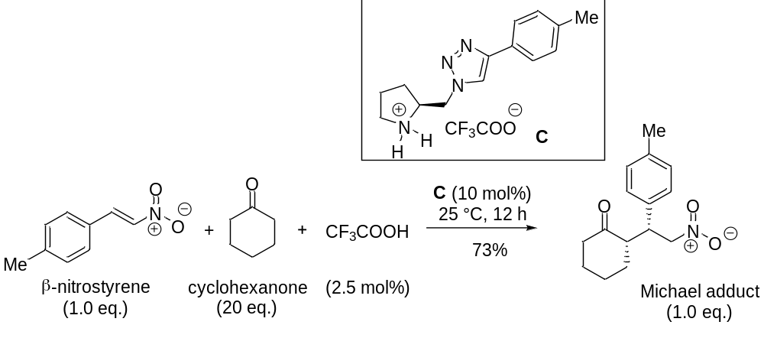

Apparatus Requirement:

Round Bottom (RB) flask; Magnetic bid; Magnetic stirrer; Measuring cylinder.

Chemicals Requirement:

- L-prolinyl triazole derivative (Organocatalyst)
- Cyclohexanone (Reagent)
- β-Nitrostyrene (Reagent)
- N, N-Dimethylformamide (DMF as Solvent)

Molecular Wt. and Physical Details of Reagents:
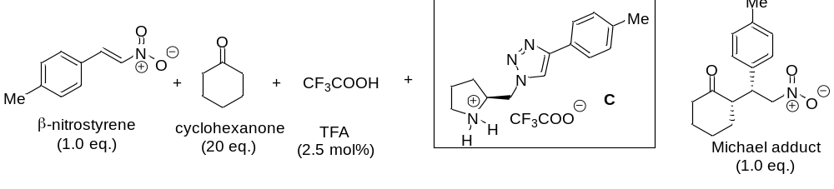equiv.: 1.0 eq. 10 eq. C (0.1 eq.)

mmol: 1 mmol 10 mmol 0.1 mmol 1 mmol

MW: 163.16 98.14 356.35 261.32

density: --- 0.945 --- ---
------------------------------------------------------------------------------------------------------------------------
Amount: 163 mg 1.03 mL 36 mg 261 mg

Experimental Procedure for the Asymmetric Michael Addition:

In a round-bottom flask fitted with a stirrer, 36 (0.1 mmol, 0.1 equiv.) of L-prolinyl triazole derivative (Click Reaction Product) was taken in 1 mL of N, N-dimethylformamide.

1.03 ml (10 mmol, 10 equiv.) of cyclohexanone was added to RB flask and the stirring was continued. After 5 minutes the reaction mixture was placed on an ice-bath having temperature at 0 °C.

Next, 163 mg (1 mmol, 1.0 equiv.) of β-nitrostyrene was slowly added to the reaction mixture over a period of 5 minutes maintaining temperature at 0 °C. The stirring was continued for another 12 h.

Upon completion of the reaction [as judged by running TLC (Thin Layer Chromatography)], 2 mL of ethylacetate (EtOAc) and 2 mL of H₂O was added to the reaction mixture and extracted using a separatory funnel. Further, another 1 mL of ethyl acetate (EtOAc) was added and extracted second time.

Sodium sulphate was added to dry the organic layer and then solvents were evaporated under reduced pressure to furnish crude Michael adduct. Finally, purification was done via the column chromatography using 20% EtOAc in n-hexane as eluents.

------------------------------------------------------------------------------------------------------------------------
Characterization of Organocatalyst, L-prolinyl triazole:

The final product was characterized by IR spectra, ¹H NMR spectra, ¹³C NMR spectra, and HRMS spectroscopy.

Results & Observation:

Actual Yield: 201 mg % of Yield: (Actual Yield / Theoretical Yield) × 100

Theorertical Yield: 261 mg = (201/261) × 100

= 77
Physical State: Gel type

Melting Point: Not Solid

Specific Rotation: [α]_{D} ^{25.0} = −15.9 (c = 0.6, CH₃OH)

TLC System: R_{f} = 0.32 (10% EtOAc in n-hexane)

IR Frequencies: X cm⁻¹

------------------------------------------------------------------------------------------------------------------------
Characterization using NMR Techniques:

¹H NMR (500 MHz, CDCl₃) δ

¹³C NMR (126 MHz, CDCl₃) δ

HPLC Analysis:

Conclusion:

In summary, we have performed the organocatalytic enantioselective Michael addition of cyclohexanone onto b-nitrostyrene. The reaction is very efficient and 10 mol% of L-prolinyl triazole derivative as catalyst afforded Michael addition product in 77% yield with X% ee. The diastereoselectivity of this reaction found to be excellent (>20:1 dr).

The mechanism of this reaction is very interesting and should be taken as home assignment. Also, the transition state must be drawn in order to understand the observed enantioslectivity as well as diastereoselectivities.

------------------------------------------------------------------------------------------------------------------------

