CH4203: Organic Synthesis Laboratory

Expt. No. 2: Mizoriki-Heck Cross-Coupling of 4-Iodotolune with Ethyl Acrylates: Synthesis of Substituted Cinnamates

Aim and Objectives: In this lab, we will learn Mizoriki-Heck Cross-Coupling which is nothing but a Cross-Coupling reaction and we will make a substituted cinnamate from 4-iodotoluene and ethyl acrylate.

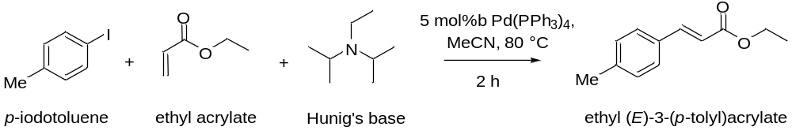

Apparatus Requirement:

Sealed Tube, Round Bottom (RB) flask; Conical flask; Measuring cylinder; Separating funnel; Septum, Balloon, Needle, Syringe

Chemicals Requirement:

- 4-Iodo Toluene
- Ethyl Acrylate
- Ethyl diisopropyl amine
- Pd(PPh₃)₄
- Acetonitrile

Molecular Wt. and Physical Details of Reagents:

Molecular formula of 4-Iodo Toluene = C₇H₇I

Molecular weight of 4-Iodo Toluene = 218.04 g/mole

Molecular formula of Ethyl Acrylate = C₅H₈O₂

Molecular weight of Ethyl Acrylate = 100.12 g/mole

Molecular formula of Ethyl diisopropyl amine = C₈H₁₉N

Molecular weight of Ethyl diisopropyl amine = 129.25 g/mole

Experimental Procedure:

In an over dried sealed tube fitted with a magnetic stirrer, 1 gm (4.58 mmol) of 4-Iodotoluene was taken in 10 mL of acetonitrile and it was stirred for 2 minutes.

To this solution was added 733 μL (6.88 mmol) of ethyl acrylate at room temperature using a syringe and it was stirred for 2 minutes.

Further, to the reaction mixture was added 2.4 mL (13.74 mmol) of diisopropyl ethylamine at room temperature using a syringe and it was stirred for 2 minutes.

Next, the mixture was degassed using N₂ balloon, needle and septum for 10 minutes in stirring condition to make sure that the reaction is under oxygen-free atmosphere.

After that, 160 mg (5 mol% with respect to 4-iodotoluene) Pd(PPh₃)₂Cl₂ (catalyst for the cross-coupling reaction) was added quickly to the reaction mixture without much exposing to air. This Pd(II) can be reduced to Pd(0) in the reaction condition, which acts as the real catalyst for this reaction.

Once all the reagents were added, the sealed tube was dipped in a pre-heated oil bath maintaining temperature at 100 ˚C. After 10 h, TLC was checked to confirm the completion of the reaction.

Upon completion of the reaction (as monitored by running TLC), the reaction mixture was transferred to a Round Bottom flask and most of the solvents (acetonitrile) were evaporated under the reduced pressure.

Next, the reaction mixture was diluted with 20 mL hexane and water (20 mL) and the Round Bottom flask was stirred vigorously. Then the layers were separated using separating funnel and the organic layer was collected in a conical flask. This was repeated two more time (20 mL X 2).

Finally, the organic layer was evaporated and column was done using 100-200 mess silica in n-hexane.

R_{f} (in n-hexane) = 0.3

Note: Diisopropyl ethylamine may cause a skin allergy, itching and a skin rash. So, proper precaution has to be taken during the experiment.

Also, the vapours of ethyl acrylate are very irritating.

Characterization of Cinnamates:

In summary, we have conducted Mizoriki-Heck Cross-Coupling for the Synthesis of Cinnamates: Reaction of 4-Iodotolune with Ethyl Acrylates

The final product was characterized by IR spectra, ¹H NMR spectra, ¹³C NMR spectra, and HRMS spectroscopy.

Reaction Mechanism:

Mizoriki-Heck Cross-Coupling of Bromobenzene with Methyl Acrylates (as model reaction)

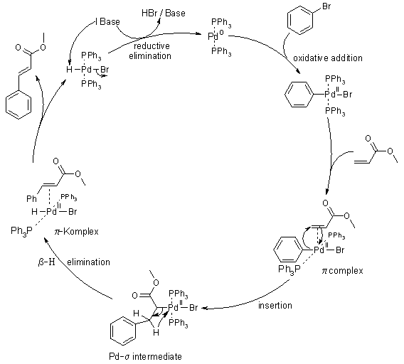

Calculations (mmol):

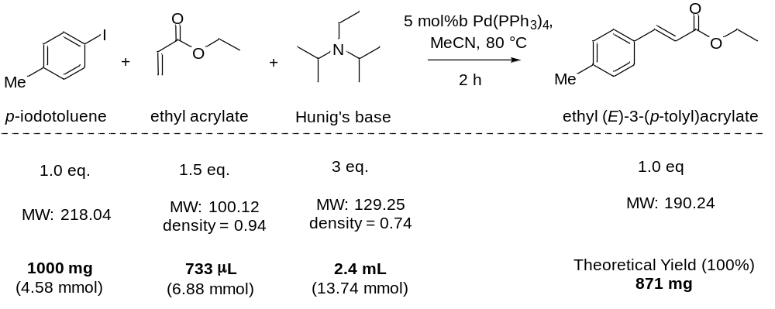

------------------------------------------------------------------------------------------------------------------------

Results & Observation:

Yield: 760 mg % of Yield: 88%

TLC System: R_{f} = 0.30 (n-hexane)

Compound Characterization:

IR Frequencies: cm⁻¹

¹H-NMR: (400 MHz, CDCl₃) δ

¹³C-NMR: (126 MHz, CDCl₃) δ

Conclusion:

In summary, we have done the Mizoriki-Heck Cross-Coupling for the synthesis of cinnamates. In particular, we have chosen 4-iodotolune as haloarene and ethyl acrylates as the coupling partner. The catalyst used was palladium(0) tetrakistriphenylphosphine.

