CH4203: Organic Synthesis Laboratory

Expt. No. 3: Sonogashira Cross-Coupling of Iodoarene with Terminal Alkyne: Synthesis of Disubstituted Alkynes

Aim and Objectives: In this lab, we will learn Sonogashira Coupling which is nothing but a Cross-Coupling reaction and we will make a disubstituted alkyne from 4-iodotoluene and trimethylsilylacetylene.

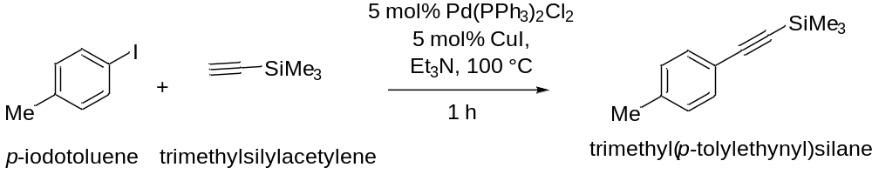

Apparatus Requirement:
Sealed tube; Needle-Syringe; Round Bottom (RB) flask; Conical flask; Measuring cylinder; Separating funnel; Funnel.

Chemicals Requirement:

- 4-Iodotoluene
- Trimethylsilylacetylene
- Triethyl amine
- Pd(PPh₃)₂Cl₂
- Copper iodide

Molecular Wt. and Physical Details of Reagents:

Molecular formula of 4-Iodotoluene = C₇H₇I

Molecular weight of 4-Iodotoluene = 218.0375 g/mole

Molecular formula of Trimethylsilylacetylene = C₅H₁₀Si

Molecular weight of Trimethylsilylacetylene = 98.22 g/mole

Density of Trimethylsilylacetylene = 0.695 g/ml

Molecular weight of Pd(PPh₃)₂Cl₂ = 701.89 g/mole

Molecular weight of CuI = 190.45 g/mole

Experimental Procedure:

In an over dried sealed tube fitted with a magnetic stirrer, 1 gm (4.58 mmol) of 4-Iodotoluene was taken in 25 ml of triethylamine and it was stirred for 2 minutes.

To this solution was added 1.62 mL (11.45 mmol) of trimethylsilyl acetylene at room temperature using a syringe and it was stirred for 2 minutes.

Next, the mixture was degassed using N₂ balloon, needle and septum for 10 minutes in stirring condition to make sure that the reaction is under oxygen-free atmosphere.

Following de-gas of the reaction mixture, 42 mg (5 mol% with respect to 4-iodotoluene) of CuI (as co-catalyst to activate the terminal alkyne) was added quickly to the mixture under N₂ atmosphere and the tube was sealed using the cap.

After that, 160 mg (5 mol% with respect to 4-iodotoluene) Pd(PPh₃)₂Cl₂ (catalyst for the cross-coupling reaction) was added quickly to the reaction mixture without much exposing to air. This Pd(II) can reduced in the reaction mixture.

Once all the reagents were added, the sealed tube was dipped in a pre-heated oil bath maintaining temperature at 100 ˚C. After 1 h, TLC was checked to confirm the completion of the reaction.

Upon completion of the reaction (as monitored by running TLC), the reaction mixture was transferred to a Round Bottom flask and most of the triethylamine was evaporated under the reduced pressure.

Next, the reaction mixture was diluted with 20 mL hexane and water (20 mL) and the Round Bottom flask was stirred vigorously. Then the layers were separated using separating funnel and the organic layer was collected in a conical flask. This was repeated two more time (20 mL X 2).

Finally, the organic layer was evaporated and column was done using 100-200 mess silica in n-hexane.

R_{f} (in n-hexane) = 0.8

Note: Triethylamine may cause a skin allergy, itching and a skin rash. So, proper precaution have to be taken during the experiment.

Characterization of Disubstituted alkyne:

In summary, we have conducted Sonogashira Cross-Coupling for the Synthesis of Disubstituted alkyne.

The final product was characterized by IR spectra, ¹H NMR spectra, ¹³C NMR spectra, and HRMS spectroscopy.

Reaction Mechanism:

Sonogashira Coupling for the synthesis of Disubstituted alkyne reaction mechanism (as model reaction)

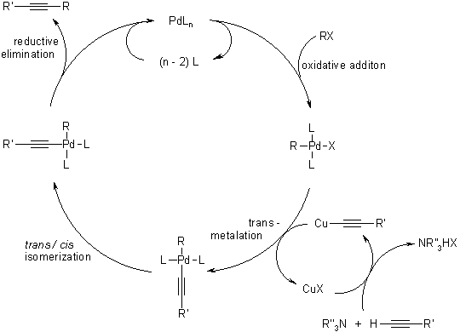

Calculations (mmol):

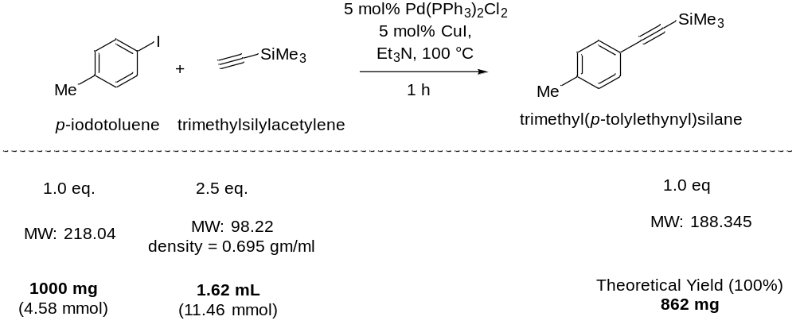

------------------------------------------------------------------------------------------------------------------------

Results & Observation:

Yield: 819.5 mg % of Yield: 95%

TLC System: R_{f} = 0.8 (in n-hexane)

Compound Characterization:

IR Frequencies: cm⁻¹

¹H-NMR: (400 MHz, CDCl₃) δ

¹³C-NMR: (126 MHz, CDCl₃) δ

Conclusion:

In summary, we have done the Sonogashira Cross-Coupling for the synthesis of disubstituted alkyne. In particular, we have chosen 4-iodotolune as haloarene and trimethylsilylacetylene as the coupling partner in the presence of Pd(0) as catalyst and CuI as co-catalyst.

