CH4203: Organic Synthesis Laboratory

Expt. No. 4: Suzuki Cross-Coupling Reaction of 4-Iodotolune with 3-Tolylboronic acid: Efficient Synthesis of Biaryls

Aim and Objectives: In this lab, we will learn Suzuki Cross-Coupling which is nothing but a Cross-Coupling reaction and we will make a substituted biaryl from p-iodotoluene and m-tolylboronic acid.

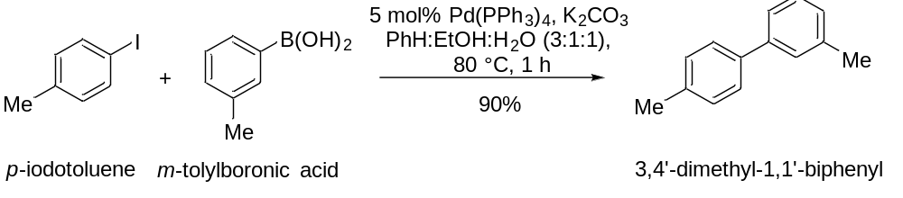

Apparatus Requirement:
Round Bottom (RB) flask; Needle-Syringe; Conical flask; Measuring cylinder; Beaker; Separating funnel; Funnel, Condenser, Septum, Balloon.

Chemicals Requirement:

- p-Iodo Toluene
- m-Tolylboronic acid
- K₂CO₃
- Pd(PPh₃)₄
- Benzene
- Ethanol
- Water

Molecular Wt. and Physical Details of Reagents:

Molecular formula of p-iodotoluene = C₇H₇I

Molecular weight of p-iodotoluene = 218.0375 g/mole

Molecular formula of m-tolylboronic acid = C₇H₉ BO₂

Molecular weight of m-tolylboronic acid = 135.9570 g/mole

Molecular formula of Pd(PPh₃)₄ [tetrakis(triphenylphosphine)palladium(0)]

Molecular weight of tetrakis(triphenylphosphine)palladium(0) = 1155.59 g/mole

Molecular formula of potassium carbonate =K₂CO₃

Molecular weight of potassium carbonate = 138.21 g/mole

Experimental Procedure:

In a round-bottom (RB) flask fitted with a magnetic stirrer bar, 1 g (4.58 mmol) of p-Iodotoluene was taken in 10 ml of benzene, 3 ml of ethanol and 3 ml of water.

To this reaction mixture, 4-tolylboronic acid was added in one portion and stirred the RB for 2 minutes.

Next, 1.330 g (9.62 mmol) of K₂CO₃ was added and the mixture was degassed using N₂ balloon, needle and septum for 10 minutes in stirring condition to make sure that the reaction is under oxygen-free atmosphere.

After that, 160 mg (5 mol% with respect to 4-iodotoluene) Pd(PPh₃)₂Cl₂ (catalyst for the cross-coupling reaction) was added quickly to the reaction mixture without much exposing to air.

Once all the reagents were added, the sealed tube was dipped in a pre-heated oil bath maintaining temperature at 100 ˚C. After 1 h, TLC was checked to confirm the completion of the reaction.

Upon completion of the reaction (as monitored by running TLC), the reaction mixture was transferred to a Round Bottom flask and most of the solvents (benzene and ethanol) were evaporated under the reduced pressure.

Next, the reaction mixture was diluted with 20 mL hexane and water (20 mL) and the Round Bottom flask was stirred vigorously. Then the layers were separated using separating funnel and the organic layer was collected in a conical flask. This was repeated two more time (20 mL X 2).

Finally, the organic layer was evaporated and column was done using 100-200 mess silica in n-hexane.

R_{f} (in n-hexane) = 0.52

Note: The chemicals and solvents (in particular benzene) used in reaction are not good for health so proper precaution have to be maintained during the experiment.

Characterization of biaryls:

In summary, we have conducted Suzuki Cross-Coupling for the Synthesis of substituted biaryls.

The final product was characterized by IR spectra, ¹H NMR spectra, ¹³C NMR spectra, and HRMS spectroscopy.

Reaction Mechanism:

Suzuki Cross-Coupling of 4-Iodotolune with m-Tolylboronic acid (as model reaction).

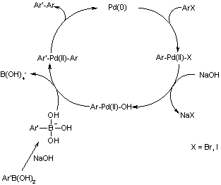

Calculations (mmol):

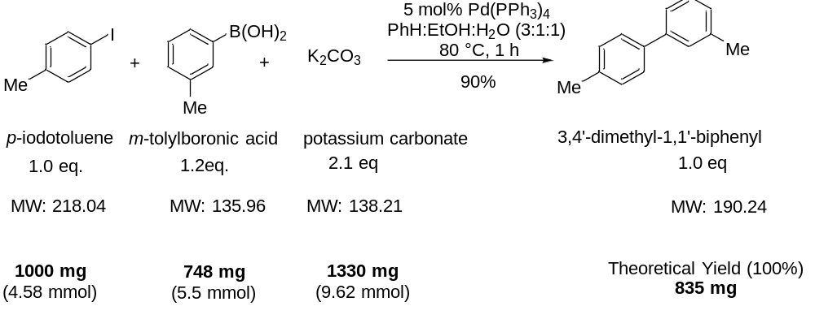

------------------------------------------------------------------------------------------------------------------------

Results & Observation:

Yield: 751.5 mg

% of Yield: 90%

Nature of the compound: Liquid

TLC System: R_{f} = 0.52 (n-hexane)

Compound Characterization:

IR Frequencies: cm⁻¹

¹H-NMR: (400 MHz, CDCl₃) δ

¹³C-NMR: (126 MHz, CDCl₃) δ

Conclusion:

In summary, we have done the Suzuki Cross-Coupling for the synthesis of biaryls. This is a very important C-C bond forming reaction that is used in the synthesis of advanced intermediates and pharmaceutically important compounds. In particular, we have chosen p-iodotolune as haloarene and m-tolylboronic acid as the coupling partner.

