CH4203: Organic Synthesis Laboratory

Expt. No. 1: Nitro-Aldol Reaction of p-Tolualdehyde with Nitromethane: Synthesis of β-Nitrostyrene

Aim and Objectives: In this lab, we will learn Henry Reaction which is nothing but a nitro-aldol reaction and we will make a substituted β-nitro styrene using nitroaldol reaction followed by elimination.

Apparatus Requirement:
Round Bottom (RB) flask; Conical flask; Measuring cylinder; Beaker; Separating funnel; Celite funnel; Filter paper.

Chemicals Requirement:

- 4-Methyl Benzaldehyde
- Nitromethane
- Sodium Hydroxide
- Hydrochloric Acid
- Methanol
- Ethanol

Molecular Wt. and Physical Details of Reagents:

Molecular formula of 4-Methyl Benzaldehyde = C₈H₈O
Molecular weight of 4-Methyl Benzaldehyde = 120.15 g/mole

Molecular formula of Nitromethane = CH₃NO₂
Molecular weight of Maleic Anhydride = 61.04 g/mole

Experimental Procedure:

In a round-bottom flask fitted with a stirrer, 5 mL (42.4 mmol) of p-tolualdehyde, 3.4 mL (63.6 mmol) of nitromethane (MeNO₂) were taken in 50 mL of MeOH.

A solution of sodium hydroxide is prepared by dissolving 2.54 g (63.6 mmol) of NaOH in approximately 10 mL of water and was added to the reaction mixture at 0 °C. A bulky white precipitate forms rapidly during the addition of the alkali.

The reaction was slowly warmed to room temperature and stirred for 30 minutes at room temperature. The mixture gets so thick that stirring becomes difficult and it may be advisable to add 5 mL more of MeOH.

After stirring of 30 minutes, the pasty mass is converted to a clear solution by the addition of 5 mL of ice water containing crushed ice.

Next, 50 mL hydrochloric acid (6N HCl) was taken in a beaker and cooled it to 0 °C. Later, the reaction mixture was slowly added to this cold solution.

A pale-yellow crystalline mass separates almost immediately as the alkaline solution comes in contact with the acid and the solid settles to the bottom of the beaker.

The major part of the cloudy liquid layer is removed by decantation, and the residue filtered by suction and washed with water until free from chlorides.

The crude β-nitrostyrene then purified by the re-crystallization in 50 mL of hot EtOH. The yield of recrystallized β-nitrostyrene is approximately 80-85%.

Melting Point: 57 – 59 °C

Rf (20%EtOAc in n-hexane) = 0.39

Note: The vapors of hot solutions of β-nitrostyrene are very irritating to the eyes and nose, and the skin of the face is sensitive to the solid substance.

Characterization of β-nitrostyrene:

In summary, we have conducted the nitro-Aldol reaction of p-tolualdehyde with nitromethane followed by the elimination for the synthesis of β-nitrostyrene.

The final product was characterized by IR spectra, ¹H NMR spectra, ¹³C NMR spectra, and HRMS spectroscopy.

Reaction Mechanism:

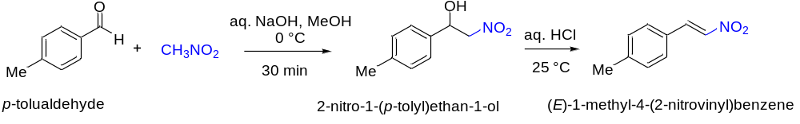

Results & Observation:

Yield: X g % of Yield: XX% MP: XX – XX °C

TLC System: R_{f} = 0.XX (20% EtOAc in n-hexane)

Compound Characterization:

IR Frequencies: cm⁻¹

¹H-NMR: (400 MHz, DMSO-d6) δ

¹³C-NMR: (126 MHz, DMSO-d6) δ

Conclusion:

In summary, we have done the Diels-Alder reaction of anthracene and maleic anhydride. The chemical yield was X%. Further, the compound was characterised by IR spectra, NMR spectra and melting point was also checked.

