CH4203: Organic Synthesis Laboratory

Expt. No. 6: Preparation of N-Boc-L-Prolinyl Azide via Mitsunobu Reaction

Aim and Objectives:

In this laboratory experiment, we will learn the Mitsunobu conversion of a chiral alcohol into an enantioenriched azide. N-tert-butyloxycarbonyl-L-prolinyl azide is synthesized from N-tert-butyloxycarbonyl-L-prolinol using diphenyl phosphoryl azide (DPPA) in the presence of triphenylphosphine and diisopropyl azodicarboxylate under mild reaction conditions.
------------------------------------------------------------------------------------------------------------------------

Reaction Scheme:
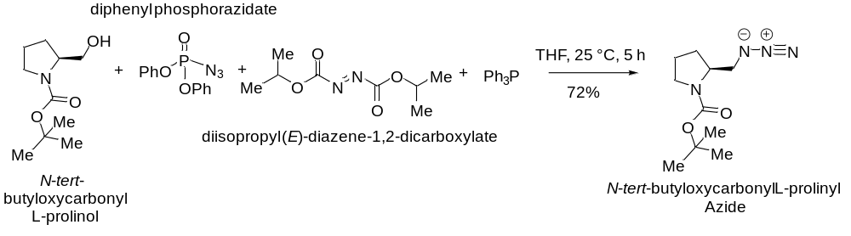
Apparatus Requirement:

Round Bottom (RB) flask; Magnetic bid; Magnetic stirrer; Column chromatography set-up; Measuring cylinder.

Chemicals Requirement:

• N-tert-Butoxycarbonyl-L-prolinol (1.0 equiv)
• Diphenyl phosphoryl azide (DPPA) (1.5 equiv)
• Diisopropyl azodicarboxylate (DIAD) (1.5 equiv)
• Triphenylphosphine (PPh₃) (1.5 equiv)
• Tetrahydrofuran (THF) – anhydrous (solvent

Work-up & Purification Chemicals
- Saturated aqueous NH₄Cl (quench)
- Ethyl acetate (EtOAc)
- Brine
- Anhydrous Na₂SO₄ (drying agent)
- Hexanes / EtOAc (column chromatograph

Molecular Wt. and Physical Details of Reagents:
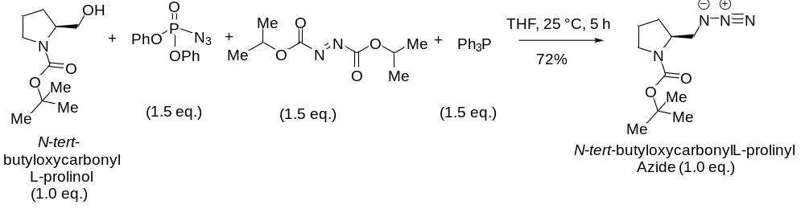

equiv.: 1.0 eq. 1.5 eq. 1.5 eq. 1.5 eq.
mmol: 4.97 5.82 7.24 7.45 4.97
MW: 201.27 1167.25 201.21 262.29 226.28
density: NA 1.28 gm/cc 1.03 gm/cc NA
------------------------------------------------------------------------------------------------------------------------
Amount: 1.0 gm 6.8 ml 1.45 ml 394 mg 1.513 gm
(Theoretical Yield)

Experimental Procedure:

To a flame-dried round-bottom flask under a nitrogen atmosphere was added N-tert-butoxycarbonyl-L-prolinol (1 gm, 1.0 equiv) and anhydrous THF.
The resulting solution was cooled to 0 °C, and triphenylphosphine (394 mg, 1.5 equiv) was added, followed by diphenyl phosphoryl azide (DPPA), (6.8 ml, 1.5 equiv).
Diisopropyl azodicarboxylate (DIAD), (1.45 ml, 1.5 equiv) was then added dropwise at 0 °C.
The reaction mixture was allowed to warm to room temperature (25 °C) and stirred for 5 h.
Reaction progress was monitored by TLC. Upon completion, the reaction was quenched with saturated aqueous NH₄Cl and diluted with EtOAc.
The organic layer was separated, and the aqueous phase was extracted with EtOAc (3×). The combined organic extracts were washed with brine, dried over anhydrous Na₂SO₄, filtered, and concentrated under reduced pressure.
Purification of the crude product by silica gel column chromatography (hexanes/EtOAc) afforded N-tert-butoxycarbonyl-L-prolinyl azide as a colorless oil.

Characterization of Mitsunobu Product N-Boc-L-Prolinyl Azide

The final product was characterized by IR spectra, ¹H NMR spectra, ¹³C NMR spectra, and HRMS spectroscopy.

Results & Observation:

Actual Yield: g % of Yield: (Actual Yield / Theoretical Yield) × 100

Theoretical Yield: 1.513 g = (1.15/1.513) × 100

= 76%

Physical State: White solid

Melting Point: 119-121 °C

Specific Rotation: [α]_{D} ^{25.0} = −54.5 (c = 0.5, CHCl₃)

TLC System: R_{f} = 0.42 (30% EtOAc in n-hexane)

IR Frequencies: cm⁻¹

¹H NMR (500 MHz, CDCl₃): δ 7.80 – 7.63 (m, 3H), 7.26 (d, J = 7.7 Hz, 2H), 4.61 (ddt, J = 49.1, 31.3, 15.4 Hz, 2H), 4.22 – 4.11 (m, 1H), 3.30 (t, J = 66.1 Hz, 2H), 2.40 (s, 3H), 1.99 (d, J = 18.9 Hz, 2H), 1.77 (s, 1H), 1.53 (d, J = 2.3 Hz, 9H).

¹³C NMR (126 MHz, CDCl₃) δ 154.2, 149.1, 138.0, 129.5, 125.6, 120.2, 119.7, 80.0, 57.3, 52.8, 51.5, 47.1, 28.5, 24.8, 23.4, 21.3.
------------------------------------------------------------------------------------------------------------------------

Conclusion:

In conclusion, N-tert-butyloxycarbonyl-L-prolinyl azide was successfully synthesized from N-tert-butyloxycarbonyl-L-prolinol via a Mitsunobu reaction using diphenyl phosphoryl azide. The reaction proceeded smoothly under mild conditions and afforded the enantioenriched azide in good yield. This experiment demonstrates an efficient method for the conversion of chiral alcohols to azides while preserving stereochemical integrity and functional group compatibility.

The chemical yield was 76%. Further, the compound was characterised by IR spectra, NMR spectra was also checked.

------------------------------------------------------------------------------------------------------------------------

