CH4203: Organic Synthesis Laboratory

Expt. No. 4: Suzuki Cross-Coupling Reaction of 4-Iodotolune with 3-Tolylboronic acid: Efficient Synthesis of Biaryls

Home Assignment Due date: 7 days after the expt. done

(Q1) Write-down the intermediate product structures of A-C in below reaction sequence.
[1.5+1.5+2 = 5]

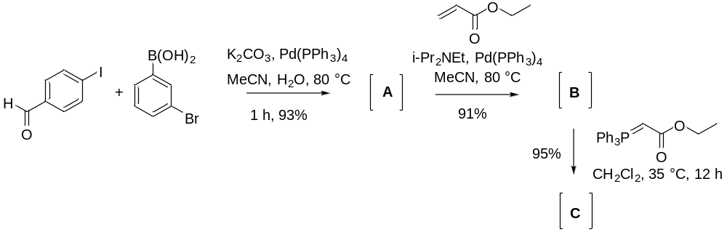

(Q2) Write-down the intermediate product structures of D-F in below reaction sequence.
[1.5+1.5+2 = 5]

