CH4203: Organic Synthesis Laboratory
------------------------------------------------------------------------------------------------------------------------
Expt. No. 5: Preparation of N-Boc-L-Prolinyl Azide via Mitsunobu Reaction

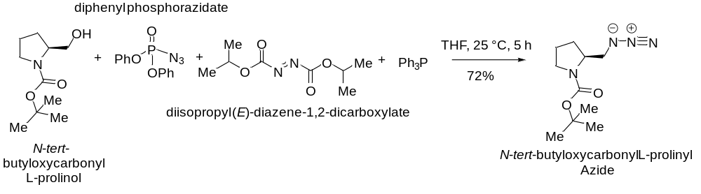

Aim and Objectives:

Apparatus Requirement:

Chemicals Requirement:

Molecular Wt. and Physical Details of Reagents:

Experimental Procedure:

Reaction Mechanism:

Results & Observation:

Yield:

% of Yield:

TLC System:

Compound Characterization:

FT-IR:

1H-NMR:

13C-NMR:

HRMS:

Conclusion:

