CH4104_Model Question 1
- Design the retrosynthesis of the A. Use ‘B’ as the starting material (end point of retrosynthesis)
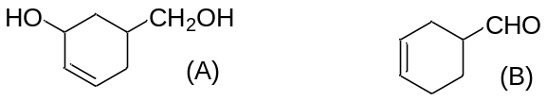
- What are Total Synthesis, Formal Synthesis, Linear synthesis, and Convergent synthesis?
- Write the disconnections of the molecules.
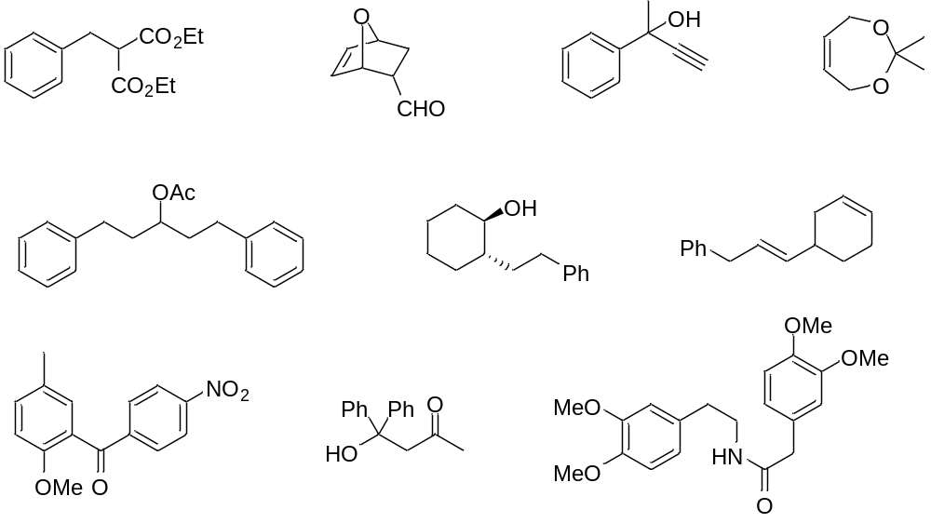
- Draw the retro and forward synthesis with proper reagents of the above molecule.
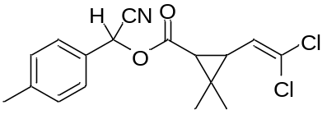
- Predict the missing reagents and products in the following syntheses. Show the mechanism of the mentioned steps.
