Yamaha Sales Data Customer Insight Generation Finding

1. Identified and handled extreme and negative values in selling price, buying price, and discount, creating a new data frame for further analysis.
2. Year-long dealer and product analysis, monthly profit, invoice, customer trends, and parameter correlations (Correlation matrix).

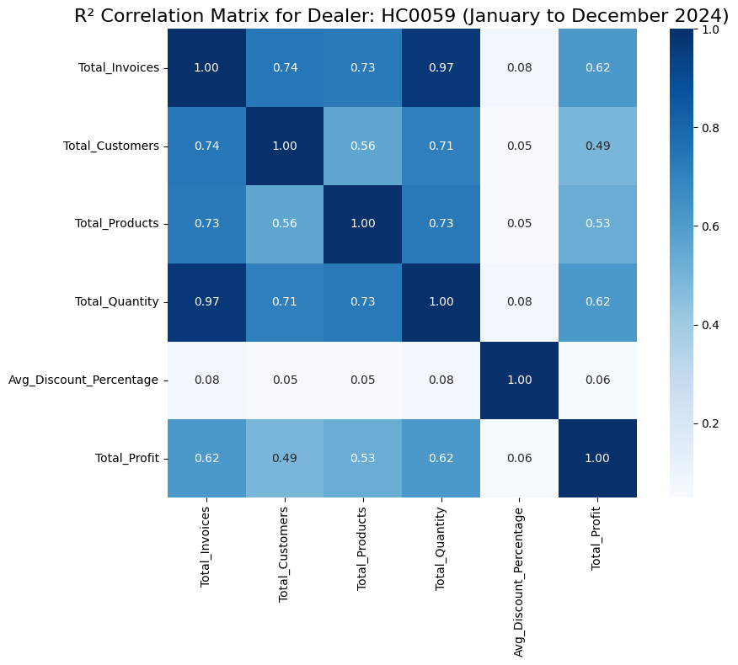

1. Identified 10 counter sales products causing the maximum loss.

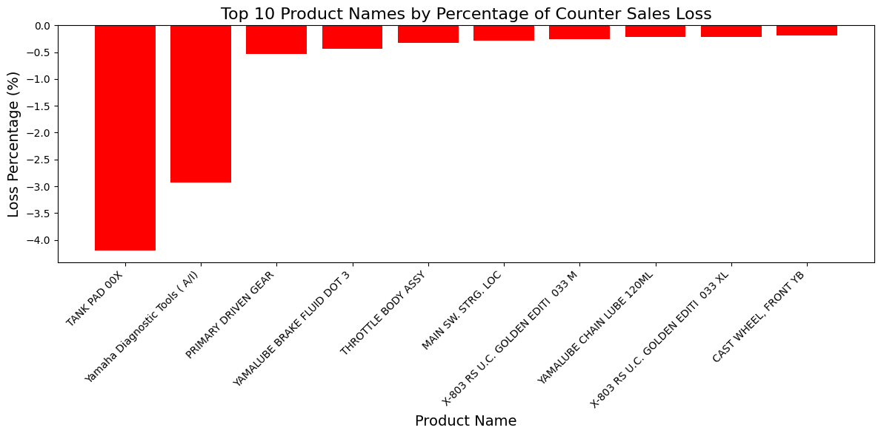

1. Identified the top 10 products contributing to profit or loss in counter sales and calculated their average profit per invoice for both counter and non-counter sales.

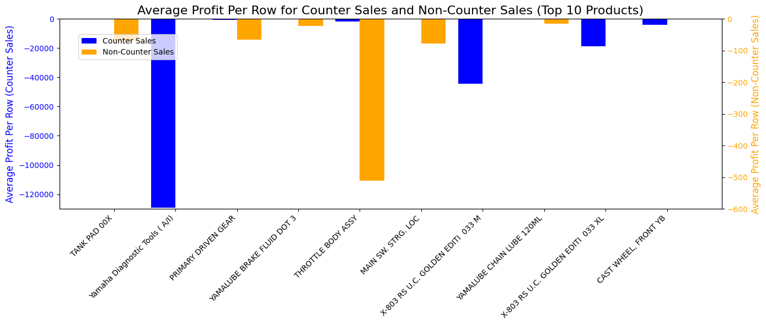

1. Identified the top 10 products with the highest total loss, focusing on those with high counter sales and significant discount percentages.

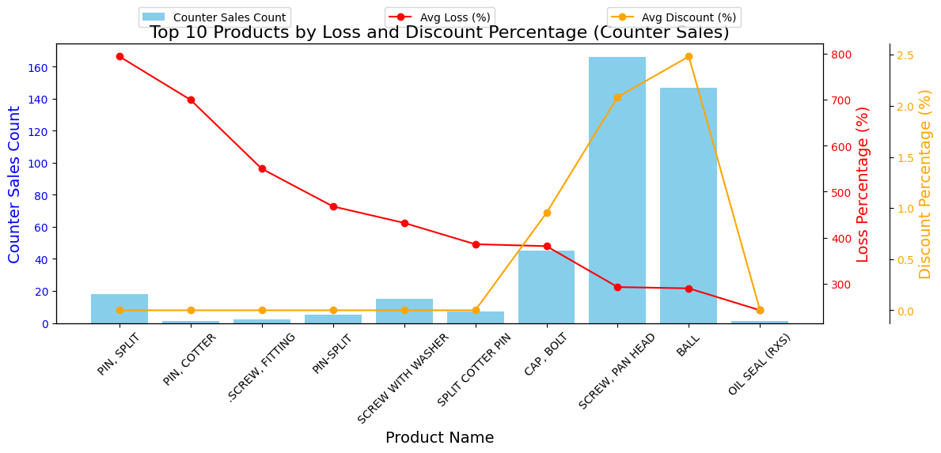

1. Excluded products with an average discount of over 5%, resulting in increased month-wise loss percentage due to removing low-priced yet revenue-generating products.

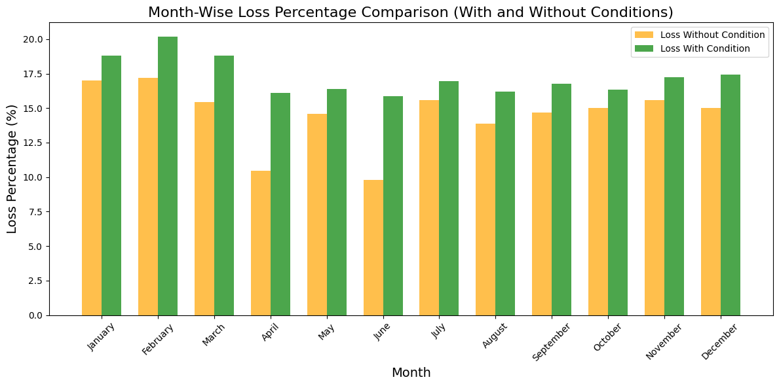

1. Found that the monthly counter sales loss percentage consistently exceeded the proportion of counter sales invoices to total invoices.

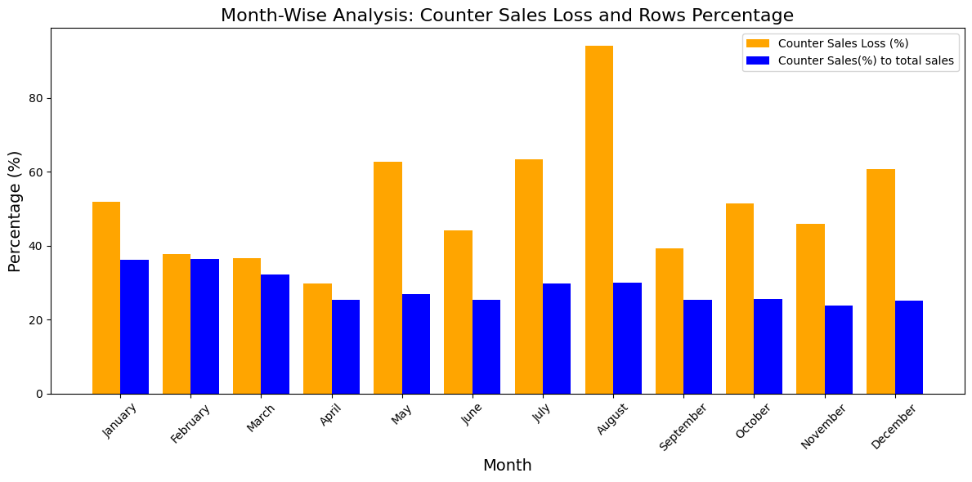

1. Analyzed service intervals for multiple customers to identify patterns in service timing, but no consistent time interval pattern was found.
2. Identified the 50 most sold products by quantity, sorted them by average discount percentage, and found that most are contributing to a higher loss percentage.

