***Lab No-01***

***Name of the lab:*****some Linux basics Questions.**

**Name : Shuvo Biswas**

**ID : IT-16014**

***Objective:***

Install Linux in case you do not already have it installed (Tip, Ubuntu:

[**http://www.ubuntu.com/desktop/get-­**](http://www.ubuntu.com/desktop/get-)**ubuntu/download**).

You can either make a clean installation or run it through virtualization by first installing VirtualBox from: [**http://www.virtualbox.org/**.](http://www.virtualbox.org/)

1. **Introduction**

# Virtual Interfaces

# Add a New Network

# Multinetwork Scenario Configuration

**Introduction**

**Question-01:**

If you have a network that ranges from 192.168.1.0 to 192.168.1.255 explain why individual devices in the network can only be assigned IP addresses in the range of 192.168.1.1 to 192.168.1.254.

**Answer:**

192.168.1.2 is a private, default IP address for some types of home broadband routing. It is also often assigned to individual devices on a home network when a router has an IP address of 192.168.1.1.

192.168.1.2 is a private, default IP address for some types of home broadband routing. It is also often assigned to individual devices on a home network when a router has an IP address of 192.168.1.1. As a Private IP address, 192.168.1.2 does not need to be unique across the Internet, but must be unique within the local network.

Although this IP address is set by the manufacturer by default for some routers, any router or computer on the local network can be set to use 192.168.1.2.

# Question-02: Find IP & MAC Address.

Find out about network and hardware information for the computer you are currently using.

**Answer:**

To know more about our computer hardware and software information for the computer we are currently using to check the computer or laptop hardware in Windows is the built-in **Windows System Information Tool**. If we go to **Run –> msinfo32**, this will show basic details about the hardware installed in our computer. We can also use the device manager to see the devices installed in our computer.

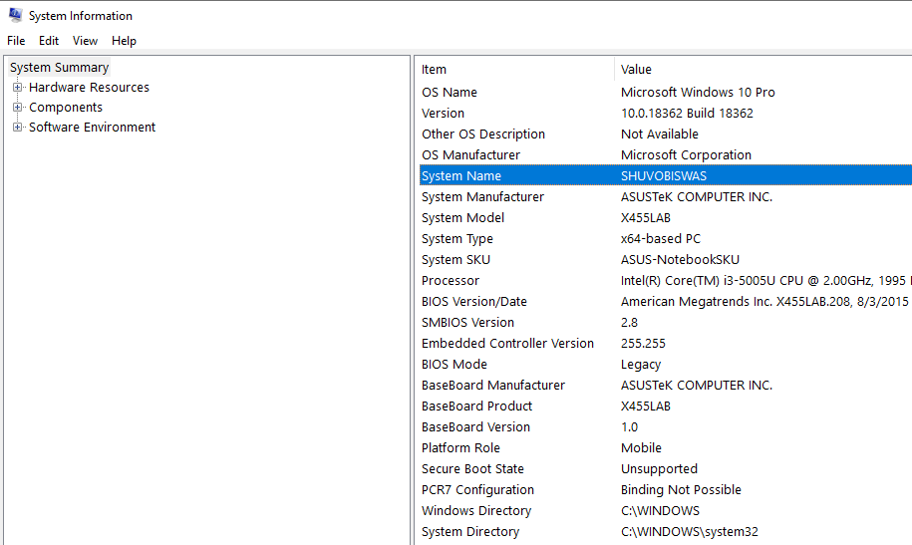

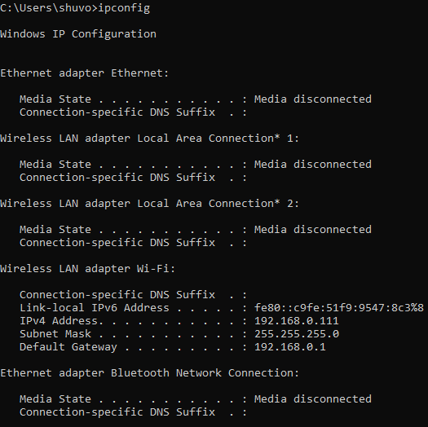

**the IP address: IPv4 Address………………. : 192.168.0.111**

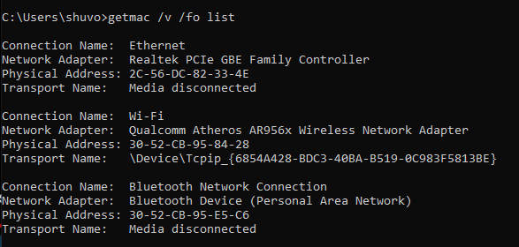

**and MAC address : Physical Address : 2C-56-DC-82-33-4E**

# Question-03: Routing Table

Now, enter the command: **"$ netstat -­r"** to print my computers routing table. Explain (very briefly) the different columns: **Destination, Gateway, Genmask, Flags, MSS, Window, irtt and Iface.**

**Answer:**

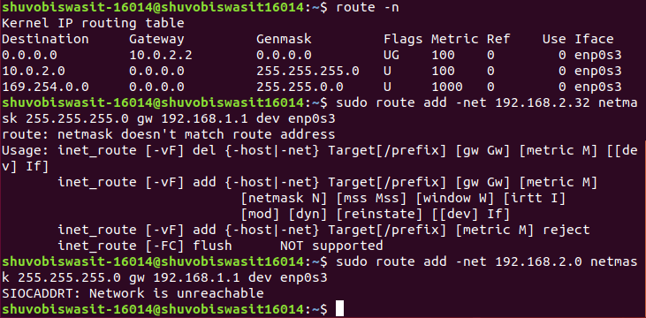

**netstat** is a useful tool for checking your network configuration and activity. It is in fact a collection of several tools lumped together.

**Destination :** The first column is Destination from which the internet ip is started.

**Gateway:** The second column of **netstat** 's output shows the gateway to which the routing entry points. If no gateway is used, an asterisk is printed instead.

**Genmask:** The third column shows the “generality” of the route, i.e., the network mask for this route. When given an IP address to find a suitable route for, the kernel steps through each of the routing table entries, taking the bitwise AND of the address and the genmask before comparing it to the target of the route.

**Flags:** The fourth column displays the following flags that describe the route:

G ->The route uses a gateway.

U ->The interface to be used is up.

H ->Only a single host can be reached through the route. For example, this is the case for the loopback entry 127.0.0.1.

D ->This route is dynamically created. It is set if the table entry has been generated by a routing daemon like **gated** or by an ICMP redirect message.

M ->This route is set if the table entry was modified by an ICMP redirect message.

! ->The route is a reject route and datagrams will be dropped.

The next three columns show the MSS, Window and irtt that will be applied to TCP connections established via this route.

**MSS:** The MSS is the Maximum Segment Size and is the size of the largest datagram the kernel will construct for transmission via this route.

**Window:**The Window is the maximum amount of data the system will accept in a single burst from a remote host.

**Irtt:**The acronym irtt stands for “initial round trip time.”

# Virtual Interfaces

**Question-04**

Linux offers the possibility to set up interfaces according to my networking needs. For instance, if needed, i can configure an interface for multiple IP addresses by creating new virtual interfaces with another IP address.

1. Create a new virtual interface with following IP address, 192.168.2.32 and netmask 255.255.255.0 then check to see if the interface was created successfully?

**Answer:**



1. Now, i need to set up a route for this interface so that my computer can see it. Otherwise, everyone else on the network will be able to reach the new interface except me. Issue the needed command, then issue the "$ netstat -­‐r" command and check if the route to my added interface is visible.

**Answer:**

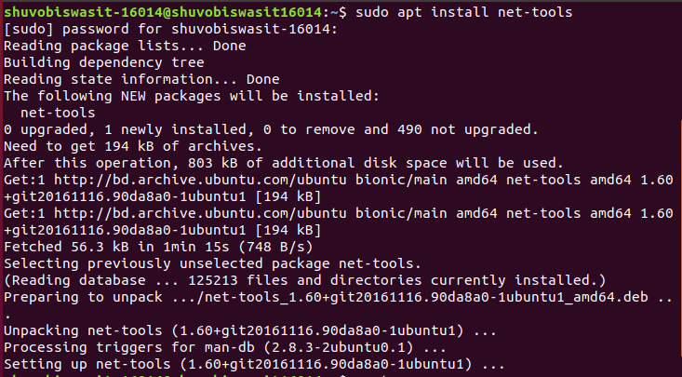

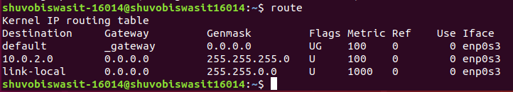

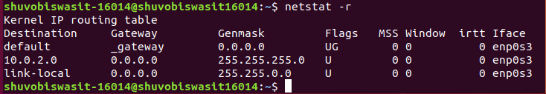

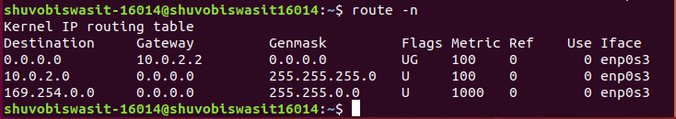

1. Next remove the route for this interface.

**Answer:**



# Multinetwork Scenario Configuration

**Question-06:**

You should now set up a working routing table for a multi-­‐network scenario. Assume that you have two network cards available connected to two different LANs. The destination of the first network is, 10.0.2.0 with netmask 255.0.0.0 and the second, 192.168.1.0 with netmask 255.255.255.0. Furthermore, a firewall is assumed to exist between the two networks, where network card eth0 is attached to the 10.0.2.0 network and eth1 is attached to the 192.168.1.0 network. To forward packets on the Internet the firewall needs to route packets from the 10.0.2.0 network through the 192.168.1.0 network. The firewall system must be set up with two IP addresses, 10.0.2.1 on eth0 and 192.168.1.25 on eth1. The gateway to the Internet on the 192.168.1.0 network should be 192.168.1.1.

**Conclution :**

In this lab report, we will discuss about some Linux basics Questions such as Virtual Interfaces ,Add a New Network and Multinetwork Scenario Configuration. From this lab report ,i learnt about how linux works and the basic interface about linux.Linux is extremely easy to get started with. Linux has an extraordinarily simple syntax. Linux is an example of FLOSS (Free/Libré and Open Source Software).