Lab on : Introduction to Python programming

Lab Report No: 02

Name : Shuvo Biswas

ID : IT-16014

Objectives :

The objective of the lab 1 is to:
▪ Setup python environment for programing,
▪ Learn the basics of python,
▪ Create and run basic examples using python.

Theory :

Definition of Python:

Python is an easy to learn, powerful programming language. It has efficient high-level data structures and a simple but effective approach to object-oriented programming. Python's elegant syntax and dynamic typing, together with its interpreted nature, make it an ideal language for scripting and rapid application development in many areas on most platforms.

Methodology :

Section 3.1: Setup of Python Environment

✓ STEP 1: Open Eclipse and setup a correct access to Internet (This is required only in RMIT network). In order to set up Manual Proxy follow the instructions:

a. Go to Windows > Preferences > General > Network Connections.
b. Change Active Provider to Manual.
c. Input proxy details, including username/password if required.
▪ Host: proxy.rmit.edu.au
▪ Port: 8080
▪ Username/password: No required
d. Clear SOCKS proxy.
e. Restart Eclipse.

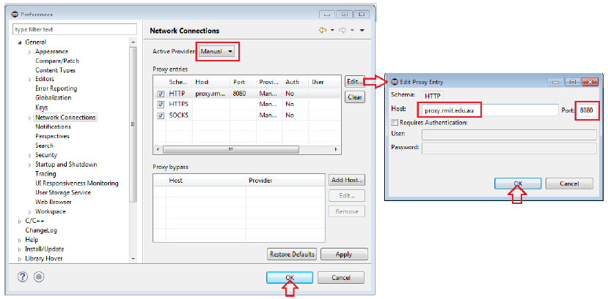

STEP 2: Installing python environment using Eclipse Graphical Interface1.

- To install PyDev and PyDev Extensions using the Eclipse Update Manager, you need to use the Help > Install New Software... menu .

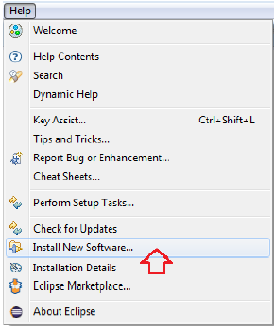

- In the next screen, add the update site(s) you want to work with . The available update sites are:
▪ http://pydev.org/updates (Last version for your personal PC)
▪ http://pydev.org/updates4.5( version for RMIT Labs)

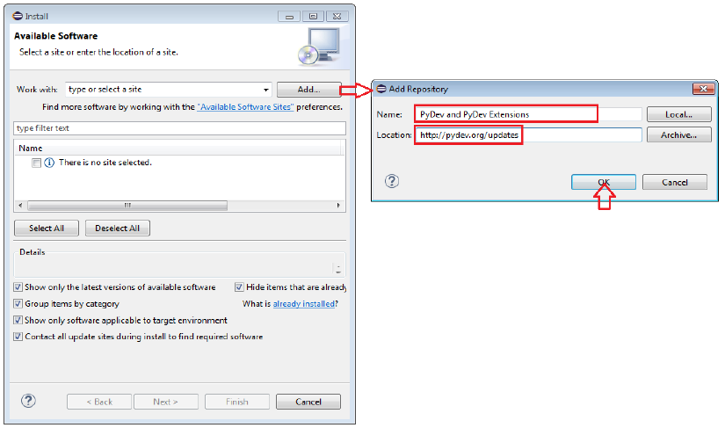

- After entering the update sites, select the update site you entered or select "All available sites" and add a filter for PyDev, so that it shows the contents of all the update sites that have PyDev .

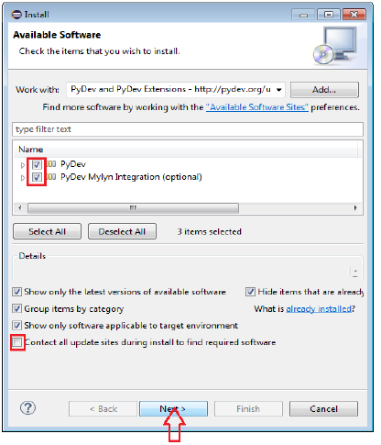

d. Then, UNCHECK the 'Contact all update sites during install to find required software' and press 'Next' again to confirm your selection

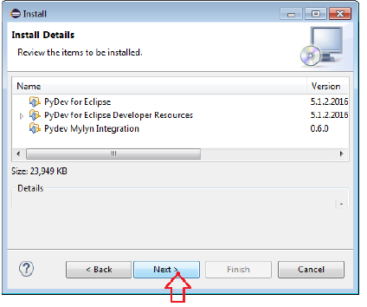

e. And finally, read the license agreement and if you accept, select the accept radio button and click 'Finish'

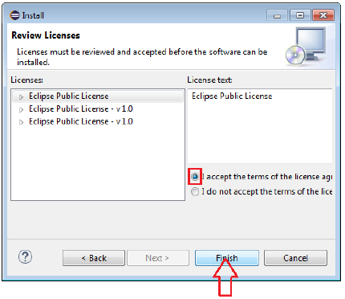

Some Code in python language :

1. Addition :
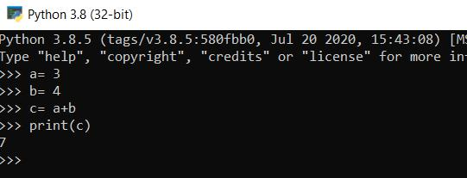

- Subtraction :

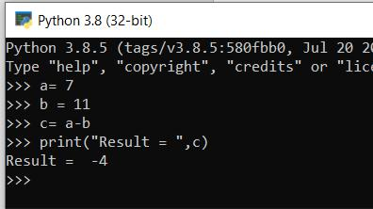

3. Input & print:
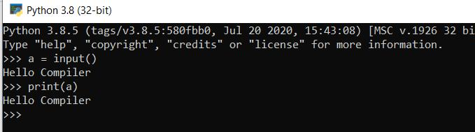

4. Loop:
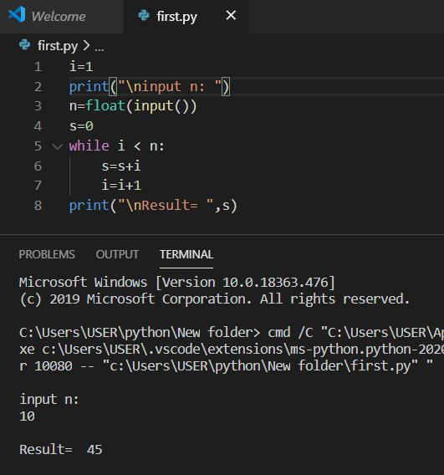

Conclusion:
There are many benefits of learning Python, especially as your first language, which we will discuss. It is a language that is remarkably easy to learn, and it can be used as a stepping stone into other programming languages and frameworks. If you’re an absolute beginner and this is your first time working with any type of coding language, that’s something you definitely want. Python is widely used, including by a number of big companies like Google, Pinterest, Instagram, Disney, Yahoo!, Nokia, IBM, and many others. The Raspberry Pi – which is a mini computer and DIY lover’s dream – relies on Python as it’s main programming language too.

