Lab No: 05

Lab Report Name : Software Defined Network ( SDN Mininet with Ryu Controller)
Name : Shubo Biswas

ID : IT-16014

Objectives :

The objective of the lab 5 is to:
▪ Install and use traffic generators as powerful tools for testing network performance.
▪ Install and configure SDN Controller
▪ Install and understand how the mininet simulator works
▪ Implement and run basic examples for understanding the role of the controller and how it interact with mininet

Theory :

2.1. Traffic Generator:
What is iPerf?: iPerf is a tool for active measurements of the maximum achievable bandwidth on IP networks. It supports tuning of various parameters related to timing, buffers and protocols (TCP, UDP, SCTP with IPv4 and IPv6). For each test it reports the bandwidth, loss, and other parameters.

2.2. Software Defined Networking:
Software-defined networking was pioneered between 2008 and 2011 by work done at Stanford University and the Nicira Company.

that by separating control of network functions from hardware devices, administrators acquire more power to route and direct traffic in response to changing requirements.

Software-Defined vs. Traditional Networking: The key difference between traditional and software-defined networking is how SDNs handle data packets. In a traditional network, the way a switch handles an incoming data packet is written into its firmware. Most switches — particularly those used in commercial data centers rather than enterprise environments — respond to and route all packets the same way. SDN provides admins with granular control over the way switches handle data, giving them the ability to automatically prioritize or block certain types of packets. This, in turn, allows for greater efficiency without the need to invest in expensive, application-specific network switches

Benefits of Software-Defined Networking:

There are several benefits to the more advanced level of control afforded by implementing SND in a multi-tenant network environment:
▪ Automation: SND allows for automation of complex operational tasks that make networks faster, more efficient and easier to manage.
▪ Increased uptime: SDN has proven effective in reducing deployment and configuration errors that can lead to service disruptions.
▪ Less drain on resources: SDN gives administrators control over how their routers and switches operate from a single, virtual workflow. This frees up key staff to focus on more important tasks.
▪ Better visibility: With SDN, system administrator’s gain improved visibility into overall network function, allowing them to allocate resources more effectively.
▪ Cost savings: SND can lead to significant overall costs savings. It also reduces the amount of spending required on infrastructure by allowing data centers to get the most use of their existing devices.

Methodology :

TIP: For getting extra space in your USB-please use the following tips:
• Empty the trash
• Delete the Android related staff
• Delete the extras for other courses
• Delete the already installed package sources

Install iperf :

1. Open the Synaptic Package Manager (Navigator ->System-> Synaptic Package Manager)
2. Setup the proxy:
o Click on settings-> Preference -> Network
o Click on manual proxy configuration
o HTT and FTP Proxy: proxy.rmit.edu.au Port: 8080
3. Search for Quick filter `iperf`
4. Click on Mark for installation
5. Then click on Apply and wait until the package is installed

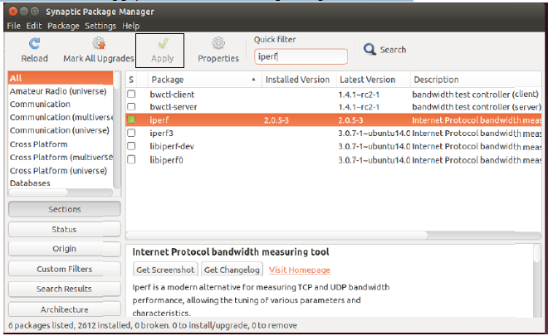

Install mininet
1. In Synaptic Package
2. Search for Quick filter `mininet`
3. Click on Mark for installation
4. Then click on Apply and wait until the package is installed

Install Controller
OVS controller:
1. In Synaptic Package
2. Search for Quick filter `openvswitch-controller`
3. Click on Mark for installation
4. Then click on Apply and wait until the package is installed

Install Ryu Controller

1.To install Ryu Controller Firstly,We need to install Python in our system

$ sudo apt install python3-pip
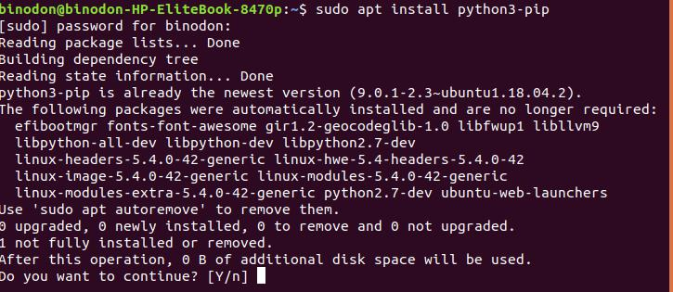

2.Now we may install Ryu Controller by following instruction

$ sudo pip3 install ryu
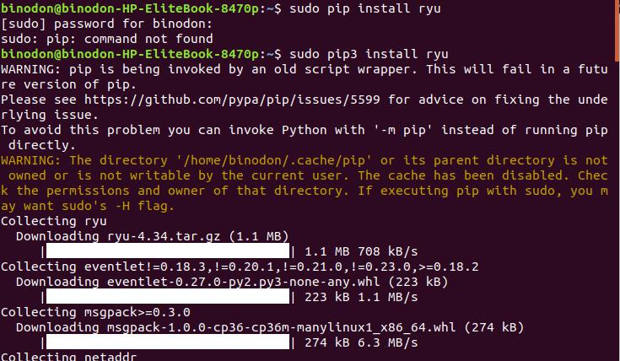
3.After Completing installation Now We can check the version:

$ ryu-manager --version

Install Mininet:

1.$ git clone git://github.com/mininet/mininet

Mininet Already exists in my system

2.$ git tag
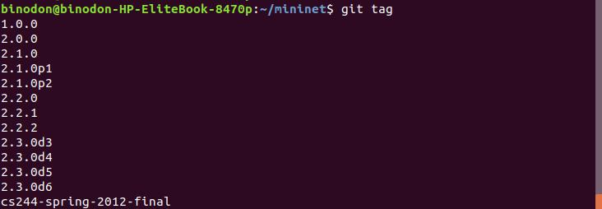

3.$ git checkout -b 2.2.2 2.2.2

Run Ryu Controller

$ ryu-manager ryu.app.simple_switch
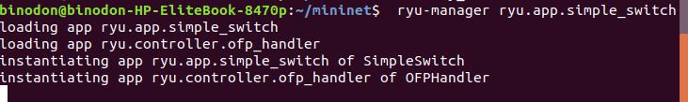
Run Mininet topology

$ sudo mn --topo single,3 --mac --switch ovsk --controller remote
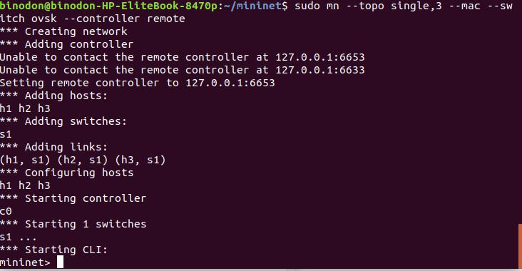

Application:

mininet> pingall
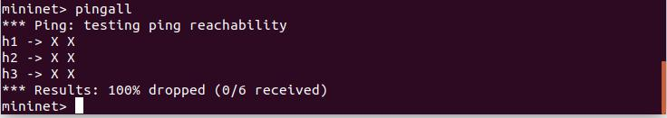

Conclusion:
In this lab we will learn basically in Software-defined networking most switches — particularly those used in commercial data centers rather than enterprise environments — respond to and route all packets the same way. SDN provides admins with granular control over the way switches handle data, giving them the ability to automatically prioritize or block certain types of packets.

