Name : Shuvo Biswas

ID : IT-16014
Lab Report No : 03
Lab Report on : Programming with Python

Objectives :

The objective of the lab 2 is to:
▪ Understand how python function works
▪ Understand the use of global and local variables
▪ Understand how python modules works
▪ Learning the basis of networking programing with python

Theory :

Python functions: Functions are reusable pieces of programs. They allow you to give a name to a block of statements, allowing you to run that block using the specified name anywhere in the program and any number of times. This is known as calling the function.

Local Variables: Variables declared inside a function definition are not related in any way to other variables with the same names used outside the function (variable names are local to the function). This is called the scope of the variable. All variables have the scope of the block they are declared in starting from the point of definition of the name.

The global statement: Variables defined at the top level of the program are intended global. Global variables are intended to be used in any functions or classes). Global statement allows defining global variables inside functions as well.

Modules: Modules allow reusing a number of functions in other programs.

Networking background for sockets
What is a socket and how use it? A socket is one endpoint of a two-way communication link between two programs running on the network or PC. A socket is bound to a port number so that the TCP layer can identify the application that data is destined to be sent to.
Endpoint: An endpoint is a combination of an IP address and a port number.
Server and Client: Normally, a server runs on a specific computer and has a socket that is bound to a specific port number.

• On the server-side: The server just waits, listening to the socket for a client to make a connection request.

• On the client-side: The client knows the hostname of the machine on which the server is running and the port number on which the server is listening. To make a connection request, the client tries to rendezvous with the server on the server's machine and port. The client also needs to identify itself to the server so it binds to a local port number that it will use during this connection. This is usually assigned by the system.

Methodology:

Defining functions: Functions are defined using the def keyword. After this keyword comes an identifier name for the function, followed by a pair of parentheses which may enclose some names of variables, and by the final colon that ends the line.

Defining local and global variables: Local and global variables can be defined using:

Defining modules: There are various methods of writing modules, but the simplest way is to create a file with a .py extension that contains functions and variables.

Using modules: A module can be imported by another program to make use of its functionality. This is how we can use the Python standard library as well.

Some Code in python language :

- First code:

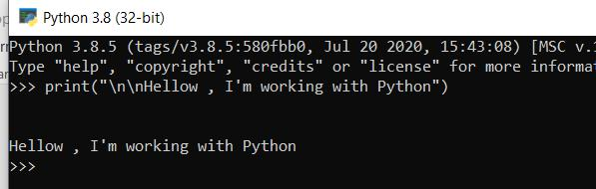

2. Addition :

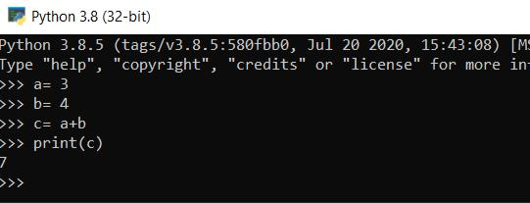

3. Subtraction :

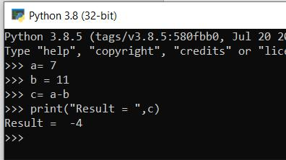
4. Multiplication:

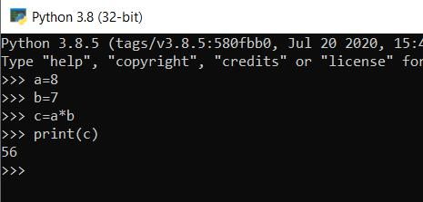

5. Division:

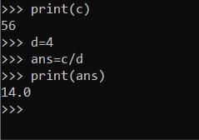

6. Input & print:

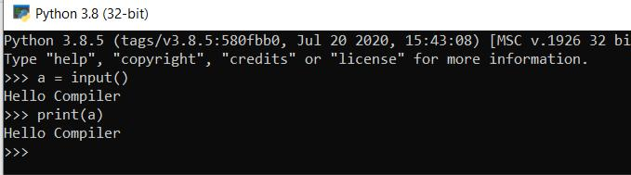
7. Loop:
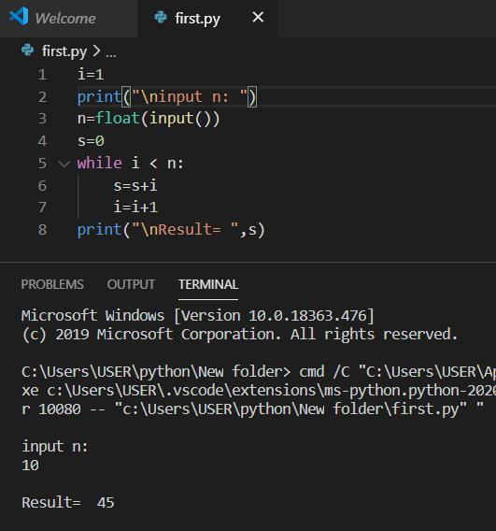

Conclusion:

Python is a general-purpose language sometimes referred to as utilitarian which is designed to be simple to read and write. The point that it’s not a complex language is important. The designers placed less of an emphasis on conventional syntax, which makes it easier to work with, even for non-programmers or developers.

Python is widely used, including by a number of big companies like Google, Pinterest, Instagram, Disney, Yahoo!, Nokia, IBM, and many others. The Raspberry Pi which is a mini computer and DIY lover’s dream relies on Python as it’s main programming language too.

