***Lab No-07***

***Name of the lab:***Implementation of FCFS scheduling algorithm.

***Name:******Shuvo Biswas ID:******IT-16014***

***Objective:***

(1) What is FCFS Scheduling Algorithm?

(2) How to implementation in C?

**(1) What is FCFS Scheduling Algorithm?**

**Ans:**

First come first serve (FCFS) scheduling algorithm simply schedules the jobs according to their arrival time. The job which comes first in the ready queue will get the CPU first. The lesser the arrival time of the job, the sooner will the job get the CPU. FCFS scheduling may cause the problem of starvation if the burst time of the first process is the longest among all the jobs.

## Advantages of FCFS :

1. Simple
2. Easy
3. First come, First serve

## Disadvantages of FCFS :

1. The scheduling method is non preemptive, the process will run to the completion.
2. Due to the non-preemptive nature of the algorithm, the problem of starvation may occur.
3. Although it is easy to implement, but it is poor in performance since the average waiting time is higher as compare to other scheduling algorithms.

**(2) How to implementation in C?**

**Ans:**

**Source code :**

#include<stdio.h>

int main(){

int bt[10]={0},at[10]={0},tat[10]={0},wt[10]={0},ct[10]={0};

int n,sum=0;

float totalTAT=0,totalWT=0;

printf("Enter number of processes ");

scanf("%d",&n);

printf("Enter arrival time and burst time for each process\n\n");

for(int i=0;i<n;i++)

{

printf("Arrival time of process[%d] ",i+1);

scanf("%d",&at[i]);

printf("Burst time of process[%d] ",i+1);

scanf("%d",&bt[i]);

printf("\n");

}

//calculate completion time of processes

for(int j=0;j<n;j++)

{

sum+=bt[j];

ct[j]+=sum;

}

//calculate turnaround time and waiting times

for(int k=0;k<n;k++)

{

tat[k]=ct[k]-at[k];

totalTAT+=tat[k];

}

for(int k=0;k<n;k++)

{

wt[k]=tat[k]-bt[k];

totalWT+=wt[k];

}

printf("Solution: \n\n");

printf("P#\t AT\t BT\t CT\t TAT\t WT\t\n\n");

for(int i=0;i<n;i++)

{

printf("P%d\t %d\t %d\t %d\t %d\t %d\ n",i+1,at[i],bt[i],ct[i],tat[i],wt[i]);

}

printf("\n\nAverage Turnaround Time = %f\n",totalTAT/n);

printf("Average WT = %f\n\n",totalWT/n);

return 0;

}

**Output :**

without arrival time :

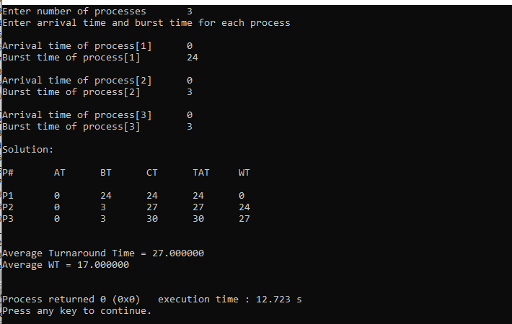

**with arrival time :**

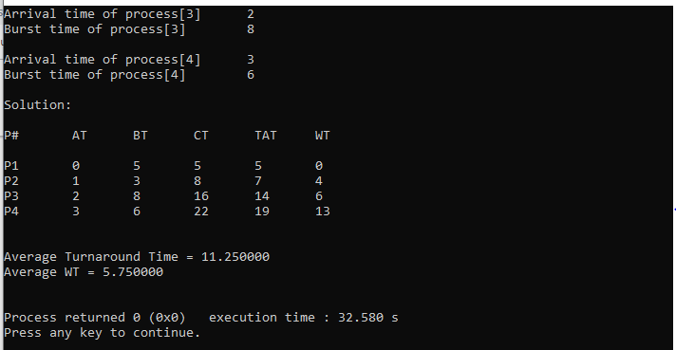

**Conclusion :**

By doing this lab, I have Implemented of FCFS scheduling algorithm.

Firstly I solve this algorithm in codeblocks during this time I faced many problems.

But later I solve this problem in my pc.