***Lab No-08***

***Name of the lab:*** *Implementation of* SJF Scheduling Algorithm

***Name:******Shuvo Biswas ID:******IT-16014***

***Objective:***

**(1) What is SJF Scheduling Algorithm?**

**(2) How to implementation in C?**

**(1) What is SJF scheduling Algorithm?**

**Ans:**

Shortest Job First scheduling works on the process with the shortest **burst time** or **duration** first.

* This is the best approach to minimize waiting time.
* This is used in Batch
* It is of two types:
  + Non Pre-emptive
  + Pre-emptive
* To successfully implement it, the burst time/duration time of the processes should be known to the processor in advance, which is practically not feasible all the time.
* This scheduling algorithm is optimal if all the jobs/processes are available at the same time. (either Arrival time is 0 for all, or Arrival time is same for all)

**(2) How to implementation in C?**

**Ans :**

**Source Code:**

#include<stdio.h>

int main()

{

int bt[20],p[20],wt[20],tat[20],i,j,n,total=0,pos,temp;

float avg_wt,avg_tat;

printf("\n\nEnter number of process: ");

scanf("%d",&n);

for(i=0; i<n; i++)

{

printf("Enter burst time for process %d: ",i+1);

scanf("%d",&bt[i]);

p[i]=i+1;

}

for(i=0; i<n; i++)

{

pos=i;

for(j=i+1; j<n; j++)

{

if(bt[j]<bt[pos])

pos=j;

}

temp=bt[i];

bt[i]=bt[pos];

bt[pos]=temp;

temp=p[i];

p[i]=p[pos];

p[pos]=temp;

}

wt[0]=0;

for(i=1; i<n; i++)

{

wt[i]=0;

for(j=0; j<i; j++)

wt[i]+=bt[j];

total+=wt[i];

}

avg_wt=(float)total/n;

total=0;

printf("\nProcess\t Burst Time \tWaiting Time\tTurnaround Time");

for(i=0; i<n; i++)

{

tat[i]=bt[i]+wt[i];

total+=tat[i];

printf("\nprocess %d\t %d\t\t %d\t\t\t%d",p[i],bt[i],wt[i],tat[i]);

}

avg_tat=(float)total/n;

printf("\n\nAverage Waiting Time=%f",avg_wt);

printf("\nAverage Turnaround Time=%f\n",avg_tat);

}

**Output :**

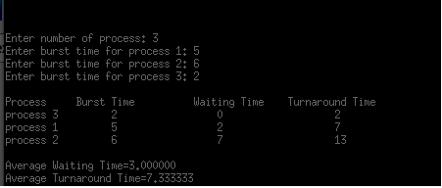

**Conclusion :**

By doing this lab, I have implemented SJF scheduling algorithm .

Firstly I solve this algorithm in codeblocks during this time I faced many problems.

But later I solve this problem in my pc.