***Lab No-09***

***Name of the lab:*** *Implementation of* Priority Scheduling Algorithm

***Name:******Shuvo Biswas ID:******IT-16014***

***Objective:***

**(1) What is Priority Scheduling Algorithm?**

**(2) How to implementation in C?**

**(1) What is Priority Scheduling Algorithm?**

**Ans :** Priority Scheduling Algorithm :

* Priority scheduling is a non-preemptive algorithm and one of the most common scheduling algorithms in batch systems.
* Each process is assigned a priority. Process with highest priority is to be executed first and so on.
* Processes with same priority are executed on first come first served basis.
* Priority can be decided based on memory requirements, time requirements or any other resource requirement.

**(2) How to implementation in C?**

**Ans:**

**Source code :**

#include<stdio.h>

int main()

{

int bt[20], p[20], wt[20], tat[20], pr[20],i,j,n,total=0,pos,temp,avg_wt,avg_tat;

printf("Enter Total Number of Process:");

scanf("%d",&n);

printf("\nEnter Burst Time and Priority\n");

for(i=0; i<n; i++)

{

printf("\nP[%d]\n",i+1);

printf("Burst Time:");

scanf("%d",&bt[i]);

printf("Priority:");

scanf("%d",&pr[i]);

p[i]=i+1; //contains process number

}

for(i=0; i<n; i++)

{

pos=i;

for(j=i+1; j<n; j++)

{

if(pr[j]<pr[pos])

pos=j;

}

temp=pr[i];

pr[i]=pr[pos];

pr[pos]=temp;

temp=bt[i];

bt[i]=bt[pos];

bt[pos]=temp;

temp=p[i];

p[i]=p[pos];

p[pos]=temp;

}

wt[0]=0; //waiting time for first process is zero

//calculate waiting time

for(i=1; i<n; i++)

{

wt[i]=0;

for(j=0; j<i; j++)

wt[i]+=bt[j];

total+=wt[i];

}

avg_wt=total/n; //average waiting time

total=0;

printf("\nProcess\t Burst Time \tWaiting Time\tTurnaround Time");

for(i=0; i<n; i++)

{

tat[i]=bt[i]+wt[i]; //calculate turnaround time

total+=tat[i];

printf("\nP[%d]\t\t %d\t\t %d\t\t\t%d",p[i],bt[i],wt[i],tat[i]);

}

avg_tat=total/n; //average turnaround time

printf("\n\nAverage Waiting Time=%d",avg_wt);

printf("\nAverage Turnaround Time=%d\n",avg_tat);

printf("\n");

return 0;

}

**Output :**

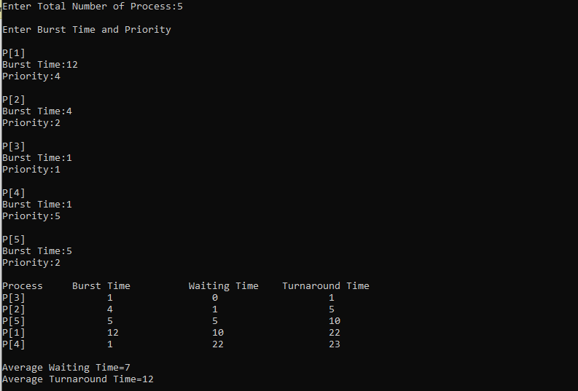

**Conclusion :**

By doing this lab, I have Implemented ofPriorityscheduling algorithm.

Firstly I solve this algorithm in codeblocks during this time I faced many problems.

But later I solve this problem in my pc.