***Lab No-11***

***Name of the lab:*****FIFO page replacement algorithm**

***Name:******Shuvo Biswas ID:******IT-16014***

***Objective:***

**(1) What is FIFO page replacement algorithm ?**

**(2) How to implementation in C?**

**(1) What is FIFO page replacement algorithm ?**

**Ans :**

This is the simplest page replacement algorithm. In a page replacement algorithm we decide when a page replacement occures then which frames are to be replaced.For evaluating an algorithm we take a particular string of memory references ,called reference string.

In FIFO page replacement algorithm- for each page we track the time when it was brought into the memory and when any replacement request comes then oldest page is chosen. If we choose a queue to hold all pages in memory then its more easy to understand and implement rather than tracking time of all pages.

**(2) How to implementation in C?**

**Ans :**

**Source code :**

#include<stdio.h>

int main()

{

int i,j,n,a[50],frame[10],no,k,avail,count=0;

printf("Enter the number of Pages: ");

scanf("%d",&n);

printf("Enter the page number : ");

for(i=1; i<=n; i++)

scanf("%d",&a[i]);

printf("Enter the number of FRAMES : ");

scanf("%d",&no);

for(i=0; i<no; i++)

frame[i]= -1;

j=0;

printf("\n");

printf("tref string\t page frames\n");

for(i=1; i<=n; i++)

{

printf("%d\t\t",a[i]);

avail=0;

for(k=0; k<no; k++)

if(frame[k]==a[i])

avail=1;

if (avail==0)

{

frame[j]=a[i];

j=(j+1)%no;

count++;

for(k=0; k<no; k++)

printf("%d\t",frame[k]);

}

printf("\n");

}

printf("Page Fault is: %d\n",count);

int cc =count;

printf("Page Hit is : %d\n",n-cc);

return 0;

}

**Output :**

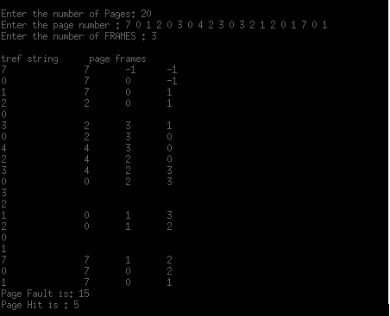

**Conclusion :**

By doing this lab, I have implemented FIFO page replacement algorithm.

Firstly I solve this algorithm in codeblocks during this time I faced many problems.

But later I solve this problem in my pc.