

American International University-Bangladesh (AIUB) Department of Computer Science

Faculty of Science &Technology (FST) Summer 21 22

Section: A

Software Quality Assurance and Testing

PHONE UNLOCK SYSTEM WITH ADVANCED EYE DETECTION

A Report submitted

By

|  |  |  |
| --- | --- | --- |
| SN | Student Name | Student ID |
| 1 | Shiraji, Yeamin Rahman Shuvo | 19-40874-2 |
| 2 | Nafisa Binte Shahadat | 19-40789-2 |
| 3 | Shium, Sheikh Mahmudul Hasan | 19-40764-2 |
| 4 | Sumaiya Jahan | 19-40834-2 |

Under the supervision of

**Abhijit Bhowmik**

Associate Professor

Software Test Plan

for

Phone Unlock System with Advanced Eye

Detection

Version 1.0 approved

Prepared by

Sheikh Mahmudul Hasan Shium, Nafisa Binte Shahadat, Sumaiya Jahanand,

Shiraji, Yeamin Rahman Shuvo

ABC Software Solutions

August 14, 2022

**Checked By Industry Personnel**

**Name:** Esha Sheikh

**Designation:** Software Quality Assurance Engineer

**Company:** Dream 71 Bangladesh Limited

**Sign:**

**Date:** 16 August 2022

Table of Contents

Revision History 3

1. TEST PLAN IDENTIFIER: FACE-DETECTION1.0 4

2. REFERENCES 4

3. INTRODUCTION 5

Background to the Problem 5

Solution to the Problem 5

4. REQUEIREMNT SPECIFICATION 6

4.1 System Features 6

4.2 System Quality Attributes 7

System Interface 8

4.3 Project Requirements 17

5. FEATURES NOT TO BE TESTED 23

6. TESTING APPROACH 23

6.1 Testing Levels 23

6.2 Test Tools 24

6.3 Meetings 24

7. TEST CASES/TEST ITEMS 25

8. ITEM PASS/FAIL CRITERIA 31

9. TEST DELIVERABLES 31

10. STAFFING AND TRAINING NEEDS 33

11. RESPONSIBILITIES 33

12. TESTING SCHEDULE 34

13. PLANNING RISKS AND CONTINGENCIES 36

14. APROVALS 37

# Revision History

|  |  |  |  |
| --- | --- | --- | --- |
| Revision | Date | Updated by | Update Comments |
| 0.1 | 2022.08.10 | Shium, Sheikh Mahmudul Hasan | First Draft |
| 0.2 | 2022.08.15 | Nafisa Binte Shahadat | Second Edition (As industry personnel Instruction) |

# TEST PLAN IDENTIFIER: FACE-DETECTION1.0

# REFERENCES

1. Vibhuti, N. Jindal, H. Singh, and P. S. Rana, “Face mask detection in COVID-19: a strategic review,” Multimed. Tools Appl., pp. 1–30, 2022.
2. Researchgate.net. [Online]. Available: https://www.researchgate.net/publication/232625997_RealTime_Iris_Recognition_System_Using_A_Proposed_Method. [Accessed: 19-Aug-2022].
3. “does galaxy s8 use iris detection unlock - Google Search,” Google.com. [Online]. Available:

https://www.google.com/search?q=does+galaxy+s8+use+iris+detection+unlock&oq=does+galaxy+s8+use +iris+detection+unl&aqs=chrome.1.69i57j33i160l2.29635j1j7&sourceid=chrome&ie=UTF-8. [Accessed:

19-Aug-2022].

Photo source:

* + [https://www.google.com/imgres?imgurl=https%3A%2F%2Fqph.cf2.quoracdn.net%2Fmainqimg-79536218cf6350e150a6928170f44a55-](https://www.google.com/imgres?imgurl=https%3A%2F%2Fqph.cf2.quoracdn.net%2Fmain-qimg-79536218cf6350e150a6928170f44a55-lq&imgrefurl=https%3A%2F%2Fwww.quora.com%2FIn-Islamic-countries-where-women-must-wear-burqas-are-their-passport-pictures-taken-with-their-head-covered-and-only-face-visible&tbnid=6djSgzk5EI0T7M&vet=12ahUKEwi2wrehocT5AhW9jtgFHXlVAlMQMygIegUIARDMAQ..i&docid=VrH3jTg3al7yVM&w=602&h=540&q=girl%20wearing%20niqab%20for%20face%20recognition&ved=2ahUKEwi2wrehocT5AhW9jtgFHXlVAlMQMygIegUIARDMAQ)

[lq&imgrefurl=https%3A%2F%2Fwww.quora.com%2FIn-Islamic-countries-where-women-mustwear-burqas-are-their-passport-pictures-taken-with-their-head-covered-and-only-face-](https://www.google.com/imgres?imgurl=https%3A%2F%2Fqph.cf2.quoracdn.net%2Fmain-qimg-79536218cf6350e150a6928170f44a55-lq&imgrefurl=https%3A%2F%2Fwww.quora.com%2FIn-Islamic-countries-where-women-must-wear-burqas-are-their-passport-pictures-taken-with-their-head-covered-and-only-face-visible&tbnid=6djSgzk5EI0T7M&vet=12ahUKEwi2wrehocT5AhW9jtgFHXlVAlMQMygIegUIARDMAQ..i&docid=VrH3jTg3al7yVM&w=602&h=540&q=girl%20wearing%20niqab%20for%20face%20recognition&ved=2ahUKEwi2wrehocT5AhW9jtgFHXlVAlMQMygIegUIARDMAQ)

[visible&tbnid=6djSgzk5EI0T7M&vet=12ahUKEwi2wrehocT5AhW9jtgFHXlVAlMQMygIegUI ARDMAQ..i&docid=VrH3jTg3al7yVM&w=602&h=540&q=girl%20wearing%20niqab%20for%](https://www.google.com/imgres?imgurl=https%3A%2F%2Fqph.cf2.quoracdn.net%2Fmain-qimg-79536218cf6350e150a6928170f44a55-lq&imgrefurl=https%3A%2F%2Fwww.quora.com%2FIn-Islamic-countries-where-women-must-wear-burqas-are-their-passport-pictures-taken-with-their-head-covered-and-only-face-visible&tbnid=6djSgzk5EI0T7M&vet=12ahUKEwi2wrehocT5AhW9jtgFHXlVAlMQMygIegUIARDMAQ..i&docid=VrH3jTg3al7yVM&w=602&h=540&q=girl%20wearing%20niqab%20for%20face%20recognition&ved=2ahUKEwi2wrehocT5AhW9jtgFHXlVAlMQMygIegUIARDMAQ)

[20face%20recognition&ved=2ahUKEwi2wrehocT5AhW9jtgFHXlVAlMQMygIegUIARDMAQ](https://www.google.com/imgres?imgurl=https%3A%2F%2Fqph.cf2.quoracdn.net%2Fmain-qimg-79536218cf6350e150a6928170f44a55-lq&imgrefurl=https%3A%2F%2Fwww.quora.com%2FIn-Islamic-countries-where-women-must-wear-burqas-are-their-passport-pictures-taken-with-their-head-covered-and-only-face-visible&tbnid=6djSgzk5EI0T7M&vet=12ahUKEwi2wrehocT5AhW9jtgFHXlVAlMQMygIegUIARDMAQ..i&docid=VrH3jTg3al7yVM&w=602&h=540&q=girl%20wearing%20niqab%20for%20face%20recognition&ved=2ahUKEwi2wrehocT5AhW9jtgFHXlVAlMQMygIegUIARDMAQ)

* + [https://www.google.com/imgres?imgurl=https%3A%2F%2Fwww.arabnews.com%2Fsites%2Fdef ault%2Ffiles%2F2020%2F05%2F11%2F2100871-](https://www.google.com/imgres?imgurl=https%3A%2F%2Fwww.arabnews.com%2Fsites%2Fdefault%2Ffiles%2F2020%2F05%2F11%2F2100871-109131450.jpg&imgrefurl=https%3A%2F%2Fwww.arabnews.com%2Fnode%2F1673056%2Flifestyle&tbnid=Xy-BcmLyV3Xq2M&vet=12ahUKEwi2wrehocT5AhW9jtgFHXlVAlMQMygCegUIARC-AQ..i&docid=ZSZKhOdLOw3y5M&w=1000&h=696&q=girl%20wearing%20niqab%20for%20face%20recognition&ved=2ahUKEwi2wrehocT5AhW9jtgFHXlVAlMQMygCegUIARC-AQ)

[109131450.jpg&imgrefurl=https%3A%2F%2Fwww.arabnews.com%2Fnode%2F1673056%2Flife style&tbnid=Xy-](https://www.google.com/imgres?imgurl=https%3A%2F%2Fwww.arabnews.com%2Fsites%2Fdefault%2Ffiles%2F2020%2F05%2F11%2F2100871-109131450.jpg&imgrefurl=https%3A%2F%2Fwww.arabnews.com%2Fnode%2F1673056%2Flifestyle&tbnid=Xy-BcmLyV3Xq2M&vet=12ahUKEwi2wrehocT5AhW9jtgFHXlVAlMQMygCegUIARC-AQ..i&docid=ZSZKhOdLOw3y5M&w=1000&h=696&q=girl%20wearing%20niqab%20for%20face%20recognition&ved=2ahUKEwi2wrehocT5AhW9jtgFHXlVAlMQMygCegUIARC-AQ)

[BcmLyV3Xq2M&vet=12ahUKEwi2wrehocT5AhW9jtgFHXlVAlMQMygCegUIARCAQ..i&docid=ZSZKhOdLOw3y5M&w=1000&h=696&q=girl%20wearing%20niqab%20for%20f ace%20recognition&ved=2ahUKEwi2wrehocT5AhW9jtgFHXlVAlMQMygCegUIARC-AQ](https://www.google.com/imgres?imgurl=https%3A%2F%2Fwww.arabnews.com%2Fsites%2Fdefault%2Ffiles%2F2020%2F05%2F11%2F2100871-109131450.jpg&imgrefurl=https%3A%2F%2Fwww.arabnews.com%2Fnode%2F1673056%2Flifestyle&tbnid=Xy-BcmLyV3Xq2M&vet=12ahUKEwi2wrehocT5AhW9jtgFHXlVAlMQMygCegUIARC-AQ..i&docid=ZSZKhOdLOw3y5M&w=1000&h=696&q=girl%20wearing%20niqab%20for%20face%20recognition&ved=2ahUKEwi2wrehocT5AhW9jtgFHXlVAlMQMygCegUIARC-AQ)

* + [https://www.google.com/imgres?imgurl=https%3A%2F%2Famaliah-media.imgix.net%2Fwpcontent%2Fuploads%2F2017%2F10%2FAustriaFaceVeil.png%3Fw%3D700%26fm%3Dpjpg%2 6auto%3Dformat%26dpr%3D2%26q%3D80&imgrefurl=https%3A%2F%2Fwww.amaliah.com%](https://www.google.com/imgres?imgurl=https%3A%2F%2Famaliah-media.imgix.net%2Fwp-content%2Fuploads%2F2017%2F10%2FAustriaFaceVeil.png%3Fw%3D700%26fm%3Dpjpg%26auto%3Dformat%26dpr%3D2%26q%3D80&imgrefurl=https%3A%2F%2Fwww.amaliah.com%2Fpost%2F32110%2Fniqab-ban-austria-face-veil-ban-muslim-women&tbnid=NO2uNoJkCBwRoM&vet=12ahUKEwi2wrehocT5AhW9jtgFHXlVAlMQMyhQegUIARCCAQ..i&docid=_U1agAy8JzKNQM&w=1400&h=1400&q=girl%20wearing%20niqab%20for%20face%20recognition&ved=2ahUKEwi2wrehocT5AhW9jtgFHXlVAlMQMyhQegUIARCCAQ)

[2Fpost%2F32110%2Fniqab-ban-austria-face-veil-ban-muslim-](https://www.google.com/imgres?imgurl=https%3A%2F%2Famaliah-media.imgix.net%2Fwp-content%2Fuploads%2F2017%2F10%2FAustriaFaceVeil.png%3Fw%3D700%26fm%3Dpjpg%26auto%3Dformat%26dpr%3D2%26q%3D80&imgrefurl=https%3A%2F%2Fwww.amaliah.com%2Fpost%2F32110%2Fniqab-ban-austria-face-veil-ban-muslim-women&tbnid=NO2uNoJkCBwRoM&vet=12ahUKEwi2wrehocT5AhW9jtgFHXlVAlMQMyhQegUIARCCAQ..i&docid=_U1agAy8JzKNQM&w=1400&h=1400&q=girl%20wearing%20niqab%20for%20face%20recognition&ved=2ahUKEwi2wrehocT5AhW9jtgFHXlVAlMQMyhQegUIARCCAQ)

[women&tbnid=NO2uNoJkCBwRoM&vet=12ahUKEwi2wrehocT5AhW9jtgFHXlVAlMQMyhQe gUIARCCAQ..i&docid=_U1agAy8JzKNQM&w=1400&h=1400&q=girl%20wearing%20niqab%](https://www.google.com/imgres?imgurl=https%3A%2F%2Famaliah-media.imgix.net%2Fwp-content%2Fuploads%2F2017%2F10%2FAustriaFaceVeil.png%3Fw%3D700%26fm%3Dpjpg%26auto%3Dformat%26dpr%3D2%26q%3D80&imgrefurl=https%3A%2F%2Fwww.amaliah.com%2Fpost%2F32110%2Fniqab-ban-austria-face-veil-ban-muslim-women&tbnid=NO2uNoJkCBwRoM&vet=12ahUKEwi2wrehocT5AhW9jtgFHXlVAlMQMyhQegUIARCCAQ..i&docid=_U1agAy8JzKNQM&w=1400&h=1400&q=girl%20wearing%20niqab%20for%20face%20recognition&ved=2ahUKEwi2wrehocT5AhW9jtgFHXlVAlMQMyhQegUIARCCAQ)

[20for%20face%20recognition&ved=2ahUKEwi2wrehocT5AhW9jtgFHXlVAlMQMyhQegUIAR](https://www.google.com/imgres?imgurl=https%3A%2F%2Famaliah-media.imgix.net%2Fwp-content%2Fuploads%2F2017%2F10%2FAustriaFaceVeil.png%3Fw%3D700%26fm%3Dpjpg%26auto%3Dformat%26dpr%3D2%26q%3D80&imgrefurl=https%3A%2F%2Fwww.amaliah.com%2Fpost%2F32110%2Fniqab-ban-austria-face-veil-ban-muslim-women&tbnid=NO2uNoJkCBwRoM&vet=12ahUKEwi2wrehocT5AhW9jtgFHXlVAlMQMyhQegUIARCCAQ..i&docid=_U1agAy8JzKNQM&w=1400&h=1400&q=girl%20wearing%20niqab%20for%20face%20recognition&ved=2ahUKEwi2wrehocT5AhW9jtgFHXlVAlMQMyhQegUIARCCAQ)

[CCAQ](https://www.google.com/imgres?imgurl=https%3A%2F%2Famaliah-media.imgix.net%2Fwp-content%2Fuploads%2F2017%2F10%2FAustriaFaceVeil.png%3Fw%3D700%26fm%3Dpjpg%26auto%3Dformat%26dpr%3D2%26q%3D80&imgrefurl=https%3A%2F%2Fwww.amaliah.com%2Fpost%2F32110%2Fniqab-ban-austria-face-veil-ban-muslim-women&tbnid=NO2uNoJkCBwRoM&vet=12ahUKEwi2wrehocT5AhW9jtgFHXlVAlMQMyhQegUIARCCAQ..i&docid=_U1agAy8JzKNQM&w=1400&h=1400&q=girl%20wearing%20niqab%20for%20face%20recognition&ved=2ahUKEwi2wrehocT5AhW9jtgFHXlVAlMQMyhQegUIARCCAQ)

# INTRODUCTION

## **Background to the Problem**

* In this modern world smart technologies are being involved in each and every human’s life. Even if a person does not know anything about technology, he is also involved with the technology system. Like where he works, where he lives, what he wants to eat, how he wants to pay, everything is covered by some technology system. The most common technologies are mobile phones and computers. In every phone has a common feature to unlock system. And this feature contains biometric fingerprint, face-detection, and pattern. But these three of the system can be mis manipulated easily.
* In android or iPhone use extraordinarily strong lock system. Even though using a strong lock system a lot of hacked cases happened in mobile phone lock system. So, using eye detection is also needed in mobiles and computers. Because girls who wear niqab (a veil worn by some Muslim women in public, covering all the face apart from the eyes) cannot use face recognition in public. While they can use eye recognition in this situation. Also in investigation of any crime eye detection is immensely powerful evidence. Like terrorists’ attack, they almost cover their full faces expect eyes. So, at this point eye analysis where they scan their eye as for credit card payment or any other use, from their database eye scanning code can be recollected to open their personal mobile and computer to unlock these devices. By that, defense can easily collect secret information from these. So, for security purposes as well as to make electronic devices more smart eye detection is a useful and advanced technology.

## **Solution to the Problem**

* In modern devices which types of problems can be faced that is described above. To solve these kinds of problems eye scanning technology is a very strong alternative technology. Fingerprints are used to scan the outer part of the human body. Even fingerprints are unique character for every human being, but it cannot work as if someone got a cut in the finger. Also, it can be hacked easily. Like by putting a sticky object (glue or clay) on the ginger one can easily get a person’s fingerprint. Eye detection is a hygiene-based solution. It is known that in covid era distance is the only best method to keep one safe. In eye detection technology, there is no need for any physical touch. Also, eye detection is an advanced technology than fingerprint. So, it can make a product highly demandable in the market. It is also a desire technology in business purpose.
* Some products in the market have already used iris detection unlock pattern. But there is no record that anyone can collect the iris code pattern for investigation purposes. Also, for iris scanning, a well resolution camera is needed. Which is very tough to adjust to mobile phones. Because of this feature, all other qualities can be balanced. Like battery savings, heating problems and so on. For this reason, we have tried to propose an idea that can detect eyes with the help of eye distance, eyeball color, eye length, movement of eyes and unlock mobiles with this.
* This is as easy as the face recognition feature. This category of lock system indicates if users blink eyes or not. So that it can confirm that it is a human not robot or photo. By adding this feature, a mobile company can earn more interest in the market with low investment. Because it has just done a few types of code in development but no extra resources. And users can get more security with this feature.

# REQUEIREMNT SPECIFICATION

## System Features

**Functional Requirements:**

1. **Camera Capture:** 
   1. The software will allow the camera to capture eye view of the users.
   2. While detecting the eye view it will detect blinking of eyes, movement of eyeball.
   3. Without blinking the eye, it will consider it a photo or robot. And for that it will not capture the eye view.
   4. If users look into the camera and move their eyes with proper instruction, the camera will capture the eye quality and save it in database.

Priority Level: High

1. **Preview the capture:** 
   1. As the software only detects the outside of eye capture so it will be wanted to sure of the eyes of users.
   2. After capturing the photo, it will preview the captured photo to the users, so that next time users will look at the camera exactly that way to unlock the phone.
   3. If the users want to save the photo with glasses, they will capture the detection with proper clean glass, where eye movement, color of eyeballs and eyebrows can be seen properly.
   4. If the users do not like the photo of their eyes, they can cancel it and click the desire photo in 5 mins.

Priority Level: Medium

Precondition: Users capture the exact photo of his/her eyes.

1. **System Unlock:**
   1. After saving the photo, they lock the mobile. Then they look at the camera with the exact eye like the photo.
   2. The system will be unlocked with the help of only eyes, without detecting the face.
   3. If it is not able to unlock the first time, it will automatically allow the user to try it for the second time.
   4. After failing a second time it will instruct the user to try after 5 mins.
   5. Then after 5mins it will again allow the user to unlock the phone only for 2times.
   6. After failing again, it will allow the user to unlock the phones in another way (fingerprint or pin).
   7. Unlocking the phones with the help of altered way system will suggest the user to capture another photo of eyes. And try to unlock it with the help of that photo.

Priority Level: High

Precondition: Users must capture the exact photo and must select unlock with eye detection.

### Non-Functional Requirements

**1. Users Behavior:**

Users must see into camera patient fully and follow the proper instruction (blink eye, look down, look up, look left-right) of the system. Use glasses if he/she regularly uses glasses. Glasses must be clean. Make the eyebrows visible to the camera. Eyeballs color must be same (do not use lenses) while setting the photo to unlock the phones.

## System Quality Attributes

Eyes are the unique part of a human body. Unlocking phones using eye detection can make device more attractive. The process of eye recognition involves the use of a specialized digital camera. The camera will use both visible and near-infrared light to take a clear, extreme contrast picture of a person’s eyes. With Eye Recognition, the camera focuses on the eye and locates the center of the pupil, edge of the pupil, edge of the iris and eyelids and eyelashes. Eye recognition is compatible with contact lenses and even eyeglasses and can be used by blind people also. This makes it an extremely versatile technology when it comes to secure identification. Here we listed down the quality attributes of the system should perform:

**Accuracy** – Correct eye should be recognized while using this feature. While adding the eye features, proper eye color, eye distance, eye size should be taken as input and match it with the database stored features. This matching should be perfect 100%. If 1% of quality mismatch, mobile phone will not unlock.

**Contactless** – As the eye scanner is done camera, there will be no physical touch between users and device.

**Flexible and Scalable** – Eye recognition is extremely flexible. The use of an infrared camera means scanners can be used at night or in the dark. Because of its flexibility, Eye Recognition is also highly scalable and has been deployed by government and other agencies worldwide.

**Liveness Detection** – The technology in the eye scanner detects movement of the eyes which identifies the liveness of the individual, reducing the risk of forged access through high quality static images.

**Fast Matching/Usable** – If an individual is already enrolled in the biometric system, Eye Recognition is one of the fastest forms of biometric identification. Users can get the result within 5sec of scanning.

**Security –** The system must be secured enough to prevent any kind of data breach of the users for the protection of privacy.

**Fault Tolerance –** The system has a backup drive for any kind of data loss, the system automatically saves all the data changes and can tolerate 5 failures before crashing.

**Compatible:** This eye detection feature works the same way across different platforms.

**Reliable:** This feature can work with failing as long as wrong input is inserted.

## **System Interface**

o **Summary of user interface:**

.

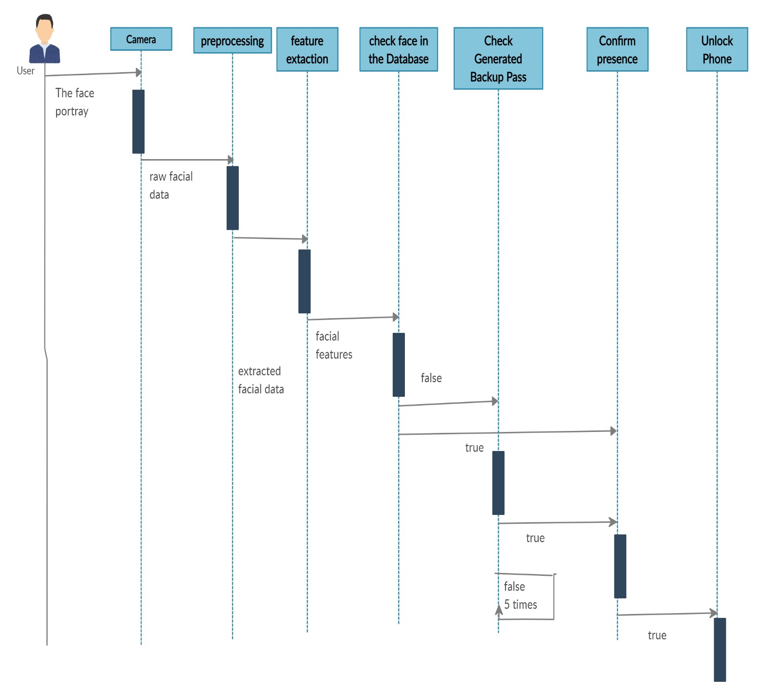

**User Registration:**

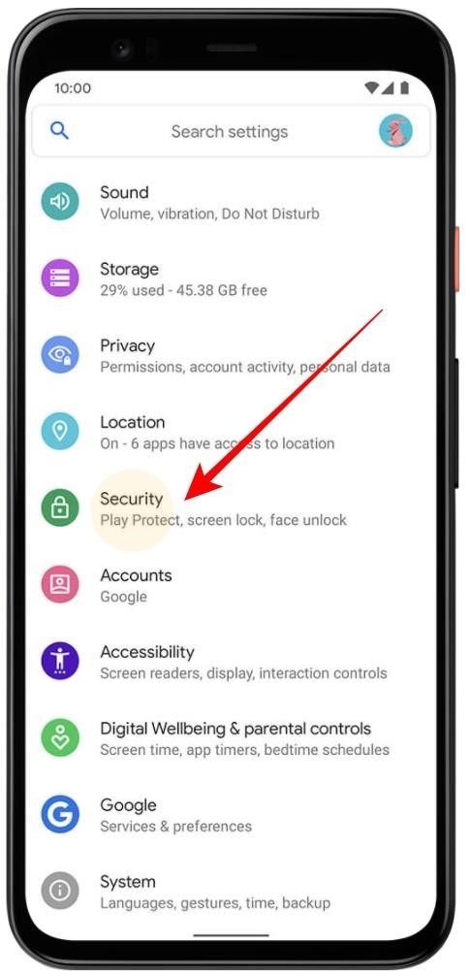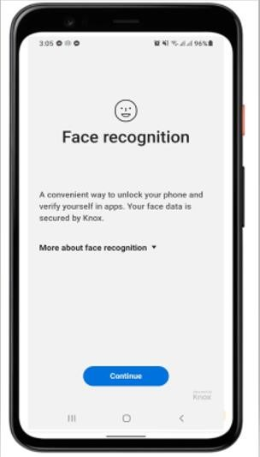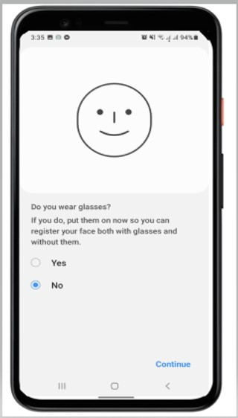

|  |  |  |  |  |  |  |
| --- | --- | --- | --- | --- | --- | --- |
| |  |  |  | | --- | --- | --- | | 1. Go to settings 2. Search Security Option |  | 1. Open Face Recognition 2. Select Continue | | |  |  | | --- | --- | | 5. | Select your option in the according to your preference of frequently wearing glass | |

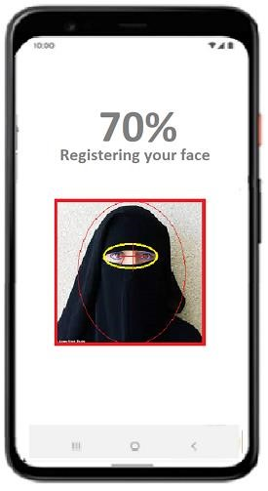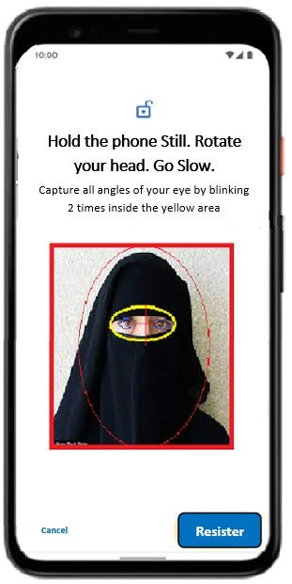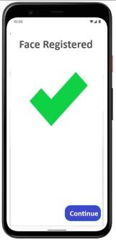

|  |  |  |  |  |  |  |  |  |
| --- | --- | --- | --- | --- | --- | --- | --- | --- |
| |  |  | | --- | --- | | 6. | Hold the camera  Still | | 7. | Rotate your Head | | |  | | --- | | 1. Put eyes inside the yellow area 2. Blink 2 times at least 3. Enter register to save eye details inside user database | | |  | | --- | | 1. Wait until ‘Face Registered’ message is displayed 2. Enter Continue | |

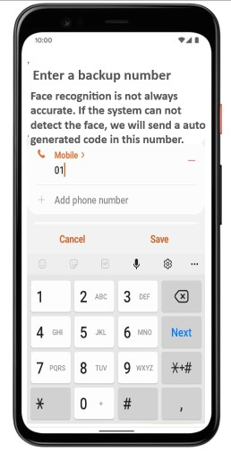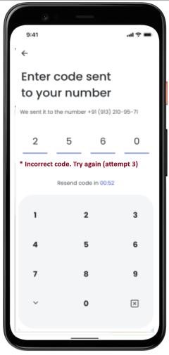

|  |  |  |  |
| --- | --- | --- | --- |
| |  | | --- | | 1. Enter Backup Number 2. Select Save | | |  | | --- | | 1. An OTP (One Time Password) is sent to the given phone number16. 2. Enter correct backup password | |

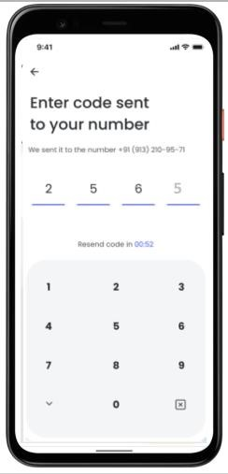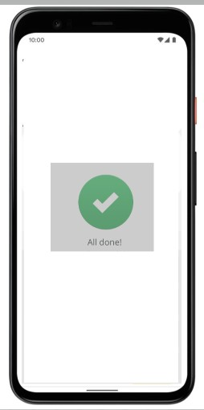

|  |  |  |  |
| --- | --- | --- | --- |
| |  | | --- | | 1. Password is sensitive so enter password carefully 2. Enter Password within 2 minutes | | |  | | --- | | 1. Wait until ‘All   done!’ Message is displayed   1. Now all the required info is saved in user database | |

**User Verification**

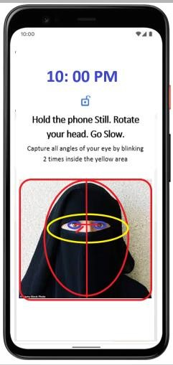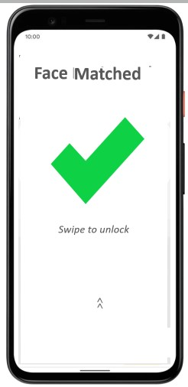

|  |  |  |  |
| --- | --- | --- | --- |
| |  | | --- | | 1. Hold the eyes inside yellow area 2. Blink at least 2 times | | |  | | --- | | 1. Wait until any message is displayed 2. If ‘Face Matched’ is displayed swipe to unlock the device | |

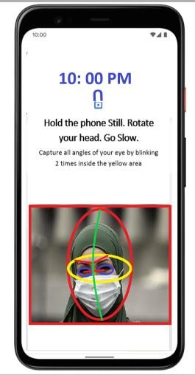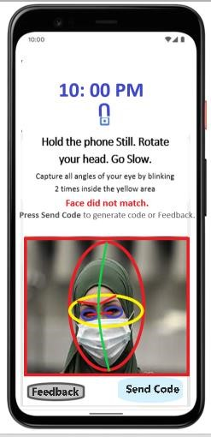

1. If ‘Face Does not match’ message is displayed Select ‘Send Code’ for OTP
2. Or select ‘Feedback’ if there is any problem

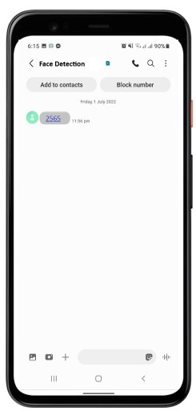

1. If ‘Send Code’ is selected, then an OTP will come as Enter Password within 2 minutes
2. Enter the correct OTP within 2 minutes

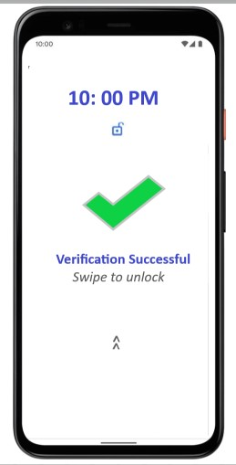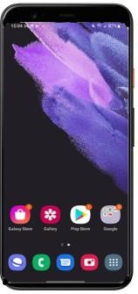

1. Wait till ‘Verification Successful’ is displayed
2. Swipe to unlock the phone

## **Project Requirements**

**System Requirements:**

|  |  |
| --- | --- |
| **Minimum Requirements:** |  |
| **Client-Side Android Platform:**   * A smartphone or tablet that is running **Android 5.0 (API level 21)** OS or newer.   o **API level 22** is the recommended target for code compilation.   * ARM-based **1.5 GHz processor recommended** for face processing in the specified time. Slower processors may be also used, but the face processing will take longer time. * At least **256 MB of free RAM** should be available for the application. * Any smartphone's or tablet's **built-in camera** which is supported by Android OS. The camera should have at least 0.3 Megapixel (640 x 480 pixels) resolution. | **Client-Side IOS Platform:**   * One of the following devices, running **iOS 11.0** or newer: o **iPhone 5S** or newer iPhone.   + **iPad Air** or newer iPad models. * At least **256 MB of free RAM** should be available for the application. * **Development environment** requirements: o a Mac running macOS 10.12.6 or newer.   + Xcode 9.x or newer. |
| **Client-Side Linux Platform:**     * **Linux 3.10** kernel or newer * glibc 2.17 library or newer * GStreamer 1.10.x or newer with gst-plugin-base and gstplugin-good is required for face capture using camera/webcam or rtsp video * gcc 4.8 or newer (for application development) * GNU Make 3.81 or newer (for application development) * Java SE JDK 8 or newer (for application development) | **Client-Side Windows Platform:**   * Microsoft Windows **7 / 8 / 10**. * Microsoft **.NET framework 4.5** or newer (for .NET components usage). * One of the following **development environments** for application development:   + Microsoft Visual Studio 2012 or newer (for application development under C/C++, C#, Visual Basic .NET)   + Java SE JDK 8 or newer |
| **Client-Side Mac OS Platform:**   * **macOS 10.12.6** or newer. * XCode 6.x or newer (for application development) * GStreamer 1.10.x or newer with gst-plugin-base and gst-plugingood is required for face capture using camera/webcam or rtsp   video (for application development)   * GNU Make 3.81 or newer (to build samples and tutorials development) * Java SE JDK 8 or newer (for application development) | **Server-Side Platform:**   * **Server hardware** with:   + Intel **Core i9-9900K** or similar multi-core processor from Intel.   + At least **32 GB of RAM**.   + **SSD** persistent storage is recommended for increasing overall system performance. * **Linux 3.10** or newer kernel. * glibc 2.17 or newer. * High-speed network connection. |
| **Additional Requirements** o A backup drive (OneDrive/Google Drive/ Dropbox) for any kind of data loss and store activity log.  o AlexNet/RNN machine learning algorithm that can classify facial features o A COTS security system against any type of data breach o Some APIs (COTS) to connect server-client. | |

**https://www.neurotechnology.com/face-verification-system-requirements.html Resource Requirements:**

Considering the average salary per hour is $10 and the total estimated effort is 162(person hour). So, the cost estimation is given below:

**Time required:** About two working years

**Staff Required:** About 24 people at least

|  |  |
| --- | --- |
| **Categories** | **Cost** |
| Employee salary | $10*162*24=$38880 |
| Software (COTS) | $250 |
| Installation and Maintenance | $550 |
| Equipment | $1000 |
| Worst case fund | $900 |
| Tax | $250 |
| Other | $1000 |
| **Total budget required** | $42830 ~ **$43000** |

The detailed calculations are given below:

**Project Cost Estimation:** (COCOMO Model)

Since only line of code is not sufficient to estimate the required effort, time, and project member, here **Intermediate** COCOMO model is used to estimate these. Here is the table given below that is used for estimation as reference:

|  |  |  |  |  |  |
| --- | --- | --- | --- | --- | --- |
| **Cost Drivers** | **Very**  **Low** | **Low** | **Nominal** | **High** | **Very**  **High** |
| **Product Attributes:** |  |  |  |  |  |
| Required Software Reliability | 0.75 | 0.88 | 1 | 1.15 | 1.4 |
| Size of Application Database |  | 0.94 | 1 | 1.08 | 1.16 |
| Complexity of The Product | 0.7 | 0.85 | 1 | 1.15 | 1.3 |
| **Hardware Attributes:** |  |  |  |  |  |
| Runtime Performance Constraints |  |  | 1 | 1.11 | 1.3 |
| Memory Constraints |  |  | 1 | 1.06 | 1.21 |
| Volatility of the virtual machine environment |  | 0.87 | 1 | 1.15 | 1.3 |
| Required turnabout time |  | 0.94 | 1 | 1.07 | 1.15 |
| **Personnel attributes:** |  |  |  |  |  |
| Analyst capability | 1.46 | 1.19 | 1 | 0.86 | 0.71 |
| Applications experience | 1.29 | 1.13 | 1 | 0.91 | 0.82 |
| Software engineer capability | 1.42 | 1.17 | 1 | 0.86 | 0.7 |
| Virtual machine experience | 1.21 | 1.1 | 1 | 0.9 |  |
| Programming language experience | 1.14 | 1.07 | 1 | 0.95 |  |
| **Project Attributes:** |  |  |  |  |  |
| Application of software engineering methods | 1.24 | 1.1 | 1 | 0.91 | 0.82 |
| Use of software tools | 1.24 | 1.1 | 1 | 0.91 | 0.83 |
| Required development schedule | 1.23 | 1.08 | 1 | 1.04 | 1.1 |

**Calculations:**

### (i) Product attributes –

Required software reliability extent (Very High) = 1.40

Size of the application database (High) = 1.08

The complexity of the product (Very High) = 1.15

### (ii) Hardware attributes –

Run-time performance constraints (Very high) = 1.30

Memory constraints (High) = 1.06

The volatility of the virtual machine environment (low) = 0.87

Required turnabout time (High) = 1.07

**(iii) Personnel attributes –** Analyst capability (High) = 0.86

Software engineering capability (High) = 0.86

Applications experience (High) = 0.91

Virtual machine experience (Nominal) = 1.00

Programming language experience (High) = 0.95

### (iv) Project attributes –

Use of software tools (High) = 0.82

Application of software engineering methods (High) = 0.83

Required development schedule (High) = 1.10

_____________________________________________________________________________________

Multiply all the above values -

Effort Adjustment Factor (EAF) = (1.4*1.08*1.15) *(1.3*1.06*0.87*1.07) *(0.86*0.86*0.91*1.00*0.95) *(0.82*0.83*1.10)

=1.06769795132

|  |  |  |  |  |
| --- | --- | --- | --- | --- |
| Software Projects | a | b | c | d |
| Organic | 2.4 | 1.05 | 2.5 | 0.38 |

Semi Detached 3.0 1.12 2.5 0.35

Embedded 3.6 1.20 2.5 0.32

According to Barry Boehm’s COCOMO intermediate law- E= (a(KLOC)^b) *EAF

here,

KLOC =kilo lines of code= 50,000 lines of code =50 kilo lines of code,

and the project is embedded since the project has fixed requirements resources, tight constraint, high level of complexity due to implementation in smartphone with bad image quality and limited storage capacity.

Now,

Effort= (a(KLOC)^b) *EAF

= (3.6* (50000/1000) ^1.2) * 1.06769795132

= (3.6* (50) ^1.2) * 1.06769795132

= 420.256960704~421 person-months

Development Time = c* (Effort ^d)

= 2.5*(421^0.32)

= 17.2866~18 months (about 2 years)

Average Staff Required = Effort/Time

= 421/18

= 23.388 ~24 persons

NB: Since the whole estimation is based on average statistical data the original effort, time and resource may vary.

# FEATURES NOT TO BE TESTED

The following is a list of the areas that will not be specifically addressed. All testing in these areas will be indirect because of other testing efforts. For example:

* Since the majority of the system users’ device are phones with low resolution camera and lower storage that cannot detect iris pattern properly, we will avoid the iris pattern feature to maintain scope instead we will use and test alternative features e.g., eye color, eye distance, eyebrow distance, eyebrow pattern, skin color etc.
* Every source code generates some auxiliary files e.g., assembly code, log file, executable file, cache directory, library directory, linker etc. That types of files do not need to be tested.

# TESTING APPROACH

## **Testing Levels**

In this project we have constructed and evolved the systems by the developers, and they must check if the program works like it is featured or not. The systems must be checked with separate levels of testing by the developers and testers and will also test the system as a whole. Thus, we must check if the system is completely under the testing levels and match the level criteria.

* **Unit Testing:** The concept of testing this portion is to test the system with individual aspects like eyebrow, the eye distance measurement of face and iris recognition as well. The test must be in isolation of individual perspective to test the desired feature. The procedure of the program is being tested with the help of selenium. For the feature to be implemented the developers will develop the system with the high-end android version to check the recognition is done individually.
* **Integration Testing:** The features will be connected and assembled to a larger subsystem so that we can see if the system works together interconnectedly. The system might fail in certain criteria if the system is working together as an assembled system. For that we will be using flutter testing to test the modules for cross platform system. Also, we have used the postman testing for the security and functionality test. The features that are connected for security reasons are tested by postman testing. Thus, this testing is tested by testers to check if the assembled systems are working properly or not, and the functionality is operating normally.
* **System Testing:** After integrating the functionality of all the system the entire system is developed and is widely tested. For that the phone recognition for eye distance measurement, biometric iris pattern and eyebrow testing works in the entire system perfectly or not. This included feature can make the android more stressful and the recent android OS or IOS might find other features error for the stress. So, this feature in the phone must contain a high-end operating system to be completely functional. The feature will be complex to operate with recent android or IOS. Therefore, we need more powerful android like android 12 to make the feature more operatable. To support this kind of feature the phone needs around 256GB of ROM to take the load for operating the feature in the android system. Such a high-end embedded system will be required for the system to operate.
* **Domain Testing**: The project has been tested with two of the major parts.
* Computational Error o Domain Error
* In the project the system has been tested to find if any computational error is detected. The system was checked by the testing team if the specific input image was taken by the camera and executed the process following the desired path towards the database and the output value is right or wrong. But according to our system feature the output was right as expected, for which we considered the system computational error free.
* According to the project we have tested the domain error as well. We have checked that the system has taken the user input and executed the process in the wrong path. But again, it has successfully executed the right path matched the database. Thus, both of the testing was corrected as we were expecting the feature to be implemented.

## Test Tools

There will be 3 testing tools that will be used for implementation of the project. Since 3 tools are multipurpose tools there might be more than 1 tool used for testing for convenience.

* Selenium will be used for unit testing of python/java module and system testing. It will be used by the developers and testers
* Flutter Testing will be used for unit and integration testing for dart modules for cross-platform systems. It will be used by the testers.
* Postman Testing will be used for API testing in integration testing to verify whether the project fulfills its expected quality attributes e.g., functionality, security, performance, and reliability. It will be used by the testers.

## Meetings

After completion of the five phases of our project, the results looked good, and we have realized that we were on the right track. We thought no significant issues occurred in our project. We organized the project well. Our test team had met once every week to evaluate the progress to date and identify error trends and problems. But when our test team leader meets with development and the project manager after two weeks the management board thought otherwise. There might be some issues in item pass fail criteria and test case. Later we resolved everything by meeting among ourselves. Then we have decided that two meetings will be scheduled in different weeks. In each meeting we got the management review and audit that focuses more on the software process rather than the software work products. We had set a list of activities designed to ensure that the project manager follows the standard process which is already pre-defined. We got reviews and checked if the project management activities are executed to the highest possible standard. Only through the result of this review can the management board evaluate the quality of our project handling. In any emergency situations and critical bug solution we have also held meetings as well. We monitored and improved the process of preventing quality problems.

# TEST CASES/TEST ITEMS

|  |  |  |  |  |  |  |  |  |  |  |
| --- | --- | --- | --- | --- | --- | --- | --- | --- | --- | --- |
| Project Name: Phone Unlock System With Advanced Eye Detection | | | | | | Test Designed by:  Shium | | | | |
| Test Case ID: FR_1 | | | | | | Test Designed date: 13-08-2022 | | | | |
| Test Priority: High | | | | | | Test Executed by:  Shuvo | | | | |
| Module Name: Registration Session | | | | | | Test Execution date: 16-08-22 | | | | |
| Test Title: Register with face of user or backup password auto generated from the system into mobile | | | | | |  | | | | |
| Description: Test registration page with decent eye features and phone number saved into user database | | | | | |  | | | | |
| Precondition (If any): User must patiently stare at a certain point and blink 2-3 times for 10 seconds to capture eye features and liveliness decently. | | | | | | | | | | |
| Test Steps | | Test Data | | Expected Results | | | | Actual Results | | Status  (Pass/Fail) |
| 1. Press the power button 2. Open the camera near the eyes 3. Stare at a specific point for 10 sec and   blink 2-3 times   1. Enter phone number for backup password 2. Enter the autogenerated code   for verification 6. Press Confirm Registration button | | 10a121M | | Users should register into the system  successfully | | | | As expected, | | Pass |
| Post Condition: User is added to database and the information will be used for verification. | | | | | | | | | | |
| Project Name: Phone Unlock System With Advanced Eye Detection | | | | | Test Designed by: Shium | | | | | |
| Test Case ID: FR_2 | | | | | Test Designed date: 13-08-2022 | | | | | |
| Test Priority (Low, Medium, High): High | | | | | Test Executed by:  Saharukh | | | | | |
| Module Name: Login Session | | | | | Test Execution date: 16-08-22 | | | | | |
| Test Title: verify login with facial feature of user or backup password | | | | |  | | | | | |
| Description: Test system login page with eye and if the system does not identify the face use backup password to login | | | | |  | | | | | |
| Precondition (If any): User must have valid password, or the facial geometry (e.g.: eye distance, Cornea color, retina, and iris pattern etc..) must be stored in the user database and the camera must be fully functional. | | | | | | | | | | |
| Test Steps | Test Data | | Expected Results | | | | Actual Results | | Status  (Pass/Fail) | |
| 1. Press the power   button     1. Open the camera near the eyes      1. Stare at a specific point for 5 sec and blink 2-3   times   1. Swipe to unlock |  | | User should login into the system and the  attendance  should be  given | | | | As expected, | | Pass | |
| Post Condition: User is validated with database and successfully unlocked the phone | | | | | | | | | | |

|  |  |  |  |  |  |
| --- | --- | --- | --- | --- | --- |
| Project Name: Phone Unlock System With Advanced Eye Detection | | | Test Designed by: Shium | | |
| Test Case ID: FR_3 | | | Test Designed date: 13-08-2022 | | |
| Test Priority: High | | | Test Executed by: Anika | | |
| Module Name: Login_Session_Backup_Pass_Gen | | | Test Execution date: 18-08-22 | | |
| Test Title: Register with face of user or backup password auto generated from the system into mobile | | |  | | |
| Description: Check whether the system generates a backup password to login correctly or not if face is not recognized properly | | |  | | |
| Precondition (If any): User must give valid auto generated password within two minutes, or another password will be generated. Failure 5 times in a row will cause temporary block of the account and user must contact the admin for further investigation of the problem. The phone must be turned on and there must be decent network connectivity. | | | | | |
| Test Steps | Test Data | Expected Results | | Actual Results | Status  (Pass/Fail) |
| 1. Press the power   button     1. Open the camera near the eyes      1. Stare at a specific point for 5 sec and blink 2-3   times   1. Swipe to unlock | 121df12 | Users should login into the system by giving the backup password 121df12 when facial details are not recognized | | As expected, | Pass |
| Post Condition: User is validated with database and successfully unlocked the phone | | | | | |

|  |  |  |  |  |  |
| --- | --- | --- | --- | --- | --- |
| Project Name: Phone Unlock System With Advanced Eye Detection | | | Test Designed by: Shium | | |
| Test Case ID: FR_4 | | | Test Designed date: 1308-2022 | | |
| Test Priority: High | | | Test Executed by: Nafisa | | |
| Module Name: Login_Session_Backup_Pass_Gen | | | Test Execution date: 18-08-22 | | |
| Test Title: Register with face of user or backup password auto generated from the system into mobile | | |  | | |
| Description: Check whether the system generates a backup password to login correctly or not if face is not recognized properly | | |  | | |
| Precondition (If any): User must give valid auto generated password within two minutes, or another password will be generated. Failure 5 times in a row will cause temporary block of the account and user must contact the admin for further investigation of the problem. The phone must be turned on and there must be decent network connectivity. | | | | | |
| Test Steps | Test Data | Expected Results | | Actual Results | Status  (Pass/Fail) |
| 1. Press the power button      1. Open the camera near   the eyes     1. Stare at a specific point for 5 sec and blink 2-3 times 2. Enter the autogenerated   code for   1. Swipe to unlock | 121Df12 | Users should not be able to login into the system by giving the backup password 121df12 when facial details are not recognized | | As expected, | Pass |
| Post Condition: The system will give another chance to enter correct password 2 times if the user cannot give provide valid password within 2 minutes the system will resend another password if the user fails 3 times, then the unlock option will be temporary unavailable, and admin must override it to activate the account. The activity log will be saved. | | | | | |

|  |  |  |  |  |  |
| --- | --- | --- | --- | --- | --- |
| Project Name: Phone Unlock System with Advanced Eye Detection | | | Test Designed by: Shium | | |
| Test Case ID: FR_5 | | | Test Designed date: 1308-2022 | | |
| Test Priority: High | | | Test Executed by: Nafisa | | |
| Module Name: Login_Session_No_Backup_Pass_Gen | | | Test Execution date: 18-08-22 | | |
| Test Title: Register with face of user or backup password auto generated from the system into mobile | | |  | | |
| Description: Check whether the system generates a backup password to login correctly or not if face is not recognized properly | | |  | | |
| Precondition (If any): User must give valid auto generated password within two minutes, or another password will be generated. Failure 5 times in a row will cause temporary block of the account and user must contact the admin for further investigation of the problem. The phone must be turned on and there must be decent network connectivity. | | | | | |
| Test Steps | Test Data | Expected Results | | Actual Results | Status  (Pass/Fail) |
| 1. Press the power   button     1. Open the camera near the eyes      1. Stare at a specific point for 5 sec and blink 2-3   times   1. Enter the autogenerated   code for   1. Swipe to unlock |  | User should get a message containing auto generated backup password | | Did not get any message | Fail |
| Post Condition: There will be an error log generated by the system and feedback will directly sent for investigation. The user will be asked to restart the device and check the network. | | | | | |

|  |  |  |  |  |  |
| --- | --- | --- | --- | --- | --- |
| Project Name: Phone Unlock System With Advanced Eye Detection | | | Test Designed by: Shium | | |
| Test Case ID: FR_6 | | | Test Designed date: 1308-2022 | | |
| Test Priority: High | | | Test Executed by: Nafisa | | |
| Module Name: Validation_Failure | | | Test Execution date: 18-08-22 | | |
| Test Title: Register with face of user or backup password auto generated from the system into mobile | | |  | | |
| Description: Check whether the system generates a backup password to login correctly or not if face is not recognized properly | | |  | | |
| Precondition (If any): User must give valid auto generated password within two minutes, or another password will be generated. Failure 5 times in a row will cause temporary block of the account and user must contact the admin for further investigation of the problem. The phone must be turned on and there must be decent network connectivity. | | | | | |
| Test Steps | Test Data | Expected Results | | Actual Results | Status  (Pass/Fail) |
| 1. Press the power   button     1. Open the camera near the eyes      1. Stare at a specific point for 5 sec and blink 2-3   times   1. Enter the autogenerated   code for   1. Swipe to unlock | 12121ABC | User should not be able to unlock the device since the  actual backup password was  121Df12 | | The phone is unlocked | Fail |
| Post Condition: There will be an error log generated by the system and feedback will directly sent for investigation. The user will be suggested to retry. | | | | | |

# ITEM PASS/FAIL CRITERIA

In the feature the information is stored in the database. The database has some stored images which will match with the user’s input image. If the input is matched with the database image the system will get unlocked thus considering it a pass criterion. Also, if the system does not match with the database, it will show a message from an invalid user and ask for backup password which will be system pass. For that it will ask for a backup password and if the password gets matched with the database it will also be a pass. But if the input image matches with the image stored in the database and the system still asks for a backup password and after giving the correct password the system does not unlock it will be considered as a failure criterion. Sometimes image detection cannot be accurate so if the system cannot match with the data stored and asks for backup password giving the correct password the system gets unlocked it will be a pass criterion for the procedure we are following on. Finally, if the user input image is matched and the system still asks for the password, after giving the password it does not get unlocked or get unlocked after giving wrong face or password by any method error it will be a failure criterion for the system. Thus. Following our methods and procedures the system will pass and fail based on the output performance it has been giving.

# TEST DELIVERABLES

* **Acceptance Test Plan:** Acceptance testing is formal testing for product evaluation to determine whether a system is satisfies its acceptance criteria or not. This type of testing verifies functionality and usability of the software. At this level of testing, the software should be in a sufficiently detect-free state to permit the emphasis to change.

Our team will do the business acceptance testing. Basic test cases will be executed to ensure that the system will eventually pass the UAT. If the test cases will pass and there is no bus during testing, then the software might be deliverables to the client. Obviously testing team must check the system is included with the acceptance criteria. Must fulfill the quality attribute which the customers have prioritized before.

* **System/Integration test plan:** System integration testing is a systematic technique for assembling a software system while conducting tests to uncover errors associated with interfacing the modules. SIT will start in a specific time. In our project all the functional and non-functional requirements will be written and designed. 100%-unit test will be done. SIT will check that all the modules on eye detection has already done perfectly. Eye detection unlock system is executed with bugs. It will be in observation for two weeks.

After integrated all the eye scanning module (eye distance measurement, eyeball color detection, movement of eyes.) the final software will be ready. And this ready software testing is system testing. System testing contain regression testing. This testing is needed to verify final software is working as expected result. Monitoring the test cases and report it time to time. Pass fail of test cases, execution number of test cases, plan test cases vs final result all these points are documented in this phase. For our software user related beta testing will not possible. Because one user found any defect the market demand will go low.

* **Unit test plans/turnover documentation:** After developing one module, the module will be tested if it is working properly or not. All the tested modules will be integrated later and after that testing team will do the test cases execution.
* **Report mock-ups:** After every step of testing a summary or draft report will be written by testing team.
* **Defect/Incident reports and summaries:** The purpose of using defect report template is to convey the detailed information (like environment details) about the bug to the developers. Testing team design defect report so that developers can replicate the bus easily. If the final result of eye scanning is not matched with the expected result of test cases, testing team will obviously mention it in the defect report so that developers can reproduce the development task.

In our project final test result should be proper phone unlock with correct eye recognition. o **Acceptance Test Report:**

|  |  |
| --- | --- |
| 1. Date | August 14, 2022 |
| 2. Test Case Execution status: | Number of test cases execution today: 6  Number of test cases passing: 4  Number of test cases failing: 2 |
| 3. Defect identification: | Defect Number: 0 |
| 4. ACC number: | Nothing |
| 5. Cumulative test execution: | Total number of test cases executed: 6  Total number of test cases passing: 4  Total number of test cases fail: 2  Total number of test cases executed: 6(Estimated) |

*This Test report is written as documented test cases (As a base on prediction)*

# STAFFING AND TRAINING NEEDS

To produce the integrated system, the team requires: 1 UI designer,1 Business Analyst, 2 Machine Learning Expert, 1 Image Processing Expert, 1 Project Manager, 2 Requirement Engineer, 8 Tester, 2 Quality Assurance Engineer ,1 Test Manager, 2 Data Analyst, 2 Flutter Developer, 1 java developer, 1 python developer, 2 Technical Writer, and 1 Database Administrator at least as members. If the project manager is unavailable, the business analyst can work as an alternative. It is preferred that there will be at least 3 full time testers assigned to the project for the system/integration and acceptance testing phases of the project. To provide complete and proper testing the following areas need to be addressed in terms of training. The legal and licensing consultants will be added to the team temporarily to maintain legal constraint and intellectual property usage.

* The developer and testers will need to be trained on basic operation of flutter test, selenium unit test, postman API testing, programming language: dart, python, java for cross-platform support
* Machine learning experts and image processing experts must work together to improve the convolutional neural network (CNN) algorithms from machine learning.
* UI designer must know various tools Figma, Adobe XD, Sketch etc. for prototyping

# RESPONSIBILITIES

* **Acceptance and test documentation and Execution:**

TM: Test manager will test the final product as client’s perspective and ensure the system is deliverables or not.

PM: PM will solve the reported bugs by TM. And make it duplicate as customer’s choice. Test Team: Test team will check if all the criteria of users’ demand are fulfilled or not. If there is anything missing of users’ point of view this team will report to solve it.

Client: Client will ensure that system satisfies the contractual acceptance criteria before being signed-off as meeting user needs.

* **System/Integration test Documentation & exec.:**

TM: Test Manager will check if the report is okay or not. If there is a problem, it can be solved or not.

Dev Team: The whole procedures of system and integration testing will be done and documented by development team.

Test Team: Test team will check if there is any defect or bugs after integrated the modules and the whole system. o **Unit test documentation & execution:**

TM: TM will guide the whole development teams and testing team.

Dev Team: This team will develop the module with quality attributes.

Test Team: This team will check if there is any error or bugs in the modules or not. If there is a bug, then they will report it to the TM.

# TESTING SCHEDULE

From section 4.4 we can find the estimated time was 18 months (~2 years). By using the standard software definition life cycle (SDLC) all the required time is calculated here:

|  |  |  |
| --- | --- | --- |
| **Activity** | **Standard Work Effort%** | **Estimated Time (Month)** |
| **Definition Phase** |  | |
| Business Requirements | 6% | 1.08 |
| Functional Specifications | 10% | 1.8 |
| **Delivery Phase** |  | |
| Detailed Design | 14% | 2.52 |
| Code and Unit Test | 40% | 7.2 |
| Integration and System Testing | 20% | 3.6 |
| User Acceptance Testing | 10% | 1.8 |
| **Total Effort** | **100%** | 18 |

Collected from: <https://www.igi-global.com/chapter/effort-estimation-model-each-phase/46269>

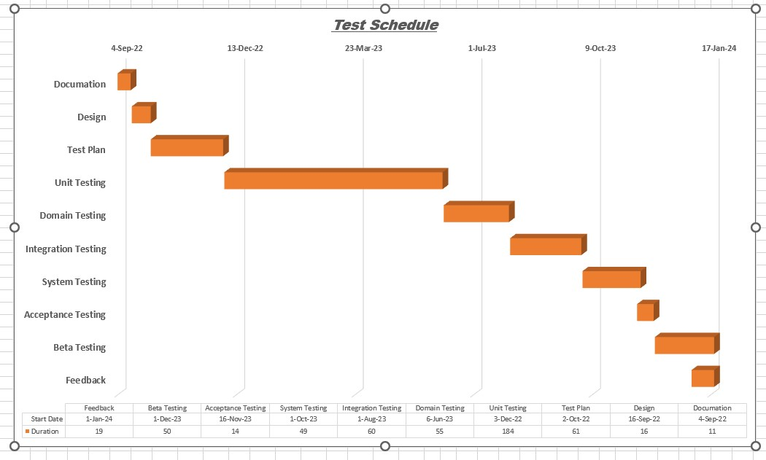

# PLANNING RISKS AND CONTINGENCIES

The Project has a significant value of adding a new layer of security feature by adding facial recognition and eye pattern. But our project has some risks as well.

* It can be misused if a video of anyone shown by any device is matched with the stored database. The system can only detect face recognition and eye pattern only, but it is not built for live images only. Any live video of any person who has access to the system will get unlocked which is a risk.
* Another security issue is that the system can get unlocked by an unmatched person if the system software fails to operate. It will be a big issue for the system as it will hamper anyone’s personal confidential data.
* Some risks include technological error because the system can be manipulated by more advanced technology and also can be hacked by professional hackers. Though the system is highly developed to prevent any kind of hacks, it can also be decoded and also encrypted to break its security.
* The user’s device using the system has a certain amount of memory to store in the database but adding more and more new users can exceed its memory limits which has a risk of losing previous data. So, we have connected the database to cloud in case if user enlisting is exceeding, the previous data will not be lost, rather it will transfer the previous user’s data to cloud in order to take new user enlistment.
* The feature of this system is that if any user face is not recognized for any system error and user also could not give correct the backup password the system will deny user identification normally. But trying to access various times the system will get locked and will not take any user input. It will ask for administrative enlisting. Only admin will check the database of the user and if the user is valid and matched with the database then the admin can again enlist the user with new facial recognition with eye pattern and will provide user backup password connecting with the exiting database user previously had.

These are the major risks and the contingencies for the system. Some risks have their own solutions making the functionality more reliable and usable for the user and some of the features we are working on to improve the system in the future versions to overcome and handle if any unexpected risks happen.

# APROVALS

|  |  |
| --- | --- |
| **Roles** |  |
| **Project Sponsor-** Sumaiya Jahan |  |
| **Project Manager**- Sheikh Mahmudul Hasan Shium |  |
| **Test Manager-** Shiraji, Yeamin Rahman Shuvo |  |
| **Chief Developer-** Nafisa Binte Shahadat |  |
| **QA Engineer-** Esha Sheikh |  |