**How to get Environment Clearance License**

In light of Bangladesh Environment Conservation Act, 1995 (as amended in 2010), no industrial organization is allowed to set up without environment clearance certificate from the Department of Environment (DoE).

For issuance the environment clearance certificate, according to the sites, impact on the environment, type of industry and location have been categorized in the following 04 (four) ways:

* Green
* Orange – A
* Orange – B
* Red

**Required Documents for Environment Clearance Certificate:**

* An Application has to be submitted through prescribed form-3 under Environment Conservation Rules 1997
* Location Map
* Scheduled map mentioning Dag Khatian
* Trade License
* TIN and VAT certificate, and
* Rent Agreement

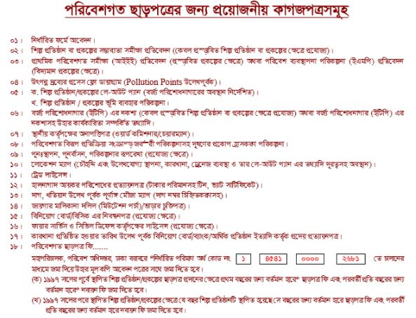

**Additional Documents:**

* Bank Statement or Bank Solvency Certificate
* No Objection Certificate from Local Authority (Ward Commissioner or Chairman)
* Lay-out Plan
* Registration Certificate of Board of Investment / BISIC (Where applicable)
* Fire License (Where applicable)
* Initial Environment Examination Report (IEE) (Where applicable)
* Process Flow Diagram on Official Pad (To be mentioned Pollution Points)
* Diagram of Effluent Treatment Plant (ETP) (Where applicable)
* Treasury Challan in favor of Director General of Department of Environment account being No. 1 – 4541 – 0000 – 2681.

**Step by Step General Process for Environmental Clearance:**

1. Submit application along with supporting documents.
2. Verification of application and supporting documents by DOE
3. thereafter, Inspection by the authorized officer after verification of all report and documents.
4. Subsequently, Meeting of Environmental Clearance Committee (for Orange – B and Red Category)
5. Finally, a Decision

**Time Frame:**

|  |  |  |
| --- | --- | --- |
| **Category** | **Site Clearance** | **Environmental Clearance** |
| Green | N/A | 15 days |
| Orange – A | 30 days | 15 days |
| Orange – B | 60 days | 30 days |
| Red | 60 days | 30 days |

**Government Fee Schedule:**

The Government fee for filling an application for Environment clearance certificate and its renewal under these Rules shall be deposited with the Bangladesh Bank or a Government Treasury by a Treasury Chalan. Furthermore, Treasury Chalan shall be deposited in favor of the Director General of Department of Environment account being No. 1 – 4541 – 0000 – 2681.

**Fee Schedule:**

|  |  |  |
| --- | --- | --- |
| **Investment Amount** | **Environment Clearance Fee** | **Renewal Fee** |
| 01 (One) Lac to 5 (Five) Lac | 1500 | ¼ of the Environment  Clearance Fee |
| 5 (Five) Lac to 10 (Ten) Lac | 3000 | ¼ of the Environment  Clearance Fee |
| 10 (Ten) Lac to 50 (Fifty) Lac | 5000 | ¼ of the Environment  Clearance Fee |
| 50 (Fifty) Lac to 01 (One) Crore | 10000 | ¼ of the Environment  Clearance Fee |
| 01 (One) Crore to 05 (Five) Crore | 20000 | ¼ of the Environment  Clearance Fee |
| 05 (Five) Crore to 20 (Twenty) Crore | 40000 | ¼ of the Environment  Clearance Fee |
| 20 (Twenty) Crore to 50 (Fifty) Crore | 80000 | ¼ of the Environment  Clearance Fee |
| 50 (Fifty) Crore to 100 (One Hundred) Crore | 120000 | ¼ of the Environment  Clearance Fee |
| 100 (One Hundred) Crore to 200 (Two Hundred) Crore | 200000 | ¼ of the Environment  Clearance Fee |
| 200 (Two Hundred) Crore to 500 (Five Hundred) Crore | 300000 | ¼ of the Environment  Clearance Fee |
| 500 (Five Hundred) Crore to 1000 (One Thousand) Crore | 400000 | ¼ of the Environment  Clearance Fee |
| 1000 (One Thousand) Crore to Above | 500000 | ¼ of the Environment  Clearance Fee |

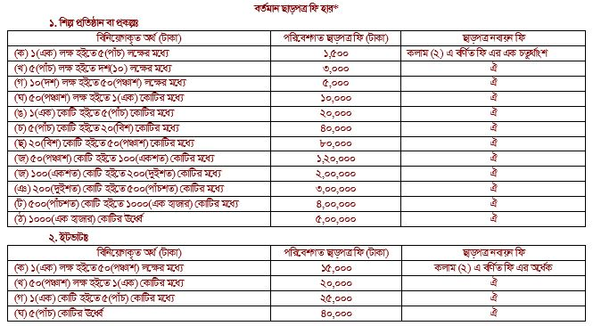

**Renewal Process:**

The period of validity of an Environmental Clearance Certificate shall be, in case of Green Category, 03 years from the date of its issuance and in all other cases, 01 year. Each Environmental Clearance Certificate has to be applied for renewal at least thirty (30) days before expiry.