**COMPANY PROFILE**

****

**CORPORATE OFFICE**

House # 28, Level # 2nd, Kawran Bazar, Dhaka-1215, Bangladesh.

Tel: +88 02 818 908 4, Mobile Phone: +88 01711 459 532

Email: srcl.group.bd@gmail.com

Web: www.srclgroup.com

**BACKGROUND OF THE FIRM**

Sustainable Research and Consultancy Limited (SRCL) is an autonomous, multi-disciplinary consulting firm. It has been inaugurated by a group of highly qualified and dedicated experts of development interventions. It is a limited company incorporated under the Company’s Law of Bangladesh. Its journey begins in the year 2012. SRCL is proud to be an evolvement, partner providing appropriate, adequate and sustainable solutions and resolution for infrastructure development through innovative, originative ideas, capacity building, and training. SRCL provides services from the stage of inception to the completion of projects. Focusing on the need of clients and society, SRCL has expanded its activities in diversified fields to develop areas of expertise and strengthen its capabilities.

**Business Information**

|  |  |  |  |
| --- | --- | --- | --- |
| 01 | Focal Person | : | ABU JUBAYER (Managing Director) |
| 02 | Head Office |  | Taz Mansion, 2nd Floor, 28 Kawran Bazar, Dhaka-1215. |
| 03 | Mobile | : | +88 01711 459 532  +88 01717 933 932 |
| 04 | Email | : | [srcl.group.bd@gmail.com](mailto:srcl.group.bd@gmail.com)  [jubayer.buet.bd@gmail.com](mailto:jubayer.buet.bd@gmail.com) |
| 05 | Website | : | http://www.srclbd.com/ |
| 06 | Type of Organization | : | Private Limited Company |
| 07 | Category of Organization | : | Consultancy & Research |
| 08 | Certificate of Incorporation | : | C-127679/2015 |
| 09 | Trade License | : | 05-28140 |
| 10 | TIN | : | 839930663812 |
| 11 | VAT |  | BIN: 001334493-0402 |
| 12 | Register of Joint Stock (RJSC) | : | 127- 679 |
| 13 | Dhaka North City Corporation (DNCC) | : | 05-28-140 |
| 14 | National Board of Revenue (NBR) | : | 721-453-621-457 |

**Sister Concerns of SRCL:**

|  |  |  |
| --- | --- | --- |
| **Sl. No.** | **Name** | **Sector** |
| 01 | Socheton Academic care | Education |
| 02 | Socheton IT Home | IT |
| 03 | Socheton Business Initiative | Supply & Installation |
| 04 | SRC Construction | Construction & Development |
| 05 | SRC Housing Society | Housing & Development |
| 06 | Center of International Registration & Permission | Registration & Permission |

**General Legal Status:**

The SRCL has been established as a consultancy company for **sustainable and easy business solution** for different establishment and other corporate companies in Bangladesh. The SRCL is approved by **the Government of the People’s Republic of Bangladesh** as a consultancy firm. The SRCL contains the license from the Register of Joint Stock (RJSC), Dhaka North City Corporation (DNCC) and National Board of Revenue (NBR) as a Limited company.

**COMPANY GOALS**

**MISSION** is to be the leader in the Green industry sector by providing enhanced services, relationship and profitability.

**VISION** is to provide quality services that exceeds the expectations of our esteemed customers.

**CORE VALUES**

Our relationship with our clients is what that matters the most. We succeed when our clients succeed. And thus, our values stand for:

* Integrity and Diversity
* Quality and Commitment
* Sustainability and Safety

**OBJECTIVES**

* Regional expansion in the field of Power Plant, Garments, leather, Agriculture, Cultural and other business arena consultancy.
* Increase the business and profit of the customers company to the national and international market.
* To build good reputation in the field of most quick permission, authorization and licenses from different ministry and authorities and become a key player in the field.

**PRINCIPLES AND STRATEGIES**

****SRCL thrives for sustainable integrated development by participating in planning and implementation of development interventions through consulting services in multi-sectoral activities. SRCL believes that in development efforts, participatory approach is very effective and sustainable; and experts give due considerations to local wisdom in all stages of project cycle. In its actions the firm adheres to the following principles:

* Bear in mind the social and economic interests of the women and deprived section of the population;
* Be concerned with the effects of development work on people and environment; and
* Join hands with experts from different fields in a coordinated manner.

**OUR SECTORS AND SERVICES**

|  |  |  |
| --- | --- | --- |
| Sector | Sub-Sector | Services |
| Environmental & Social | * Environmental Management * Waste Management * Costal Management | * Initial Environmental Examination (IEE) * EIA (Environmental Impact Assessment) * EMP (Environmental Management Plan) * Resettlement Action Plan (RAP) * Socioeconomic Survey and Studies * Topographic Survey * Bathymetry and Hydrological Assessment * Air and Noise Modeling * Effluent Treatment Plant (ETP) * Periodical Environment Monitoring and Reporting * Countermeasure for Non-Conformance to EIA/EMP * Countermeasure for Non-Conformance to EIA/EMP * Temporary Power line Clearance * Land Acquisition Plan (LAP)/ Market Price Survey |
| Feasibility Study | * Development * Construction * Environment * Social * Educational * Market * Industrial | * Engineering Feasibility * Environmental Feasibility * Social Feasibility * Educational Feasibility * SME Development Feasibility * Economic Feasibility * Market Feasibility * Baseline, Mid-term & Final Evaluation of Projects |
| 4th Industrial Revolution (4IR) | * 3D Printing * Advance Materials * Automation & Robotics * Blockchain & Distributed Ledger * Geo Engineering * Internet of Things | * Project Conceptualization * Concept Note preparation * Donor Agencies and Ministry Proposal Preparation * File Processing * Fund Arrangement * International Training Arrangement * Master ToT Preparation * Field Training Implementation * Online Training Program Arrangement (Classroom and Trainer Module) * Cloud Based Hands on Training Program * Procurement and Setup advance level technologies for factories * Run Online based market for apparel sectors |
| Ready Made Garments (RMG) | * BKMEA * BGMEA | * Audit & Certification * Factory Bank Loan Management * Project Conceptualization * Concept Note preparation * Proposal Preparation for Donor Agencies and Ministries * File Processing * Fund Arrangement * Full Project Management * Arrange and Coordinate Training Program (Foreign and Local) * Liaison Management * Training Center Development |
| Leather Institutes & Tanneries | * BTA * BFLLFEA | * Project Conceptualization * Concept Note preparation * Donor Agencies and Ministry Proposal Preparation * File Processing * Fund Arrangement * Full Project Management * Arrange and Coordinate Training Program (Foreign and Local) * Liaison Management * Training Center Development |
| Textiles | * BTMA | * Project Conceptualization * Concept Note preparation * Donor Agencies and Ministry Proposal Preparation * File Processing * Fund Arrangement * Full Project Management * Arrange and Coordinate Training Program (Foreign and Local) * Liaison Management * Training Center Development |
| Construction and Development | * Engineering * Design * Supply * Dredging * Installation * Testing & Commissioning | * Architecture & Civil Design * Sand and Stone supply * Dredging & Riverbank Management * Industrial Machineries Installation * Labor Supply * Electrical & Mechanical Support for Testing & Commissioning |
| Information Technology (IT) | * Socheton * Startup Bangladesh | * Online Based Live Classroom Preparation * IT Support for Class Operations and Maintenance * Online Based Live Exam System Development * Online Based Homework System * Teachers Training for SMART Class Use and Operations * Feasibility Study for Different Education-Based Program. * Educational Game Preparation |
| Human Resource Supply | | * Supply of Electrical & Mechanical Engineers * Outsourcing of different HR functions * Third party deployment of security services, housekeeping, web development, etc. |
| Training Service | * TVET * NGO * Fire Safety * RMG * Nursing * SME | * Skill Development Program * Online Based Training * Mid-level Management * Skilled Manpower Preparation * SME Training * Fire Safety Training * International Training |
| Land & Loan Management | * Land Acquisition * Loan Management | * U-PASS Foreign LC * Bank Guarantee (local & International) * Foreign Transaction * Industrial Bank Loan * International Joint Venture * Land Acquisition Plan (LAP)/ Market Price Survey |
| Project Cycle Management | | * Feasibility Study * Survey (Baseline, Midterm, Final) * Monitoring, Evaluation, Accountability and Learning (MEAL) Services |
| Transportation | * Railway and MRT * Roads & Highways * Bridges, and BRT * Water Transport | * Environmental Assessment including REA, IEE, EIA & ESIA * Environmental Management and Monitoring Plan * Environmental Monitoring Services (EMS) * Resettlement Action Plan (RAP) * Socioeconomic Survey and Studies * Topographic Survey * Bathymetry and Hydrological Assessment * Air and Noise Modeling * Land Acquisition Plan (LAP)/ Market Price Survey |
| Water | * Water Supply * Drainage & Sanitation * Drainage Infrastructure * Treatment Plant | * Environmental Assessment including REA, IEE, EIA & ESIA * Environmental Management and Monitoring Plan * Environmental Monitoring Services (EMS) * Resettlement Action Plan (RAP) * Socioeconomic Survey and Studies * Topographic Survey * Water Treatment Plant (WTP) * GIS Mapping and Digitization * Land Acquisition Plan (LAP)/ Market Price Survey * Temporary waste water / Sanitation discharge * Cooling Water Discharge |
| Port, Estuary, Inland and Navigation | * Ferry and Terminal * Airport * Inland Water | * Environmental Assessment including REA, IEE, EIA & ESIA * Environmental Management and Monitoring Plan * Environmental Monitoring Services (EMS) * Compliance and OHS * Resettlement Action Plan (RAP) * Topographic Survey * Bathymetry and Hydrological Assessment * Socioeconomic Survey and Studies |
| Urban Infrastructure & Governance | | * Environmental Assessment including REA, IEE, EIA & ESIA * Environmental Management and Monitoring Plan * Environmental Monitoring Services (EMS) * Resettlement Action Plan (RAP) * Socioeconomic Survey and Studies * Topographic Survey * GIS Mapping and Digitization * Land Acquisition Plan (LAP)/ Market Price Survey |
| Natural Resource Management and Agriculture | * Forestry * Ecology * Biodiversity * Fisheries * Water Resource * Agriculture | * Environmental Assessment including REA, IEE, EIA & ESIA * Environmental Management and Monitoring Plan * Environmental Monitoring Services (EMS) * Resettlement Action Plan (RAP) * Socioeconomic Survey and Studies * Contaminated Site Assessment and Remediation * Land Acquisition Plan (LAP)/ Market Price Survey |
| Industrial Environment and Management Control | | * Environmental Compliance and Management * Environmental Audit, Cleaner Production Assessment and Low Carbon development * Effluent Treatment Plant Management Services * Laboratory Testing Facility |
| Energy | * Power Generation * Power Distribution | * Environmental Assessment including REA, IEE, EIA & ESIA * Environmental Management and Monitoring Plan * Environmental Monitoring Services (EMS) * Compliance and OHS * Resettlement Action Plan (RAP) * Topographic Survey * Bathymetry and Hydrological Assessment * Socioeconomic Survey and Studies |
| Gas and Mineral | * Natural Gas * Mining and Petroleum | * Environmental Assessment including REA, IEE, EIA & ESIA * Environmental Management and Monitoring Plan * Environmental Monitoring Services (EMS) * Compliance and OHS * Resettlement Action Plan (RAP) * Topographic Survey * Bathymetry and Hydrological Assessment * Socioeconomic Survey and Studies |
| Climate Change and Disaster Management | | * Climate Change Resilience and Adaptation * Disaster Preparedness and Response |
| Certification | | * LEED * OSHA * ISO * IRC * ERC * GBI |
| Permission | * Board of Investment (BOI) * Deed Registrar (DR) * Registrar of Joint Stock Companies (RJSC) * Ministry of Home Affairs (MoHA) * Department of Environment (DoE) * Department of Explosives (DOE) * Bangladesh Inland Water Transport Authority (BIWTA) * National Board of Revenue (NBR) * Bangladesh Bank (BB) * Ministry of Finance (MoF) * Fire Service and Civil Defense (FSCD) | * No Objection Certificate (NOC) * Authorization and Approval * Registration * Incorporation Certificates * Name Clearance * Work Permits * National Security Clearance * Import & Export related permits, certificates, and licenses * Chemical License * Operation & Import Permission * Explosive Route Permission * Statuary Firefighting system approval & permission |
| Research & Development | | * Environmental Study * Household & Monitoring Survey * Socioeconomic and Topographic Survey * Diester Preparedness and Management * Master Plan for Paurashava and Municipalities * Excellence of bringing new ideas to fruition in the marketplace in line with client’s vision |
| Foreign Student Consultancy | | * Research related support * Survey, Filed Visit, Questionnaire preparation with Accommodation, Food and Transport (local) support |
| Technical Education Service | * TVET * NSDA * BTEB * Fire Safety * RMG * Nursing | * NSDA Certification * BTEB Certification * Skill Development Program * Online Based Training * Mid-level Management * Skilled Manpower Preparation |

**OUR PRIMORDIAL INVOLVEMENTS**

* **ENVIRONMENTAL AND SOCIAL CONSULTANCY**
  + Environmental Impact Assessment (EIA), IEE, Baseline Survey, Environmental Data Collection, and Analysis
  + Environmental and Social Impact Assessment (ESIA)
  + Environmental Management Plan (EMP)
  + Social Assessment including IPSA, LA, RP, Socio- Economic Survey
  + Environmental Auditing and Due Diligence Assessment
  + Implementation of Environmental Mitigative and Monitoring Services including Survey and Environmental Quality Testing (Air, Water, Soil and Noise) and Interpretation.
  + Impact Evaluation Studies
  + Noise and Air Modeling
  + Stakeholder Identification and FGD
* **RURAL ROADS AND HIGHWAYS CONSULTANCY**
* Environmental Parameter Assessment (Air, Noise, Surface Water, Ground Water), Noise Level Measurement, Environmental Quality Assessment
* 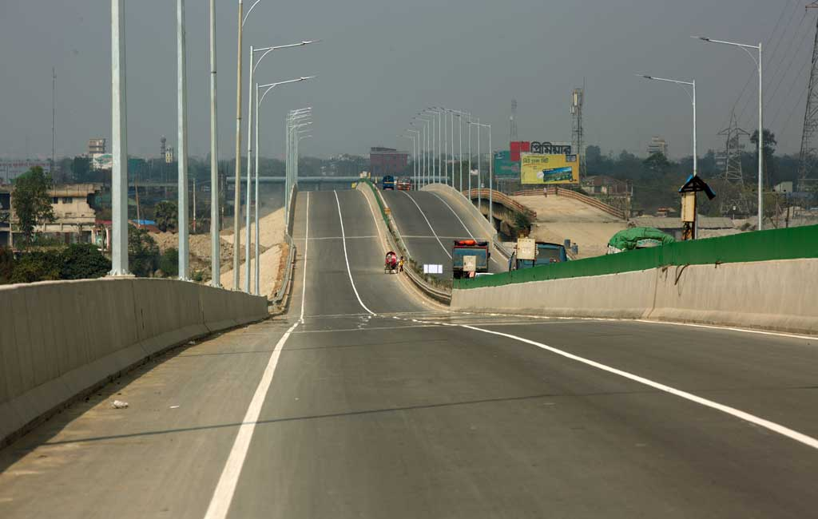Baseline Survey, Economic and Social Studies, Natural Resource and Environmental and Social Impact Assessment ((ESIA, IEE, EIA, and EMP)
* Resettlement Action Plan (RAP)
* Social Assessment including IPSA, LA, RP, Socio- Economic Survey
* Environmental Auditing and Due Diligence Assessment Contaminated Site Assessment and Remediation
* Ecological Assessment
* Noise Modeling
* **DEVELOPMENT CONSULTANCY**
* Natural Resource and Environmental Assessment (EIA), Conducting FGD, Sample Collection, Preparing Report, Public Consultation
* 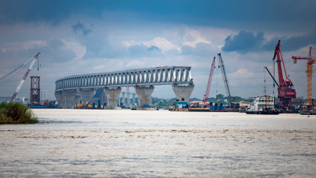Environmental Impact Assessment (EIA)
* Initial Environmental Examination (IEE)
* Baseline Survey, Economic and Social Studies, Natural Resource and Environmental and Social Impact Assessment (ESIA)
* Physical Conduct Household Survey, Biological Environment, Environmental Quality, Socio-Economic and Cultural Environment
* Social Impact Assessment for preparing Environmental Management Plan (EMP) and Social Management Plan (SMP) according EMF and World Bank Guidelines, and GOB Policies
* **BASELINE SURVEY, ECONOMIC AND SOCIAL STUDIES & INSTITUTIONAL STRENGTHENING**
* Baseline Survey, Environmental Data Collection, Analysis
* Socioeconomic Survey and Studies
* Environmental and Social Impact Assessment
* Impact Evaluation Studies
* Stakeholder Identification and Focus Group Discussions
* Monitoring and Evaluation
* Capacity Building
* Institution Strengthening
* Community Development
* Land Price Valuation / Market Price Survey
* **WATER RESOURCE MANAGEMENT AND AGRICULTURE CONSULTANCY**
* 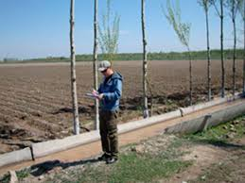Water Resource Management
* Irrigation, Drainage and Flood Control
* Drainage Master Plan
* Embankment Protection
* Ground Water Modeling
* Hydrology and Hydrogeology
* Simulation Modeling
* Agriculture, Forestry and Fishery
* **INDUSTRIAL ENVIRONMENT MANAGEMENT & CONTROL CONSULTANCY**
* 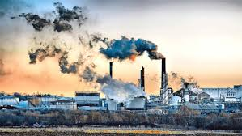Cleaner Production
* Low Carbon Development
* Waste Reduce, Recycle and Reuse (3R)
* Chemical and Hazardous Waste Management and Disposal
* Waste Control and Disposal Technology and Engineering
* Emergency Preparedness and Response Plan
* **WATER SUPPLY AND SANITATION**
* 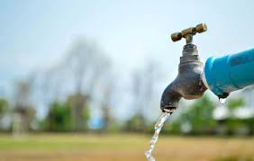Water Sanitation and Health (WASH)
* Water Pollution Control
* Solid and Municipal Waste Management
* Environmental Sanitation
* **CONSTRUCTION AND DEVELOPMENT**
* Architecture & Civil Design
* Sand and Stone supply
* Dredging & Riverbank Management
* Industrial Machineries Installation
* Labor Supply
* Electrical & Mechanical Support for Testing & Commissioning
* **DREDGING**
* **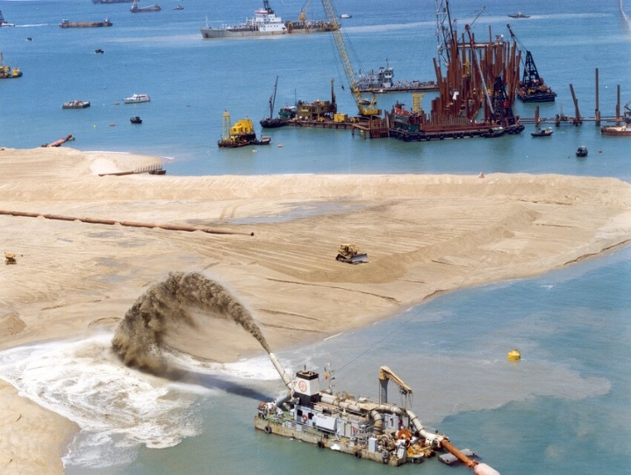**Dredging & Riverbank Management
* Machineries Supply & Installation
* Monthly Rental Service
* Load, Unload, & Cutter Dredger Supply
* River Channel Cutting
* Sedimentation Cutting
* Riverbank Protection
* Port Service
* BIWTA and BWDB Project Support
* **RESIDENTIAL AND COMMERCIAL BUILDING DEVELOPMENT**
* 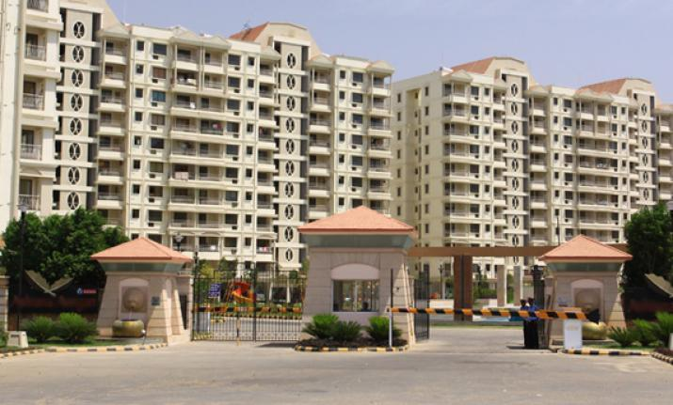Housing Society Construction
* Industrial Building Construction
* Steel & RCC Structure Construction
* Commercial cum Residential Building Construction
* Electrical & Plumbing Service
* Monthly Basis Facility Management Services
* Registration, RAJUK Permission
* WASA, DESA, Fire & Titas Gas Permission
* Utility Services

**POOL OF RESOURCES**

|  |  |  |  |
| --- | --- | --- | --- |
| Experts | Qualification | Experience | Appellation |
| Dr. Md. Mazedul Haque | PhD, Netherland | 18 Years | Environmental Specialist and Researcher |
| Dr. Sayed Md. Nazim Uddin | PhD, Canada | 13 Years | WASH & Environment Expert and Researcher |
| Dr. Razib Amirul Islam | PhD, Canada | 12 Years | Educationalist and Researcher |
| Dr. Zahanara Parvin | PhD, Japan | 12 Years | Educationalist and Researcher |
| Md. Mukul Ashraf | M.Sc. in Geography, CU | 30 Years | Environmental Specialist |
| Sattya Ranjan Bhattacharjee | M.Sc. in Mechanical Engineering, USSR | 23 Years | Head of Technical |
| Emdad Ali | M.Sc. JU | 18 Years | Online Class Expert |
| Md. Saiful Alam | B.Sc. in EEE, BUET  MBA, IBA, DU | 18 Years | Power Sector Specialist |
| Jinnat Ara Khatun | M.Ed. DU | 14 Years | Online Class Expert |
| Abu Jubayer | M.Sc. in Water Resource  Development, BUET | 12 Years | Environmental Specialist & Researcher |
| MR. Sajal Chandra Debnath | M.Sc. in Geography and  Environment, CU | 10 years | GIS Specialist |
| Dr. Nazim Uddin | PhD from Victoria University, Canada.  M.Sc. in Water Pollution, Nagoya University, Japan. | 10 years | Social and Water Management Specialist |
| Md. Yeasir Arafat | B.Sc. in Architecture, Khulna University | 10 years | Architect & Development Specialist |
| Md. Sharif Ahamed | M.Sc. & B.Sc. in Environmental  Science, Jahangirnagar University | 10 years | Environmental Specialist |
| Md. Sadequr Rahman | M.Sc. in Water Resource Development, BUET  B.Sc. in Civil and Environmental Engineering | 9 Years | Climate Change Specialist |
| Mehedi Hassan | MSS in P.Adm, DU | 6 Years | IT Specialist |
| Nazmul Hassan | B.Sc. in CSE, UAP | 6 Years | IT Specialist |
| Sanjida Rahman | B.Sc. in CSE, CUET | 5 Years | IT Specialist |
| Tanvir Rahman | B.Sc. in CSE, CUET | 5 Years | IT Specialist |
| Salim Ahmed | B.Sc. in CSE, BUET | 5 Years | IT Specialist |

OUR VALUABLE PARTNERS

|  |  |  |  |
| --- | --- | --- | --- |
| **BKMEA** |  |  | **BAIRA** |
| **BTA** |  |  | **BFLLFEA** |
| **FSCD** |  |  | **RAILWAY** |
| **LGED** |  |  | **PWD** |
| **RHD** |  |  | **IMED** |
| **PC** |  |  | **MoICT** |
| **DSHE** |  |  | **MoE** |
| **ADB** |  |  | **GIZ** |
| **BEXIMCO** |  |  | **DOREEN** |
| **SGS** |  |  | **SUMMIT** |
| **UOS** |  |  | **SAGA-U** |
| **USYD** |  |  | **U-Tokyo** |
| **UVIC** |  |  | **USTB** |

**OUR PREVIOUS AND ONGOING WORK RECORDS**

|  |  |  |  |
| --- | --- | --- | --- |
| Sl. No. | Project Name | Current Status | Client/Funding Agencies |
| 4th Industrial Revolution (4IR) | | | |
| 01 | Expression of Interest for a “Mutual Collaborative Fund-Raising Program for 4th Industrial Revolution (4IR) Activities in Bangladesh” | Ongoing | Bangladesh Knitwear Manufacturers and Exporters Association (BKMEA) |
| 02 | Appointed consultant firm for different national & international project | Ongoing | Bangladesh Association of International Recruiting Agencies (BAIRA) |
| 03 | Expression of Interest for a “Mutual Collaborative Fund-Raising Program for 4th Industrial Revolution (4IR) Activities in Bangladesh” | Ongoing | Bangladesh Tanners Association (BTA) |
| 04 | Expression of Interest for a “Mutual Collaborative Fund-Raising  Program for 4th Industrial Revolution (4IR) Activities in Bangladesh” | Ongoing | Bangladesh Finished Leather, Leathergoods and Footwear Exporters Association (BFLLFEA) |
| Information Technology (IT) | | | |
| 05 | Expression of Interest for a technical cooperation on D-Learning Hub Project: “Conduction of Online Based Live Class Program for Students and Training for Teachers in Bangladesh.” | Ongoing | Directorate of Secondary and Higher Education (DSHE) |
| 06 | D-Learning Enhancement Project | Ongoing | Startup Bangladesh |
| Environmental Monitoring | | | |
| 07 | Dhaka Northern Power Generations Limited | Completed | Doreen Power |
| 08 | Dhaka Southern Power Generations Limited | Completed | Doreen Power |
| 09 | Banco Energy | Completed | Doreen Power |
| 10 | BHAIRAB Power Ltd. | Ongoing | Doreen Power |
| 11 | Doreen Power Plant in Chandpur | Completed | Doreen Power |
| 12 | Teesta Solar Limited | Completed | Beximco Group |
| 13 | SYMPA Solar Power Limited | Ongoing | Paragon Group |
| Environmental Impact Assessment (EIA) | | | |
| 14 | Baseline survey of EMP preparation of Matarbari Ultra Super Critical Coal Fired Power Plant Ltd. | Ongoing | SGS Bangladesh Survey Team |
| 15 | IEE, EIA of 33 MW Summit Uttaranchal power company Ltd | Completed | Summit Group |
| 16 | IEE & ESCC of 55 MW power plant Dhaka Northern Power Generation Ltd | Completed | Doreen Group |
| 17 | Joty Fashions Ltd. | Completed | Factory Owner |
| 18 | Emdad Group | Completed | Factory Owner |
| 19 | Dhaka- CTG Cox’s Bazar Railway Project | Completed | Bangladesh Railway SMEC - ENRAC |
| 20 | Dhaka Joydevpur-Ishwardi Railway Project | Completed | Bangladesh Railway SMEC - ENRAC |
| 21 | Bangladesh Retired Officers Housing Society | Completed | Society Office |
| 22 | Bangladesh Govt School Teachers Housing Society | Completed | Society Office |
| Feasibility Study | | | |
| 23 | Feasibility Study on “Coordinated Complex of Department of Public Libraries (DPL) and National Museum” | Completed | PWD, Ministry of Housing and Public Works |
| 24 | Feasibility Study on “Establishment of National Museum Complex at Dhaka” | Completed | PWD, Ministry of Housing and Public Works |
| Development and Master Plan | | | |
| 25 | Preparation of Drainage Master Plan Project | Completed | SMEC-AQUA-RCC JV, LGED |
| 26 | Paurashava Wise Construction Project | Ongoing | Municipal Authority |
| 27 | Preparation of Environmental Master Plan Project | Ongoing | Municipal Authority |
| 28 | Expression of Interest for “Urban Fire Safety Readiness Project” | Proposed | Bangladesh Fire Service and Civil Defence |
| Disaster and Survey Related Work | | | |
| 29 | Flood response Scenario of affected people in North Bengal Districts Bangladesh | Ongoing | Different NGOS |
| 30 | Resource Survey of Different Paurashava for Development Projects | Ongoing | Municipality Office |
| 31 | Drinking Water Supply Option Selection in Southwestern Costal Bangladesh | Completed | BUET and ADB |
| 32 | Socio Economic Analysis of Spot Migration in Southwestern Coastal Bangladesh | Completed | University of Southampton |
| 33 | Immediate Response of WASH due to Amphan Heat | Completed | B-EX Group, UK |
| 34 | Changes of River Flow Dimension Due to Climate Change | Completed | B-EX Group, UK |
| 35 | Socio Economic Infrastructure SHAFT Analysis Due to Climate Change | Completed | B-EX Group, UK |
| 36 | Chronological History and Destruction Pattern of Tornado in Bangladesh | Completed | Central University of China |
| 37 | Socio-Economic and WASH Practices of Small Shopkeepers in Mega Cities | Completed | Central University of China |
| 38 | Regular economic scenario in the field of Microcredit sector of Bangladesh | Completed | Sydney Central University, Australia |

**LOGISTICS SUPPORT OF SRCL**

|  |  |
| --- | --- |
| Transport and Vehicles | |
| * Toyota Noah (1800 cc) * Toyota Regius ACE Super GL (2500 cc) * Bajaj CT Motor Cycle (100 cc) * Hero HFDAWN Motor Cycle (100 cc) | 01 Nos.  01 Nos.  02 Nos.  02 Nos. |
| Environmental Quality Testing and Survey Equipment | |
| * Real-time Air Quality Sampler * Dust Sampler * Noise Meter * Vibration Meter * Leveling Instruments (Survey Machine) * Theodolite Leveling stand Inclinometer * Map reducing & enlarging instrument * Portable tab * Ekman Bottom Grabs * Test Sieves of different mess sizes between 200mm and 500 * TDS Tester * pH Tester * Plankton Net * EC Meter * pH Meter * Turbidity Meter * Dissolve Oxygen Meter * Binoculars | 01 Nos.  01 Nos.  01 Nos.  01 Nos.  01 Nos.  01 Nos.  01 Nos.  01 Nos.  01 Nos.  01 Nos.  01 Nos.  01 Nos.  01 Nos.  01 Nos.  01 Nos.  01 Nos.  01 Nos.  01 Nos.  01 Nos. |
| Computer | |
| 1. Hardware:   Work station: Intel Core™ 2 Duo 3.0 GHz, 2 GB RAM, 500 HDD, 17“LCD Monitor.  Laptop/Notebook (SAMSUNG, ASUS, COPAQ, HP, ACER)  iPad (Apple Air)  Tab (Samsung 9.6)  Printer HP Color  Printer EPSON Color  Printer Canon  Printer TOSHIBA  Scanner HP  Scanner EPSON  Scanner TOSHIB  Wireless Router (Wi-Fi)   1. Software   Microsoft Windows8, Windows7 & Windows XP  MS office 2007  Auto CAD  PDF Converter  MS Access  SPSS  Word Converter  Adobe Photoshop CS  Adobe illustrator CS | 10 Nos.  07 Nos.  01 Nos.  01 Nos.  03 Nos.  01 Nos.  01 Nos.  01 Nos.  01 Nos.  01 Nos.  01 Nos.  01 Nos. |
| Photocopier | |
| * EPSON L200 series | 01 Nos. |
| Support Electricity | |
| * IPS Rahimafrooz (1200+600 watt) | 01 Nos. |
| Survey Equipment |  |
| * Plain –table set * Prismatic compass * Slide calipers * Ranging Rod * Measuring Taps * Plan meter | 01 Nos.  01 Nos.  01 Nos.  01 Nos.  01 Nos.  01 Nos. |
| Health & Safety |  |
| * Rain Coat * Flag * Color Vest * First Aid Kit | 12 Nos.  10 Nos.  05 Nos.  01 Box |
| Communication Facilities |  |
| * Telephone ISD/IDD lines * Corporate mobile numbers for all staff members | 02 Nos.  30 Nos. |

**SRCL GALLERIES**

|  |  |
| --- | --- |
| C:\Users\DELL\Desktop\247976_442513419124764_2019715563_n.jpg | C:\Users\DELL\Desktop\548848_442901812419258_698133894_n.jpg |
| Figure 01: NUGELP Japan Team, and ADB Team Field Visit | |
| E:\Photography\Camera\IMAG7250.jpg | E:\Photography\Camera\IMAG7226.jpg |
| E:\Photography\Camera\IMAG7289.jpg | E:\Photography\Camera\IMAG7481.jpg |
| Figure 02: Matarbari USCCF Power Plant Filed Visit | |

**Thank You for Your Kind Attention**

**どうもありがとうございました**