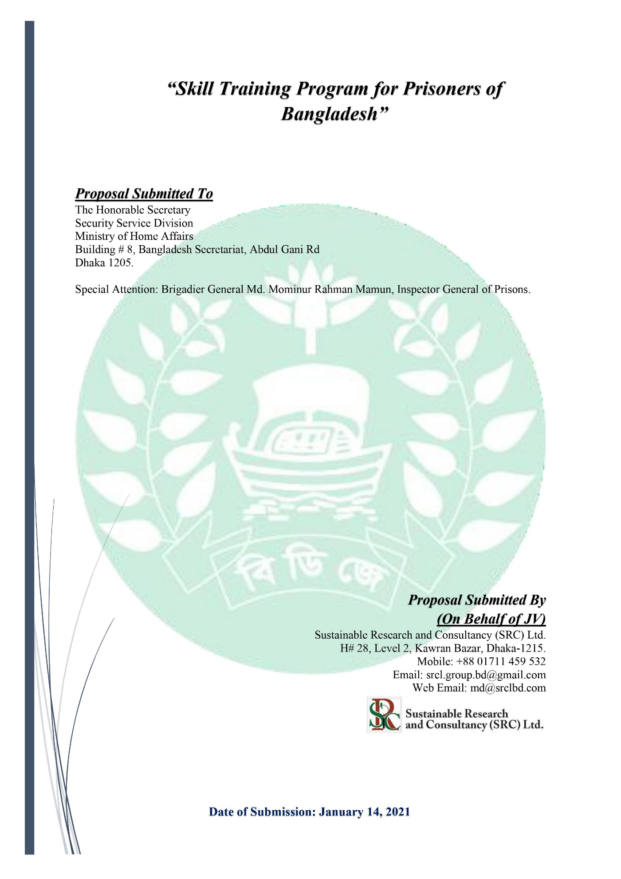

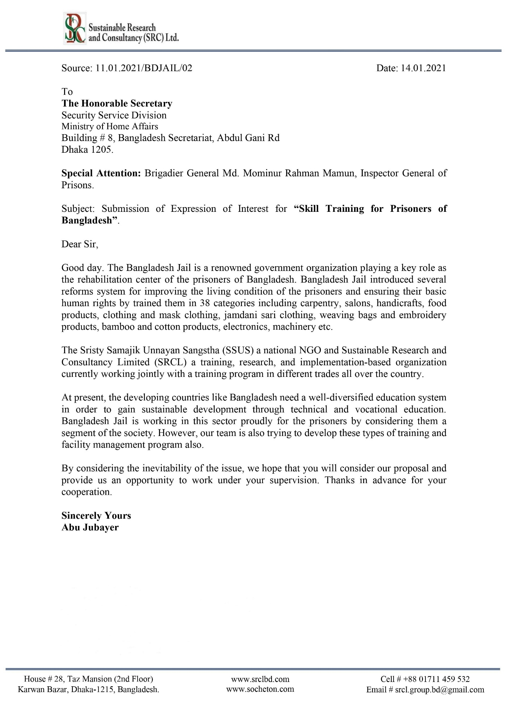

1. **Introduction:**

Advanced societies have opted for sustainable social development, which implies that all groups have a place in society. For such a society is fair, livable and conducive to coexistence frameworks appropriate to the nature of quality of life, it is necessary that all citizens have the ability to function and have discretion over their lives. A society with ghettos or groups without their own space will hardly achieve those levels of development needed for its survival over time. Bangladesh Jail is working to develop the theme **“Rakhibo Nirapad, Dekhabo Alor Poth”** for the prisoners after release. The different training programs are already running in different trades with Bangladesh Jail. However, the modern and social activities related training program is more convenient and useful for prisoners.

Sristy Samajik Unnayan Sangstha (SSUS) is a national NGO enlisted at Department of Social Service (cua-282/07, dated: 04-01-2007; Bureau of NGO Affairs, dated: 24-07-2014; MRA Temporary Certificate Submission No 121, dated: 07-12-2014; and Permanent Certificate No 21112-00121-00805, dated: 24-05-2018) and SRCL is an incorporated (Incorporation No: 127679/2015) and registered (TL No: 05-28140) consultancy and research-based company in Bangladesh (Annex-1). The SRCL is working on training, skilled certification, project proposal preparation, management, submission, fund management, local and international fund liaison, project implementation, one stop service center and final report processing. The SSUS and the SRCL have a joint agreement to conduct program all over Bangladesh. Both of the organization are serving their clients with an unparalleled service.

Social inclusion is a topic of interest today in all areas especially including former prisoners to society and labour market. In fact, internationally, the UN has included the issue in the Sustainable Development Goals of poverty eradication, as well as other issues related to social inclusion. Though prisoners are excluded from social inclusion, they yet are required to work which will help to create their new identity upon release. By training skilled prisoners can join social and regular life with financial access. This is highly required issue for released prisoners and their family as well. We are working to develop this type of raining for social inclusion and gaining SDG goal no 8 (economic growth) and goal no 10 (reduced inequalities).

1. **Goals, Objectives and Beneficiaries:**

* **Goals:**
* Create trained prisoner and skilled worker for society job placement.
* One stop solution for Job Placement after in-prison training for different shops, Commercial Edifices and Corporate Premises.
* **Objectives:**
* Training for general prisoners in ICT, hardware and software, refrigeration, electronics, general mechanics (motorcycle, vehicles etc.), wielding, agro-farming, agri-food processing, cattle rearing (cow, goat, duck etc.)
* Ensuring the job safety after prison time
* Ensuring the happy life after completing the prison time
* Fund allocation for prisoners after training and starting the job/shop/business
* Maintain the standard of NSDA level certification
* Curriculum followed by Bangladesh Technical Education Board (CBTA)
* Creating awareness among all level of stakeholders
* **Beneficiaries:**
* Prisoners
* Bangladesh Jail
* Commercial Edifices
* Corporate Offices

1. **Duration of the Project:**

|  |  |
| --- | --- |
| **Starting Date** | **March 01, 2021** |
| **Implementation Period** | **March 2021 to June 2023** |
| **Closing Date** | **June 30, 2023** |

1. **Basic Activities of Project:**

The project team will perform the following activities: -

|  |  |
| --- | --- |
| **Sl. No** | **Activities** |
| **01** | A feasibility study for In-prison Training Requirement |
| **02** | Conduct Training program on Twelve (12) Trades |
| **03** | Rehabilitation Program for the skilled prisoners |
| **04** | Certification as national standard (NSDA/BTEB) |
| **05** | Job Confirmation for trained prisoners in different trade association |
| **06** | Classroom Decoration with modern facilities |
| **07** | E-Learning training platform and curriculum development for prisoners |
| **08** | Work under direct supervision of Bangladesh Jail |
| **09** | Reporting & Documentation |

1. **Types of the Project:**

* A GO-NGO based training program for Social Inclusion and Social Infrastructure development.

1. **Target Working Areas:**

* **10 Central Jails:**
* Kashimpur Central Jail Part I,
* Kashimpur Central Jail Part II,
* Mymensigh Central Jail,
* Chittagong Central Jail,
* Sylhet Central Jail,
* Comilla Central Jail,
* Rajshahi Central Jail,
* Rangpur Central Jail,
* Jessore Central Jail and
* Barisal Central Jail.
* **20 District Jails: Discussion Based**

1. **General Methods of Service:**

|  |  |  |
| --- | --- | --- |
|  | **Service** | **Method** |
|  | Feasibility Study | On-spot survey |
| Online based survey |
| KII and reporting method |
|  | Classroom and Materials Development | Computer Training Lab Development |
| Hardware lab Development |
| Workshop development (electrical, mechanical, house wearing, motor vehicles, wielding and others) |
| Online Training program for hosing Societies |
| Offline Training program |
| Course materials development (E-Learning) |
| On ground practical training with materials |
|  | Training Services | Practical training |
| Online training |
| Direct job-oriented training |
|  | Awareness Program | Central jail and district jail wise awareness program |
| Non-formal education for job awareness |
| Special day wise awareness program |

1. **Basic Training Plan**

|  |  |  |  |  |  |
| --- | --- | --- | --- | --- | --- |
| **Sl.** | **Name of the Course** | **Duration** | **Number of Course** | **Desired number of Participants (each course)** | **Total number of desired Participants** |
| 01 | Computer Operator  (Word, Excel, PowerPoint) | 04 months | 04 | 30 | 120 |
| 02 | Affiliate and e-Commerce Marketing | 04 months | 04 | 30 | 120 |
| 03 | Digital Marketing | 04 months | 04 | 30 | 120 |
| 04 | Graphics Design | 04 months | 04 | 30 | 120 |
| 05 | Web Site Design and Development | 04 months | 04 | 30 | 120 |
| 06 | IT Support Technician | 04 months | 04 | 30 | 120 |
| 07 | IT Maintenance and Servicing | 04 months | 04 | 30 | 120 |
| 08 | Professional Freelancing | 04 months | 04 | 30 | 120 |
| 09 | Customer Support & Services | 04 months | 04 | 30 | 120 |
| 10 | Front Desk Executive | 04 months | 04 | 30 | 120 |
| 11 | Auto mechanics | 03 Months | 4 | 40 | 160 |
| 12 | Machinist | 03 Months | 4 | 40 | 160 |
| 13 | Electrical House wiring and Electrician | 03 Months | 4 | 36 | 144 |
| 14 | Refrigeration & Air-conditioning | 03 Months | 4 | 36 | 144 |
| 15 | Welding & Fabrication | 03 Months | 4 | 36 | 144 |
| 16 | Electrical Machine Maintenance | 03 Months | 4 | 36 | 144 |
| 17 | Wood Working | 03 Months | 2 | 40 | 80 |
| 18 | Civil Construction | 03 Months | 2 | 36 | 72 |
| 19 | Consumer Electronics | 03 Months | 4 | 30 | 120 |
| 20 | Driving | 02 Months | 12 | 20 | 240 |
| 21 | Caregiver | 04 months | 3 | 30 | 90 |
| 22 | Hospital Cleaning Labor | 03 months | 3 | 30 | 90 |

1. **Training Target:**

|  |  |  |
| --- | --- | --- |
| **Total Target: 20,000 nos** | | |
| **Category A** | Central Jail | 12,000 nos |
| **Category B** | District Jail | 8,000 nos |

1. **Facilities for Bangladesh Jail:**

* Project Management Unit (PMU) control
* Monitoring the full project
* Remunerations for monitoring officers and PMU unit
* Remunerations for trainers and master trainers.
* Branding opportunity for Bangladesh Jail
* Create Skilled Manpower

1. **Roles and Activities of SRCL:**
2. Organize and implement the basic training program for all level stakeholders
3. Manage all type of training facilities
4. Conduct the training program with a standard manner
5. Supply the trainers and accessors
6. Assessment & Certification
7. Job placement
8. Fund allocation for skilled prisoners (startup)
9. Arrange workshop, seminar and certificate providing ceremony
10. Program reporting monthly and half yearly
11. Other responsibility according to discussion
12. **General Resource Person for Research and Study:**

A strong team including trainer, accessor, exam management expert, certification expert, and Project Management experts are working with each other to develop the total system. Basic team members list is attached herewith.

|  |  |  |
| --- | --- | --- |
| **Sl.** | **Name** | **Basic Certification** |
| **Advisory Team** | | |
| 01 | Abul Kalam Azad | Former Secretary, Ministry of Planning |
| **Technical Team** | | |
| 01 | Abu Jubayer (Lead Coordinator) | M.Sc. In WRD, BUET  NSDA Certified, Project Management Expert |
| 02 | Eng. S M Abdullah Al Faruq (Training Expert) | B.Sc. Engineer  NFPA Certified |
| 03 | Eng. Abdullah Al Mamun (Certification Expert) | B.Sc. Engineer  NSDA Certified |
| 04 | Eng. Manik Hossain | B.Sc. Engineer  Job Placement Expert |
| 05 | Eng. S M Saiful Islam | B.Sc. Engineer  Electrical & Refrigeration Expert |
| 06 | Eng. Siddiqur Rahman | Structural Safety Expert  Assessor (NSDA Certified) |
| 07 | Accessor (15) | B.Sc. Engineer  (NSDA Certified) |
| 08 | Trainer (20-30) | B.Sc. Engineer  (NSDA Certified) |

1. **GO-NGO Involvement of SRCL-SSUS**
2. Feasibility Study for skilled prisoners
3. Signed MoU with different trade organization
4. Government certified Skilled trainer and accessor pool
5. Job placement confirmation pool
6. Previous work experience
7. Two-Envelope tendering process
8. **Publicity of this project:**

* Paper Publication
* Facebook
* You tube
* A roundtable
* TV Talk Show
* Banner
* Poster
* Rally and
* Workshops
* Awareness Campaign

1. **Facilities for Bangladesh Jail**

* Project Management Unit (PMU) control
* Monitoring the full project
* Remunerations for monitoring officers and PMU unit
* Remunerations for trainers and masters trainers.
* Remunerations for ISFM monitoring visit
* Certification and declaration body
* International training for officers (Singapore and Australia)
* Branding opportunity for Bangladesh Jail
* Create public awareness

1. **Team Experience of Relevant Programs:**

|  |  |  |  |  |
| --- | --- | --- | --- | --- |
| Sl. | Project Name | Organization | Present Status | Starting Year |
| **01** | Skill Manpower Development | BAIRA | Running | 2019 |
| **02** | 4th Industrial revolution | BTA | Running | 2019 |
| **03** | 4th Industrial revolution | BFLLFEA | Running | 2020 |
| **04** | Fire Safety Training Program | FSCD | On Process | 2020 |
| **05** | Online Education System Development | ICT Bangladesh | On Process | 2020 |
| **06** | Online Education System Development | Ministry of Education | Running | 2020 |
| **07** | Training for Future Program | SEIP | Running | 2019 |

1. **Tentative Costing for Training Program**

|  |  |
| --- | --- |
| **Component A** | |
| **Basic Training Operation** | |
| **Item** | **Cost in BDT** |
| **Per Trainee Cost** | **5500.00** |
| **Breakdown** | |
| Trainers Cost | 1000.00 |
| Food and Travel, Venue | 1000.00 |
| Materials (Development, Printing and Distribution) | 500.00 |
| Online Class, Activities and CBLM Development | 500.00 |
| Assessment, Certificates and Remuneration | 1500.00 |
| Publicity | 500.00 |
| Overhead | 300.00 |
| Others | 200.00 |
| **Sub-Total** | **5500 per person** |
| **Sub-Total A (for 20,000 person)** | **11,00,00,000.00** |

|  |  |  |
| --- | --- | --- |
| **Component B** | | |
| **Project Management Unit (PMU)** | | |
| **Sl. No.** | **Item** | **Cost in BDT** |
| 01 | Remuneration (Govt. Staff) | 2,00,00,000.00 |
| 02 | Remuneration (Project Staff) | 1,20,00,000.00 |
| 03 | Office Rent & Utility | 30,00,000.00 |
| 04 | Field Visit & Others | 30,00,000.00 |
| 05 | Transportation | 30,00,000.00 |
| 06 | Electronics Item | 20,00,000.00 |
| 07 | Furniture | 15,00,000.00 |
| 08 | Stationery and Others | 5,00,000.00 |
| 09 | Vat & Tax | 1,00,00,000.00 |
| **Sub-Total B** | | **5,50,00,000.00** |

|  |  |  |
| --- | --- | --- |
| **Component C** | | |
| **Infrastructure Management** | | |
| **Sl. No.** | **Item** | **Cost in BDT** |
| 01 | Computer Lab Development | 1,00,00,000.00 |
| 02 | Workshop Development | 2,00,00,000.00 |
| 03 | Online Class Development | 60,00,000.00 |
| 04 | Security Structure Development | 25,00,000.00 |
| 05 | Report & Documentation | 15,00,000.00 |
| **Sub-Total C** | | **4,00,00,000.00** |

|  |  |  |
| --- | --- | --- |
| **Component D** | | |
| **Awareness Building & COVID-19 Preparedness** | | |
| **Sl. No.** | **Item** | **Cost in BDT** |
| 01 | COVD-19 Preparedness Training | 20,00,000.00 |
| 03 | Promoting Awareness via Social Media | 15,00,000.00 |
| 04 | TV Talk show, Rally & Campaign | 15,00,000.00 |
| 05 | Work shop & Seminar | 20,00,000.00 |
| 08 | Research and Development | 30,00,000.00 |
| **Sub-Total D** | | **1,00,00,000.00** |

|  |  |  |  |
| --- | --- | --- | --- |
| **Total Financial Proposal** | | | |
| **Sl. No.** | **Components** | **Item** | **Cost in BDT** |
| 01 | Component A | **Basic Training Operation** | 11,00,00,000.00 |
| 02 | Component B | Project Management Unit (PMU) | 5,50,00,000.00 |
| 03 | Component C | Infrastructure Management | 4,00,00,000.00 |
| 04 | Component D | Awareness Building & COVID-19 Preparedness | 1,00,00,000.00 |
| **Grand-Total D** | | | **21,50,00,000.00** |
| **In Words: Twenty-One Crore and Fifty Lac Taka Only** | | | |

1. **Source of Fund:**

|  |  |  |  |  |
| --- | --- | --- | --- | --- |
| **Total Financial Proposal** | | | | |
| **Sl.** | **Components** | **Funding Share** | **Funding Types** | **Cost in BDT** |
| 01 | Bangladesh Jail | 80% | Monetary | 17,20,00,000 |
| 02 | SRCL-SSUS | 20% | In Kinds | 4,30,00,000 |

1. **Our Application to Your Authority**
2. A general feasibility study for Training Need Assessment for Prisoners Project
3. To conduct Basic Skilled Training for prisoners.
4. Official cooperation and set up
5. Awareness program for prisoners in different jails.
6. **Our Legal Entity**

Our Company Sustainable Research and Consultancy Ltd. (SRCL) is legally registered to Bangladesh Government and carrying all types of legal documentation for continuing our activities. It includes

1. Trade License
2. Incorporation Certificates
3. Taxpayer Identification Number (TIN)
4. NGO Bureau Registration
5. Department of Social Services Registration
6. MRA Registration

