**Background:**

Small and Medium Enterprises (SMEs) play an important role in the developing economy of a country like Bangladesh. Their role in terms of sustainable economic growth, production, development of entrepreneurs, employment generation, contribution to exports and facilitating equitable distribution of income is very critical for a developing country. An estimated number of SMEs in Bangladesh are about 7.81 million that employ 2.45 crore people along with 27 million who are self-employed like hawkers, street vendors and small businessmen. These are producing around 50 percent of our industrial output each year, generates highest number of employment and contributing in import substitution and saving foreign currencies[1]. But in the advent of COVID-19, these people face the risk of unemployment. In Bangladesh, it is estimated that 20 million people are jobless in the informal sector which includes day-laborers and construction workers.

According to a research commissioned by a2i entitled “Post COVID-19 Jobs and Skills in Bangladesh”, eleven (11) high impact sectors are identified where jobs have been lost due to COVID-19, and the informal and SME sector is one of the major sectors among them. The other sectors are transportation, construction, furniture, readymade goods and textile, leather goods and footwear, tourism and hospitality, light engineering, migration, real estate and housing, and ceramic sector. The study projects that over 20.4 million workers are currently unemployed across these high impact sectors in Bangladesh. The study further forecasts that an additional 5.5 million workers will lose their jobs by the end of this year. It also projects that over 2.53 million people will lose their jobs in the coming year 2021. The immediate losers of this scenario are informal and SME sector, transportation sector and construction sector, with an estimated 18 million jobs being lost across these sectors. They represent 88% of the total job loss scenario.

The government has identified SMEs as a key element in its development strategy. Thus, in Bangladesh, SME businesses have come to the forefront of economic activity and are considered the backbone of the economy of Bangladesh. In this corona pandemic, many informal SMEs are being developed through the online-based system (Facebook, YouTube, etc.). Now it all just needs a comprehensive country plan by the support from associations (SME Foundation, DCCI, NASCIB, ISC, etc.) and government entities (NSDA, District administration, etc.) to revive this sector slowly.

**Literature Review and GAP analysis:**

In the input supply sector, newly established SMEs worked to introduce and expand the sale and use of higher-quality inputs such as improved seeds, specialized varieties, and appropriate fertilizers and bio-pesticides. Some of the key input supply companies (Ispahani, Partex, and NAAFCO Pharma) provided embedded training to a combined 39,000 lead farmers in the use of high-quality inputs, resulting in an increase in sales of these products in southern districts of up to 60 percent.

In supply chain management, SMEs collaboration with the Dhaka Chamber of Commerce and Industry (DCCI) is particularly notable. Consequently, three large agribusinesses launched national-level safe food brands: Banglafresh (NAAFCO), Gardenfresh (Ispahani), and Shuddho (Shwapno), to introduce new agricultural practices and quality assurance procedures to deliver certifiably safe food to consumers. Within three months of the introduction of the Shuddho brand, 45,203 customers have purchased 118 tons of Shuddho vegetables, generating sales revenue of approximately BDT16 million.

Finally, and most importantly, some notable improvement is seen in recent years in GOB patronization of enabling a productive business environment by convening stakeholder workshops, sector-wide events, and dialogues, and regional and national agro-input, agro-technology, and value chain specific industry fairs to boost SME sector. SMEs efforts in this area were meant to shift firms away from competition, resulting in several partners have engaged in firm-to-firm cooperation, focusing on joint branding, marketing, or mutually beneficial investment opportunities.

SME interventions focused on three core technical areas: Input Distribution Models (partnered with agricultural input suppliers; promoted modern marketing and promotional strategies), Supply Chain Management (facilitated agricultural firms, traders and processors; launched three national safe food brands by leading retail outlets, requiring significant investments in SCM, benefiting the smallholder farmer suppliers), and Interconnected systems and support services (targeted agricultural machinery firms, specialized agricultural services, agricultural universities and research institutes, policy and advocacy organizations most notably DCCI, media, and financial services).

SMEs adaptive management approach drew in four fundamental ways: First, incorporation of market based teams to encourage responsive adaptation and modification towards better practices on marketing and branding, media and strategic communications, behavior change, entrepreneurship, and research and technology; Second, incorporation of regular series of learning events and courses with a few key initiatives like; Quarterly Portfolio Reviews (to reflect on the project’s performance and its partners), Learning Lunches (to highlight activities of the partners), and Systems Talks (to deepen interested staffs' understanding); Third, expansion of Monitoring and Evaluation/Knowledge Management team to include data collection and monitoring, knowledge management, & the Collaborating, Learning, and Adapting (CLA) function; Fourth, realigning partnership engagement strategy to coincide with the new technical approach by being adaptive, strategy driven, and accessible to private sector firms.

**Objectives:**

* To develop hygienic and safe food & products supply system first in Bangladesh;
* To develop direct marketing linkup with buyers with a sustainable supply chain;
* To develop a sustainable agriculture & product supply chain all over Bangladesh;
* To reform an online based digital market system, engage wholesale agent at kawran bazar, khatunganj, shyambazar etc.;
* To make a breakthrough in our wholesale supply chain market;
* To develop farmer to consumer (F2C) system;
* Paradigm shift of general shop to live shop system.

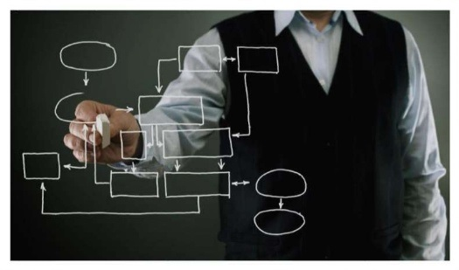**Basic Plan:**

1. Production
2. Online Purchase with Agent Engagement
3. Sustainable & Customized Transport System with GPS Tracking and software use
4. Warehouse input (8 locations)
5. Disinfecting, Cleaning, Hygienic and Vacuum Packaging
6. Online pre-order and sale
7. Delivery within 6 hours
8. Artificial Intelligence (AI) based customer need analysis
9. Demand calculation and storing with seasonal calendar
10. Profit sharing with regular customer

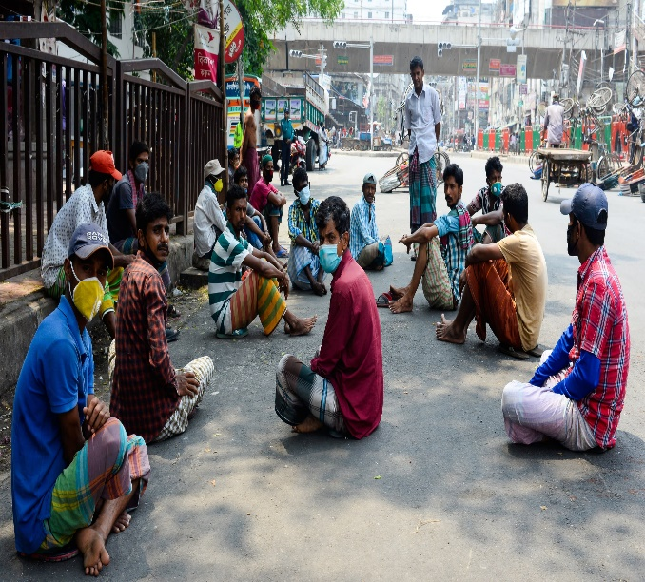**Production Point:**

1. Engaging informal farmers and SMEs as our basic production house
2. Perform as a direct buyer
3. Provide advance amount for cultivating crops and agricultural products
4. High yield varieties seed supply
5. Provide small scale bank loan for suppliers and agents as part of cultivation and supply
6. Provide training for cultivation and harvesting of crops

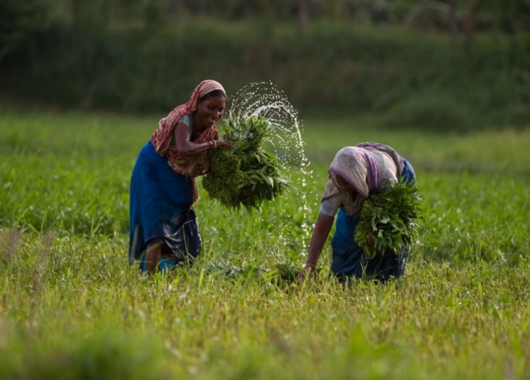**Support to Terminated Employee Due to COVID-19:**

1. Make a list for employees who lost their job due to COVID-19 pandemic
2. Communicate with different trade organizations (BKMEA, BAIRA, BTA, BFLLFEA, BDMS etc.)
3. Trained the dismissed employees with different trades (according to DoY, GoB)
4. Purchase their products with advance payment and sale to present employees with hygiene condition
5. Support all kinds of technical (seed supply, training, packaging, hygienic etc.) and financial management (product buying, selling, bank loan, land leasing, and pesticide supply)
6. Develop a SMART supply chain and delivery system
7. Develop mobile app and webpage-based market system

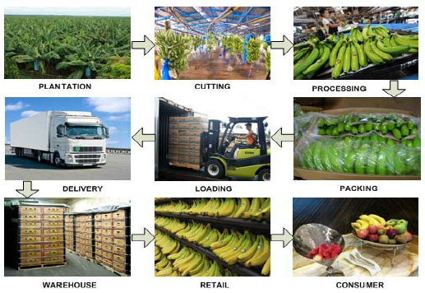**Transportation System:**

1. Customized vehicle (vegetables, fish, fruits, crops, liquid etc.)
2. Circular and radius-based transportation collection system (Toyota, Nishan, Japanese collection model)
3. Three types of vehicle (collection, transportation, and delivery) use
4. Mobile app-based vehicle tracking system
5. Manage ten (10) ferry ghats with agent for quick transportation
6. Anti-trip management system development all over Bangladesh
7. Sustainable Express Courier Service development in 2500 unions
8. 24/7 technical support for logistic management
9. Engage with BRTC and postal logistic delivery system
10. Use digital economy system (Nogod, Bkash, Rocket, Sure Cash etc.)

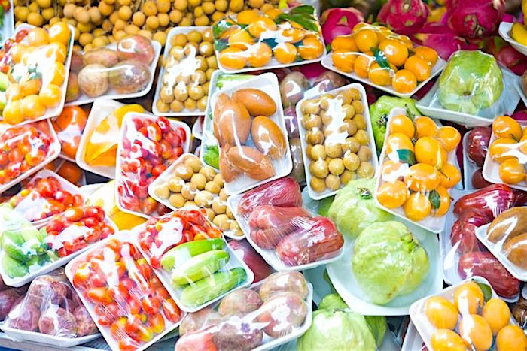**Hygiene Food:**

1. Product collection with hygienic practice (PPE and polybag usage)
2. In-house disinfection (water heating, spraying, & cleaning) process
3. Grading and sorting
4. Grade-wise special treatment for category of products

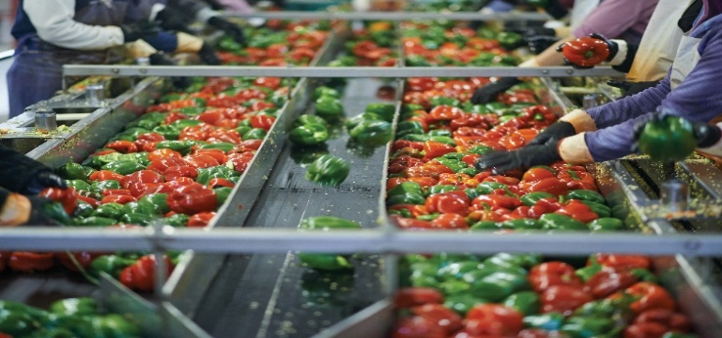**Smart Packaging:**

1. General packing for vegetables and quick perishable goods
2. Vacuum packing for grade-wise product
3. Product auto labeling
4. Manufacturing & expire date enabling
5. Weight-wise packing (2kg, 5kg, 10kg etc.)
6. QC pass system development
7. Respray for final delivery

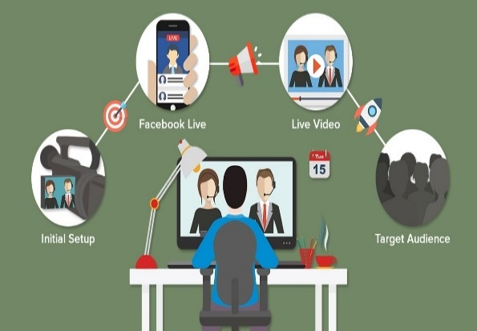**Online Sales:**

1. Mobile app development
2. Website development
3. Fixed customer (present worker of BKMEA, BAIRA, BTA, BFLLFEA, BDMS Etc.)
4. General customer development with branding
5. Social media marketing

**Live Market:**

1. Live shopping mall development
2. Shop number wise separate live link
3. Live consumer-shopkeeper-consumer link development
4. Direct purchase from every shop
5. Live wholesale market (kawran bazar, khatunganj etc.) development
6. Local hut (market) management through agent

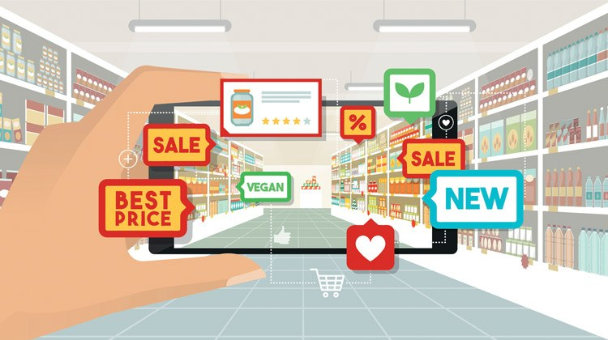**Live Shops:**

1. Mohallas/Paras/Goli wise live shop development
2. Market wise live shop development
3. House wise live shop development (different items based on FB group)
4. Wholesale market wise live shop development
5. Barcode scanning poster shop development
6. Flat & housing society wise live shop development

**Garments/Trade Body wise Sales point:**

1. General grocery shop development in factory (online & offline)
2. Delivery system development for employees & owners house
3. Running employee purchase system from terminated employee (RE-TE system development)
4. Regular demand analysis and supply system

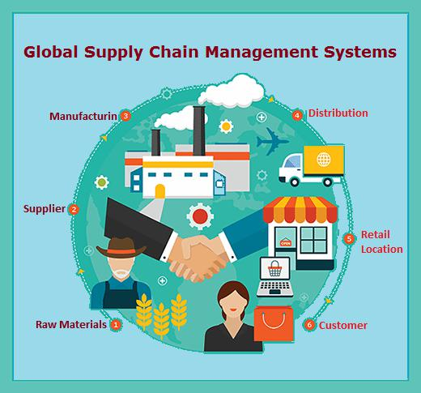**Smooth Supply Chain:**

1. Specific production house
2. High yield varieties production
3. Pre-processing hygiene maintaining
4. Day to day collection
5. Hygiene packaging
6. 4-tier delivery system (bike, bicycle, small pickup van, large supply van)
7. Online payment gateway (general & mobile banking)
8. Agent engagement & supply system
9. SMART transport system
10. Bank loan, micro-credit loan, and other financial services
11. Many production houses and one direct buyer
12. Advance payment during production against post sale

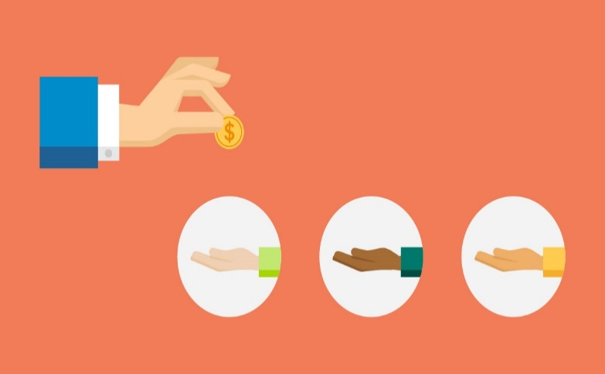**Beneficiaries:**

1. Terminated employees due to COVID-19
2. Association members
3. General hygiene food supplier
4. General shop keepers
5. Market owners
6. Chain shop owners
7. Different institutions
8. Safe food suppliers
9. Gender involvement
10. Non-formal SMEs
11. Regional farmers
12. Commission agent
13. Transport system
14. Youth development

**Major Spent:**

1. System development
2. Training
3. Hygiene & cleaning machineries
4. Packaging machineries
5. Online shop development
6. Transportation
7. Seed and pesticides supply
8. Advance payment
9. Bank loan interest
10. Marketing
11. Branding
12. Labeling
13. Delivery system

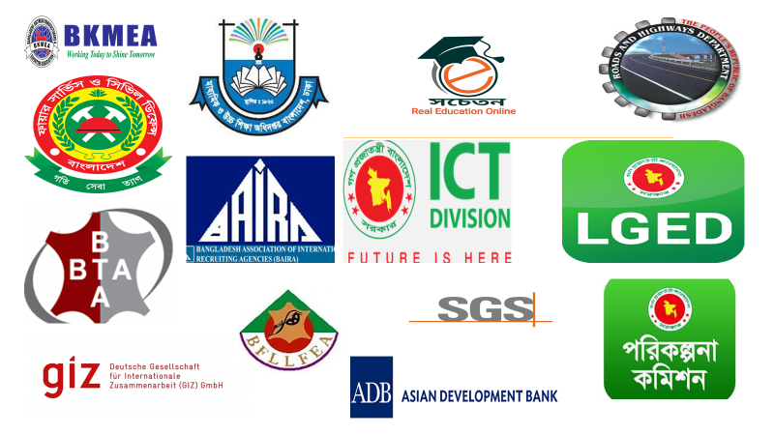**Our Strength:**

1. MoU and strong communication with different trade organizations in Bangladesh (BKMEA, BAIRA, BTA, BFLLFEA, BDMS etc.)
2. Listing the terminated employees from different factories
3. Already experienced with live projects (www.socheton.com)
4. ICT ministry affiliation (iDEA project, Startup Bangladesh, ICT, GoB)
5. Communication with transport regulatory body (private)
6. Mutual agreement with Bangladesh Dokan Malik Somity (BDMS)
7. Communication with 2500+ union parishad areas
8. Strong IT support team
9. 24/7 support team
10. Online based sales platform
11. Donor based communication

**Winning Team:**

|  |  |  |  |
| --- | --- | --- | --- |
| **Sl. No.** | **Name** | **Qualification and Special Fields** | **Year of Experience** |
| **01** | Dr. Md. Mazedul Haque | PhD, Netherland, Business Expert and Researcher | 18 |
| **02** | Dr. Sayed Md. Nazim Uddin | PhD, Canada, University Professor, Online Shop Expert and Researcher | 13 |
| **03** | Dr. Razib Amirul Islam | PhD, Canada, Project Management Professional and Researcher | 12 |
| **04** | Dr. Zahanara Parvin | PhD, Japan, Training Expert | 12 |
| **05** | Abu Jubayer | M. Sc. (BUET), NSDA L-4 in IT, Project Management Professional, Online System Expert and Researcher | 12 |
| **06** | Sadequr Rahman | M. Sc. (BUET), Project Management Professional | 10 |
| **07** | Emdad Ali | M. Sc. (JU), Business Management Consultant | 18 |
| **08** | Jinnat Ara Khatun | M. ED (DU), Business Management Consultant | 14 |
| **09** | Mehedi Hassan | M. S. S. (DU), IT Professional | 10 |
| **10** | Nazmul Hassan | B. SC. In CSE, (UAP), IT Professional | 8 |
| **11** | Sanjida Rahman | B. SC. In CSE, (CUET), IT Professional | 8 |
| **12** | Saidur Rahman Akash | MBA (IBA), E-Commerce Management Specialist | 5 |
| **13** | Salim Ahmed | MBA (IBA), E-Commerce Management Specialist | 5 |
| **14** | IT Support Technician (6) | Various | Various |
| **15** | Office Staff (70) | Various | Various |

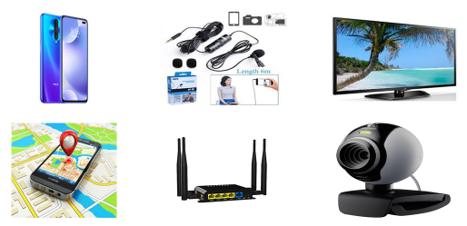**Technology Required:**

1. Mobile app
2. E-commerce website
3. Online payment gateway (card & mobile banking)
4. GPS tracking system
5. 4G router for rural areas
6. Web Camera (1080p) for high resolution videos
7. HDMI Cable (10 Meters)
8. Sound System for customer communication
9. Internet stabilizers for poor connection
10. 42’ LED TV for customer Monitoring
11. Voltage stabilizers
12. Moveable Camera Stands
13. Broadband connection with LAN facilities
14. Multiplug
15. USB Hub and customized connector
16. Super soft lighting for showroom
17. Audio Card USB Connector
18. Moveable stand table
19. YouTube Channel for every shop
20. Boya for clear voice communication
21. Facebook group
22. Bluetooth Mouse and key board
23. Online server for every shop
24. Laptop, Desktop or Smart phone

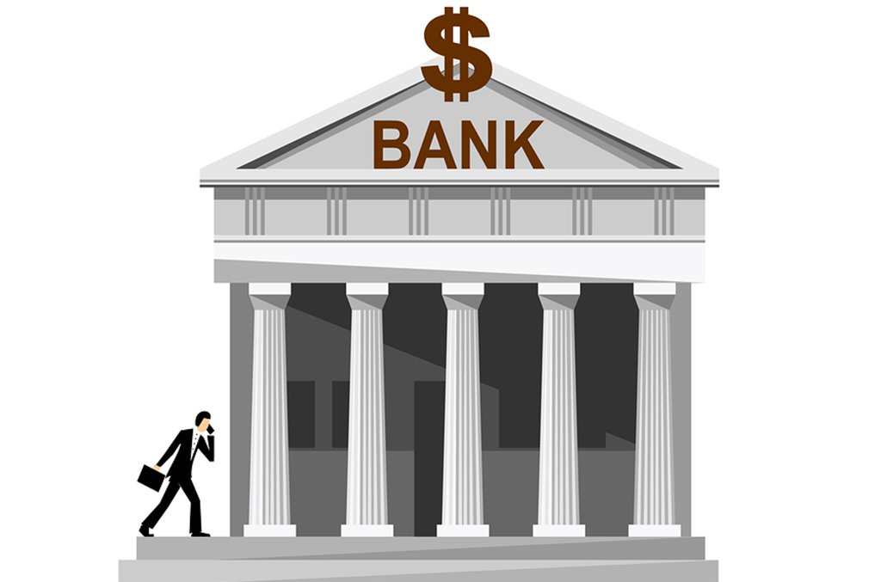**Equity Required:**

1. Office set up
2. Transportation management
3. Online e-commerce management
4. Bank loan support for supply chain SMEs, farmers and shopkeepers SMEs
5. Agricultural product support (seed, pesticides etc.)
6. Running capital
7. Delivery system
8. Hygiene and packing machineries
9. Certification
10. Long-term financial support
11. Shop decoration (online & offline)
12. Shopping mall wise equipment set up

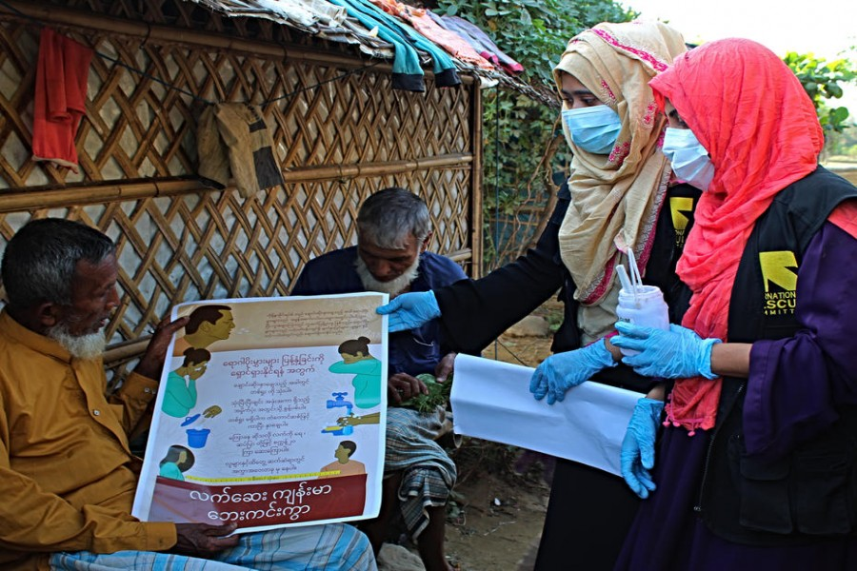**COVID-19 Preparedness:**

1. People used to online marketing and purchasing due to COVID-19
2. SMART delivery system
3. Mobile banking payment
4. Terminated employee support
5. Ensure hygiene
6. Production date wise labeling
7. Support to non-formal SMEs
8. COVID affected people’s support
9. Support to business paradigm shift due to COVID
10. Initiate Fourth Industrial Revolution (4IR) practices

**Sustainability:**

1. Regular product demand
2. Eco-Friendly
3. Trend increasing for online purchasing
4. Support to new entrepreneurs
5. Support to running SMEs
6. Different association involvement
7. Present demand of SME sector
8. Automated software
9. Supplier-customer live relationship
10. Government-TO-Association-NGO and public relationship
11. Season and area wise product diversification and supply
12. Strong market research

**Poverty Reduction:**

1. Creating new market opportunities
2. Employment generation for expatriates, terminated employee and other affected people due to COVID-19
3. Non-formal SME development
4. Supply chain establishment with producer, agent, supplier, and consumer
5. Product diversification from one place to all over Bangladesh
6. Contribution on national economic growth
7. Proper distribution of area wise product

**SDG Target:**

1. No Poverty (SDG-1)
2. Good-Health and Well-being (SDG-3)
3. Decent work and economic growth (SDG-8)
4. Industry, Innovation and Infrastructure (SDG-9)
5. Responsible consumption and production ((SDG-12)
6. Climate action (SDG-13)

**Funding Request:**

It’s a continuous project and need to support in different parts like primary, secondary, and tertiary level. However, our primary funding request is $5,000,000.00 (five million US dollars) in the context of equity and running capital.

1. Abdin, J. (2014, July 06). Bangladesh's SMEs facing so many challenges. Retrieved from https://joynal.wordpress.com/2010/08/01/bangladeshs-smes-facing-so-many-challenges/