**Startup Bangladesh**

**D-Learning Enhancement Project**

1. **Introduction**:

|  |  |  |  |
| --- | --- | --- | --- |
| **Company Name** | **:** | Sustainable Research and Consultancy Ltd. (SRCL) | |
| **Project Name** | **:** | D- Learning Hub Project (Socheton Academic Care) | |
| **Company Logo** | **:** |  |  |
| **Tag Line** | **:** | Real Education Online | |

1. **Company Information:**

|  |  |  |
| --- | --- | --- |
| **Establishment Area** | **:** | Dhaka North City Corporation |
| **Location of Operations** | **:** | 8 Divisions of Bangladesh |
| **Incorporation Certificate No** | **:** | 127679-2015 (Annex-1) |
| **Trade License No** | **:** | 05-28140 (BNCC) (Annex-1) |
| **TIN Certificate No** | **:** | 839930663812 (Annex-1) |
| **Mission of the Startup** | **:** | The mission is to establish Socheton as the number one online platform in the country that will be affordable and sustainable. |
| **Objectives of the Startup** | **:** | The objective is to meeting the country's academic, vocational and technical demand for distance learning activities as well as adapting to national and international markets. |

1. **Objectives:**

* To provide new online based education system with a unique and SMART classroom set up
* To provide Online based technical training is essential for teachers, IT personnel, company employee and other worker
* To adapt with national and international competitions
* Start Work-Training-Work (WTW) practices for industry level and technical level
* Different Pandemic situation like COVID-19, Flood, Storm Surge, Dengue and like others situation all institutes go down off and then E-Learning is the only way.
* Introducing time flexibility is present here and people can join class any time anywhere.
* World is going for E-learning platform for every level of education and we need to join this mob as soon as possible for entering the international market

1. **Description of Product or Service:**

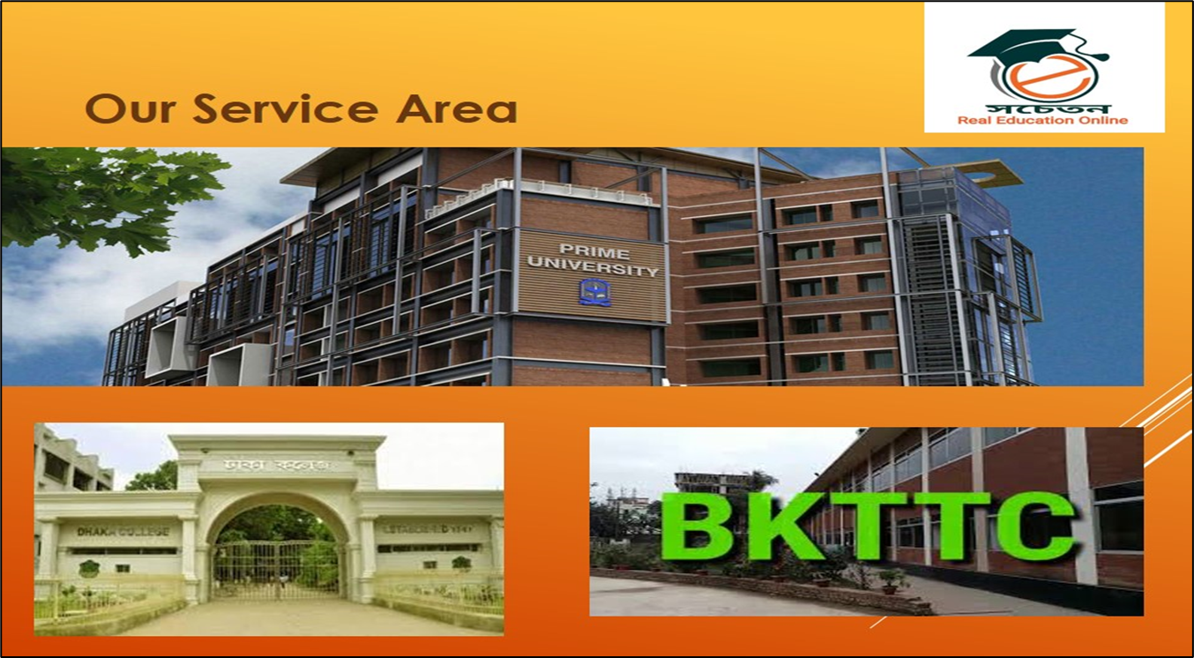

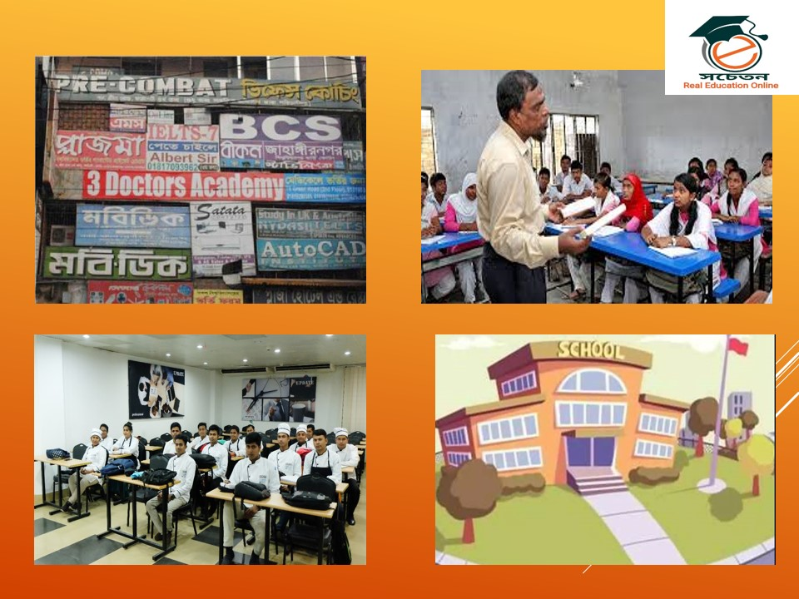

1. **Our Prime Services:**

* Online Based Live classroom preparation
* IT Support for class operations and maintenance
* Online based Live Exam System (MCQ & Written) Development
* Online homework submission and checking
* Teachers Training for SMART Class use and operations
* Feasibility study for different education-based program.
* Educational game preparation for joy full education program
* Social media live program (You tube channel, Facebook live for classes, Likee, Tiktok video for student education) management
* Communication with different international institute for educational development
* Teacher training (online and offline)

1. **Problem Statement:**

**What is the problem we are trying to solve?**

|  |  |  |
| --- | --- | --- |
| **Sl. No.** | **Items** | **General Services Problems** |
| **01** | Free Class time | Only 45 min. and need to reconnect |
| **03** | Entry | Need to submit user name and password |
| **04** | MB Cost | 500 MB-700 MB for each class |
| **05** | Remote Areas | Only Available for 4G network |
| **06** | Class Sound | Sometimes missing and not clear from teacher |
| **07** | Live Exam System | No exam system |
| **08** | Home Work | No Home Work System |
| **09** | Student Payment | No payment gateway and restriction |
| **10** | IT Support | No IT support from company |
| **11** | Training for Teachers | No training Opportunities from company |
| **12** | Online Purchase | Sometimes tough to purchase for general teachers |

1. **Solution Statement:**

To establish an affordable and sustainable online platform to meet the demand for conducting training, educational and day-to-day administrative activities smoothly in case of epidemics and emergencies as well as general times. At present it’s a time demand for future development.

|  |  |  |  |  |
| --- | --- | --- | --- | --- |
| **Sl. No.** | | **Items** | **General Services Problems** | **Socheton Solution Services** |
| **01** | Free Class time | Only 45 min. and need to reconnect | Free up to 120 Min |
| **03** | Entry | Need to submit user name and password | Direct entry for live class |
| **04** | MB Cost | 500 MB-700 MB for each class | Only 180 MB- 220MB Cost for each class |
| **05** | Remote Areas | Only Available for 4G network | Available for 2G, 3G and 4G network |
| **06** | Class Sound | Sometimes missing and not clear from teacher | Very clear sound like as real |
| **07** | Live Exam System | No exam system | Smooth online based Live Exam system |
| **08** | Home Work | No Home Work System | Smart Online based home work system is available |
| **09** | Student Payment | No payment gateway and restriction | Highly secured for student payment and entry for live classes |
| **10** | IT Support | No IT support from company | Full IT support from us |
| **11** | Training for Teachers | No training Opportunities from company | Full training support from company |
| **12** | Online Purchase | Sometimes tough to purchase for general teachers | Free from purchasing |

1. **Market Size:**

* **Description**:
* **The Target Market:** School, College, University, Madrasah, Polytechnic, Technical Education, Youth development Centers, Govt. Office Training Centers, NGO Training Centers, Corporate Offices and others.
* **The Total Market Size:** Around 50,000 + Institutes in Bangladesh.
* **The Market Share the Company will Target:** 15%-20% of Total Market.

1. **Competitive Advantage:**

* **Direct and Indirect Competitors:**
* Different coaching centers and you tube channels
* Different IT firm working on these issues
* Donor based project working people
* Local computer shops for school and college advantages
* **Our Competitive Advantage:**
* First corporate start for SMART classroom setup program
* Professional IT and support management team
* Modern and updated technology used
* Fully online based complete solution packages
* Use ability of free media for all level users
* Free access and paid access for institutes
* Digital Economy Payment gateway for teachers, institutes and other (Bank, bKash, Nagadh)
* Teachers training program online and offline
* 24/7, IT support team for any operational management

1. **Funding Request:**

Description of our funding request is:

|  |  |  |
| --- | --- | --- |
| **Amount Requested** | : | BDT 100,000,000 |
| **Industry Focus** | : | Education and Classroom |
| **Venture Stage** | : | BDT 50,000,000 |
| **Timeline to Achieve Profitability** | : | July to August 2021 |
| **Monthly Burn Rate** | : | On Demand Basis |

1. **Management Team:**

**Team Members at a Glance:**

|  |  |  |  |
| --- | --- | --- | --- |
| **Sl. No.** | **Name** | **Qualification and Special Fields** | **Year of Experience** |
| **01** | Dr. Md. Mazedul Haque | PhD, Netherland, Educationalist and Researcher | 18 |
| **02** | Dr. Sayed Md. Nazim Uddin | PhD, Canada, University Professor, Online Class Expert and Researcher | 13 |
| **03** | Dr. Razib Amirul Islam | PhD, Canada, Educationalist and Researcher | 12 |
| **04** | Dr. Zahanara Parvin | PhD, Japan, Educationalist and Researcher | 12 |
| **05** | Abu Jubayer | M. Sc. (BUET), NSDA L-4 in IT, Project Management Professional Trained, Online Class Expert and Researcher | 12 |
| **06** | Sadequr Rahman | M. Sc. (BUET), Project Management Professional Trained | 10 |
| **07** | Emdad Ali | M. Sc. (JU), College Teacher and Online Class Expert | 18 |
| **08** | Jinnat Ara Khatun | M. ED (DU), College Teacher and Online Class Expert | 14 |
| **09** | Mehedi Hassan | M. S. S. (DU), IT | 10 |
| **10** | Nazmul Hassan | B. SC. In CSE, (UAP), IT | 8 |
| **11** | Sanjida Rahman | B. SC. In CSE, (CUET), IT | 8 |
| **12** | Tanvir Rahman | B. SC. In CSE, (CUET), IT | 5 |
| **13** | Salim Ahmed | B. SC. In CSE, (BUET), IT | 5 |
| **14** | IT Support Technician (6) | Various | Various |
| **15** | Office Staff (70) | Various | Various |

**Organogram of the Company:**

1. **Product Architecture Overview:**
2. **Key Technologies & Platforms:**

* **Basic Media:**
* Google Meet
* Google Classroom
* Wu-Commerce
* Bkash / Nagadh
* SSL e-commerce.
* Online and Offline 24*7 IT Service for Institutes
* Training program for Teacher and officials (Online and Offline)

1. **Classroom Decoration Technology:**

Following technologies will be needed to decorate a classroom:

|  |  |
| --- | --- |
| Web Camera (1080p) for high resolution videos | HDMI Cable (10 Meters) |
| Sound System for student communication | Internet stabilizers |
| 42’ LED TV monitoring Screen for student Monitoring | Voltage stabilizers |
| Moveable Camera Stands, | Broadband connection with LAN facilities |
| Whiteboard, marker and multiplug | Projector with multimedia |
| USB Hub and customized Connector | Super soft lighting for clear class |
| Audio Card USB Connected, | Moveable stand table |
| Video Recording and class live equipment (1 Set) | YouTube Channel for every school |
| Boya for clear voice communication | Facebook group |
| Bluetooth Mouse and key board | Online server for every classroom |
| Laptop or desktop | Online classroom facilities from Google |

1. **Scalability/Security/Deployment Plan:**

* **Scalability:** Around 30,000 Scholl and College in Bangladesh (Source: DSHE) and most of them are out of these types of smart facilities. It’s highly scalable for these institutes.
* **Security:** Web pages are secured as built and provide security for institutes.

1. **Deployment Plan:**
2. **Integration with Other Products/Services:**
3. **Product Plan:**

* **Product Package Plan**
* **Basic:** For small Class or Private Tuition
* **Standard:** For School / College Classroom
* **Smart:** For English Medium and Kindergarten Classroom
* **Ultra:** For University and National Level Training Room
* **Advance:** For International NGO, Liaison Office, International Training Classroom

1. **Proposed Partnerships:**

|  |  |  |
| --- | --- | --- |
| **Basic Partner** | **:** | Company Directors (07) |
| **Strategic partner** | **:** | IDEA Project, A2I Project, ICT ministry |
| **Implementation Partners** | **:** | DHSE, DME, DTE, INGOS, NGOS and Different Training Centers |
| **Field Operational Partners** | **:** | Socheton Academic Care, |
| **Media Partner** | **:** | ATN News, ETV, The Daily Prothom Alo, The Daily Star, The Bangladesh Protidin. |
| **Field Partners** | **:** | Different School, college, madrasah, technical institutes, polytechnic, NGO training centers and others. |
| **Foreign Partners** | **:** | International Business Expert (b-Ex) Group, UK |
| **Donor Partners** | **:** | USAID, DFID, Swiss Contact, Embassy of Netherland |
| **International Certification Partners** | **:** | ISO, UKAS, 3 Plum Certification |

1. **Marketing Plan (Web/Social/Electronic/Print):**

* **Web page:** A smart HTML based Integrated Webpage
* **Social Media:** Facebook Boosting (Daily $100), YouTube Branding (Daily $100)
* **Electronic Media:** 5 Talk shows, 2 Round Tables, Special Interviews 10, 1 advertisement
* **Print Media:** Inauguration Program (Full Page), Daily Advertisement (20 Times in 5 National Dailies)

1. **Sales Plan (Direct/Indirect/Channels):**

* **Direct Sales:**

School, College, Madrassa, Technical Institutes, NGO Training Centers, Govt. training centers, Skill Programs in Bangladesh. (Work order collection and implementation)

* **Indirect Sales:**

Collect permission from different departments and according to project cycle implementation

* **Channels:**

Government, Donors, Foreign Donation, Teachers Associations and others channels will be used as Sales purposes

1. **Financial Strategy:**

* **Funding sources:** IDEA Project, A2I Project, Personal, Directors funds,
* **Amount of Funding:** Preliminary BDT 100,000,000
* **Use of funds:** Product Purchase, Demo Setup, Operational Cost, Overhead, Web page development, financial framework development, Mobile App development, Consultancy and others.

1. **Revenue Model:**
2. **Cash Flow Projection:**

* **1st Phase:**
* 3,500 Classroom Set Up
* Total Cash Flow projection is around 454,354,600
* **2nd Phase:**
* 20% Increase
* **3rd Phase:**
* 15% Increase

1. **Implementation Plan:**

* **Quarterly Plan (4 Qtrs.) – Business**
* **1st Quarter:** Communication and Project Submission in Different Authorities
* **2nd Quarter:** Corrections and Resubmission according to instructions
* **3rd Quarter:** Fund Collection, Work Order collection and Start Implementation
* **4th Quarter:** Monitoring, Evaluation, Management and Development
* **Quarterly Plan (4 Qtrs.) – Technical**
* **1st Quarter:** Web Page Development with integrated facilities
* **2nd Quarter:** Demo Classroom Preparation, Test Class start, Virtual coaching start, Problems identifications and solutions for clear live class productions.
* **3rd Quarter:** Classroom preparation, project running, day-to-day IT problems solutions, Digital revenue generations.
* **4th Quarter:** Advance Technology adding, Game Development, Monitoring, Evaluation, Management and Development
* **Quarterly Plan (4 Qtrs.) – Financial**
* **1st Quarter:** Application for fund, contact for personal fund, collect different source of fund, prepare a presentation and show to funding authorities
* **2nd Quarter:** Collect project fund, work order fund, start a live coaching center for regular activities, fund use for different purposed
* **3rd Quarter:** Revenue collections and fund generation.
* **4th Quarter:** Advance Technology adding, Research and Development investment, Monitoring, Evaluation, Management and Training program

1. **Some Snapshots of Our Ongoing Projects:**

|  |  |
| --- | --- |
|  |  |
|  |  |