Table 1(1) Natural and Social Environmental Components for Data Collection
Items | Survey area | Number of sampling  points & others | Frequency | Duration | Parameter | Remarks | As reference
A Land
Topography | Within 15km radius of the site | Map and areal photos | … | … | Sand bank, marsh, mangrove, residential area, forest area, lakes, rivers, etc | … | ESIA of FS 1&2
Seabed topography drift sand | Coastal area facing and surrounding the site (35 km2) | -- | -1time/Rainy season (July)  -1 time/Dry season  (February) | … | Seabed topography | Bathymetry
C Marine Environment
Current | Coastal area facing and surrounding the site | 4 points  Near water outlet:1  Offshore:3  (Measure:1-2 layers)  -Surface, Bottom | -1time/Rainy season (July)  -1time/Dry season (February) | Continual observation for 2 weeks  (every 10 min.) | Current direction, velocity with water temperature and salinity | Current meter
Tidal level | Within 15 km radius of the site | Records of the past | … | … | The highest and lowest sea level of the year (Tidal level, time and data of occurrence) | Last 3 years | Similar survey of ESIA of FS 1 &2
Tidal level | Within 15 km radius of the site | Tidal level chart | … | …  … | Tidal level | Chittagong & Cox’s Bazar Port
Waves | Within 15 km radius of the site | Records of the past | … | … | Wave height, Wave direction, frequency | Last 3 years | Similar survey of ESIA of FS 1&2
Waves | Coastal area facing the site | 1 point  Coastal area facing the site-1 | -After cyclone  (August-Sep) | … | Same as above | Video recording  (Visual insp)
Water temperature salinity | Coastal area facing and surrounding the site | 5 point  -Coastal area facing the site: 2  -Near water route-1  -Background:1  (Measured layer)  Surface to bottom | -1time/Rainy season  (July)  -1 time/Dry season  (February) | … | Water temperature, salinity | STD meter | Similar survey of ESIA of FS 1 &2
Marine water quality | Coastal area facing and surrounding the site | 5points  -Same as ‘water temperature, salinity’  (Sampling:3 layers)  -0.5m, middle layer, 1 m up from the bottom | -1time/Rainy season(July)  -1time/Dry season(February) | … | Parameters of Sea Water Quality, such as  Transparency, Temperature, Salinity, SS, Turbidity, P^{H}, DO, BOD, COD, SS, Nutrient (PO₄-P,T-P,NO₂-N.NO₃-N NH4-N,T-N),Oil and grease, Heavy metals (T-Cr, Cu, Fe, Zn, Pb, Cd, Hg, As, etc) | Sampling and Analysis | Similar survey of EMOR of FS 1&2
Sea bottom sediment | Coastal area facing and surrounding the site | 13 points  -Shoreline 5 (Approx. 1km)  -Breaker zone (2-3m depth): 5 (approx. 2km)  -Coast (approx...10m depth):3 (approx. 2km) | -1 time/Rainy season(July)  -1 time/Dry season  (February) | … | Sieving test, Specific weight. Content of mineral (Mineral analysis) | Sampling and Analysis | Similar survey/of EMOR of FS 1&2
Sea bottom sediment | Coastal area facing and surrounding the site | 5 points  -Same as “Water temperature and salinity”  -1 point includes “heavy metal”. Near planned water route | -1 time/Rainy season(July)  -1 time/Dry season  (February) | …. | Temperature, Sulfide, Loss on Ignition, Heavy metals (Hg, Cd, Pb, Org-P, Cr⁶⁺, As, CN, Cu, Zn, F, etc)etc. | Sampling and Analysis | Similar survey/of EMOR of FS 1&2

Terms of Reference for Survey on Natural Conditions
- Bathymetry and shoreline
The purpose of this survey is to confirm the location of sedimentation.
-Survey season: Dry Season, Rainy season and normal season
-Block distance: 11km
-Survey interval: 500m
-Survey point: 23 points
-Survey method: Shoreline (2 points) + inside the channel) 3 points)
Shoreline: Leveling using stud
Inside the channel: using multi-beam on a boat
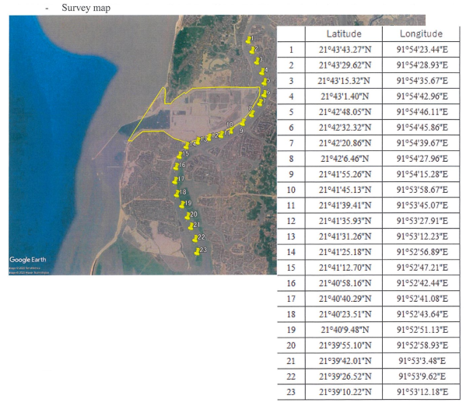
- Tidal level
The purpose of this survey is to confirm and compare the geostationary fluctuation.
- Survey season: Dry season, Rainy season
- Survey point: 3 points
- Survey period for each season: 1month
- Survey method “To be discussed.
- Survey map

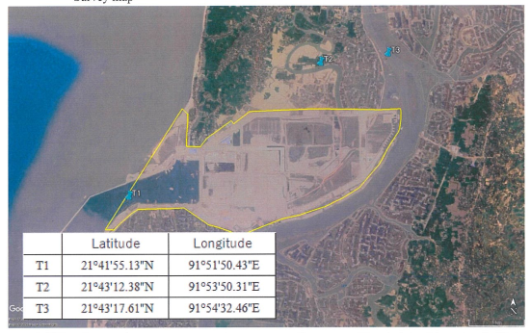

- Waves and Current
The purpose of this study is to confirm waves and current characteristics
-Survey season: Dry season, Rainy season
-Survey point: 3 points
-Survey period for each season: 1 month
-Survey method: To be discussed
-Survey map
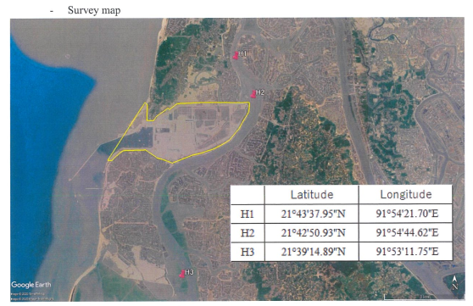

- Sedimentation and Turbidity
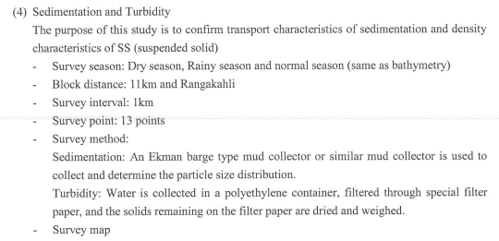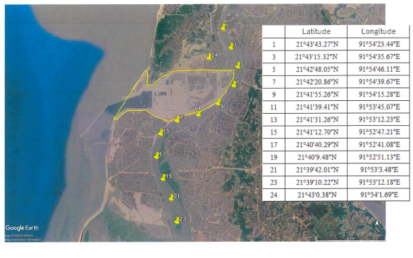

Terms of Reference for Topographic Survey
1. Scope of the Work- Topographic Survey
-Topographical survey
-Investigation of existing structures
- Survey area and condition are following: Total survey are to be approx...4km2
- Survey drawing scale to be 1:5,000 for longitudinal section and 1:500for cross section
- Topographic map scale to be 1:1,000.
Detailed specification for topographic survey to be shown in attached TS-001 Topographic Survey.
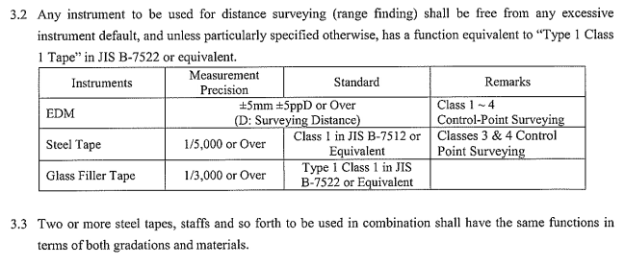
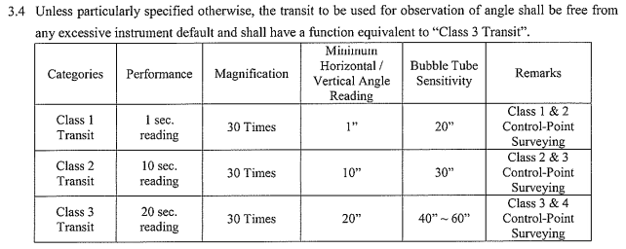

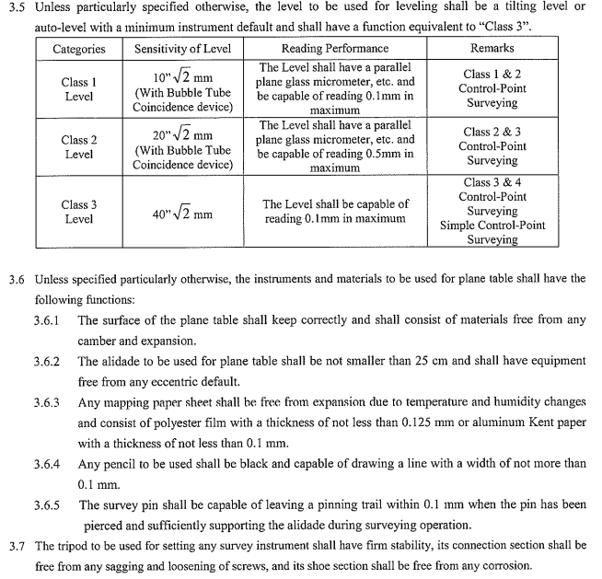
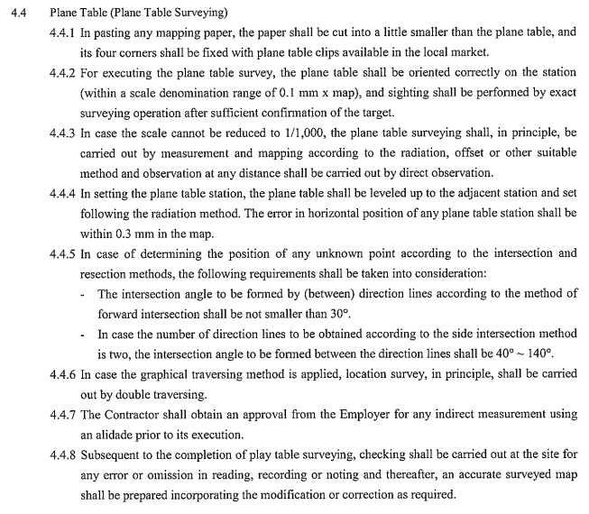
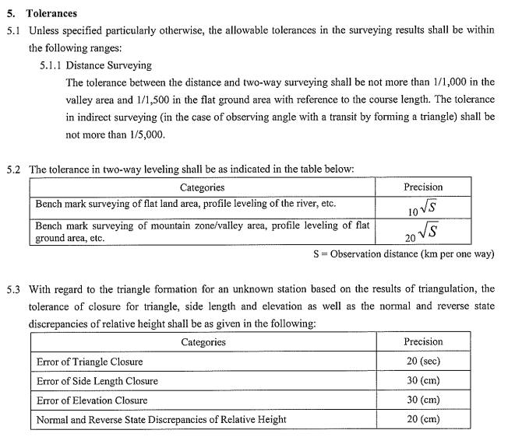
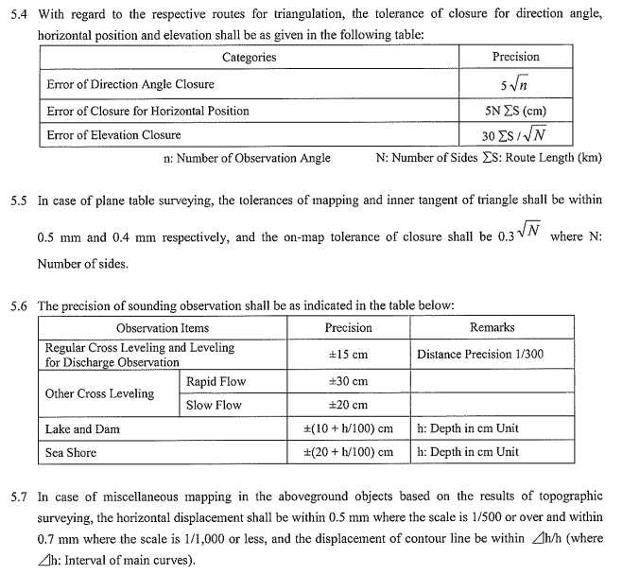
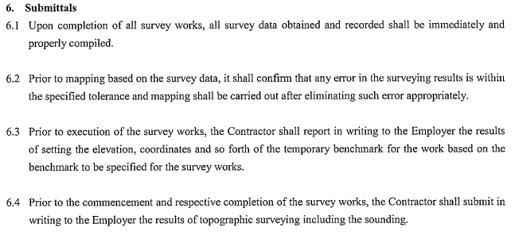
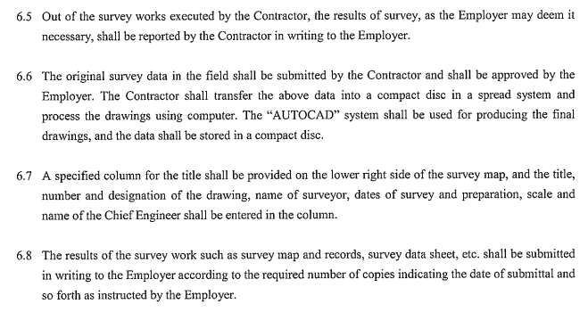
Terms of Reference for Soil Investigation
Scope of the Work
Soil Investigation (5 bore holes will be drilled) location
Borehole No Nothing Easting
BH-1 2400621.39 385225.5
BH-2 2400621.26 384868.52
BH-3 2400803.4 384869.37
BH-4 2400621.64 384422.34
BH-5 2400621.87 384073.32
-Boring hole, Standard Penetration test (SPT)
Soil investigation will be executed in order to grasp the geographical features in the power plant site.
-Soil investigation (boring position) is properly placed in order to understanding overall stratum structure .Standard penetration Test (SPT) and sampling will be performed.
-The boring of facility area will confirm the depth of designed soil bearing layer with N-value (SPT) of not less 50 and confirm the laboratory test.
-Physical property test
- Total unit weight/bulk density
- Moisture gravity
- Specific gravity
- Grain size analysis
- Liquid limit, plastic limit
- Chemical analysis of soil
-Mechanical property test
- Unconfirmed compression test
- Direct shear test
- Tri-axial compression test (UU Test) (If necessary)
- Consolidation test
- Permeability test
- Compaction test
-Other test
- Chemical Analysis on soil at each borehole
- Groundwater measurement at each borehole
- Chemical Analysis on ground water at each borehole
2. Codes and Standards
2.1 The codes and standards of the following organizations shall be applied to the design, manufactured testing of the work.
-JIIS Japan Industrial Standard
-ASTM American Society for Testing and Materials

3.1 Scope of investigations
3.1.1 The following minimum of the investigation program is compulsory.
i) Sampling and coring
2) Standard penetration test.

3) Physical property test.
-Total unit weight/bulk density
- Moisture content
-Specific gravity
-Grain size analysis
-Liquid limit, plastic limit
-Chemical analysis of soil

4) Mechanical property test
-Unconfined compression test
-Direct shear test
- Tri-axial compression test (UU Test)
-Consolidation test
-Permeability test
-Compaction test

5) Other test
-Chemical Analysis on soil at each borehole
-Groundwater measurement at each borehole
-Chemical Analysis on ground water at each borehole.

3.1.2 The following minimum, quantity of boring, sampling, SPT test and frequency of laboratory test shall be required under this Contact.
1. The boring holes shall be arranged 5 nos. in the area of the structure with horizontal projection.
2) The boring holes shall be conducted until Bearing layer which the Contractor shall confirm the N value over 50 with 5timrs continuously. It is expected that the drilling length will be approx... 3.5m.
3) STP and sampling shall be performed in 1.0m interval.
4) Undisturbed sample of soil for laboratory test shall be taken minimum 1 (one) at each different layer.
5) The laboratory test shall be performed for each layer of boring holes.
6) The chemical analysis of soil shall be performed for each major structure.

