Shuyang Ding – Assignment 2

DSC 450: Database Processing for Large-Scale Analytics

Assignment 2

Due Sunday, April 28th

Supplemental reading: SQL reference book Oracle 11g SQL by Price, ISBN 9780071498500 (available in Books 24x7 DePaul online library as eBook). Sections:
Pp.31-34, “Performing Arithmetic”
pp.35-40, “Combining Column Output Using Concatentation”, “Null Values”, “Displaying Distinct Rows”, “Comparing Values”, “Using the LIKE Operator”
pp. 43- 46, “Using the Logical Operators”, “Sorting Rows Using the ORDER BY Clause”

For a normalization reference, you can read Section 14.6 in “Information modeling and relational databases”, ISBN 9780123735683 in the online library (although in this class we only consider 1NF/2NF/3NF).

Part 1

You are given a following schema in 1NF:
(First, Last, Address, Job, Salary, Assistant) and the following set of functional dependencies:

First, Last → Address
Job → Salary, Assistant

Decompose the schema to make sure it is in Third Normal Form (3NF).

Write SQL DDL and SQL INSERT statements to create the 3NF tables and manually load the data provided in the text file data_hw2.txt (posted together with this assignment). Make sure that NULL in the data file is loaded as database NULL and not as ‘NULL’ string.

(First, Last, Job)

(First, Last, Address)

(Job, Salary, Assistant)

CREATE TABLE Occupation
(
Job VARCHAR2(20),
Salary VARCHAR2(6),
Assisstant VARCHAR2(5),

CONSTRAINT Occupation_PK
PRIMARY KEY(Job)
);

CREATE TABLE Address
(
First VARCHAR2(25),
Last VARCHAR2(25),
Address VARCHAR2(60),

CONSTRAINT Address_PK
PRIMARY KEY(First, Last)
);

CREATE TABLE Employee
(
First VARCHAR2(25),
Last VARCHAR2(25),
Job VARCHAR2(20),

CONSTRAINT Employee_PK
PRIMARY KEY(First, Last, Job),

CONSTRAINT Employee_FK
FOREIGN KEY (First, Last)
REFERENCES Address(First, Last),

CONSTRAINT Employee_FK2
FOREIGN KEY (Job)
REFERENCES Occupation(Job)
);
INSERT INTO employee VALUES ('John', 'Smith', 'plumber');
INSERT INTO employee VALUES ('John', 'Smith', 'bouncer');
INSERT INTO employee VALUES ('Jane', 'Doe', 'waitress');
INSERT INTO employee VALUES ('Jane', 'Doe', 'accountant');
INSERT INTO employee VALUES ('Jane', 'Doe', 'bouncer');
INSERT INTO employee VALUES ('Mike', 'Jackson', 'accountant');
INSERT INTO employee VALUES ('Mike', 'Jackson', 'plumber');
INSERT INTO employee VALUES ('Mary', 'Who', 'accountant');
INSERT INTO employee VALUES ('Mary', 'Who', 'risk analyst');

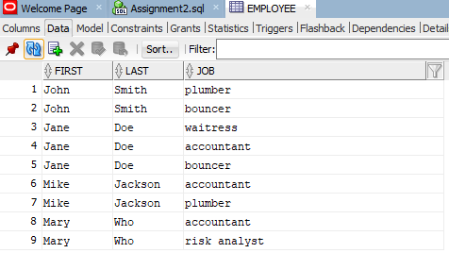

INSERT INTO address VALUES ('John', 'Smith', '111 N. Wabash Avenue');
INSERT INTO address VALUES ('Jane', 'Doe', '243 S. Wabash Avenue');
INSERT INTO address VALUES ('Mike', 'Jackson', '1 Michigan Avenue');
INSERT INTO address VALUES ('Mary', 'Who', '20 S. Michigan Avenue');

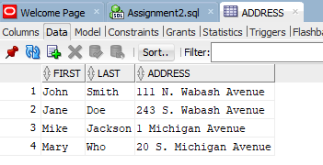

INSERT INTO occupation VALUES ('plumber', '40K', NULL);
INSERT INTO occupation VALUES ('bouncer', '35K', NULL);
INSERT INTO occupation VALUES ('waitress', '50K', 'Yes');
INSERT INTO occupation VALUES ('accountant', '42K', 'Yes');
INSERT INTO occupation VALUES ('risk analyst', '80K', 'Yes');

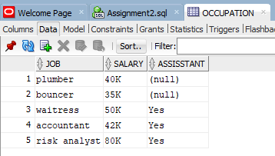

Part 2

Write a python script that is going to create your tables from Part 1 and populate them with data automatically. Use sqlite3 database and make the necessary data type changes in your DDL from part1 (e.g., NUMBER(5,0)→INTEGER, NUMBER(5,2)→REAL).
Your python code must successfully load data into all tables (however many tables you have created in Part-1). Note that you are loading data into SQLite, not into Oracle (the process is the same, but connecting to Oracle DB using python is somewhat complicated, so we use SQLite instead). Your python code must read the input file data_hw2.txt directly and automatically load the data. Do not create INSERT SQL statements manually instead reading the file.

import os
import sqlite3

conn = sqlite3.connect('DSC450-1.db')
os.getcwd()
c=conn.cursor()

Occupation = '''CREATE TABLE IF NOT EXISTS Occupation
(
Job VARCHAR2(20),
Salary VARCHAR2(6),
Assisstant VARCHAR2(5),

CONSTRAINT Occupation_PK
PRIMARY KEY(Job)
);'''

c.execute(Occupation)

Address = '''CREATE TABLE IF NOT EXISTS Address
(
First VARCHAR2(25),
Last VARCHAR2(25),
Address VARCHAR2(60),

CONSTRAINT Address_PK
PRIMARY KEY(First, Last)
);'''

c.execute(Address)

Employee = '''CREATE TABLE IF NOT EXISTS Employee
(
First VARCHAR2(25),
Last VARCHAR2(25),
Job VARCHAR2(20),

CONSTRAINT Employee_PK
PRIMARY KEY(First, Last, Job),

CONSTRAINT Employee_FK
FOREIGN KEY (First, Last)
REFERENCES Address(First, Last),

CONSTRAINT Employee_FK2
FOREIGN KEY (Job)
REFERENCES Occupation(Job)
);'''

c.execute(Employee)

os.getcwd()
file = open('C:\\Users\\shuya\Downloads\\Depaul\\DSC450\\Lecture 4\\data_hw2.txt','r')
contents = file.readlines()
file.close()

newdata=[]
for line in contents:
newline = line.strip()
data = newline.split(',')
for x in range (len(data)):
if data[x] ==' NULL':
data[x] = None
newdata.append(data)

for x in range (len(newdata)):
c.execute("INSERT OR IGNORE INTO Occupation VALUES('%s','%s','%s');" %(newdata[x][3],newdata[x][4],newdata[x][5]));
c.execute("INSERT OR IGNORE INTO Address VALUES('%s','%s','%s');" %(newdata[x][0],newdata[x][1],newdata[x][2]));
c.execute("INSERT OR IGNORE INTO Employee VALUES('%s','%s','%s');" %(newdata[x][0],newdata[x][1],newdata[x][3]));

occupation_result= c.execute("SELECT * FROM Occupation").fetchall()
print(occupation_result)

address_result = c.execute("SELECT * FROM Address").fetchall()
print(address_result)

employee_result = c.execute("SELECT * FROM Employee").fetchall()
print(employee_result)

conn.commit()
conn.close

Part 3

You were hired to do some data analysis for a local zoo. Below is the data table, including the necessary constraints and all the insert statements to populate the database.

-- Drop all the tables to clean up
DROP TABLE Animal;

-- ACategory: Animal category 'common', 'rare', 'exotic'. May be NULL
-- TimeToFeed: Time it takes to feed the animal (hours)
CREATE TABLE Animal
(
AID NUMBER(3, 0),
AName VARCHAR2(30) NOT NULL,
ACategory VARCHAR2(18),

TimeToFeed NUMBER(4,2),

CONSTRAINT Animal_PK
PRIMARY KEY(AID)
);
INSERT INTO Animal VALUES(1, 'Galapagos Penguin', 'exotic', 0.5);
INSERT INTO Animal VALUES(2, 'Emperor Penguin', 'rare', 0.75);
INSERT INTO Animal VALUES(3, 'Sri Lankan sloth bear', 'exotic', 2.5);
INSERT INTO Animal VALUES(4, 'Grizzly bear', 'common', 3.0);
INSERT INTO Animal VALUES(5, 'Giant Panda bear', 'exotic', 1.5);
INSERT INTO Animal VALUES(6, 'Florida black bear', 'rare', 1.75);
INSERT INTO Animal VALUES(7, 'Siberian tiger', 'rare', 3.25);
INSERT INTO Animal VALUES(8, 'Bengal tiger', 'common', 2.75);
INSERT INTO Animal VALUES(9, 'South China tiger', 'exotic', 2.5);
INSERT INTO Animal VALUES(10, 'Alpaca', 'common', 0.25);
INSERT INTO Animal VALUES(11, 'Llama', NULL, 3.5);

Since none of the managers in the zoo know SQL, it is up to you to write the queries to answer the following list of questions.
- Find all the animals (their names) that take less than 1.5 hours to feed.
SELECT Aname, TimeToFeed
FROM Animal
WHERE TimeToFeed <1.5;

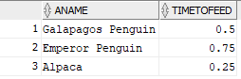

- Find all the rare animals and sort the query output by feeding time (from small to large)
SELECT Aname, Acategory, TimeToFeed
FROM Animal
WHERE Acategory = 'rare'
ORDER BY TimeToFeed;

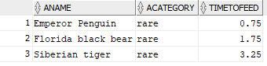

- Find the animal names and categories for animals related to a bear (hint: use the LIKE operator)
SELECT Aname, Acategory
FROM Animal
WHERE Aname LIKE '%bear%';

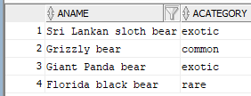

- Return the listings for all animals whose rarity is missing in the database
SELECT * FROM Animal
WHERE Acategory IS NULL;

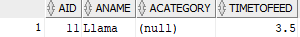

- Find the rarity rating of all animals that require between 1 and 2.5 hours to be fed
SELECT Acategory, TimeToFeed
FROM Animal
WHERE TimeToFeed > 1 AND TimeToFeed <2.5;

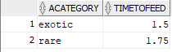
- Find the names of the animals that are related to the tiger and are not common
SELECT Aname, Acategory
FROM Animal
WHERE Aname LIKE '%tiger%' AND Acategory != 'common';

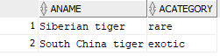

- Find the names of the animals that are not related to the tiger
SELECT Aname
FROM Animal
WHERE Aname NOT LIKE '%tiger%';

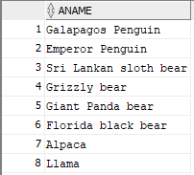

- Find the minimum and maximum feeding time amongst all the animals in the zoo
Maximum feeding time:
SELECT MAX(TimeToFeed)
FROM Animal

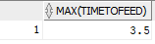
Minimum feeding time:
SELECT MIN(TimeToFeed)
FROM Animal

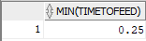

- Find the average feeding time for all of the rare animals
SELECT AVG(TimeToFeed)
FROM Animal
WHERE Acategory = 'rare';

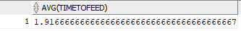

Be sure that your name and “Assignment 2” appear at the top of your submitted file.

