Shuyang Ding – Assignment3

CSC 455: Database Processing for Large-Scale Analytics

Assignment 3
Due Saturday, May 11th.

Supplemental reading: reference book Oracle 11g SQL by Price, ISBN 9780071498500 (available in Books 24x7 DePaul online library as eBook).
Chapter 2, “Using Column Aliases”, “Displaying Distinct Rows”, “Sorting Rows Using the ORDER BY Clause”, “Performing SELECT Statements That Use Two Tables”, "Using Table Aliases", "Cartesian Products", "Performing SELECT Statements That Use More than Two Tables", "Join Conditions and Join Types", "Performing Joins Using the SQL/92 Syntax"
Chapter 4, “Using Aggregate Functions”, “Grouping Rows”
Chapter 6 from “Types of Subqueries” to “Writing Nested Subqueries”,
Chapter 7, “Using the SET Operators”

Part 1

In this and the next part we will use an extended version of the schema from Assignment 2. You can find it in a file ZooDatabase.sql posted with this assignment on D2L.

Once again, it is up to you to write the SQL queries to answer the following questions:

- List the animals (animal names) and the ID of the zoo keeper assigned to them.
SELECT ANAME,ZID
FROM ANIMAL INNER JOIN HANDLES
ON AID = ANIMALID
INNER JOIN ZOOKEEPER
ON ZID = ZOOKEEPID;
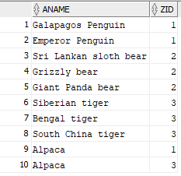

- Now repeat the previous query and make sure that the animals without an assigned handler also appear in the answer.
SELECT ANAME, ZID
FROM ANIMAL FULL OUTER JOIN HANDLES
ON AID = ANIMALID
FULL OUTER JOIN ZOOKEEPER
ON ZID = ZOOKEEPID;
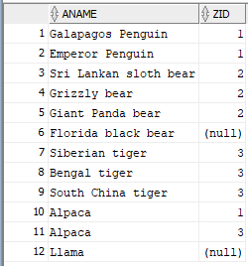

- Report, for every zoo keeper name, the average number of hours they spend feeding all animals in their care.
SELECT ZNAME,AVG(TIMETOFEED)
FROM ANIMAL INNER JOIN HANDLES
ON AID = ANIMALID
INNER JOIN ZOOKEEPER
ON ZID = ZOOKEEPID
GROUP BY ZNAME;
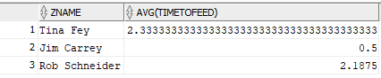

- Report every handling assignment (as a list of assignment date, zoo keeper name and animal name). Sort the result of the query by the assignment date in an ascending order.
SELECT ANAME,ZNAME,ASSIGNED
FROM ANIMAL INNER JOIN HANDLES
ON AID = ANIMALID
INNER JOIN ZOOKEEPER
ON ZID = ZOOKEEPID
ORDER BY ASSIGNED;
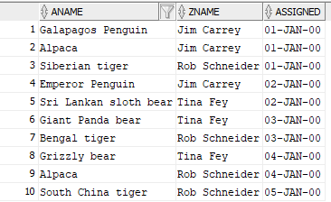
- Find the names of animals that have at least 1 zoo keeper assigned to them.
SELECT ANAME
FROM ANIMAL FULL OUTER JOIN HANDLES
ON AID = ANIMALID
FULL OUTER JOIN ZOOKEEPER
ON ZID = ZOOKEEPID
WHERE ZID IS NOT NULL
GROUP BY ANAME;
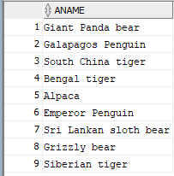

- Find the names of animals that have 0 or 1 (i.e., less than 2) zoo keepers assigned to them.
SELECT ANAME
FROM ANIMAL FULL OUTER JOIN HANDLES
ON AID = ANIMALID
FULL OUTER JOIN ZOOKEEPER
ON ZID = ZOOKEEPID
GROUP BY ANAME
HAVING COUNT(ZID) <2;
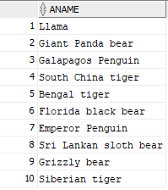

Part 2

- Write a python script that is going to read the queries that you have created in Part-1 from a SQL file, execute each SQL query against a SQLite database and print the output of that query (i.e., given a queries.sql, execute each query from that file automatically). You must read your SQL queries from a file, please do not copy SQL directly into the python code. The code that runs commands from the ZooDatabase.sql file is included with the homework (runSQL.py). All you have to do is to change it so that it reads your queries from a SQL file (that just means you need to rename the file) and also prints the output of your queries. You must print every row individually using a for-loop.
import sqlite3
from sqlite3 import OperationalError

conn = sqlite3.connect('csc455_HW3.db')
c = conn.cursor()

# Open and read the file as a single buffer
fd = open('C:\\Users\\shuya\\Downloads\\Depaul\\DSC450\\Lecture 6\\ZooDatabase.sql', 'r')
# Read as a single document (not individual lines)
sqlFile = fd.read()
fd.close()

# all SQL commands (split on ';' which separates them)
sqlCommands = sqlFile.split(';')

# Execute every command from the input file (separated by ";")
for command in sqlCommands:
# This will skip and report errors
# For example, if the tables do not yet exist, this will skip over
# the DROP TABLE commands
try:
a = c.execute(command)
print(a.fetchall())
except OperationalError as msg:
print ("Command skipped: ", msg)

c.close()
conn.commit()
conn.close()

- Create the table and use python to automate loading of the following file into SQLite:
http://rasinsrv07.cstcis.cti.depaul.edu/CSC455/Public_Chauffeurs_Short_hw3.csv
It contains comma-separated data, with two changes: NULL may now be represented by NULL string or an empty string (e.g., either ,NULL, or ,,) and some of the names have the following form “Last, First” instead of “First Last”, which is problematic because when you split the string on a comma, you end up with too many values to insert.

- Implement loading the data using .split() on comma, similarly to the previous homework and report any issues that you encountered.

- Once you do part-1, you can use csvreader to resolve the problem, like so:

import csv
fd = open('Public_Chauffeurs_Short_hw3.csv', 'r')
reader = csv.reader(fd)
for row in reader:
print(row)
fd.close()

import sqlite3

conn = sqlite3.connect('DSC450_hw3.db')
c = conn.cursor()

file = open('C:\\Users\\shuya\\Downloads\\Depaul\\DSC450\\Lecture 6\\Public_Chauffeurs_Short_hw3.csv','r')
contents = file.readlines()
file.close()

public = '''CREATE TABLE IF NOT EXISTS Public
(
LicenseNumber INTEGER,
Renewed VARCHAR2(10),
Status VARCHAR2(10),
StatusDate DATE,
DriverType VARCHAR2(20),
LicenseType VARCHAR2(20),
OriginalIssueDate DATE,
Name VARCHAR2(30),
Sex VARCHAR2(10),
ChauffeurCity VARCHAR2(20),
ChauffeurState VARCHAR2(5),
RecordNumber INTEGER,

CONSTRAINT Public_PK
PRIMARY KEY(LicenseNumber)
);'''

c.execute(public)

newdata=[]
for line in contents:
newline = line.strip()
commands = newline.split(',')
if (len(commands) > 12 ):
commands[7] = commands[8]+commands[7]
del commands[8]
newdata.append(commands)

for x in range(len(newdata)):
c.execute("INSERT OR IGNORE INTO public VALUES(?,?,?,?,?,?,?,?,?,?,?,?);",newdata[x]);

public_result= c.execute("SELECT * FROM public").fetchall()
print(public_result)

conn.commit()
conn.close

Part 3

Using the company.sql database (posted in with this assignment on D2L), write the following SQL queries.

1. Find the names of all employees who are directly supervised by 'Franklin T Wong' (your SQL query must use the name to match the name, not the SSN).
SELECT FNAME, MINIT,LNAME FROM EMPLOYEE
WHERE FNAME IN (SELECT FNAME FROM EMPLOYEE WHERE SUPER_SSN = 333445555);
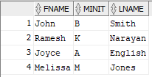

2. For each project, list the project name, project number, and the total hours per week (by all employees) spent on that project.
SELECT PNAME,PNUMBER, SUM(HOURS)
FROM PROJECT JOIN WORKS_ON
ON (PNO = PNUMBER)
GROUP BY PNAME, PNUMBER;
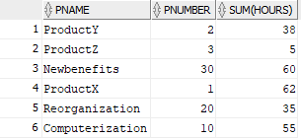

3. For each department, retrieve the department name and the average salary of all employees working in that department. Order the output by department number in ascending order.
SELECT DNAME, AVG(SALARY) FROM
(SELECT DNAME,SALARY
FROM EMPLOYEE JOIN DEPARTMENT
ON(DNO = DNUMBER)
ORDER BY DNUMBER)
GROUP BY DNAME;
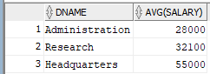

4. Retrieve the average salary of all female employees.
SELECT AVG(SALARY)
FROM EMPLOYEE
WHERE SEX IN ('F');
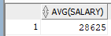

5. For each department whose average salary is greater than $42,000, retrieve the department name and the number of employees in that department.
SELECT DNAME, AVG(SALARY), COUNT(DNO) FROM EMPLOYEE JOIN DEPARTMENT
ON (DNO = DNUMBER)
GROUP BY DNAME
HAVING AVG(SALARY) > 42000;
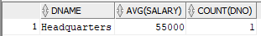

6. Retrieve the names of employees whose salary is within $25,000 of the salary of the employee who is paid the most in the company (e.g., if the highest salary in the company is $85,000, retrieve the names of all employees that make at least $60,000.).
SELECT FNAME, MINIT, LNAME
FROM EMPLOYEE
WHERE (SALARY >= (SELECT MAX(SALARY)FROM EMPLOYEE)-25000);
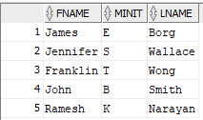

Be sure that your name and “Assignment 3” appear at the top of your submitted file.

