Hi!

I’ve been having problems with my jupyter notebook(4.2.0) plus the qt console(4.2.0) and I installed via installation using anaconda from this website https://www.continuum.io/downloads. I installed this one as shown on the photo inserted.
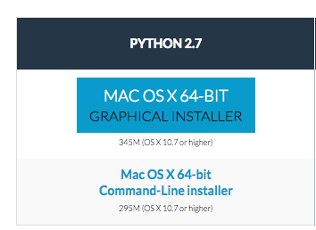

I’ll try giving all the details you need to clone my problem and hopefully help me fix it another way apart from the one I’ll point out in a branch I’ll add.

My laptop is a MacBook Pro (13-inch, Mid 2012), Processor 2.5 GHz Intel Core i5, Memory 4GB 1600 MHz DDR3, Graphics Intel HD Graphics 4000 1536 MB. Not sure what information to add but, I suppose that will suffice for now.

My Problem : The package in jupyter matplotlib and pandas works in terminal after changing the locale but not in jupyter. Here’s an example in the terminal version 2.6.1.

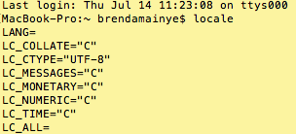
As you can see it’s not set correctly.
I add a quick fix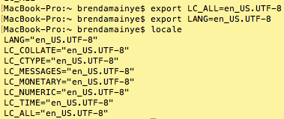

Then when I test these packages it works on the same shell

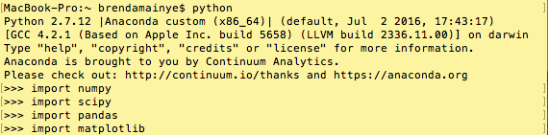

Without doing all that this is the error I get.

ValueError : unknown locale: UF-8 on my terminal if you import matplotlib/ pandas. Also here’s the problem stated in other words.

