Jupyter notebook and qt console
A few checks on the programs initially reported. After opening both jupyter and the qt console. Looking if the package works in either.

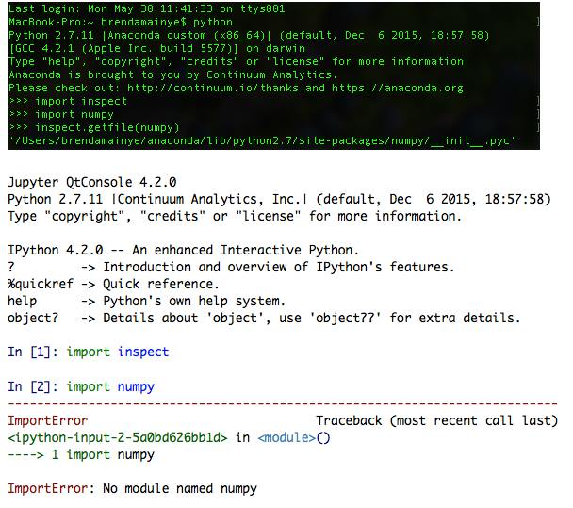

Using Import sys and sys.executable on jupyter and python
After executing the above commands in Python and jupyter notebook. Result.

Python
Result.
Sys.executable
'/Users/brendamainye/anaconda/bin/python'

sys.path

['', '/Users/brendamainye/anaconda/lib/python27.zip', '/Users/brendamainye/anaconda/lib/python2.7', '/Users/brendamainye/anaconda/lib/python2.7/plat-darwin', '/Users/brendamainye/anaconda/lib/python2.7/plat-mac', '/Users/brendamainye/anaconda/lib/python2.7/plat-mac/lib-scriptpackages', '/Users/brendamainye/anaconda/lib/python2.7/lib-tk', '/Users/brendamainye/anaconda/lib/python2.7/lib-old', '/Users/brendamainye/anaconda/lib/python2.7/lib-dynload', '/Users/brendamainye/anaconda/lib/python2.7/site-packages', '/Users/brendamainye/anaconda/lib/python2.7/site-packages/Sphinx-1.3.5-py2.7.egg', '/Users/brendamainye/anaconda/lib/python2.7/site-packages/aeosa', '/Users/brendamainye/anaconda/lib/python2.7/site-packages/setuptools-20.3-py2.7.egg']

On jupyter
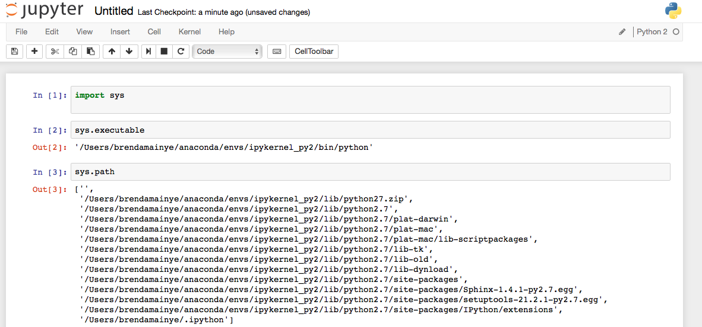

I ‘ll make a branch another day to show you my solution. I hope I’ve give enough information.

