1.

(a)

In this game, there are exactly two subgames. One is start from player 2’s node, and the other one is the whole game graph.

Using the ‘backward induction’ method, we can easily see that in subgame 1, player 2’s must always choose strategy a to maximize its payoff in this subgame, i.e., the payoff of choosing a is 5 which is far greater than choosing b with payoff -10.

Then, following ‘backward induction’, we substitute player 2’s node to a leaf node that with payoff (4,5). Then, we can find the SPNE of the game, that is player 1 plays B and player 2 plays a, i.e., (B,a)

|  |  |  |
| --- | --- | --- |
|  | a | b |
| A | (2,10) | (2,10) |
| B | (4,5) | (-10, -10) |

When we look back to the NE of this game, we can see that there are two NE in this game (A,b) and (B,a). Under both of these situations, neither player 1 nor player 2 can improve their payoff by unilaterally changing their strategy.

1. The first pure NE is (A,b). This is where player 1 plays A and player 2 plays b, we can see this a pure Nash equilibrium since neither player can deviate from there strategy to increase their payoff.
2. The first pure NE is (B,a). This is where player 1 plays B and player 2 plays a, we can see this a pure Nash equilibrium since neither player can deviate from there strategy to increase their payoff.

As a result, we can find out that (A, b) is NE but it is not SPNE, while (B,a) is NE and it is also SPNE.

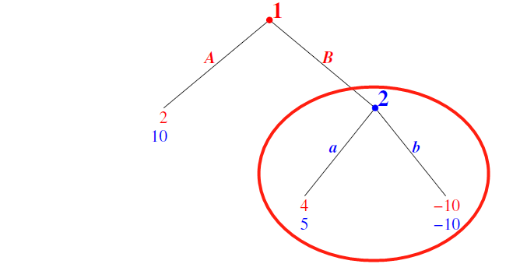

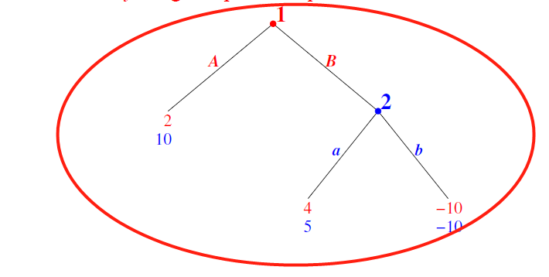

(b)

We could prove this by ‘back induction’.

Assume that there is a game tree T for a game,

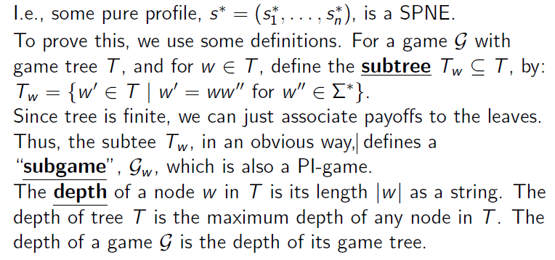

(c)

2.