1.

(a)

-(x^TAy)^T

(b)

Profile = (x\*,y\*), where

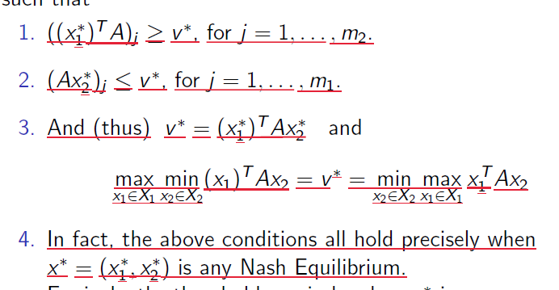

(c)

EE 1 P1: (1) 1/2 1/2 EP= 4 P2: (1) 2/3 1/3 0 EP= -4

(d)

Minimize 8y1+6y2+4y3

s.t.

2y1+y2+y3 >=5

3y1+y2+4y3>=3

Y1,y2>=0

(e)

2.