1.

(a)

EE 1 P1: (1) 0 0 1 EP= 7 P2: (1) 0 0 1 EP= 6

EE 2 P1: (2) 3/8 0 5/8 EP= 9/2 P2: (2) 1/2 0 1/2 EP= 9/2

EE 3 P1: (3) 1 0 0 EP= 6 P2: (3) 1 0 0 EP= 7

(b)

Min x1

s.t.

x1-2x3 >=16

x3 >=0

x1=16 x2=2 x3=0

v=16

(c)

2.

(a)

Max welfare /min NE welfare

(b)

(7+8)/(2+3) = 3

(c)

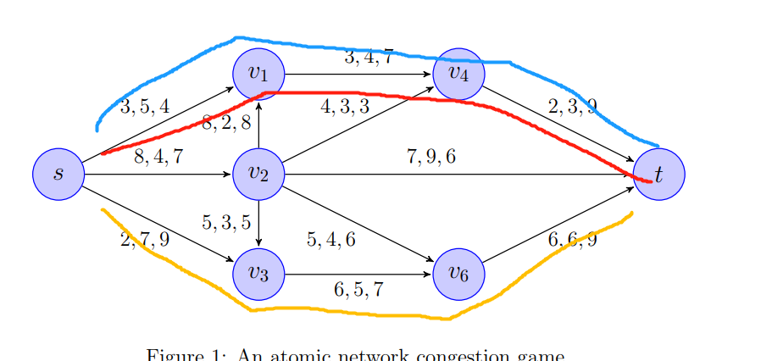

14 12 12

(d)

3

(a)