1.

EE 1 P1: (1) 1/4 0 3/4 EP= 8 P2: (1) 0 0 1 EP= 4

EE 2 P1: (2) 1 0 0 EP= 8 P2: (1) 0 0 1 EP= 7

2. r=4

3.

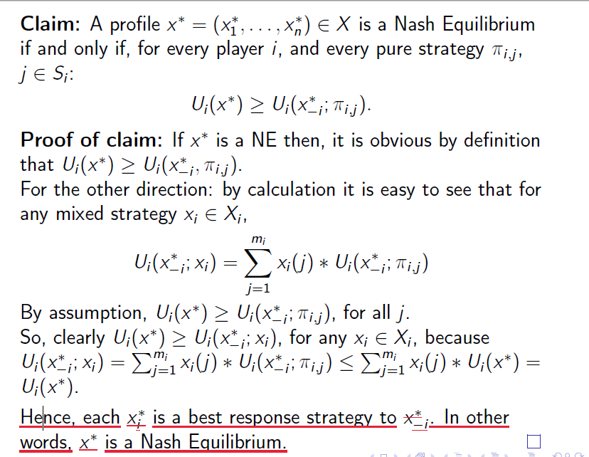

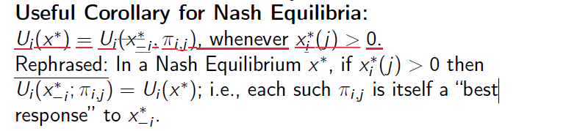

1.

(1)

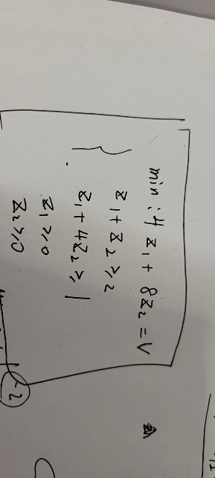

(2)

Z1=2, z2=0

2.

1.

[(p,1-p), (4/5, 1/5), (0,1)], [(1/2,1/2), (0,1)]

2.

A:1 B:2 C:0 payoff= 26

Payoff A = 24-16=8

Payoff B = 25-10 =15

Payoff C = 26 – 26 = 0

3.