Instruction for Running Motion/Force Control Simulation in RobotStudio

I Introduction

This file aims at providing step-by-step instructions for running the hybrid motion/force control simulation in RobotStudio. The software is self-contained that the entire simulation can be running on one Windows PC.

II. RobotStudio Preparation and Software Installation

1. Configure RobotStudio Station

Launch RobotStudio and create a new solution file

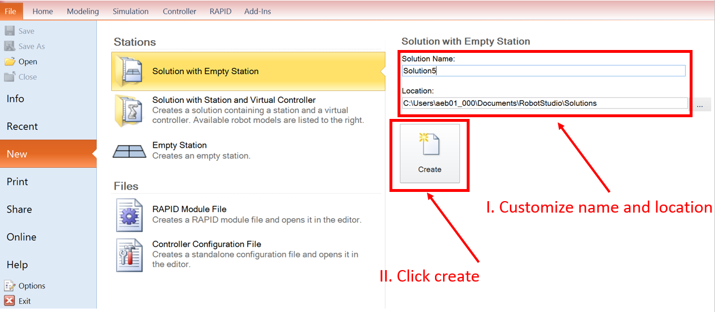

Import robot model

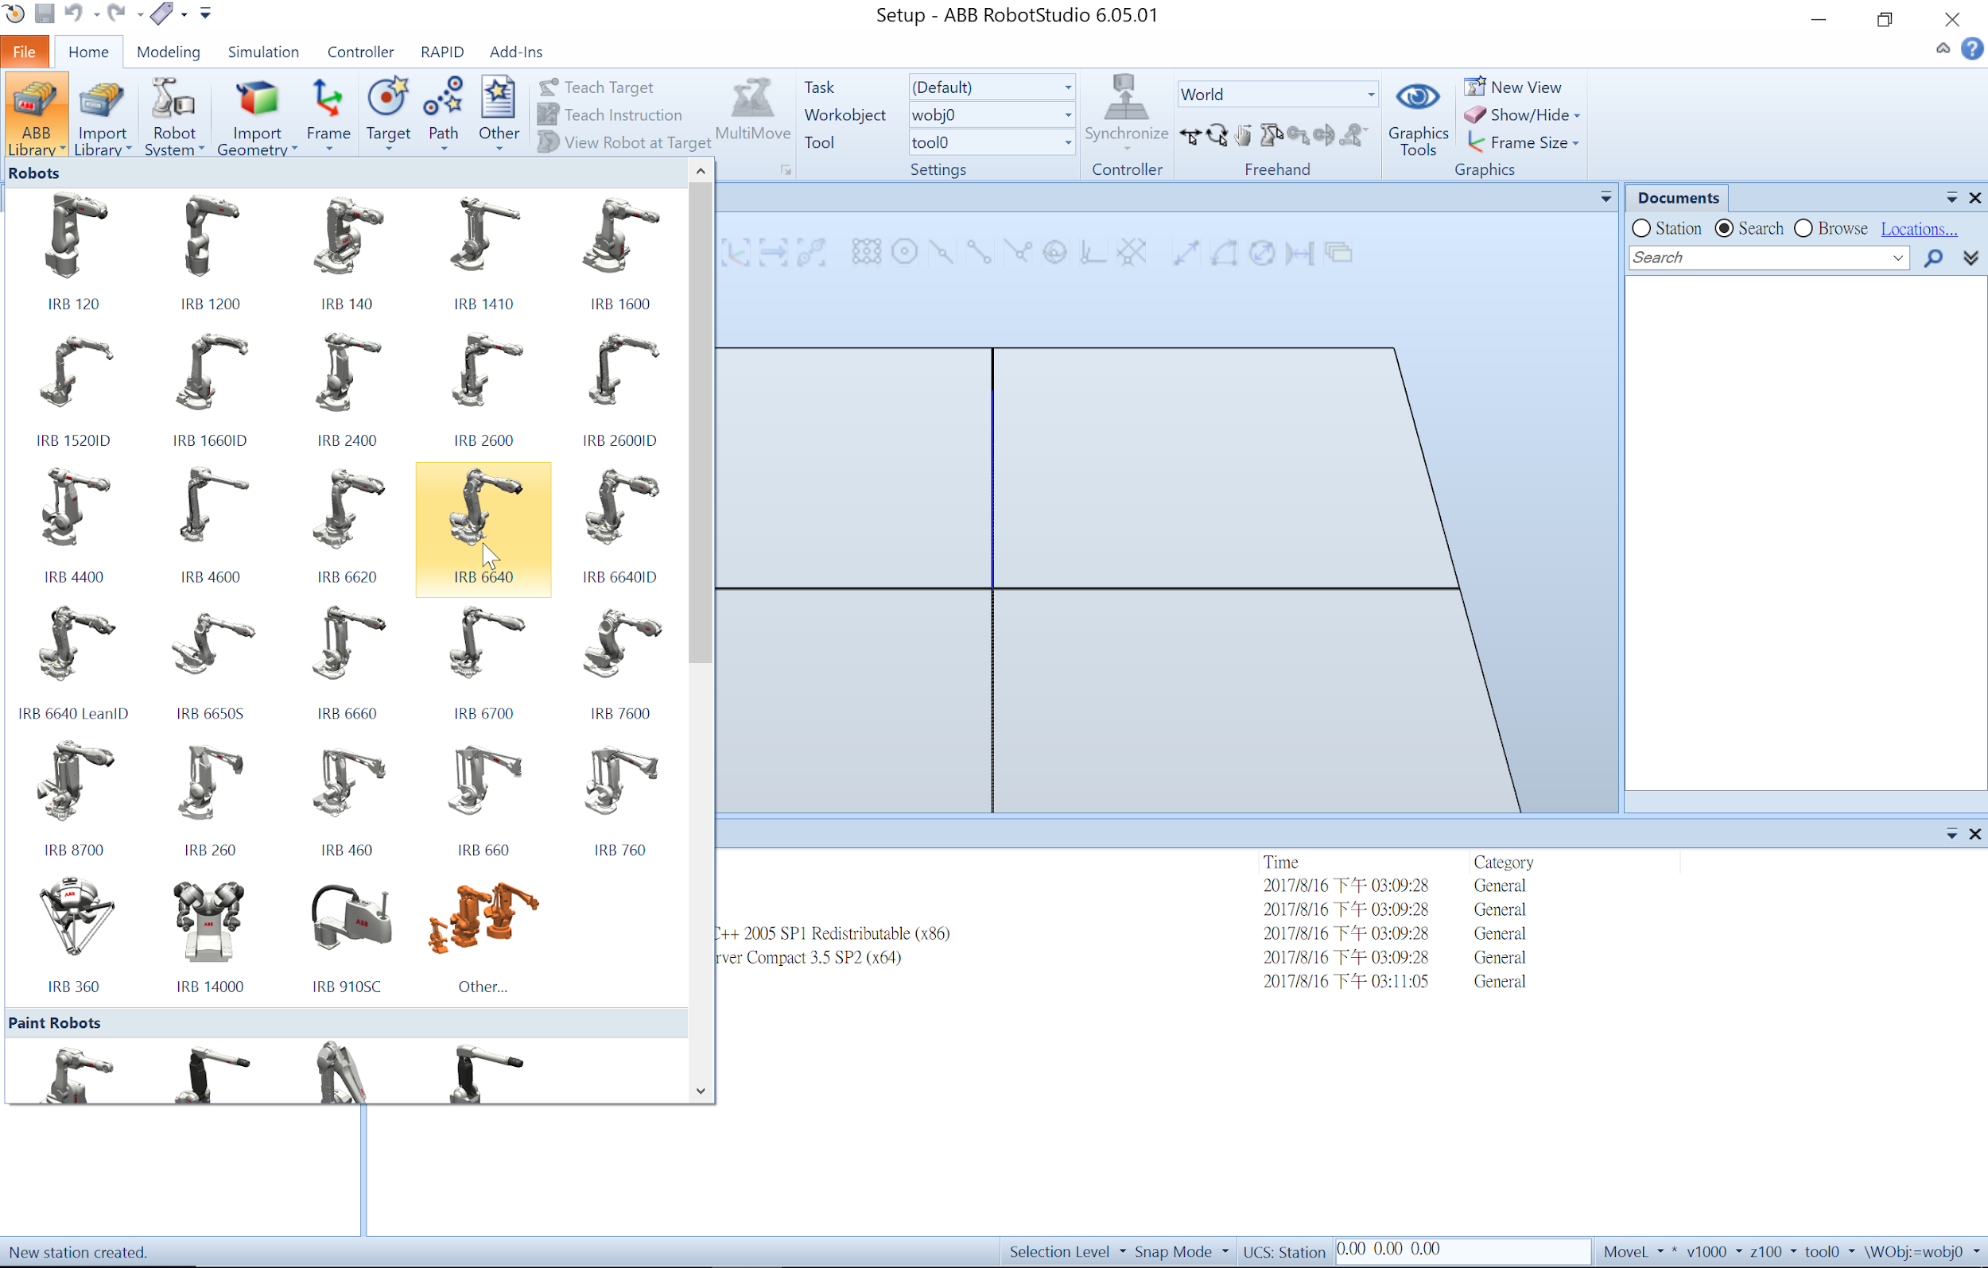

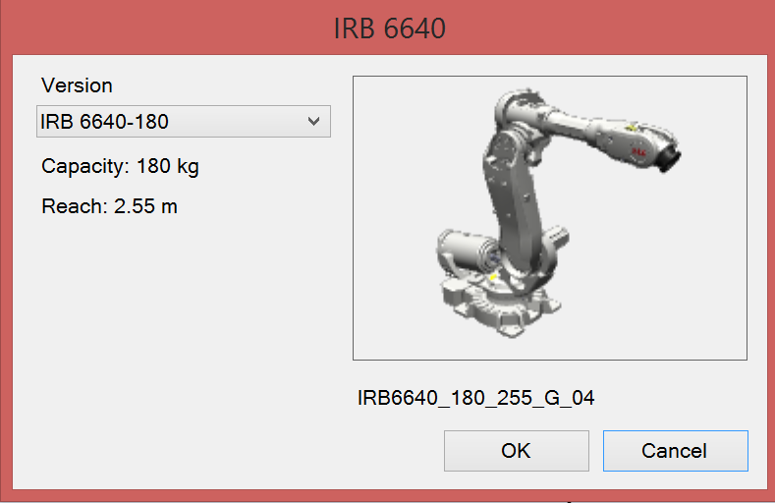

Import controller and add EGM

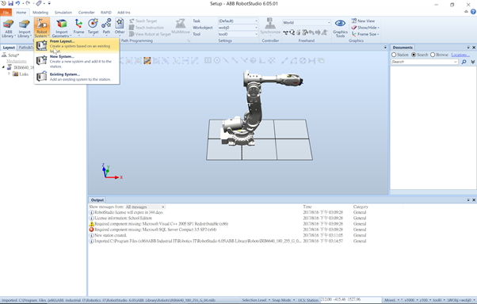

Customize your controller name and location, click next until you see the following window, and click options.

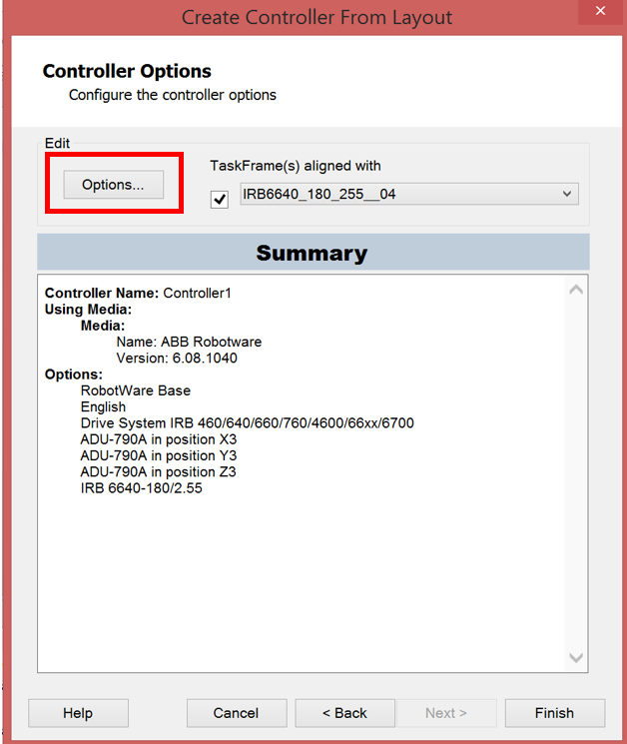

Type EGM in filter to search for EGM and add it

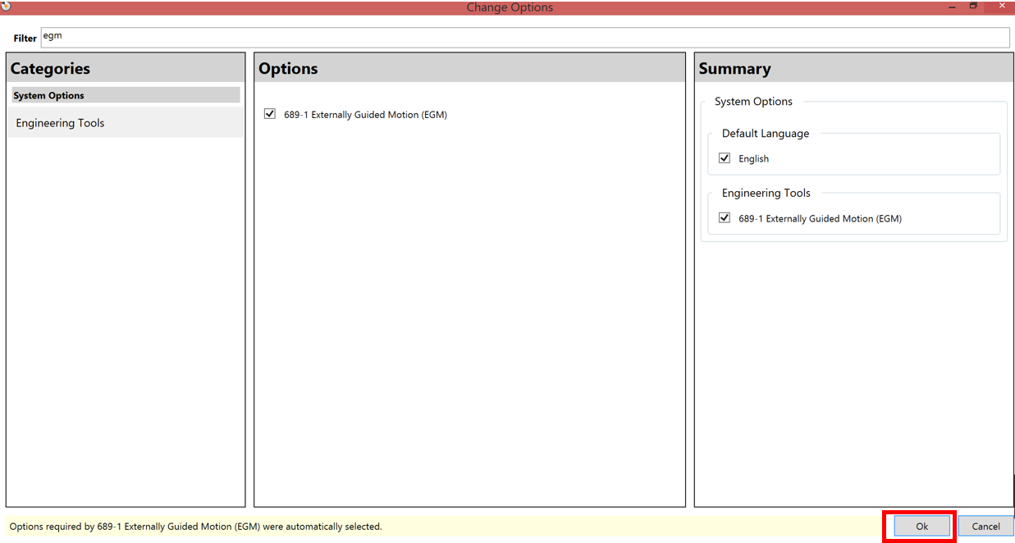

Then click Finish, the controller will restart

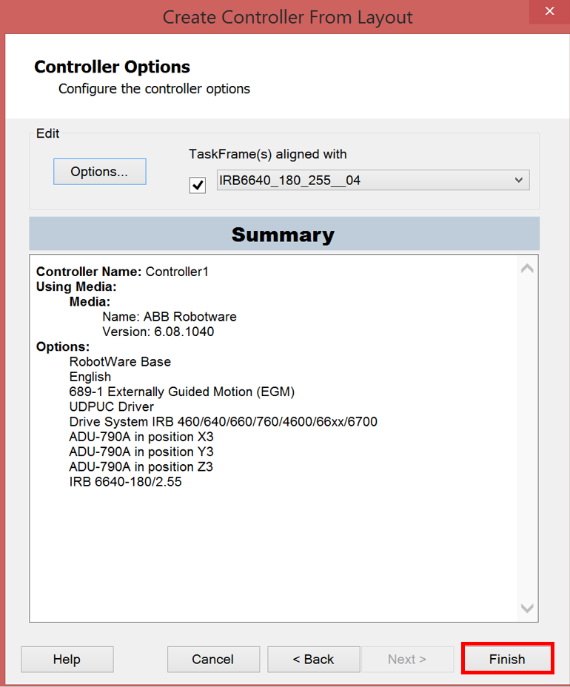

It will take a while, wait until the controller status bar turns into green.

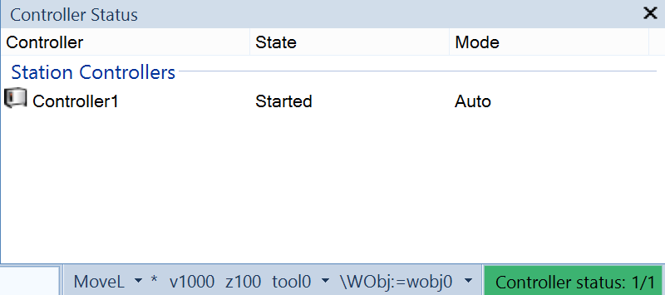

Go to “Rapid”, and double click “Module 1”.

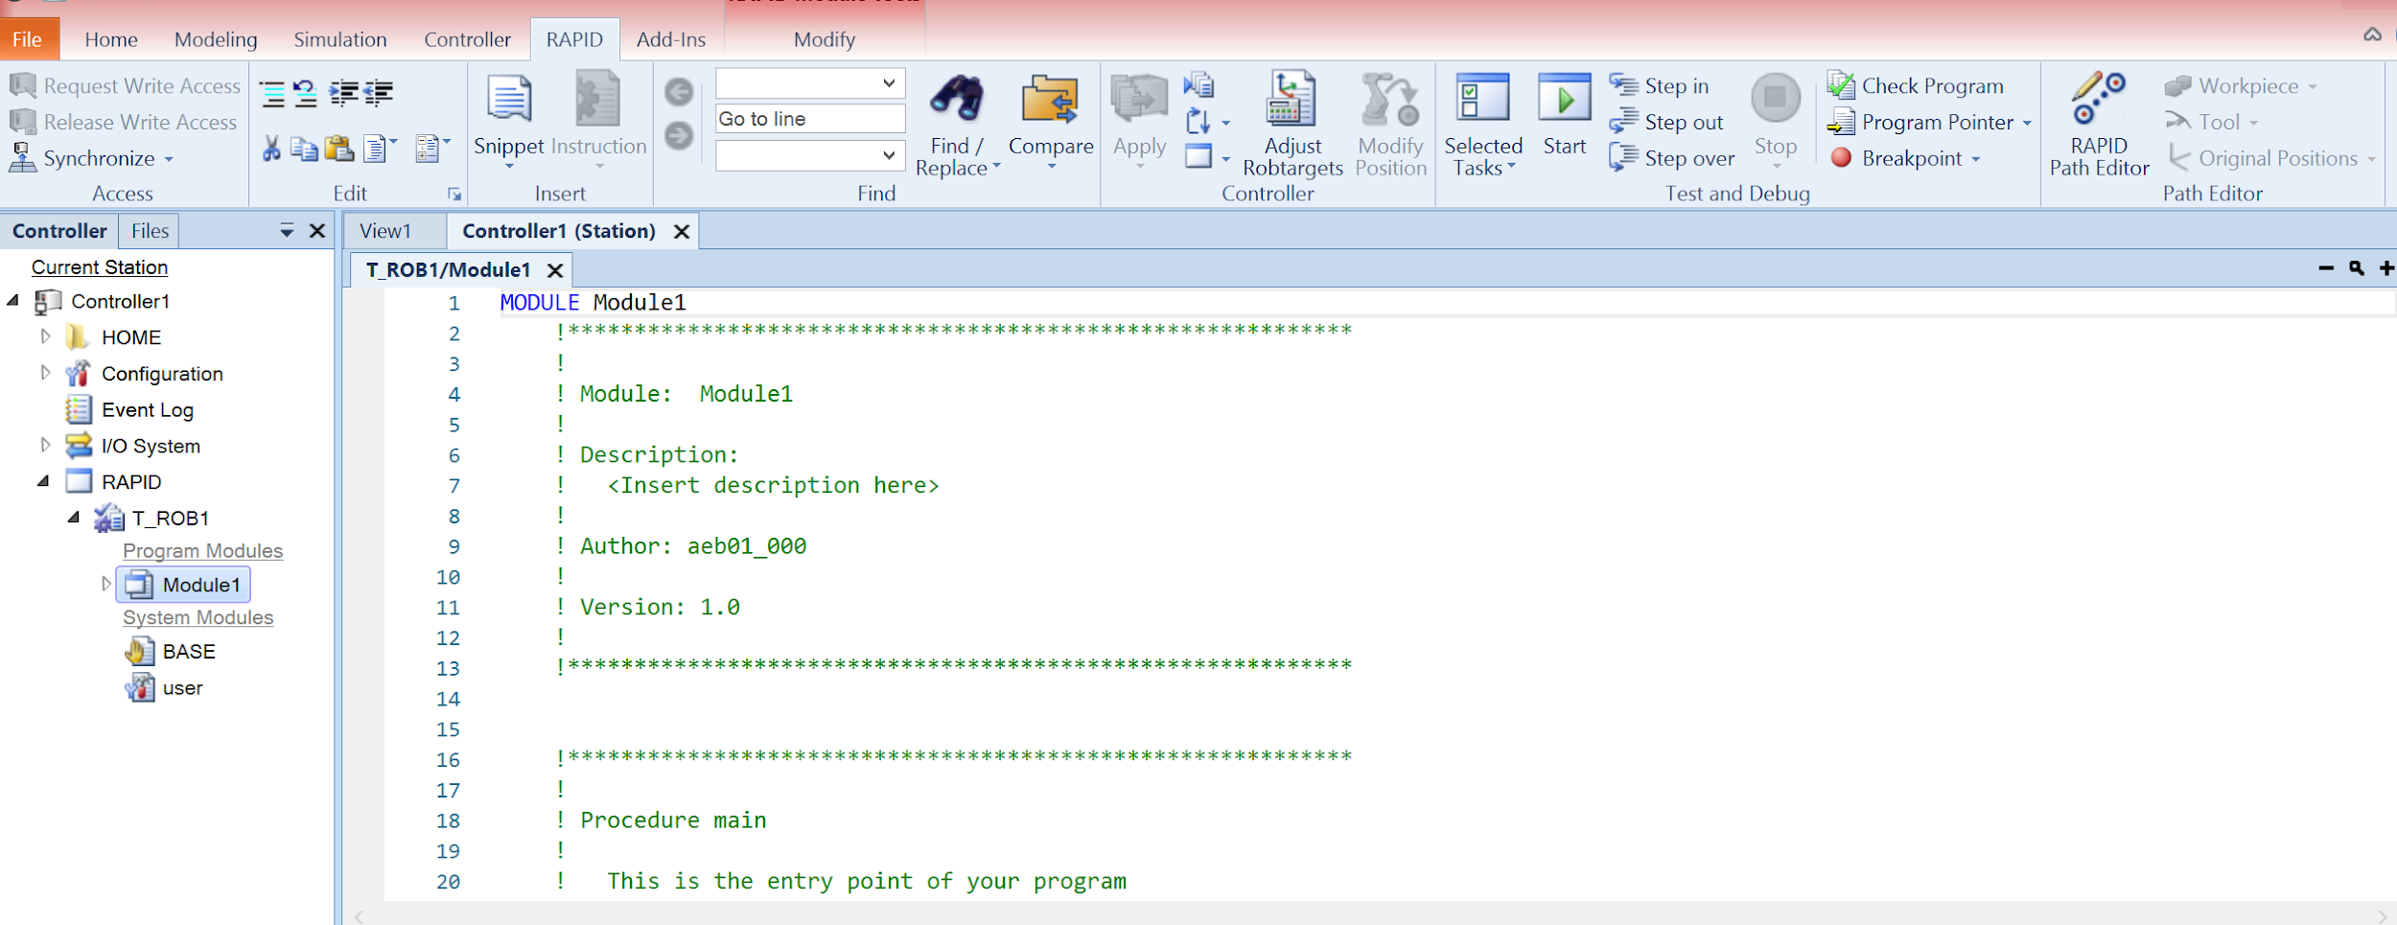

Copy and paste the code into the editor to replace the old one from here:

<https://github.com/ShuyoungChen/force_motion_control_simulation_RS/blob/master/EGM_test_UDP.mod>

Save the edit by “ctrl+shift+s”

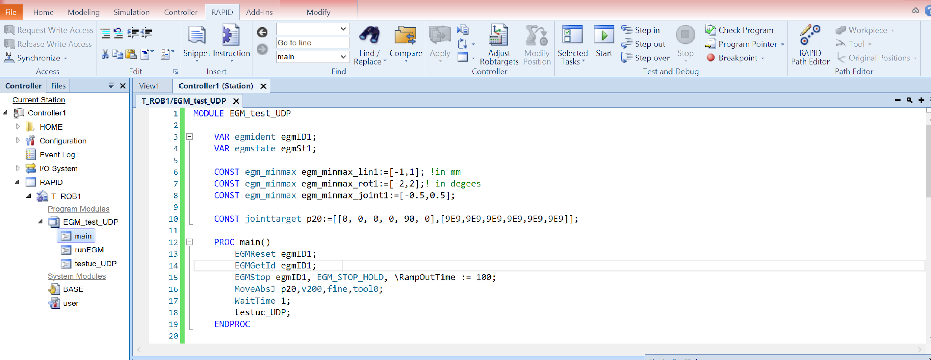

Set UDPUC interface for EGM

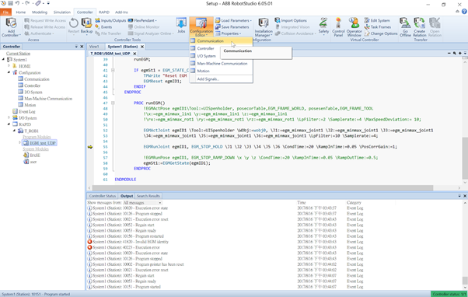

Go to “Transmission protocol” and double click the “UCdevice” protocol

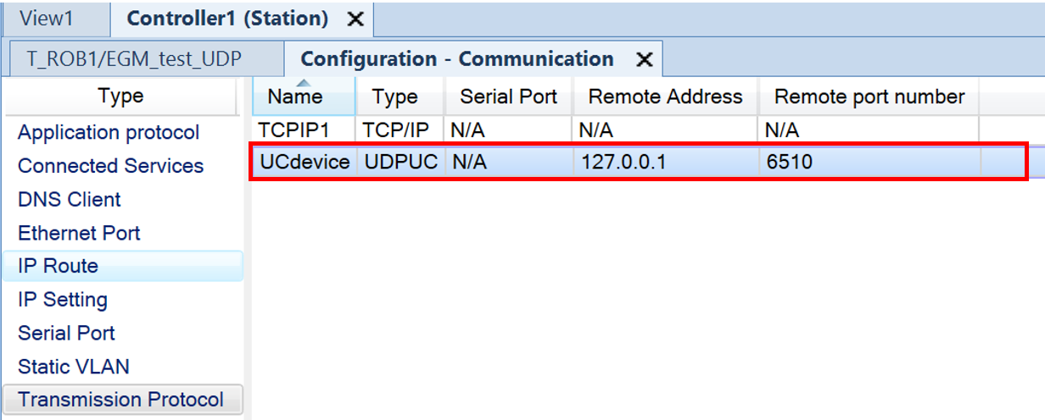

Note: If you only see one protocol “TCPIP1”, then right click in blank space and create a new transmission protocol

Edit the protocol as below:

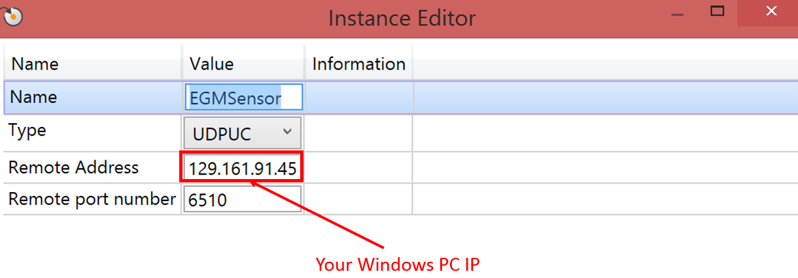

Restart the controller by “Controller -> Restart -> Restart (Warmstart)”

Click on the “Flex Pendant” under Controller to display the virtual pendant

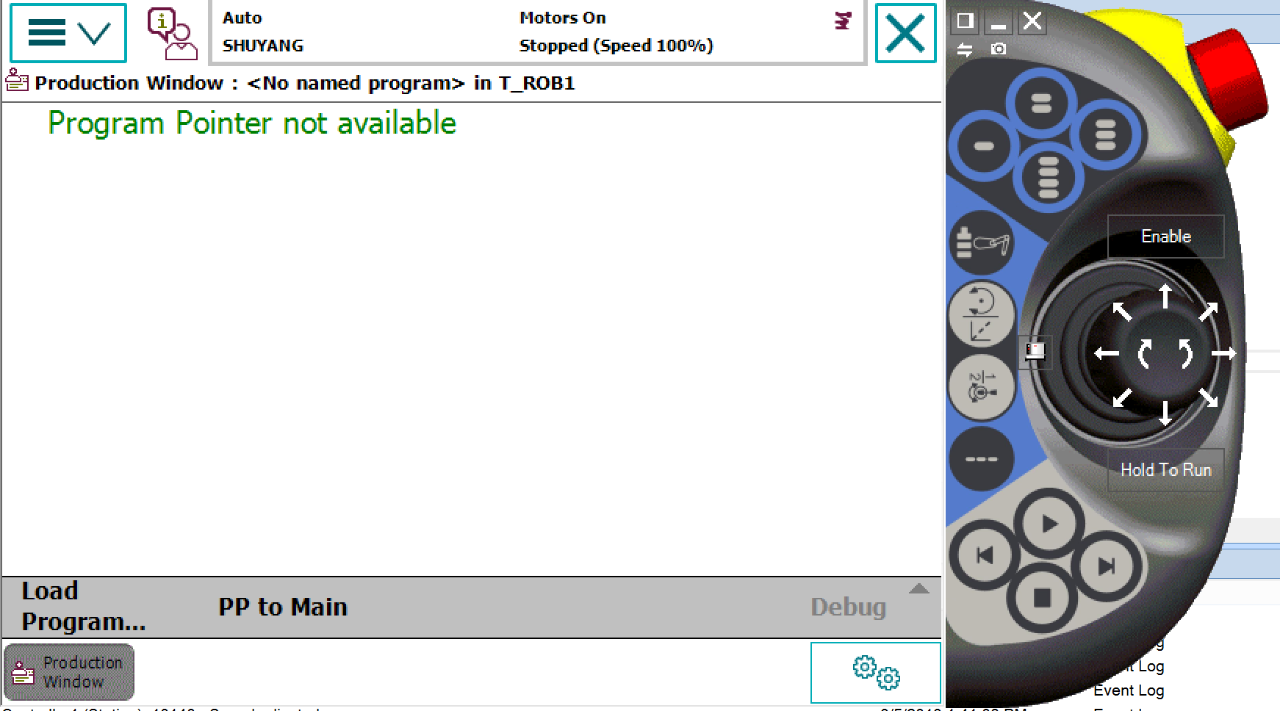

Click “PP to Main” to reset the program pointer to the main function

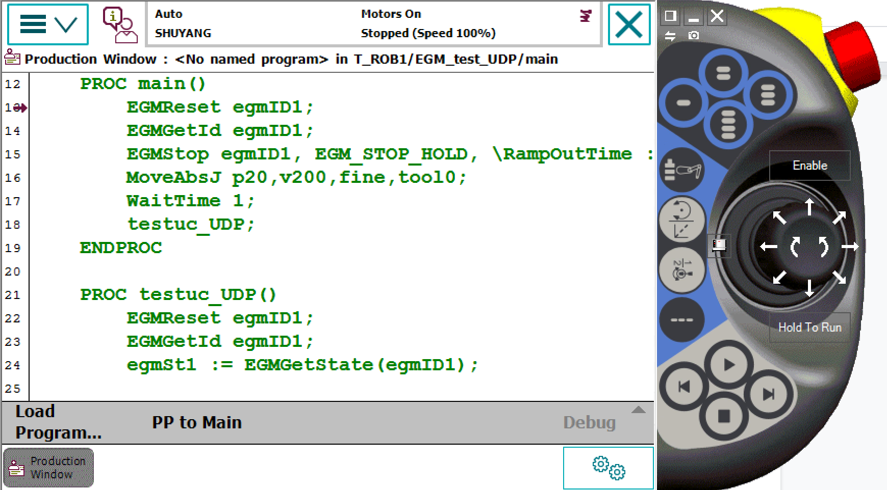

1. Install the Controller Software

Install necessary Python packages, including:

* numpy, quadprog,
* general_robotics_toolbox by RPI:

<https://github.com/rpiRobotics/rpi_general_robotics_toolbox_py>

* rpi_abb_irc5 by RPI:

<https://github.com/rpiRobotics/rpi_abb_irc5>

* Download the code “force_motion_control.py” and “QuadProg.py” here and put them into one directory.

<https://github.com/ShuyoungChen/force_motion_control_simulation_RS>

III. Run the Simulation

First run the python file in a command window by:

*python force_motion_control.py*

Then, click the start button on flex pendant to run the RAPID code in RobotStudio

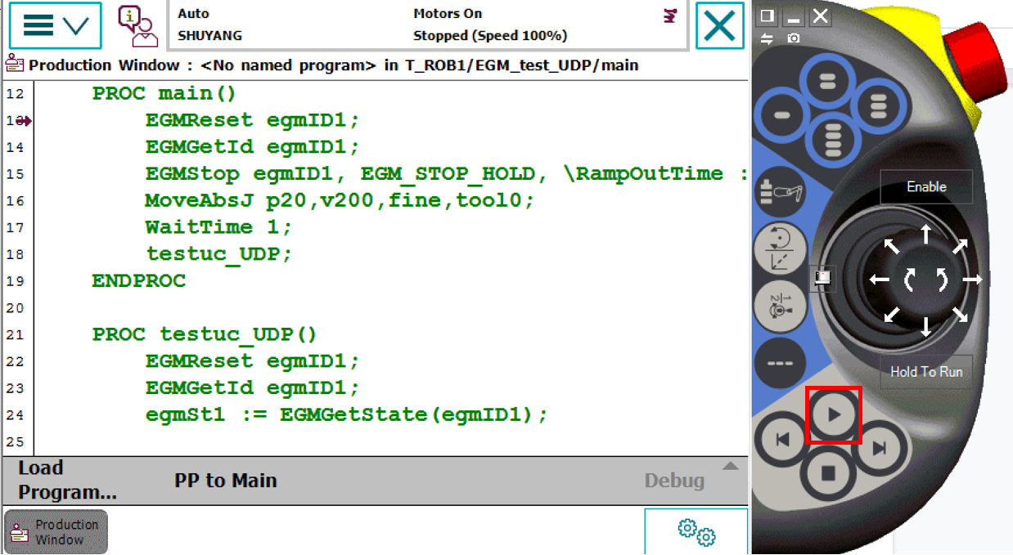

Note: before running each simulation, you must click “PP to Main” to reset the pointer

You can see the current contact force looping out in the command window where you run the python file:

