user_input = input("Should we print again?(y/n)")

"You know {}!".format(person)

@classmethod //当里面想创建的东西，与call起这个对象的class有关

def franchise(cls, store):

store1 = Store(store)

store1.name = store.name + " - franchise"

return store1

@staticmethod

def go_to_school():

return "I'm going to school"

class WorkingStudent(Student):

pass

def __init__(self,name,school,salary):

super().__init__(name,school)

self.salary = salary

*arg 可以放任何多的元素

**kwargs job_tiltle = "softwarte developer" keyword arguments

03 Your first REST API

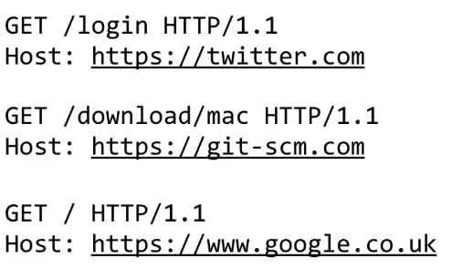

HTTP Verbs

GET Retrieve something Normally return a HTML

POST Receive data

PUT Make sure something is there

DELETE Remove something

REST API

Stateless