total_loss = clf_loss + alpha*adv_loss

training 1 epoch...

/opt/conda/lib/python3.7/site-packages/ipykernel_launcher.py:41: UserWarning: To copy construct from a tensor, it is recommended to use sourceTensor.clone().detach() or sourceTensor.clone().detach().requires_grad_(True), rather than torch.tensor(sourceTensor).

84.97944903373718 seconds used......

1 training finished! average train loss: 0.7093351151336703

total clf loss: 156.79904526472092 total adv loss: 98.58722227811813

evaluating...

Confusion matrix, without normalization

[[ 208 56 30]

[ 699 2990 132]

[ 46 12 784]]

Normalized confusion matrix

[[0.70748299 0.19047619 0.10204082]

[0.1829364 0.78251767 0.03454593]

[0.05463183 0.01425178 0.93111639]]

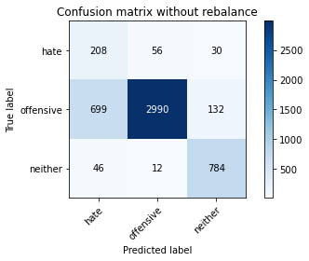

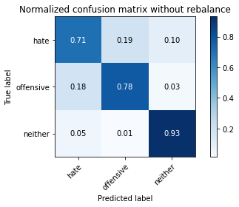

precision recall f1-score support

hate 0.22 0.71 0.33 294

offensive 0.98 0.78 0.87 3821

neither 0.83 0.93 0.88 842

accuracy 0.80 4957

macro avg 0.67 0.81 0.69 4957

weighted avg 0.91 0.80 0.84 4957

average eval_loss: 0.4655904023713936, accuracy: 0.8033084526931612

training 2 epoch...

/opt/conda/lib/python3.7/site-packages/ipykernel_launcher.py:41: UserWarning: To copy construct from a tensor, it is recommended to use sourceTensor.clone().detach() or sourceTensor.clone().detach().requires_grad_(True), rather than torch.tensor(sourceTensor).

84.17098808288574 seconds used......

2 training finished! average train loss: 0.4030952765688039

total clf loss: 88.6533532589674 total adv loss: 65.04739314084873

evaluating...

Confusion matrix, without normalization

[[ 216 47 31]

[ 673 2932 216]

[ 25 7 810]]

Normalized confusion matrix

[[0.73469388 0.15986395 0.10544218]

[0.1761319 0.76733839 0.0565297 ]

[0.02969121 0.00831354 0.96199525]]

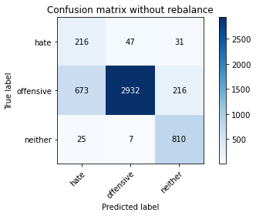

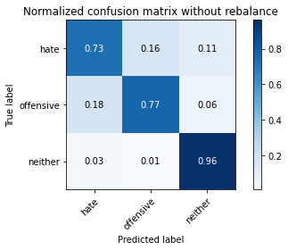

precision recall f1-score support

hate 0.24 0.73 0.36 294

offensive 0.98 0.77 0.86 3821

neither 0.77 0.96 0.85 842

accuracy 0.80 4957

macro avg 0.66 0.82 0.69 4957

weighted avg 0.90 0.80 0.83 4957

average eval_loss: 0.5338528092016446, accuracy: 0.7984668146056082

training 3 epoch...

/opt/conda/lib/python3.7/site-packages/ipykernel_launcher.py:41: UserWarning: To copy construct from a tensor, it is recommended to use sourceTensor.clone().detach() or sourceTensor.clone().detach().requires_grad_(True), rather than torch.tensor(sourceTensor).

84.05449986457825 seconds used......

3 training finished! average train loss: 0.2821865100086781

total clf loss: 61.76977461576462 total adv loss: 51.374993953853846

evaluating...

Confusion matrix, without normalization

[[ 252 27 15]

[1067 2645 109]

[ 65 11 766]]

Normalized confusion matrix

[[0.85714286 0.09183673 0.05102041]

[0.27924627 0.69222717 0.02852656]

[0.07719715 0.01306413 0.90973872]]

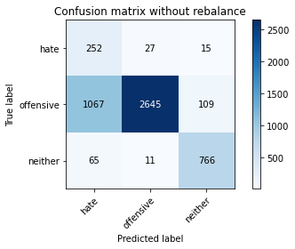

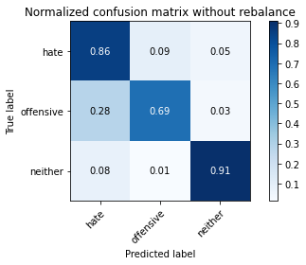

precision recall f1-score support

hate 0.18 0.86 0.30 294

offensive 0.99 0.69 0.81 3821

neither 0.86 0.91 0.88 842

accuracy 0.74 4957

macro avg 0.68 0.82 0.67 4957

weighted avg 0.92 0.74 0.80 4957

average eval_loss: 0.6320278630718544, accuracy: 0.7389550131127698

training 4 epoch...

/opt/conda/lib/python3.7/site-packages/ipykernel_launcher.py:41: UserWarning: To copy construct from a tensor, it is recommended to use sourceTensor.clone().detach() or sourceTensor.clone().detach().requires_grad_(True), rather than torch.tensor(sourceTensor).

84.19053435325623 seconds used......

4 training finished! average train loss: 0.1830824290753522

total clf loss: 39.934515736531466 total adv loss: 36.1655609337613

evaluating...

Confusion matrix, without normalization

[[ 248 32 14]

[1078 2643 100]

[ 58 19 765]]

Normalized confusion matrix

[[0.84353741 0.10884354 0.04761905]

[0.2821251 0.69170374 0.02617116]

[0.06888361 0.02256532 0.90855107]]

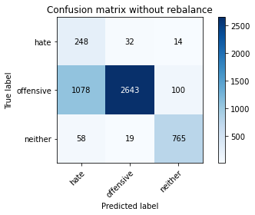

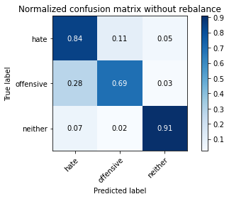

precision recall f1-score support

hate 0.18 0.84 0.30 294

offensive 0.98 0.69 0.81 3821

neither 0.87 0.91 0.89 842

accuracy 0.74 4957

macro avg 0.68 0.81 0.67 4957

weighted avg 0.91 0.74 0.79 4957

average eval_loss: 0.744134405633474, accuracy: 0.7375428686705668

training 5 epoch...

/opt/conda/lib/python3.7/site-packages/ipykernel_launcher.py:41: UserWarning: To copy construct from a tensor, it is recommended to use sourceTensor.clone().detach() or sourceTensor.clone().detach().requires_grad_(True), rather than torch.tensor(sourceTensor).

84.57017374038696 seconds used......

5 training finished! average train loss: 0.1016109019411695

total clf loss: 22.075138323940337 total adv loss: 21.842945777112618

evaluating...

Confusion matrix, without normalization

[[ 239 38 17]

[ 999 2711 111]

[ 76 14 752]]

Normalized confusion matrix

[[0.81292517 0.1292517 0.05782313]

[0.26144988 0.70950013 0.02904999]

[0.09026128 0.01662708 0.89311164]]

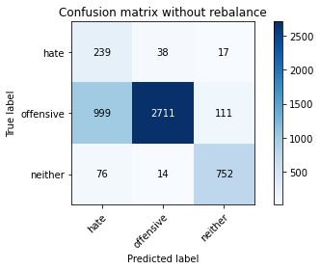

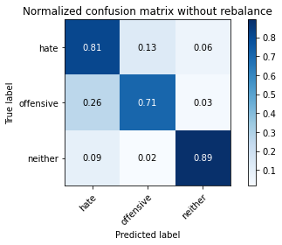

precision recall f1-score support

hate 0.18 0.81 0.30 294

offensive 0.98 0.71 0.82 3821

neither 0.85 0.89 0.87 842

accuracy 0.75 4957

macro avg 0.67 0.81 0.66 4957

weighted avg 0.91 0.75 0.80 4957

average eval_loss: 0.9575320316065001, accuracy: 0.7468226750050434

training 6 epoch...

/opt/conda/lib/python3.7/site-packages/ipykernel_launcher.py:41: UserWarning: To copy construct from a tensor, it is recommended to use sourceTensor.clone().detach() or sourceTensor.clone().detach().requires_grad_(True), rather than torch.tensor(sourceTensor).

84.35311484336853 seconds used......

6 training finished! average train loss: 0.07735325441912241

total clf loss: 16.744013105053455 total adv loss: 17.850580463535152

evaluating...

Confusion matrix, without normalization

[[ 222 53 19]

[ 708 2996 117]

[ 41 20 781]]

Normalized confusion matrix

[[0.75510204 0.18027211 0.06462585]

[0.18529181 0.78408794 0.03062026]

[0.04869359 0.02375297 0.92755344]]

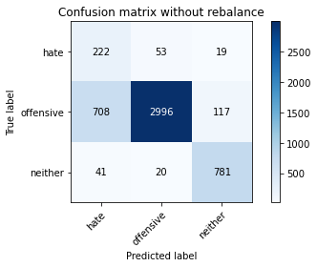

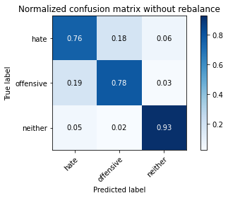

precision recall f1-score support

hate 0.23 0.76 0.35 294

offensive 0.98 0.78 0.87 3821

neither 0.85 0.93 0.89 842

accuracy 0.81 4957

macro avg 0.69 0.82 0.70 4957

weighted avg 0.91 0.81 0.84 4957

average eval_loss: 0.7209820098994902, accuracy: 0.8067379463385111

training 7 epoch...

/opt/conda/lib/python3.7/site-packages/ipykernel_launcher.py:41: UserWarning: To copy construct from a tensor, it is recommended to use sourceTensor.clone().detach() or sourceTensor.clone().detach().requires_grad_(True), rather than torch.tensor(sourceTensor).

84.5222806930542 seconds used......

7 training finished! average train loss: 0.04404679359970288

total clf loss: 9.517817229963839 total adv loss: 10.497034382198763

evaluating...

Confusion matrix, without normalization

[[ 228 44 22]

[ 822 2850 149]

[ 40 14 788]]

Normalized confusion matrix

[[0.7755102 0.14965986 0.07482993]

[0.21512693 0.74587804 0.03899503]

[0.04750594 0.01662708 0.93586698]]

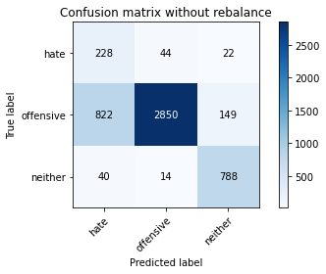

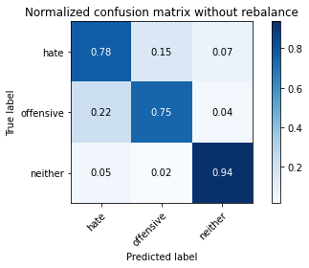

precision recall f1-score support

hate 0.21 0.78 0.33 294

offensive 0.98 0.75 0.85 3821

neither 0.82 0.94 0.88 842

accuracy 0.78 4957

macro avg 0.67 0.82 0.68 4957

weighted avg 0.91 0.78 0.82 4957

average eval_loss: 1.0448223260843992, accuracy: 0.7799072019366552

training 8 epoch...

/opt/conda/lib/python3.7/site-packages/ipykernel_launcher.py:41: UserWarning: To copy construct from a tensor, it is recommended to use sourceTensor.clone().detach() or sourceTensor.clone().detach().requires_grad_(True), rather than torch.tensor(sourceTensor).

84.22094058990479 seconds used......

8 training finished! average train loss: 0.04004217128487909

total clf loss: 8.686000589979813 total adv loss: 8.87228957323532

evaluating...

Confusion matrix, without normalization

[[ 211 61 22]

[ 857 2815 149]

[ 50 14 778]]

Normalized confusion matrix

[[0.71768707 0.20748299 0.07482993]

[0.22428684 0.73671814 0.03899503]

[0.05938242 0.01662708 0.9239905 ]]

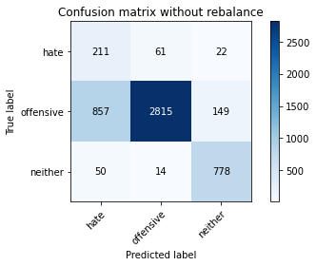

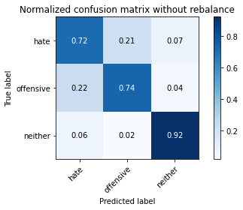

precision recall f1-score support

hate 0.19 0.72 0.30 294

offensive 0.97 0.74 0.84 3821

neither 0.82 0.92 0.87 842

accuracy 0.77 4957

macro avg 0.66 0.79 0.67 4957

weighted avg 0.90 0.77 0.81 4957

average eval_loss: 1.0963306647540405, accuracy: 0.7673996368771434

training 9 epoch...

/opt/conda/lib/python3.7/site-packages/ipykernel_launcher.py:41: UserWarning: To copy construct from a tensor, it is recommended to use sourceTensor.clone().detach() or sourceTensor.clone().detach().requires_grad_(True), rather than torch.tensor(sourceTensor).

84.27711296081543 seconds used......

9 training finished! average train loss: 0.03698449851914407

total clf loss: 8.05635074689053 total adv loss: 7.522298520359982

evaluating...

Confusion matrix, without normalization

[[ 203 73 18]

[ 551 3170 100]

[ 54 43 745]]

Normalized confusion matrix

[[0.69047619 0.24829932 0.06122449]

[0.14420309 0.82962575 0.02617116]

[0.06413302 0.05106888 0.8847981 ]]

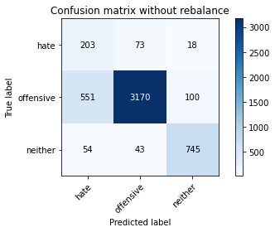

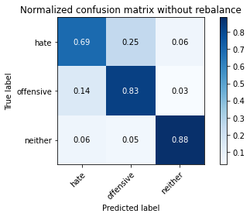

precision recall f1-score support

hate 0.25 0.69 0.37 294

offensive 0.96 0.83 0.89 3821

neither 0.86 0.88 0.87 842

accuracy 0.83 4957

macro avg 0.69 0.80 0.71 4957

weighted avg 0.91 0.83 0.86 4957

average eval_loss: 0.7528311553431585, accuracy: 0.8307444018559612

training 10 epoch...

/opt/conda/lib/python3.7/site-packages/ipykernel_launcher.py:41: UserWarning: To copy construct from a tensor, it is recommended to use sourceTensor.clone().detach() or sourceTensor.clone().detach().requires_grad_(True), rather than torch.tensor(sourceTensor).

84.21645259857178 seconds used......

10 training finished! average train loss: 0.02158712401292736

total clf loss: 4.690418175596278 total adv loss: 4.62892175369052

evaluating...

Confusion matrix, without normalization

[[ 219 50 25]

[ 649 2997 175]

[ 36 13 793]]

Normalized confusion matrix

[[0.74489796 0.17006803 0.08503401]

[0.16985082 0.78434965 0.04579953]

[0.04275534 0.01543943 0.94180523]]

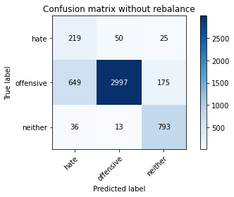

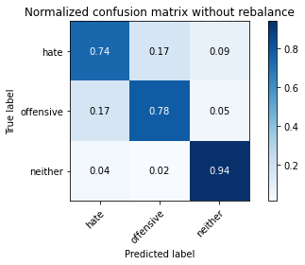

precision recall f1-score support

hate 0.24 0.74 0.37 294

offensive 0.98 0.78 0.87 3821

neither 0.80 0.94 0.86 842

accuracy 0.81 4957

macro avg 0.67 0.82 0.70 4957

weighted avg 0.90 0.81 0.84 4957

average eval_loss: 1.0117826755731887, accuracy: 0.8087552955416583