Confusion matrix, without normalization

[[1133 3 0]

[ 0 1135 1]

[ 0 0 1136]]

Normalized confusion matrix

[[9.97359155e-01 2.64084507e-03 0.00000000e+00]

[0.00000000e+00 9.99119718e-01 8.80281690e-04]

[0.00000000e+00 0.00000000e+00 1.00000000e+00]]

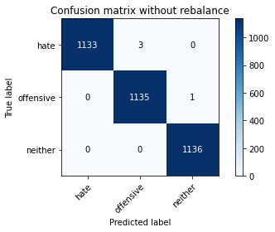

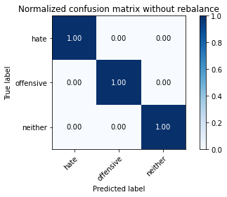

precision recall f1-score support

hate 1.00 1.00 1.00 1136

offensive 1.00 1.00 1.00 1136

neither 1.00 1.00 1.00 1136

accuracy 1.00 3408

macro avg 1.00 1.00 1.00 3408

weighted avg 1.00 1.00 1.00 3408

average eval_loss: 0.006183933831747262, accuracy: 0.9988262910798122