training 1 epoch...

29.180194854736328 seconds used......

1 training finished! average train loss: 0.6749150734721568

evaluating...

Confusion matrix, without normalization

[[ 209 42 43]

[ 730 2922 169]

[ 27 12 803]]

Normalized confusion matrix

[[0.71088435 0.14285714 0.1462585 ]

[0.19104946 0.76472128 0.04422926]

[0.03206651 0.01425178 0.95368171]]

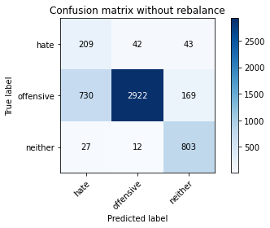

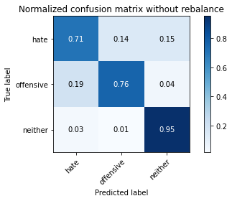

precision recall f1-score support

hate 0.22 0.71 0.33 294

offensive 0.98 0.76 0.86 3821

neither 0.79 0.95 0.86 842

accuracy 0.79 4957

macro avg 0.66 0.81 0.69 4957

weighted avg 0.90 0.79 0.83 4957

average eval_loss: 0.5072166173748912, accuracy: 0.7936251765180553

training 2 epoch...

28.288172721862793 seconds used......

2 training finished! average train loss: 0.3840296327283508

evaluating...

Confusion matrix, without normalization

[[ 215 45 34]

[ 713 2922 186]

[ 27 8 807]]

Normalized confusion matrix

[[0.73129252 0.15306122 0.11564626]

[0.18660037 0.76472128 0.04867836]

[0.03206651 0.00950119 0.9584323 ]]

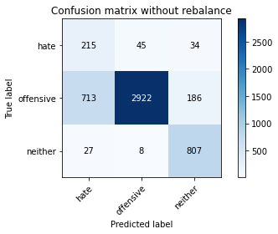

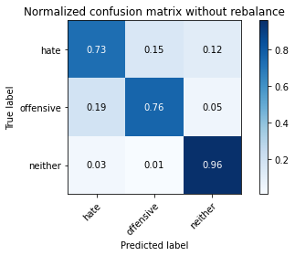

precision recall f1-score support

hate 0.23 0.73 0.34 294

offensive 0.98 0.76 0.86 3821

neither 0.79 0.96 0.86 842

accuracy 0.80 4957

macro avg 0.66 0.82 0.69 4957

weighted avg 0.90 0.80 0.83 4957

average eval_loss: 0.5276163774091871, accuracy: 0.7956425257212023

training 3 epoch...

28.31065821647644 seconds used......

3 training finished! average train loss: 0.2665021074881331

evaluating...

Confusion matrix, without normalization

[[ 246 38 10]

[ 973 2786 62]

[ 122 19 701]]

Normalized confusion matrix

[[0.83673469 0.1292517 0.03401361]

[0.25464538 0.7291285 0.01622612]

[0.14489311 0.02256532 0.83254157]]

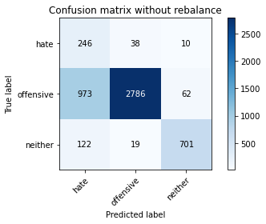

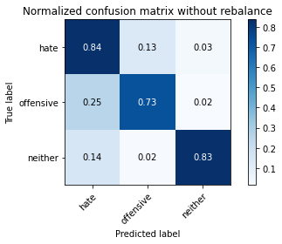

precision recall f1-score support

hate 0.18 0.84 0.30 294

offensive 0.98 0.73 0.84 3821

neither 0.91 0.83 0.87 842

accuracy 0.75 4957

macro avg 0.69 0.80 0.67 4957

weighted avg 0.92 0.75 0.81 4957

average eval_loss: 0.5792847817403174, accuracy: 0.7530764575347992

training 4 epoch...

28.207947254180908 seconds used......

4 training finished! average train loss: 0.16538574069476963

evaluating...

Confusion matrix, without normalization

[[ 235 41 18]

[ 925 2798 98]

[ 47 30 765]]

Normalized confusion matrix

[[0.79931973 0.13945578 0.06122449]

[0.24208322 0.73226904 0.02564774]

[0.05581948 0.03562945 0.90855107]]

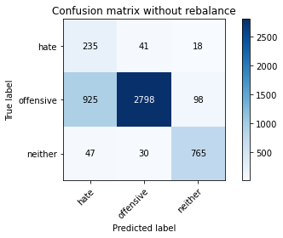

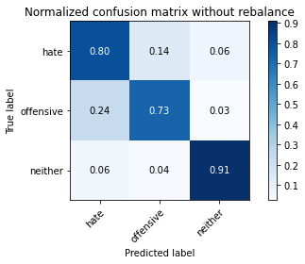

precision recall f1-score support

hate 0.19 0.80 0.31 294

offensive 0.98 0.73 0.84 3821

neither 0.87 0.91 0.89 842

accuracy 0.77 4957

macro avg 0.68 0.81 0.68 4957

weighted avg 0.91 0.77 0.81 4957

average eval_loss: 0.6216020511102772, accuracy: 0.7661892273552552

training 5 epoch...

28.279043912887573 seconds used......

5 training finished! average train loss: 0.08326778618607954

evaluating...

Confusion matrix, without normalization

[[ 198 73 23]

[ 571 3144 106]

[ 32 33 777]]

Normalized confusion matrix

[[0.67346939 0.24829932 0.07823129]

[0.14943732 0.82282125 0.02774143]

[0.03800475 0.0391924 0.92280285]]

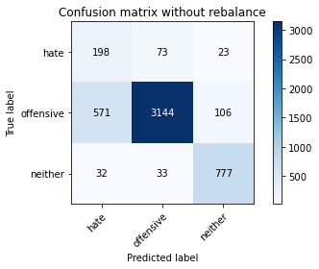

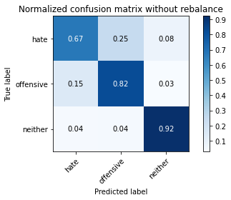

precision recall f1-score support

hate 0.25 0.67 0.36 294

offensive 0.97 0.82 0.89 3821

neither 0.86 0.92 0.89 842

accuracy 0.83 4957

macro avg 0.69 0.81 0.71 4957

weighted avg 0.91 0.83 0.86 4957

average eval_loss: 0.5794261475619409, accuracy: 0.8309461367762759

training 6 epoch...

28.19892978668213 seconds used......

6 training finished! average train loss: 0.04248453099661839

evaluating...

Confusion matrix, without normalization

[[ 213 59 22]

[ 709 2980 132]

[ 37 20 785]]

Normalized confusion matrix

[[0.7244898 0.20068027 0.07482993]

[0.18555352 0.77990055 0.03454593]

[0.04394299 0.02375297 0.93230404]]

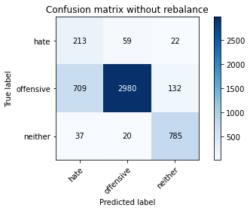

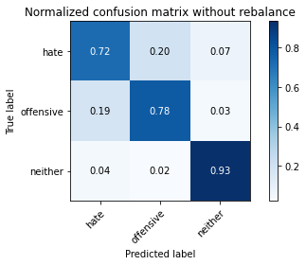

precision recall f1-score support

hate 0.22 0.72 0.34 294

offensive 0.97 0.78 0.87 3821

neither 0.84 0.93 0.88 842

accuracy 0.80 4957

macro avg 0.68 0.81 0.70 4957

weighted avg 0.91 0.80 0.84 4957

average eval_loss: 0.8494760476075293, accuracy: 0.8025015130119023

training 7 epoch...

28.142491102218628 seconds used......

7 training finished! average train loss: 0.028062706083407878

evaluating...

Confusion matrix, without normalization

[[ 224 53 17]

[ 792 2909 120]

[ 55 22 765]]

Normalized confusion matrix

[[0.76190476 0.18027211 0.05782313]

[0.20727558 0.76131903 0.03140539]

[0.06532067 0.02612827 0.90855107]]

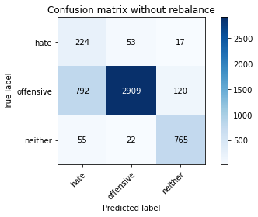

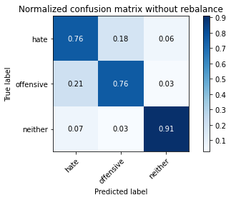

precision recall f1-score support

hate 0.21 0.76 0.33 294

offensive 0.97 0.76 0.85 3821

neither 0.85 0.91 0.88 842

accuracy 0.79 4957

macro avg 0.68 0.81 0.69 4957

weighted avg 0.91 0.79 0.83 4957

average eval_loss: 0.9852210967820288, accuracy: 0.7863627193867259

training 8 epoch...

28.16436529159546 seconds used......

8 training finished! average train loss: 0.012062644503250914

evaluating...

Confusion matrix, without normalization

[[ 211 63 20]

[ 665 3004 152]

[ 36 15 791]]

Normalized confusion matrix

[[0.71768707 0.21428571 0.06802721]

[0.17403821 0.78618163 0.03978016]

[0.04275534 0.01781473 0.93942993]]

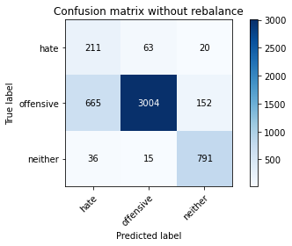

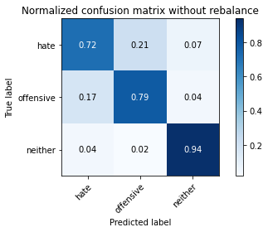

precision recall f1-score support

hate 0.23 0.72 0.35 294

offensive 0.97 0.79 0.87 3821

neither 0.82 0.94 0.88 842

accuracy 0.81 4957

macro avg 0.68 0.81 0.70 4957

weighted avg 0.90 0.81 0.84 4957

average eval_loss: 0.9705155540878261, accuracy: 0.8081500907807141

training 9 epoch...

28.337580680847168 seconds used......

9 training finished! average train loss: 0.02346188338471397

evaluating...

Confusion matrix, without normalization

[[ 208 67 19]

[ 628 3110 83]

[ 46 58 738]]

Normalized confusion matrix

[[0.70748299 0.22789116 0.06462585]

[0.16435488 0.81392306 0.02172206]

[0.05463183 0.06888361 0.87648456]]

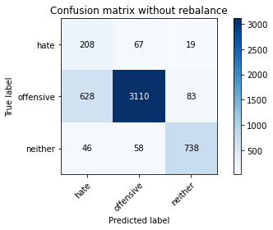

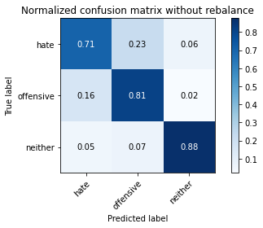

precision recall f1-score support

hate 0.24 0.71 0.35 294

offensive 0.96 0.81 0.88 3821

neither 0.88 0.88 0.88 842

accuracy 0.82 4957

macro avg 0.69 0.80 0.70 4957

weighted avg 0.90 0.82 0.85 4957

average eval_loss: 0.8115036279909433, accuracy: 0.8182368367964494

training 10 epoch...

28.19379687309265 seconds used......

10 training finished! average train loss: 0.023281070781593912

evaluating...

Confusion matrix, without normalization

[[ 226 54 14]

[ 803 2901 117]

[ 59 27 756]]

Normalized confusion matrix

[[0.76870748 0.18367347 0.04761905]

[0.21015441 0.75922533 0.03062026]

[0.07007126 0.03206651 0.89786223]]

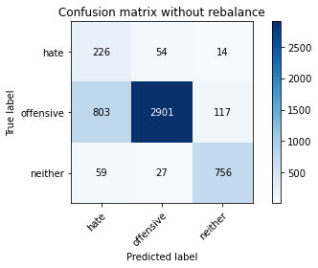

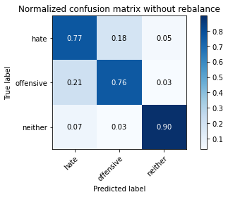

precision recall f1-score support

hate 0.21 0.77 0.33 294

offensive 0.97 0.76 0.85 3821

neither 0.85 0.90 0.87 842

accuracy 0.78 4957

macro avg 0.68 0.81 0.68 4957

weighted avg 0.91 0.78 0.83 4957

average eval_loss: 0.9709390690475102, accuracy: 0.7833366955820052