1 run

[1, 0.5, 1]

training 1 epoch...

28.57789397239685 seconds used......

1 training finished! average train loss: 0.6305097630410864

evaluating...

Confusion matrix, without normalization

[[ 235 25 34]

[1591 2060 170]

[ 32 9 801]]

Normalized confusion matrix

[[0.79931973 0.08503401 0.11564626]

[0.41638315 0.53912588 0.04449097]

[0.03800475 0.01068884 0.95130641]]

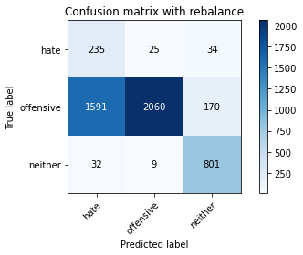

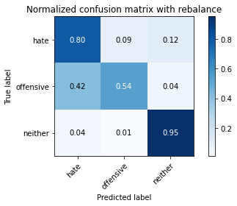

precision recall f1-score support

hate 0.13 0.80 0.22 294

offensive 0.98 0.54 0.70 3821

neither 0.80 0.95 0.87 842

accuracy 0.62 4957

macro avg 0.64 0.76 0.59 4957

weighted avg 0.90 0.62 0.70 4957

average eval_loss: 0.7568732079479003, accuracy: 0.6245713132943312

training 2 epoch...

27.625807762145996 seconds used......

2 training finished! average train loss: 0.36119948880888564

evaluating...

Confusion matrix, without normalization

[[ 247 31 16]

[ 964 2741 116]

[ 53 11 778]]

Normalized confusion matrix

[[0.84013605 0.10544218 0.05442177]

[0.25228998 0.71735148 0.03035854]

[0.06294537 0.01306413 0.9239905 ]]

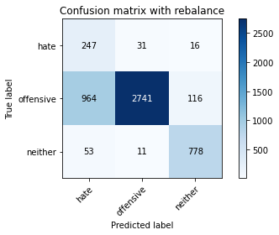

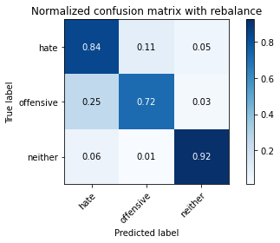

precision recall f1-score support

hate 0.20 0.84 0.32 294

offensive 0.98 0.72 0.83 3821

neither 0.85 0.92 0.89 842

accuracy 0.76 4957

macro avg 0.68 0.83 0.68 4957

weighted avg 0.92 0.76 0.81 4957

average eval_loss: 0.5609637860268835, accuracy: 0.7597337099051846

training 3 epoch...

27.704034328460693 seconds used......

3 training finished! average train loss: 0.2355594028070656

evaluating...

Confusion matrix, without normalization

[[ 259 23 12]

[1536 2196 89]

[ 101 8 733]]

Normalized confusion matrix

[[0.88095238 0.07823129 0.04081633]

[0.40198901 0.57471866 0.02329233]

[0.11995249 0.00950119 0.87054632]]

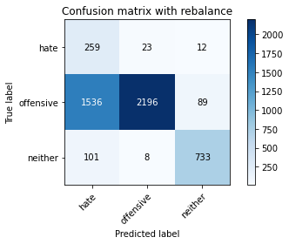

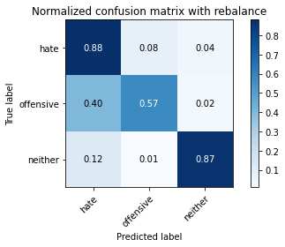

precision recall f1-score support

hate 0.14 0.88 0.24 294

offensive 0.99 0.57 0.73 3821

neither 0.88 0.87 0.87 842

accuracy 0.64 4957

macro avg 0.67 0.78 0.61 4957

weighted avg 0.92 0.64 0.72 4957

average eval_loss: 0.8952409672520815, accuracy: 0.6431309259632843

training 4 epoch...

27.693385362625122 seconds used......

4 training finished! average train loss: 0.14491839130675932

evaluating...

Confusion matrix, without normalization

[[ 240 39 15]

[ 892 2817 112]

[ 57 14 771]]

Normalized confusion matrix

[[0.81632653 0.13265306 0.05102041]

[0.23344674 0.73724156 0.0293117 ]

[0.06769596 0.01662708 0.91567696]]

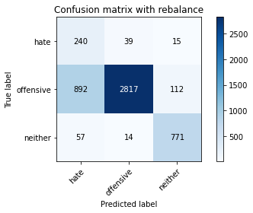

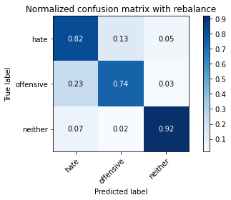

precision recall f1-score support

hate 0.20 0.82 0.32 294

offensive 0.98 0.74 0.84 3821

neither 0.86 0.92 0.89 842

accuracy 0.77 4957

macro avg 0.68 0.82 0.68 4957

weighted avg 0.91 0.77 0.82 4957

average eval_loss: 0.5965798757519694, accuracy: 0.7722412749646964

training 5 epoch...

27.70378065109253 seconds used......

5 training finished! average train loss: 0.08668097428846777

evaluating...

Confusion matrix, without normalization

[[ 247 35 12]

[1279 2467 75]

[ 88 29 725]]

Normalized confusion matrix

[[0.84013605 0.11904762 0.04081633]

[0.33472913 0.6456425 0.01962837]

[0.10451306 0.03444181 0.86104513]]

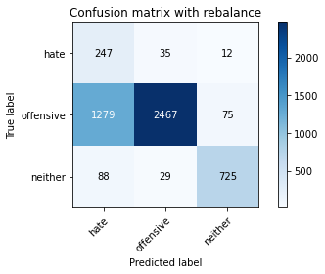

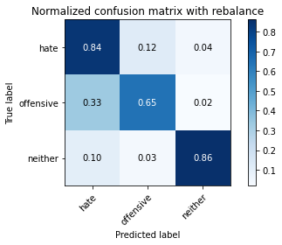

precision recall f1-score support

hate 0.15 0.84 0.26 294

offensive 0.97 0.65 0.78 3821

neither 0.89 0.86 0.88 842

accuracy 0.69 4957

macro avg 0.67 0.78 0.64 4957

weighted avg 0.91 0.69 0.76 4957

average eval_loss: 0.8659470850721963, accuracy: 0.6937663909622755

training 6 epoch...

27.765967845916748 seconds used......

6 training finished! average train loss: 0.05484079421778367

evaluating...

Confusion matrix, without normalization

[[ 202 75 17]

[ 471 3259 91]

[ 36 40 766]]

Normalized confusion matrix

[[0.68707483 0.25510204 0.05782313]

[0.12326616 0.85291808 0.02381576]

[0.04275534 0.04750594 0.90973872]]

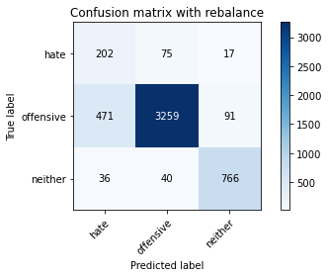

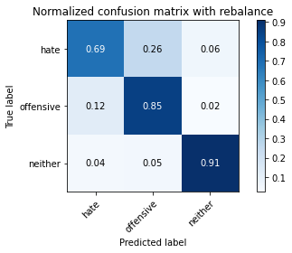

precision recall f1-score support

hate 0.28 0.69 0.40 294

offensive 0.97 0.85 0.91 3821

neither 0.88 0.91 0.89 842

accuracy 0.85 4957

macro avg 0.71 0.82 0.73 4957

weighted avg 0.91 0.85 0.87 4957

average eval_loss: 0.6062411300297226, accuracy: 0.8527335081702643

training 7 epoch...

27.733539819717407 seconds used......

7 training finished! average train loss: 0.034197314103182996

evaluating...

Confusion matrix, without normalization

[[ 229 47 18]

[1095 2616 110]

[ 66 21 755]]

Normalized confusion matrix

[[0.77891156 0.15986395 0.06122449]

[0.2865742 0.68463753 0.02878828]

[0.0783848 0.02494062 0.89667458]]

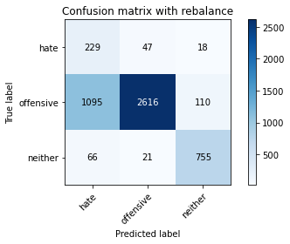

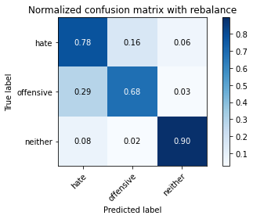

precision recall f1-score support

hate 0.16 0.78 0.27 294

offensive 0.97 0.68 0.80 3821

neither 0.86 0.90 0.88 842

accuracy 0.73 4957

macro avg 0.66 0.79 0.65 4957

weighted avg 0.91 0.73 0.78 4957

average eval_loss: 1.0400603517266591, accuracy: 0.7262457131329433

training 8 epoch...

27.734318733215332 seconds used......

8 training finished! average train loss: 0.025308282489681408

evaluating...

Confusion matrix, without normalization

[[ 219 59 16]

[ 755 2980 86]

[ 74 34 734]]

Normalized confusion matrix

[[0.74489796 0.20068027 0.05442177]

[0.19759225 0.77990055 0.0225072 ]

[0.08788599 0.04038005 0.87173397]]

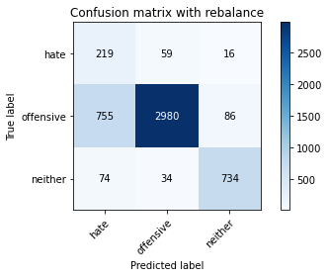

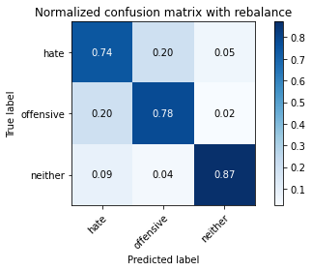

precision recall f1-score support

hate 0.21 0.74 0.33 294

offensive 0.97 0.78 0.86 3821

neither 0.88 0.87 0.87 842

accuracy 0.79 4957

macro avg 0.69 0.80 0.69 4957

weighted avg 0.91 0.79 0.83 4957

average eval_loss: 0.9155883373858805, accuracy: 0.7934234415977406

training 9 epoch...

27.703591108322144 seconds used......

9 training finished! average train loss: 0.019565093223644116

evaluating...

Confusion matrix, without normalization

[[ 217 49 28]

[ 762 2938 121]

[ 42 27 773]]

Normalized confusion matrix

[[0.73809524 0.16666667 0.0952381 ]

[0.19942423 0.76890866 0.0316671 ]

[0.04988124 0.03206651 0.91805226]]

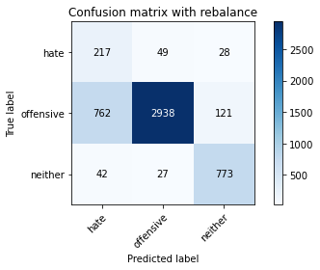

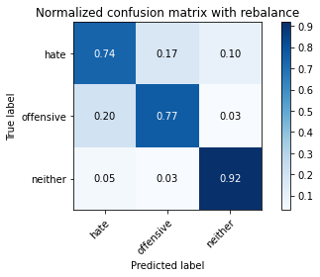

precision recall f1-score support

hate 0.21 0.74 0.33 294

offensive 0.97 0.77 0.86 3821

neither 0.84 0.92 0.88 842

accuracy 0.79 4957

macro avg 0.68 0.81 0.69 4957

weighted avg 0.91 0.79 0.83 4957

average eval_loss: 0.9340532236186142, accuracy: 0.7924147669961671

training 10 epoch...

27.755217790603638 seconds used......

10 training finished! average train loss: 0.027254516481624764

evaluating...

Confusion matrix, without normalization

[[ 217 50 27]

[ 765 2923 133]

[ 38 15 789]]

Normalized confusion matrix

[[0.73809524 0.17006803 0.09183673]

[0.20020937 0.76498299 0.03480764]

[0.04513064 0.01781473 0.93705463]]

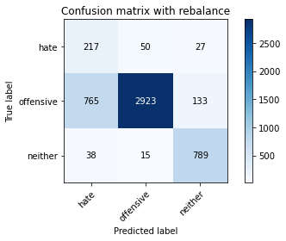

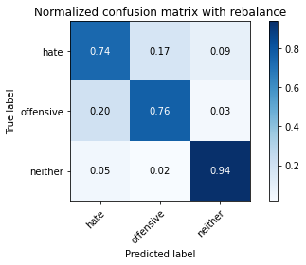

precision recall f1-score support

hate 0.21 0.74 0.33 294

offensive 0.98 0.76 0.86 3821

neither 0.83 0.94 0.88 842

accuracy 0.79 4957

macro avg 0.67 0.81 0.69 4957

weighted avg 0.91 0.79 0.83 4957

average eval_loss: 1.0484112675287414, accuracy: 0.7926165019164817

2 run

training 1 epoch...

28.38304352760315 seconds used......

1 training finished! average train loss: 0.6369553013590344

evaluating...

Confusion matrix, without normalization

[[ 219 44 31]

[ 739 2939 143]

[ 32 9 801]]

Normalized confusion matrix

[[0.74489796 0.14965986 0.10544218]

[0.19340487 0.76917037 0.03742476]

[0.03800475 0.01068884 0.95130641]]

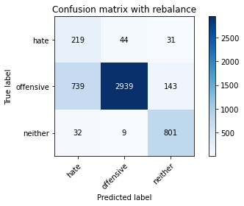

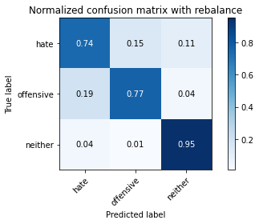

precision recall f1-score support

hate 0.22 0.74 0.34 294

offensive 0.98 0.77 0.86 3821

neither 0.82 0.95 0.88 842

accuracy 0.80 4957

macro avg 0.68 0.82 0.70 4957

weighted avg 0.91 0.80 0.84 4957

average eval_loss: 0.48732161831351056, accuracy: 0.7986685495259229

training 2 epoch...

27.782800436019897 seconds used......

2 training finished! average train loss: 0.3519162000619877

evaluating...

Confusion matrix, without normalization

[[ 229 41 24]

[ 788 2884 149]

[ 32 9 801]]

Normalized confusion matrix

[[0.77891156 0.13945578 0.08163265]

[0.20622874 0.75477624 0.03899503]

[0.03800475 0.01068884 0.95130641]]

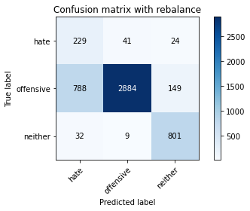

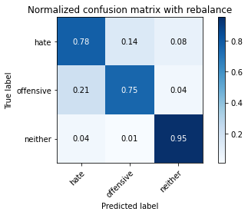

precision recall f1-score support

hate 0.22 0.78 0.34 294

offensive 0.98 0.75 0.85 3821

neither 0.82 0.95 0.88 842

accuracy 0.79 4957

macro avg 0.67 0.83 0.69 4957

weighted avg 0.91 0.79 0.83 4957

average eval_loss: 0.4643202693532071, accuracy: 0.7895904781117612

training 3 epoch...

27.745949268341064 seconds used......

3 training finished! average train loss: 0.2382543690459073

evaluating...

Confusion matrix, without normalization

[[ 242 39 13]

[1159 2553 109]

[ 78 10 754]]

Normalized confusion matrix

[[0.82312925 0.13265306 0.04421769]

[0.30332374 0.6681497 0.02852656]

[0.09263658 0.01187648 0.89548694]]

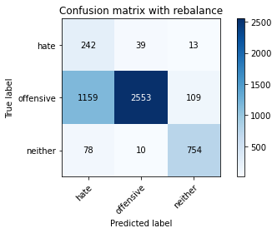

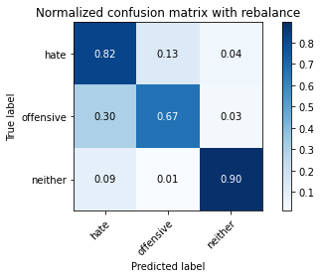

precision recall f1-score support

hate 0.16 0.82 0.27 294

offensive 0.98 0.67 0.79 3821

neither 0.86 0.90 0.88 842

accuracy 0.72 4957

macro avg 0.67 0.80 0.65 4957

weighted avg 0.91 0.72 0.78 4957

average eval_loss: 0.6347753220508175, accuracy: 0.7159572321968933

training 4 epoch...

27.823322772979736 seconds used......

4 training finished! average train loss: 0.1485681687835713

evaluating...

Confusion matrix, without normalization

[[ 238 41 15]

[ 971 2732 118]

[ 59 18 765]]

Normalized confusion matrix

[[0.80952381 0.13945578 0.05102041]

[0.25412196 0.71499607 0.03088197]

[0.07007126 0.02137767 0.90855107]]

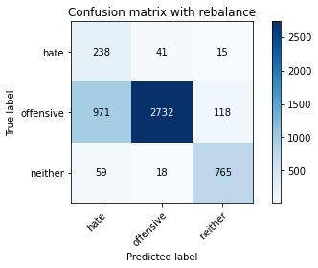

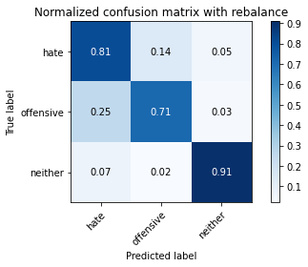

precision recall f1-score support

hate 0.19 0.81 0.30 294

offensive 0.98 0.71 0.83 3821

neither 0.85 0.91 0.88 842

accuracy 0.75 4957

macro avg 0.67 0.81 0.67 4957

weighted avg 0.91 0.75 0.80 4957

average eval_loss: 0.5915906331351688, accuracy: 0.7534799273754287

training 5 epoch...

27.69494390487671 seconds used......

5 training finished! average train loss: 0.08228705279605343

evaluating...

Confusion matrix, without normalization

[[ 208 68 18]

[ 574 3138 109]

[ 33 33 776]]

Normalized confusion matrix

[[0.70748299 0.23129252 0.06122449]

[0.15022245 0.82125098 0.02852656]

[0.0391924 0.0391924 0.9216152 ]]

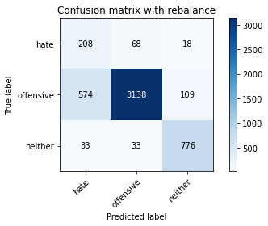

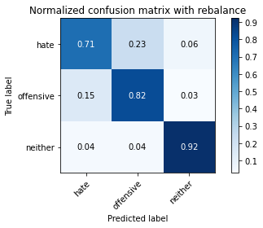

precision recall f1-score support

hate 0.26 0.71 0.38 294

offensive 0.97 0.82 0.89 3821

neither 0.86 0.92 0.89 842

accuracy 0.83 4957

macro avg 0.69 0.82 0.72 4957

weighted avg 0.91 0.83 0.86 4957

average eval_loss: 0.575200350395584, accuracy: 0.8315513415372201

training 6 epoch...

27.709534883499146 seconds used......

6 training finished! average train loss: 0.05117491078127328

evaluating...

Confusion matrix, without normalization

[[ 218 62 14]

[ 574 3151 96]

[ 49 27 766]]

Normalized confusion matrix

[[0.7414966 0.21088435 0.04761905]

[0.15022245 0.82465323 0.02512431]

[0.05819477 0.03206651 0.90973872]]

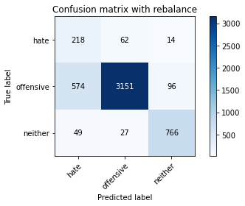

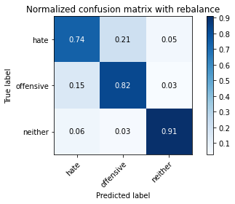

precision recall f1-score support

hate 0.26 0.74 0.38 294

offensive 0.97 0.82 0.89 3821

neither 0.87 0.91 0.89 842

accuracy 0.83 4957

macro avg 0.70 0.83 0.72 4957

weighted avg 0.91 0.83 0.86 4957

average eval_loss: 0.6648243244440716, accuracy: 0.8341738955013113

training 7 epoch...

27.743035554885864 seconds used......

7 training finished! average train loss: 0.03140246775307644

evaluating...

Confusion matrix, without normalization

[[ 221 55 18]

[ 687 3006 128]

[ 46 22 774]]

Normalized confusion matrix

[[0.75170068 0.18707483 0.06122449]

[0.17979586 0.78670505 0.03349908]

[0.05463183 0.02612827 0.9192399 ]]

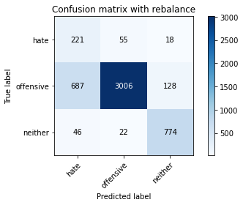

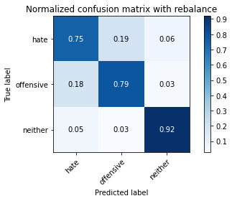

precision recall f1-score support

hate 0.23 0.75 0.35 294

offensive 0.98 0.79 0.87 3821

neither 0.84 0.92 0.88 842

accuracy 0.81 4957

macro avg 0.68 0.82 0.70 4957

weighted avg 0.91 0.81 0.84 4957

average eval_loss: 0.7529835975916696, accuracy: 0.8071414161791406

training 8 epoch...

27.750624656677246 seconds used......

8 training finished! average train loss: 0.02430744716871737

evaluating...

Confusion matrix, without normalization

[[ 240 41 13]

[ 962 2751 108]

[ 53 26 763]]

Normalized confusion matrix

[[0.81632653 0.13945578 0.04421769]

[0.25176655 0.71996859 0.02826485]

[0.06294537 0.03087886 0.90617577]]

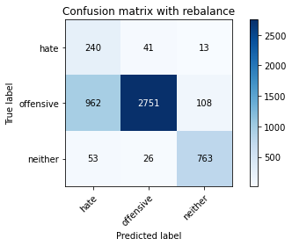

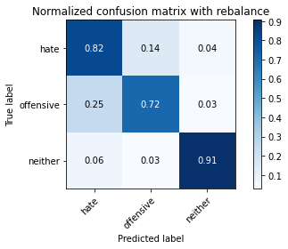

precision recall f1-score support

hate 0.19 0.82 0.31 294

offensive 0.98 0.72 0.83 3821

neither 0.86 0.91 0.88 842

accuracy 0.76 4957

macro avg 0.68 0.81 0.67 4957

weighted avg 0.91 0.76 0.81 4957

average eval_loss: 1.0085346724898103, accuracy: 0.7573128908614081

training 9 epoch...

27.8119637966156 seconds used......

9 training finished! average train loss: 0.019669572452399118

evaluating...

Confusion matrix, without normalization

[[ 211 58 25]

[ 609 3047 165]

[ 38 18 786]]

Normalized confusion matrix

[[0.71768707 0.19727891 0.08503401]

[0.15938236 0.79743523 0.04318241]

[0.04513064 0.02137767 0.93349169]]

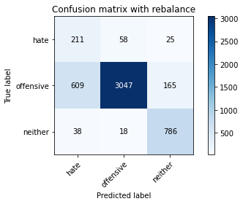

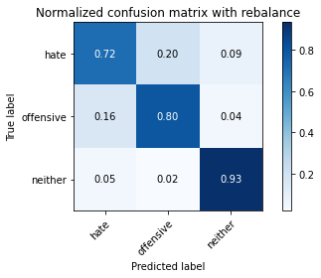

precision recall f1-score support

hate 0.25 0.72 0.37 294

offensive 0.98 0.80 0.88 3821

neither 0.81 0.93 0.86 842

accuracy 0.82 4957

macro avg 0.68 0.82 0.70 4957

weighted avg 0.90 0.82 0.85 4957

average eval_loss: 0.8613599760302028, accuracy: 0.815816017752673

training 10 epoch...

27.748130321502686 seconds used......

10 training finished! average train loss: 0.01765165274723825

evaluating...

Confusion matrix, without normalization

[[ 232 41 21]

[ 764 2938 119]

[ 43 19 780]]

Normalized confusion matrix

[[0.78911565 0.13945578 0.07142857]

[0.19994766 0.76890866 0.03114368]

[0.05106888 0.02256532 0.9263658 ]]

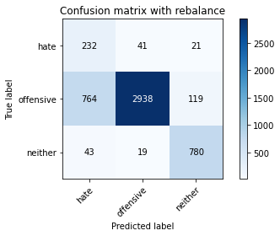

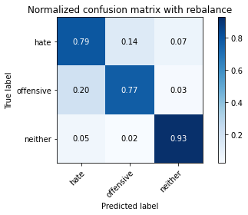

precision recall f1-score support

hate 0.22 0.79 0.35 294

offensive 0.98 0.77 0.86 3821

neither 0.85 0.93 0.89 842

accuracy 0.80 4957

macro avg 0.68 0.83 0.70 4957

weighted avg 0.91 0.80 0.84 4957

average eval_loss: 1.0191097769486313, accuracy: 0.7968529352430905

3 run

training 1 epoch...

27.721036434173584 seconds used......

1 training finished! average train loss: 0.6130534715471212

evaluating...

Confusion matrix, without normalization

[[ 213 47 34]

[ 668 2983 170]

[ 32 11 799]]

Normalized confusion matrix

[[0.7244898 0.15986395 0.11564626]

[0.17482334 0.78068568 0.04449097]

[0.03800475 0.01306413 0.94893112]]

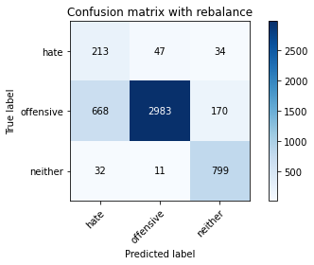

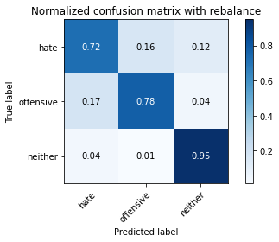

precision recall f1-score support

hate 0.23 0.72 0.35 294

offensive 0.98 0.78 0.87 3821

neither 0.80 0.95 0.87 842

accuracy 0.81 4957

macro avg 0.67 0.82 0.70 4957

weighted avg 0.91 0.81 0.84 4957

average eval_loss: 0.45428941852503246, accuracy: 0.8059310066572524

training 2 epoch...

27.776342153549194 seconds used......

2 training finished! average train loss: 0.37150419263811835

evaluating...

Confusion matrix, without normalization

[[ 209 47 38]

[ 621 3000 200]

[ 20 9 813]]

Normalized confusion matrix

[[0.71088435 0.15986395 0.1292517 ]

[0.1625229 0.78513478 0.05234232]

[0.02375297 0.01068884 0.96555819]]

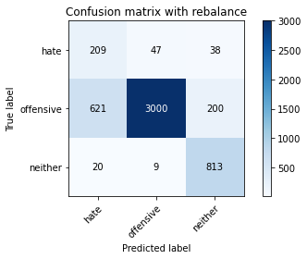

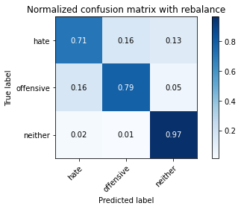

precision recall f1-score support

hate 0.25 0.71 0.37 294

offensive 0.98 0.79 0.87 3821

neither 0.77 0.97 0.86 842

accuracy 0.81 4957

macro avg 0.67 0.82 0.70 4957

weighted avg 0.90 0.81 0.84 4957

average eval_loss: 0.4450624569529487, accuracy: 0.8113778495057494

training 3 epoch...

27.677383184432983 seconds used......

3 training finished! average train loss: 0.241989030279437

evaluating...

Confusion matrix, without normalization

[[ 252 25 17]

[1181 2513 127]

[ 54 11 777]]

Normalized confusion matrix

[[0.85714286 0.08503401 0.05782313]

[0.30908139 0.65768124 0.03323737]

[0.06413302 0.01306413 0.92280285]]

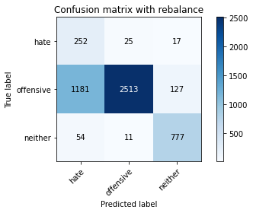

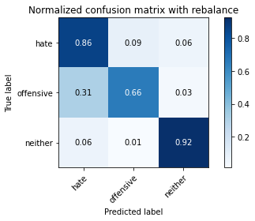

precision recall f1-score support

hate 0.17 0.86 0.28 294

offensive 0.99 0.66 0.79 3821

neither 0.84 0.92 0.88 842

accuracy 0.71 4957

macro avg 0.67 0.81 0.65 4957

weighted avg 0.91 0.71 0.77 4957

average eval_loss: 0.6651717199373149, accuracy: 0.7145450877546904

training 4 epoch...

27.762075662612915 seconds used......

4 training finished! average train loss: 0.1644585795417341

evaluating...

Confusion matrix, without normalization

[[ 243 34 17]

[ 996 2714 111]

[ 59 27 756]]

Normalized confusion matrix

[[0.82653061 0.11564626 0.05782313]

[0.26066475 0.71028527 0.02904999]

[0.07007126 0.03206651 0.89786223]]

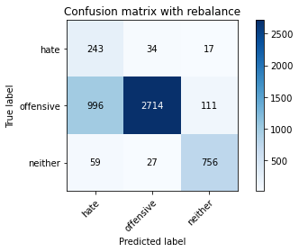

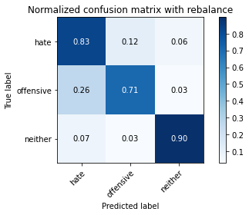

precision recall f1-score support

hate 0.19 0.83 0.31 294

offensive 0.98 0.71 0.82 3821

neither 0.86 0.90 0.88 842

accuracy 0.75 4957

macro avg 0.67 0.81 0.67 4957

weighted avg 0.91 0.75 0.80 4957

average eval_loss: 0.6000418411567807, accuracy: 0.7490417591285051

training 5 epoch...

27.725786924362183 seconds used......

5 training finished! average train loss: 0.10043754259244217

evaluating...

Confusion matrix, without normalization

[[ 238 36 20]

[1000 2702 119]

[ 59 23 760]]

Normalized confusion matrix

[[0.80952381 0.12244898 0.06802721]

[0.26171159 0.70714473 0.03114368]

[0.07007126 0.02731591 0.90261283]]

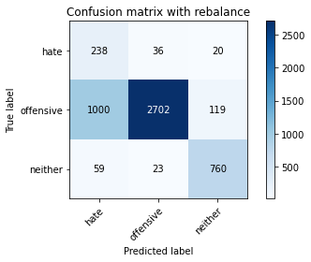

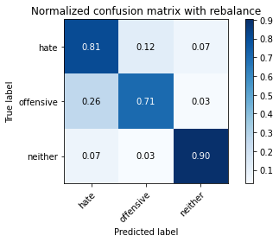

precision recall f1-score support

hate 0.18 0.81 0.30 294

offensive 0.98 0.71 0.82 3821

neither 0.85 0.90 0.87 842

accuracy 0.75 4957

macro avg 0.67 0.81 0.66 4957

weighted avg 0.91 0.75 0.80 4957

average eval_loss: 0.7965613499794516, accuracy: 0.746419205164414

training 6 epoch...

27.706112384796143 seconds used......

6 training finished! average train loss: 0.055876050746253535

evaluating...

Confusion matrix, without normalization

[[ 216 62 16]

[ 686 3000 135]

[ 67 33 742]]

Normalized confusion matrix

[[0.73469388 0.21088435 0.05442177]

[0.17953415 0.78513478 0.03533107]

[0.07957245 0.0391924 0.88123515]]

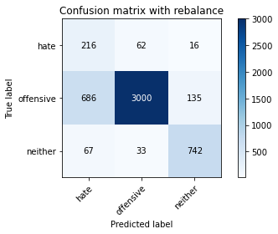

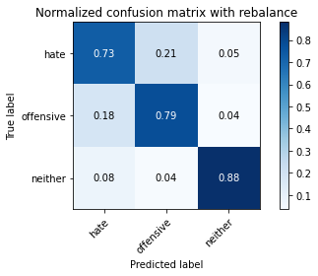

precision recall f1-score support

hate 0.22 0.73 0.34 294

offensive 0.97 0.79 0.87 3821

neither 0.83 0.88 0.86 842

accuracy 0.80 4957

macro avg 0.67 0.80 0.69 4957

weighted avg 0.90 0.80 0.83 4957

average eval_loss: 0.7066459291231548, accuracy: 0.7984668146056082

training 7 epoch...

27.75709342956543 seconds used......

7 training finished! average train loss: 0.030315299944241383

evaluating...

Confusion matrix, without normalization

[[ 227 49 18]

[ 901 2815 105]

[ 49 26 767]]

Normalized confusion matrix

[[0.77210884 0.16666667 0.06122449]

[0.23580215 0.73671814 0.02747972]

[0.05819477 0.03087886 0.91092637]]

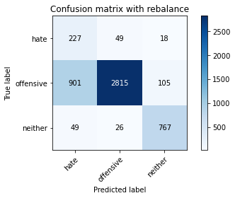

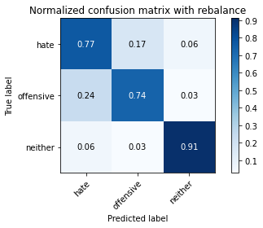

precision recall f1-score support

hate 0.19 0.77 0.31 294

offensive 0.97 0.74 0.84 3821

neither 0.86 0.91 0.89 842

accuracy 0.77 4957

macro avg 0.68 0.81 0.68 4957

weighted avg 0.91 0.77 0.82 4957

average eval_loss: 0.9942186860087884, accuracy: 0.768408311478717

training 8 epoch...

27.739441633224487 seconds used......

8 training finished! average train loss: 0.02988940523903305

evaluating...

Confusion matrix, without normalization

[[ 196 73 25]

[ 606 3106 109]

[ 39 47 756]]

Normalized confusion matrix

[[0.66666667 0.24829932 0.08503401]

[0.15859723 0.81287621 0.02852656]

[0.04631829 0.05581948 0.89786223]]

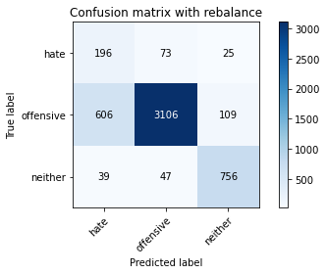

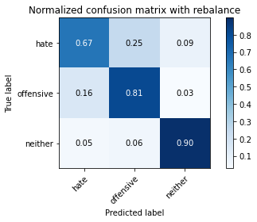

precision recall f1-score support

hate 0.23 0.67 0.35 294

offensive 0.96 0.81 0.88 3821

neither 0.85 0.90 0.87 842

accuracy 0.82 4957

macro avg 0.68 0.79 0.70 4957

weighted avg 0.90 0.82 0.85 4957

average eval_loss: 0.7410390651944438, accuracy: 0.8186403066370789

training 9 epoch...

27.6330828666687 seconds used......

9 training finished! average train loss: 0.01667129701634526

evaluating...

Confusion matrix, without normalization

[[ 205 65 24]

[ 694 2979 148]

[ 35 35 772]]

Normalized confusion matrix

[[0.69727891 0.22108844 0.08163265]

[0.18162785 0.77963884 0.03873332]

[0.0415677 0.0415677 0.91686461]]

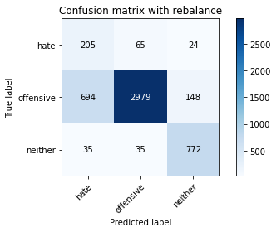

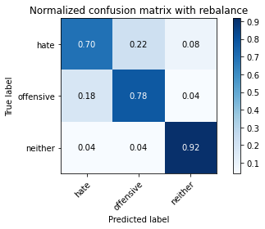

precision recall f1-score support

hate 0.22 0.70 0.33 294

offensive 0.97 0.78 0.86 3821

neither 0.82 0.92 0.86 842

accuracy 0.80 4957

macro avg 0.67 0.80 0.69 4957

weighted avg 0.90 0.80 0.83 4957

average eval_loss: 0.903866320867711, accuracy: 0.7980633447649789

training 10 epoch...

27.728413820266724 seconds used......

10 training finished! average train loss: 0.015211249806861017

evaluating...

Confusion matrix, without normalization

[[ 202 71 21]

[ 614 3086 121]

[ 42 28 772]]

Normalized confusion matrix

[[0.68707483 0.2414966 0.07142857]

[0.16069092 0.80764198 0.0316671 ]

[0.04988124 0.03325416 0.91686461]]

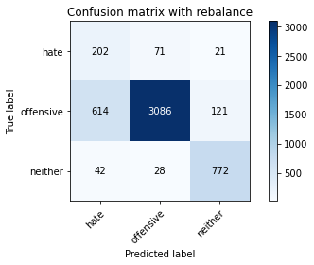

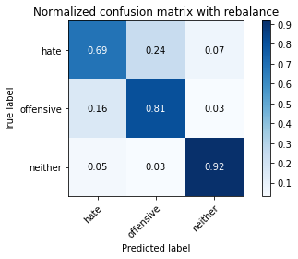

precision recall f1-score support

hate 0.24 0.69 0.35 294

offensive 0.97 0.81 0.88 3821

neither 0.84 0.92 0.88 842

accuracy 0.82 4957

macro avg 0.68 0.80 0.70 4957

weighted avg 0.90 0.82 0.85 4957

average eval_loss: 0.8600167237267259, accuracy: 0.8190437764777083

4 run

training 1 epoch...

27.74328851699829 seconds used......

1 training finished! average train loss: 0.6470265967978371

evaluating...

Confusion matrix, without normalization

[[ 243 23 28]

[1691 1983 147]

[ 50 10 782]]

Normalized confusion matrix

[[0.82653061 0.07823129 0.0952381 ]

[0.44255431 0.51897409 0.0384716 ]

[0.05938242 0.01187648 0.92874109]]

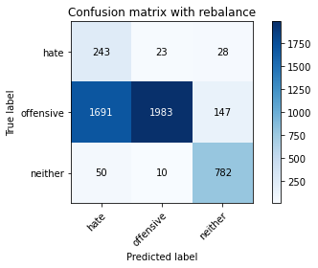

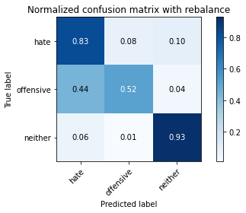

precision recall f1-score support

hate 0.12 0.83 0.21 294

offensive 0.98 0.52 0.68 3821

neither 0.82 0.93 0.87 842

accuracy 0.61 4957

macro avg 0.64 0.76 0.59 4957

weighted avg 0.90 0.61 0.68 4957

average eval_loss: 0.8045533568628372, accuracy: 0.6068186403066371

training 2 epoch...

27.75931453704834 seconds used......

2 training finished! average train loss: 0.3652262179213658

evaluating...

Confusion matrix, without normalization

[[ 235 32 27]

[ 905 2776 140]

[ 35 9 798]]

Normalized confusion matrix

[[0.79931973 0.10884354 0.09183673]

[0.23684899 0.72651138 0.03663962]

[0.0415677 0.01068884 0.94774347]]

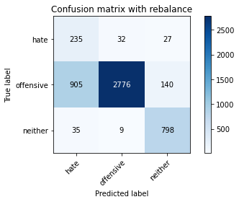

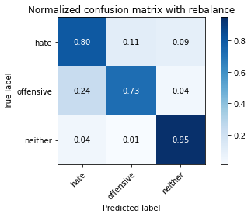

precision recall f1-score support

hate 0.20 0.80 0.32 294

offensive 0.99 0.73 0.84 3821

neither 0.83 0.95 0.88 842

accuracy 0.77 4957

macro avg 0.67 0.82 0.68 4957

weighted avg 0.91 0.77 0.81 4957

average eval_loss: 0.5337108537975338, accuracy: 0.768408311478717

training 3 epoch...

27.684067249298096 seconds used......

3 training finished! average train loss: 0.24288640813956483

evaluating...

Confusion matrix, without normalization

[[ 238 36 20]

[1002 2664 155]

[ 63 8 771]]

Normalized confusion matrix

[[0.80952381 0.12244898 0.06802721]

[0.26223502 0.69719969 0.0405653 ]

[0.07482185 0.00950119 0.91567696]]

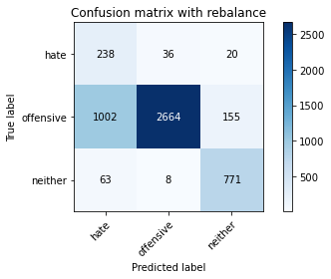

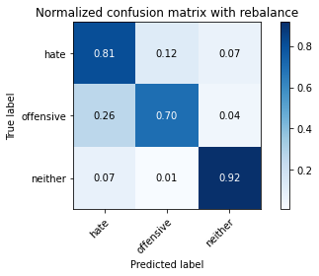

precision recall f1-score support

hate 0.18 0.81 0.30 294

offensive 0.98 0.70 0.82 3821

neither 0.82 0.92 0.86 842

accuracy 0.74 4957

macro avg 0.66 0.81 0.66 4957

weighted avg 0.91 0.74 0.79 4957

average eval_loss: 0.6422653654890675, accuracy: 0.7409723623159169

training 4 epoch...

27.73190951347351 seconds used......

4 training finished! average train loss: 0.1473959878588106

evaluating...

Confusion matrix, without normalization

[[ 224 48 22]

[ 765 2948 108]

[ 41 19 782]]

Normalized confusion matrix

[[0.76190476 0.16326531 0.07482993]

[0.20020937 0.77152578 0.02826485]

[0.04869359 0.02256532 0.92874109]]

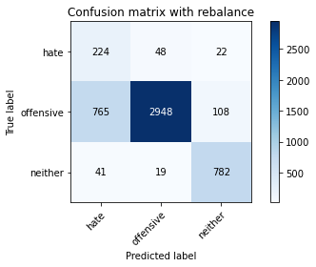

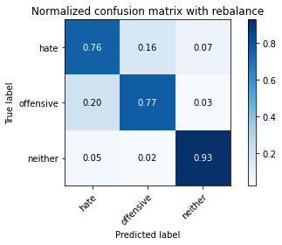

precision recall f1-score support

hate 0.22 0.76 0.34 294

offensive 0.98 0.77 0.86 3821

neither 0.86 0.93 0.89 842

accuracy 0.80 4957

macro avg 0.68 0.82 0.70 4957

weighted avg 0.91 0.80 0.84 4957

average eval_loss: 0.5278568329034193, accuracy: 0.7976598749243494

training 5 epoch...

27.724535942077637 seconds used......

5 training finished! average train loss: 0.08670331989496685

evaluating...

Confusion matrix, without normalization

[[ 251 30 13]

[1274 2460 87]

[ 89 15 738]]

Normalized confusion matrix

[[0.8537415 0.10204082 0.04421769]

[0.33342057 0.64381052 0.02276891]

[0.10570071 0.01781473 0.87648456]]

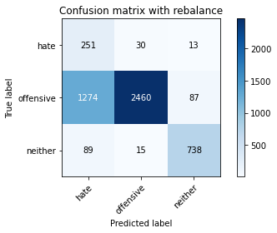

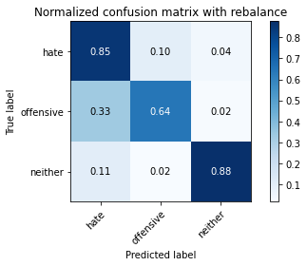

precision recall f1-score support

hate 0.16 0.85 0.26 294

offensive 0.98 0.64 0.78 3821

neither 0.88 0.88 0.88 842

accuracy 0.70 4957

macro avg 0.67 0.79 0.64 4957

weighted avg 0.92 0.70 0.76 4957

average eval_loss: 1.0117308689852156, accuracy: 0.6957837401654227

training 6 epoch...

27.741315841674805 seconds used......

6 training finished! average train loss: 0.053921701148293956

evaluating...

Confusion matrix, without normalization

[[ 210 61 23]

[ 697 2986 138]

[ 39 19 784]]

Normalized confusion matrix

[[0.71428571 0.20748299 0.07823129]

[0.18241298 0.78147082 0.0361162 ]

[0.04631829 0.02256532 0.93111639]]

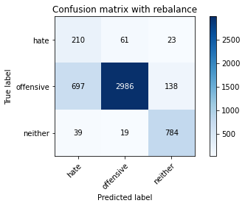

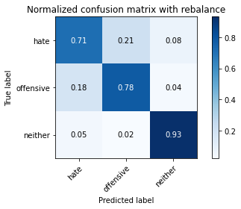

precision recall f1-score support

hate 0.22 0.71 0.34 294

offensive 0.97 0.78 0.87 3821

neither 0.83 0.93 0.88 842

accuracy 0.80 4957

macro avg 0.68 0.81 0.69 4957

weighted avg 0.90 0.80 0.84 4957

average eval_loss: 0.7411628469107522, accuracy: 0.8029049828525318

training 7 epoch...

27.822166681289673 seconds used......

7 training finished! average train loss: 0.027728236526147358

evaluating...

Confusion matrix, without normalization

[[ 206 66 22]

[ 586 3124 111]

[ 38 31 773]]

Normalized confusion matrix

[[0.70068027 0.2244898 0.07482993]

[0.15336299 0.81758702 0.02904999]

[0.04513064 0.0368171 0.91805226]]

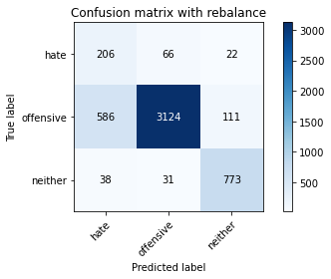

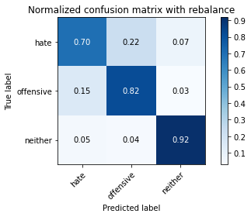

precision recall f1-score support

hate 0.25 0.70 0.37 294

offensive 0.97 0.82 0.89 3821

neither 0.85 0.92 0.88 842

accuracy 0.83 4957

macro avg 0.69 0.81 0.71 4957

weighted avg 0.91 0.83 0.86 4957

average eval_loss: 0.7451537683875593, accuracy: 0.8277183780512407

training 8 epoch...

27.878110647201538 seconds used......

8 training finished! average train loss: 0.027765687141493942

evaluating...

Confusion matrix, without normalization

[[ 219 52 23]

[ 729 2960 132]

[ 35 14 793]]

Normalized confusion matrix

[[0.74489796 0.17687075 0.07823129]

[0.19078775 0.77466632 0.03454593]

[0.0415677 0.01662708 0.94180523]]

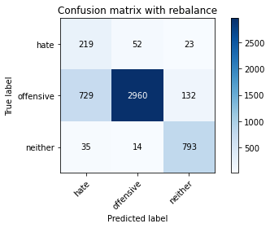

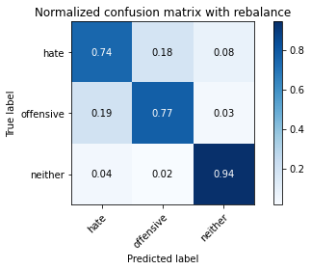

precision recall f1-score support

hate 0.22 0.74 0.34 294

offensive 0.98 0.77 0.86 3821

neither 0.84 0.94 0.89 842

accuracy 0.80 4957

macro avg 0.68 0.82 0.70 4957

weighted avg 0.91 0.80 0.84 4957

average eval_loss: 0.951425179317143, accuracy: 0.8012911034900141

training 9 epoch...

27.84092903137207 seconds used......

9 training finished! average train loss: 0.02251189387960316

evaluating...

Confusion matrix, without normalization

[[ 179 91 24]

[ 406 3289 126]

[ 23 33 786]]

Normalized confusion matrix

[[0.60884354 0.30952381 0.08163265]

[0.10625491 0.86076943 0.03297566]

[0.02731591 0.0391924 0.93349169]]

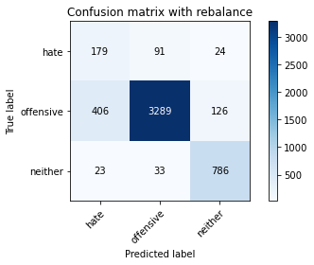

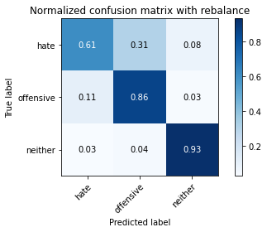

precision recall f1-score support

hate 0.29 0.61 0.40 294

offensive 0.96 0.86 0.91 3821

neither 0.84 0.93 0.88 842

accuracy 0.86 4957

macro avg 0.70 0.80 0.73 4957

weighted avg 0.90 0.86 0.87 4957

average eval_loss: 0.7219144278100312, accuracy: 0.8581803510187613

training 10 epoch...

27.73198628425598 seconds used......

10 training finished! average train loss: 0.018599613757234894

evaluating...

Confusion matrix, without normalization

[[ 205 64 25]

[ 664 3021 136]

[ 34 22 786]]

Normalized confusion matrix

[[0.69727891 0.21768707 0.08503401]

[0.1737765 0.79063072 0.03559278]

[0.04038005 0.02612827 0.93349169]]

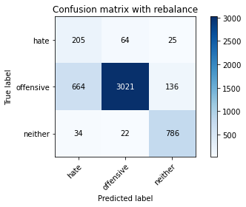

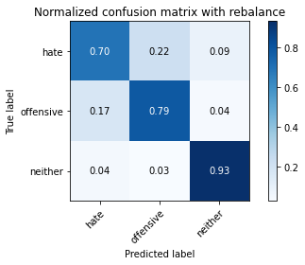

precision recall f1-score support

hate 0.23 0.70 0.34 294

offensive 0.97 0.79 0.87 3821

neither 0.83 0.93 0.88 842

accuracy 0.81 4957

macro avg 0.68 0.81 0.70 4957

weighted avg 0.90 0.81 0.84 4957

average eval_loss: 0.9334668506269208, accuracy: 0.8093605003026024

5 run

training 1 epoch...

27.87999939918518 seconds used......

1 training finished! average train loss: 0.6344909342060312

evaluating...

Confusion matrix, without normalization

[[ 232 30 32]

[1212 2446 163]

[ 37 6 799]]

Normalized confusion matrix

[[0.78911565 0.10204082 0.10884354]

[0.31719445 0.64014656 0.04265899]

[0.04394299 0.00712589 0.94893112]]

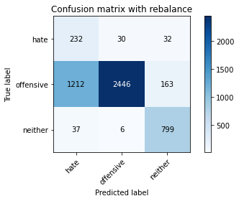

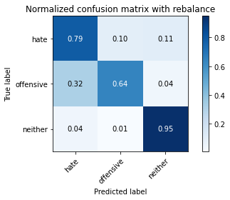

precision recall f1-score support

hate 0.16 0.79 0.26 294

offensive 0.99 0.64 0.78 3821

neither 0.80 0.95 0.87 842

accuracy 0.70 4957

macro avg 0.65 0.79 0.64 4957

weighted avg 0.91 0.70 0.76 4957

average eval_loss: 0.696078141310042, accuracy: 0.7014323179342344

training 2 epoch...

27.8177011013031 seconds used......

2 training finished! average train loss: 0.3682995703920983

evaluating...

Confusion matrix, without normalization

[[ 232 31 31]

[1118 2530 173]

[ 30 7 805]]

Normalized confusion matrix

[[0.78911565 0.10544218 0.10544218]

[0.29259356 0.66213033 0.04527611]

[0.03562945 0.00831354 0.95605701]]

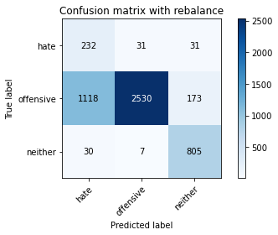

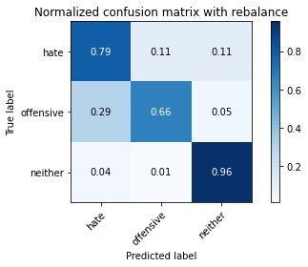

precision recall f1-score support

hate 0.17 0.79 0.28 294

offensive 0.99 0.66 0.79 3821

neither 0.80 0.96 0.87 842

accuracy 0.72 4957

macro avg 0.65 0.80 0.65 4957

weighted avg 0.90 0.72 0.77 4957

average eval_loss: 0.6271287990553726, accuracy: 0.719588460762558

training 3 epoch...

27.888323068618774 seconds used......

3 training finished! average train loss: 0.24438643821498804

evaluating...

Confusion matrix, without normalization

[[ 245 34 15]

[1031 2688 102]

[ 68 12 762]]

Normalized confusion matrix

[[0.83333333 0.11564626 0.05102041]

[0.26982465 0.70348076 0.02669458]

[0.0807601 0.01425178 0.90498812]]

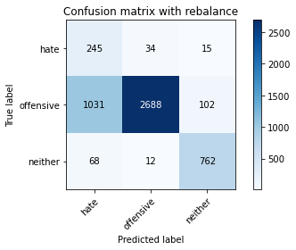

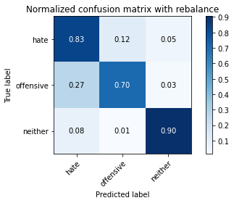

precision recall f1-score support

hate 0.18 0.83 0.30 294

offensive 0.98 0.70 0.82 3821

neither 0.87 0.90 0.89 842

accuracy 0.75 4957

macro avg 0.68 0.81 0.67 4957

weighted avg 0.92 0.75 0.80 4957

average eval_loss: 0.6526199022548334, accuracy: 0.7454105305628405

training 4 epoch...

27.78350329399109 seconds used......

4 training finished! average train loss: 0.15106048259056276

evaluating...

Confusion matrix, without normalization

[[ 238 32 24]

[1020 2656 145]

[ 35 12 795]]

Normalized confusion matrix

[[0.80952381 0.10884354 0.08163265]

[0.26694583 0.69510599 0.03794818]

[0.0415677 0.01425178 0.94418052]]

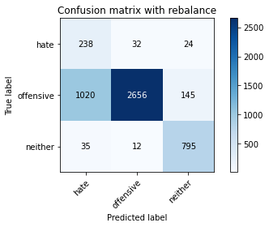

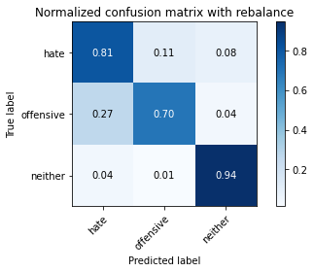

precision recall f1-score support

hate 0.18 0.81 0.30 294

offensive 0.98 0.70 0.81 3821

neither 0.82 0.94 0.88 842

accuracy 0.74 4957

macro avg 0.66 0.82 0.66 4957

weighted avg 0.91 0.74 0.80 4957

average eval_loss: 0.6479710007026311, accuracy: 0.7442001210409522

training 5 epoch...

27.927390813827515 seconds used......

5 training finished! average train loss: 0.09406138906168224

evaluating...

Confusion matrix, without normalization

[[ 239 35 20]

[1026 2674 121]

[ 44 21 777]]

Normalized confusion matrix

[[0.81292517 0.11904762 0.06802721]

[0.2685161 0.6998168 0.0316671 ]

[0.05225653 0.02494062 0.92280285]]

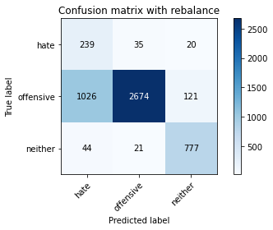

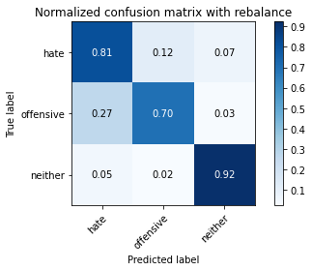

precision recall f1-score support

hate 0.18 0.81 0.30 294

offensive 0.98 0.70 0.82 3821

neither 0.85 0.92 0.88 842

accuracy 0.74 4957

macro avg 0.67 0.81 0.67 4957

weighted avg 0.91 0.74 0.80 4957

average eval_loss: 0.7306143123836767, accuracy: 0.7444018559612668

training 6 epoch...

27.790145874023438 seconds used......

6 training finished! average train loss: 0.04999086291158888

evaluating...

Confusion matrix, without normalization

[[ 217 61 16]

[ 695 3027 99]

[ 58 34 750]]

Normalized confusion matrix

[[0.73809524 0.20748299 0.05442177]

[0.18188956 0.79220099 0.02590945]

[0.06888361 0.04038005 0.89073634]]

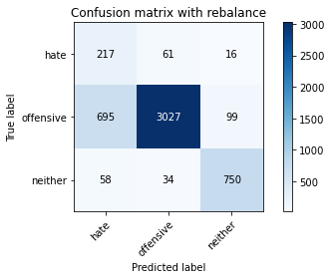

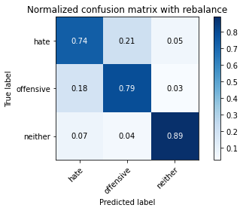

precision recall f1-score support

hate 0.22 0.74 0.34 294

offensive 0.97 0.79 0.87 3821

neither 0.87 0.89 0.88 842

accuracy 0.81 4957

macro avg 0.69 0.81 0.70 4957

weighted avg 0.91 0.81 0.84 4957

average eval_loss: 0.7294933834796651, accuracy: 0.8057292717369376

training 7 epoch...

27.823791980743408 seconds used......

7 training finished! average train loss: 0.029552039097006058

evaluating...

Confusion matrix, without normalization

[[ 235 37 22]

[1103 2589 129]

[ 44 17 781]]

Normalized confusion matrix

[[0.79931973 0.12585034 0.07482993]

[0.28866789 0.67757132 0.0337608 ]

[0.05225653 0.02019002 0.92755344]]

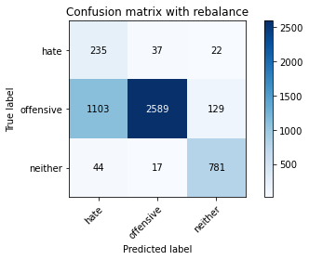

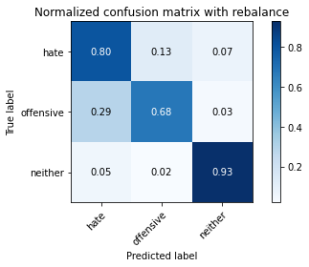

precision recall f1-score support

hate 0.17 0.80 0.28 294

offensive 0.98 0.68 0.80 3821

neither 0.84 0.93 0.88 842

accuracy 0.73 4957

macro avg 0.66 0.80 0.65 4957

weighted avg 0.91 0.73 0.78 4957

average eval_loss: 1.1171119094435726, accuracy: 0.7272543877345169

training 8 epoch...

27.825140953063965 seconds used......

8 training finished! average train loss: 0.03862529871093479

evaluating...

Confusion matrix, without normalization

[[ 243 41 10]

[ 898 2843 80]

[ 77 32 733]]

Normalized confusion matrix

[[0.82653061 0.13945578 0.03401361]

[0.23501701 0.74404606 0.02093693]

[0.09144893 0.03800475 0.87054632]]

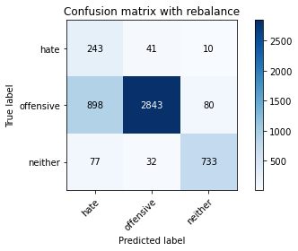

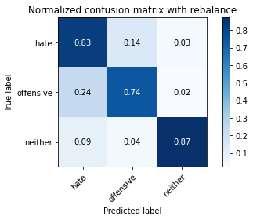

precision recall f1-score support

hate 0.20 0.83 0.32 294

offensive 0.97 0.74 0.84 3821

neither 0.89 0.87 0.88 842

accuracy 0.77 4957

macro avg 0.69 0.81 0.68 4957

weighted avg 0.91 0.77 0.82 4957

average eval_loss: 0.9832366433693096, accuracy: 0.770425660681864

training 9 epoch...

27.809566736221313 seconds used......

9 training finished! average train loss: 0.013051253784317197

evaluating...

Confusion matrix, without normalization

[[ 229 40 25]

[ 863 2760 198]

[ 40 12 790]]

Normalized confusion matrix

[[0.77891156 0.13605442 0.08503401]

[0.22585711 0.722324 0.0518189 ]

[0.04750594 0.01425178 0.93824228]]

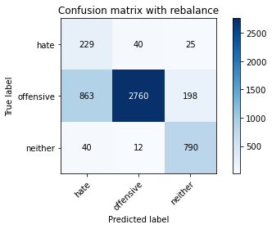

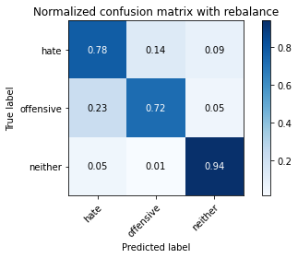

precision recall f1-score support

hate 0.20 0.78 0.32 294

offensive 0.98 0.72 0.83 3821

neither 0.78 0.94 0.85 842

accuracy 0.76 4957

macro avg 0.65 0.81 0.67 4957

weighted avg 0.90 0.76 0.81 4957

average eval_loss: 1.1617208703030502, accuracy: 0.7623562638692758

training 10 epoch...

27.837518453598022 seconds used......

10 training finished! average train loss: 0.008551328022687217

evaluating...

Confusion matrix, without normalization

[[ 213 59 22]

[ 626 3072 123]

[ 41 27 774]]

Normalized confusion matrix

[[0.7244898 0.20068027 0.07482993]

[0.16383146 0.80397802 0.03219053]

[0.04869359 0.03206651 0.9192399 ]]

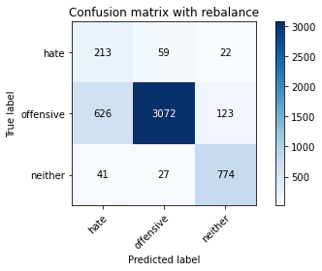

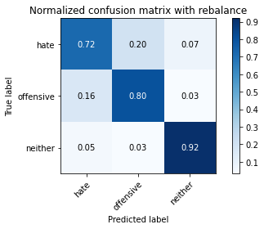

precision recall f1-score support

hate 0.24 0.72 0.36 294

offensive 0.97 0.80 0.88 3821

neither 0.84 0.92 0.88 842

accuracy 0.82 4957

macro avg 0.69 0.82 0.71 4957

weighted avg 0.91 0.82 0.85 4957

average eval_loss: 0.990100691131257, accuracy: 0.8188420415573936