training 1 epoch...

44.35047388076782 seconds used......

1 training finished! average train loss: 1.9196486511425666

total clf loss: 114.0932799577713 total adv loss: 107.08331954479218

evaluating...

Confusion matrix, without normalization

[[ 236 35 23]

[ 964 2742 115]

[ 46 13 783]]

Normalized confusion matrix

[[0.80272109 0.11904762 0.07823129]

[0.25228998 0.71761319 0.03009683]

[0.05463183 0.01543943 0.92992874]]

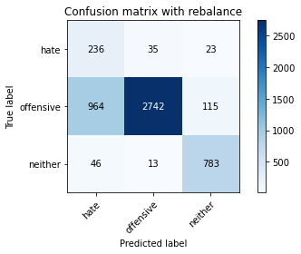

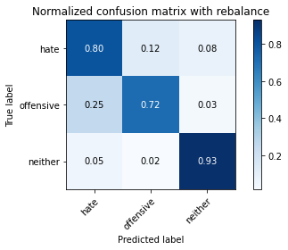

precision recall f1-score support

hate 0.19 0.80 0.31 294

offensive 0.98 0.72 0.83 3821

neither 0.85 0.93 0.89 842

accuracy 0.76 4957

macro avg 0.67 0.82 0.67 4957

weighted avg 0.91 0.76 0.81 4957

average eval_loss: 0.5841176229258699, accuracy: 0.758725035303611

Confusion matrix, without normalization

[[ 241 33 20]

[1099 2631 91]

[ 55 16 771]]

Normalized confusion matrix

[[0.81972789 0.1122449 0.06802721]

[0.28762104 0.6885632 0.02381576]

[0.06532067 0.01900238 0.91567696]]

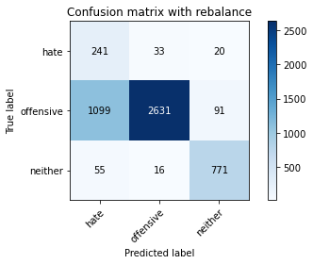

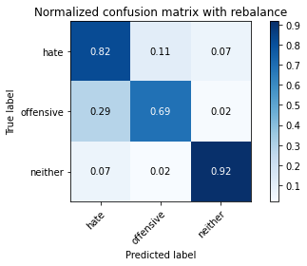

precision recall f1-score support

hate 0.17 0.82 0.29 294

offensive 0.98 0.69 0.81 3821

neither 0.87 0.92 0.89 842

accuracy 0.73 4957

macro avg 0.68 0.81 0.66 4957

weighted avg 0.92 0.73 0.79 4957

training 2 epoch...

44.43308353424072 seconds used......

2 training finished! average train loss: 1.1682638783901058

total clf loss: 65.83348752558231 total adv loss: 66.96981754153967

evaluating...

Confusion matrix, without normalization

[[ 218 51 25]

[ 681 3001 139]

[ 42 11 789]]

Normalized confusion matrix

[[0.7414966 0.17346939 0.08503401]

[0.1782256 0.78539649 0.03637791]

[0.04988124 0.01306413 0.93705463]]

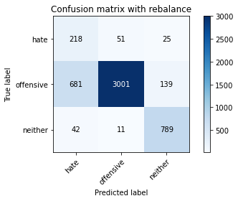

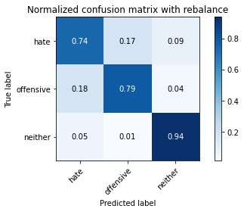

precision recall f1-score support

hate 0.23 0.74 0.35 294

offensive 0.98 0.79 0.87 3821

neither 0.83 0.94 0.88 842

accuracy 0.81 4957

macro avg 0.68 0.82 0.70 4957

weighted avg 0.91 0.81 0.84 4957

average eval_loss: 0.4553855026982004, accuracy: 0.8085535606213435

Confusion matrix, without normalization

[[ 197 73 24]

[ 432 3265 124]

[ 40 16 786]]

Normalized confusion matrix

[[0.67006803 0.24829932 0.08163265]

[0.11305941 0.85448835 0.03245224]

[0.04750594 0.01900238 0.93349169]]

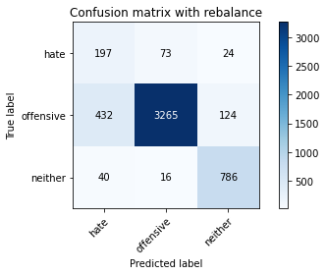

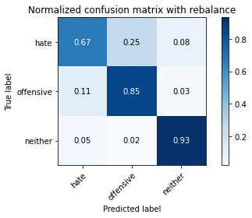

precision recall f1-score support

hate 0.29 0.67 0.41 294

offensive 0.97 0.85 0.91 3821

neither 0.84 0.93 0.89 842

accuracy 0.86 4957

macro avg 0.70 0.82 0.73 4957

weighted avg 0.91 0.86 0.88 4957

training 3 epoch...

44.33608603477478 seconds used......

3 training finished! average train loss: 0.7645259430708243

total clf loss: 42.8785735219717 total adv loss: 43.927681332454085

evaluating...

Confusion matrix, without normalization

[[ 244 34 16]

[1109 2587 125]

[ 49 13 780]]

Normalized confusion matrix

[[0.82993197 0.11564626 0.05442177]

[0.29023816 0.67704789 0.03271395]

[0.05819477 0.01543943 0.9263658 ]]

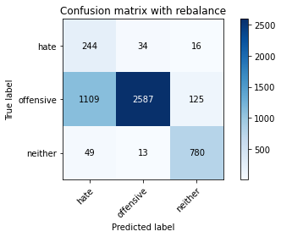

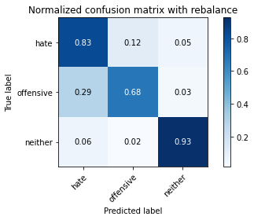

precision recall f1-score support

hate 0.17 0.83 0.29 294

offensive 0.98 0.68 0.80 3821

neither 0.85 0.93 0.88 842

accuracy 0.73 4957

macro avg 0.67 0.81 0.66 4957

weighted avg 0.91 0.73 0.79 4957

average eval_loss: 0.6886015954096952, accuracy: 0.7284647972564051

Confusion matrix, without normalization

[[ 251 28 15]

[1217 2485 119]

[ 53 13 776]]

Normalized confusion matrix

[[0.8537415 0.0952381 0.05102041]

[0.31850301 0.65035331 0.03114368]

[0.06294537 0.01543943 0.9216152 ]]

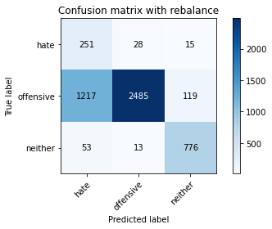

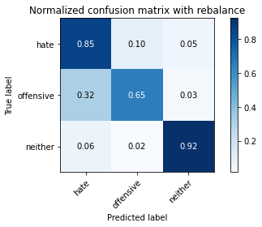

precision recall f1-score support

hate 0.17 0.85 0.28 294

offensive 0.98 0.65 0.78 3821

neither 0.85 0.92 0.89 842

accuracy 0.71 4957

macro avg 0.67 0.81 0.65 4957

weighted avg 0.91 0.71 0.77 4957

training 4 epoch...

44.32013702392578 seconds used......

4 training finished! average train loss: 0.45803456557424443

total clf loss: 25.852234333753586 total adv loss: 26.23583833919838

evaluating...

Confusion matrix, without normalization

[[ 236 38 20]

[ 842 2862 117]

[ 59 18 765]]

Normalized confusion matrix

[[0.80272109 0.1292517 0.06802721]

[0.22036116 0.74901858 0.03062026]

[0.07007126 0.02137767 0.90855107]]

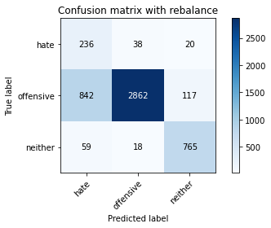

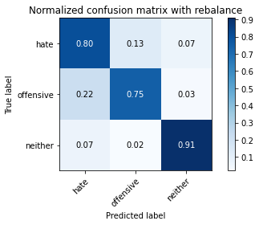

precision recall f1-score support

hate 0.21 0.80 0.33 294

offensive 0.98 0.75 0.85 3821

neither 0.85 0.91 0.88 842

accuracy 0.78 4957

macro avg 0.68 0.82 0.69 4957

weighted avg 0.91 0.78 0.82 4957

average eval_loss: 0.6500112000522354, accuracy: 0.7793019971757111

Confusion matrix, without normalization

[[ 242 32 20]

[ 948 2767 106]

[ 67 16 759]]

Normalized confusion matrix

[[0.82312925 0.10884354 0.06802721]

[0.24810259 0.72415598 0.02774143]

[0.07957245 0.01900238 0.90142518]]

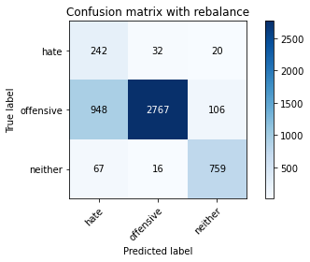

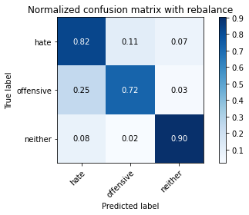

precision recall f1-score support

hate 0.19 0.82 0.31 294

offensive 0.98 0.72 0.83 3821

neither 0.86 0.90 0.88 842

accuracy 0.76 4957

macro avg 0.68 0.82 0.67 4957

weighted avg 0.91 0.76 0.81 4957

training 5 epoch...

44.39535307884216 seconds used......

5 training finished! average train loss: 0.23140312603549562

total clf loss: 13.320711763575673 total adv loss: 13.124611484410707

evaluating...

Confusion matrix, without normalization

[[ 250 35 9]

[1044 2696 81]

[ 68 29 745]]

Normalized confusion matrix

[[0.85034014 0.11904762 0.03061224]

[0.2732269 0.70557446 0.02119864]

[0.0807601 0.03444181 0.8847981 ]]

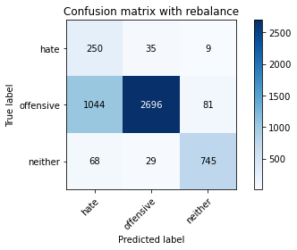

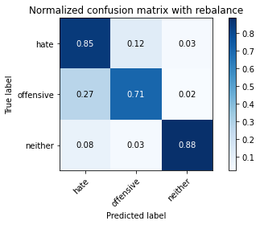

precision recall f1-score support

hate 0.18 0.85 0.30 294

offensive 0.98 0.71 0.82 3821

neither 0.89 0.88 0.89 842

accuracy 0.74 4957

macro avg 0.68 0.81 0.67 4957

weighted avg 0.92 0.74 0.80 4957

average eval_loss: 1.0310828427318484, accuracy: 0.7446035908815816

Confusion matrix, without normalization

[[ 253 30 11]

[1108 2638 75]

[ 93 25 724]]

Normalized confusion matrix

[[0.86054422 0.10204082 0.03741497]

[0.28997645 0.69039518 0.01962837]

[0.11045131 0.02969121 0.85985748]]

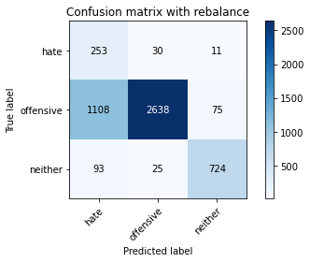

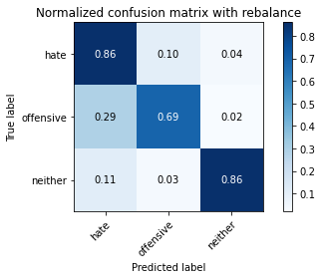

precision recall f1-score support

hate 0.17 0.86 0.29 294

offensive 0.98 0.69 0.81 3821

neither 0.89 0.86 0.88 842

accuracy 0.73 4957

macro avg 0.68 0.80 0.66 4957

weighted avg 0.92 0.73 0.79 4957

training 6 epoch...

44.29138135910034 seconds used......

6 training finished! average train loss: 0.17751317019628807

total clf loss: 9.479148878250271 total adv loss: 10.437801562962704

evaluating...

Confusion matrix, without normalization

[[ 211 63 20]

[ 629 3073 119]

[ 45 26 771]]

Normalized confusion matrix

[[0.71768707 0.21428571 0.06802721]

[0.16461659 0.80423973 0.03114368]

[0.05344418 0.03087886 0.91567696]]

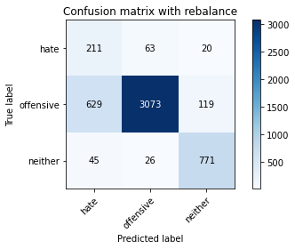

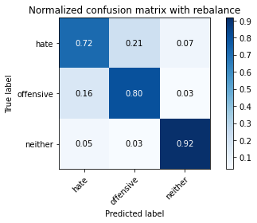

precision recall f1-score support

hate 0.24 0.72 0.36 294

offensive 0.97 0.80 0.88 3821

neither 0.85 0.92 0.88 842

accuracy 0.82 4957

macro avg 0.69 0.81 0.71 4957

weighted avg 0.91 0.82 0.85 4957

average eval_loss: 0.6846620826831749, accuracy: 0.8180351018761347

Confusion matrix, without normalization

[[ 207 69 18]

[ 601 3112 108]

[ 45 39 758]]

Normalized confusion matrix

[[0.70408163 0.23469388 0.06122449]

[0.15728867 0.81444648 0.02826485]

[0.05344418 0.04631829 0.90023753]]

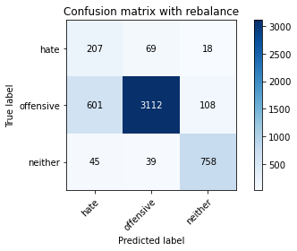

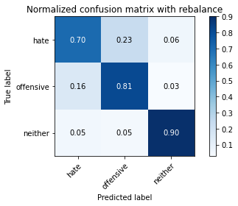

precision recall f1-score support

hate 0.24 0.70 0.36 294

offensive 0.97 0.81 0.88 3821

neither 0.86 0.90 0.88 842

accuracy 0.82 4957

macro avg 0.69 0.81 0.71 4957

weighted avg 0.91 0.82 0.85 4957

training 7 epoch...

44.297929525375366 seconds used......

7 training finished! average train loss: 0.08859453548620079

total clf loss: 5.105218421318568 total adv loss: 5.022223568244954

evaluating...

Confusion matrix, without normalization

[[ 210 60 24]

[ 656 3032 133]

[ 35 21 786]]

Normalized confusion matrix

[[0.71428571 0.20408163 0.08163265]

[0.17168281 0.79350955 0.03480764]

[0.0415677 0.02494062 0.93349169]]

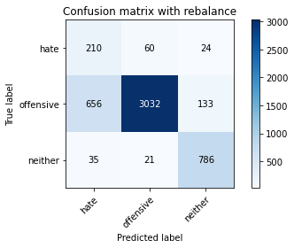

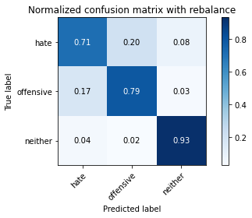

precision recall f1-score support

hate 0.23 0.71 0.35 294

offensive 0.97 0.79 0.87 3821

neither 0.83 0.93 0.88 842

accuracy 0.81 4957

macro avg 0.68 0.81 0.70 4957

weighted avg 0.91 0.81 0.84 4957

average eval_loss: 0.8028220953419805, accuracy: 0.8125882590276376

Confusion matrix, without normalization

[[ 211 59 24]

[ 618 3072 131]

[ 32 23 787]]

Normalized confusion matrix

[[0.71768707 0.20068027 0.08163265]

[0.16173776 0.80397802 0.03428422]

[0.03800475 0.02731591 0.93467933]]

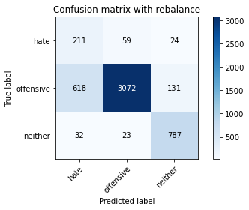

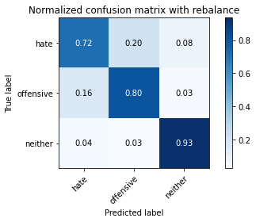

precision recall f1-score support

hate 0.25 0.72 0.37 294

offensive 0.97 0.80 0.88 3821

neither 0.84 0.93 0.88 842

accuracy 0.82 4957

macro avg 0.68 0.82 0.71 4957

weighted avg 0.91 0.82 0.85 4957

training 8 epoch...

44.36756229400635 seconds used......

8 training finished! average train loss: 0.10082468364424513

total clf loss: 5.208588743233122 total adv loss: 6.0162160599575145

evaluating...

Confusion matrix, without normalization

[[ 221 61 12]

[ 674 3042 105]

[ 60 34 748]]

Normalized confusion matrix

[[0.75170068 0.20748299 0.04081633]

[0.17639361 0.79612667 0.02747972]

[0.07125891 0.04038005 0.88836105]]

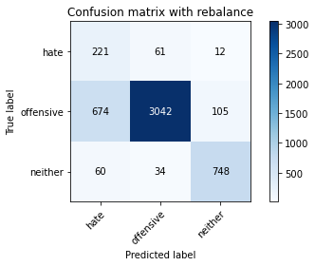

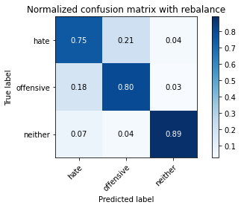

precision recall f1-score support

hate 0.23 0.75 0.35 294

offensive 0.97 0.80 0.87 3821

neither 0.86 0.89 0.88 842

accuracy 0.81 4957

macro avg 0.69 0.81 0.70 4957

weighted avg 0.91 0.81 0.84 4957

average eval_loss: 0.8045648989744575, accuracy: 0.8091587653822877

Confusion matrix, without normalization

[[ 214 67 13]

[ 654 3071 96]

[ 71 39 732]]

Normalized confusion matrix

[[0.72789116 0.22789116 0.04421769]

[0.17115938 0.8037163 0.02512431]

[0.08432304 0.04631829 0.86935867]]

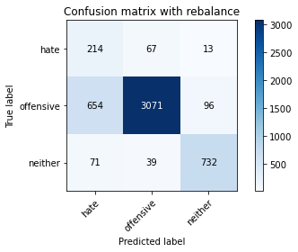

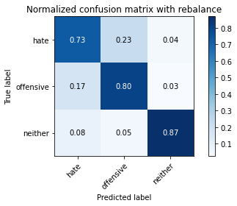

precision recall f1-score support

hate 0.23 0.73 0.35 294

offensive 0.97 0.80 0.88 3821

neither 0.87 0.87 0.87 842

accuracy 0.81 4957

macro avg 0.69 0.80 0.70 4957

weighted avg 0.91 0.81 0.84 4957

training 9 epoch...

44.326868772506714 seconds used......

9 training finished! average train loss: 0.06368308619538877

total clf loss: 3.6224697924335487 total adv loss: 3.633668951531945

evaluating...

Confusion matrix, without normalization

[[ 195 68 31]

[ 560 3115 146]

[ 25 23 794]]

Normalized confusion matrix

[[0.66326531 0.23129252 0.10544218]

[0.14655849 0.81523161 0.03820989]

[0.02969121 0.02731591 0.94299287]]

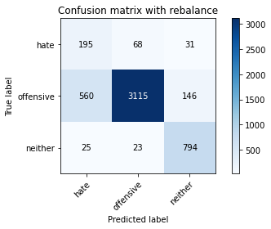

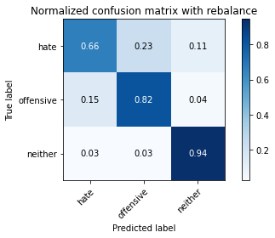

precision recall f1-score support

hate 0.25 0.66 0.36 294

offensive 0.97 0.82 0.89 3821

neither 0.82 0.94 0.88 842

accuracy 0.83 4957

macro avg 0.68 0.81 0.71 4957

weighted avg 0.90 0.83 0.85 4957

average eval_loss: 0.7987287769764436, accuracy: 0.8279201129715553

Confusion matrix, without normalization

[[ 193 72 29]

[ 522 3152 147]

[ 24 21 797]]

Normalized confusion matrix

[[0.65646259 0.24489796 0.09863946]

[0.13661345 0.82491494 0.0384716 ]

[0.02850356 0.02494062 0.94655582]]

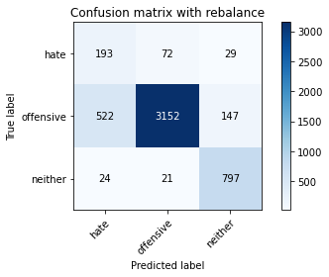

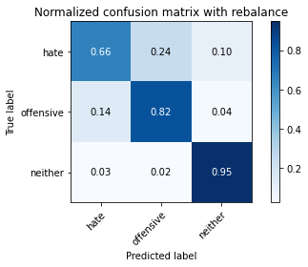

precision recall f1-score support

hate 0.26 0.66 0.37 294

offensive 0.97 0.82 0.89 3821

neither 0.82 0.95 0.88 842

accuracy 0.84 4957

macro avg 0.68 0.81 0.71 4957

weighted avg 0.90 0.84 0.86 4957

training 10 epoch...

44.279860496520996 seconds used......

10 training finished! average train loss: 0.042741960233515834

total clf loss: 2.3050648940261453 total adv loss: 2.5019051515118917

evaluating...

Confusion matrix, without normalization

[[ 205 66 23]

[ 539 3154 128]

[ 24 26 792]]

Normalized confusion matrix

[[0.69727891 0.2244898 0.07823129]

[0.14106255 0.82543837 0.03349908]

[0.02850356 0.03087886 0.94061758]]

