1 run

training 1 epoch...

104.32349371910095 seconds used......

1 training finished! average train loss: 0.6508013308048248

total clf loss: 114.4152429252863 total adv loss: 62.564298532903194

evaluating...

Confusion matrix, without normalization

[[ 209 42 43]

[ 691 2949 181]

[ 27 12 803]]

Normalized confusion matrix

[[0.71088435 0.14285714 0.1462585 ]

[0.18084271 0.77178749 0.0473698 ]

[0.03206651 0.01425178 0.95368171]]

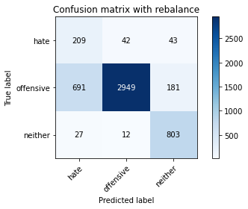

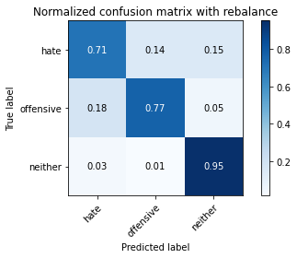

precision recall f1-score support

hate 0.23 0.71 0.34 294

offensive 0.98 0.77 0.86 3821

neither 0.78 0.95 0.86 842

accuracy 0.80 4957

macro avg 0.66 0.81 0.69 4957

weighted avg 0.90 0.80 0.83 4957

average eval_loss: 0.48201964002463127, accuracy: 0.7990720193665524

training 2 epoch...

103.54665350914001 seconds used......

2 training finished! average train loss: 0.37801032543879504

total clf loss: 67.11121401190758 total adv loss: 49.42896970361471

evaluating...

Confusion matrix, without normalization

[[ 230 56 8]

[ 591 3166 64]

[ 135 17 690]]

Normalized confusion matrix

[[0.78231293 0.19047619 0.02721088]

[0.15467155 0.82857891 0.01674954]

[0.16033254 0.02019002 0.81947743]]

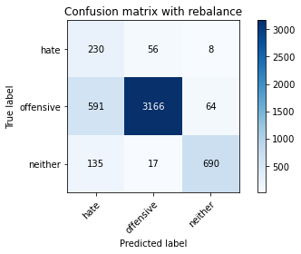

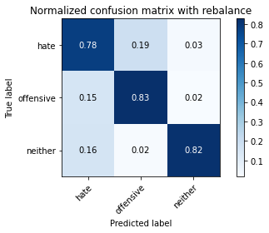

precision recall f1-score support

hate 0.24 0.78 0.37 294

offensive 0.98 0.83 0.90 3821

neither 0.91 0.82 0.86 842

accuracy 0.82 4957

macro avg 0.71 0.81 0.71 4957

weighted avg 0.92 0.82 0.86 4957

average eval_loss: 0.45990350235614086, accuracy: 0.8242888844058907

training 3 epoch...

103.54909753799438 seconds used......

3 training finished! average train loss: 0.2547550480703861

total clf loss: 45.91212363541126 total adv loss: 46.98020742833614

evaluating...

Confusion matrix, without normalization

[[ 229 37 28]

[ 850 2809 162]

[ 38 10 794]]

Normalized confusion matrix

[[0.77891156 0.12585034 0.0952381 ]

[0.22245485 0.73514787 0.04239728]

[0.04513064 0.01187648 0.94299287]]

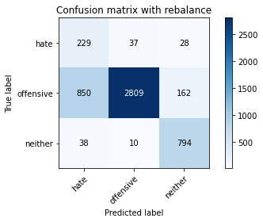

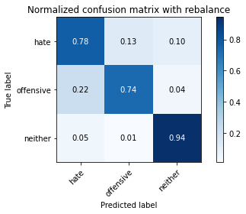

precision recall f1-score support

hate 0.21 0.78 0.32 294

offensive 0.98 0.74 0.84 3821

neither 0.81 0.94 0.87 842

accuracy 0.77 4957

macro avg 0.67 0.82 0.68 4957

weighted avg 0.91 0.77 0.82 4957

average eval_loss: 0.6105517885617672, accuracy: 0.7730482146459552

training 4 epoch...

103.5602457523346 seconds used......

4 training finished! average train loss: 0.1692813682800148

total clf loss: 31.406644189730287 total adv loss: 49.190603941679

evaluating...

Confusion matrix, without normalization

[[ 240 34 20]

[1092 2612 117]

[ 62 16 764]]

Normalized confusion matrix

[[0.81632653 0.11564626 0.06802721]

[0.28578906 0.68359068 0.03062026]

[0.0736342 0.01900238 0.90736342]]

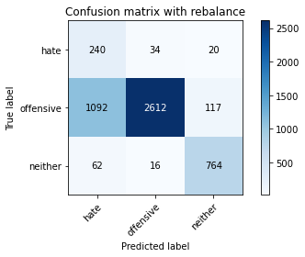

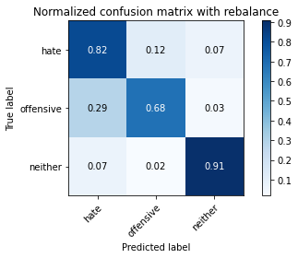

precision recall f1-score support

hate 0.17 0.82 0.28 294

offensive 0.98 0.68 0.81 3821

neither 0.85 0.91 0.88 842

accuracy 0.73 4957

macro avg 0.67 0.80 0.66 4957

weighted avg 0.91 0.73 0.79 4957

average eval_loss: 0.7900903462357218, accuracy: 0.7294734718579786

training 5 epoch...

103.54757738113403 seconds used......

5 training finished! average train loss: 0.07438234882756022

total clf loss: 15.30301162507385 total adv loss: 51.67259895056486

evaluating...

Confusion matrix, without normalization

[[ 226 45 23]

[ 866 2828 127]

[ 52 21 769]]

Normalized confusion matrix

[[0.76870748 0.15306122 0.07823129]

[0.22664224 0.74012039 0.03323737]

[0.06175772 0.02494062 0.91330166]]

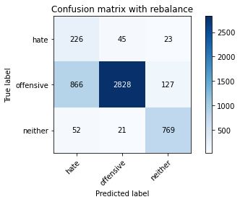

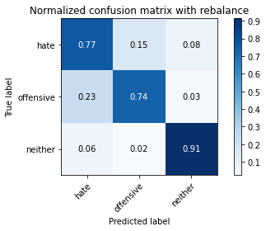

precision recall f1-score support

hate 0.20 0.77 0.31 294

offensive 0.98 0.74 0.84 3821

neither 0.84 0.91 0.87 842

accuracy 0.77 4957

macro avg 0.67 0.81 0.68 4957

weighted avg 0.91 0.77 0.82 4957

average eval_loss: 0.8440150518154335, accuracy: 0.7712326003631229

training 6 epoch...

103.47902965545654 seconds used......

6 training finished! average train loss: 0.038108852446863524

total clf loss: 9.093654768308625 total adv loss: 51.540818355977535

evaluating...

Confusion matrix, without normalization

[[ 202 64 28]

[ 543 3153 125]

[ 45 32 765]]

Normalized confusion matrix

[[0.68707483 0.21768707 0.0952381 ]

[0.1421094 0.82517666 0.03271395]

[0.05344418 0.03800475 0.90855107]]

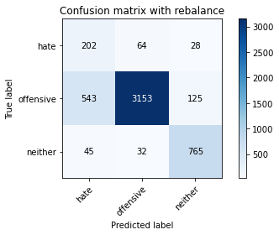

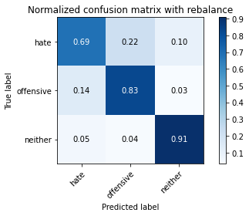

precision recall f1-score support

hate 0.26 0.69 0.37 294

offensive 0.97 0.83 0.89 3821

neither 0.83 0.91 0.87 842

accuracy 0.83 4957

macro avg 0.69 0.81 0.71 4957

weighted avg 0.90 0.83 0.86 4957

average eval_loss: 0.6846408955508753, accuracy: 0.8311478716965907

training 7 epoch...

103.4945662021637 seconds used......

7 training finished! average train loss: 0.004647089077203333

total clf loss: 3.374229226843454 total adv loss: 51.591539392247796

evaluating...

Confusion matrix, without normalization

[[ 221 56 17]

[ 774 2926 121]

[ 60 30 752]]

Normalized confusion matrix

[[0.75170068 0.19047619 0.05782313]

[0.20256477 0.76576812 0.0316671 ]

[0.07125891 0.03562945 0.89311164]]

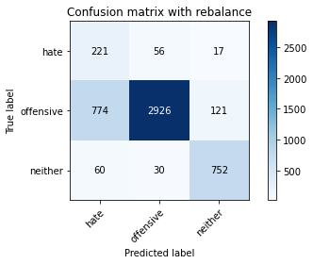

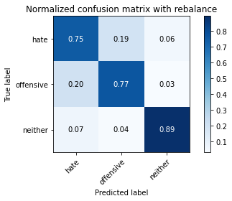

precision recall f1-score support

hate 0.21 0.75 0.33 294

offensive 0.97 0.77 0.86 3821

neither 0.84 0.89 0.87 842

accuracy 0.79 4957

macro avg 0.68 0.80 0.68 4957

weighted avg 0.90 0.79 0.83 4957

average eval_loss: 1.044633775122366, accuracy: 0.7865644543070406

training 8 epoch...

103.62628030776978 seconds used......

8 training finished! average train loss: 0.011235720446681854

total clf loss: 4.627263628062792 total adv loss: 54.11910779029131

evaluating...

Confusion matrix, without normalization

[[ 230 54 10]

[ 876 2871 74]

[ 107 41 694]]

Normalized confusion matrix

[[0.78231293 0.18367347 0.03401361]

[0.22925936 0.75137399 0.01936666]

[0.12707838 0.04869359 0.82422803]]

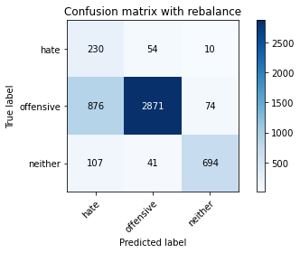

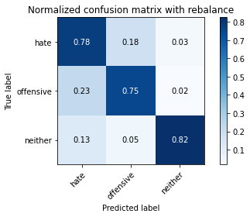

precision recall f1-score support

hate 0.19 0.78 0.31 294

offensive 0.97 0.75 0.85 3821

neither 0.89 0.82 0.86 842

accuracy 0.77 4957

macro avg 0.68 0.79 0.67 4957

weighted avg 0.91 0.77 0.82 4957

average eval_loss: 1.0079122922766293, accuracy: 0.765584022594311

training 9 epoch...

103.54844355583191 seconds used......

9 training finished! average train loss: 0.0065781929290564785

total clf loss: 3.8035738811595365 total adv loss: 53.57405664771795

evaluating...

Confusion matrix, without normalization

[[ 231 52 11]

[ 815 2925 81]

[ 87 48 707]]

Normalized confusion matrix

[[0.78571429 0.17687075 0.03741497]

[0.21329495 0.76550641 0.02119864]

[0.10332542 0.05700713 0.83966746]]

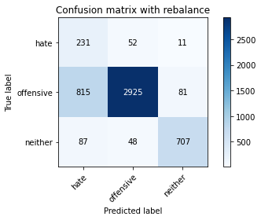

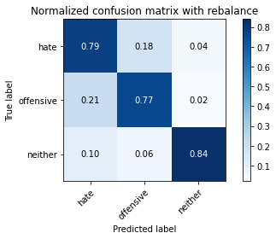

precision recall f1-score support

hate 0.20 0.79 0.32 294

offensive 0.97 0.77 0.85 3821

neither 0.88 0.84 0.86 842

accuracy 0.78 4957

macro avg 0.69 0.80 0.68 4957

weighted avg 0.91 0.78 0.82 4957

average eval_loss: 1.080018394936492, accuracy: 0.7793019971757111

training 10 epoch...

103.58443140983582 seconds used......

10 training finished! average train loss: -0.0006012540523028164

total clf loss: 2.5677094010461587 total adv loss: 53.41047587990761

evaluating...

Confusion matrix, without normalization

[[ 231 48 15]

[ 801 2921 99]

[ 68 28 746]]

Normalized confusion matrix

[[0.78571429 0.16326531 0.05102041]

[0.20963099 0.76445957 0.02590945]

[0.0807601 0.03325416 0.88598575]]

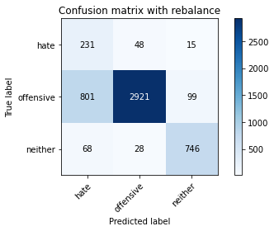

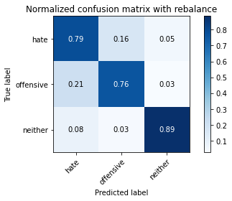

precision recall f1-score support

hate 0.21 0.79 0.33 294

offensive 0.97 0.76 0.86 3821

neither 0.87 0.89 0.88 842

accuracy 0.79 4957

macro avg 0.68 0.81 0.69 4957

weighted avg 0.91 0.79 0.83 4957

average eval_loss: 1.1544374272212266, accuracy: 0.7863627193867259

2 run

training 1 epoch...

103.51354002952576 seconds used......

1 training finished! average train loss: 0.6288577858467548

total clf loss: 110.63601019978523 total adv loss: 62.02657138556242

evaluating...

Confusion matrix, without normalization

[[ 212 57 25]

[ 612 3084 125]

[ 60 14 768]]

Normalized confusion matrix

[[0.72108844 0.19387755 0.08503401]

[0.1601675 0.80711856 0.03271395]

[0.07125891 0.01662708 0.91211401]]

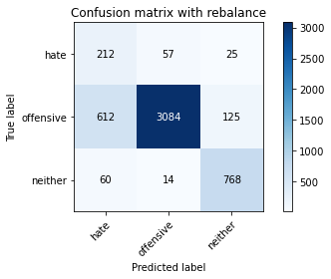

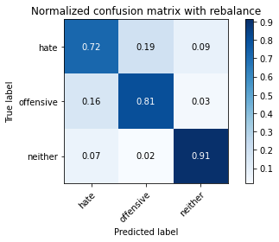

precision recall f1-score support

hate 0.24 0.72 0.36 294

offensive 0.98 0.81 0.88 3821

neither 0.84 0.91 0.87 842

accuracy 0.82 4957

macro avg 0.68 0.81 0.71 4957

weighted avg 0.91 0.82 0.85 4957

average eval_loss: 0.44893491935105095, accuracy: 0.8198507161589671

training 2 epoch...

103.59401845932007 seconds used......

2 training finished! average train loss: 0.38202733167430813

total clf loss: 67.79722645878792 total adv loss: 49.4110598936677

evaluating...

Confusion matrix, without normalization

[[ 242 29 23]

[1058 2669 94]

[ 63 20 759]]

Normalized confusion matrix

[[0.82312925 0.09863946 0.07823129]

[0.27689087 0.69850824 0.02460089]

[0.07482185 0.02375297 0.90142518]]

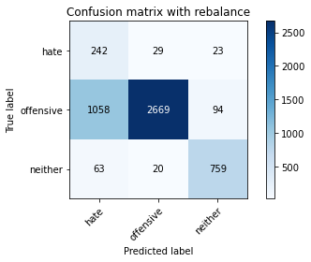

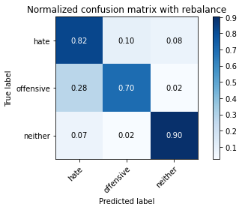

precision recall f1-score support

hate 0.18 0.82 0.29 294

offensive 0.98 0.70 0.82 3821

neither 0.87 0.90 0.88 842

accuracy 0.74 4957

macro avg 0.68 0.81 0.66 4957

weighted avg 0.91 0.74 0.80 4957

average eval_loss: 0.6157836032009893, accuracy: 0.7403671575549727

training 3 epoch...

103.55271863937378 seconds used......

3 training finished! average train loss: 0.26146524135916555

total clf loss: 47.171287667006254 total adv loss: 49.214624263346195

evaluating...

Confusion matrix, without normalization

[[ 222 52 20]

[ 712 3003 106]

[ 46 26 770]]

Normalized confusion matrix

[[0.75510204 0.17687075 0.06802721]

[0.18633865 0.78591992 0.02774143]

[0.05463183 0.03087886 0.91448931]]

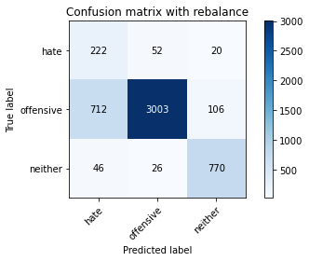

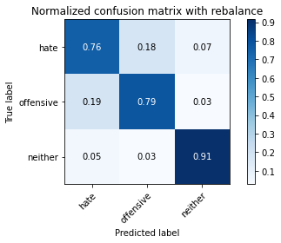

precision recall f1-score support

hate 0.23 0.76 0.35 294

offensive 0.97 0.79 0.87 3821

neither 0.86 0.91 0.89 842

accuracy 0.81 4957

macro avg 0.69 0.82 0.70 4957

weighted avg 0.91 0.81 0.84 4957

average eval_loss: 0.47139884483429695, accuracy: 0.8059310066572524

training 4 epoch...

103.55686950683594 seconds used......

4 training finished! average train loss: 0.1792489499376531

total clf loss: 33.080515556037426 total adv loss: 48.578902922570705

evaluating...

Confusion matrix, without normalization

[[ 230 40 24]

[ 937 2751 133]

[ 53 16 773]]

Normalized confusion matrix

[[0.78231293 0.13605442 0.08163265]

[0.24522376 0.71996859 0.03480764]

[0.06294537 0.01900238 0.91805226]]

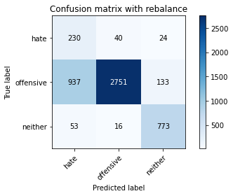

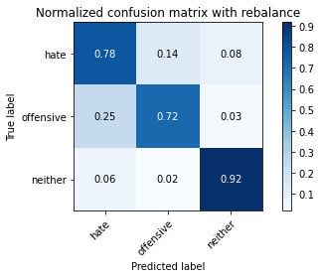

precision recall f1-score support

hate 0.19 0.78 0.30 294

offensive 0.98 0.72 0.83 3821

neither 0.83 0.92 0.87 842

accuracy 0.76 4957

macro avg 0.67 0.81 0.67 4957

weighted avg 0.91 0.76 0.81 4957

average eval_loss: 0.684631499521915, accuracy: 0.7573128908614081

training 5 epoch...

103.54932188987732 seconds used......

5 training finished! average train loss: 0.10253316386771655

total clf loss: 20.025711375288665 total adv loss: 49.850806422531605

evaluating...

Confusion matrix, without normalization

[[ 216 61 17]

[ 701 3023 97]

[ 65 34 743]]

Normalized confusion matrix

[[0.73469388 0.20748299 0.05782313]

[0.18345983 0.79115415 0.02538602]

[0.07719715 0.04038005 0.8824228 ]]

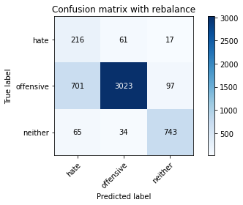

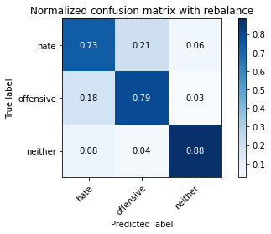

precision recall f1-score support

hate 0.22 0.73 0.34 294

offensive 0.97 0.79 0.87 3821

neither 0.87 0.88 0.87 842

accuracy 0.80 4957

macro avg 0.69 0.80 0.69 4957

weighted avg 0.91 0.80 0.84 4957

average eval_loss: 0.6041570631787181, accuracy: 0.8033084526931612

training 6 epoch...

103.64779806137085 seconds used......

6 training finished! average train loss: 0.052315161718676485

total clf loss: 11.471735024359077 total adv loss: 50.51684634760022

evaluating...

Confusion matrix, without normalization

[[ 232 51 11]

[ 930 2819 72]

[ 109 47 686]]

Normalized confusion matrix

[[0.78911565 0.17346939 0.03741497]

[0.24339178 0.73776498 0.01884323]

[0.12945368 0.05581948 0.81472684]]

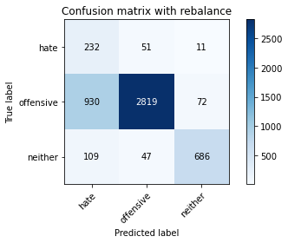

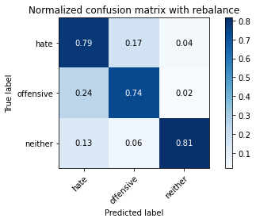

precision recall f1-score support

hate 0.18 0.79 0.30 294

offensive 0.97 0.74 0.84 3821

neither 0.89 0.81 0.85 842

accuracy 0.75 4957

macro avg 0.68 0.78 0.66 4957

weighted avg 0.91 0.75 0.81 4957

average eval_loss: 0.8298722237288472, accuracy: 0.7538833972160581

training 7 epoch...

103.58615446090698 seconds used......

7 training finished! average train loss: 0.01710390196895303

total clf loss: 5.494007950765081 total adv loss: 51.38481339812279

evaluating...

Confusion matrix, without normalization

[[ 236 41 17]

[1065 2651 105]

[ 82 17 743]]

Normalized confusion matrix

[[0.80272109 0.13945578 0.05782313]

[0.27872285 0.69379744 0.02747972]

[0.09738717 0.02019002 0.8824228 ]]

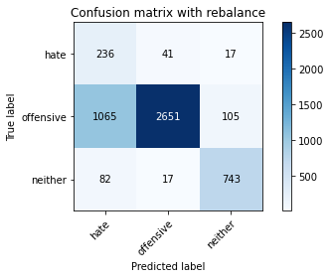

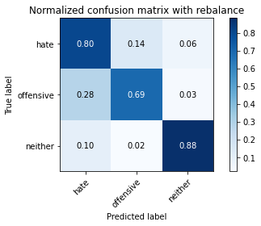

precision recall f1-score support

hate 0.17 0.80 0.28 294

offensive 0.98 0.69 0.81 3821

neither 0.86 0.88 0.87 842

accuracy 0.73 4957

macro avg 0.67 0.79 0.65 4957

weighted avg 0.91 0.73 0.79 4957

average eval_loss: 1.1969280723302114, accuracy: 0.7322977607423845

training 8 epoch...

103.64258122444153 seconds used......

8 training finished! average train loss: 0.02457420432079605

total clf loss: 6.808070585713722 total adv loss: 52.11763196438551

evaluating...

Confusion matrix, without normalization

[[ 215 58 21]

[ 736 2967 118]

[ 57 24 761]]

Normalized confusion matrix

[[0.73129252 0.19727891 0.07142857]

[0.19261973 0.7764983 0.03088197]

[0.06769596 0.02850356 0.90380048]]

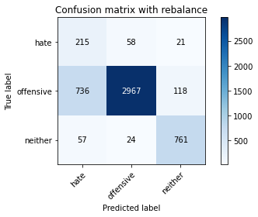

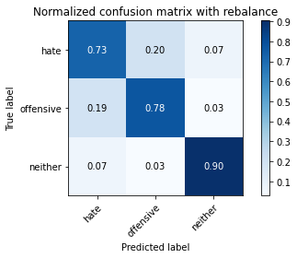

precision recall f1-score support

hate 0.21 0.73 0.33 294

offensive 0.97 0.78 0.86 3821

neither 0.85 0.90 0.87 842

accuracy 0.80 4957

macro avg 0.68 0.80 0.69 4957

weighted avg 0.91 0.80 0.83 4957

average eval_loss: 0.9556072626775506, accuracy: 0.7954407908008876

training 9 epoch...

103.5912458896637 seconds used......

9 training finished! average train loss: 0.003232455324948008

total clf loss: 3.169593840779271 total adv loss: 52.336879305541515

evaluating...

Confusion matrix, without normalization

[[ 214 63 17]

[ 702 3022 97]

[ 90 32 720]]

Normalized confusion matrix

[[0.72789116 0.21428571 0.05782313]

[0.18372154 0.79089244 0.02538602]

[0.10688836 0.03800475 0.85510689]]

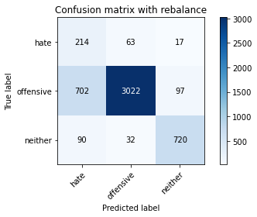

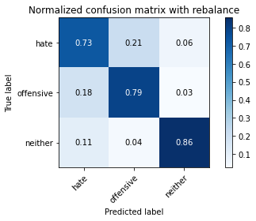

precision recall f1-score support

hate 0.21 0.73 0.33 294

offensive 0.97 0.79 0.87 3821

neither 0.86 0.86 0.86 842

accuracy 0.80 4957

macro avg 0.68 0.79 0.69 4957

weighted avg 0.91 0.80 0.84 4957

average eval_loss: 1.0765237906917688, accuracy: 0.7980633447649789

training 10 epoch...

103.75847506523132 seconds used......

10 training finished! average train loss: 0.0022756563641174493

total clf loss: 3.065569364349358 total adv loss: 53.52864148467779

evaluating...

Confusion matrix, without normalization

[[ 239 42 13]

[ 971 2776 74]

[ 117 39 686]]

Normalized confusion matrix

[[0.81292517 0.14285714 0.04421769]

[0.25412196 0.72651138 0.01936666]

[0.13895487 0.04631829 0.81472684]]

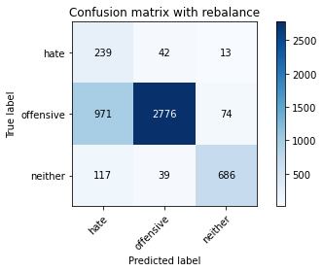

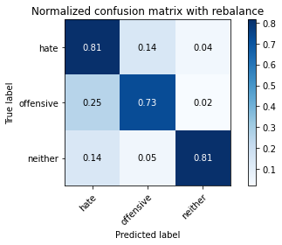

precision recall f1-score support

hate 0.18 0.81 0.29 294

offensive 0.97 0.73 0.83 3821

neither 0.89 0.81 0.85 842

accuracy 0.75 4957

macro avg 0.68 0.78 0.66 4957

weighted avg 0.91 0.75 0.80 4957

average eval_loss: 1.4300987779973977, accuracy: 0.7466209400847287

3 run

training 1 epoch...

103.6898832321167 seconds used......

1 training finished! average train loss: 0.6588501835252807

total clf loss: 115.81916809082031 total adv loss: 63.115740329027176

evaluating...

Confusion matrix, without normalization

[[ 237 33 24]

[ 909 2789 123]

[ 60 12 770]]

Normalized confusion matrix

[[0.80612245 0.1122449 0.08163265]

[0.23789584 0.72991364 0.03219053]

[0.07125891 0.01425178 0.91448931]]

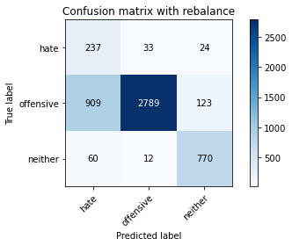

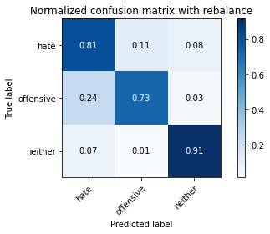

precision recall f1-score support

hate 0.20 0.81 0.32 294

offensive 0.98 0.73 0.84 3821

neither 0.84 0.91 0.88 842

accuracy 0.77 4957

macro avg 0.67 0.82 0.68 4957

weighted avg 0.91 0.77 0.81 4957

average eval_loss: 0.5835398898249672, accuracy: 0.7657857575146257

training 2 epoch...

103.6369948387146 seconds used......

2 training finished! average train loss: 0.38176936346885054

total clf loss: 67.74922174960375 total adv loss: 49.33320711553097

evaluating...

Confusion matrix, without normalization

[[ 200 65 29]

[ 504 3161 156]

[ 36 19 787]]

Normalized confusion matrix

[[0.68027211 0.22108844 0.09863946]

[0.13190264 0.82727035 0.04082701]

[0.04275534 0.02256532 0.93467933]]

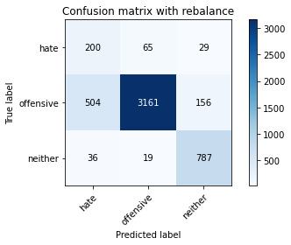

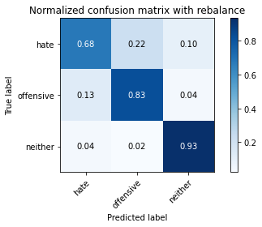

precision recall f1-score support

hate 0.27 0.68 0.39 294

offensive 0.97 0.83 0.89 3821

neither 0.81 0.93 0.87 842

accuracy 0.84 4957

macro avg 0.68 0.81 0.72 4957

weighted avg 0.90 0.84 0.86 4957

average eval_loss: 0.40944429841493407, accuracy: 0.8367964494654024

training 3 epoch...

103.72810387611389 seconds used......

3 training finished! average train loss: 0.2586018783394356

total clf loss: 46.69418638944626 total adv loss: 49.46530333906412

evaluating...

Confusion matrix, without normalization

[[ 244 38 12]

[1045 2682 94]

[ 88 15 739]]

Normalized confusion matrix

[[0.82993197 0.1292517 0.04081633]

[0.27348862 0.70191049 0.02460089]

[0.10451306 0.01781473 0.87767221]]

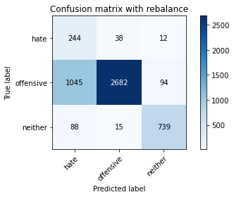

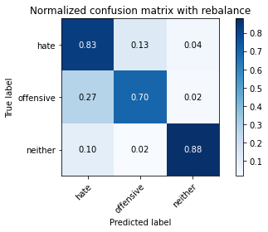

precision recall f1-score support

hate 0.18 0.83 0.29 294

offensive 0.98 0.70 0.82 3821

neither 0.87 0.88 0.88 842

accuracy 0.74 4957

macro avg 0.68 0.80 0.66 4957

weighted avg 0.91 0.74 0.80 4957

average eval_loss: 0.6803517826502362, accuracy: 0.7393584829533992

training 4 epoch...

103.64521861076355 seconds used......

4 training finished! average train loss: 0.16783480180634391

total clf loss: 31.13935941271484 total adv loss: 48.79216608032584

evaluating...

Confusion matrix, without normalization

[[ 217 60 17]

[ 610 3110 101]

[ 61 27 754]]

Normalized confusion matrix

[[0.73809524 0.20408163 0.05782313]

[0.15964407 0.81392306 0.02643287]

[0.07244656 0.03206651 0.89548694]]

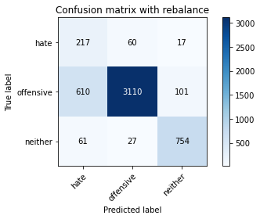

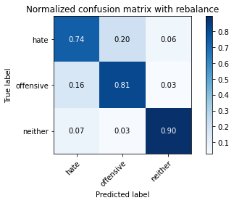

precision recall f1-score support

hate 0.24 0.74 0.37 294

offensive 0.97 0.81 0.89 3821

neither 0.86 0.90 0.88 842

accuracy 0.82 4957

macro avg 0.69 0.82 0.71 4957

weighted avg 0.91 0.82 0.85 4957

average eval_loss: 0.514552557825922, accuracy: 0.8232802098043172

training 5 epoch...

103.61881852149963 seconds used......

5 training finished! average train loss: 0.08477753148637494

total clf loss: 16.931502196006477 total adv loss: 48.69088563323021

evaluating...

Confusion matrix, without normalization

[[ 229 48 17]

[ 827 2890 104]

[ 58 31 753]]

Normalized confusion matrix

[[0.77891156 0.16326531 0.05782313]

[0.21643549 0.75634651 0.02721801]

[0.06888361 0.0368171 0.89429929]]

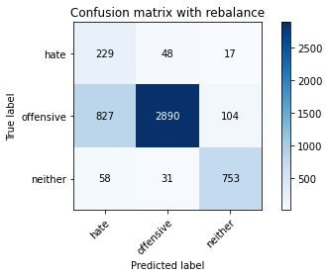

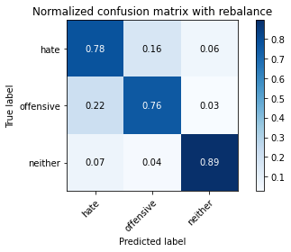

precision recall f1-score support

hate 0.21 0.78 0.33 294

offensive 0.97 0.76 0.85 3821

neither 0.86 0.89 0.88 842

accuracy 0.78 4957

macro avg 0.68 0.81 0.68 4957

weighted avg 0.91 0.78 0.82 4957

average eval_loss: 0.7567441104761055, accuracy: 0.7811176114585435

training 6 epoch...

103.54408431053162 seconds used......

6 training finished! average train loss: 0.03085755492555119

total clf loss: 7.786549480399117 total adv loss: 50.19815144315362

evaluating...

Confusion matrix, without normalization

[[ 235 48 11]

[ 899 2850 72]

[ 82 39 721]]

Normalized confusion matrix

[[0.79931973 0.16326531 0.03741497]

[0.23527872 0.74587804 0.01884323]

[0.09738717 0.04631829 0.85629454]]

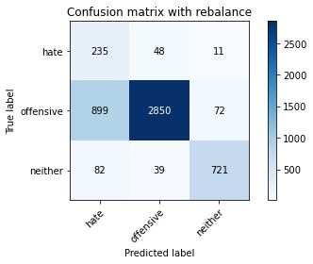

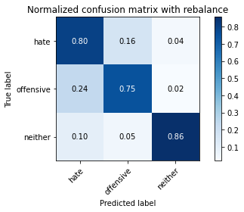

precision recall f1-score support

hate 0.19 0.80 0.31 294

offensive 0.97 0.75 0.84 3821

neither 0.90 0.86 0.88 842

accuracy 0.77 4957

macro avg 0.69 0.80 0.68 4957

weighted avg 0.91 0.77 0.82 4957

average eval_loss: 0.9114949190838924, accuracy: 0.7678031067177729

training 7 epoch...

103.70902991294861 seconds used......

7 training finished! average train loss: 0.027565644114490664

total clf loss: 7.249269563471898 total adv loss: 50.71088695526123

evaluating...

Confusion matrix, without normalization

[[ 176 98 20]

[ 272 3456 93]

[ 31 50 761]]

Normalized confusion matrix

[[0.59863946 0.33333333 0.06802721]

[0.07118555 0.90447527 0.02433918]

[0.0368171 0.05938242 0.90380048]]

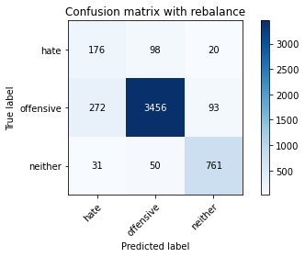

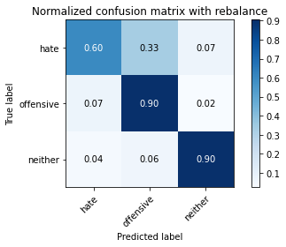

precision recall f1-score support

hate 0.37 0.60 0.46 294

offensive 0.96 0.90 0.93 3821

neither 0.87 0.90 0.89 842

accuracy 0.89 4957

macro avg 0.73 0.80 0.76 4957

weighted avg 0.91 0.89 0.90 4957

average eval_loss: 0.5313264238408714, accuracy: 0.8862215049425055

training 8 epoch...

103.6785204410553 seconds used......

8 training finished! average train loss: 0.0076883620587967294

total clf loss: 3.831893627240788 total adv loss: 50.3436733186245

evaluating...

Confusion matrix, without normalization

[[ 215 64 15]

[ 649 3076 96]

[ 75 54 713]]

Normalized confusion matrix

[[0.73129252 0.21768707 0.05102041]

[0.16985082 0.80502486 0.02512431]

[0.08907363 0.06413302 0.84679335]]

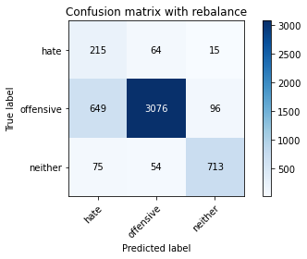

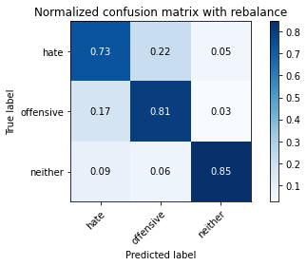

precision recall f1-score support

hate 0.23 0.73 0.35 294

offensive 0.96 0.81 0.88 3821

neither 0.87 0.85 0.86 842

accuracy 0.81 4957

macro avg 0.69 0.79 0.69 4957

weighted avg 0.90 0.81 0.84 4957

average eval_loss: 0.8865449607462412, accuracy: 0.8077466209400848

training 9 epoch...

103.66494035720825 seconds used......

9 training finished! average train loss: 0.0017167907453289157

total clf loss: 2.8657274362049066 total adv loss: 51.44312322884798

evaluating...

Confusion matrix, without normalization

[[ 210 63 21]

[ 579 3116 126]

[ 59 22 761]]

Normalized confusion matrix

[[0.71428571 0.21428571 0.07142857]

[0.15153101 0.81549333 0.03297566]

[0.07007126 0.02612827 0.90380048]]

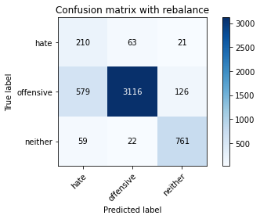

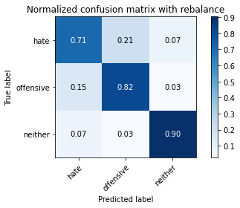

precision recall f1-score support

hate 0.25 0.71 0.37 294

offensive 0.97 0.82 0.89 3821

neither 0.84 0.90 0.87 842

accuracy 0.82 4957

macro avg 0.69 0.81 0.71 4957

weighted avg 0.91 0.82 0.85 4957

average eval_loss: 0.8963163627889909, accuracy: 0.8244906193262054

training 10 epoch...

103.59948396682739 seconds used......

10 training finished! average train loss: 0.013462657313140338

total clf loss: 4.903944115707418 total adv loss: 52.036593087017536

evaluating...

Confusion matrix, without normalization

[[ 216 60 18]

[ 688 2953 180]

[ 67 19 756]]

Normalized confusion matrix

[[0.73469388 0.20408163 0.06122449]

[0.18005758 0.77283434 0.04710809]

[0.07957245 0.02256532 0.89786223]]

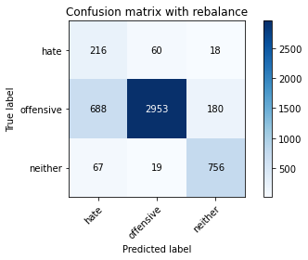

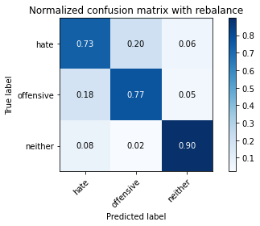

precision recall f1-score support

hate 0.22 0.73 0.34 294

offensive 0.97 0.77 0.86 3821

neither 0.79 0.90 0.84 842

accuracy 0.79 4957

macro avg 0.66 0.80 0.68 4957

weighted avg 0.90 0.79 0.83 4957

average eval_loss: 1.063681302171561, accuracy: 0.7918095622352229

4 run

training 1 epoch...

103.49739098548889 seconds used......

1 training finished! average train loss: 0.6445923115600619

total clf loss: 113.34791114926338 total adv loss: 62.45251851528883

evaluating...

Confusion matrix, without normalization

[[ 235 37 22]

[ 936 2790 95]

[ 73 18 751]]

Normalized confusion matrix

[[0.79931973 0.12585034 0.07482993]

[0.24496205 0.73017535 0.0248626 ]

[0.08669834 0.02137767 0.89192399]]

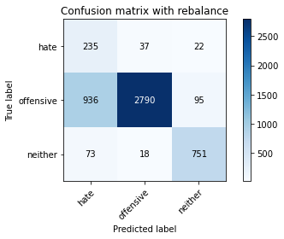

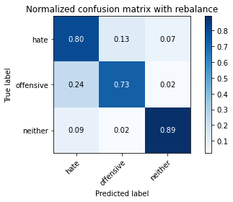

precision recall f1-score support

hate 0.19 0.80 0.31 294

offensive 0.98 0.73 0.84 3821

neither 0.87 0.89 0.88 842

accuracy 0.76 4957

macro avg 0.68 0.81 0.67 4957

weighted avg 0.91 0.76 0.81 4957

average eval_loss: 0.5608420358790506, accuracy: 0.7617510591083316

training 2 epoch...

103.44976282119751 seconds used......

2 training finished! average train loss: 0.3799471495270032

total clf loss: 67.39476723223925 total adv loss: 48.47608959674835

evaluating...

Confusion matrix, without normalization

[[ 231 51 12]

[ 736 3012 73]

[ 89 35 718]]

Normalized confusion matrix

[[0.78571429 0.17346939 0.04081633]

[0.19261973 0.78827532 0.01910495]

[0.10570071 0.0415677 0.85273159]]

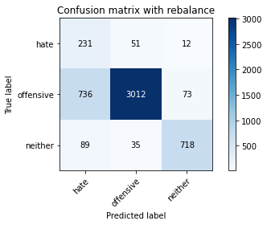

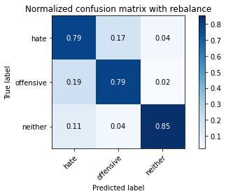

precision recall f1-score support

hate 0.22 0.79 0.34 294

offensive 0.97 0.79 0.87 3821

neither 0.89 0.85 0.87 842

accuracy 0.80 4957

macro avg 0.70 0.81 0.70 4957

weighted avg 0.91 0.80 0.84 4957

average eval_loss: 0.46631119150908723, accuracy: 0.7990720193665524

training 3 epoch...

103.41116642951965 seconds used......

3 training finished! average train loss: 0.25347496569156647

total clf loss: 45.84744480252266 total adv loss: 50.06451204791665

evaluating...

Confusion matrix, without normalization

[[ 230 47 17]

[ 786 2929 106]

[ 59 29 754]]

Normalized confusion matrix

[[0.78231293 0.15986395 0.05782313]

[0.20570531 0.76655326 0.02774143]

[0.07007126 0.03444181 0.89548694]]

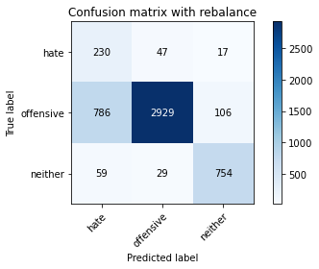

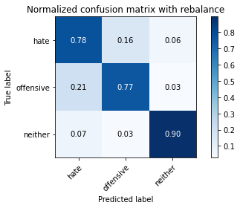

precision recall f1-score support

hate 0.21 0.78 0.34 294

offensive 0.97 0.77 0.86 3821

neither 0.86 0.90 0.88 842

accuracy 0.79 4957

macro avg 0.68 0.81 0.69 4957

weighted avg 0.91 0.79 0.83 4957

average eval_loss: 0.5114555368199944, accuracy: 0.7893887431914465

training 4 epoch...

103.66889429092407 seconds used......

4 training finished! average train loss: 0.15217096039382685

total clf loss: 28.540389711037278 total adv loss: 50.38310918211937

evaluating...

Confusion matrix, without normalization

[[ 212 62 20]

[ 678 3025 118]

[ 60 25 757]]

Normalized confusion matrix

[[0.72108844 0.21088435 0.06802721]

[0.17744046 0.79167757 0.03088197]

[0.07125891 0.02969121 0.89904988]]

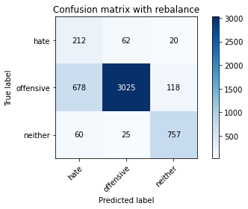

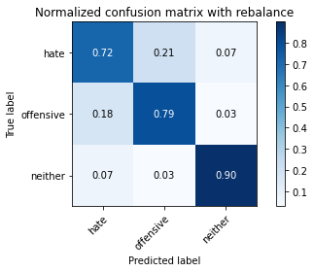

precision recall f1-score support

hate 0.22 0.72 0.34 294

offensive 0.97 0.79 0.87 3821

neither 0.85 0.90 0.87 842

accuracy 0.81 4957

macro avg 0.68 0.80 0.70 4957

weighted avg 0.91 0.81 0.84 4957

average eval_loss: 0.5671175139235153, accuracy: 0.8057292717369376

training 5 epoch...

103.51420497894287 seconds used......

5 training finished! average train loss: 0.07211526261359366

total clf loss: 14.843464214354753 total adv loss: 50.23508404940367

evaluating...

Confusion matrix, without normalization

[[ 222 54 18]

[ 918 2797 106]

[ 58 22 762]]

Normalized confusion matrix

[[0.75510204 0.18367347 0.06122449]

[0.24025124 0.73200733 0.02774143]

[0.06888361 0.02612827 0.90498812]]

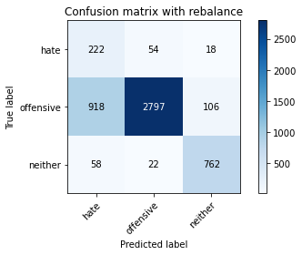

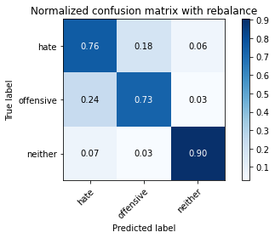

precision recall f1-score support

hate 0.19 0.76 0.30 294

offensive 0.97 0.73 0.84 3821

neither 0.86 0.90 0.88 842

accuracy 0.76 4957

macro avg 0.67 0.80 0.67 4957

weighted avg 0.91 0.76 0.81 4957

average eval_loss: 0.7796166000527239, accuracy: 0.7627597337099051

training 6 epoch...

103.53945422172546 seconds used......

6 training finished! average train loss: 0.031715631196329815

total clf loss: 7.962942727608606 total adv loss: 50.79139493405819

evaluating...

Confusion matrix, without normalization

[[ 182 83 29]

[ 471 3232 118]

[ 33 36 773]]

Normalized confusion matrix

[[0.61904762 0.28231293 0.09863946]

[0.12326616 0.84585187 0.03088197]

[0.0391924 0.04275534 0.91805226]]

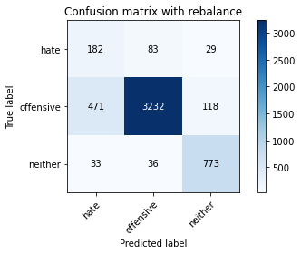

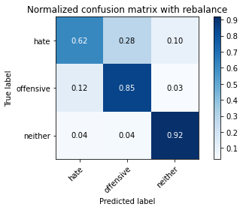

precision recall f1-score support

hate 0.27 0.62 0.37 294

offensive 0.96 0.85 0.90 3821

neither 0.84 0.92 0.88 842

accuracy 0.84 4957

macro avg 0.69 0.79 0.72 4957

weighted avg 0.90 0.84 0.87 4957

average eval_loss: 0.6131555157396267, accuracy: 0.844664111357676

training 7 epoch...

103.45660042762756 seconds used......

7 training finished! average train loss: 0.015998107456052076

total clf loss: 5.29089427262079 total adv loss: 51.10435730218887

evaluating...

Confusion matrix, without normalization

[[ 232 43 19]

[ 930 2793 98]

[ 61 38 743]]

Normalized confusion matrix

[[0.78911565 0.1462585 0.06462585]

[0.24339178 0.73096048 0.02564774]

[0.07244656 0.04513064 0.8824228 ]]

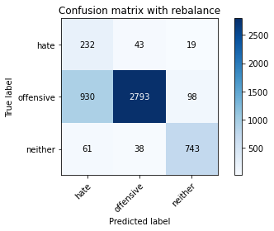

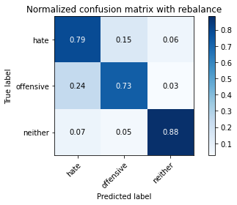

precision recall f1-score support

hate 0.19 0.79 0.31 294

offensive 0.97 0.73 0.83 3821

neither 0.86 0.88 0.87 842

accuracy 0.76 4957

macro avg 0.68 0.80 0.67 4957

weighted avg 0.91 0.76 0.81 4957

average eval_loss: 1.1096528798093899, accuracy: 0.760137179745814

training 8 epoch...

103.51906657218933 seconds used......

8 training finished! average train loss: 0.015144532811909653

total clf loss: 5.133197645714972 total adv loss: 50.8696501404047

evaluating...

Confusion matrix, without normalization

[[ 231 44 19]

[ 952 2740 129]

[ 65 16 761]]

Normalized confusion matrix

[[0.78571429 0.14965986 0.06462585]

[0.24914944 0.71708977 0.0337608 ]

[0.07719715 0.01900238 0.90380048]]

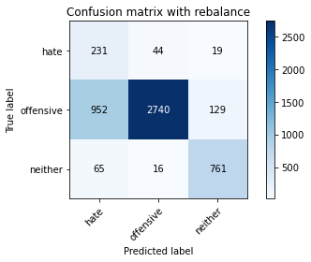

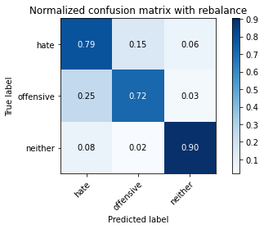

precision recall f1-score support

hate 0.19 0.79 0.30 294

offensive 0.98 0.72 0.83 3821

neither 0.84 0.90 0.87 842

accuracy 0.75 4957

macro avg 0.67 0.80 0.67 4957

weighted avg 0.91 0.75 0.80 4957

average eval_loss: 1.3184869821228447, accuracy: 0.7528747226144845

training 9 epoch...

103.49135899543762 seconds used......

9 training finished! average train loss: 0.012548322361834043

total clf loss: 4.677830051863566 total adv loss: 50.64133770763874

evaluating...

Confusion matrix, without normalization

[[ 199 74 21]

[ 531 3181 109]

[ 63 42 737]]

Normalized confusion matrix

[[0.67687075 0.25170068 0.07142857]

[0.13896886 0.83250458 0.02852656]

[0.07482185 0.04988124 0.87529691]]

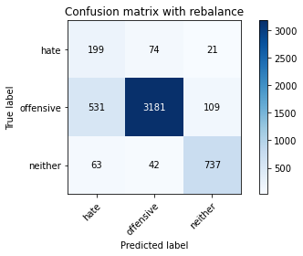

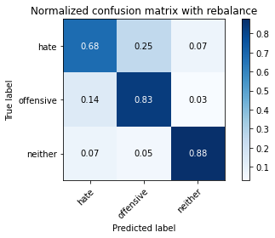

precision recall f1-score support

hate 0.25 0.68 0.37 294

offensive 0.96 0.83 0.89 3821

neither 0.85 0.88 0.86 842

accuracy 0.83 4957

macro avg 0.69 0.79 0.71 4957

weighted avg 0.90 0.83 0.86 4957

average eval_loss: 0.8002626104134833, accuracy: 0.8305426669356466

training 10 epoch...

103.47153282165527 seconds used......

10 training finished! average train loss: -0.005122202157168187

total clf loss: 1.706393403117545 total adv loss: 51.645798571407795

evaluating...

Confusion matrix, without normalization

[[ 215 58 21]

[ 748 2962 111]

[ 60 42 740]]

Normalized confusion matrix

[[0.73129252 0.19727891 0.07142857]

[0.19576027 0.77518974 0.02904999]

[0.07125891 0.04988124 0.87885986]]

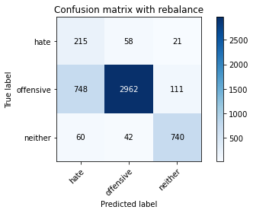

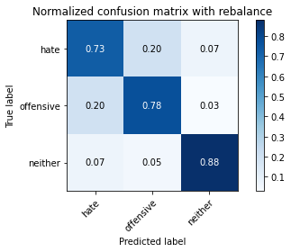

precision recall f1-score support

hate 0.21 0.73 0.33 294

offensive 0.97 0.78 0.86 3821

neither 0.85 0.88 0.86 842

accuracy 0.79 4957

macro avg 0.68 0.80 0.68 4957

weighted avg 0.90 0.79 0.83 4957

average eval_loss: 1.1708310844692131, accuracy: 0.7901956828727053

5 run

training 1 epoch...

104.03300189971924 seconds used......

1 training finished! average train loss: 0.6810432975752312

total clf loss: 119.64117467403412 total adv loss: 63.6554174348712

evaluating...

Confusion matrix, without normalization

[[ 233 48 13]

[ 783 2971 67]

[ 148 17 677]]

Normalized confusion matrix

[[0.79251701 0.16326531 0.04421769]

[0.20492018 0.77754515 0.01753468]

[0.17577197 0.02019002 0.804038 ]]

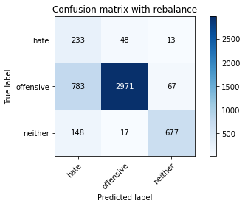

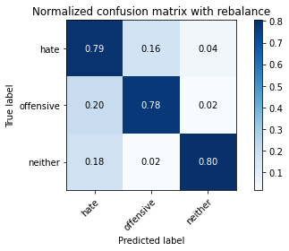

precision recall f1-score support

hate 0.20 0.79 0.32 294

offensive 0.98 0.78 0.87 3821

neither 0.89 0.80 0.85 842

accuracy 0.78 4957

macro avg 0.69 0.79 0.68 4957

weighted avg 0.92 0.78 0.83 4957

average eval_loss: 0.4775587092604368, accuracy: 0.7829332257413758

training 2 epoch...

103.48180437088013 seconds used......

2 training finished! average train loss: 0.3863798760705524

total clf loss: 68.53359992057085 total adv loss: 49.252815663814545

evaluating...

Confusion matrix, without normalization

[[ 205 63 26]

[ 497 3178 146]

[ 43 9 790]]

Normalized confusion matrix

[[0.69727891 0.21428571 0.08843537]

[0.13007066 0.83171945 0.03820989]

[0.05106888 0.01068884 0.93824228]]

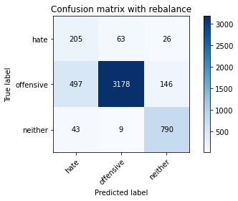

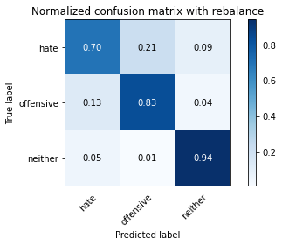

precision recall f1-score support

hate 0.28 0.70 0.39 294

offensive 0.98 0.83 0.90 3821

neither 0.82 0.94 0.88 842

accuracy 0.84 4957

macro avg 0.69 0.82 0.72 4957

weighted avg 0.91 0.84 0.87 4957

average eval_loss: 0.4016322654581839, accuracy: 0.8418398224732702

training 3 epoch...

103.46927118301392 seconds used......

3 training finished! average train loss: 0.2599743377221258

total clf loss: 46.898269820958376 total adv loss: 48.85315879061818

evaluating...

Confusion matrix, without normalization

[[ 231 42 21]

[ 891 2830 100]

[ 73 23 746]]

Normalized confusion matrix

[[0.78571429 0.14285714 0.07142857]

[0.23318503 0.74064381 0.02617116]

[0.08669834 0.02731591 0.88598575]]

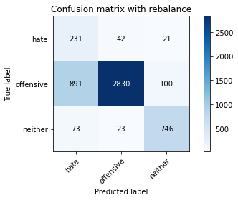

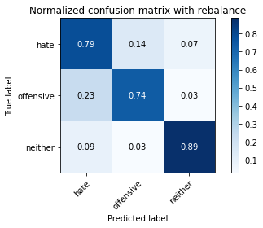

precision recall f1-score support

hate 0.19 0.79 0.31 294

offensive 0.98 0.74 0.84 3821

neither 0.86 0.89 0.87 842

accuracy 0.77 4957

macro avg 0.68 0.80 0.68 4957

weighted avg 0.91 0.77 0.82 4957

average eval_loss: 0.5462252003471216, accuracy: 0.7680048416380876

training 4 epoch...

103.49936318397522 seconds used......

4 training finished! average train loss: 0.1561385004329141

total clf loss: 29.133088536560535 total adv loss: 48.668097741901875

evaluating...

Confusion matrix, without normalization

[[ 194 69 31]

[ 538 3113 170]

[ 28 18 796]]

Normalized confusion matrix

[[0.65986395 0.23469388 0.10544218]

[0.14080084 0.81470819 0.04449097]

[0.03325416 0.02137767 0.94536817]]

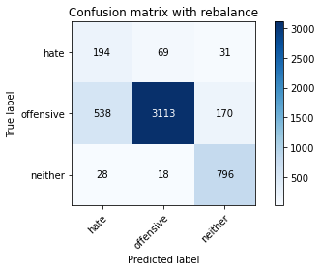

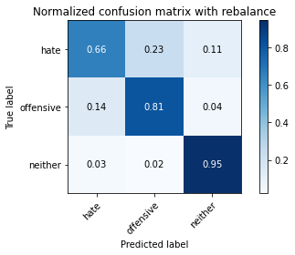

precision recall f1-score support

hate 0.26 0.66 0.37 294

offensive 0.97 0.81 0.89 3821

neither 0.80 0.95 0.87 842

accuracy 0.83 4957

macro avg 0.68 0.81 0.71 4957

weighted avg 0.90 0.83 0.85 4957

average eval_loss: 0.472599754508044, accuracy: 0.8277183780512407

training 5 epoch...

103.50292038917542 seconds used......

5 training finished! average train loss: 0.06644263564015342

total clf loss: 13.841843362897635 total adv loss: 49.60305241495371

evaluating...

Confusion matrix, without normalization

[[ 229 45 20]

[ 896 2800 125]

[ 74 14 754]]

Normalized confusion matrix

[[0.77891156 0.15306122 0.06802721]

[0.23449359 0.73279246 0.03271395]

[0.08788599 0.01662708 0.89548694]]

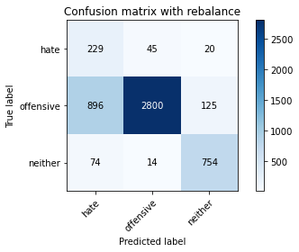

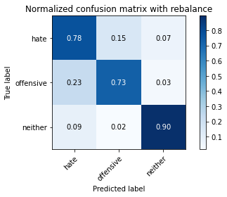

precision recall f1-score support

hate 0.19 0.78 0.31 294

offensive 0.98 0.73 0.84 3821

neither 0.84 0.90 0.87 842

accuracy 0.76 4957

macro avg 0.67 0.80 0.67 4957

weighted avg 0.91 0.76 0.81 4957

average eval_loss: 0.9463107942888934, accuracy: 0.7631632035505346

training 6 epoch...

103.35739088058472 seconds used......

6 training finished! average train loss: 0.026796554629173543

total clf loss: 7.075667454162613 total adv loss: 49.869131445884705

evaluating...

Confusion matrix, without normalization

[[ 242 34 18]

[1214 2485 122]

[ 92 12 738]]

Normalized confusion matrix

[[0.82312925 0.11564626 0.06122449]

[0.31771787 0.65035331 0.03192881]

[0.10926366 0.01425178 0.87648456]]

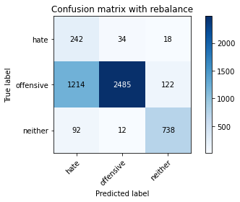

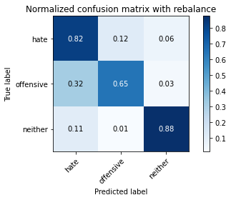

precision recall f1-score support

hate 0.16 0.82 0.26 294

offensive 0.98 0.65 0.78 3821

neither 0.84 0.88 0.86 842

accuracy 0.70 4957

macro avg 0.66 0.78 0.63 4957

weighted avg 0.91 0.70 0.76 4957

average eval_loss: 1.4966073275333451, accuracy: 0.6990114988904579

training 7 epoch...

103.2677366733551 seconds used......

7 training finished! average train loss: 0.01926775483349175

total clf loss: 5.805591546173673 total adv loss: 50.21610797196627

evaluating...

Confusion matrix, without normalization

[[ 206 56 32]

[ 593 3076 152]

[ 41 16 785]]

Normalized confusion matrix

[[0.70068027 0.19047619 0.10884354]

[0.15519498 0.80502486 0.03978016]

[0.04869359 0.01900238 0.93230404]]

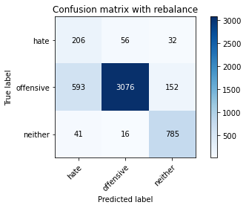

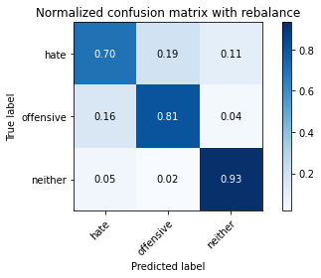

precision recall f1-score support

hate 0.25 0.70 0.36 294

offensive 0.98 0.81 0.88 3821

neither 0.81 0.93 0.87 842

accuracy 0.82 4957

macro avg 0.68 0.81 0.70 4957

weighted avg 0.91 0.82 0.85 4957

average eval_loss: 0.9001940877248172, accuracy: 0.8204559209199113

training 8 epoch...

103.29303455352783 seconds used......

8 training finished! average train loss: 0.0013663933928293444

total clf loss: 2.8377676420786884 total adv loss: 52.08228664845228

evaluating...

Confusion matrix, without normalization

[[ 206 64 24]

[ 604 3105 112]

[ 50 31 761]]

Normalized confusion matrix

[[0.70068027 0.21768707 0.08163265]

[0.1580738 0.8126145 0.0293117 ]

[0.05938242 0.0368171 0.90380048]]

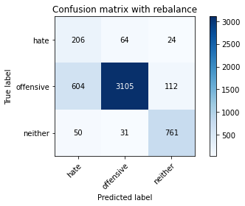

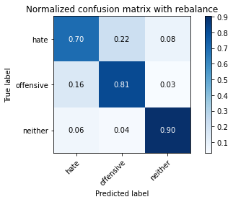

precision recall f1-score support

hate 0.24 0.70 0.36 294

offensive 0.97 0.81 0.88 3821

neither 0.85 0.90 0.88 842

accuracy 0.82 4957

macro avg 0.69 0.81 0.71 4957

weighted avg 0.91 0.82 0.85 4957

average eval_loss: 0.9425897109172037, accuracy: 0.8214645955214848

training 9 epoch...

103.28082966804504 seconds used......

9 training finished! average train loss: 0.00018172459377313566

total clf loss: 2.670280632650247 total adv loss: 52.78411369398236

evaluating...

Confusion matrix, without normalization

[[ 198 73 23]

[ 589 3135 97]

[ 46 43 753]]

Normalized confusion matrix

[[0.67346939 0.24829932 0.07823129]

[0.15414813 0.82046585 0.02538602]

[0.05463183 0.05106888 0.89429929]]

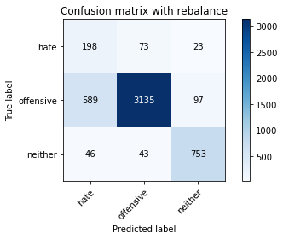

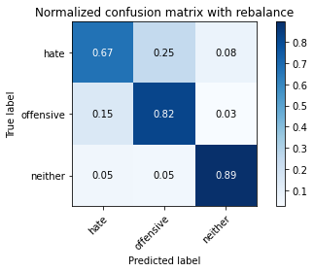

precision recall f1-score support

hate 0.24 0.67 0.35 294

offensive 0.96 0.82 0.89 3821

neither 0.86 0.89 0.88 842

accuracy 0.82 4957

macro avg 0.69 0.80 0.71 4957

weighted avg 0.90 0.82 0.85 4957

average eval_loss: 0.950358426735376, accuracy: 0.8242888844058907

training 10 epoch...

103.22104907035828 seconds used......

10 training finished! average train loss: -0.0023234516384940574

total clf loss: 2.317449702444719 total adv loss: 54.29519774764776

evaluating...

Confusion matrix, without normalization

[[ 239 40 15]

[ 963 2776 82]

[ 113 29 700]]

Normalized confusion matrix

[[0.81292517 0.13605442 0.05102041]

[0.25202826 0.72651138 0.02146035]

[0.13420428 0.03444181 0.83135392]]

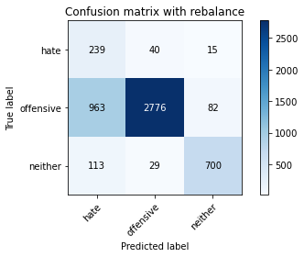

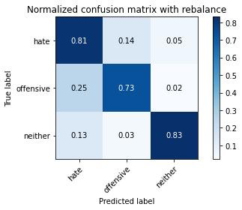

precision recall f1-score support

hate 0.18 0.81 0.30 294

offensive 0.98 0.73 0.83 3821

neither 0.88 0.83 0.85 842

accuracy 0.75 4957

macro avg 0.68 0.79 0.66 4957

weighted avg 0.91 0.75 0.80 4957

average eval_loss: 1.608068535497765, accuracy: 0.7494452289691346