1 run

[1.5, 0.3,1]

training 1 epoch...

64.19749164581299 seconds used......

1 training finished! average train loss: 0.5851526364945528

evaluating...

Confusion matrix, without normalization

[[ 220 37 37]

[ 813 2808 200]

[ 27 10 805]]

Normalized confusion matrix

[[0.74829932 0.12585034 0.12585034]

[0.21277153 0.73488616 0.05234232]

[0.03206651 0.01187648 0.95605701]]

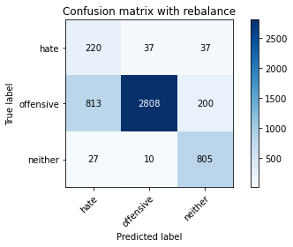

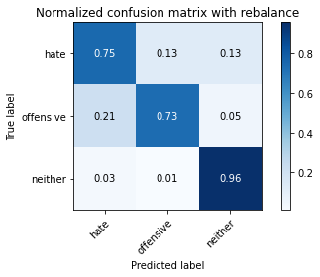

precision recall f1-score support

hate 0.21 0.75 0.32 294

offensive 0.98 0.73 0.84 3821

neither 0.77 0.96 0.85 842

accuracy 0.77 4957

macro avg 0.65 0.81 0.67 4957

weighted avg 0.90 0.77 0.81 4957

average eval_loss: 0.561041270593001, accuracy: 0.7732499495662699

training 2 epoch...

63.570385217666626 seconds used......

2 training finished! average train loss: 0.31119144982413244

evaluating...

Confusion matrix, without normalization

[[ 260 19 15]

[2014 1705 102]

[ 101 8 733]]

Normalized confusion matrix

[[0.88435374 0.06462585 0.05102041]

[0.52708715 0.44621827 0.02669458]

[0.11995249 0.00950119 0.87054632]]

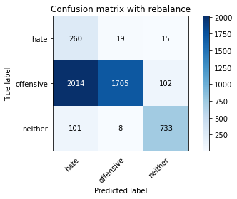

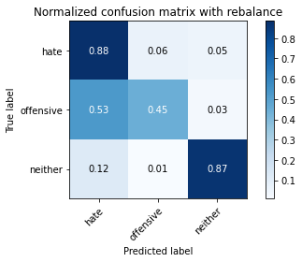

precision recall f1-score support

hate 0.11 0.88 0.19 294

offensive 0.98 0.45 0.61 3821

neither 0.86 0.87 0.87 842

accuracy 0.54 4957

macro avg 0.65 0.73 0.56 4957

weighted avg 0.91 0.54 0.63 4957

average eval_loss: 0.8090607588209452, accuracy: 0.5442808150090781

training 3 epoch...

63.64975929260254 seconds used......

3 training finished! average train loss: 0.19566798038039987

evaluating...

Confusion matrix, without normalization

[[ 250 27 17]

[1115 2602 104]

[ 86 15 741]]

Normalized confusion matrix

[[0.85034014 0.09183673 0.05782313]

[0.29180843 0.68097357 0.02721801]

[0.10213777 0.01781473 0.88004751]]

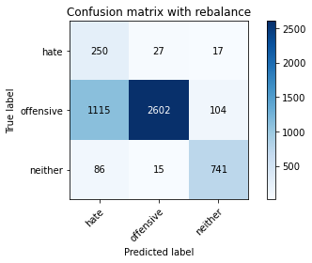

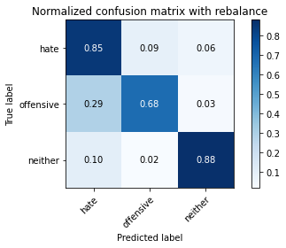

precision recall f1-score support

hate 0.17 0.85 0.29 294

offensive 0.98 0.68 0.80 3821

neither 0.86 0.88 0.87 842

accuracy 0.72 4957

macro avg 0.67 0.80 0.65 4957

weighted avg 0.91 0.72 0.79 4957

average eval_loss: 0.6162229567585934, accuracy: 0.7248335686907403

training 4 epoch...

63.54345893859863 seconds used......

4 training finished! average train loss: 0.12700052541947504

evaluating...

Confusion matrix, without normalization

[[ 243 29 22]

[1151 2527 143]

[ 55 18 769]]

Normalized confusion matrix

[[0.82653061 0.09863946 0.07482993]

[0.30123004 0.6613452 0.03742476]

[0.06532067 0.02137767 0.91330166]]

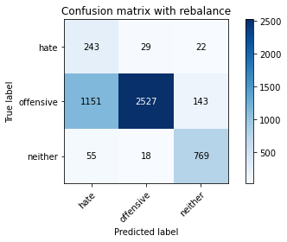

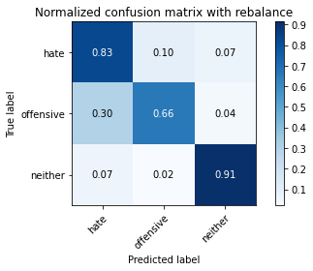

precision recall f1-score support

hate 0.17 0.83 0.28 294

offensive 0.98 0.66 0.79 3821

neither 0.82 0.91 0.87 842

accuracy 0.71 4957

macro avg 0.66 0.80 0.65 4957

weighted avg 0.91 0.71 0.77 4957

average eval_loss: 0.7176441947719262, accuracy: 0.7139398829937462

training 5 epoch...

63.705483198165894 seconds used......

5 training finished! average train loss: 0.10324661372153209

evaluating...

Confusion matrix, without normalization

[[ 224 41 29]

[ 916 2742 163]

[ 39 11 792]]

Normalized confusion matrix

[[0.76190476 0.13945578 0.09863946]

[0.23972782 0.71761319 0.04265899]

[0.04631829 0.01306413 0.94061758]]

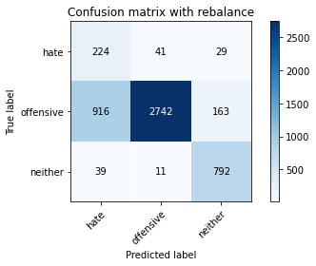

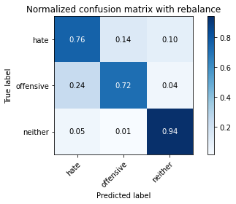

precision recall f1-score support

hate 0.19 0.76 0.30 294

offensive 0.98 0.72 0.83 3821

neither 0.80 0.94 0.87 842

accuracy 0.76 4957

macro avg 0.66 0.81 0.67 4957

weighted avg 0.90 0.76 0.80 4957

average eval_loss: 0.6669119152600967, accuracy: 0.758119830542667

training 6 epoch...

63.74294710159302 seconds used......

6 training finished! average train loss: 0.06985181996092331

evaluating...

Confusion matrix, without normalization

[[ 240 29 25]

[1005 2681 135]

[ 50 20 772]]

Normalized confusion matrix

[[0.81632653 0.09863946 0.08503401]

[0.26302015 0.70164878 0.03533107]

[0.05938242 0.02375297 0.91686461]]

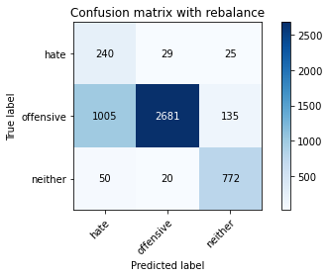

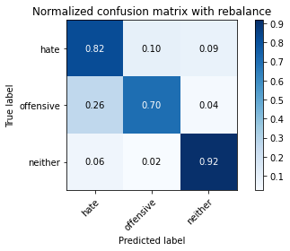

precision recall f1-score support

hate 0.19 0.82 0.30 294

offensive 0.98 0.70 0.82 3821

neither 0.83 0.92 0.87 842

accuracy 0.75 4957

macro avg 0.67 0.81 0.66 4957

weighted avg 0.91 0.75 0.80 4957

average eval_loss: 0.8457798370039992, accuracy: 0.745007060722211

training 7 epoch...

63.664061546325684 seconds used......

7 training finished! average train loss: 0.049871278835504115

evaluating...

Confusion matrix, without normalization

[[ 229 52 13]

[ 801 2935 85]

[ 110 35 697]]

Normalized confusion matrix

[[0.77891156 0.17687075 0.04421769]

[0.20963099 0.76812353 0.02224549]

[0.13064133 0.0415677 0.82779097]]

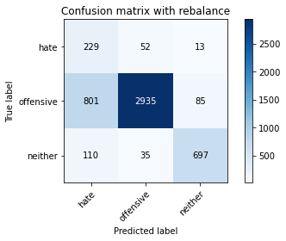

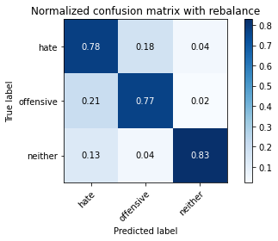

precision recall f1-score support

hate 0.20 0.78 0.32 294

offensive 0.97 0.77 0.86 3821

neither 0.88 0.83 0.85 842

accuracy 0.78 4957

macro avg 0.68 0.79 0.68 4957

weighted avg 0.91 0.78 0.82 4957

average eval_loss: 0.8063024349600798, accuracy: 0.7788985273350817

training 8 epoch...

63.752886056900024 seconds used......

8 training finished! average train loss: 0.045425339742176975

evaluating...

Confusion matrix, without normalization

[[ 240 36 18]

[1131 2578 112]

[ 64 20 758]]

Normalized confusion matrix

[[0.81632653 0.12244898 0.06122449]

[0.29599581 0.67469249 0.0293117 ]

[0.0760095 0.02375297 0.90023753]]

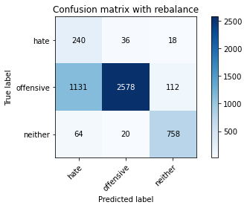

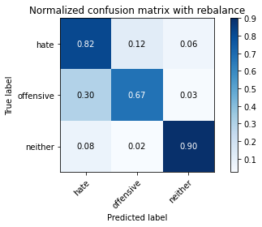

precision recall f1-score support

hate 0.17 0.82 0.28 294

offensive 0.98 0.67 0.80 3821

neither 0.85 0.90 0.88 842

accuracy 0.72 4957

macro avg 0.67 0.80 0.65 4957

weighted avg 0.91 0.72 0.78 4957

average eval_loss: 1.0016338954409283, accuracy: 0.7214040750453904

training 9 epoch...

63.67734336853027 seconds used......

9 training finished! average train loss: 0.020540388645495327

evaluating...

Confusion matrix, without normalization

[[ 208 65 21]

[ 795 2916 110]

[ 59 38 745]]

Normalized confusion matrix

[[0.70748299 0.22108844 0.07142857]

[0.20806072 0.76315101 0.02878828]

[0.07007126 0.04513064 0.8847981 ]]

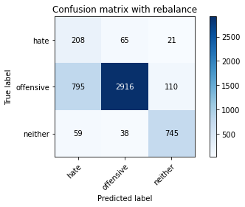

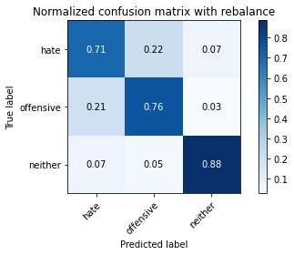

precision recall f1-score support

hate 0.20 0.71 0.31 294

offensive 0.97 0.76 0.85 3821

neither 0.85 0.88 0.87 842

accuracy 0.78 4957

macro avg 0.67 0.79 0.68 4957

weighted avg 0.90 0.78 0.82 4957

average eval_loss: 0.8953455482692187, accuracy: 0.7805124066975994

training 10 epoch...

63.734408140182495 seconds used......

10 training finished! average train loss: 0.022782032685054805

evaluating...

Confusion matrix, without normalization

[[ 233 46 15]

[ 996 2743 82]

[ 90 40 712]]

Normalized confusion matrix

[[0.79251701 0.15646259 0.05102041]

[0.26066475 0.7178749 0.02146035]

[0.10688836 0.04750594 0.8456057 ]]

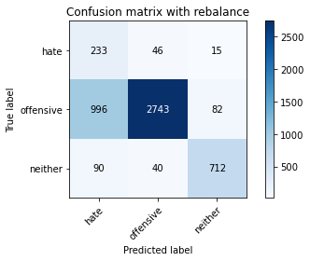

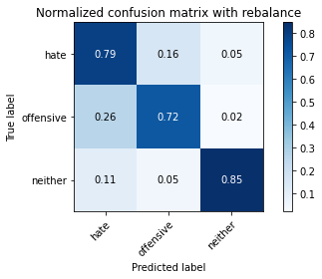

precision recall f1-score support

hate 0.18 0.79 0.29 294

offensive 0.97 0.72 0.82 3821

neither 0.88 0.85 0.86 842

accuracy 0.74 4957

macro avg 0.68 0.79 0.66 4957

weighted avg 0.91 0.74 0.80 4957

average eval_loss: 1.0671297065883634, accuracy: 0.7439983861206375

2 run

training 1 epoch...

63.761361837387085 seconds used......

1 training finished! average train loss: 0.5721987650146958

evaluating...

Confusion matrix, without normalization

[[ 234 28 32]

[1277 2377 167]

[ 34 9 799]]

Normalized confusion matrix

[[0.79591837 0.0952381 0.10884354]

[0.33420571 0.62208846 0.04370584]

[0.04038005 0.01068884 0.94893112]]

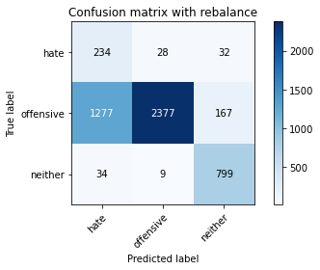

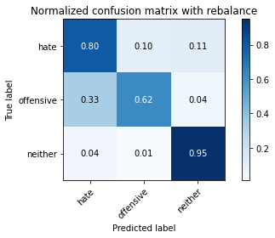

precision recall f1-score support

hate 0.15 0.80 0.25 294

offensive 0.98 0.62 0.76 3821

neither 0.80 0.95 0.87 842

accuracy 0.69 4957

macro avg 0.65 0.79 0.63 4957

weighted avg 0.90 0.69 0.75 4957

average eval_loss: 0.6658614509769024, accuracy: 0.687916078273149

training 2 epoch...

63.5816376209259 seconds used......

2 training finished! average train loss: 0.30939606137094444

evaluating...

Confusion matrix, without normalization

[[ 244 25 25]

[1547 2077 197]

[ 43 7 792]]

Normalized confusion matrix

[[0.82993197 0.08503401 0.08503401]

[0.40486784 0.54357498 0.05155718]

[0.05106888 0.00831354 0.94061758]]

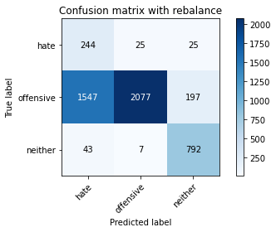

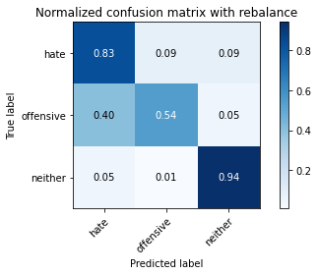

precision recall f1-score support

hate 0.13 0.83 0.23 294

offensive 0.98 0.54 0.70 3821

neither 0.78 0.94 0.85 842

accuracy 0.63 4957

macro avg 0.63 0.77 0.59 4957

weighted avg 0.90 0.63 0.70 4957

average eval_loss: 0.7354762492881667, accuracy: 0.6280008069396813

training 3 epoch...

63.50735354423523 seconds used......

3 training finished! average train loss: 0.1968021298056109

evaluating...

Confusion matrix, without normalization

[[ 254 24 16]

[1748 1980 93]

[ 121 10 711]]

Normalized confusion matrix

[[0.86394558 0.08163265 0.05442177]

[0.45747187 0.51818896 0.02433918]

[0.14370546 0.01187648 0.84441805]]

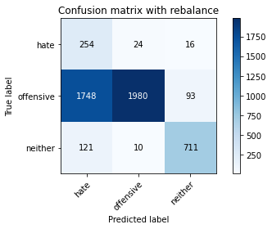

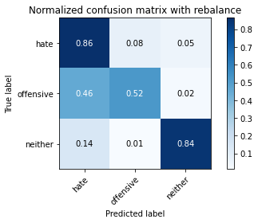

precision recall f1-score support

hate 0.12 0.86 0.21 294

offensive 0.98 0.52 0.68 3821

neither 0.87 0.84 0.86 842

accuracy 0.59 4957

macro avg 0.66 0.74 0.58 4957

weighted avg 0.91 0.59 0.68 4957

average eval_loss: 0.7943689799116503, accuracy: 0.5941093403268106

training 4 epoch...

63.595646381378174 seconds used......

4 training finished! average train loss: 0.12492117089660544

evaluating...

Confusion matrix, without normalization

[[ 246 28 20]

[1168 2514 139]

[ 74 10 758]]

Normalized confusion matrix

[[0.83673469 0.0952381 0.06802721]

[0.30567914 0.65794295 0.03637791]

[0.08788599 0.01187648 0.90023753]]

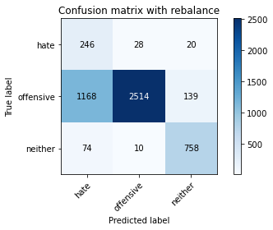

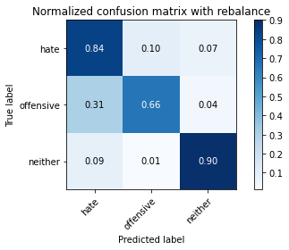

precision recall f1-score support

hate 0.17 0.84 0.28 294

offensive 0.99 0.66 0.79 3821

neither 0.83 0.90 0.86 842

accuracy 0.71 4957

macro avg 0.66 0.80 0.64 4957

weighted avg 0.91 0.71 0.77 4957

average eval_loss: 0.7406129212749581, accuracy: 0.7097034496671374

training 5 epoch...

63.56208038330078 seconds used......

5 training finished! average train loss: 0.08362949390389156

evaluating...

Confusion matrix, without normalization

[[ 228 46 20]

[ 917 2796 108]

[ 60 21 761]]

Normalized confusion matrix

[[0.7755102 0.15646259 0.06802721]

[0.23998953 0.73174562 0.02826485]

[0.07125891 0.02494062 0.90380048]]

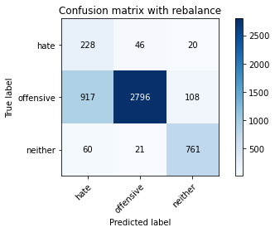

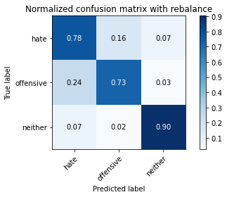

precision recall f1-score support

hate 0.19 0.78 0.30 294

offensive 0.98 0.73 0.84 3821

neither 0.86 0.90 0.88 842

accuracy 0.76 4957

macro avg 0.67 0.80 0.67 4957

weighted avg 0.91 0.76 0.81 4957

average eval_loss: 0.7102894600886371, accuracy: 0.763566673391164

training 6 epoch...

63.611006021499634 seconds used......

6 training finished! average train loss: 0.06939520609254639

evaluating...

Confusion matrix, without normalization

[[ 240 30 24]

[1045 2649 127]

[ 58 14 770]]

Normalized confusion matrix

[[0.81632653 0.10204082 0.08163265]

[0.27348862 0.69327401 0.03323737]

[0.06888361 0.01662708 0.91448931]]

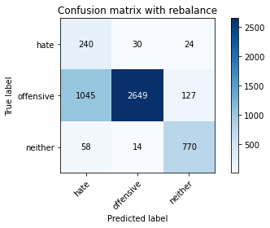

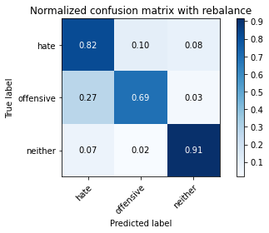

precision recall f1-score support

hate 0.18 0.82 0.29 294

offensive 0.98 0.69 0.81 3821

neither 0.84 0.91 0.87 842

accuracy 0.74 4957

macro avg 0.67 0.81 0.66 4957

weighted avg 0.91 0.74 0.79 4957

average eval_loss: 0.7979594408609574, accuracy: 0.738148073431511

training 7 epoch...

63.51779747009277 seconds used......

7 training finished! average train loss: 0.0471114212237244

evaluating...

Confusion matrix, without normalization

[[ 226 50 18]

[ 804 2912 105]

[ 56 36 750]]

Normalized confusion matrix

[[0.76870748 0.17006803 0.06122449]

[0.21041612 0.76210416 0.02747972]

[0.06650831 0.04275534 0.89073634]]

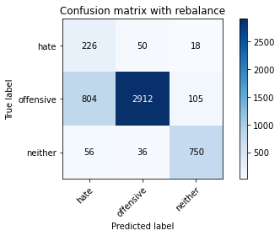

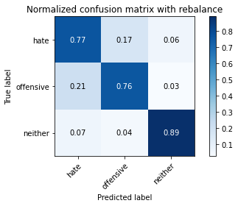

precision recall f1-score support

hate 0.21 0.77 0.33 294

offensive 0.97 0.76 0.85 3821

neither 0.86 0.89 0.87 842

accuracy 0.78 4957

macro avg 0.68 0.81 0.69 4957

weighted avg 0.91 0.78 0.83 4957

average eval_loss: 0.8065591142268761, accuracy: 0.7843453701835787

training 8 epoch...

63.51751947402954 seconds used......

8 training finished! average train loss: 0.029903846884783553

evaluating...

Confusion matrix, without normalization

[[ 220 46 28]

[ 894 2765 162]

[ 43 17 782]]

Normalized confusion matrix

[[0.74829932 0.15646259 0.0952381 ]

[0.23397016 0.72363256 0.04239728]

[0.05106888 0.02019002 0.92874109]]

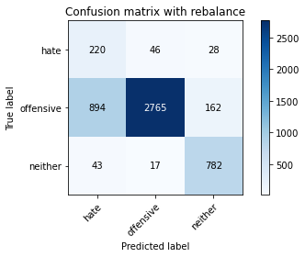

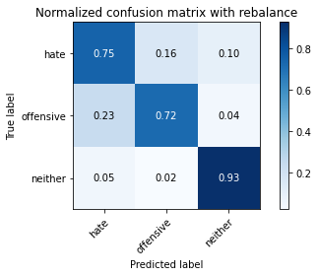

precision recall f1-score support

hate 0.19 0.75 0.30 294

offensive 0.98 0.72 0.83 3821

neither 0.80 0.93 0.86 842

accuracy 0.76 4957

macro avg 0.66 0.80 0.67 4957

weighted avg 0.90 0.76 0.81 4957

average eval_loss: 0.9619587372571621, accuracy: 0.7599354448254992

training 9 epoch...

63.89114832878113 seconds used......

9 training finished! average train loss: 0.02717103172203918

evaluating...

Confusion matrix, without normalization

[[ 223 51 20]

[ 849 2853 119]

[ 50 26 766]]

Normalized confusion matrix

[[0.7585034 0.17346939 0.06802721]

[0.22219314 0.74666318 0.03114368]

[0.05938242 0.03087886 0.90973872]]

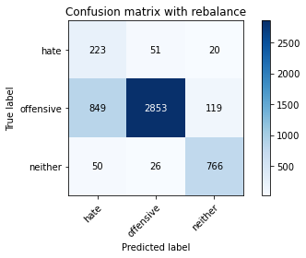

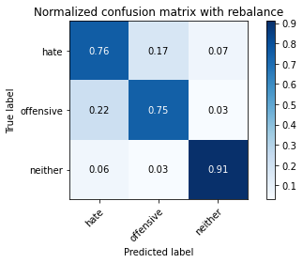

precision recall f1-score support

hate 0.20 0.76 0.31 294

offensive 0.97 0.75 0.85 3821

neither 0.85 0.91 0.88 842

accuracy 0.78 4957

macro avg 0.67 0.80 0.68 4957

weighted avg 0.91 0.78 0.82 4957

average eval_loss: 0.9719994927140614, accuracy: 0.7750655638491023

training 10 epoch...

63.685399532318115 seconds used......

10 training finished! average train loss: 0.025301005286389244

evaluating...

Confusion matrix, without normalization

[[ 182 85 27]

[ 502 3163 156]

[ 26 27 789]]

Normalized confusion matrix

[[0.61904762 0.28911565 0.09183673]

[0.13137922 0.82779377 0.04082701]

[0.03087886 0.03206651 0.93705463]]

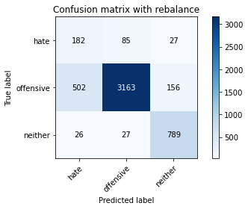

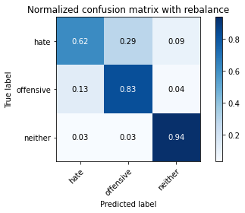

precision recall f1-score support

hate 0.26 0.62 0.36 294

offensive 0.97 0.83 0.89 3821

neither 0.81 0.94 0.87 842

accuracy 0.83 4957

macro avg 0.68 0.79 0.71 4957

weighted avg 0.90 0.83 0.86 4957

average eval_loss: 0.8403411274832193, accuracy: 0.8339721605809965

3 run

training 1 epoch...

63.72097587585449 seconds used......

1 training finished! average train loss: 0.5921724515351635

evaluating...

Confusion matrix, without normalization

[[ 260 24 10]

[1720 2008 93]

[ 115 6 721]]

Normalized confusion matrix

[[0.88435374 0.08163265 0.03401361]

[0.45014394 0.52551688 0.02433918]

[0.13657957 0.00712589 0.85629454]]

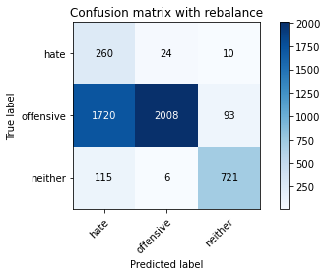

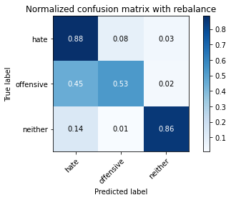

precision recall f1-score support

hate 0.12 0.88 0.22 294

offensive 0.99 0.53 0.69 3821

neither 0.88 0.86 0.87 842

accuracy 0.60 4957

macro avg 0.66 0.76 0.59 4957

weighted avg 0.92 0.60 0.69 4957

average eval_loss: 0.7850032564733298, accuracy: 0.6029856768206576

training 2 epoch...

63.679996490478516 seconds used......

2 training finished! average train loss: 0.32118384662078836

evaluating...

Confusion matrix, without normalization

[[ 253 27 14]

[1408 2317 96]

[ 127 8 707]]

Normalized confusion matrix

[[0.86054422 0.09183673 0.04761905]

[0.36848992 0.60638576 0.02512431]

[0.15083135 0.00950119 0.83966746]]

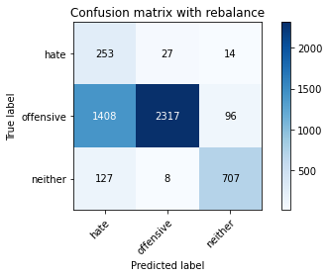

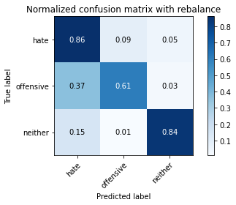

precision recall f1-score support

hate 0.14 0.86 0.24 294

offensive 0.99 0.61 0.75 3821

neither 0.87 0.84 0.85 842

accuracy 0.66 4957

macro avg 0.66 0.77 0.62 4957

weighted avg 0.91 0.66 0.74 4957

average eval_loss: 0.7261069600860919, accuracy: 0.6610853338712931

training 3 epoch...

63.80785012245178 seconds used......

3 training finished! average train loss: 0.21139833418249387

evaluating...

Confusion matrix, without normalization

[[ 250 26 18]

[1327 2386 108]

[ 85 11 746]]

Normalized confusion matrix

[[0.85034014 0.08843537 0.06122449]

[0.34729129 0.62444386 0.02826485]

[0.10095012 0.01306413 0.88598575]]

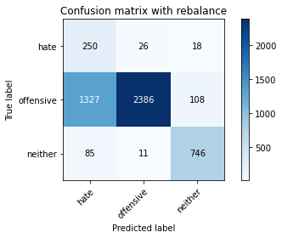

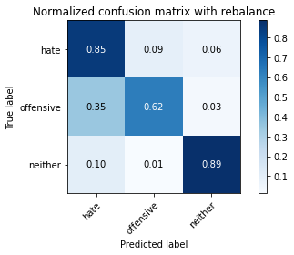

precision recall f1-score support

hate 0.15 0.85 0.26 294

offensive 0.98 0.62 0.76 3821

neither 0.86 0.89 0.87 842

accuracy 0.68 4957

macro avg 0.66 0.79 0.63 4957

weighted avg 0.91 0.68 0.75 4957

average eval_loss: 0.7173736984090459, accuracy: 0.6822675005043373

training 4 epoch...

63.57055187225342 seconds used......

4 training finished! average train loss: 0.12872086202845587

evaluating...

Confusion matrix, without normalization

[[ 220 44 30]

[ 866 2819 136]

[ 45 17 780]]

Normalized confusion matrix

[[0.74829932 0.14965986 0.10204082]

[0.22664224 0.73776498 0.03559278]

[0.05344418 0.02019002 0.9263658 ]]

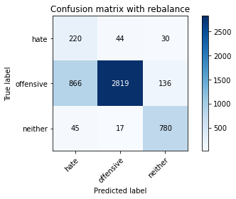

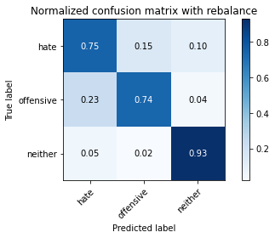

precision recall f1-score support

hate 0.19 0.75 0.31 294

offensive 0.98 0.74 0.84 3821

neither 0.82 0.93 0.87 842

accuracy 0.77 4957

macro avg 0.67 0.80 0.67 4957

weighted avg 0.91 0.77 0.82 4957

average eval_loss: 0.615412918460225, accuracy: 0.770425660681864

training 5 epoch...

63.6026828289032 seconds used......

5 training finished! average train loss: 0.08720401671785884

evaluating...

Confusion matrix, without normalization

[[ 240 38 16]

[1112 2612 97]

[ 74 23 745]]

Normalized confusion matrix

[[0.81632653 0.1292517 0.05442177]

[0.29102329 0.68359068 0.02538602]

[0.08788599 0.02731591 0.8847981 ]]

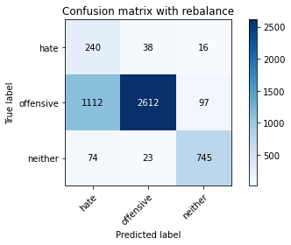

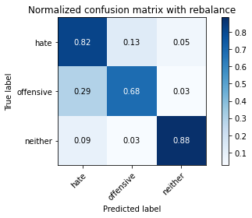

precision recall f1-score support

hate 0.17 0.82 0.28 294

offensive 0.98 0.68 0.80 3821

neither 0.87 0.88 0.88 842

accuracy 0.73 4957

macro avg 0.67 0.79 0.65 4957

weighted avg 0.91 0.73 0.79 4957

average eval_loss: 0.7855848611572818, accuracy: 0.7256405083719992

training 6 epoch...

63.69542908668518 seconds used......

6 training finished! average train loss: 0.0655046686889571

evaluating...

Confusion matrix, without normalization

[[ 234 40 20]

[ 915 2794 112]

[ 75 17 750]]

Normalized confusion matrix

[[0.79591837 0.13605442 0.06802721]

[0.23946611 0.73122219 0.0293117 ]

[0.08907363 0.02019002 0.89073634]]

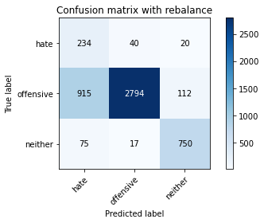

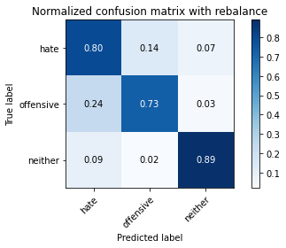

precision recall f1-score support

hate 0.19 0.80 0.31 294

offensive 0.98 0.73 0.84 3821

neither 0.85 0.89 0.87 842

accuracy 0.76 4957

macro avg 0.67 0.81 0.67 4957

weighted avg 0.91 0.76 0.81 4957

average eval_loss: 0.7718820163168975, accuracy: 0.7621545289489611

training 7 epoch...

63.74629855155945 seconds used......

7 training finished! average train loss: 0.05070240175002935

evaluating...

Confusion matrix, without normalization

[[ 241 38 15]

[1211 2525 85]

[ 93 21 728]]

Normalized confusion matrix

[[0.81972789 0.1292517 0.05102041]

[0.31693274 0.66082177 0.02224549]

[0.11045131 0.02494062 0.86460808]]

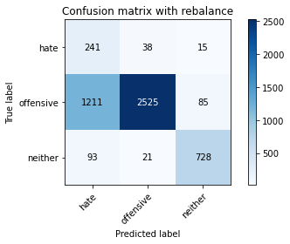

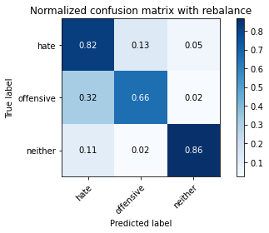

precision recall f1-score support

hate 0.16 0.82 0.26 294

offensive 0.98 0.66 0.79 3821

neither 0.88 0.86 0.87 842

accuracy 0.70 4957

macro avg 0.67 0.78 0.64 4957

weighted avg 0.91 0.70 0.77 4957

average eval_loss: 1.0303991569746886, accuracy: 0.7048618115795844

training 8 epoch...

63.731916666030884 seconds used......

8 training finished! average train loss: 0.031142989375726564

evaluating...

Confusion matrix, without normalization

[[ 225 48 21]

[ 944 2791 86]

[ 66 30 746]]

Normalized confusion matrix

[[0.76530612 0.16326531 0.07142857]

[0.24705574 0.73043706 0.0225072 ]

[0.0783848 0.03562945 0.88598575]]

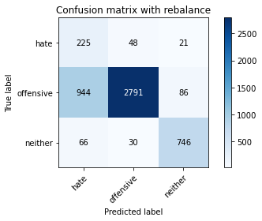

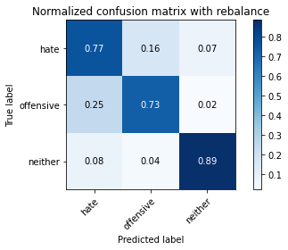

precision recall f1-score support

hate 0.18 0.77 0.29 294

offensive 0.97 0.73 0.83 3821

neither 0.87 0.89 0.88 842

accuracy 0.76 4957

macro avg 0.68 0.79 0.67 4957

weighted avg 0.91 0.76 0.81 4957

average eval_loss: 0.9175142259787648, accuracy: 0.7589267702239257

training 9 epoch...

63.79059863090515 seconds used......

9 training finished! average train loss: 0.016875777764270378

evaluating...

Confusion matrix, without normalization

[[ 224 52 18]

[ 808 2938 75]

[ 65 38 739]]

Normalized confusion matrix

[[0.76190476 0.17687075 0.06122449]

[0.21146297 0.76890866 0.01962837]

[0.07719715 0.04513064 0.87767221]]

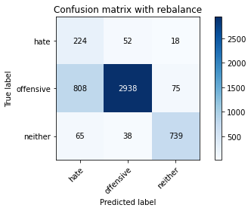

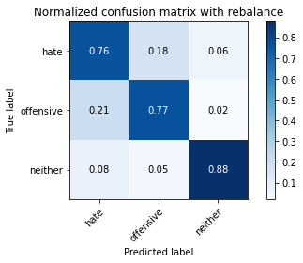

precision recall f1-score support

hate 0.20 0.76 0.32 294

offensive 0.97 0.77 0.86 3821

neither 0.89 0.88 0.88 842

accuracy 0.79 4957

macro avg 0.69 0.80 0.69 4957

weighted avg 0.91 0.79 0.83 4957

average eval_loss: 0.9687570837596732, accuracy: 0.7869679241476699

training 10 epoch...

63.67325687408447 seconds used......

10 training finished! average train loss: 0.01539898106837863

evaluating...

Confusion matrix, without normalization

[[ 214 56 24]

[ 722 2989 110]

[ 56 26 760]]

Normalized confusion matrix

[[0.72789116 0.19047619 0.08163265]

[0.18895577 0.78225595 0.02878828]

[0.06650831 0.03087886 0.90261283]]

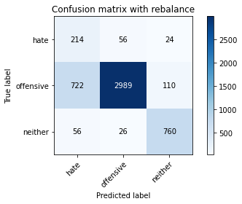

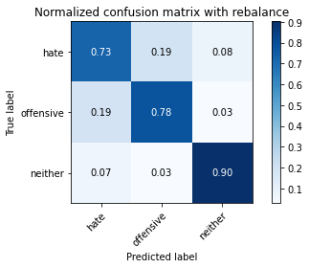

precision recall f1-score support

hate 0.22 0.73 0.33 294

offensive 0.97 0.78 0.87 3821

neither 0.85 0.90 0.88 842

accuracy 0.80 4957

macro avg 0.68 0.80 0.69 4957

weighted avg 0.91 0.80 0.84 4957

average eval_loss: 0.9872864795390577, accuracy: 0.7994754892071818

4 run

training 1 epoch...

63.6475145816803 seconds used......

1 training finished! average train loss: 0.5874564159683316

evaluating...

Confusion matrix, without normalization

[[ 250 27 17]

[1483 2197 141]

[ 68 8 766]]

Normalized confusion matrix

[[0.85034014 0.09183673 0.05782313]

[0.38811829 0.57498037 0.03690133]

[0.0807601 0.00950119 0.90973872]]

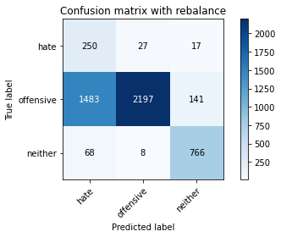

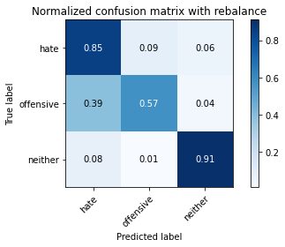

precision recall f1-score support

hate 0.14 0.85 0.24 294

offensive 0.98 0.57 0.73 3821

neither 0.83 0.91 0.87 842

accuracy 0.65 4957

macro avg 0.65 0.78 0.61 4957

weighted avg 0.91 0.65 0.72 4957

average eval_loss: 0.6962038391540127, accuracy: 0.6481742989711519

training 2 epoch...

63.557955741882324 seconds used......

2 training finished! average train loss: 0.31238810704988346

evaluating...

Confusion matrix, without normalization

[[ 248 25 21]

[1674 1996 151]

[ 57 7 778]]

Normalized confusion matrix

[[0.84353741 0.08503401 0.07142857]

[0.43810521 0.52237634 0.03951845]

[0.06769596 0.00831354 0.9239905 ]]

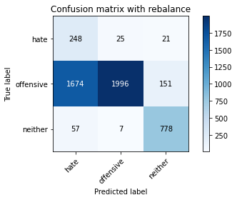

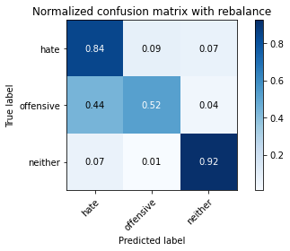

precision recall f1-score support

hate 0.13 0.84 0.22 294

offensive 0.98 0.52 0.68 3821

neither 0.82 0.92 0.87 842

accuracy 0.61 4957

macro avg 0.64 0.76 0.59 4957

weighted avg 0.91 0.61 0.69 4957

average eval_loss: 0.7258293741653042, accuracy: 0.609642929191043

training 3 epoch...

63.54138422012329 seconds used......

3 training finished! average train loss: 0.19429660116850633

evaluating...

Confusion matrix, without normalization

[[ 247 21 26]

[1848 1731 242]

[ 53 5 784]]

Normalized confusion matrix

[[0.84013605 0.07142857 0.08843537]

[0.48364303 0.45302277 0.06333421]

[0.06294537 0.00593824 0.93111639]]

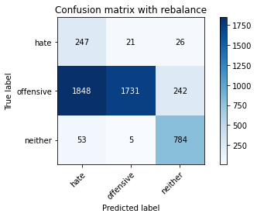

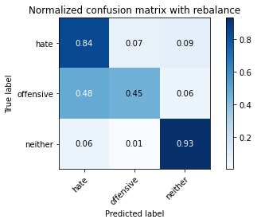

precision recall f1-score support

hate 0.11 0.84 0.20 294

offensive 0.99 0.45 0.62 3821

neither 0.75 0.93 0.83 842

accuracy 0.56 4957

macro avg 0.62 0.74 0.55 4957

weighted avg 0.89 0.56 0.63 4957

average eval_loss: 0.8694066513449915, accuracy: 0.5571918499092193

training 4 epoch...

63.559749364852905 seconds used......

4 training finished! average train loss: 0.1257431340834115

evaluating...

Confusion matrix, without normalization

[[ 241 30 23]

[1025 2648 148]

[ 49 11 782]]

Normalized confusion matrix

[[0.81972789 0.10204082 0.07823129]

[0.26825438 0.6930123 0.03873332]

[0.05819477 0.01306413 0.92874109]]

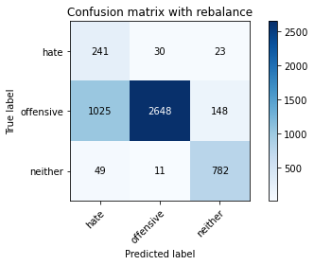

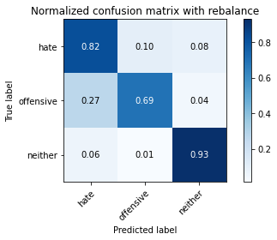

precision recall f1-score support

hate 0.18 0.82 0.30 294

offensive 0.98 0.69 0.81 3821

neither 0.82 0.93 0.87 842

accuracy 0.74 4957

macro avg 0.66 0.81 0.66 4957

weighted avg 0.91 0.74 0.79 4957

average eval_loss: 0.7114969350157245, accuracy: 0.7405688924752875

training 5 epoch...

63.64245104789734 seconds used......

5 training finished! average train loss: 0.09190750083129047

evaluating...

Confusion matrix, without normalization

[[ 231 38 25]

[ 946 2733 142]

[ 48 19 775]]

Normalized confusion matrix

[[0.78571429 0.1292517 0.08503401]

[0.24757917 0.71525779 0.03716305]

[0.05700713 0.02256532 0.92042755]]

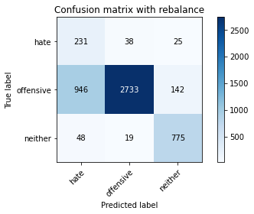

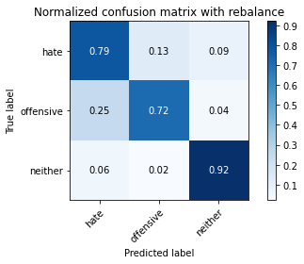

precision recall f1-score support

hate 0.19 0.79 0.30 294

offensive 0.98 0.72 0.83 3821

neither 0.82 0.92 0.87 842

accuracy 0.75 4957

macro avg 0.66 0.81 0.67 4957

weighted avg 0.91 0.75 0.80 4957

average eval_loss: 0.7502776534116317, accuracy: 0.7542868670566875

training 6 epoch...

63.64894652366638 seconds used......

6 training finished! average train loss: 0.07016101684584691

evaluating...

Confusion matrix, without normalization

[[ 231 45 18]

[ 843 2868 110]

[ 61 31 750]]

Normalized confusion matrix

[[0.78571429 0.15306122 0.06122449]

[0.22062287 0.75058885 0.02878828]

[0.07244656 0.0368171 0.89073634]]

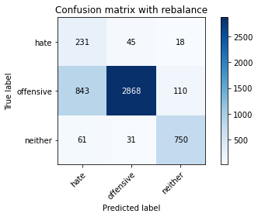

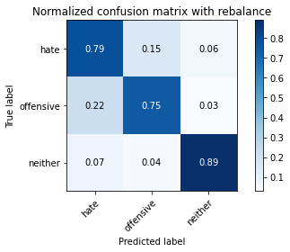

precision recall f1-score support

hate 0.20 0.79 0.32 294

offensive 0.97 0.75 0.85 3821

neither 0.85 0.89 0.87 842

accuracy 0.78 4957

macro avg 0.68 0.81 0.68 4957

weighted avg 0.91 0.78 0.82 4957

average eval_loss: 0.7414596775065987, accuracy: 0.7764777082913052

training 7 epoch...

63.618980169296265 seconds used......

7 training finished! average train loss: 0.05200225809842283

evaluating...

Confusion matrix, without normalization

[[ 247 33 14]

[1042 2674 105]

[ 73 22 747]]

Normalized confusion matrix

[[0.84013605 0.1122449 0.04761905]

[0.27270348 0.6998168 0.02747972]

[0.08669834 0.02612827 0.8871734 ]]

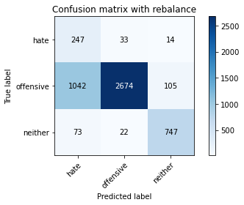

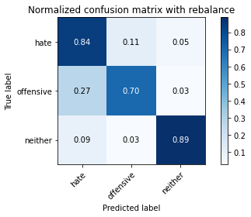

precision recall f1-score support

hate 0.18 0.84 0.30 294

offensive 0.98 0.70 0.82 3821

neither 0.86 0.89 0.87 842

accuracy 0.74 4957

macro avg 0.67 0.81 0.66 4957

weighted avg 0.91 0.74 0.80 4957

average eval_loss: 0.9595213969117932, accuracy: 0.7399636877143434

training 8 epoch...

63.66653895378113 seconds used......

8 training finished! average train loss: 0.05172334819057227

evaluating...

Confusion matrix, without normalization

[[ 225 50 19]

[ 864 2836 121]

[ 56 19 767]]

Normalized confusion matrix

[[0.76530612 0.17006803 0.06462585]

[0.22611882 0.74221408 0.0316671 ]

[0.06650831 0.02256532 0.91092637]]

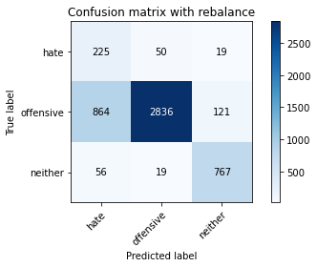

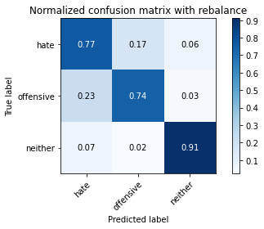

precision recall f1-score support

hate 0.20 0.77 0.31 294

offensive 0.98 0.74 0.84 3821

neither 0.85 0.91 0.88 842

accuracy 0.77 4957

macro avg 0.67 0.81 0.68 4957

weighted avg 0.91 0.77 0.82 4957

average eval_loss: 0.9041186638566996, accuracy: 0.7722412749646964

training 9 epoch...

63.618637800216675 seconds used......

9 training finished! average train loss: 0.0480982464859371

evaluating...

Confusion matrix, without normalization

[[ 243 35 16]

[1081 2606 134]

[ 70 14 758]]

Normalized confusion matrix

[[0.82653061 0.11904762 0.05442177]

[0.28291023 0.68202041 0.03506935]

[0.08313539 0.01662708 0.90023753]]

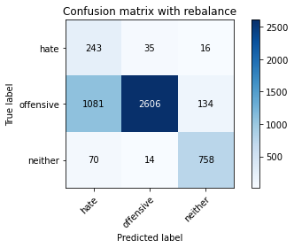

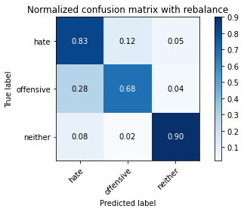

precision recall f1-score support

hate 0.17 0.83 0.29 294

offensive 0.98 0.68 0.80 3821

neither 0.83 0.90 0.87 842

accuracy 0.73 4957

macro avg 0.66 0.80 0.65 4957

weighted avg 0.91 0.73 0.78 4957

average eval_loss: 1.0004059292616383, accuracy: 0.7276578575751462

training 10 epoch...

63.59957194328308 seconds used......

10 training finished! average train loss: 0.017740265888023077

evaluating...

Confusion matrix, without normalization

[[ 228 40 26]

[ 945 2718 158]

[ 51 15 776]]

Normalized confusion matrix

[[0.7755102 0.13605442 0.08843537]

[0.24731746 0.71133211 0.04135043]

[0.06057007 0.01781473 0.9216152 ]]

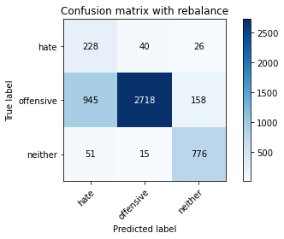

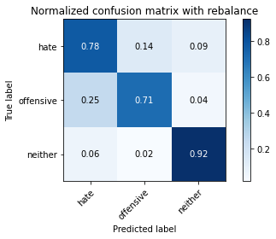

precision recall f1-score support

hate 0.19 0.78 0.30 294

offensive 0.98 0.71 0.82 3821

neither 0.81 0.92 0.86 842

accuracy 0.75 4957

macro avg 0.66 0.80 0.66 4957

weighted avg 0.90 0.75 0.80 4957

average eval_loss: 1.0451868630217147, accuracy: 0.7508573734113375

5 run

training 1 epoch...

63.63134765625 seconds used......

1 training finished! average train loss: 0.6031156007135123

evaluating...

Confusion matrix, without normalization

[[ 233 31 30]

[1287 2385 149]

[ 41 8 793]]

Normalized confusion matrix

[[0.79251701 0.10544218 0.10204082]

[0.33682282 0.62418215 0.03899503]

[0.04869359 0.00950119 0.94180523]]

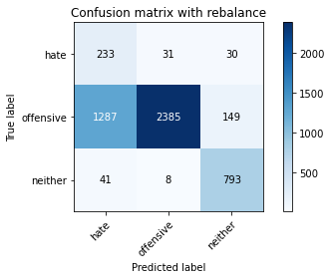

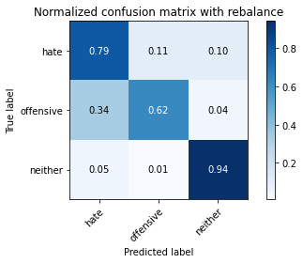

precision recall f1-score support

hate 0.15 0.79 0.25 294

offensive 0.98 0.62 0.76 3821

neither 0.82 0.94 0.87 842

accuracy 0.69 4957

macro avg 0.65 0.79 0.63 4957

weighted avg 0.91 0.69 0.75 4957

average eval_loss: 0.6368094636427779, accuracy: 0.6881178131934638

training 2 epoch...

63.76813578605652 seconds used......

2 training finished! average train loss: 0.32257946628576134

evaluating...

Confusion matrix, without normalization

[[ 252 22 20]

[1630 2066 125]

[ 69 9 764]]

Normalized confusion matrix

[[0.85714286 0.07482993 0.06802721]

[0.4265899 0.54069615 0.03271395]

[0.08194774 0.01068884 0.90736342]]

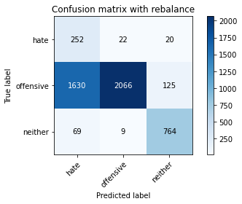

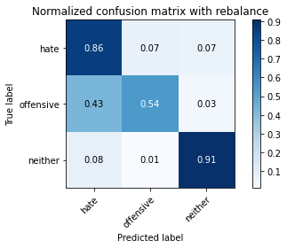

precision recall f1-score support

hate 0.13 0.86 0.22 294

offensive 0.99 0.54 0.70 3821

neither 0.84 0.91 0.87 842

accuracy 0.62 4957

macro avg 0.65 0.77 0.60 4957

weighted avg 0.91 0.62 0.70 4957

average eval_loss: 0.7489714139411526, accuracy: 0.6217470244099254

training 3 epoch...

63.68174338340759 seconds used......

3 training finished! average train loss: 0.2086386950523184

evaluating...

Confusion matrix, without normalization

[[ 232 31 31]

[1045 2587 189]

[ 51 6 785]]

Normalized confusion matrix

[[0.78911565 0.10544218 0.10544218]

[0.27348862 0.67704789 0.04946349]

[0.06057007 0.00712589 0.93230404]]

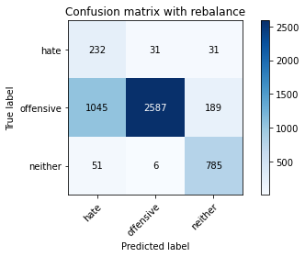

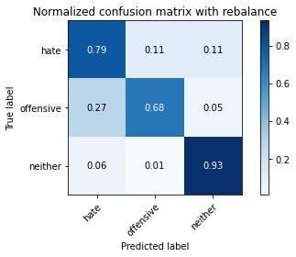

precision recall f1-score support

hate 0.17 0.79 0.29 294

offensive 0.99 0.68 0.80 3821

neither 0.78 0.93 0.85 842

accuracy 0.73 4957

macro avg 0.65 0.80 0.65 4957

weighted avg 0.90 0.73 0.78 4957

average eval_loss: 0.5770665844001116, accuracy: 0.7270526528142022

training 4 epoch...

63.610777378082275 seconds used......

4 training finished! average train loss: 0.12544938904500147

evaluating...

Confusion matrix, without normalization

[[ 244 33 17]

[1059 2675 87]

[ 67 18 757]]

Normalized confusion matrix

[[0.82993197 0.1122449 0.05782313]

[0.27715258 0.70007851 0.02276891]

[0.07957245 0.02137767 0.89904988]]

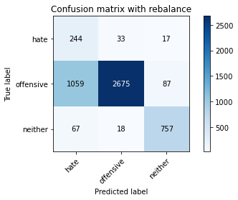

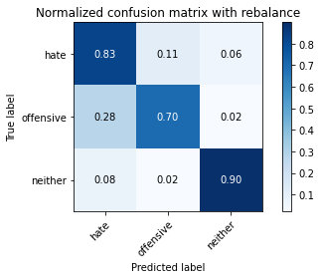

precision recall f1-score support

hate 0.18 0.83 0.29 294

offensive 0.98 0.70 0.82 3821

neither 0.88 0.90 0.89 842

accuracy 0.74 4957

macro avg 0.68 0.81 0.67 4957

weighted avg 0.92 0.74 0.80 4957

average eval_loss: 0.6835415271381217, accuracy: 0.741577567076861

training 5 epoch...

63.583818674087524 seconds used......

5 training finished! average train loss: 0.09163232432536737

evaluating...

Confusion matrix, without normalization

[[ 249 24 21]

[1475 2228 118]

[ 65 10 767]]

Normalized confusion matrix

[[0.84693878 0.08163265 0.07142857]

[0.3860246 0.58309343 0.03088197]

[0.07719715 0.01187648 0.91092637]]

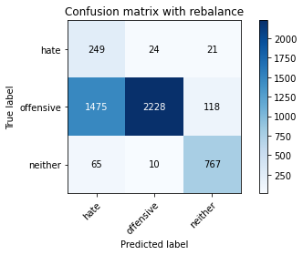

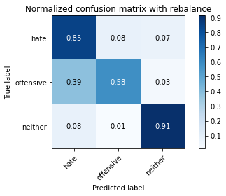

precision recall f1-score support

hate 0.14 0.85 0.24 294

offensive 0.98 0.58 0.73 3821

neither 0.85 0.91 0.88 842

accuracy 0.65 4957

macro avg 0.66 0.78 0.62 4957

weighted avg 0.91 0.65 0.73 4957

average eval_loss: 0.9098982188490129, accuracy: 0.6544280815009078

training 6 epoch...

63.75225567817688 seconds used......

6 training finished! average train loss: 0.075075075773751

evaluating...

Confusion matrix, without normalization

[[ 233 44 17]

[ 910 2805 106]

[ 84 19 739]]

Normalized confusion matrix

[[0.79251701 0.14965986 0.05782313]

[0.23815755 0.73410102 0.02774143]

[0.09976247 0.02256532 0.87767221]]

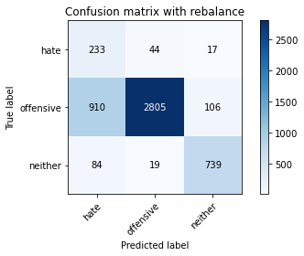

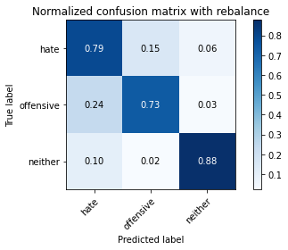

precision recall f1-score support

hate 0.19 0.79 0.31 294

offensive 0.98 0.73 0.84 3821

neither 0.86 0.88 0.87 842

accuracy 0.76 4957

macro avg 0.68 0.80 0.67 4957

weighted avg 0.91 0.76 0.81 4957

average eval_loss: 0.7238905629398481, accuracy: 0.7619527940286464

training 7 epoch...

63.61039900779724 seconds used......

7 training finished! average train loss: 0.054732218899421

evaluating...

Confusion matrix, without normalization

[[ 239 44 11]

[1060 2677 84]

[ 86 17 739]]

Normalized confusion matrix

[[0.81292517 0.14965986 0.03741497]

[0.27741429 0.70060194 0.02198377]

[0.10213777 0.02019002 0.87767221]]

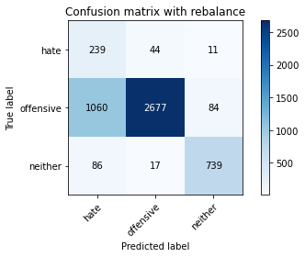

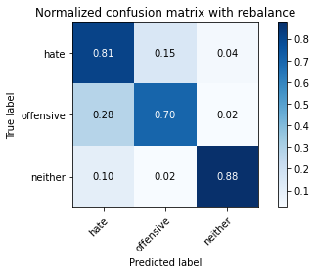

precision recall f1-score support

hate 0.17 0.81 0.28 294

offensive 0.98 0.70 0.82 3821

neither 0.89 0.88 0.88 842

accuracy 0.74 4957

macro avg 0.68 0.80 0.66 4957

weighted avg 0.91 0.74 0.80 4957

average eval_loss: 0.8993317154874545, accuracy: 0.7373411337502521

training 8 epoch...

63.676358461380005 seconds used......

8 training finished! average train loss: 0.04864436424642322

evaluating...

Confusion matrix, without normalization

[[ 222 49 23]

[ 817 2872 132]

[ 51 18 773]]

Normalized confusion matrix

[[0.75510204 0.16666667 0.07823129]

[0.21381837 0.7516357 0.03454593]

[0.06057007 0.02137767 0.91805226]]

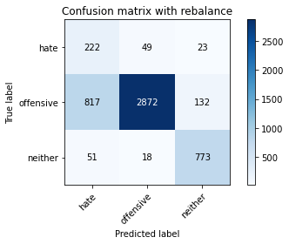

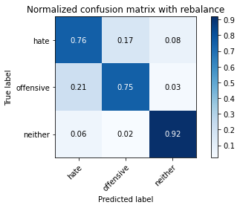

precision recall f1-score support

hate 0.20 0.76 0.32 294

offensive 0.98 0.75 0.85 3821

neither 0.83 0.92 0.87 842

accuracy 0.78 4957

macro avg 0.67 0.81 0.68 4957

weighted avg 0.91 0.78 0.82 4957

average eval_loss: 0.8104206325088237, accuracy: 0.7801089368569699

training 9 epoch...

63.624107122421265 seconds used......

9 training finished! average train loss: 0.041159754224143356

evaluating...

Confusion matrix, without normalization

[[ 235 43 16]

[ 975 2728 118]

[ 61 25 756]]

Normalized confusion matrix

[[0.79931973 0.1462585 0.05442177]

[0.2551688 0.71394923 0.03088197]

[0.07244656 0.02969121 0.89786223]]

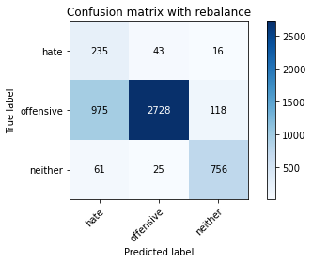

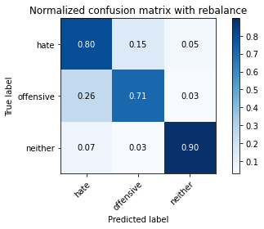

precision recall f1-score support

hate 0.18 0.80 0.30 294

offensive 0.98 0.71 0.82 3821

neither 0.85 0.90 0.87 842

accuracy 0.75 4957

macro avg 0.67 0.80 0.67 4957

weighted avg 0.91 0.75 0.80 4957

average eval_loss: 0.9954018720234143, accuracy: 0.7502521686503933

training 10 epoch...

63.61504244804382 seconds used......

10 training finished! average train loss: 0.014837273428719001

evaluating...

Confusion matrix, without normalization

[[ 226 49 19]

[ 748 2951 122]

[ 50 23 769]]

Normalized confusion matrix

[[0.76870748 0.16666667 0.06462585]

[0.19576027 0.77231091 0.03192881]

[0.05938242 0.02731591 0.91330166]]

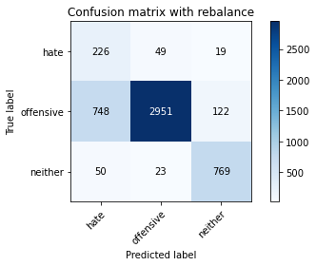

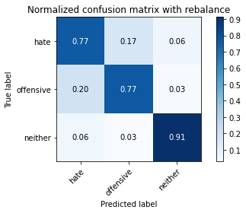

precision recall f1-score support

hate 0.22 0.77 0.34 294

offensive 0.98 0.77 0.86 3821

neither 0.85 0.91 0.88 842

accuracy 0.80 4957

macro avg 0.68 0.82 0.69 4957

weighted avg 0.91 0.80 0.83 4957

average eval_loss: 0.9643199755770301, accuracy: 0.7960459955618318