1 run

training 1 epoch...

103.67135095596313 seconds used......

1 training finished! average train loss: 1.4913666572487145

total clf loss: 116.66152176260948 total adv loss: 69.18108856678009

evaluating...

Confusion matrix, without normalization

[[ 197 67 30]

[ 450 3245 126]

[ 70 21 751]]

Normalized confusion matrix

[[0.67006803 0.22789116 0.10204082]

[0.11777022 0.84925412 0.03297566]

[0.08313539 0.02494062 0.89192399]]

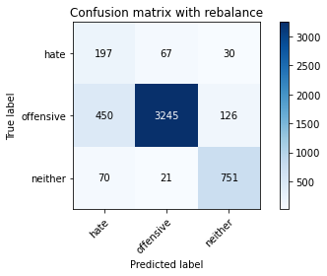

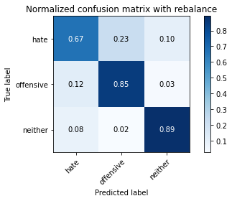

precision recall f1-score support

hate 0.27 0.67 0.39 294

offensive 0.97 0.85 0.91 3821

neither 0.83 0.89 0.86 842

accuracy 0.85 4957

macro avg 0.69 0.80 0.72 4957

weighted avg 0.91 0.85 0.87 4957

average eval_loss: 0.40287703287697607, accuracy: 0.8458745208795643

training 2 epoch...

103.67014837265015 seconds used......

2 training finished! average train loss: 1.006933001398343

total clf loss: 72.2426229417324 total adv loss: 49.97146002575755

evaluating...

Confusion matrix, without normalization

[[ 224 52 18]

[ 704 3005 112]

[ 75 24 743]]

Normalized confusion matrix

[[0.76190476 0.17687075 0.06122449]

[0.18424496 0.78644334 0.0293117 ]

[0.08907363 0.02850356 0.8824228 ]]

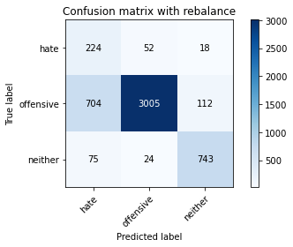

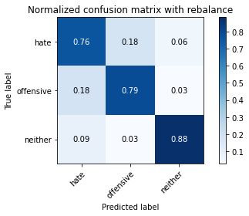

precision recall f1-score support

hate 0.22 0.76 0.35 294

offensive 0.98 0.79 0.87 3821

neither 0.85 0.88 0.87 842

accuracy 0.80 4957

macro avg 0.68 0.81 0.69 4957

weighted avg 0.91 0.80 0.84 4957

average eval_loss: 0.44839210222445186, accuracy: 0.8012911034900141

training 3 epoch...

103.58839869499207 seconds used......

3 training finished! average train loss: 0.7523069593467211

total clf loss: 52.18862000852823 total adv loss: 38.227935157716274

evaluating...

Confusion matrix, without normalization

[[ 223 60 11]

[ 612 3129 80]

[ 89 26 727]]

Normalized confusion matrix

[[0.7585034 0.20408163 0.03741497]

[0.1601675 0.81889558 0.02093693]

[0.10570071 0.03087886 0.86342043]]

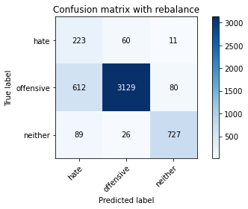

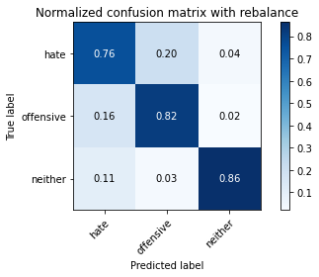

precision recall f1-score support

hate 0.24 0.76 0.37 294

offensive 0.97 0.82 0.89 3821

neither 0.89 0.86 0.88 842

accuracy 0.82 4957

macro avg 0.70 0.81 0.71 4957

weighted avg 0.92 0.82 0.86 4957

average eval_loss: 0.4572558010357522, accuracy: 0.8228767399636877

training 4 epoch...

103.61505174636841 seconds used......

4 training finished! average train loss: 0.47083676630380555

total clf loss: 32.41890566982329 total adv loss: 24.04709064029157

evaluating...

Confusion matrix, without normalization

[[ 224 49 21]

[ 707 3003 111]

[ 73 20 749]]

Normalized confusion matrix

[[0.76190476 0.16666667 0.07142857]

[0.1850301 0.78591992 0.02904999]

[0.08669834 0.02375297 0.88954869]]

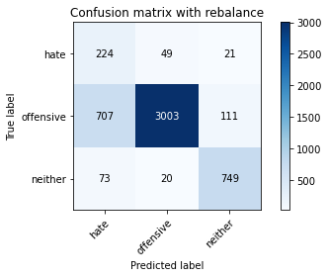

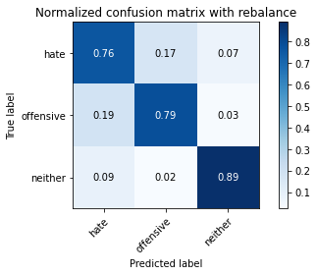

precision recall f1-score support

hate 0.22 0.76 0.35 294

offensive 0.98 0.79 0.87 3821

neither 0.85 0.89 0.87 842

accuracy 0.80 4957

macro avg 0.68 0.81 0.70 4957

weighted avg 0.91 0.80 0.84 4957

average eval_loss: 0.6263925016016489, accuracy: 0.802098043171273

training 5 epoch...

103.63952946662903 seconds used......

5 training finished! average train loss: 0.28144137052633955

total clf loss: 19.31522566638887 total adv loss: 14.405624505830929

evaluating...

Confusion matrix, without normalization

[[ 237 39 18]

[1018 2691 112]

[ 87 15 740]]

Normalized confusion matrix

[[0.80612245 0.13265306 0.06122449]

[0.2664224 0.7042659 0.0293117 ]

[0.10332542 0.01781473 0.87885986]]

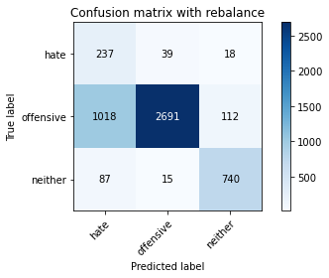

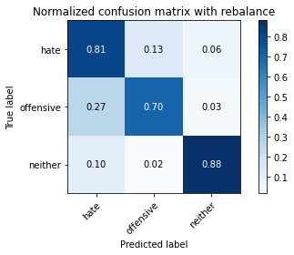

precision recall f1-score support

hate 0.18 0.81 0.29 294

offensive 0.98 0.70 0.82 3821

neither 0.85 0.88 0.86 842

accuracy 0.74 4957

macro avg 0.67 0.80 0.66 4957

weighted avg 0.91 0.74 0.80 4957

average eval_loss: 0.9171381459210909, accuracy: 0.7399636877143434

training 6 epoch...

103.61224365234375 seconds used......

6 training finished! average train loss: 0.1489956442999234

total clf loss: 9.830576376407407 total adv loss: 7.823839426870109

evaluating...

Confusion matrix, without normalization

[[ 215 62 17]

[ 695 3020 106]

[ 89 22 731]]

Normalized confusion matrix

[[0.73129252 0.21088435 0.05782313]

[0.18188956 0.79036901 0.02774143]

[0.10570071 0.02612827 0.86817102]]

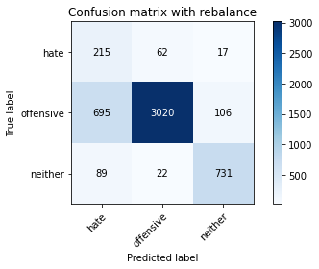

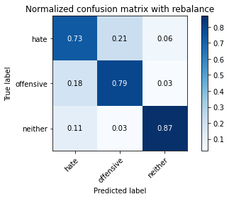

precision recall f1-score support

hate 0.22 0.73 0.33 294

offensive 0.97 0.79 0.87 3821

neither 0.86 0.87 0.86 842

accuracy 0.80 4957

macro avg 0.68 0.80 0.69 4957

weighted avg 0.91 0.80 0.84 4957

average eval_loss: 0.8613359746185222, accuracy: 0.8000806939681259

training 7 epoch...

103.61230373382568 seconds used......

7 training finished! average train loss: 0.12773586542220317

total clf loss: 8.775487176142633 total adv loss: 6.533672894947813

evaluating...

Confusion matrix, without normalization

[[ 204 68 22]

[ 558 3152 111]

[ 64 24 754]]

Normalized confusion matrix

[[0.69387755 0.23129252 0.07482993]

[0.14603507 0.82491494 0.02904999]

[0.0760095 0.02850356 0.89548694]]

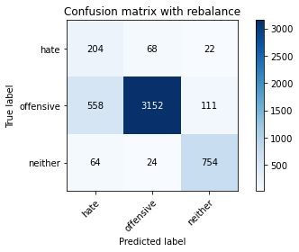

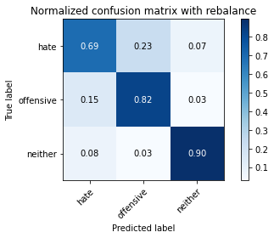

precision recall f1-score support

hate 0.25 0.69 0.36 294

offensive 0.97 0.82 0.89 3821

neither 0.85 0.90 0.87 842

accuracy 0.83 4957

macro avg 0.69 0.80 0.71 4957

weighted avg 0.91 0.83 0.86 4957

average eval_loss: 0.7288507661357853, accuracy: 0.8291305224934437

training 8 epoch...

103.65488791465759 seconds used......

8 training finished! average train loss: 0.06458969480100725

total clf loss: 4.525318763509858 total adv loss: 3.259759534517798

evaluating...

Confusion matrix, without normalization

[[ 222 50 22]

[ 803 2876 142]

[ 60 17 765]]

Normalized confusion matrix

[[0.75510204 0.17006803 0.07482993]

[0.21015441 0.75268254 0.03716305]

[0.07125891 0.02019002 0.90855107]]

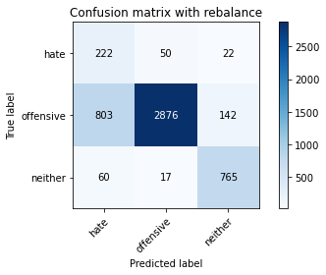

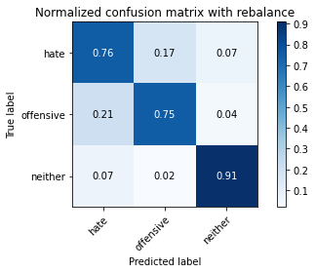

precision recall f1-score support

hate 0.20 0.76 0.32 294

offensive 0.98 0.75 0.85 3821

neither 0.82 0.91 0.86 842

accuracy 0.78 4957

macro avg 0.67 0.81 0.68 4957

weighted avg 0.91 0.78 0.82 4957

average eval_loss: 1.0429435106644016, accuracy: 0.7793019971757111

training 9 epoch...

103.63316917419434 seconds used......

9 training finished! average train loss: 0.0630377512922162

total clf loss: 3.6959462875965983 total adv loss: 3.541754573905564

evaluating...

Confusion matrix, without normalization

[[ 232 47 15]

[ 826 2903 92]

[ 118 35 689]]

Normalized confusion matrix

[[0.78911565 0.15986395 0.05102041]

[0.21617378 0.75974876 0.02407747]

[0.14014252 0.0415677 0.81828979]]

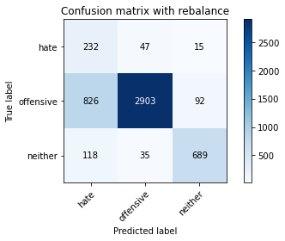

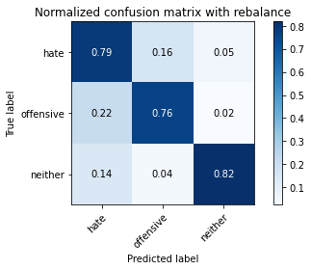

precision recall f1-score support

hate 0.20 0.79 0.32 294

offensive 0.97 0.76 0.85 3821

neither 0.87 0.82 0.84 842

accuracy 0.77 4957

macro avg 0.68 0.79 0.67 4957

weighted avg 0.91 0.77 0.82 4957

average eval_loss: 1.0454670636212424, accuracy: 0.7714343352834375

training 10 epoch...

103.82640767097473 seconds used......

10 training finished! average train loss: 0.05404512362067223

total clf loss: 3.559228967758827 total adv loss: 2.8412435627542436

evaluating...

Confusion matrix, without normalization

[[ 219 57 18]

[ 654 3062 105]

[ 67 31 744]]

Normalized confusion matrix

[[0.74489796 0.19387755 0.06122449]

[0.17115938 0.8013609 0.02747972]

[0.07957245 0.0368171 0.88361045]]

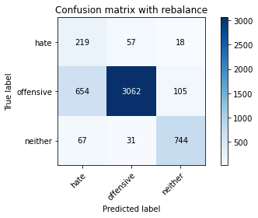

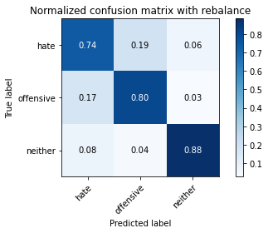

precision recall f1-score support

hate 0.23 0.74 0.35 294

offensive 0.97 0.80 0.88 3821

neither 0.86 0.88 0.87 842

accuracy 0.81 4957

macro avg 0.69 0.81 0.70 4957

weighted avg 0.91 0.81 0.85 4957

average eval_loss: 0.9722399435375982, accuracy: 0.8119830542666936

2 run

training 1 epoch...

103.74838328361511 seconds used......

1 training finished! average train loss: 1.5190927442054303

total clf loss: 118.92065864801407 total adv loss: 70.42210105061531

evaluating...

Confusion matrix, without normalization

[[ 210 49 35]

[ 707 2976 138]

[ 37 11 794]]

Normalized confusion matrix

[[0.71428571 0.16666667 0.11904762]

[0.1850301 0.7788537 0.0361162 ]

[0.04394299 0.01306413 0.94299287]]

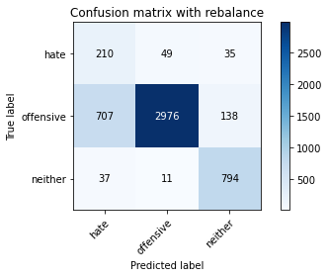

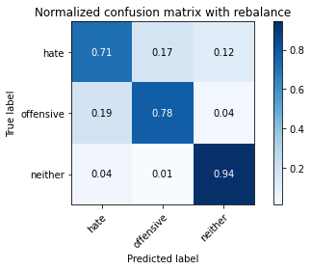

precision recall f1-score support

hate 0.22 0.71 0.34 294

offensive 0.98 0.78 0.87 3821

neither 0.82 0.94 0.88 842

accuracy 0.80 4957

macro avg 0.67 0.81 0.69 4957

weighted avg 0.91 0.80 0.84 4957

average eval_loss: 0.45419858888753, accuracy: 0.8029049828525318

training 2 epoch...

103.72103953361511 seconds used......

2 training finished! average train loss: 0.9779964427501835

total clf loss: 69.89192961156368 total adv loss: 48.67273113876581

evaluating...

Confusion matrix, without normalization

[[ 227 46 21]

[ 738 2969 114]

[ 55 29 758]]

Normalized confusion matrix

[[0.77210884 0.15646259 0.07142857]

[0.19314316 0.77702172 0.02983512]

[0.06532067 0.03444181 0.90023753]]

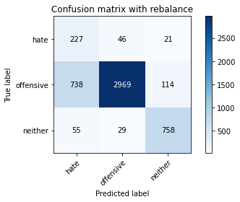

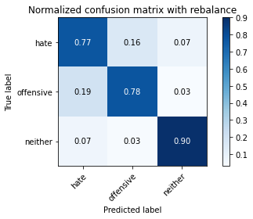

precision recall f1-score support

hate 0.22 0.77 0.35 294

offensive 0.98 0.78 0.86 3821

neither 0.85 0.90 0.87 842

accuracy 0.80 4957

macro avg 0.68 0.82 0.69 4957

weighted avg 0.91 0.80 0.84 4957

average eval_loss: 0.44773835766940345, accuracy: 0.7976598749243494

training 3 epoch...

103.83855986595154 seconds used......

3 training finished! average train loss: 0.7227663274048365

total clf loss: 50.25578001141548 total adv loss: 36.66863087750971

evaluating...

Confusion matrix, without normalization

[[ 243 38 13]

[ 959 2779 83]

[ 83 21 738]]

Normalized confusion matrix

[[0.82653061 0.1292517 0.04421769]

[0.25098142 0.72729652 0.02172206]

[0.09857482 0.02494062 0.87648456]]

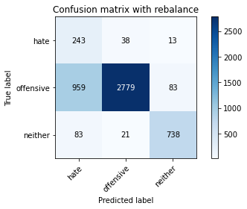

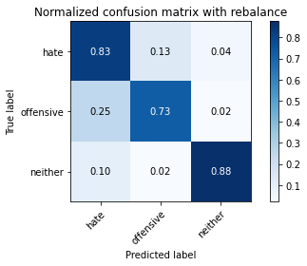

precision recall f1-score support

hate 0.19 0.83 0.31 294

offensive 0.98 0.73 0.83 3821

neither 0.88 0.88 0.88 842

accuracy 0.76 4957

macro avg 0.68 0.81 0.67 4957

weighted avg 0.92 0.76 0.81 4957

average eval_loss: 0.579124117630624, accuracy: 0.7585233003832963

training 4 epoch...

103.68028736114502 seconds used......

4 training finished! average train loss: 0.4905014055949903

total clf loss: 33.70435865782201 total adv loss: 25.085690818261355

evaluating...

Confusion matrix, without normalization

[[ 215 61 18]

[ 774 2931 116]

[ 72 20 750]]

Normalized confusion matrix

[[0.73129252 0.20748299 0.06122449]

[0.20256477 0.76707668 0.03035854]

[0.08551069 0.02375297 0.89073634]]

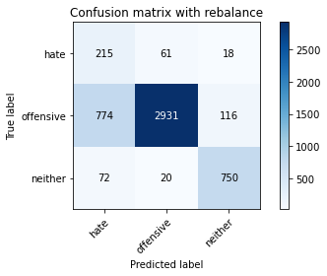

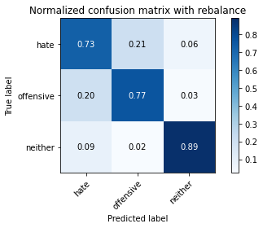

precision recall f1-score support

hate 0.20 0.73 0.32 294

offensive 0.97 0.77 0.86 3821

neither 0.85 0.89 0.87 842

accuracy 0.79 4957

macro avg 0.67 0.80 0.68 4957

weighted avg 0.91 0.79 0.83 4957

average eval_loss: 0.5427847337578574, accuracy: 0.7859592495460964

training 5 epoch...

103.5694899559021 seconds used......

5 training finished! average train loss: 0.2653857114131165

total clf loss: 17.67568006273359 total adv loss: 13.85263813007623

evaluating...

Confusion matrix, without normalization

[[ 235 42 17]

[ 990 2735 96]

[ 79 34 729]]

Normalized confusion matrix

[[0.79931973 0.14285714 0.05782313]

[0.25909448 0.71578121 0.02512431]

[0.09382423 0.04038005 0.86579572]]

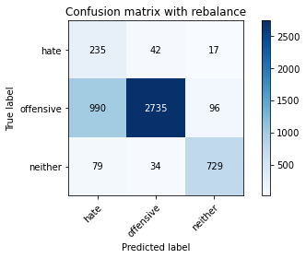

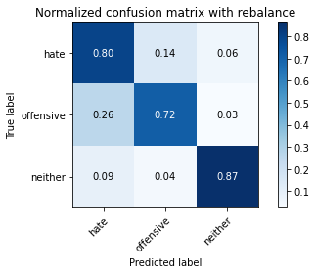

precision recall f1-score support

hate 0.18 0.80 0.29 294

offensive 0.97 0.72 0.82 3821

neither 0.87 0.87 0.87 842

accuracy 0.75 4957

macro avg 0.67 0.79 0.66 4957

weighted avg 0.91 0.75 0.80 4957

average eval_loss: 0.9470516911843011, accuracy: 0.7462174702440992

training 6 epoch...

103.47736239433289 seconds used......

6 training finished! average train loss: 0.15631353006594711

total clf loss: 10.400942348176613 total adv loss: 8.164335620836937

evaluating...

Confusion matrix, without normalization

[[ 229 49 16]

[ 918 2803 100]

[ 96 23 723]]

Normalized confusion matrix

[[0.77891156 0.16666667 0.05442177]

[0.24025124 0.7335776 0.02617116]

[0.11401425 0.02731591 0.85866983]]

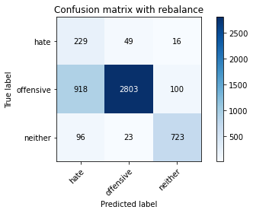

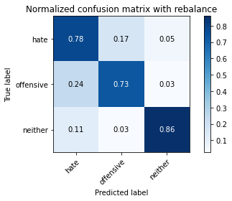

precision recall f1-score support

hate 0.18 0.78 0.30 294

offensive 0.97 0.73 0.84 3821

neither 0.86 0.86 0.86 842

accuracy 0.76 4957

macro avg 0.67 0.79 0.67 4957

weighted avg 0.91 0.76 0.81 4957

average eval_loss: 1.0338555727334273, accuracy: 0.7575146257817228

training 7 epoch...

103.46767807006836 seconds used......

7 training finished! average train loss: 0.11630774422872768

total clf loss: 8.02469995454885 total adv loss: 5.931962219947309

evaluating...

Confusion matrix, without normalization

[[ 210 67 17]

[ 665 3018 138]

[ 78 26 738]]

Normalized confusion matrix

[[0.71428571 0.22789116 0.05782313]

[0.17403821 0.78984559 0.0361162 ]

[0.09263658 0.03087886 0.87648456]]

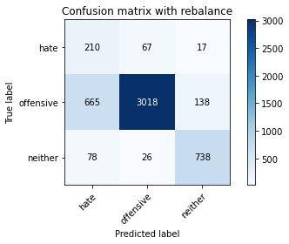

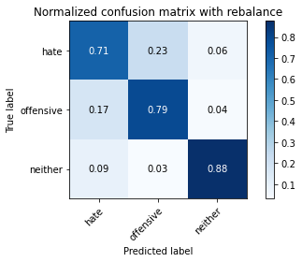

precision recall f1-score support

hate 0.22 0.71 0.34 294

offensive 0.97 0.79 0.87 3821

neither 0.83 0.88 0.85 842

accuracy 0.80 4957

macro avg 0.67 0.79 0.69 4957

weighted avg 0.90 0.80 0.84 4957

average eval_loss: 0.833324609121548, accuracy: 0.8000806939681259

training 8 epoch...

103.53102445602417 seconds used......

8 training finished! average train loss: 0.07708187679261819

total clf loss: 6.033697020844556 total adv loss: 3.5736520178470528

evaluating...

Confusion matrix, without normalization

[[ 236 50 8]

[ 986 2737 98]

[ 166 18 658]]

Normalized confusion matrix

[[0.80272109 0.17006803 0.02721088]

[0.25804763 0.71630463 0.02564774]

[0.19714964 0.02137767 0.78147268]]

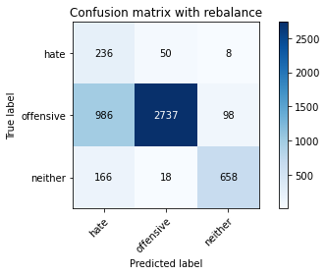

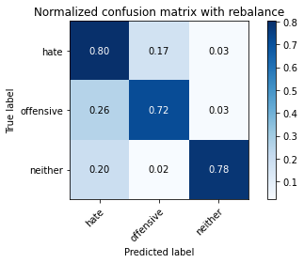

precision recall f1-score support

hate 0.17 0.80 0.28 294

offensive 0.98 0.72 0.83 3821

neither 0.86 0.78 0.82 842

accuracy 0.73 4957

macro avg 0.67 0.77 0.64 4957

weighted avg 0.91 0.73 0.79 4957

average eval_loss: 1.2751887382699116, accuracy: 0.7324994956626992

training 9 epoch...

103.43618822097778 seconds used......

9 training finished! average train loss: 0.07106582167604666

total clf loss: 5.090675574261695 total adv loss: 3.5307900027619326

evaluating...

Confusion matrix, without normalization

[[ 198 69 27]

[ 498 3184 139]

[ 47 27 768]]

Normalized confusion matrix

[[0.67346939 0.23469388 0.09183673]

[0.13033237 0.83328971 0.03637791]

[0.05581948 0.03206651 0.91211401]]

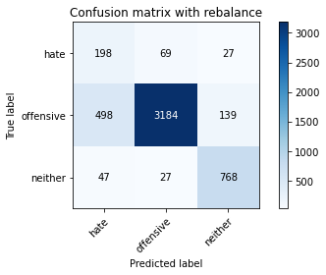

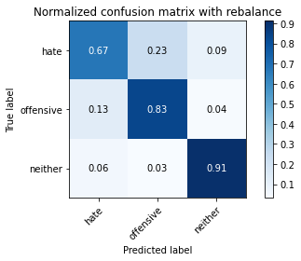

precision recall f1-score support

hate 0.27 0.67 0.38 294

offensive 0.97 0.83 0.90 3821

neither 0.82 0.91 0.86 842

accuracy 0.84 4957

macro avg 0.69 0.81 0.71 4957

weighted avg 0.90 0.84 0.86 4957

average eval_loss: 0.8169733293076616, accuracy: 0.8371999193060319

training 10 epoch...

103.46235203742981 seconds used......

10 training finished! average train loss: 0.05101766703073044

total clf loss: 3.3488659056602046 total adv loss: 2.6875775885710027

evaluating...

Confusion matrix, without normalization

[[ 225 53 16]

[ 826 2874 121]

[ 91 23 728]]

Normalized confusion matrix

[[0.76530612 0.18027211 0.05442177]

[0.21617378 0.75215912 0.0316671 ]

[0.10807601 0.02731591 0.86460808]]

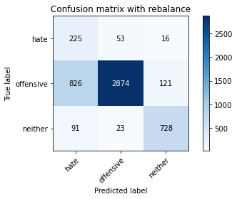

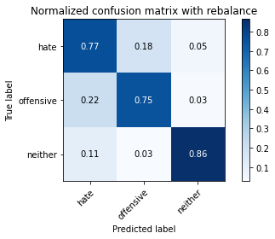

precision recall f1-score support

hate 0.20 0.77 0.31 294

offensive 0.97 0.75 0.85 3821

neither 0.84 0.86 0.85 842

accuracy 0.77 4957

macro avg 0.67 0.79 0.67 4957

weighted avg 0.91 0.77 0.82 4957

average eval_loss: 1.2028210995598667, accuracy: 0.7720395400443817

3 run

training 1 epoch...

103.5350182056427 seconds used......

1 training finished! average train loss: 1.5339255005295513

total clf loss: 120.1533271074295 total adv loss: 71.07396680861712

evaluating...

Confusion matrix, without normalization

[[ 211 47 36]

[ 726 2921 174]

[ 39 12 791]]

Normalized confusion matrix

[[0.71768707 0.15986395 0.12244898]

[0.19000262 0.76445957 0.04553782]

[0.04631829 0.01425178 0.93942993]]

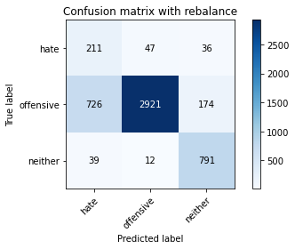

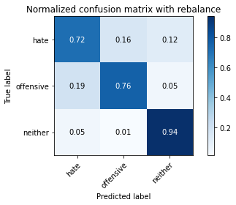

precision recall f1-score support

hate 0.22 0.72 0.33 294

offensive 0.98 0.76 0.86 3821

neither 0.79 0.94 0.86 842

accuracy 0.79 4957

macro avg 0.66 0.81 0.68 4957

weighted avg 0.90 0.79 0.83 4957

average eval_loss: 0.4719855031899868, accuracy: 0.7914060923945935

training 2 epoch...

103.55310416221619 seconds used......

2 training finished! average train loss: 1.0004881123701732

total clf loss: 72.02807787060738 total adv loss: 49.527694284915924

evaluating...

Confusion matrix, without normalization

[[ 223 55 16]

[ 657 3071 93]

[ 94 13 735]]

Normalized confusion matrix

[[0.7585034 0.18707483 0.05442177]

[0.17194452 0.8037163 0.02433918]

[0.11163895 0.01543943 0.87292162]]

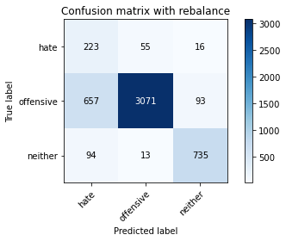

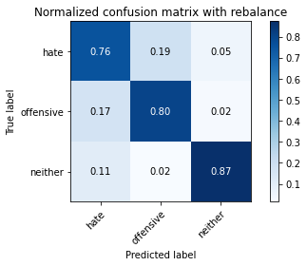

precision recall f1-score support

hate 0.23 0.76 0.35 294

offensive 0.98 0.80 0.88 3821

neither 0.87 0.87 0.87 842

accuracy 0.81 4957

macro avg 0.69 0.81 0.70 4957

weighted avg 0.92 0.81 0.85 4957

average eval_loss: 0.4544563992249389, accuracy: 0.8127899939479524

training 3 epoch...

103.53802967071533 seconds used......

3 training finished! average train loss: 0.7301244207641535

total clf loss: 51.32200164720416 total adv loss: 36.764637153595686

evaluating...

Confusion matrix, without normalization

[[ 215 54 25]

[ 643 3043 135]

[ 44 25 773]]

Normalized confusion matrix

[[0.73129252 0.18367347 0.08503401]

[0.16828055 0.79638838 0.03533107]

[0.05225653 0.02969121 0.91805226]]

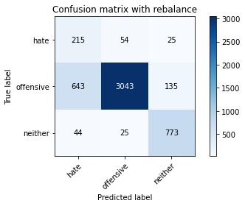

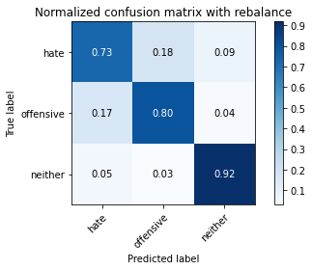

precision recall f1-score support

hate 0.24 0.73 0.36 294

offensive 0.97 0.80 0.88 3821

neither 0.83 0.92 0.87 842

accuracy 0.81 4957

macro avg 0.68 0.82 0.70 4957

weighted avg 0.91 0.81 0.84 4957

average eval_loss: 0.46551417108745347, accuracy: 0.8131934637885818

training 4 epoch...

103.51712775230408 seconds used......

4 training finished! average train loss: 0.4598508366977262

total clf loss: 32.20219978503883 total adv loss: 23.2161464728415

evaluating...

Confusion matrix, without normalization

[[ 219 55 20]

[ 663 3052 106]

[ 67 22 753]]

Normalized confusion matrix

[[0.74489796 0.18707483 0.06802721]

[0.17351479 0.79874378 0.02774143]

[0.07957245 0.02612827 0.89429929]]

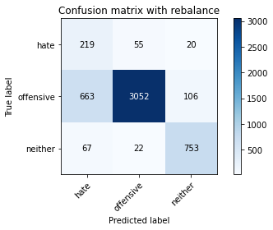

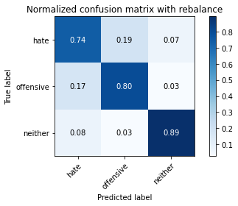

precision recall f1-score support

hate 0.23 0.74 0.35 294

offensive 0.98 0.80 0.88 3821

neither 0.86 0.89 0.88 842

accuracy 0.81 4957

macro avg 0.69 0.81 0.70 4957

weighted avg 0.91 0.81 0.85 4957

average eval_loss: 0.5725493171672907, accuracy: 0.8117813193463789

training 5 epoch...

103.52159810066223 seconds used......

5 training finished! average train loss: 0.2878430552497419

total clf loss: 19.306766695342958 total adv loss: 14.957197829149663

evaluating...

Confusion matrix, without normalization

[[ 207 70 17]

[ 437 3271 113]

[ 54 31 757]]

Normalized confusion matrix

[[0.70408163 0.23809524 0.05782313]

[0.11436797 0.85605862 0.02957341]

[0.06413302 0.0368171 0.89904988]]

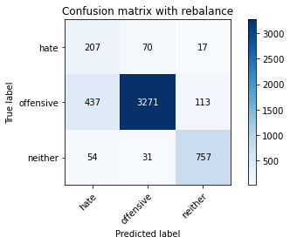

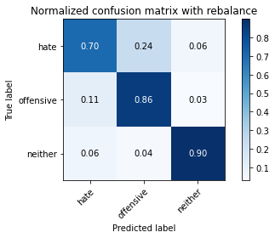

precision recall f1-score support

hate 0.30 0.70 0.42 294

offensive 0.97 0.86 0.91 3821

neither 0.85 0.90 0.88 842

accuracy 0.85 4957

macro avg 0.71 0.82 0.73 4957

weighted avg 0.91 0.85 0.87 4957

average eval_loss: 0.5454407738326418, accuracy: 0.8543473875327819

training 6 epoch...

103.54353213310242 seconds used......

6 training finished! average train loss: 0.14937635308011757

total clf loss: 10.30181536427699 total adv loss: 7.620770435169106

evaluating...

Confusion matrix, without normalization

[[ 217 60 17]

[ 660 3066 95]

[ 63 38 741]]

Normalized confusion matrix

[[0.73809524 0.20408163 0.05782313]

[0.17272965 0.80240775 0.0248626 ]

[0.07482185 0.04513064 0.88004751]]

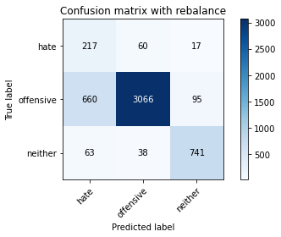

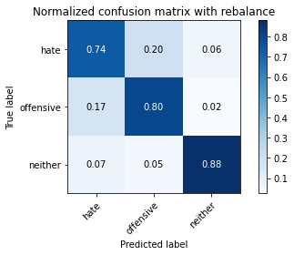

precision recall f1-score support

hate 0.23 0.74 0.35 294

offensive 0.97 0.80 0.88 3821

neither 0.87 0.88 0.87 842

accuracy 0.81 4957

macro avg 0.69 0.81 0.70 4957

weighted avg 0.91 0.81 0.85 4957

average eval_loss: 0.732435769117963, accuracy: 0.8117813193463789

training 7 epoch...

103.5288438796997 seconds used......

7 training finished! average train loss: 0.11188584710580259

total clf loss: 7.632099983049557 total adv loss: 5.7501899266499095

evaluating...

Confusion matrix, without normalization

[[ 218 54 22]

[ 719 2978 124]

[ 61 28 753]]

Normalized confusion matrix

[[0.7414966 0.18367347 0.07482993]

[0.18817064 0.77937713 0.03245224]

[0.07244656 0.03325416 0.89429929]]

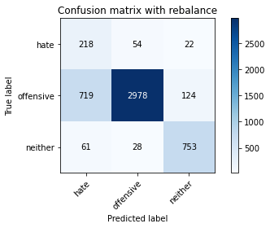

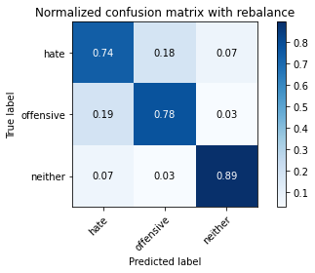

precision recall f1-score support

hate 0.22 0.74 0.34 294

offensive 0.97 0.78 0.87 3821

neither 0.84 0.89 0.87 842

accuracy 0.80 4957

macro avg 0.68 0.81 0.69 4957

weighted avg 0.91 0.80 0.83 4957

average eval_loss: 0.8789547844301729, accuracy: 0.7966512003227759

training 8 epoch...

103.59412479400635 seconds used......

8 training finished! average train loss: 0.09505285123194301

total clf loss: 5.921150184120052 total adv loss: 5.166443645801337

evaluating...

Confusion matrix, without normalization

[[ 229 48 17]

[ 878 2842 101]

[ 93 30 719]]

Normalized confusion matrix

[[0.77891156 0.16326531 0.05782313]

[0.22978278 0.74378435 0.02643287]

[0.11045131 0.03562945 0.85391924]]

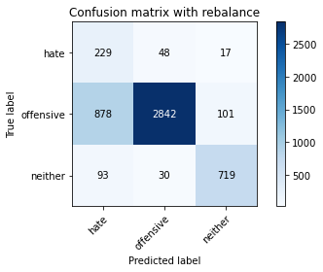

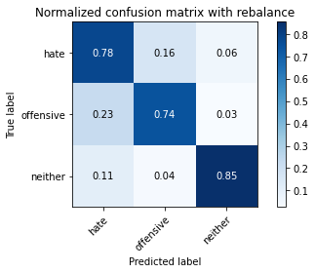

precision recall f1-score support

hate 0.19 0.78 0.31 294

offensive 0.97 0.74 0.84 3821

neither 0.86 0.85 0.86 842

accuracy 0.76 4957

macro avg 0.67 0.79 0.67 4957

weighted avg 0.91 0.76 0.81 4957

average eval_loss: 1.1355964888202688, accuracy: 0.7645753479927375

training 9 epoch...

103.51401829719543 seconds used......

9 training finished! average train loss: 0.08942734109570016

total clf loss: 5.491914796992205 total adv loss: 4.900080285864533

evaluating...

Confusion matrix, without normalization

[[ 233 45 16]

[1097 2625 99]

[ 115 23 704]]

Normalized confusion matrix

[[0.79251701 0.15306122 0.05442177]

[0.28709762 0.68699293 0.02590945]

[0.13657957 0.02731591 0.83610451]]

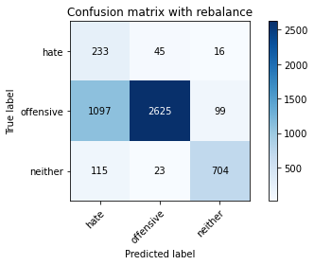

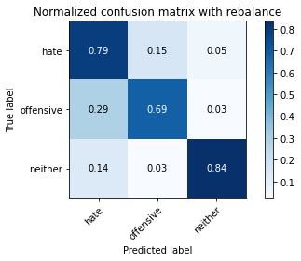

precision recall f1-score support

hate 0.16 0.79 0.27 294

offensive 0.97 0.69 0.81 3821

neither 0.86 0.84 0.85 842

accuracy 0.72 4957

macro avg 0.67 0.77 0.64 4957

weighted avg 0.91 0.72 0.78 4957

average eval_loss: 1.398148881016119, accuracy: 0.7185797861609845

training 10 epoch...

103.45839595794678 seconds used......

10 training finished! average train loss: 0.053768376364339995

total clf loss: 3.066446523705963 total adv loss: 3.063972943189583

evaluating...

Confusion matrix, without normalization

[[ 220 53 21]

[ 803 2906 112]

[ 77 30 735]]

Normalized confusion matrix

[[0.74829932 0.18027211 0.07142857]

[0.21015441 0.76053389 0.0293117 ]

[0.09144893 0.03562945 0.87292162]]

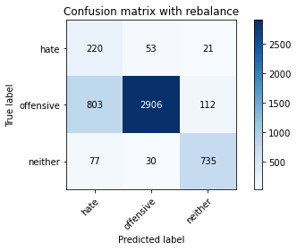

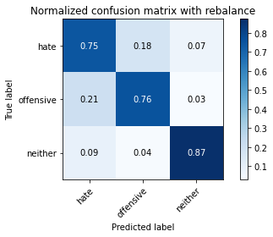

precision recall f1-score support

hate 0.20 0.75 0.32 294

offensive 0.97 0.76 0.85 3821

neither 0.85 0.87 0.86 842

accuracy 0.78 4957

macro avg 0.67 0.79 0.68 4957

weighted avg 0.91 0.78 0.82 4957

average eval_loss: 1.1132128925866358, accuracy: 0.7788985273350817

4 run

training 1 epoch...

103.5739541053772 seconds used......

1 training finished! average train loss: 1.5182182959645811

total clf loss: 117.67955534160137 total adv loss: 70.96788634359837

evaluating...

Confusion matrix, without normalization

[[ 246 29 19]

[1155 2572 94]

[ 99 15 728]]

Normalized confusion matrix

[[0.83673469 0.09863946 0.06462585]

[0.30227689 0.67312222 0.02460089]

[0.1175772 0.01781473 0.86460808]]

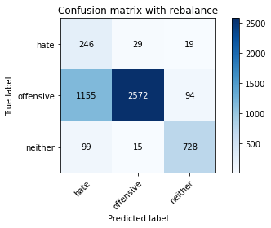

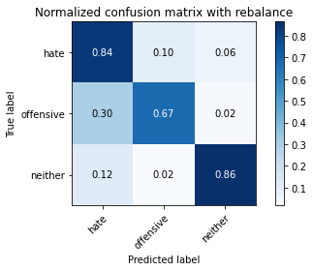

precision recall f1-score support

hate 0.16 0.84 0.27 294

offensive 0.98 0.67 0.80 3821

neither 0.87 0.86 0.87 842

accuracy 0.72 4957

macro avg 0.67 0.79 0.65 4957

weighted avg 0.91 0.72 0.78 4957

average eval_loss: 0.6692533322399662, accuracy: 0.7153520274359492

training 2 epoch...

103.64716029167175 seconds used......

2 training finished! average train loss: 0.9957967921655778

total clf loss: 71.85392607748508 total adv loss: 49.213662691414356

evaluating...

Confusion matrix, without normalization

[[ 217 49 28]

[ 615 3072 134]

[ 43 12 787]]

Normalized confusion matrix

[[0.73809524 0.16666667 0.0952381 ]

[0.16095263 0.80397802 0.03506935]

[0.05106888 0.01425178 0.93467933]]

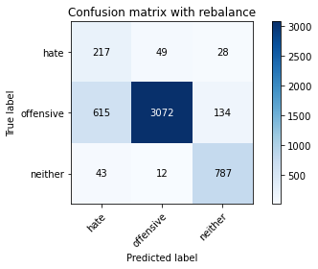

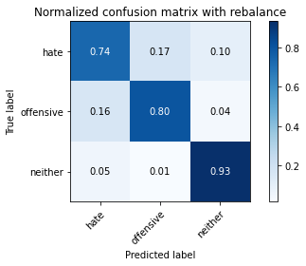

precision recall f1-score support

hate 0.25 0.74 0.37 294

offensive 0.98 0.80 0.88 3821

neither 0.83 0.93 0.88 842

accuracy 0.82 4957

macro avg 0.69 0.83 0.71 4957

weighted avg 0.91 0.82 0.85 4957

average eval_loss: 0.44066889166471457, accuracy: 0.8222715352027435

training 3 epoch...

103.61247420310974 seconds used......

3 training finished! average train loss: 0.7202596329806144

total clf loss: 50.57527703791857 total adv loss: 36.29456026945263

evaluating...

Confusion matrix, without normalization

[[ 228 50 16]

[ 844 2855 122]

[ 79 8 755]]

Normalized confusion matrix

[[0.7755102 0.17006803 0.05442177]

[0.22088459 0.7471866 0.03192881]

[0.09382423 0.00950119 0.89667458]]

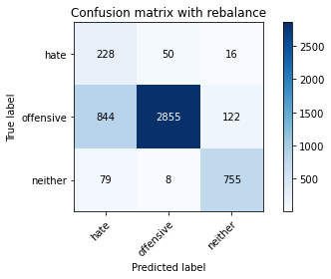

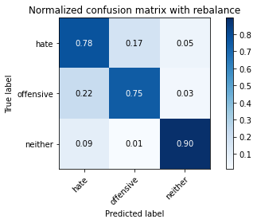

precision recall f1-score support

hate 0.20 0.78 0.32 294

offensive 0.98 0.75 0.85 3821

neither 0.85 0.90 0.87 842

accuracy 0.77 4957

macro avg 0.67 0.81 0.68 4957

weighted avg 0.91 0.77 0.82 4957

average eval_loss: 0.5593705445287689, accuracy: 0.7742586241678434

training 4 epoch...

103.71631145477295 seconds used......

4 training finished! average train loss: 0.4867491677882727

total clf loss: 33.15866953507066 total adv loss: 25.037718993611634

evaluating...

Confusion matrix, without normalization

[[ 218 59 17]

[ 757 2957 107]

[ 79 14 749]]

Normalized confusion matrix

[[0.7414966 0.20068027 0.05782313]

[0.19811568 0.77388118 0.02800314]

[0.09382423 0.01662708 0.88954869]]

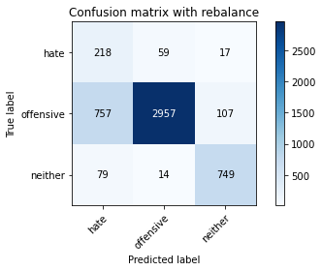

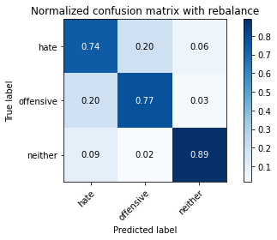

precision recall f1-score support

hate 0.21 0.74 0.32 294

offensive 0.98 0.77 0.86 3821

neither 0.86 0.89 0.87 842

accuracy 0.79 4957

macro avg 0.68 0.80 0.69 4957

weighted avg 0.91 0.79 0.83 4957

average eval_loss: 0.6258158627747288, accuracy: 0.7916078273149082

training 5 epoch...

103.60264468193054 seconds used......

5 training finished! average train loss: 0.2993661945152004

total clf loss: 19.117543391883373 total adv loss: 16.037038133305032

evaluating...

Confusion matrix, without normalization

[[ 223 56 15]

[ 867 2861 93]

[ 88 25 729]]

Normalized confusion matrix

[[0.7585034 0.19047619 0.05102041]

[0.22690395 0.74875687 0.02433918]

[0.10451306 0.02969121 0.86579572]]

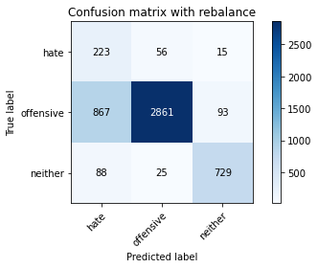

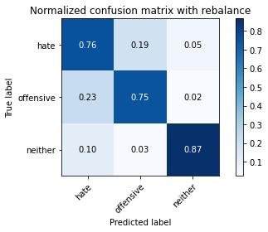

precision recall f1-score support

hate 0.19 0.76 0.30 294

offensive 0.97 0.75 0.85 3821

neither 0.87 0.87 0.87 842

accuracy 0.77 4957

macro avg 0.68 0.79 0.67 4957

weighted avg 0.91 0.77 0.82 4957

average eval_loss: 0.7131835677841257, accuracy: 0.7692152511599758

training 6 epoch...

103.4817385673523 seconds used......

6 training finished! average train loss: 0.10869990955297536

total clf loss: 8.068988863844424 total adv loss: 5.259347794264613

evaluating...

Confusion matrix, without normalization

[[ 202 68 24]

[ 536 3153 132]

[ 53 20 769]]

Normalized confusion matrix

[[0.68707483 0.23129252 0.08163265]

[0.14027741 0.82517666 0.03454593]

[0.06294537 0.02375297 0.91330166]]

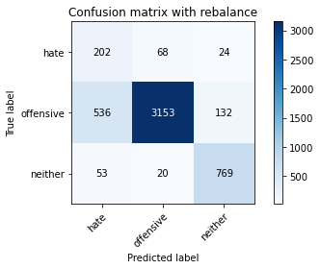

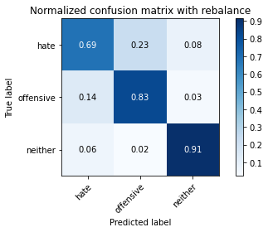

precision recall f1-score support

hate 0.26 0.69 0.37 294

offensive 0.97 0.83 0.89 3821

neither 0.83 0.91 0.87 842

accuracy 0.83 4957

macro avg 0.69 0.81 0.71 4957

weighted avg 0.91 0.83 0.86 4957

average eval_loss: 0.7296259629703502, accuracy: 0.8319548113778495

training 7 epoch...

103.61421275138855 seconds used......

7 training finished! average train loss: 0.10975455509482376

total clf loss: 7.738743302877992 total adv loss: 5.514642917616584

evaluating...

Confusion matrix, without normalization

[[ 216 60 18]

[ 723 2986 112]

[ 82 23 737]]

Normalized confusion matrix

[[0.73469388 0.20408163 0.06122449]

[0.18921748 0.78147082 0.0293117 ]

[0.09738717 0.02731591 0.87529691]]

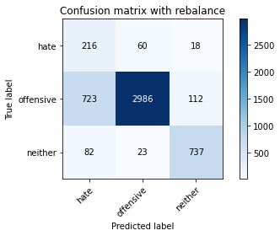

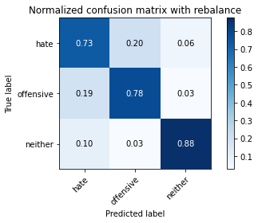

precision recall f1-score support

hate 0.21 0.73 0.33 294

offensive 0.97 0.78 0.87 3821

neither 0.85 0.88 0.86 842

accuracy 0.79 4957

macro avg 0.68 0.80 0.69 4957

weighted avg 0.91 0.79 0.83 4957

average eval_loss: 0.8919558606425961, accuracy: 0.7946338511196288

training 8 epoch...

103.4851655960083 seconds used......

8 training finished! average train loss: 0.08944175471156858

total clf loss: 6.480488411500119 total adv loss: 4.407025857857661

evaluating...

Confusion matrix, without normalization

[[ 204 71 19]

[ 510 3197 114]

[ 73 18 751]]

Normalized confusion matrix

[[0.69387755 0.2414966 0.06462585]

[0.13347291 0.83669197 0.02983512]

[0.08669834 0.02137767 0.89192399]]

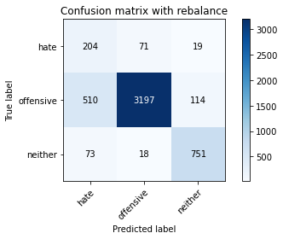

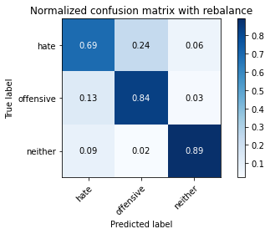

precision recall f1-score support

hate 0.26 0.69 0.38 294

offensive 0.97 0.84 0.90 3821

neither 0.85 0.89 0.87 842

accuracy 0.84 4957

macro avg 0.69 0.81 0.72 4957

weighted avg 0.91 0.84 0.86 4957

average eval_loss: 0.7181873036728751, accuracy: 0.8376033891466613

training 9 epoch...

103.41917371749878 seconds used......

9 training finished! average train loss: 0.05544438062042368

total clf loss: 3.650992379989475 total adv loss: 2.9149983491140574

evaluating...

Confusion matrix, without normalization

[[ 188 81 25]

[ 491 3198 132]

[ 43 26 773]]

Normalized confusion matrix

[[0.63945578 0.2755102 0.08503401]

[0.12850039 0.83695368 0.03454593]

[0.05106888 0.03087886 0.91805226]]

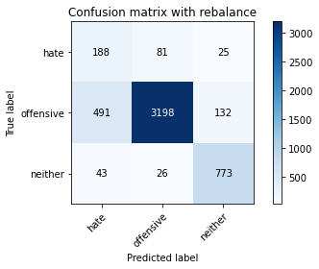

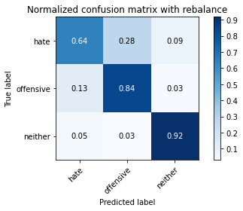

precision recall f1-score support

hate 0.26 0.64 0.37 294

offensive 0.97 0.84 0.90 3821

neither 0.83 0.92 0.87 842

accuracy 0.84 4957

macro avg 0.69 0.80 0.71 4957

weighted avg 0.90 0.84 0.86 4957

average eval_loss: 0.7336703095230229, accuracy: 0.8390155335888643

training 10 epoch...

103.40155220031738 seconds used......

10 training finished! average train loss: 0.050714652307266204

total clf loss: 3.7918487486313097 total adv loss: 2.440178442511751

evaluating...

Confusion matrix, without normalization

[[ 209 61 24]

[ 671 3016 134]

[ 57 17 768]]

Normalized confusion matrix

[[0.71088435 0.20748299 0.08163265]

[0.17560848 0.78932217 0.03506935]

[0.06769596 0.02019002 0.91211401]]

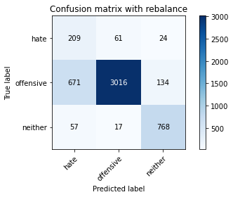

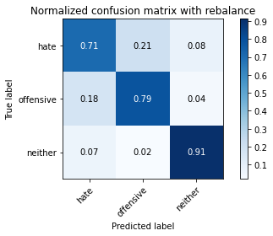

precision recall f1-score support

hate 0.22 0.71 0.34 294

offensive 0.97 0.79 0.87 3821

neither 0.83 0.91 0.87 842

accuracy 0.81 4957

macro avg 0.68 0.80 0.69 4957

weighted avg 0.91 0.81 0.84 4957

average eval_loss: 0.9742966394894005, accuracy: 0.8055275368166229

5 run

training 1 epoch...

103.50875997543335 seconds used......

1 training finished! average train loss: 1.5141131128484047

total clf loss: 117.09080308675766 total adv loss: 70.91127001494169

evaluating...

Confusion matrix, without normalization

[[ 190 58 46]

[ 537 3107 177]

[ 38 13 791]]

Normalized confusion matrix

[[0.6462585 0.19727891 0.15646259]

[0.14053913 0.81313792 0.04632295]

[0.04513064 0.01543943 0.93942993]]

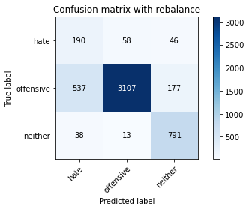

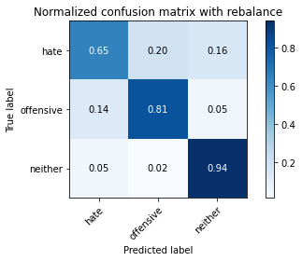

precision recall f1-score support

hate 0.25 0.65 0.36 294

offensive 0.98 0.81 0.89 3821

neither 0.78 0.94 0.85 842

accuracy 0.82 4957

macro avg 0.67 0.80 0.70 4957

weighted avg 0.90 0.82 0.85 4957

average eval_loss: 0.43263100778623936, accuracy: 0.8246923542465201

training 2 epoch...

103.41000032424927 seconds used......

2 training finished! average train loss: 0.9988740508319341

total clf loss: 71.09273587167263 total adv loss: 49.85736330598593

evaluating...

Confusion matrix, without normalization

[[ 235 43 16]

[ 869 2838 114]

[ 83 12 747]]

Normalized confusion matrix

[[0.79931973 0.1462585 0.05442177]

[0.22742738 0.7427375 0.02983512]

[0.09857482 0.01425178 0.8871734 ]]

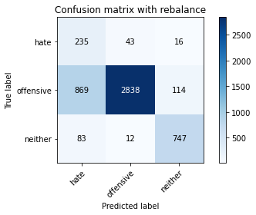

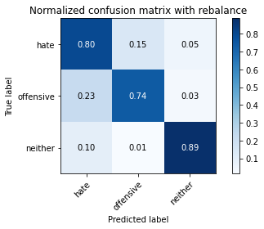

precision recall f1-score support

hate 0.20 0.80 0.32 294

offensive 0.98 0.74 0.85 3821

neither 0.85 0.89 0.87 842

accuracy 0.77 4957

macro avg 0.68 0.81 0.68 4957

weighted avg 0.91 0.77 0.82 4957

average eval_loss: 0.5164394669475094, accuracy: 0.7706273956021787

training 3 epoch...

103.34547352790833 seconds used......

3 training finished! average train loss: 0.7293554371037678

total clf loss: 51.055176340043545 total adv loss: 36.83230175450444

evaluating...

Confusion matrix, without normalization

[[ 218 55 21]

[ 671 3028 122]

[ 66 18 758]]

Normalized confusion matrix

[[0.7414966 0.18707483 0.07142857]

[0.17560848 0.79246271 0.03192881]

[0.0783848 0.02137767 0.90023753]]

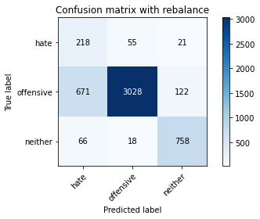

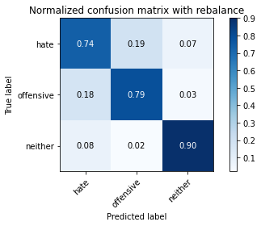

precision recall f1-score support

hate 0.23 0.74 0.35 294

offensive 0.98 0.79 0.87 3821

neither 0.84 0.90 0.87 842

accuracy 0.81 4957

macro avg 0.68 0.81 0.70 4957

weighted avg 0.91 0.81 0.84 4957

average eval_loss: 0.4764645120369331, accuracy: 0.8077466209400848

training 4 epoch...

103.38207149505615 seconds used......

4 training finished! average train loss: 0.48468621785354893

total clf loss: 31.62713228724897 total adv loss: 25.627105521969497

evaluating...

Confusion matrix, without normalization

[[ 222 50 22]

[ 726 2967 128]

[ 64 25 753]]

Normalized confusion matrix

[[0.75510204 0.17006803 0.07482993]

[0.19000262 0.7764983 0.03349908]

[0.0760095 0.02969121 0.89429929]]

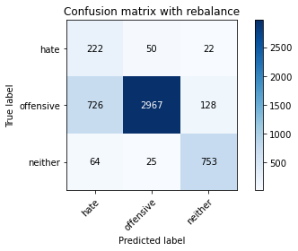

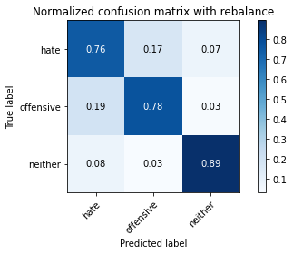

precision recall f1-score support

hate 0.22 0.76 0.34 294

offensive 0.98 0.78 0.86 3821

neither 0.83 0.89 0.86 842

accuracy 0.80 4957

macro avg 0.68 0.81 0.69 4957

weighted avg 0.91 0.80 0.83 4957

average eval_loss: 0.564394623108749, accuracy: 0.795239055880573

training 5 epoch...

103.42018961906433 seconds used......

5 training finished! average train loss: 0.3153823722665857

total clf loss: 20.43164019752294 total adv loss: 16.74937270823284

evaluating...

Confusion matrix, without normalization

[[ 178 78 38]

[ 437 3180 204]

[ 25 27 790]]

Normalized confusion matrix

[[0.60544218 0.26530612 0.1292517 ]

[0.11436797 0.83224287 0.05338917]

[0.02969121 0.03206651 0.93824228]]

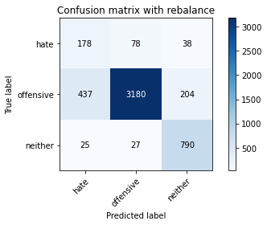

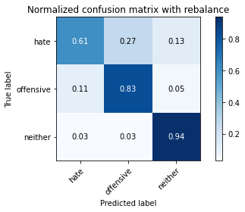

precision recall f1-score support

hate 0.28 0.61 0.38 294

offensive 0.97 0.83 0.90 3821

neither 0.77 0.94 0.84 842

accuracy 0.84 4957

macro avg 0.67 0.79 0.71 4957

weighted avg 0.89 0.84 0.86 4957

average eval_loss: 0.5486388975574125, accuracy: 0.8367964494654024

training 6 epoch...

103.40071940422058 seconds used......

6 training finished! average train loss: 0.20659222459278956

total clf loss: 13.702047151047736 total adv loss: 10.812611689907499

evaluating...

Confusion matrix, without normalization

[[ 231 44 19]

[ 840 2842 139]

[ 67 21 754]]

Normalized confusion matrix

[[0.78571429 0.14965986 0.06462585]

[0.21983774 0.74378435 0.03637791]

[0.07957245 0.02494062 0.89548694]]

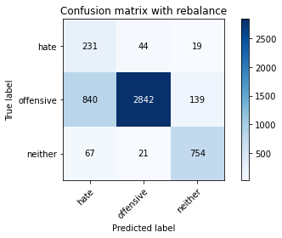

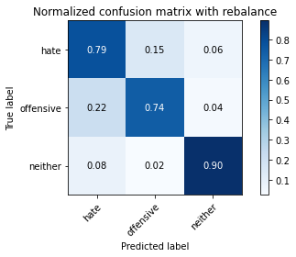

precision recall f1-score support

hate 0.20 0.79 0.32 294

offensive 0.98 0.74 0.84 3821

neither 0.83 0.90 0.86 842

accuracy 0.77 4957

macro avg 0.67 0.81 0.68 4957

weighted avg 0.91 0.77 0.82 4957

average eval_loss: 0.9224787479071247, accuracy: 0.7720395400443817

training 7 epoch...

103.46082973480225 seconds used......

7 training finished! average train loss: 0.09816205120857871

total clf loss: 6.981132865534164 total adv loss: 4.90228897081397

evaluating...

Confusion matrix, without normalization

[[ 207 62 25]

[ 623 3036 162]

[ 38 20 784]]

Normalized confusion matrix

[[0.70408163 0.21088435 0.08503401]

[0.16304632 0.7945564 0.04239728]

[0.04513064 0.02375297 0.93111639]]

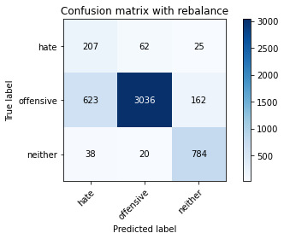

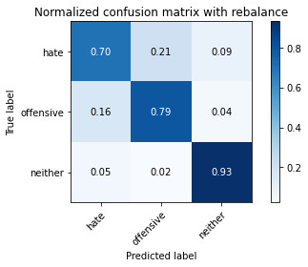

precision recall f1-score support

hate 0.24 0.70 0.36 294

offensive 0.97 0.79 0.88 3821

neither 0.81 0.93 0.86 842

accuracy 0.81 4957

macro avg 0.67 0.81 0.70 4957

weighted avg 0.90 0.81 0.84 4957

average eval_loss: 0.8742345554299743, accuracy: 0.8123865241073229

training 8 epoch...

103.48999786376953 seconds used......

8 training finished! average train loss: 0.0973857837063342

total clf loss: 6.363782211556099 total adv loss: 5.1445933692812105

evaluating...

Confusion matrix, without normalization

[[ 223 57 14]

[ 721 3006 94]

[ 76 35 731]]

Normalized confusion matrix

[[0.7585034 0.19387755 0.04761905]

[0.18869406 0.78670505 0.02460089]

[0.09026128 0.0415677 0.86817102]]

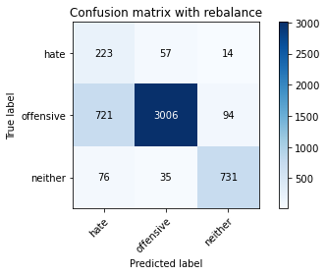

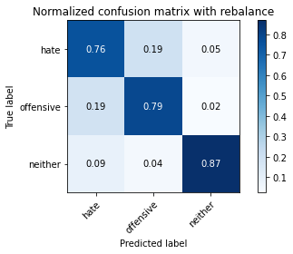

precision recall f1-score support

hate 0.22 0.76 0.34 294

offensive 0.97 0.79 0.87 3821

neither 0.87 0.87 0.87 842

accuracy 0.80 4957

macro avg 0.69 0.80 0.69 4957

weighted avg 0.91 0.80 0.84 4957

average eval_loss: 0.9163994889785235, accuracy: 0.7988702844462376

training 9 epoch...

103.43268537521362 seconds used......

9 training finished! average train loss: 0.08087626793925591

total clf loss: 5.396439813543111 total adv loss: 4.216701010604083

evaluating...

Confusion matrix, without normalization

[[ 215 58 21]

[ 675 3033 113]

[ 63 29 750]]

Normalized confusion matrix

[[0.73129252 0.19727891 0.07142857]

[0.17665533 0.79377126 0.02957341]

[0.07482185 0.03444181 0.89073634]]

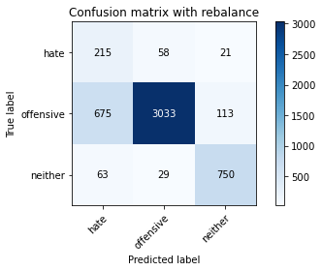

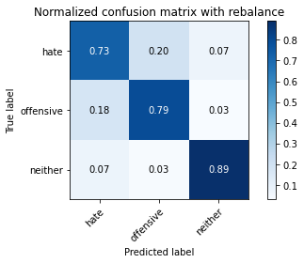

precision recall f1-score support

hate 0.23 0.73 0.34 294

offensive 0.97 0.79 0.87 3821

neither 0.85 0.89 0.87 842

accuracy 0.81 4957

macro avg 0.68 0.81 0.70 4957

weighted avg 0.91 0.81 0.84 4957

average eval_loss: 0.9233798836339114, accuracy: 0.8065362114181965

training 10 epoch...

103.53164672851562 seconds used......

10 training finished! average train loss: 0.032172548015838846

total clf loss: 2.231182044779416 total adv loss: 1.6351618127223446

evaluating...

Confusion matrix, without normalization

[[ 248 35 11]

[1079 2622 120]

[ 125 20 697]]

Normalized confusion matrix

[[0.84353741 0.11904762 0.03741497]

[0.28238681 0.6862078 0.03140539]

[0.14845606 0.02375297 0.82779097]]

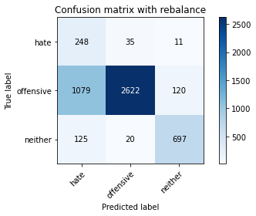

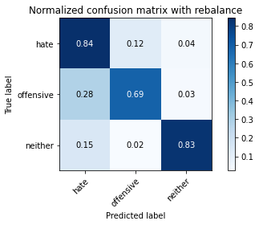

precision recall f1-score support

hate 0.17 0.84 0.28 294

offensive 0.98 0.69 0.81 3821

neither 0.84 0.83 0.83 842

accuracy 0.72 4957

macro avg 0.66 0.79 0.64 4957

weighted avg 0.91 0.72 0.78 4957

average eval_loss: 1.3866883263953271, accuracy: 0.719588460762558