e1 run

[1,0.5,1]

training 1 epoch...

28.638161420822144 seconds used......

1 training finished! average train loss: 0.6312562222020668

evaluating...

Confusion matrix, without normalization

[[ 237 36 21]

[ 953 2746 122]

[ 64 9 769]]

Normalized confusion matrix

[[0.80612245 0.12244898 0.07142857]

[0.24941115 0.71866004 0.03192881]

[0.0760095 0.01068884 0.91330166]]

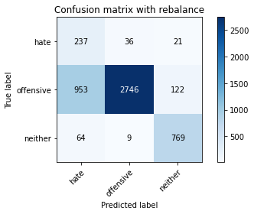

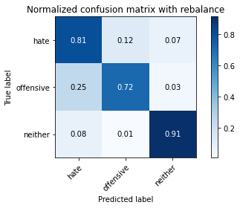

precision recall f1-score support

hate 0.19 0.81 0.31 294

offensive 0.98 0.72 0.83 3821

neither 0.84 0.91 0.88 842

accuracy 0.76 4957

macro avg 0.67 0.81 0.67 4957

weighted avg 0.91 0.76 0.81 4957

average eval_loss: 0.5565695045816321, accuracy: 0.7569094210207787

training 2 epoch...

28.035133600234985 seconds used......

2 training finished! average train loss: 0.37307259623418776

evaluating...

Confusion matrix, without normalization

[[ 238 36 20]

[ 822 2866 133]

[ 42 12 788]]

Normalized confusion matrix

[[0.80952381 0.12244898 0.06802721]

[0.21512693 0.75006543 0.03480764]

[0.04988124 0.01425178 0.93586698]]

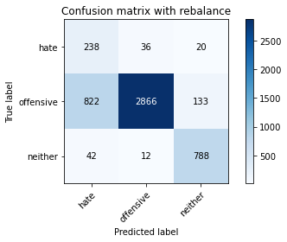

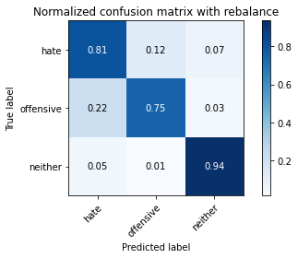

precision recall f1-score support

hate 0.22 0.81 0.34 294

offensive 0.98 0.75 0.85 3821

neither 0.84 0.94 0.88 842

accuracy 0.79 4957

macro avg 0.68 0.83 0.69 4957

weighted avg 0.91 0.79 0.83 4957

average eval_loss: 0.4779600168788625, accuracy: 0.7851523098648376

training 3 epoch...

27.922855377197266 seconds used......

3 training finished! average train loss: 0.241760943542447

evaluating...

Confusion matrix, without normalization

[[ 242 35 17]

[1127 2593 101]

[ 87 22 733]]

Normalized confusion matrix

[[0.82312925 0.11904762 0.05782313]

[0.29494897 0.67861816 0.02643287]

[0.10332542 0.02612827 0.87054632]]

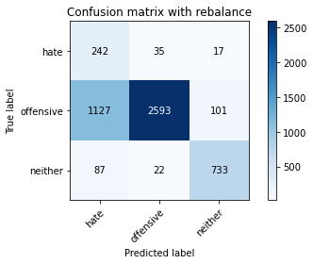

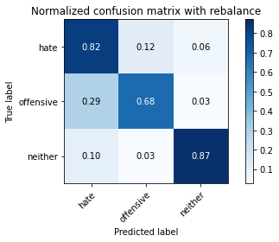

precision recall f1-score support

hate 0.17 0.82 0.28 294

offensive 0.98 0.68 0.80 3821

neither 0.86 0.87 0.87 842

accuracy 0.72 4957

macro avg 0.67 0.79 0.65 4957

weighted avg 0.91 0.72 0.78 4957

average eval_loss: 0.6799820224123616, accuracy: 0.7197901956828727

training 4 epoch...

27.95978546142578 seconds used......

4 training finished! average train loss: 0.15562790197630724

evaluating...

Confusion matrix, without normalization

[[ 238 40 16]

[ 905 2820 96]

[ 70 25 747]]

Normalized confusion matrix

[[0.80952381 0.13605442 0.05442177]

[0.23684899 0.73802669 0.02512431]

[0.08313539 0.02969121 0.8871734 ]]

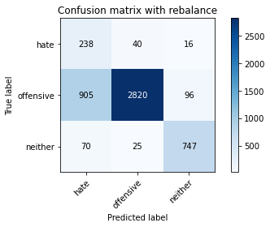

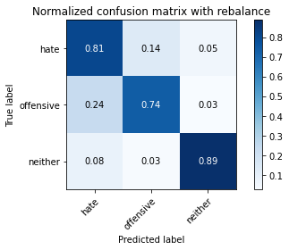

precision recall f1-score support

hate 0.20 0.81 0.32 294

offensive 0.98 0.74 0.84 3821

neither 0.87 0.89 0.88 842

accuracy 0.77 4957

macro avg 0.68 0.81 0.68 4957

weighted avg 0.91 0.77 0.82 4957

average eval_loss: 0.5886965955066825, accuracy: 0.7676013717974581

training 5 epoch...

27.93361210823059 seconds used......

5 training finished! average train loss: 0.09693544391509995

evaluating...

Confusion matrix, without normalization

[[ 213 64 17]

[ 489 3217 115]

[ 56 32 754]]

Normalized confusion matrix

[[0.7244898 0.21768707 0.05782313]

[0.12797697 0.8419262 0.03009683]

[0.06650831 0.03800475 0.89548694]]

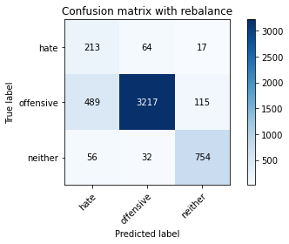

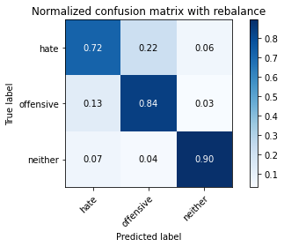

precision recall f1-score support

hate 0.28 0.72 0.40 294

offensive 0.97 0.84 0.90 3821

neither 0.85 0.90 0.87 842

accuracy 0.84 4957

macro avg 0.70 0.82 0.73 4957

weighted avg 0.91 0.84 0.87 4957

average eval_loss: 0.5852739212268423, accuracy: 0.8440589065967319

training 6 epoch...

27.927655458450317 seconds used......

6 training finished! average train loss: 0.06618892801081358

evaluating...

Confusion matrix, without normalization

[[ 231 45 18]

[ 822 2887 112]

[ 53 26 763]]

Normalized confusion matrix

[[0.78571429 0.15306122 0.06122449]

[0.21512693 0.75556137 0.0293117 ]

[0.06294537 0.03087886 0.90617577]]

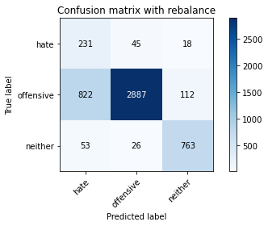

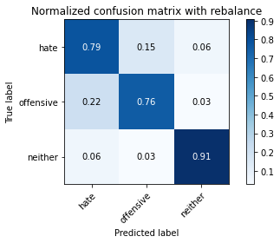

precision recall f1-score support

hate 0.21 0.79 0.33 294

offensive 0.98 0.76 0.85 3821

neither 0.85 0.91 0.88 842

accuracy 0.78 4957

macro avg 0.68 0.82 0.69 4957

weighted avg 0.91 0.78 0.83 4957

average eval_loss: 0.7197770167127131, accuracy: 0.7829332257413758

training 7 epoch...

27.92506742477417 seconds used......

7 training finished! average train loss: 0.04429219607182108

evaluating...

Confusion matrix, without normalization

[[ 213 55 26]

[ 783 2917 121]

[ 42 31 769]]

Normalized confusion matrix

[[0.7244898 0.18707483 0.08843537]

[0.20492018 0.76341272 0.0316671 ]

[0.04988124 0.0368171 0.91330166]]

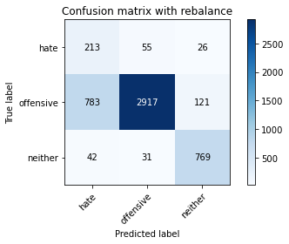

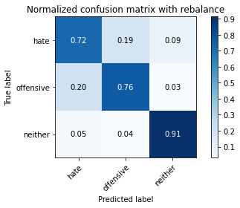

precision recall f1-score support

hate 0.21 0.72 0.32 294

offensive 0.97 0.76 0.85 3821

neither 0.84 0.91 0.87 842

accuracy 0.79 4957

macro avg 0.67 0.80 0.68 4957

weighted avg 0.90 0.79 0.83 4957

average eval_loss: 0.8678518974301105, accuracy: 0.7865644543070406

training 8 epoch...

27.962526082992554 seconds used......

8 training finished! average train loss: 0.020938553900814654

evaluating...

Confusion matrix, without normalization

[[ 228 47 19]

[ 903 2812 106]

[ 60 24 758]]

Normalized confusion matrix

[[0.7755102 0.15986395 0.06462585]

[0.23632557 0.735933 0.02774143]

[0.07125891 0.02850356 0.90023753]]

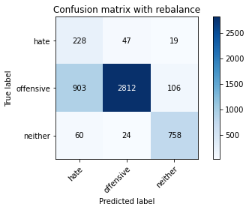

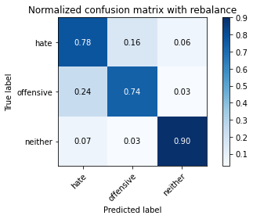

precision recall f1-score support

hate 0.19 0.78 0.31 294

offensive 0.98 0.74 0.84 3821

neither 0.86 0.90 0.88 842

accuracy 0.77 4957

macro avg 0.68 0.80 0.67 4957

weighted avg 0.91 0.77 0.81 4957

average eval_loss: 1.0676944809214723, accuracy: 0.7661892273552552

training 9 epoch...

27.939871311187744 seconds used......

9 training finished! average train loss: 0.021012765501778333

evaluating...

Confusion matrix, without normalization

[[ 237 40 17]

[ 828 2900 93]

[ 67 32 743]]

Normalized confusion matrix

[[0.80612245 0.13605442 0.05782313]

[0.2166972 0.75896362 0.02433918]

[0.07957245 0.03800475 0.8824228 ]]

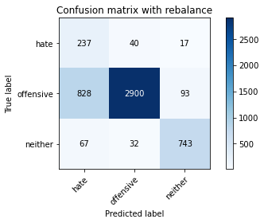

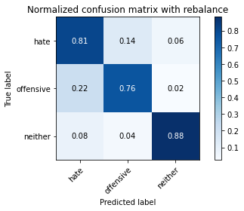

precision recall f1-score support

hate 0.21 0.81 0.33 294

offensive 0.98 0.76 0.85 3821

neither 0.87 0.88 0.88 842

accuracy 0.78 4957

macro avg 0.69 0.82 0.69 4957

weighted avg 0.91 0.78 0.83 4957

average eval_loss: 1.0803533071227702, accuracy: 0.7827314908210611

training 10 epoch...

27.91991686820984 seconds used......

10 training finished! average train loss: 0.00895968079694604

evaluating...

Confusion matrix, without normalization

[[ 218 50 26]

[ 827 2838 156]

[ 46 17 779]]

Normalized confusion matrix

[[0.7414966 0.17006803 0.08843537]

[0.21643549 0.7427375 0.04082701]

[0.05463183 0.02019002 0.92517815]]

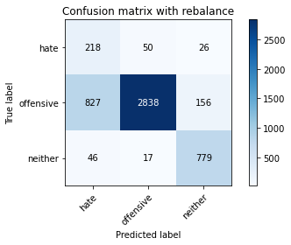

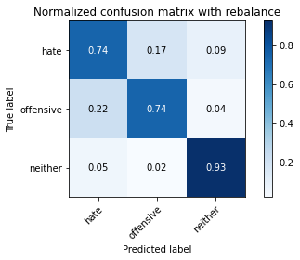

precision recall f1-score support

hate 0.20 0.74 0.31 294

offensive 0.98 0.74 0.84 3821

neither 0.81 0.93 0.86 842

accuracy 0.77 4957

macro avg 0.66 0.80 0.67 4957

weighted avg 0.90 0.77 0.82 4957

average eval_loss: 1.2092072551979893, accuracy: 0.7736534194068994

2 run

training 1 epoch...

27.892340660095215 seconds used......

1 training finished! average train loss: 0.6112407072942857

evaluating...

Confusion matrix, without normalization

[[ 257 17 20]

[2039 1669 113]

[ 70 9 763]]

Normalized confusion matrix

[[0.87414966 0.05782313 0.06802721]

[0.53362994 0.43679665 0.02957341]

[0.08313539 0.01068884 0.90617577]]

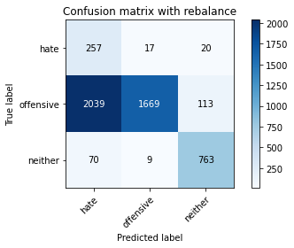

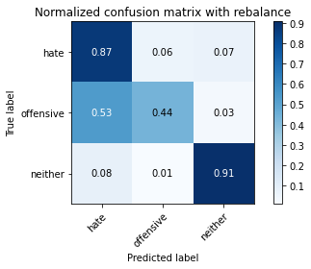

precision recall f1-score support

hate 0.11 0.87 0.19 294

offensive 0.98 0.44 0.61 3821

neither 0.85 0.91 0.88 842

accuracy 0.54 4957

macro avg 0.65 0.74 0.56 4957

weighted avg 0.91 0.54 0.63 4957

average eval_loss: 0.8837494781661418, accuracy: 0.5424652007262457

training 2 epoch...

27.877219200134277 seconds used......

2 training finished! average train loss: 0.3656315312050937

evaluating...

Confusion matrix, without normalization

[[ 241 40 13]

[ 841 2908 72]

[ 94 23 725]]

Normalized confusion matrix

[[0.81972789 0.13605442 0.04421769]

[0.22009945 0.76105731 0.01884323]

[0.11163895 0.02731591 0.86104513]]

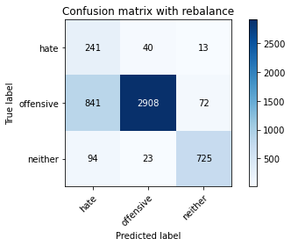

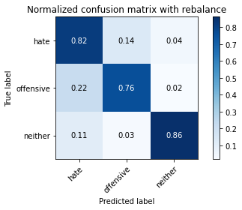

precision recall f1-score support

hate 0.20 0.82 0.33 294

offensive 0.98 0.76 0.86 3821

neither 0.90 0.86 0.88 842

accuracy 0.78 4957

macro avg 0.69 0.81 0.69 4957

weighted avg 0.92 0.78 0.83 4957

average eval_loss: 0.5052639413925428, accuracy: 0.7815210812991729

training 3 epoch...

27.96754789352417 seconds used......

3 training finished! average train loss: 0.2421683018798368

evaluating...

Confusion matrix, without normalization

[[ 232 47 15]

[ 818 2882 121]

[ 65 13 764]]

Normalized confusion matrix

[[0.78911565 0.15986395 0.05102041]

[0.21408008 0.75425281 0.0316671 ]

[0.07719715 0.01543943 0.90736342]]

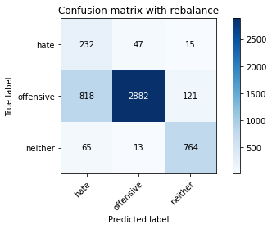

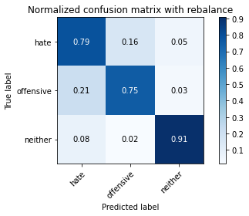

precision recall f1-score support

hate 0.21 0.79 0.33 294

offensive 0.98 0.75 0.85 3821

neither 0.85 0.91 0.88 842

accuracy 0.78 4957

macro avg 0.68 0.82 0.69 4957

weighted avg 0.91 0.78 0.83 4957

average eval_loss: 0.5508197071481375, accuracy: 0.7823280209804317

training 4 epoch...

27.849499464035034 seconds used......

4 training finished! average train loss: 0.14490422020443003

evaluating...

Confusion matrix, without normalization

[[ 231 49 14]

[ 804 2917 100]

[ 49 30 763]]

Normalized confusion matrix

[[0.78571429 0.16666667 0.04761905]

[0.21041612 0.76341272 0.02617116]

[0.05819477 0.03562945 0.90617577]]

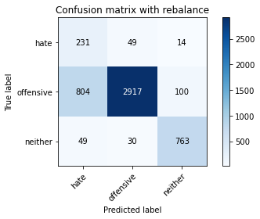

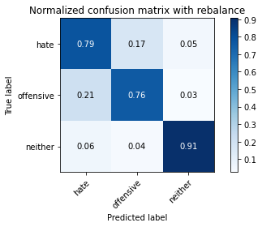

precision recall f1-score support

hate 0.21 0.79 0.34 294

offensive 0.97 0.76 0.86 3821

neither 0.87 0.91 0.89 842

accuracy 0.79 4957

macro avg 0.69 0.82 0.69 4957

weighted avg 0.91 0.79 0.83 4957

average eval_loss: 0.5715152692094806, accuracy: 0.788985273350817

training 5 epoch...

27.796467781066895 seconds used......

5 training finished! average train loss: 0.08479807131286514

evaluating...

Confusion matrix, without normalization

[[ 245 30 19]

[1111 2463 247]

[ 64 10 768]]

Normalized confusion matrix

[[0.83333333 0.10204082 0.06462585]

[0.29076158 0.64459566 0.06464276]

[0.0760095 0.01187648 0.91211401]]

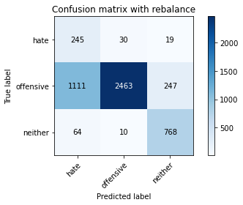

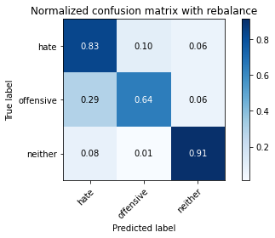

precision recall f1-score support

hate 0.17 0.83 0.29 294

offensive 0.98 0.64 0.78 3821

neither 0.74 0.91 0.82 842

accuracy 0.70 4957

macro avg 0.63 0.80 0.63 4957

weighted avg 0.89 0.70 0.76 4957

average eval_loss: 0.9962525064005486, accuracy: 0.7012305830139197

training 6 epoch...

27.83401584625244 seconds used......

6 training finished! average train loss: 0.04975777196463699

evaluating...

Confusion matrix, without normalization

[[ 238 36 20]

[1008 2679 134]

[ 49 20 773]]

Normalized confusion matrix

[[0.80952381 0.12244898 0.06802721]

[0.26380529 0.70112536 0.03506935]

[0.05819477 0.02375297 0.91805226]]

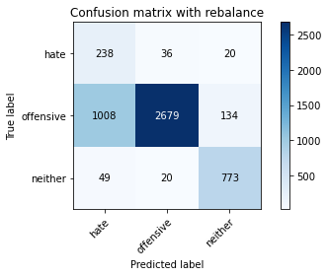

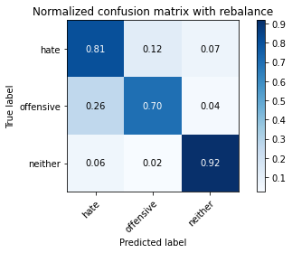

precision recall f1-score support

hate 0.18 0.81 0.30 294

offensive 0.98 0.70 0.82 3821

neither 0.83 0.92 0.87 842

accuracy 0.74 4957

macro avg 0.67 0.81 0.66 4957

weighted avg 0.91 0.74 0.80 4957

average eval_loss: 0.9716232247395261, accuracy: 0.7444018559612668

training 7 epoch...

27.95385718345642 seconds used......

7 training finished! average train loss: 0.045151832734768374

evaluating...

Confusion matrix, without normalization

[[ 237 44 13]

[ 865 2841 115]

[ 64 37 741]]

Normalized confusion matrix

[[0.80612245 0.14965986 0.04421769]

[0.22638053 0.74352264 0.03009683]

[0.0760095 0.04394299 0.88004751]]

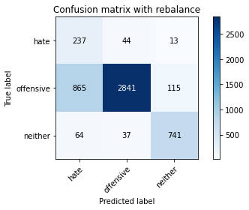

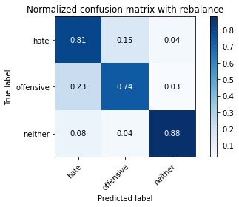

precision recall f1-score support

hate 0.20 0.81 0.32 294

offensive 0.97 0.74 0.84 3821

neither 0.85 0.88 0.87 842

accuracy 0.77 4957

macro avg 0.68 0.81 0.68 4957

weighted avg 0.91 0.77 0.82 4957

average eval_loss: 0.9245680554341825, accuracy: 0.770425660681864

training 8 epoch...

27.85836410522461 seconds used......

8 training finished! average train loss: 0.028546545754611623

evaluating...

Confusion matrix, without normalization

[[ 212 60 22]

[ 696 3021 104]

[ 39 52 751]]

Normalized confusion matrix

[[0.72108844 0.20408163 0.07482993]

[0.18215127 0.79063072 0.02721801]

[0.04631829 0.06175772 0.89192399]]

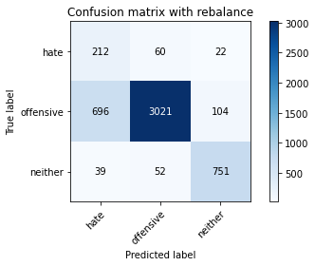

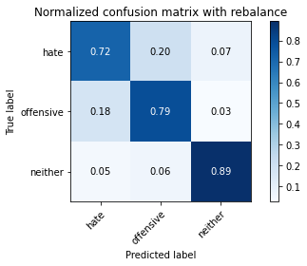

precision recall f1-score support

hate 0.22 0.72 0.34 294

offensive 0.96 0.79 0.87 3821

neither 0.86 0.89 0.87 842

accuracy 0.80 4957

macro avg 0.68 0.80 0.69 4957

weighted avg 0.90 0.80 0.84 4957

average eval_loss: 0.809802629722042, accuracy: 0.8037119225337906

training 9 epoch...

27.901628732681274 seconds used......

9 training finished! average train loss: 0.01828214829196685

evaluating...

Confusion matrix, without normalization

[[ 219 58 17]

[ 689 3028 104]

[ 50 40 752]]

Normalized confusion matrix

[[0.74489796 0.19727891 0.05782313]

[0.18031929 0.79246271 0.02721801]

[0.05938242 0.04750594 0.89311164]]

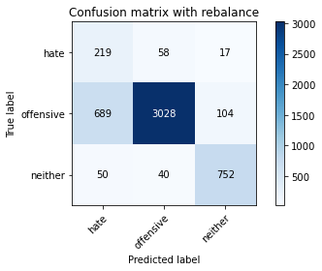

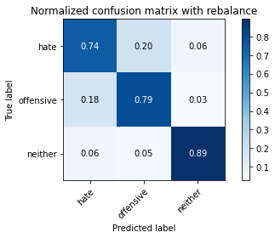

precision recall f1-score support

hate 0.23 0.74 0.35 294

offensive 0.97 0.79 0.87 3821

neither 0.86 0.89 0.88 842

accuracy 0.81 4957

macro avg 0.69 0.81 0.70 4957

weighted avg 0.91 0.81 0.84 4957

average eval_loss: 0.8699398607038141, accuracy: 0.8067379463385111

training 10 epoch...

27.901408433914185 seconds used......

10 training finished! average train loss: 0.007632558733651725

evaluating...

Confusion matrix, without normalization

[[ 246 38 10]

[1046 2686 89]

[ 79 25 738]]

Normalized confusion matrix

[[0.83673469 0.1292517 0.03401361]

[0.27375033 0.70295734 0.02329233]

[0.09382423 0.02969121 0.87648456]]

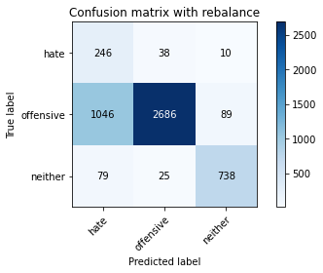

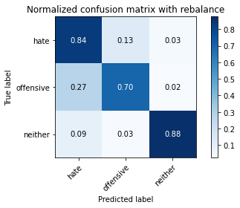

precision recall f1-score support

hate 0.18 0.84 0.30 294

offensive 0.98 0.70 0.82 3821

neither 0.88 0.88 0.88 842

accuracy 0.74 4957

macro avg 0.68 0.81 0.66 4957

weighted avg 0.91 0.74 0.80 4957

average eval_loss: 1.3617944609403851, accuracy: 0.7403671575549727

3 run

training 1 epoch...

30.509096384048462 seconds used......

1 training finished! average train loss: 0.6448965078731727

evaluating...

Confusion matrix, without normalization

[[ 218 43 33]

[ 774 2863 184]

[ 38 11 793]]

Normalized confusion matrix

[[0.7414966 0.1462585 0.1122449 ]

[0.20256477 0.74928029 0.04815493]

[0.04513064 0.01306413 0.94180523]]

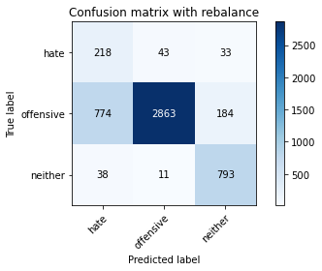

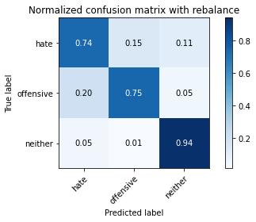

precision recall f1-score support

hate 0.21 0.74 0.33 294

offensive 0.98 0.75 0.85 3821

neither 0.79 0.94 0.86 842

accuracy 0.78 4957

macro avg 0.66 0.81 0.68 4957

weighted avg 0.90 0.78 0.82 4957

average eval_loss: 0.5078275061002181, accuracy: 0.7815210812991729

training 2 epoch...

29.70973253250122 seconds used......

2 training finished! average train loss: 0.3699945746458065

evaluating...

Confusion matrix, without normalization

[[ 228 45 21]

[ 794 2844 183]

[ 42 17 783]]

Normalized confusion matrix

[[0.7755102 0.15306122 0.07142857]

[0.20779901 0.74430777 0.04789322]

[0.04988124 0.02019002 0.92992874]]

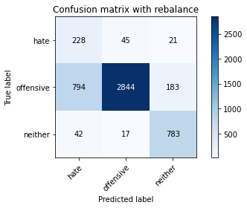

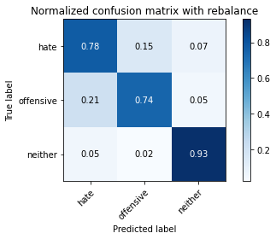

precision recall f1-score support

hate 0.21 0.78 0.34 294

offensive 0.98 0.74 0.85 3821

neither 0.79 0.93 0.86 842

accuracy 0.78 4957

macro avg 0.66 0.82 0.68 4957

weighted avg 0.90 0.78 0.82 4957

average eval_loss: 0.48807967309990236, accuracy: 0.7776881178131935

training 3 epoch...

29.731210231781006 seconds used......

3 training finished! average train loss: 0.23613065335224245

evaluating...

Confusion matrix, without normalization

[[ 239 36 19]

[ 992 2734 95]

[ 63 28 751]]

Normalized confusion matrix

[[0.81292517 0.12244898 0.06462585]

[0.2596179 0.7155195 0.0248626 ]

[0.07482185 0.03325416 0.89192399]]

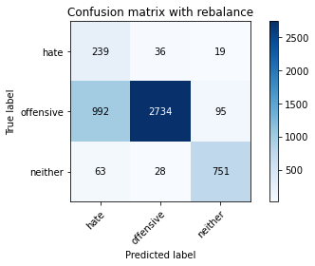

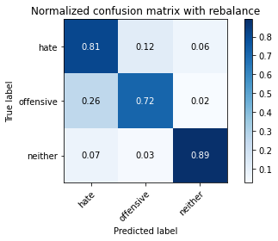

precision recall f1-score support

hate 0.18 0.81 0.30 294

offensive 0.98 0.72 0.83 3821

neither 0.87 0.89 0.88 842

accuracy 0.75 4957

macro avg 0.68 0.81 0.67 4957

weighted avg 0.91 0.75 0.80 4957

average eval_loss: 0.6012843427278342, accuracy: 0.751260843251967

training 4 epoch...

29.874236345291138 seconds used......

4 training finished! average train loss: 0.1414820627903032

evaluating...

Confusion matrix, without normalization

[[ 208 60 26]

[ 569 3132 120]

[ 36 44 762]]

Normalized confusion matrix

[[0.70748299 0.20408163 0.08843537]

[0.1489139 0.81968071 0.03140539]

[0.04275534 0.05225653 0.90498812]]

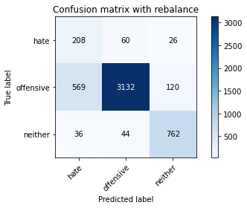

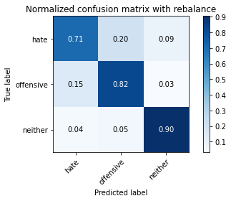

precision recall f1-score support

hate 0.26 0.71 0.38 294

offensive 0.97 0.82 0.89 3821

neither 0.84 0.90 0.87 842

accuracy 0.83 4957

macro avg 0.69 0.81 0.71 4957

weighted avg 0.90 0.83 0.85 4957

average eval_loss: 0.47988975274511764, accuracy: 0.827516643130926

training 5 epoch...

29.725614070892334 seconds used......

5 training finished! average train loss: 0.0788903549063014

evaluating...

Confusion matrix, without normalization

[[ 202 62 30]

[ 698 2968 155]

[ 30 25 787]]

Normalized confusion matrix

[[0.68707483 0.21088435 0.10204082]

[0.18267469 0.77676001 0.0405653 ]

[0.03562945 0.02969121 0.93467933]]

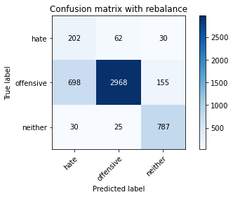

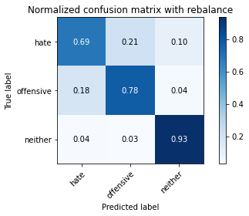

precision recall f1-score support

hate 0.22 0.69 0.33 294

offensive 0.97 0.78 0.86 3821

neither 0.81 0.93 0.87 842

accuracy 0.80 4957

macro avg 0.67 0.80 0.69 4957

weighted avg 0.90 0.80 0.83 4957

average eval_loss: 0.6542736200105038, accuracy: 0.7982650796852935

training 6 epoch...

29.674214601516724 seconds used......

6 training finished! average train loss: 0.055514054479110134

evaluating...

Confusion matrix, without normalization

[[ 220 61 13]

[ 611 3119 91]

[ 77 48 717]]

Normalized confusion matrix

[[0.74829932 0.20748299 0.04421769]

[0.15990578 0.81627846 0.02381576]

[0.09144893 0.05700713 0.85154394]]

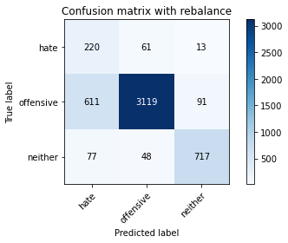

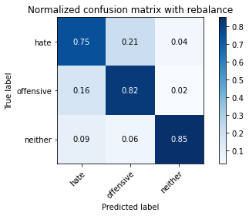

precision recall f1-score support

hate 0.24 0.75 0.37 294

offensive 0.97 0.82 0.88 3821

neither 0.87 0.85 0.86 842

accuracy 0.82 4957

macro avg 0.69 0.81 0.70 4957

weighted avg 0.91 0.82 0.85 4957

average eval_loss: 0.693142362673121, accuracy: 0.8182368367964494

training 7 epoch...

29.69642686843872 seconds used......

7 training finished! average train loss: 0.028353564492263422

evaluating...

Confusion matrix, without normalization

[[ 227 48 19]

[ 822 2892 107]

[ 42 43 757]]

Normalized confusion matrix

[[0.77210884 0.16326531 0.06462585]

[0.21512693 0.75686993 0.02800314]

[0.04988124 0.05106888 0.89904988]]

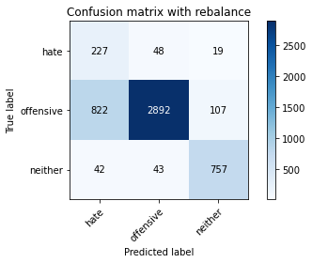

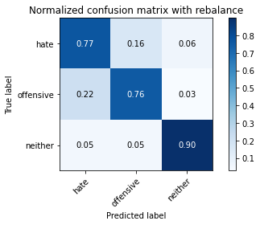

precision recall f1-score support

hate 0.21 0.77 0.33 294

offensive 0.97 0.76 0.85 3821

neither 0.86 0.90 0.88 842

accuracy 0.78 4957

macro avg 0.68 0.81 0.69 4957

weighted avg 0.91 0.78 0.82 4957

average eval_loss: 0.9500761453002211, accuracy: 0.7819245511398023

training 8 epoch...

29.69001817703247 seconds used......

8 training finished! average train loss: 0.018594077161284524

evaluating...

Confusion matrix, without normalization

[[ 231 46 17]

[ 836 2882 103]

[ 51 41 750]]

Normalized confusion matrix

[[0.78571429 0.15646259 0.05782313]

[0.21879089 0.75425281 0.02695629]

[0.06057007 0.04869359 0.89073634]]

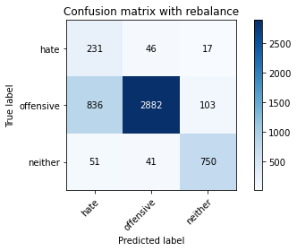

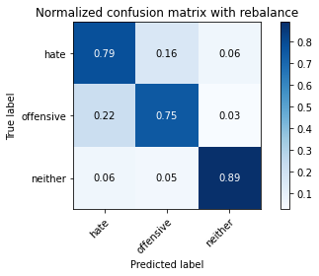

precision recall f1-score support

hate 0.21 0.79 0.33 294

offensive 0.97 0.75 0.85 3821

neither 0.86 0.89 0.88 842

accuracy 0.78 4957

macro avg 0.68 0.81 0.68 4957

weighted avg 0.91 0.78 0.82 4957

average eval_loss: 0.9934032465323746, accuracy: 0.7793019971757111

training 9 epoch...

29.708024978637695 seconds used......

9 training finished! average train loss: 0.016700444764482153

evaluating...

Confusion matrix, without normalization

[[ 192 59 43]

[ 551 2997 273]

[ 18 10 814]]

Normalized confusion matrix

[[0.65306122 0.20068027 0.1462585 ]

[0.14420309 0.78434965 0.07144727]

[0.02137767 0.01187648 0.96674584]]

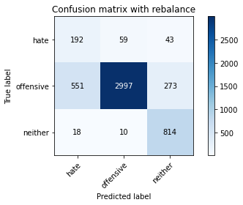

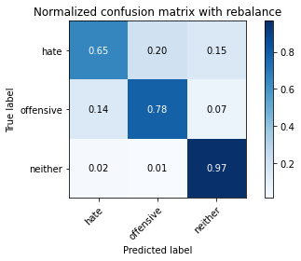

precision recall f1-score support

hate 0.25 0.65 0.36 294

offensive 0.98 0.78 0.87 3821

neither 0.72 0.97 0.83 842

accuracy 0.81 4957

macro avg 0.65 0.80 0.69 4957

weighted avg 0.89 0.81 0.83 4957

average eval_loss: 0.988016182460518, accuracy: 0.80754488601977

training 10 epoch...

29.74611735343933 seconds used......

10 training finished! average train loss: 0.031968916030239845

evaluating...

Confusion matrix, without normalization

[[ 232 45 17]

[ 920 2801 100]

[ 79 39 724]]

Normalized confusion matrix

[[0.78911565 0.15306122 0.05782313]

[0.24077467 0.73305417 0.02617116]

[0.09382423 0.04631829 0.85985748]]

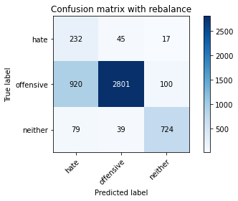

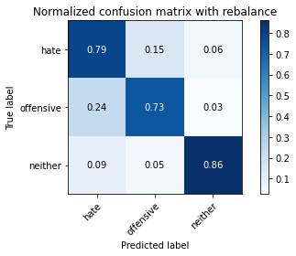

precision recall f1-score support

hate 0.19 0.79 0.30 294

offensive 0.97 0.73 0.84 3821

neither 0.86 0.86 0.86 842

accuracy 0.76 4957

macro avg 0.67 0.79 0.67 4957

weighted avg 0.91 0.76 0.81 4957

average eval_loss: 1.1332371718806005, accuracy: 0.7579180956223522

4 run

training 1 epoch...

29.805107355117798 seconds used......

1 training finished! average train loss: 0.6422093340702224

evaluating...

Confusion matrix, without normalization

[[ 225 38 31]

[ 814 2828 179]

[ 42 11 789]]

Normalized confusion matrix

[[0.76530612 0.1292517 0.10544218]

[0.21303324 0.74012039 0.04684638]

[0.04988124 0.01306413 0.93705463]]

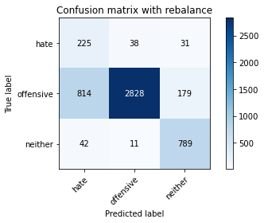

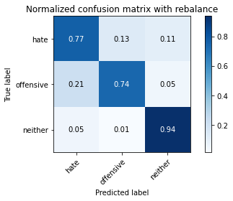

precision recall f1-score support

hate 0.21 0.77 0.33 294

offensive 0.98 0.74 0.84 3821

neither 0.79 0.94 0.86 842

accuracy 0.78 4957

macro avg 0.66 0.81 0.68 4957

weighted avg 0.90 0.78 0.82 4957

average eval_loss: 0.5613169615727759, accuracy: 0.7750655638491023

training 2 epoch...

29.870705604553223 seconds used......

2 training finished! average train loss: 0.369590244272299

evaluating...

Confusion matrix, without normalization

[[ 247 30 17]

[1213 2507 101]

[ 62 19 761]]

Normalized confusion matrix

[[0.84013605 0.10204082 0.05782313]

[0.31745616 0.65611097 0.02643287]

[0.0736342 0.02256532 0.90380048]]

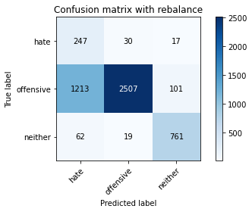

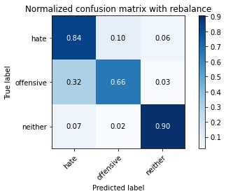

precision recall f1-score support

hate 0.16 0.84 0.27 294

offensive 0.98 0.66 0.79 3821

neither 0.87 0.90 0.88 842

accuracy 0.71 4957

macro avg 0.67 0.80 0.65 4957

weighted avg 0.91 0.71 0.77 4957

average eval_loss: 0.6677130487777533, accuracy: 0.7090982449061932

training 3 epoch...

29.77942967414856 seconds used......

3 training finished! average train loss: 0.245147522647827

evaluating...

Confusion matrix, without normalization

[[ 234 42 18]

[ 830 2845 146]

[ 44 11 787]]

Normalized confusion matrix

[[0.79591837 0.14285714 0.06122449]

[0.21722062 0.74456948 0.03820989]

[0.05225653 0.01306413 0.93467933]]

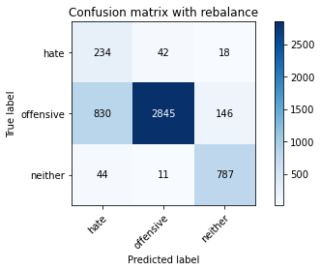

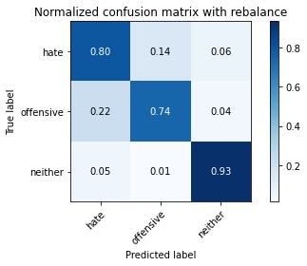

precision recall f1-score support

hate 0.21 0.80 0.33 294

offensive 0.98 0.74 0.85 3821

neither 0.83 0.93 0.88 842

accuracy 0.78 4957

macro avg 0.67 0.83 0.69 4957

weighted avg 0.91 0.78 0.82 4957

average eval_loss: 0.5564070961347991, accuracy: 0.7799072019366552

training 4 epoch...

29.75039839744568 seconds used......

4 training finished! average train loss: 0.13956003139416376

evaluating...

Confusion matrix, without normalization

[[ 198 71 25]

[ 449 3230 142]

[ 19 37 786]]

Normalized confusion matrix

[[0.67346939 0.2414966 0.08503401]

[0.11750851 0.84532845 0.03716305]

[0.02256532 0.04394299 0.93349169]]

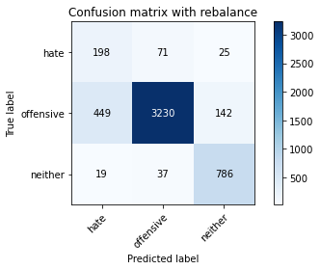

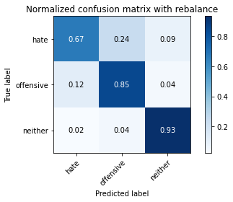

precision recall f1-score support

hate 0.30 0.67 0.41 294

offensive 0.97 0.85 0.90 3821

neither 0.82 0.93 0.88 842

accuracy 0.85 4957

macro avg 0.70 0.82 0.73 4957

weighted avg 0.90 0.85 0.87 4957

average eval_loss: 0.4695048942005322, accuracy: 0.8501109542061731

training 5 epoch...

29.72944951057434 seconds used......

5 training finished! average train loss: 0.0814635014727886

evaluating...

Confusion matrix, without normalization

[[ 224 50 20]

[ 727 2970 124]

[ 43 31 768]]

Normalized confusion matrix

[[0.76190476 0.17006803 0.06802721]

[0.19026433 0.77728343 0.03245224]

[0.05106888 0.0368171 0.91211401]]

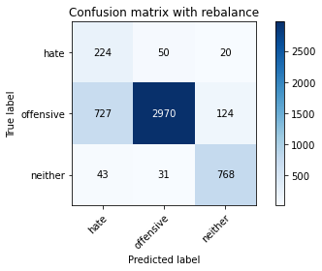

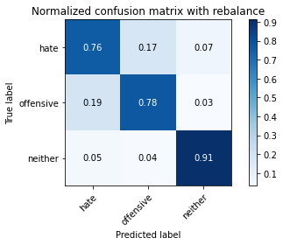

precision recall f1-score support

hate 0.23 0.76 0.35 294

offensive 0.97 0.78 0.86 3821

neither 0.84 0.91 0.88 842

accuracy 0.80 4957

macro avg 0.68 0.82 0.70 4957

weighted avg 0.91 0.80 0.84 4957

average eval_loss: 0.6843501615897573, accuracy: 0.7992737542868671

training 6 epoch...

29.607563972473145 seconds used......

6 training finished! average train loss: 0.06332953002205804

evaluating...

Confusion matrix, without normalization

[[ 228 50 16]

[ 803 2916 102]

[ 40 39 763]]

Normalized confusion matrix

[[0.7755102 0.17006803 0.05442177]

[0.21015441 0.76315101 0.02669458]

[0.04750594 0.04631829 0.90617577]]

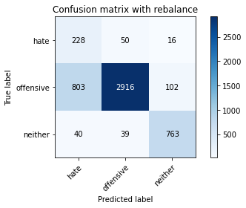

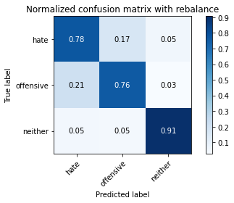

precision recall f1-score support

hate 0.21 0.78 0.33 294

offensive 0.97 0.76 0.85 3821

neither 0.87 0.91 0.89 842

accuracy 0.79 4957

macro avg 0.68 0.81 0.69 4957

weighted avg 0.91 0.79 0.83 4957

average eval_loss: 0.7444997239902976, accuracy: 0.7881783336695583

training 7 epoch...

29.74609661102295 seconds used......

7 training finished! average train loss: 0.03619613559652468

evaluating...

Confusion matrix, without normalization

[[ 202 71 21]

[ 488 3223 110]

[ 35 45 762]]

Normalized confusion matrix

[[0.68707483 0.2414966 0.07142857]

[0.12771526 0.84349647 0.02878828]

[0.0415677 0.05344418 0.90498812]]

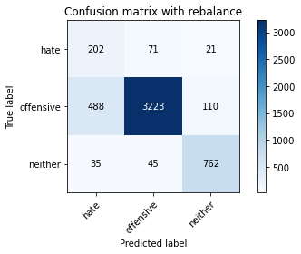

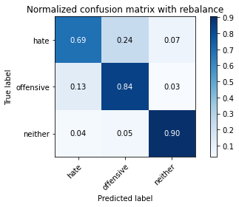

precision recall f1-score support

hate 0.28 0.69 0.40 294

offensive 0.97 0.84 0.90 3821

neither 0.85 0.90 0.88 842

accuracy 0.84 4957

macro avg 0.70 0.81 0.73 4957

weighted avg 0.91 0.84 0.87 4957

average eval_loss: 0.6649097382239322, accuracy: 0.844664111357676

training 8 epoch...

29.645012855529785 seconds used......

8 training finished! average train loss: 0.029626260250493645

evaluating...

Confusion matrix, without normalization

[[ 233 41 20]

[ 902 2794 125]

[ 39 33 770]]

Normalized confusion matrix

[[0.79251701 0.13945578 0.06802721]

[0.23606386 0.73122219 0.03271395]

[0.04631829 0.0391924 0.91448931]]

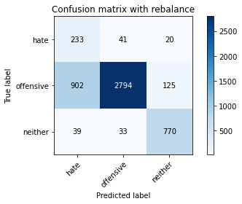

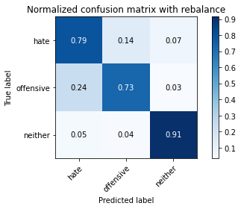

precision recall f1-score support

hate 0.20 0.79 0.32 294

offensive 0.97 0.73 0.84 3821

neither 0.84 0.91 0.88 842

accuracy 0.77 4957

macro avg 0.67 0.81 0.68 4957

weighted avg 0.91 0.77 0.81 4957

average eval_loss: 1.032788582524987, accuracy: 0.7659874924349405

training 9 epoch...

29.64074468612671 seconds used......

9 training finished! average train loss: 0.010023555120287126

evaluating...

Confusion matrix, without normalization

[[ 228 49 17]

[ 759 2962 100]

[ 44 35 763]]

Normalized confusion matrix

[[0.7755102 0.16666667 0.05782313]

[0.1986391 0.77518974 0.02617116]

[0.05225653 0.0415677 0.90617577]]

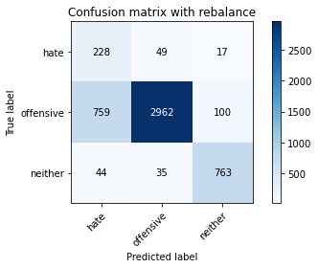

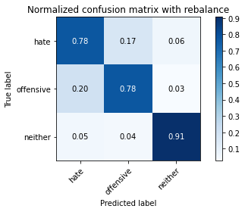

precision recall f1-score support

hate 0.22 0.78 0.34 294

offensive 0.97 0.78 0.86 3821

neither 0.87 0.91 0.89 842

accuracy 0.80 4957

macro avg 0.69 0.82 0.70 4957

weighted avg 0.91 0.80 0.84 4957

average eval_loss: 1.0084974069998884, accuracy: 0.7974581400040347

training 10 epoch...

29.60304069519043 seconds used......

10 training finished! average train loss: 0.001993544873824392

evaluating...

Confusion matrix, without normalization

[[ 231 47 16]

[ 838 2896 87]

[ 51 38 753]]

Normalized confusion matrix

[[0.78571429 0.15986395 0.05442177]

[0.21931432 0.75791678 0.02276891]

[0.06057007 0.04513064 0.89429929]]

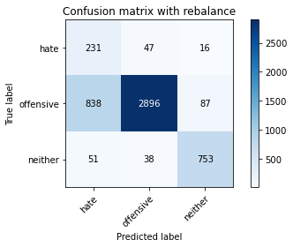

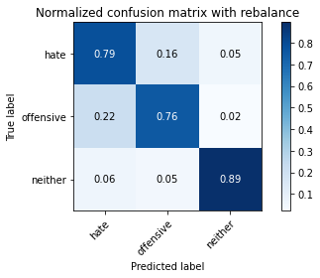

precision recall f1-score support

hate 0.21 0.79 0.33 294

offensive 0.97 0.76 0.85 3821

neither 0.88 0.89 0.89 842

accuracy 0.78 4957

macro avg 0.69 0.81 0.69 4957

weighted avg 0.91 0.78 0.83 4957

average eval_loss: 1.1981949872213356, accuracy: 0.7827314908210611

5 run

training 1 epoch...

29.897215843200684 seconds used......

1 training finished! average train loss: 0.6395703223016527

evaluating...

Confusion matrix, without normalization

[[ 224 35 35]

[ 914 2747 160]

[ 27 11 804]]

Normalized confusion matrix

[[0.76190476 0.11904762 0.11904762]

[0.2392044 0.71892175 0.04187386]

[0.03206651 0.01306413 0.95486936]]

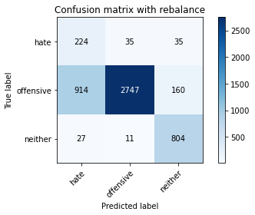

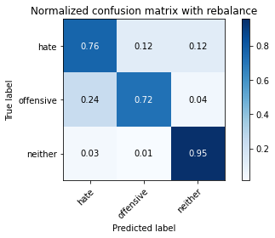

precision recall f1-score support

hate 0.19 0.76 0.31 294

offensive 0.98 0.72 0.83 3821

neither 0.80 0.95 0.87 842

accuracy 0.76 4957

macro avg 0.66 0.81 0.67 4957

weighted avg 0.91 0.76 0.81 4957

average eval_loss: 0.553126223205078, accuracy: 0.7615493241880169

training 2 epoch...

29.898976802825928 seconds used......

2 training finished! average train loss: 0.38296895692048716

evaluating...

Confusion matrix, without normalization

[[ 255 29 10]

[1167 2582 72]

[ 121 14 707]]

Normalized confusion matrix

[[0.86734694 0.09863946 0.03401361]

[0.30541743 0.67573934 0.01884323]

[0.14370546 0.01662708 0.83966746]]

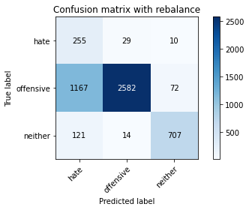

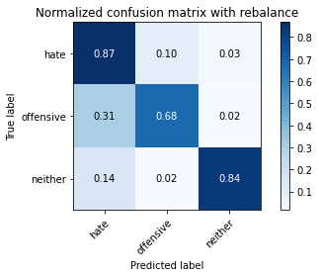

precision recall f1-score support

hate 0.17 0.87 0.28 294

offensive 0.98 0.68 0.80 3821

neither 0.90 0.84 0.87 842

accuracy 0.71 4957

macro avg 0.68 0.79 0.65 4957

weighted avg 0.92 0.71 0.78 4957

average eval_loss: 0.6964176292380979, accuracy: 0.7149485575953197

training 3 epoch...

29.82417869567871 seconds used......

3 training finished! average train loss: 0.24746709360539565

evaluating...

Confusion matrix, without normalization

[[ 242 38 14]

[ 903 2810 108]

[ 60 23 759]]

Normalized confusion matrix

[[0.82312925 0.1292517 0.04761905]

[0.23632557 0.73540958 0.02826485]

[0.07125891 0.02731591 0.90142518]]

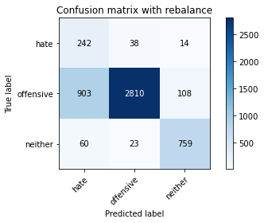

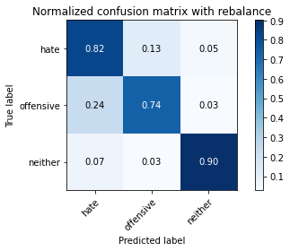

precision recall f1-score support

hate 0.20 0.82 0.32 294

offensive 0.98 0.74 0.84 3821

neither 0.86 0.90 0.88 842

accuracy 0.77 4957

macro avg 0.68 0.82 0.68 4957

weighted avg 0.91 0.77 0.82 4957

average eval_loss: 0.5740850925776025, accuracy: 0.7688117813193464

training 4 epoch...

29.786457061767578 seconds used......

4 training finished! average train loss: 0.1631086253784379

evaluating...

Confusion matrix, without normalization

[[ 239 36 19]

[ 902 2796 123]

[ 53 22 767]]

Normalized confusion matrix

[[0.81292517 0.12244898 0.06462585]

[0.23606386 0.73174562 0.03219053]

[0.06294537 0.02612827 0.91092637]]

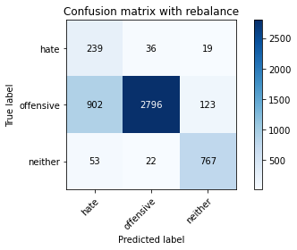

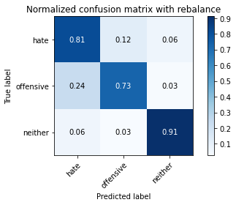

precision recall f1-score support

hate 0.20 0.81 0.32 294

offensive 0.98 0.73 0.84 3821

neither 0.84 0.91 0.88 842

accuracy 0.77 4957

macro avg 0.67 0.82 0.68 4957

weighted avg 0.91 0.77 0.81 4957

average eval_loss: 0.6325942420610978, accuracy: 0.7669961670365141

training 5 epoch...

29.847824573516846 seconds used......

5 training finished! average train loss: 0.09574283015701854

evaluating...

Confusion matrix, without normalization

[[ 236 42 16]

[ 969 2777 75]

[ 74 39 729]]

Normalized confusion matrix

[[0.80272109 0.14285714 0.05442177]

[0.25359853 0.7267731 0.01962837]

[0.08788599 0.04631829 0.86579572]]

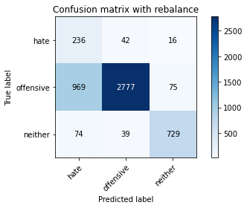

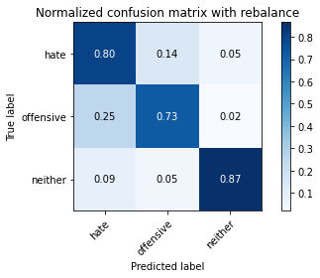

precision recall f1-score support

hate 0.18 0.80 0.30 294

offensive 0.97 0.73 0.83 3821

neither 0.89 0.87 0.88 842

accuracy 0.75 4957

macro avg 0.68 0.80 0.67 4957

weighted avg 0.91 0.75 0.81 4957

average eval_loss: 0.7392981559218418, accuracy: 0.7548920718176316

training 6 epoch...

29.864644289016724 seconds used......

6 training finished! average train loss: 0.053855039877817035

evaluating...

Confusion matrix, without normalization

[[ 224 51 19]

[ 862 2853 106]

[ 55 32 755]]

Normalized confusion matrix

[[0.76190476 0.17346939 0.06462585]

[0.22559539 0.74666318 0.02774143]

[0.06532067 0.03800475 0.89667458]]

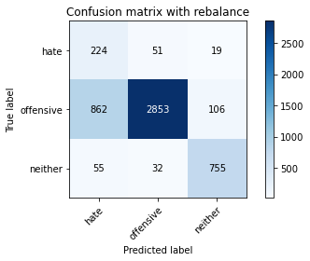

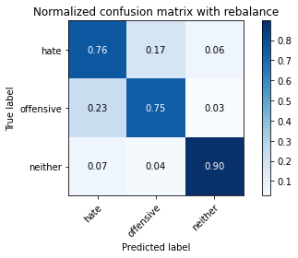

precision recall f1-score support

hate 0.20 0.76 0.31 294

offensive 0.97 0.75 0.84 3821

neither 0.86 0.90 0.88 842

accuracy 0.77 4957

macro avg 0.68 0.80 0.68 4957

weighted avg 0.91 0.77 0.82 4957

average eval_loss: 0.8333594267887454, accuracy: 0.7730482146459552

training 7 epoch...

29.874639987945557 seconds used......

7 training finished! average train loss: 0.025560755849739658

evaluating...

Confusion matrix, without normalization

[[ 245 36 13]

[1276 2454 91]

[ 93 35 714]]

Normalized confusion matrix

[[0.83333333 0.12244898 0.04421769]

[0.33394399 0.64224025 0.02381576]

[0.11045131 0.0415677 0.847981 ]]

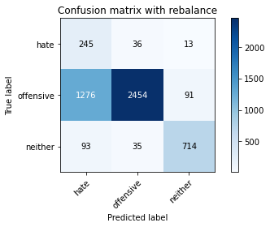

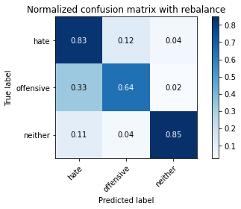

precision recall f1-score support

hate 0.15 0.83 0.26 294

offensive 0.97 0.64 0.77 3821

neither 0.87 0.85 0.86 842

accuracy 0.69 4957

macro avg 0.67 0.77 0.63 4957

weighted avg 0.91 0.69 0.76 4957

average eval_loss: 1.4179659786243592, accuracy: 0.6885212830340932

training 8 epoch...

29.892112731933594 seconds used......

8 training finished! average train loss: 0.033734383252830576

evaluating...

Confusion matrix, without normalization

[[ 219 53 22]

[ 660 3021 140]

[ 38 21 783]]

Normalized confusion matrix

[[0.74489796 0.18027211 0.07482993]

[0.17272965 0.79063072 0.03663962]

[0.04513064 0.02494062 0.92992874]]

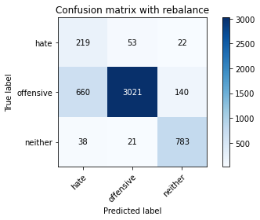

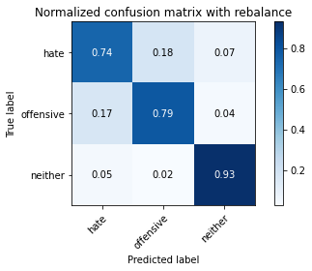

precision recall f1-score support

hate 0.24 0.74 0.36 294

offensive 0.98 0.79 0.87 3821

neither 0.83 0.93 0.88 842

accuracy 0.81 4957

macro avg 0.68 0.82 0.70 4957

weighted avg 0.91 0.81 0.84 4957

average eval_loss: 0.8686987553214309, accuracy: 0.8115795844260641

training 9 epoch...

29.839707374572754 seconds used......

9 training finished! average train loss: 0.024416532053623066

evaluating...

Confusion matrix, without normalization

[[ 230 46 18]

[ 849 2842 130]

[ 55 31 756]]

Normalized confusion matrix

[[0.78231293 0.15646259 0.06122449]

[0.22219314 0.74378435 0.03402251]

[0.06532067 0.0368171 0.89786223]]

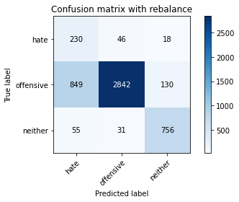

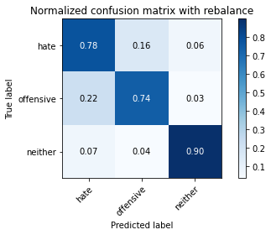

precision recall f1-score support

hate 0.20 0.78 0.32 294

offensive 0.97 0.74 0.84 3821

neither 0.84 0.90 0.87 842

accuracy 0.77 4957

macro avg 0.67 0.81 0.68 4957

weighted avg 0.90 0.77 0.82 4957

average eval_loss: 1.035027794491109, accuracy: 0.7722412749646964

training 10 epoch...

29.78064465522766 seconds used......

10 training finished! average train loss: 0.013027727644079043

evaluating...

Confusion matrix, without normalization

[[ 237 40 17]

[1002 2702 117]

[ 62 25 755]]

Normalized confusion matrix

[[0.80612245 0.13605442 0.05782313]

[0.26223502 0.70714473 0.03062026]

[0.0736342 0.02969121 0.89667458]]

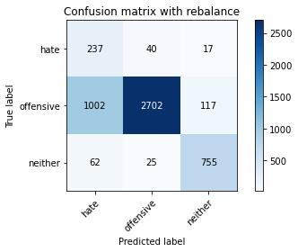

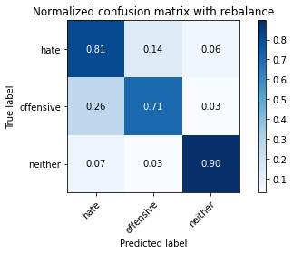

precision recall f1-score support

hate 0.18 0.81 0.30 294

offensive 0.98 0.71 0.82 3821

neither 0.85 0.90 0.87 842

accuracy 0.75 4957

macro avg 0.67 0.80 0.66 4957

weighted avg 0.91 0.75 0.80 4957

average eval_loss: 1.3017499880985386, accuracy: 0.7452087956425257