1 run

[1.5,0.5,1]

training 1 epoch...

30.002756595611572 seconds used......

1 training finished! average train loss: 0.6406407352776555

evaluating...

Confusion matrix, without normalization

[[ 238 34 22]

[ 917 2730 174]

[ 50 7 785]]

Normalized confusion matrix

[[0.80952381 0.11564626 0.07482993]

[0.23998953 0.71447265 0.04553782]

[0.05938242 0.00831354 0.93230404]]

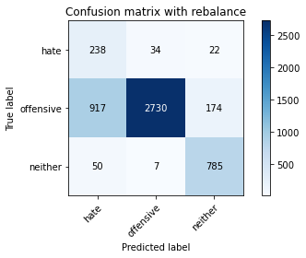

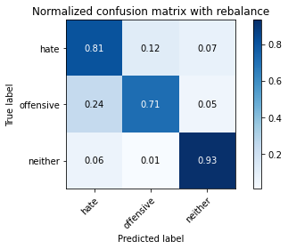

precision recall f1-score support

hate 0.20 0.81 0.32 294

offensive 0.99 0.71 0.83 3821

neither 0.80 0.93 0.86 842

accuracy 0.76 4957

macro avg 0.66 0.82 0.67 4957

weighted avg 0.91 0.76 0.80 4957

average eval_loss: 0.6215070865207142, accuracy: 0.7571111559410934

training 2 epoch...

29.366509914398193 seconds used......

2 training finished! average train loss: 0.36359623654021156

evaluating...

Confusion matrix, without normalization

[[ 248 29 17]

[1175 2513 133]

[ 52 8 782]]

Normalized confusion matrix

[[0.84353741 0.09863946 0.05782313]

[0.30751112 0.65768124 0.03480764]

[0.06175772 0.00950119 0.92874109]]

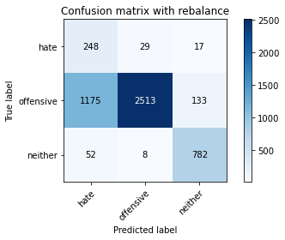

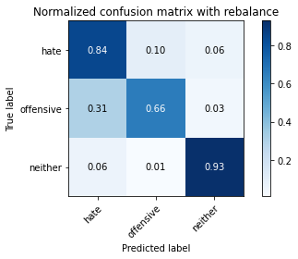

precision recall f1-score support

hate 0.17 0.84 0.28 294

offensive 0.99 0.66 0.79 3821

neither 0.84 0.93 0.88 842

accuracy 0.71 4957

macro avg 0.66 0.81 0.65 4957

weighted avg 0.91 0.71 0.77 4957

average eval_loss: 0.6711006408497211, accuracy: 0.714746822675005

training 3 epoch...

29.34109139442444 seconds used......

3 training finished! average train loss: 0.2275185577832816

evaluating...

Confusion matrix, without normalization

[[ 231 35 28]

[ 943 2701 177]

[ 34 11 797]]

Normalized confusion matrix

[[0.78571429 0.11904762 0.0952381 ]

[0.24679403 0.70688301 0.04632295]

[0.04038005 0.01306413 0.94655582]]

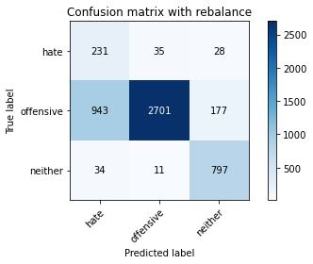

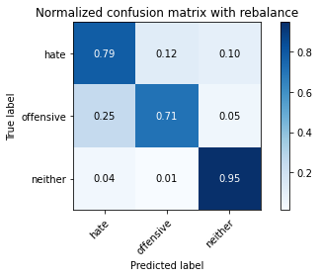

precision recall f1-score support

hate 0.19 0.79 0.31 294

offensive 0.98 0.71 0.82 3821

neither 0.80 0.95 0.86 842

accuracy 0.75 4957

macro avg 0.66 0.81 0.66 4957

weighted avg 0.90 0.75 0.80 4957

average eval_loss: 0.66032869858487, accuracy: 0.7522695178535405

training 4 epoch...

29.28095269203186 seconds used......

4 training finished! average train loss: 0.1440700936588671

evaluating...

Confusion matrix, without normalization

[[ 246 34 14]

[1124 2607 90]

[ 81 28 733]]

Normalized confusion matrix

[[0.83673469 0.11564626 0.04761905]

[0.29416383 0.68228213 0.02355404]

[0.09619952 0.03325416 0.87054632]]

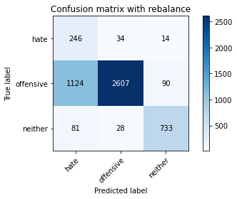

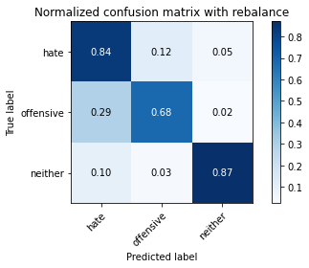

precision recall f1-score support

hate 0.17 0.84 0.28 294

offensive 0.98 0.68 0.80 3821

neither 0.88 0.87 0.87 842

accuracy 0.72 4957

macro avg 0.67 0.80 0.65 4957

weighted avg 0.91 0.72 0.78 4957

average eval_loss: 0.7481812656286263, accuracy: 0.7234214242485374

training 5 epoch...

29.38669204711914 seconds used......

5 training finished! average train loss: 0.09797829976958926

evaluating...

Confusion matrix, without normalization

[[ 226 46 22]

[ 743 2941 137]

[ 41 32 769]]

Normalized confusion matrix

[[0.76870748 0.15646259 0.07482993]

[0.19445171 0.7696938 0.03585449]

[0.04869359 0.03800475 0.91330166]]

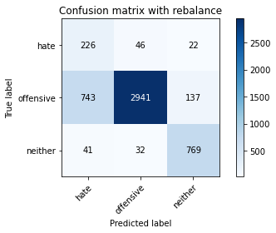

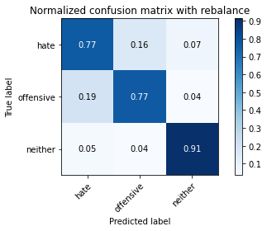

precision recall f1-score support

hate 0.22 0.77 0.35 294

offensive 0.97 0.77 0.86 3821

neither 0.83 0.91 0.87 842

accuracy 0.79 4957

macro avg 0.68 0.82 0.69 4957

weighted avg 0.90 0.79 0.83 4957

average eval_loss: 0.6653602291912502, accuracy: 0.7940286463586846

training 6 epoch...

29.292803287506104 seconds used......

6 training finished! average train loss: 0.06470102909952402

evaluating...

Confusion matrix, without normalization

[[ 241 36 17]

[1071 2625 125]

[ 63 21 758]]

Normalized confusion matrix

[[0.81972789 0.12244898 0.05782313]

[0.28029312 0.68699293 0.03271395]

[0.07482185 0.02494062 0.90023753]]

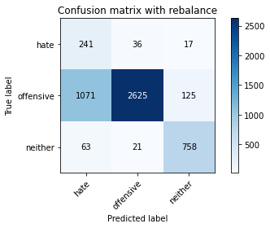

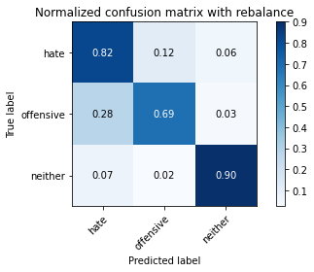

precision recall f1-score support

hate 0.18 0.82 0.29 294

offensive 0.98 0.69 0.81 3821

neither 0.84 0.90 0.87 842

accuracy 0.73 4957

macro avg 0.67 0.80 0.66 4957

weighted avg 0.91 0.73 0.79 4957

average eval_loss: 0.9315958693773756, accuracy: 0.7310873512204963

training 7 epoch...

29.363056421279907 seconds used......

7 training finished! average train loss: 0.04372327858364286

evaluating...

Confusion matrix, without normalization

[[ 242 34 18]

[1113 2571 137]

[ 65 22 755]]

Normalized confusion matrix

[[0.82312925 0.11564626 0.06122449]

[0.291285 0.67286051 0.03585449]

[0.07719715 0.02612827 0.89667458]]

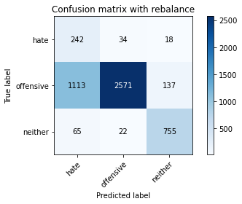

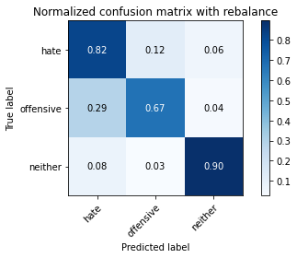

precision recall f1-score support

hate 0.17 0.82 0.28 294

offensive 0.98 0.67 0.80 3821

neither 0.83 0.90 0.86 842

accuracy 0.72 4957

macro avg 0.66 0.80 0.65 4957

weighted avg 0.91 0.72 0.78 4957

average eval_loss: 1.147208226694455, accuracy: 0.7197901956828727

training 8 epoch...

29.417649269104004 seconds used......

8 training finished! average train loss: 0.03725519865119492

evaluating...

Confusion matrix, without normalization

[[ 241 44 9]

[1065 2699 57]

[ 164 55 623]]

Normalized confusion matrix

[[0.81972789 0.14965986 0.03061224]

[0.27872285 0.70635959 0.01491756]

[0.19477435 0.06532067 0.73990499]]

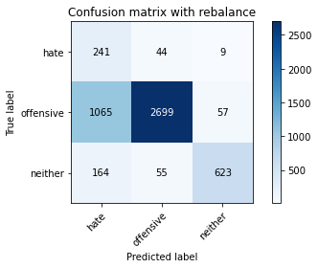

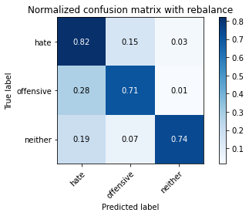

precision recall f1-score support

hate 0.16 0.82 0.27 294

offensive 0.96 0.71 0.82 3821

neither 0.90 0.74 0.81 842

accuracy 0.72 4957

macro avg 0.68 0.76 0.63 4957

weighted avg 0.91 0.72 0.78 4957

average eval_loss: 1.2025760801418894, accuracy: 0.7187815210812992

training 9 epoch...

29.400018215179443 seconds used......

9 training finished! average train loss: 0.019344954133954182

evaluating...

Confusion matrix, without normalization

[[ 228 44 22]

[ 966 2742 113]

[ 54 30 758]]

Normalized confusion matrix

[[0.7755102 0.14965986 0.07482993]

[0.2528134 0.71761319 0.02957341]

[0.06413302 0.03562945 0.90023753]]

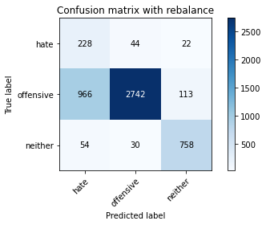

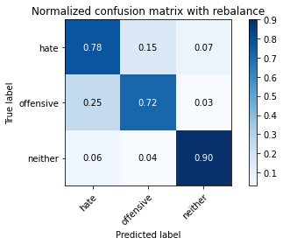

precision recall f1-score support

hate 0.18 0.78 0.30 294

offensive 0.97 0.72 0.83 3821

neither 0.85 0.90 0.87 842

accuracy 0.75 4957

macro avg 0.67 0.80 0.67 4957

weighted avg 0.91 0.75 0.80 4957

average eval_loss: 1.2685363700898784, accuracy: 0.7520677829332257

training 10 epoch...

29.46668815612793 seconds used......

10 training finished! average train loss: 0.013348442794549503

evaluating...

Confusion matrix, without normalization

[[ 220 50 24]

[ 689 3030 102]

[ 42 50 750]]

Normalized confusion matrix

[[0.74829932 0.17006803 0.08163265]

[0.18031929 0.79298613 0.02669458]

[0.04988124 0.05938242 0.89073634]]

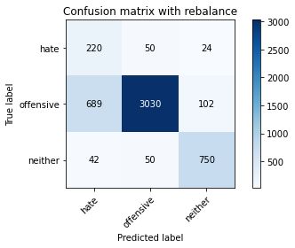

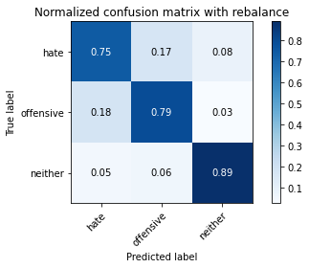

precision recall f1-score support

hate 0.23 0.75 0.35 294

offensive 0.97 0.79 0.87 3821

neither 0.86 0.89 0.87 842

accuracy 0.81 4957

macro avg 0.69 0.81 0.70 4957

weighted avg 0.91 0.81 0.84 4957

average eval_loss: 1.0186089350806264, accuracy: 0.8069396812588259

2 run

training 1 epoch...

29.30520009994507 seconds used......

1 training finished! average train loss: 0.6366589678484097

evaluating...

Confusion matrix, without normalization

[[ 234 35 25]

[ 947 2687 187]

[ 40 7 795]]

Normalized confusion matrix

[[0.79591837 0.11904762 0.08503401]

[0.24784088 0.70321905 0.04894007]

[0.04750594 0.00831354 0.94418052]]

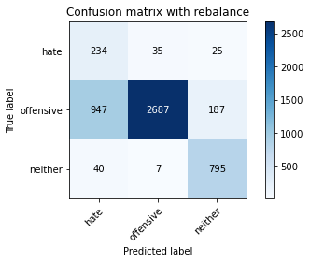

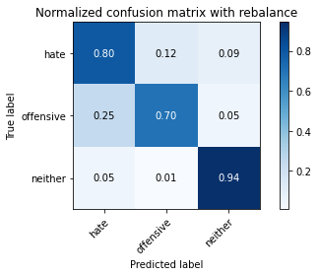

precision recall f1-score support

hate 0.19 0.80 0.31 294

offensive 0.98 0.70 0.82 3821

neither 0.79 0.94 0.86 842

accuracy 0.75 4957

macro avg 0.66 0.81 0.66 4957

weighted avg 0.90 0.75 0.80 4957

average eval_loss: 0.6082802577124488, accuracy: 0.7496469638894493

training 2 epoch...

29.322303295135498 seconds used......

2 training finished! average train loss: 0.3640555823929826

evaluating...

Confusion matrix, without normalization

[[ 262 23 9]

[1451 2271 99]

[ 114 11 717]]

Normalized confusion matrix

[[0.89115646 0.07823129 0.03061224]

[0.37974352 0.59434703 0.02590945]

[0.13539192 0.01306413 0.85154394]]

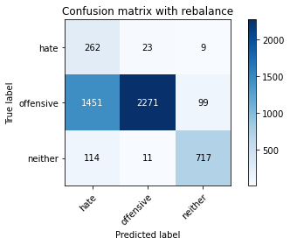

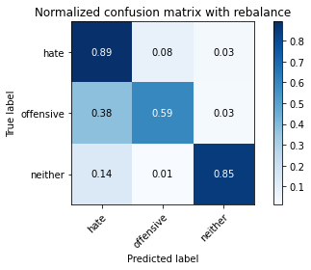

precision recall f1-score support

hate 0.14 0.89 0.25 294

offensive 0.99 0.59 0.74 3821

neither 0.87 0.85 0.86 842

accuracy 0.66 4957

macro avg 0.67 0.78 0.62 4957

weighted avg 0.92 0.66 0.73 4957

average eval_loss: 0.7157644682954396, accuracy: 0.655638491022796

training 3 epoch...

29.498664617538452 seconds used......

3 training finished! average train loss: 0.2342966242056144

evaluating...

Confusion matrix, without normalization

[[ 245 37 12]

[1047 2650 124]

[ 52 22 768]]

Normalized confusion matrix

[[0.83333333 0.12585034 0.04081633]

[0.27401204 0.69353572 0.03245224]

[0.06175772 0.02612827 0.91211401]]

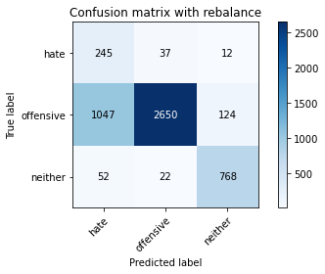

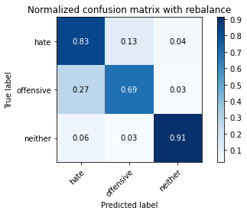

precision recall f1-score support

hate 0.18 0.83 0.30 294

offensive 0.98 0.69 0.81 3821

neither 0.85 0.91 0.88 842

accuracy 0.74 4957

macro avg 0.67 0.81 0.66 4957

weighted avg 0.91 0.74 0.79 4957

average eval_loss: 0.6391788925074281, accuracy: 0.7389550131127698

training 4 epoch...

29.38262915611267 seconds used......

4 training finished! average train loss: 0.13399115973833012

evaluating...

Confusion matrix, without normalization

[[ 242 31 21]

[1043 2579 199]

[ 42 13 787]]

Normalized confusion matrix

[[0.82312925 0.10544218 0.07142857]

[0.27296519 0.6749542 0.05208061]

[0.04988124 0.01543943 0.93467933]]

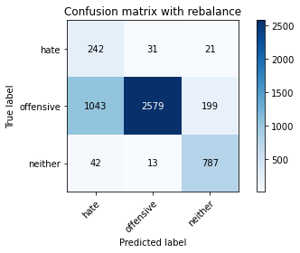

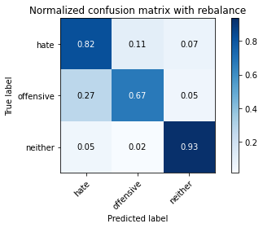

precision recall f1-score support

hate 0.18 0.82 0.30 294

offensive 0.98 0.67 0.80 3821

neither 0.78 0.93 0.85 842

accuracy 0.73 4957

macro avg 0.65 0.81 0.65 4957

weighted avg 0.90 0.73 0.78 4957

average eval_loss: 0.7480203906194337, accuracy: 0.727859592495461

training 5 epoch...

29.304062128067017 seconds used......

5 training finished! average train loss: 0.09650498892763379

evaluating...

Confusion matrix, without normalization

[[ 222 54 18]

[ 737 2973 111]

[ 44 47 751]]

Normalized confusion matrix

[[0.75510204 0.18367347 0.06122449]

[0.19288144 0.77806857 0.02904999]

[0.05225653 0.05581948 0.89192399]]

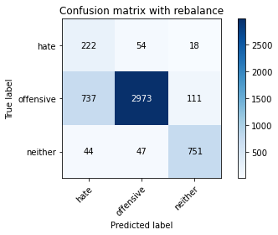

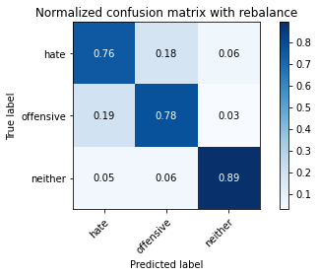

precision recall f1-score support

hate 0.22 0.76 0.34 294

offensive 0.97 0.78 0.86 3821

neither 0.85 0.89 0.87 842

accuracy 0.80 4957

macro avg 0.68 0.81 0.69 4957

weighted avg 0.90 0.80 0.83 4957

average eval_loss: 0.5951879304653455, accuracy: 0.7960459955618318

training 6 epoch...

29.489033699035645 seconds used......

6 training finished! average train loss: 0.060326051285588426

evaluating...

Confusion matrix, without normalization

[[ 243 37 14]

[ 923 2794 104]

[ 65 42 735]]

Normalized confusion matrix

[[0.82653061 0.12585034 0.04761905]

[0.2415598 0.73122219 0.02721801]

[0.07719715 0.04988124 0.87292162]]

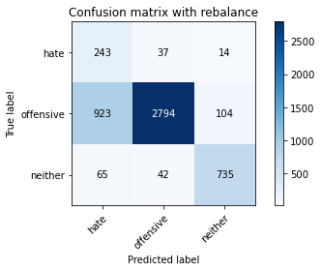

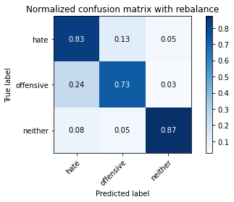

precision recall f1-score support

hate 0.20 0.83 0.32 294

offensive 0.97 0.73 0.83 3821

neither 0.86 0.87 0.87 842

accuracy 0.76 4957

macro avg 0.68 0.81 0.67 4957

weighted avg 0.91 0.76 0.81 4957

average eval_loss: 0.860684554791078, accuracy: 0.7609441194270729

training 7 epoch...

29.467777252197266 seconds used......

7 training finished! average train loss: 0.032546784131030675

evaluating...

Confusion matrix, without normalization

[[ 236 44 14]

[ 799 2921 101]

[ 49 34 759]]

Normalized confusion matrix

[[0.80272109 0.14965986 0.04761905]

[0.20910756 0.76445957 0.02643287]

[0.05819477 0.04038005 0.90142518]]

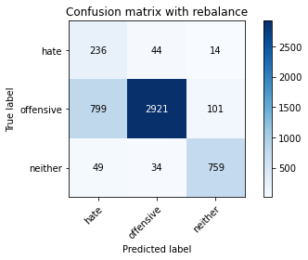

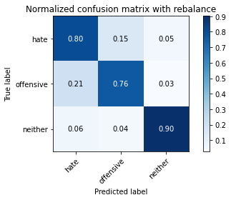

precision recall f1-score support

hate 0.22 0.80 0.34 294

offensive 0.97 0.76 0.86 3821

neither 0.87 0.90 0.88 842

accuracy 0.79 4957

macro avg 0.69 0.82 0.69 4957

weighted avg 0.91 0.79 0.83 4957

average eval_loss: 0.9259110827922761, accuracy: 0.7899939479523905

training 8 epoch...

29.339854955673218 seconds used......

8 training finished! average train loss: 0.0333203493085777

evaluating...

Confusion matrix, without normalization

[[ 220 60 14]

[ 615 3106 100]

[ 50 63 729]]

Normalized confusion matrix

[[0.74829932 0.20408163 0.04761905]

[0.16095263 0.81287621 0.02617116]

[0.05938242 0.07482185 0.86579572]]

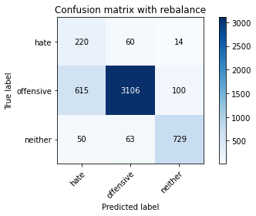

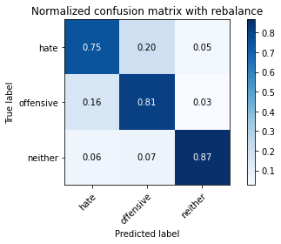

precision recall f1-score support

hate 0.25 0.75 0.37 294

offensive 0.96 0.81 0.88 3821

neither 0.86 0.87 0.87 842

accuracy 0.82 4957

macro avg 0.69 0.81 0.71 4957

weighted avg 0.90 0.82 0.85 4957

average eval_loss: 0.7644673413005583, accuracy: 0.8180351018761347

training 9 epoch...

29.404423713684082 seconds used......

9 training finished! average train loss: 0.02739329181073032

evaluating...

Confusion matrix, without normalization

[[ 224 56 14]

[ 760 2957 104]

[ 47 65 730]]

Normalized confusion matrix

[[0.76190476 0.19047619 0.04761905]

[0.19890081 0.77388118 0.02721801]

[0.05581948 0.07719715 0.86698337]]

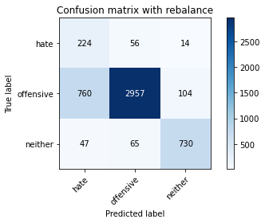

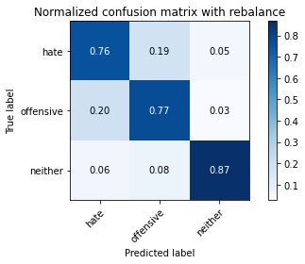

precision recall f1-score support

hate 0.22 0.76 0.34 294

offensive 0.96 0.77 0.86 3821

neither 0.86 0.87 0.86 842

accuracy 0.79 4957

macro avg 0.68 0.80 0.69 4957

weighted avg 0.90 0.79 0.83 4957

average eval_loss: 1.0406185239853878, accuracy: 0.788985273350817

training 10 epoch...

29.423760652542114 seconds used......

10 training finished! average train loss: 0.0162922496150373

evaluating...

Confusion matrix, without normalization

[[ 229 51 14]

[ 827 2897 97]

[ 56 51 735]]

Normalized confusion matrix

[[0.77891156 0.17346939 0.04761905]

[0.21643549 0.75817849 0.02538602]

[0.06650831 0.06057007 0.87292162]]

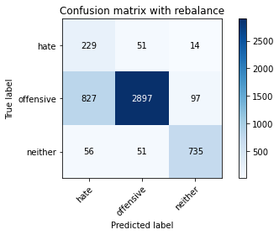

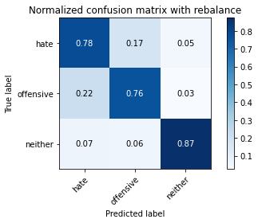

precision recall f1-score support

hate 0.21 0.78 0.33 294

offensive 0.97 0.76 0.85 3821

neither 0.87 0.87 0.87 842

accuracy 0.78 4957

macro avg 0.68 0.80 0.68 4957

weighted avg 0.90 0.78 0.82 4957

average eval_loss: 1.0685221691101399, accuracy: 0.7788985273350817

3 run

training 1 epoch...

29.398255825042725 seconds used......

1 training finished! average train loss: 0.6219539762588969

evaluating...

Confusion matrix, without normalization

[[ 255 28 11]

[1303 2452 66]

[ 139 10 693]]

Normalized confusion matrix

[[0.86734694 0.0952381 0.03741497]

[0.34101021 0.64171683 0.01727297]

[0.16508314 0.01187648 0.82304038]]

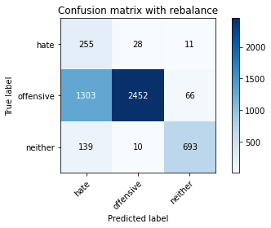

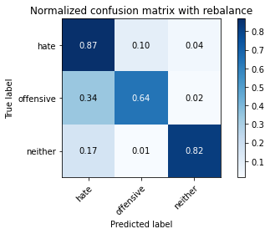

precision recall f1-score support

hate 0.15 0.87 0.26 294

offensive 0.98 0.64 0.78 3821

neither 0.90 0.82 0.86 842

accuracy 0.69 4957

macro avg 0.68 0.78 0.63 4957

weighted avg 0.92 0.69 0.76 4957

average eval_loss: 0.72518609548288, accuracy: 0.685898729070002

training 2 epoch...

29.315433979034424 seconds used......

2 training finished! average train loss: 0.36186701211838695

evaluating...

Confusion matrix, without normalization

[[ 244 31 19]

[1035 2611 175]

[ 51 10 781]]

Normalized confusion matrix

[[0.82993197 0.10544218 0.06462585]

[0.2708715 0.68332897 0.04579953]

[0.06057007 0.01187648 0.92755344]]

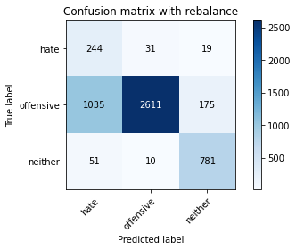

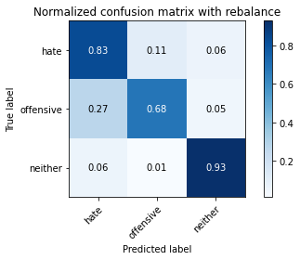

precision recall f1-score support

hate 0.18 0.83 0.30 294

offensive 0.98 0.68 0.81 3821

neither 0.80 0.93 0.86 842

accuracy 0.73 4957

macro avg 0.66 0.81 0.66 4957

weighted avg 0.91 0.73 0.79 4957

average eval_loss: 0.6189059093594551, accuracy: 0.7335081702642727

training 3 epoch...

29.426905393600464 seconds used......

3 training finished! average train loss: 0.2327835988797988

evaluating...

Confusion matrix, without normalization

[[ 249 30 15]

[1165 2560 96]

[ 91 22 729]]

Normalized confusion matrix

[[0.84693878 0.10204082 0.05102041]

[0.30489401 0.66998168 0.02512431]

[0.10807601 0.02612827 0.86579572]]

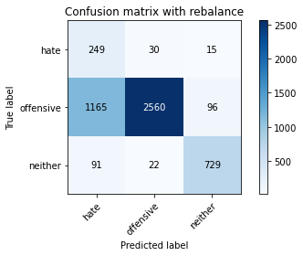

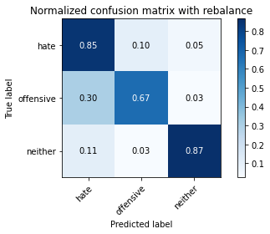

precision recall f1-score support

hate 0.17 0.85 0.28 294

offensive 0.98 0.67 0.80 3821

neither 0.87 0.87 0.87 842

accuracy 0.71 4957

macro avg 0.67 0.79 0.65 4957

weighted avg 0.91 0.71 0.78 4957

average eval_loss: 0.7243697167404236, accuracy: 0.7137381480734315

training 4 epoch...

29.34068751335144 seconds used......

4 training finished! average train loss: 0.1420337840511698

evaluating...

Confusion matrix, without normalization

[[ 216 54 24]

[ 699 3007 115]

[ 49 27 766]]

Normalized confusion matrix

[[0.73469388 0.18367347 0.08163265]

[0.1829364 0.78696676 0.03009683]

[0.05819477 0.03206651 0.90973872]]

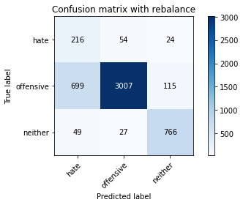

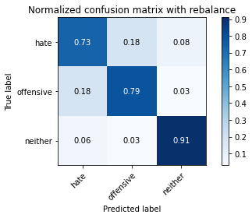

precision recall f1-score support

hate 0.22 0.73 0.34 294

offensive 0.97 0.79 0.87 3821

neither 0.85 0.91 0.88 842

accuracy 0.80 4957

macro avg 0.68 0.81 0.70 4957

weighted avg 0.91 0.80 0.84 4957

average eval_loss: 0.5453991895887039, accuracy: 0.8047205971353641

training 5 epoch...

29.423630475997925 seconds used......

5 training finished! average train loss: 0.09748940579919961

evaluating...

Confusion matrix, without normalization

[[ 239 40 15]

[1094 2626 101]

[ 71 28 743]]

Normalized confusion matrix

[[0.81292517 0.13605442 0.05102041]

[0.28631248 0.68725465 0.02643287]

[0.08432304 0.03325416 0.8824228 ]]

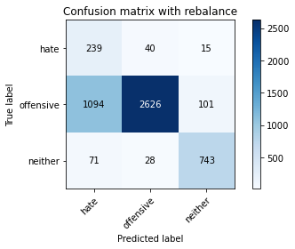

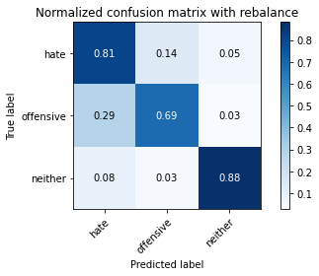

precision recall f1-score support

hate 0.17 0.81 0.28 294

offensive 0.97 0.69 0.81 3821

neither 0.86 0.88 0.87 842

accuracy 0.73 4957

macro avg 0.67 0.79 0.65 4957

weighted avg 0.91 0.73 0.79 4957

average eval_loss: 0.8157788351208212, accuracy: 0.727859592495461

training 6 epoch...

29.39420247077942 seconds used......

6 training finished! average train loss: 0.0524622444853143

evaluating...

Confusion matrix, without normalization

[[ 225 54 15]

[ 728 3019 74]

[ 72 59 711]]

Normalized confusion matrix

[[0.76530612 0.18367347 0.05102041]

[0.19052604 0.7901073 0.01936666]

[0.08551069 0.07007126 0.84441805]]

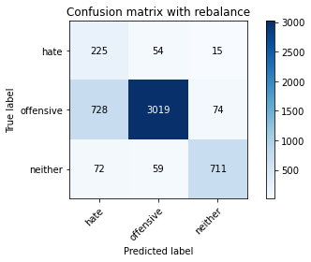

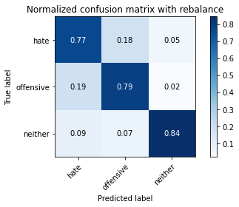

precision recall f1-score support

hate 0.22 0.77 0.34 294

offensive 0.96 0.79 0.87 3821

neither 0.89 0.84 0.87 842

accuracy 0.80 4957

macro avg 0.69 0.80 0.69 4957

weighted avg 0.91 0.80 0.84 4957

average eval_loss: 0.7600578981556839, accuracy: 0.7978616098446641

training 7 epoch...

29.325743436813354 seconds used......

7 training finished! average train loss: 0.029814628723189126

evaluating...

Confusion matrix, without normalization

[[ 233 50 11]

[ 746 3012 63]

[ 105 61 676]]

Normalized confusion matrix

[[0.79251701 0.17006803 0.03741497]

[0.19523685 0.78827532 0.01648783]

[0.12470309 0.07244656 0.80285036]]

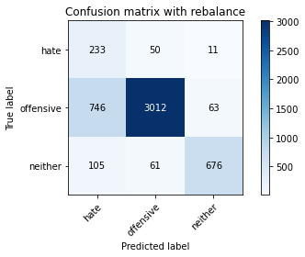

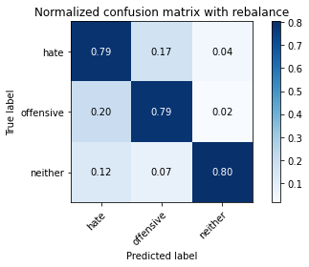

precision recall f1-score support

hate 0.21 0.79 0.34 294

offensive 0.96 0.79 0.87 3821

neither 0.90 0.80 0.85 842

accuracy 0.79 4957

macro avg 0.69 0.79 0.68 4957

weighted avg 0.91 0.79 0.83 4957

average eval_loss: 0.8645029827603139, accuracy: 0.7910026225539641

training 8 epoch...

29.265952348709106 seconds used......

8 training finished! average train loss: 0.016779542535547528

evaluating...

Confusion matrix, without normalization

[[ 191 87 16]

[ 520 3213 88]

[ 48 65 729]]

Normalized confusion matrix

[[0.64965986 0.29591837 0.05442177]

[0.13609003 0.84087935 0.02303062]

[0.05700713 0.07719715 0.86579572]]

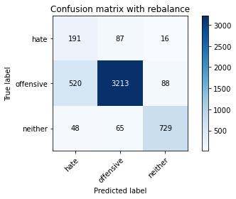

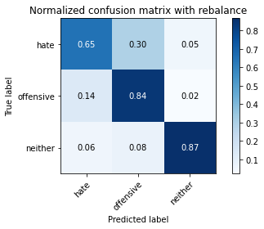

precision recall f1-score support

hate 0.25 0.65 0.36 294

offensive 0.95 0.84 0.89 3821

neither 0.88 0.87 0.87 842

accuracy 0.83 4957

macro avg 0.69 0.79 0.71 4957

weighted avg 0.90 0.83 0.86 4957

average eval_loss: 0.7960589833472171, accuracy: 0.8337704256606818

training 9 epoch...

29.319337844848633 seconds used......

9 training finished! average train loss: 0.039548994177116395

evaluating...

Confusion matrix, without normalization

[[ 229 49 16]

[ 755 2993 73]

[ 60 91 691]]

Normalized confusion matrix

[[0.77891156 0.16666667 0.05442177]

[0.19759225 0.7833028 0.01910495]

[0.07125891 0.10807601 0.82066508]]

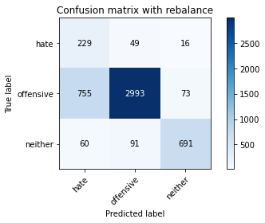

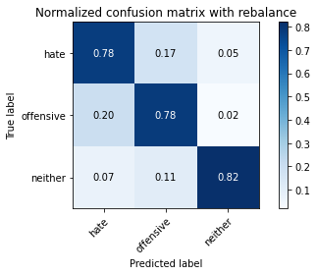

precision recall f1-score support

hate 0.22 0.78 0.34 294

offensive 0.96 0.78 0.86 3821

neither 0.89 0.82 0.85 842

accuracy 0.79 4957

macro avg 0.69 0.79 0.69 4957

weighted avg 0.90 0.79 0.83 4957

average eval_loss: 0.9471690836137221, accuracy: 0.7893887431914465

training 10 epoch...

29.391840934753418 seconds used......

10 training finished! average train loss: 0.022568223830986472

evaluating...

Confusion matrix, without normalization

[[ 240 39 15]

[ 900 2812 109]

[ 63 36 743]]

Normalized confusion matrix

[[0.81632653 0.13265306 0.05102041]

[0.23554043 0.735933 0.02852656]

[0.07482185 0.04275534 0.8824228 ]]

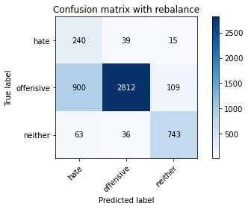

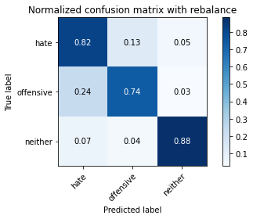

precision recall f1-score support

hate 0.20 0.82 0.32 294

offensive 0.97 0.74 0.84 3821

neither 0.86 0.88 0.87 842

accuracy 0.77 4957

macro avg 0.68 0.81 0.68 4957

weighted avg 0.91 0.77 0.81 4957

average eval_loss: 1.123241140684601, accuracy: 0.765584022594311

4 run

training 1 epoch...

29.44679307937622 seconds used......

1 training finished! average train loss: 0.661440944811057

evaluating...

Confusion matrix, without normalization

[[ 234 28 32]

[1357 2198 266]

[ 43 4 795]]

Normalized confusion matrix

[[0.79591837 0.0952381 0.10884354]

[0.35514263 0.57524208 0.06961528]

[0.05106888 0.00475059 0.94418052]]

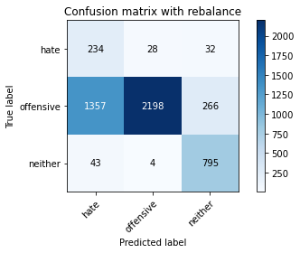

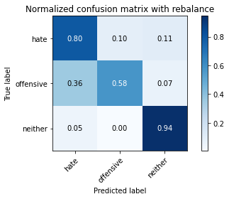

precision recall f1-score support

hate 0.14 0.80 0.24 294

offensive 0.99 0.58 0.73 3821

neither 0.73 0.94 0.82 842

accuracy 0.65 4957

macro avg 0.62 0.77 0.60 4957

weighted avg 0.89 0.65 0.71 4957

average eval_loss: 0.7958468211995017, accuracy: 0.6509985878555578

training 2 epoch...

29.360925674438477 seconds used......

2 training finished! average train loss: 0.368907280876274

evaluating...

Confusion matrix, without normalization

[[ 239 28 27]

[1130 2439 252]

[ 41 7 794]]

Normalized confusion matrix

[[0.81292517 0.0952381 0.09183673]

[0.2957341 0.63831458 0.06595132]

[0.04869359 0.00831354 0.94299287]]

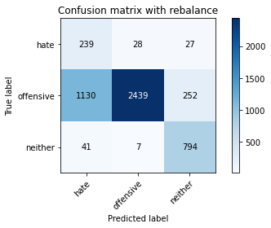

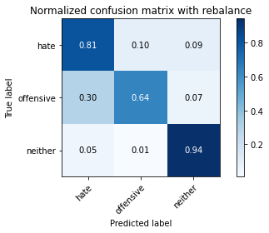

precision recall f1-score support

hate 0.17 0.81 0.28 294

offensive 0.99 0.64 0.77 3821

neither 0.74 0.94 0.83 842

accuracy 0.70 4957

macro avg 0.63 0.80 0.63 4957

weighted avg 0.90 0.70 0.75 4957

average eval_loss: 0.6664385101006877, accuracy: 0.7004236433326609

training 3 epoch...

29.387253761291504 seconds used......

3 training finished! average train loss: 0.24358143820835834

evaluating...

Confusion matrix, without normalization

[[ 257 26 11]

[1593 2107 121]

[ 126 14 702]]

Normalized confusion matrix

[[0.87414966 0.08843537 0.03741497]

[0.41690657 0.55142633 0.0316671 ]

[0.14964371 0.01662708 0.83372922]]

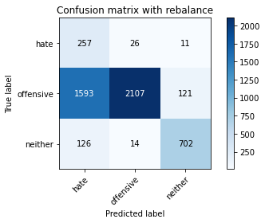

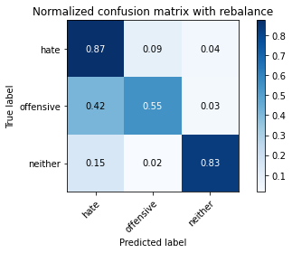

precision recall f1-score support

hate 0.13 0.87 0.23 294

offensive 0.98 0.55 0.71 3821

neither 0.84 0.83 0.84 842

accuracy 0.62 4957

macro avg 0.65 0.75 0.59 4957

weighted avg 0.91 0.62 0.70 4957

average eval_loss: 0.8350561114568864, accuracy: 0.61851926568489

training 4 epoch...

29.24446439743042 seconds used......

4 training finished! average train loss: 0.15224009186944418

evaluating...

Confusion matrix, without normalization

[[ 233 36 25]

[1046 2611 164]

[ 47 17 778]]

Normalized confusion matrix

[[0.79251701 0.12244898 0.08503401]

[0.27375033 0.68332897 0.0429207 ]

[0.05581948 0.02019002 0.9239905 ]]

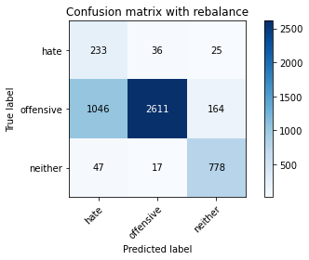

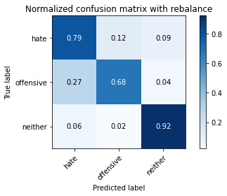

precision recall f1-score support

hate 0.18 0.79 0.29 294

offensive 0.98 0.68 0.81 3821

neither 0.80 0.92 0.86 842

accuracy 0.73 4957

macro avg 0.65 0.80 0.65 4957

weighted avg 0.90 0.73 0.78 4957

average eval_loss: 0.7585005662253788, accuracy: 0.7306838813798668

training 5 epoch...

29.481125593185425 seconds used......

5 training finished! average train loss: 0.10376767994160628

evaluating...

Confusion matrix, without normalization

[[ 243 38 13]

[1064 2657 100]

[ 90 38 714]]

Normalized confusion matrix

[[0.82653061 0.1292517 0.04421769]

[0.27846114 0.6953677 0.02617116]

[0.10688836 0.04513064 0.847981 ]]

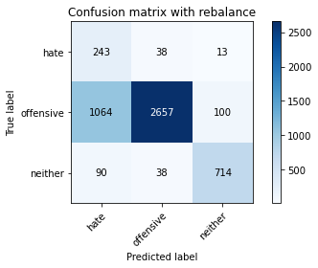

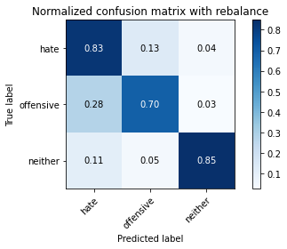

precision recall f1-score support

hate 0.17 0.83 0.29 294

offensive 0.97 0.70 0.81 3821

neither 0.86 0.85 0.86 842

accuracy 0.73 4957

macro avg 0.67 0.79 0.65 4957

weighted avg 0.91 0.73 0.79 4957

average eval_loss: 0.8608027883249545, accuracy: 0.7290700020173492

training 6 epoch...

29.487907648086548 seconds used......

6 training finished! average train loss: 0.06766298224016676

evaluating...

Confusion matrix, without normalization

[[ 220 50 24]

[ 721 2929 171]

[ 48 24 770]]

Normalized confusion matrix

[[0.74829932 0.17006803 0.08163265]

[0.18869406 0.76655326 0.04475268]

[0.05700713 0.02850356 0.91448931]]

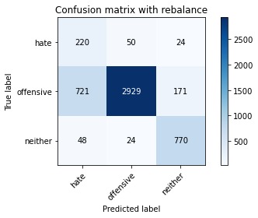

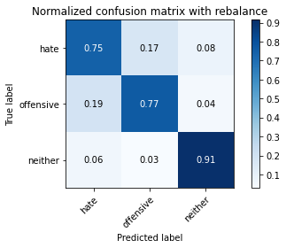

precision recall f1-score support

hate 0.22 0.75 0.34 294

offensive 0.98 0.77 0.86 3821

neither 0.80 0.91 0.85 842

accuracy 0.79 4957

macro avg 0.67 0.81 0.68 4957

weighted avg 0.90 0.79 0.83 4957

average eval_loss: 0.7520707722400285, accuracy: 0.7905991527133347

training 7 epoch...

29.253106355667114 seconds used......

7 training finished! average train loss: 0.03788681224816375

evaluating...

Confusion matrix, without normalization

[[ 237 41 16]

[ 922 2800 99]

[ 76 35 731]]

Normalized confusion matrix

[[0.80612245 0.13945578 0.05442177]

[0.24129809 0.73279246 0.02590945]

[0.09026128 0.0415677 0.86817102]]

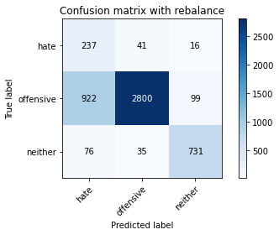

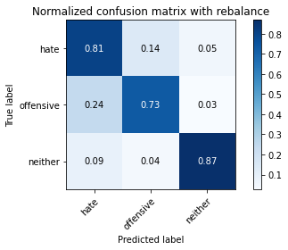

precision recall f1-score support

hate 0.19 0.81 0.31 294

offensive 0.97 0.73 0.84 3821

neither 0.86 0.87 0.87 842

accuracy 0.76 4957

macro avg 0.68 0.80 0.67 4957

weighted avg 0.91 0.76 0.81 4957

average eval_loss: 1.004136421871672, accuracy: 0.760137179745814

training 8 epoch...

29.382774829864502 seconds used......

8 training finished! average train loss: 0.029669142389473945

evaluating...

Confusion matrix, without normalization

[[ 240 37 17]

[ 998 2711 112]

[ 79 32 731]]

Normalized confusion matrix

[[0.81632653 0.12585034 0.05782313]

[0.26118817 0.70950013 0.0293117 ]

[0.09382423 0.03800475 0.86817102]]

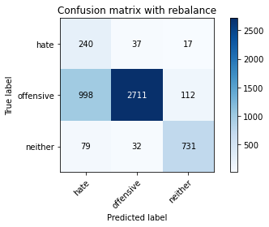

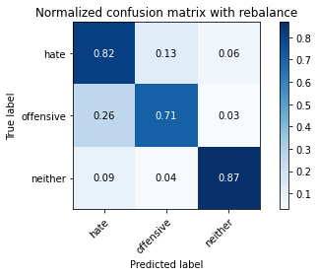

precision recall f1-score support

hate 0.18 0.82 0.30 294

offensive 0.98 0.71 0.82 3821

neither 0.85 0.87 0.86 842

accuracy 0.74 4957

macro avg 0.67 0.80 0.66 4957

weighted avg 0.91 0.74 0.80 4957

average eval_loss: 1.0953650442252476, accuracy: 0.7427879765987493

training 9 epoch...

29.32956552505493 seconds used......

9 training finished! average train loss: 0.034571766917326906

evaluating...

Confusion matrix, without normalization

[[ 244 32 18]

[1103 2594 124]

[ 68 39 735]]

Normalized confusion matrix

[[0.82993197 0.10884354 0.06122449]

[0.28866789 0.67887987 0.03245224]

[0.0807601 0.04631829 0.87292162]]

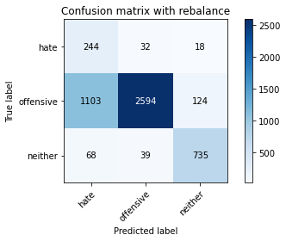

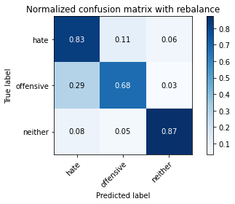

precision recall f1-score support

hate 0.17 0.83 0.29 294

offensive 0.97 0.68 0.80 3821

neither 0.84 0.87 0.86 842

accuracy 0.72 4957

macro avg 0.66 0.79 0.65 4957

weighted avg 0.90 0.72 0.78 4957

average eval_loss: 1.1954547084207017, accuracy: 0.7207988702844462

training 10 epoch...

29.397318840026855 seconds used......

10 training finished! average train loss: 0.017285052535453625

evaluating...

Confusion matrix, without normalization

[[ 225 49 20]

[ 801 2898 122]

[ 48 44 750]]

Normalized confusion matrix

[[0.76530612 0.16666667 0.06802721]

[0.20963099 0.7584402 0.03192881]

[0.05700713 0.05225653 0.89073634]]

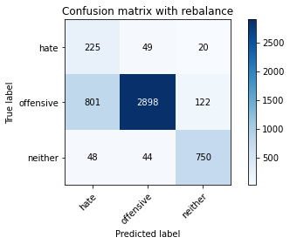

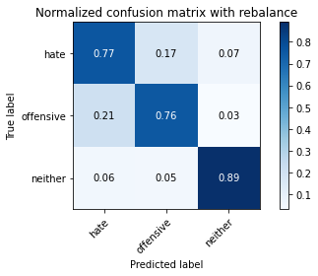

precision recall f1-score support

hate 0.21 0.77 0.33 294

offensive 0.97 0.76 0.85 3821

neither 0.84 0.89 0.87 842

accuracy 0.78 4957

macro avg 0.67 0.80 0.68 4957

weighted avg 0.90 0.78 0.82 4957

average eval_loss: 1.01110432166118, accuracy: 0.7813193463788581

5 run

training 1 epoch...

29.249173879623413 seconds used......

1 training finished! average train loss: 0.6558609107258724

evaluating...

Confusion matrix, without normalization

[[ 243 30 21]

[1040 2657 124]

[ 60 13 769]]

Normalized confusion matrix

[[0.82653061 0.10204082 0.07142857]

[0.27218006 0.6953677 0.03245224]

[0.07125891 0.01543943 0.91330166]]

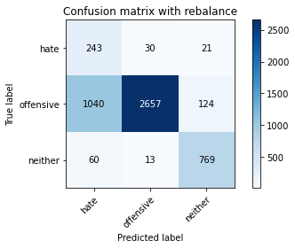

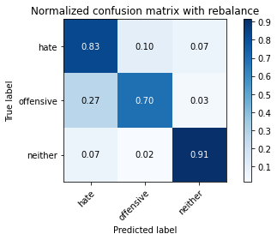

precision recall f1-score support

hate 0.18 0.83 0.30 294

offensive 0.98 0.70 0.81 3821

neither 0.84 0.91 0.88 842

accuracy 0.74 4957

macro avg 0.67 0.81 0.66 4957

weighted avg 0.91 0.74 0.79 4957

average eval_loss: 0.609179942598266, accuracy: 0.740165422634658

training 2 epoch...

29.33693814277649 seconds used......

2 training finished! average train loss: 0.3802233514381431

evaluating...

Confusion matrix, without normalization

[[ 241 35 18]

[ 949 2748 124]

[ 56 10 776]]

Normalized confusion matrix

[[0.81972789 0.11904762 0.06122449]

[0.2483643 0.71918346 0.03245224]

[0.06650831 0.01187648 0.9216152 ]]

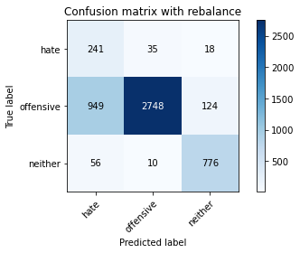

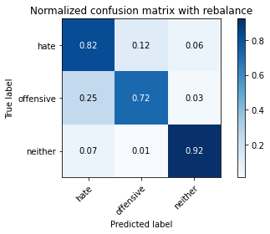

precision recall f1-score support

hate 0.19 0.82 0.31 294

offensive 0.98 0.72 0.83 3821

neither 0.85 0.92 0.88 842

accuracy 0.76 4957

macro avg 0.67 0.82 0.68 4957

weighted avg 0.91 0.76 0.81 4957

average eval_loss: 0.652597839373254, accuracy: 0.7595319749848699

training 3 epoch...

29.291472673416138 seconds used......

3 training finished! average train loss: 0.25560599055729416

evaluating...

Confusion matrix, without normalization

[[ 250 26 18]

[1289 2414 118]

[ 88 13 741]]

Normalized confusion matrix

[[0.85034014 0.08843537 0.06122449]

[0.33734624 0.63177179 0.03088197]

[0.10451306 0.01543943 0.88004751]]

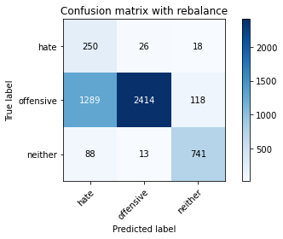

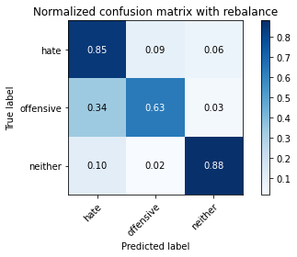

precision recall f1-score support

hate 0.15 0.85 0.26 294

offensive 0.98 0.63 0.77 3821

neither 0.84 0.88 0.86 842

accuracy 0.69 4957

macro avg 0.66 0.79 0.63 4957

weighted avg 0.91 0.69 0.76 4957

average eval_loss: 0.7213264799887135, accuracy: 0.6869074036715755

training 4 epoch...

29.25571632385254 seconds used......

4 training finished! average train loss: 0.17103270204922957

evaluating...

Confusion matrix, without normalization

[[ 249 33 12]

[1259 2489 73]

[ 105 36 701]]

Normalized confusion matrix

[[0.84693878 0.1122449 0.04081633]

[0.3294949 0.65140016 0.01910495]

[0.12470309 0.04275534 0.83254157]]

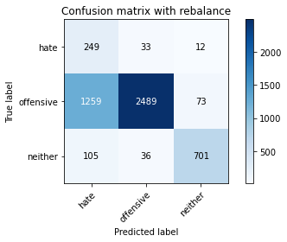

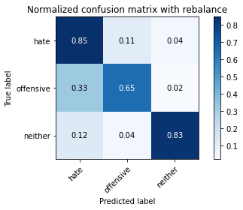

precision recall f1-score support

hate 0.15 0.85 0.26 294

offensive 0.97 0.65 0.78 3821

neither 0.89 0.83 0.86 842

accuracy 0.69 4957

macro avg 0.67 0.78 0.63 4957

weighted avg 0.91 0.69 0.76 4957

average eval_loss: 0.7424185738388088, accuracy: 0.6937663909622755

training 5 epoch...

29.417460680007935 seconds used......

5 training finished! average train loss: 0.10893574901121228

evaluating...

Confusion matrix, without normalization

[[ 238 36 20]

[1039 2638 144]

[ 54 20 768]]

Normalized confusion matrix

[[0.80952381 0.12244898 0.06802721]

[0.27191835 0.69039518 0.03768647]

[0.06413302 0.02375297 0.91211401]]

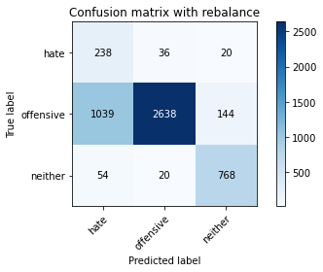

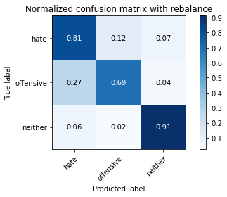

precision recall f1-score support

hate 0.18 0.81 0.29 294

offensive 0.98 0.69 0.81 3821

neither 0.82 0.91 0.87 842

accuracy 0.74 4957

macro avg 0.66 0.80 0.66 4957

weighted avg 0.91 0.74 0.79 4957

average eval_loss: 0.7355054037630437, accuracy: 0.7351220496267904

training 6 epoch...

29.497224807739258 seconds used......

6 training finished! average train loss: 0.08058800866925403

evaluating...

Confusion matrix, without normalization

[[ 243 35 16]

[1121 2555 145]

[ 85 29 728]]

Normalized confusion matrix

[[0.82653061 0.11904762 0.05442177]

[0.2933787 0.66867312 0.03794818]

[0.10095012 0.03444181 0.86460808]]

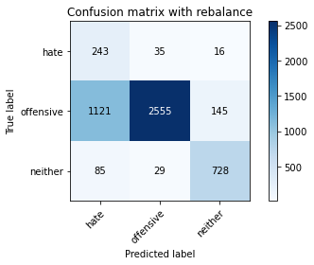

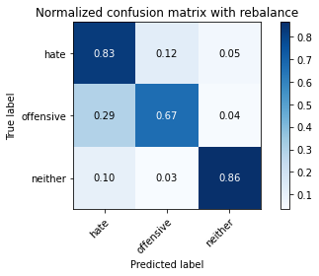

precision recall f1-score support

hate 0.17 0.83 0.28 294

offensive 0.98 0.67 0.79 3821

neither 0.82 0.86 0.84 842

accuracy 0.71 4957

macro avg 0.65 0.79 0.64 4957

weighted avg 0.90 0.71 0.77 4957

average eval_loss: 0.9307027525388666, accuracy: 0.711317329029655

training 7 epoch...

29.35798931121826 seconds used......

7 training finished! average train loss: 0.04729357514018465

evaluating...

Confusion matrix, without normalization

[[ 223 54 17]

[ 677 3025 119]

[ 56 33 753]]

Normalized confusion matrix

[[0.7585034 0.18367347 0.05782313]

[0.17717875 0.79167757 0.03114368]

[0.06650831 0.0391924 0.89429929]]

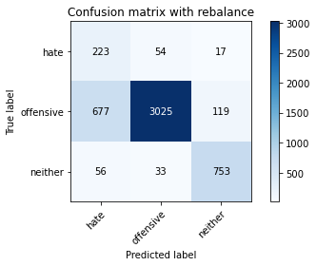

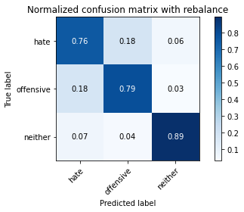

precision recall f1-score support

hate 0.23 0.76 0.36 294

offensive 0.97 0.79 0.87 3821

neither 0.85 0.89 0.87 842

accuracy 0.81 4957

macro avg 0.68 0.81 0.70 4957

weighted avg 0.91 0.81 0.84 4957

average eval_loss: 0.7507586166489825, accuracy: 0.8071414161791406

training 8 epoch...

29.493042707443237 seconds used......

8 training finished! average train loss: 0.03580479170209374

evaluating...

Confusion matrix, without normalization

[[ 227 49 18]

[ 772 2887 162]

[ 54 26 762]]

Normalized confusion matrix

[[0.77210884 0.16666667 0.06122449]

[0.20204135 0.75556137 0.04239728]

[0.06413302 0.03087886 0.90498812]]

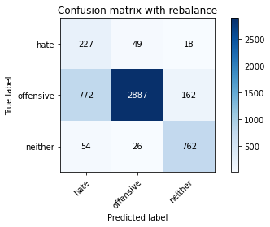

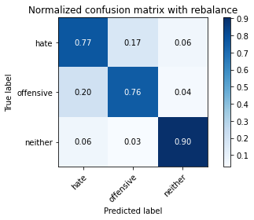

precision recall f1-score support

hate 0.22 0.77 0.34 294

offensive 0.97 0.76 0.85 3821

neither 0.81 0.90 0.85 842

accuracy 0.78 4957

macro avg 0.67 0.81 0.68 4957

weighted avg 0.90 0.78 0.82 4957

average eval_loss: 0.8710751658898869, accuracy: 0.7819245511398023

training 9 epoch...

29.285614252090454 seconds used......

9 training finished! average train loss: 0.03345068858334609

evaluating...

Confusion matrix, without normalization

[[ 221 51 22]

[ 823 2866 132]

[ 35 24 783]]

Normalized confusion matrix

[[0.75170068 0.17346939 0.07482993]

[0.21538864 0.75006543 0.03454593]

[0.0415677 0.02850356 0.92992874]]

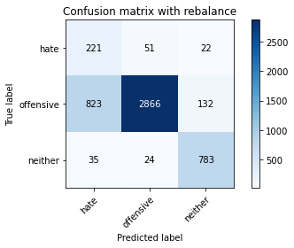

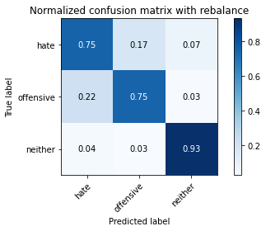

precision recall f1-score support

hate 0.20 0.75 0.32 294

offensive 0.97 0.75 0.85 3821

neither 0.84 0.93 0.88 842

accuracy 0.78 4957

macro avg 0.67 0.81 0.68 4957

weighted avg 0.91 0.78 0.82 4957

average eval_loss: 0.8746557122194057, accuracy: 0.7807141416179141

training 10 epoch...

29.430646181106567 seconds used......

10 training finished! average train loss: 0.02045054823413426

evaluating...

Confusion matrix, without normalization

[[ 235 43 16]

[ 944 2772 105]

[ 78 31 733]]

Normalized confusion matrix

[[0.79931973 0.1462585 0.05442177]

[0.24705574 0.72546454 0.02747972]

[0.09263658 0.0368171 0.87054632]]

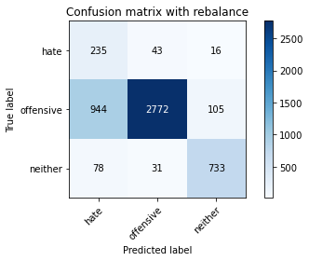

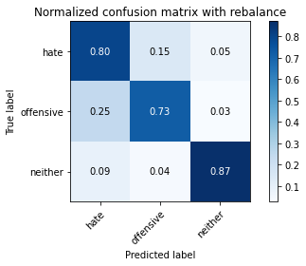

precision recall f1-score support

hate 0.19 0.80 0.30 294

offensive 0.97 0.73 0.83 3821

neither 0.86 0.87 0.86 842

accuracy 0.75 4957

macro avg 0.67 0.80 0.67 4957

weighted avg 0.91 0.75 0.81 4957

average eval_loss: 1.212594468379041, accuracy: 0.7544886019770022