1 run

[1.5, 0.3 ,1]

training 1 epoch...

29.37818717956543 seconds used......

1 training finished! average train loss: 0.5889109121254313

evaluating...

Confusion matrix, without normalization

[[ 257 13 24]

[2551 1128 142]

[ 61 6 775]]

Normalized confusion matrix

[[0.87414966 0.04421769 0.08163265]

[0.66762628 0.29521068 0.03716305]

[0.07244656 0.00712589 0.92042755]]

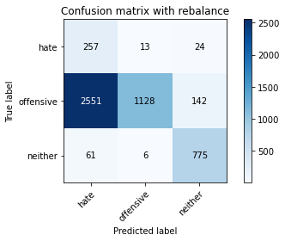

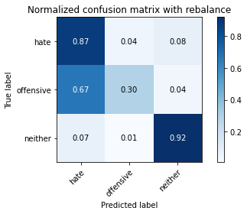

precision recall f1-score support

hate 0.09 0.87 0.16 294

offensive 0.98 0.30 0.45 3821

neither 0.82 0.92 0.87 842

accuracy 0.44 4957

macro avg 0.63 0.70 0.50 4957

weighted avg 0.90 0.44 0.51 4957

average eval_loss: 0.9351088149893668, accuracy: 0.435747427879766

training 2 epoch...

29.378254175186157 seconds used......

2 training finished! average train loss: 0.32573561897577596

evaluating...

Confusion matrix, without normalization

[[ 248 34 12]

[ 986 2741 94]

[ 89 15 738]]

Normalized confusion matrix

[[0.84353741 0.11564626 0.04081633]

[0.25804763 0.71735148 0.02460089]

[0.10570071 0.01781473 0.87648456]]

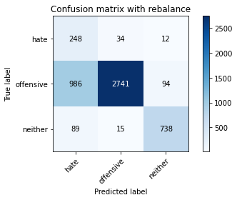

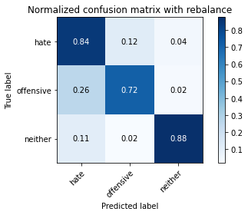

precision recall f1-score support

hate 0.19 0.84 0.31 294

offensive 0.98 0.72 0.83 3821

neither 0.87 0.88 0.88 842

accuracy 0.75 4957

macro avg 0.68 0.81 0.67 4957

weighted avg 0.92 0.75 0.81 4957

average eval_loss: 0.5744541918318118, accuracy: 0.751866048012911

training 3 epoch...

29.251457929611206 seconds used......

3 training finished! average train loss: 0.21459149296956453

evaluating...

Confusion matrix, without normalization

[[ 235 31 28]

[1141 2493 187]

[ 42 8 792]]

Normalized confusion matrix

[[0.79931973 0.10544218 0.0952381 ]

[0.29861293 0.652447 0.04894007]

[0.04988124 0.00950119 0.94061758]]

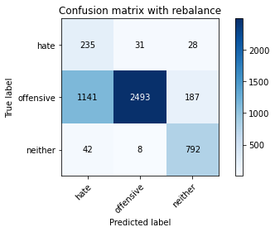

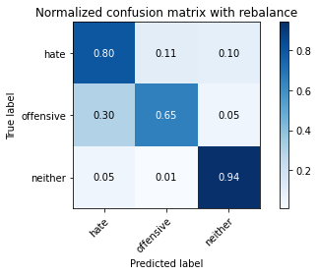

precision recall f1-score support

hate 0.17 0.80 0.27 294

offensive 0.98 0.65 0.78 3821

neither 0.79 0.94 0.86 842

accuracy 0.71 4957

macro avg 0.65 0.80 0.64 4957

weighted avg 0.90 0.71 0.77 4957

average eval_loss: 0.6476852353662252, accuracy: 0.7101069195077668

training 4 epoch...

29.350659370422363 seconds used......

4 training finished! average train loss: 0.1370623483818177

evaluating...

Confusion matrix, without normalization

[[ 251 29 14]

[1366 2367 88]

[ 79 19 744]]

Normalized confusion matrix

[[0.8537415 0.09863946 0.04761905]

[0.35749804 0.61947134 0.02303062]

[0.09382423 0.02256532 0.88361045]]

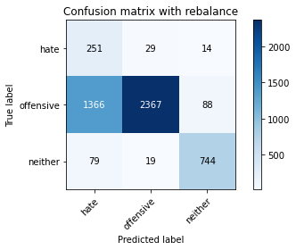

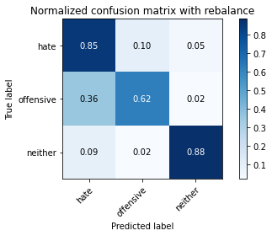

precision recall f1-score support

hate 0.15 0.85 0.25 294

offensive 0.98 0.62 0.76 3821

neither 0.88 0.88 0.88 842

accuracy 0.68 4957

macro avg 0.67 0.79 0.63 4957

weighted avg 0.91 0.68 0.75 4957

average eval_loss: 0.7778928540947456, accuracy: 0.6782328020980432

training 5 epoch...

29.341211557388306 seconds used......

5 training finished! average train loss: 0.09531559924763894

evaluating...

Confusion matrix, without normalization

[[ 243 32 19]

[1153 2499 169]

[ 55 12 775]]

Normalized confusion matrix

[[0.82653061 0.10884354 0.06462585]

[0.30175347 0.65401727 0.04422926]

[0.06532067 0.01425178 0.92042755]]

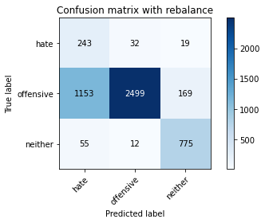

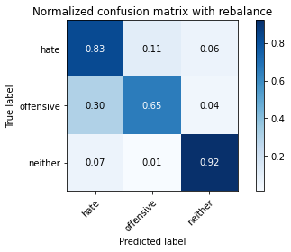

precision recall f1-score support

hate 0.17 0.83 0.28 294

offensive 0.98 0.65 0.79 3821

neither 0.80 0.92 0.86 842

accuracy 0.71 4957

macro avg 0.65 0.80 0.64 4957

weighted avg 0.90 0.71 0.77 4957

average eval_loss: 0.8184217652005534, accuracy: 0.7095017147468227

training 6 epoch...

Confusion matrix, without normalization

[[ 225 52 17]

[ 763 2960 98]

[ 52 40 750]]

Normalized confusion matrix

[[0.76530612 0.17687075 0.05782313]

[0.19968595 0.77466632 0.02564774]

[0.06175772 0.04750594 0.89073634]]

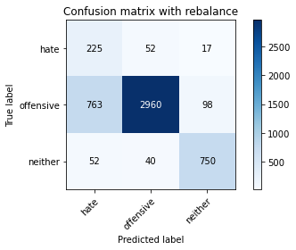

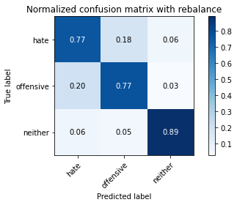

precision recall f1-score support

hate 0.22 0.77 0.34 294

offensive 0.97 0.77 0.86 3821

neither 0.87 0.89 0.88 842

accuracy 0.79 4957

macro avg 0.68 0.81 0.69 4957

weighted avg 0.91 0.79 0.83 4957

average eval_loss: 0.8894546771808828, accuracy: 0.79382691143837

training 9 epoch...

29.372613191604614 seconds used......

9 training finished! average train loss: 0.016952025431088494

evaluating...

Confusion matrix, without normalization

[[ 230 49 15]

[ 832 2904 85]

[ 65 37 740]]

Normalized confusion matrix

[[0.78231293 0.16666667 0.05102041]

[0.21774405 0.76001047 0.02224549]

[0.07719715 0.04394299 0.87885986]]

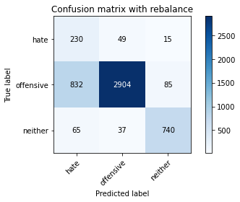

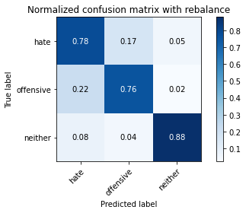

precision recall f1-score support

hate 0.20 0.78 0.32 294

offensive 0.97 0.76 0.85 3821

neither 0.88 0.88 0.88 842

accuracy 0.78 4957

macro avg 0.69 0.81 0.69 4957

weighted avg 0.91 0.78 0.83 4957

average eval_loss: 1.008499742218954, accuracy: 0.7815210812991729

training 10 epoch...

29.487773895263672 seconds used......

10 training finished! average train loss: 0.031001940477851844

evaluating...

Confusion matrix, without normalization

[[ 201 63 30]

[ 641 3002 178]

[ 29 22 791]]

Normalized confusion matrix

[[0.68367347 0.21428571 0.10204082]

[0.16775713 0.7856582 0.04658466]

[0.03444181 0.02612827 0.93942993]]

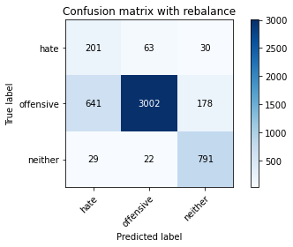

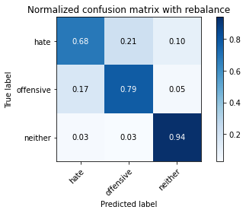

precision recall f1-score support

hate 0.23 0.68 0.35 294

offensive 0.97 0.79 0.87 3821

neither 0.79 0.94 0.86 842

accuracy 0.81 4957

macro avg 0.67 0.80 0.69 4957

weighted avg 0.90 0.81 0.84 4957

average eval_loss: 0.8010906585813274, accuracy: 0.8057292717369376

2 run

training 1 epoch...

29.370110273361206 seconds used......

1 training finished! average train loss: 0.6215669412536231

evaluating...

Confusion matrix, without normalization

[[ 236 27 31]

[1157 2377 287]

[ 62 6 774]]

Normalized confusion matrix

[[0.80272109 0.09183673 0.10544218]

[0.30280031 0.62208846 0.07511123]

[0.0736342 0.00712589 0.9192399 ]]

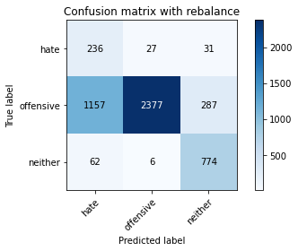

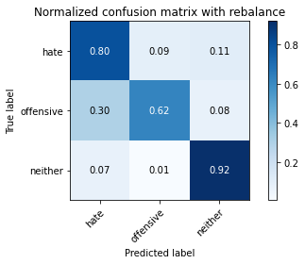

precision recall f1-score support

hate 0.16 0.80 0.27 294

offensive 0.99 0.62 0.76 3821

neither 0.71 0.92 0.80 842

accuracy 0.68 4957

macro avg 0.62 0.78 0.61 4957

weighted avg 0.89 0.68 0.74 4957

average eval_loss: 0.6965155429056575, accuracy: 0.6832761751059109

training 2 epoch...

29.368605852127075 seconds used......

2 training finished! average train loss: 0.336908568655364

evaluating...

Confusion matrix, without normalization

[[ 243 34 17]

[1026 2672 123]

[ 51 10 781]]

Normalized confusion matrix

[[0.82653061 0.11564626 0.05782313]

[0.2685161 0.69929338 0.03219053]

[0.06057007 0.01187648 0.92755344]]

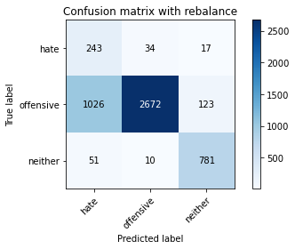

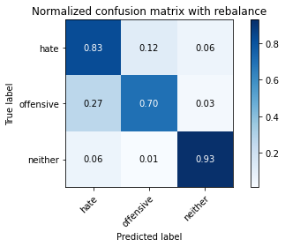

precision recall f1-score support

hate 0.18 0.83 0.30 294

offensive 0.98 0.70 0.82 3821

neither 0.85 0.93 0.89 842

accuracy 0.75 4957

macro avg 0.67 0.82 0.67 4957

weighted avg 0.91 0.75 0.80 4957

average eval_loss: 0.5357937089678261, accuracy: 0.7456122654831552

training 3 epoch...

29.33608627319336 seconds used......

3 training finished! average train loss: 0.21560623551234168

evaluating...

Confusion matrix, without normalization

[[ 247 27 20]

[1373 2284 164]

[ 51 9 782]]

Normalized confusion matrix

[[0.84013605 0.09183673 0.06802721]

[0.35933002 0.59774928 0.0429207 ]

[0.06057007 0.01068884 0.92874109]]

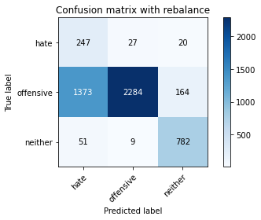

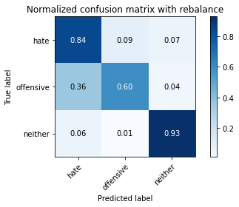

precision recall f1-score support

hate 0.15 0.84 0.25 294

offensive 0.98 0.60 0.74 3821

neither 0.81 0.93 0.87 842

accuracy 0.67 4957

macro avg 0.65 0.79 0.62 4957

weighted avg 0.91 0.67 0.74 4957

average eval_loss: 0.7139475272007046, accuracy: 0.6683477910026225

training 4 epoch...

29.362942218780518 seconds used......

4 training finished! average train loss: 0.14797435035351772

evaluating...

Confusion matrix, without normalization

[[ 257 22 15]

[1540 2083 198]

[ 65 9 768]]

Normalized confusion matrix

[[0.87414966 0.07482993 0.05102041]

[0.40303585 0.54514525 0.0518189 ]

[0.07719715 0.01068884 0.91211401]]

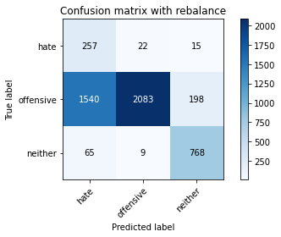

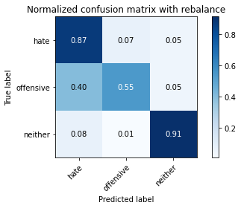

precision recall f1-score support

hate 0.14 0.87 0.24 294

offensive 0.99 0.55 0.70 3821

neither 0.78 0.91 0.84 842

accuracy 0.63 4957

macro avg 0.64 0.78 0.59 4957

weighted avg 0.90 0.63 0.70 4957

average eval_loss: 0.8050790802846032, accuracy: 0.6269921323381077

training 5 epoch...

29.305331707000732 seconds used......

5 training finished! average train loss: 0.11148690354972206

evaluating...

Confusion matrix, without normalization

[[ 246 31 17]

[1125 2541 155]

[ 57 13 772]]

Normalized confusion matrix

[[0.83673469 0.10544218 0.05782313]

[0.29442554 0.66500916 0.0405653 ]

[0.06769596 0.01543943 0.91686461]]

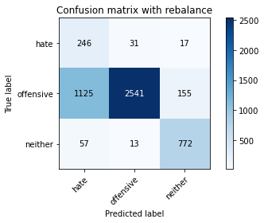

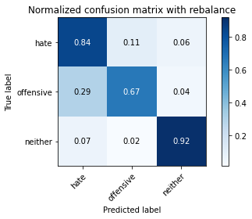

precision recall f1-score support

hate 0.17 0.84 0.29 294

offensive 0.98 0.67 0.79 3821

neither 0.82 0.92 0.86 842

accuracy 0.72 4957

macro avg 0.66 0.81 0.65 4957

weighted avg 0.91 0.72 0.78 4957

average eval_loss: 0.809974655441399, accuracy: 0.7179745814000403

training 6 epoch...

29.31844210624695 seconds used......

6 training finished! average train loss: 0.07607470250590459

evaluating...

Confusion matrix, without normalization

[[ 246 33 15]

[1065 2629 127]

[ 50 29 763]]

Normalized confusion matrix

[[0.83673469 0.1122449 0.05102041]

[0.27872285 0.68803978 0.03323737]

[0.05938242 0.03444181 0.90617577]]

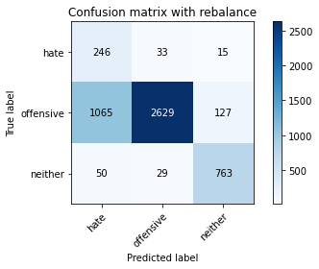

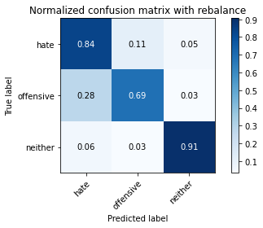

precision recall f1-score support

hate 0.18 0.84 0.30 294

offensive 0.98 0.69 0.81 3821

neither 0.84 0.91 0.87 842

accuracy 0.73 4957

macro avg 0.67 0.81 0.66 4957

weighted avg 0.91 0.73 0.79 4957

average eval_loss: 0.785873934098955, accuracy: 0.7339116401049022

training 7 epoch...

29.37165665626526 seconds used......

7 training finished! average train loss: 0.0611674285089401

evaluating...

Confusion matrix, without normalization

[[ 227 45 22]

[ 911 2731 179]

[ 36 23 783]]

Normalized confusion matrix

[[0.77210884 0.15306122 0.07482993]

[0.23841926 0.71473436 0.04684638]

[0.04275534 0.02731591 0.92992874]]

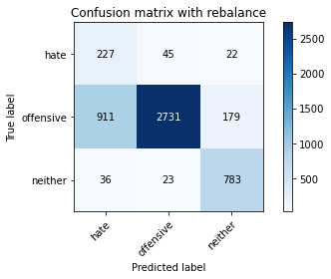

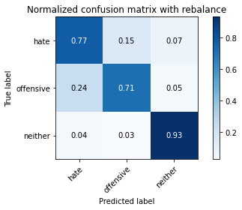

precision recall f1-score support

hate 0.19 0.77 0.31 294

offensive 0.98 0.71 0.83 3821

neither 0.80 0.93 0.86 842

accuracy 0.75 4957

macro avg 0.65 0.81 0.66 4957

weighted avg 0.90 0.75 0.80 4957

average eval_loss: 0.8709492487156943, accuracy: 0.7546903368973169

training 8 epoch...

29.302159309387207 seconds used......

8 training finished! average train loss: 0.04890929948135513

evaluating...

Confusion matrix, without normalization

[[ 232 50 12]

[ 816 2921 84]

[ 64 65 713]]

Normalized confusion matrix

[[0.78911565 0.17006803 0.04081633]

[0.21355666 0.76445957 0.02198377]

[0.0760095 0.07719715 0.84679335]]

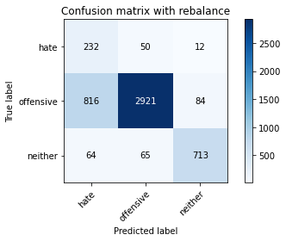

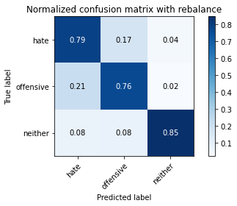

precision recall f1-score support

hate 0.21 0.79 0.33 294

offensive 0.96 0.76 0.85 3821

neither 0.88 0.85 0.86 842

accuracy 0.78 4957

macro avg 0.68 0.80 0.68 4957

weighted avg 0.90 0.78 0.82 4957

average eval_loss: 0.8373321894041803, accuracy: 0.7799072019366552

training 9 epoch...

29.288248538970947 seconds used......

9 training finished! average train loss: 0.03572774130431663

evaluating...

Confusion matrix, without normalization

[[ 223 42 29]

[ 831 2835 155]

[ 43 21 778]]

Normalized confusion matrix

[[0.7585034 0.14285714 0.09863946]

[0.21748233 0.74195237 0.0405653 ]

[0.05106888 0.02494062 0.9239905 ]]

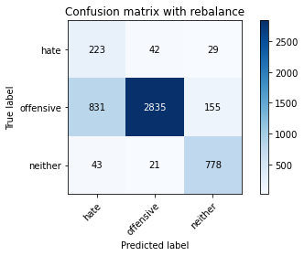

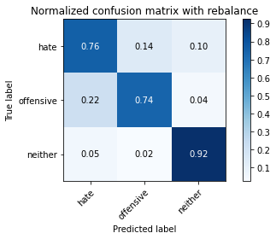

precision recall f1-score support

hate 0.20 0.76 0.32 294

offensive 0.98 0.74 0.84 3821

neither 0.81 0.92 0.86 842

accuracy 0.77 4957

macro avg 0.66 0.81 0.68 4957

weighted avg 0.90 0.77 0.82 4957

average eval_loss: 0.9089226998762423, accuracy: 0.7738551543272141

training 10 epoch...

29.33260488510132 seconds used......

10 training finished! average train loss: 0.035542157485098064

evaluating...

Confusion matrix, without normalization

[[ 243 34 17]

[1028 2667 126]

[ 68 28 746]]

Normalized confusion matrix

[[0.82653061 0.11564626 0.05782313]

[0.26903952 0.69798482 0.03297566]

[0.0807601 0.03325416 0.88598575]]

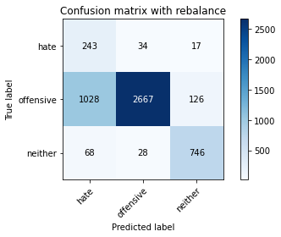

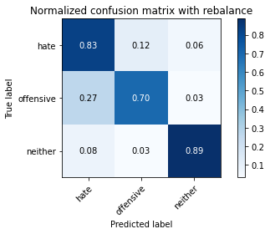

precision recall f1-score support

hate 0.18 0.83 0.30 294

offensive 0.98 0.70 0.81 3821

neither 0.84 0.89 0.86 842

accuracy 0.74 4957

macro avg 0.67 0.80 0.66 4957

weighted avg 0.91 0.74 0.79 4957

average eval_loss: 1.073448001985408, accuracy: 0.7375428686705668

3 run

training 1 epoch...

29.24281334877014 seconds used......

1 training finished! average train loss: 0.6119935567006033

evaluating...

Confusion matrix, without normalization

[[ 253 27 14]

[1440 2262 119]

[ 94 9 739]]

Normalized confusion matrix

[[0.86054422 0.09183673 0.04761905]

[0.3768647 0.59199163 0.03114368]

[0.11163895 0.01068884 0.87767221]]

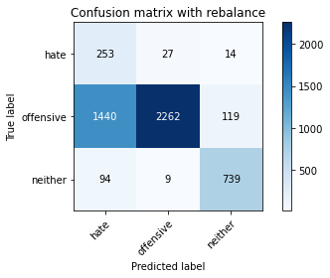

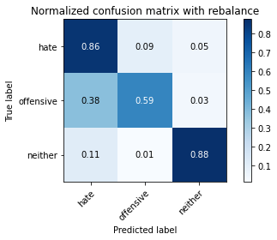

precision recall f1-score support

hate 0.14 0.86 0.24 294

offensive 0.98 0.59 0.74 3821

neither 0.85 0.88 0.86 842

accuracy 0.66 4957

macro avg 0.66 0.78 0.61 4957

weighted avg 0.91 0.66 0.73 4957

average eval_loss: 0.6979261811582311, accuracy: 0.6564454307040549

training 2 epoch...

29.34972333908081 seconds used......

2 training finished! average train loss: 0.3350996357219958

evaluating...

Confusion matrix, without normalization

[[ 251 31 12]

[1093 2594 134]

[ 75 8 759]]

Normalized confusion matrix

[[0.8537415 0.10544218 0.04081633]

[0.28605077 0.67887987 0.03506935]

[0.08907363 0.00950119 0.90142518]]

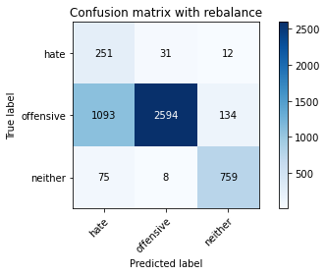

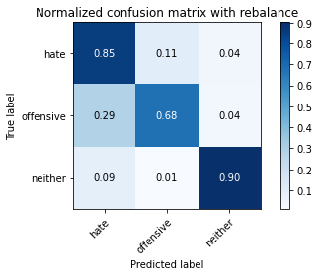

precision recall f1-score support

hate 0.18 0.85 0.29 294

offensive 0.99 0.68 0.80 3821

neither 0.84 0.90 0.87 842

accuracy 0.73 4957

macro avg 0.67 0.81 0.66 4957

weighted avg 0.91 0.73 0.78 4957

average eval_loss: 0.6646074511170867, accuracy: 0.7270526528142022

training 3 epoch...

29.25202465057373 seconds used......

3 training finished! average train loss: 0.22010358442601405

evaluating...

Confusion matrix, without normalization

[[ 248 32 14]

[1126 2585 110]

[ 70 17 755]]

Normalized confusion matrix

[[0.84353741 0.10884354 0.04761905]

[0.29468725 0.67652447 0.02878828]

[0.08313539 0.02019002 0.89667458]]

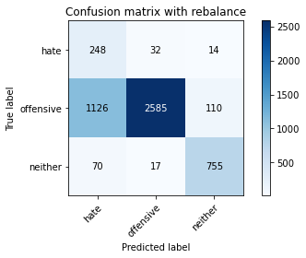

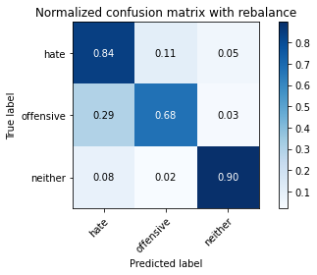

precision recall f1-score support

hate 0.17 0.84 0.29 294

offensive 0.98 0.68 0.80 3821

neither 0.86 0.90 0.88 842

accuracy 0.72 4957

macro avg 0.67 0.81 0.65 4957

weighted avg 0.91 0.72 0.78 4957

average eval_loss: 0.570453054211553, accuracy: 0.7238248940891668

training 4 epoch...

29.167468309402466 seconds used......

4 training finished! average train loss: 0.14503600952700216

evaluating...

Confusion matrix, without normalization

[[ 243 30 21]

[1345 2317 159]

[ 47 18 777]]

Normalized confusion matrix

[[0.82653061 0.10204082 0.07142857]

[0.35200209 0.60638576 0.04161214]

[0.05581948 0.02137767 0.92280285]]

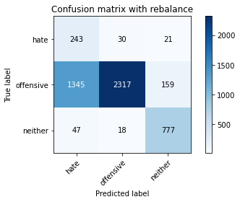

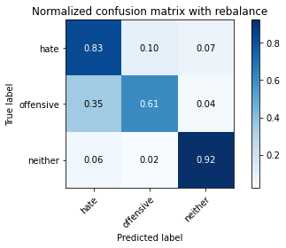

precision recall f1-score support

hate 0.15 0.83 0.25 294

offensive 0.98 0.61 0.75 3821

neither 0.81 0.92 0.86 842

accuracy 0.67 4957

macro avg 0.65 0.79 0.62 4957

weighted avg 0.90 0.67 0.74 4957

average eval_loss: 0.7146345851942897, accuracy: 0.6731894290901755

training 5 epoch...

29.254173517227173 seconds used......

5 training finished! average train loss: 0.10457268878490779

evaluating...

Confusion matrix, without normalization

[[ 250 26 18]

[1369 2252 200]

[ 51 17 774]]

Normalized confusion matrix

[[0.85034014 0.08843537 0.06122449]

[0.35828317 0.58937451 0.05234232]

[0.06057007 0.02019002 0.9192399 ]]

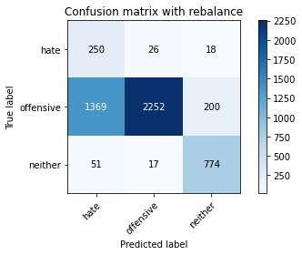

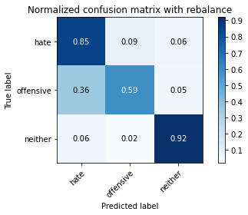

precision recall f1-score support

hate 0.15 0.85 0.25 294

offensive 0.98 0.59 0.74 3821

neither 0.78 0.92 0.84 842

accuracy 0.66 4957

macro avg 0.64 0.79 0.61 4957

weighted avg 0.90 0.66 0.73 4957

average eval_loss: 0.9052533224946068, accuracy: 0.6608835989509784

training 6 epoch...

29.42637348175049 seconds used......

6 training finished! average train loss: 0.07077926689519258

evaluating...

Confusion matrix, without normalization

[[ 253 29 12]

[1417 2278 126]

[ 63 27 752]]

Normalized confusion matrix

[[0.86054422 0.09863946 0.04081633]

[0.37084533 0.59617901 0.03297566]

[0.07482185 0.03206651 0.89311164]]

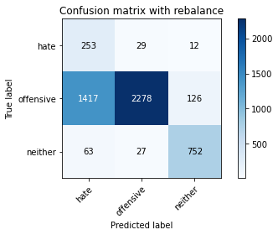

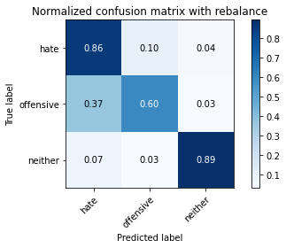

precision recall f1-score support

hate 0.15 0.86 0.25 294

offensive 0.98 0.60 0.74 3821

neither 0.84 0.89 0.87 842

accuracy 0.66 4957

macro avg 0.66 0.78 0.62 4957

weighted avg 0.90 0.66 0.73 4957

average eval_loss: 1.058973986647963, accuracy: 0.6622957433931813

training 7 epoch...

29.278716802597046 seconds used......

7 training finished! average train loss: 0.05067182219265933

evaluating...

Confusion matrix, without normalization

[[ 216 66 12]

[ 570 3144 107]

[ 40 67 735]]

Normalized confusion matrix

[[0.73469388 0.2244898 0.04081633]

[0.14917561 0.82282125 0.02800314]

[0.04750594 0.07957245 0.87292162]]

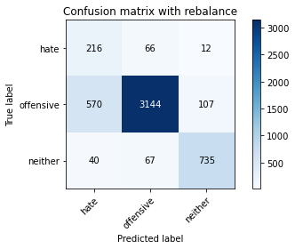

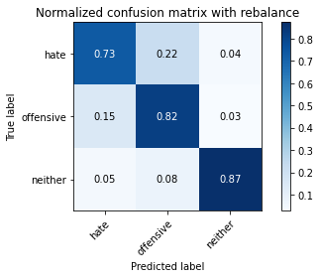

precision recall f1-score support

hate 0.26 0.73 0.39 294

offensive 0.96 0.82 0.89 3821

neither 0.86 0.87 0.87 842

accuracy 0.83 4957

macro avg 0.69 0.81 0.71 4957

weighted avg 0.90 0.83 0.85 4957

average eval_loss: 0.6968714220227764, accuracy: 0.826104498688723

training 8 epoch...

29.256478309631348 seconds used......

8 training finished! average train loss: 0.0375436849671563

evaluating...

Confusion matrix, without normalization

[[ 216 64 14]

[ 690 2989 142]

[ 55 36 751]]

Normalized confusion matrix

[[0.73469388 0.21768707 0.04761905]

[0.180581 0.78225595 0.03716305]

[0.06532067 0.04275534 0.89192399]]

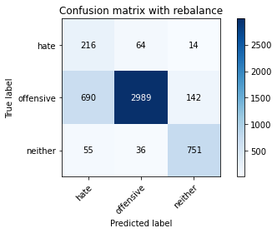

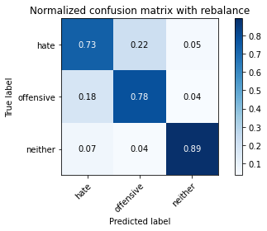

precision recall f1-score support

hate 0.22 0.73 0.34 294

offensive 0.97 0.78 0.87 3821

neither 0.83 0.89 0.86 842

accuracy 0.80 4957

macro avg 0.67 0.80 0.69 4957

weighted avg 0.90 0.80 0.83 4957

average eval_loss: 0.741721923758779, accuracy: 0.7980633447649789

training 9 epoch...

29.253055334091187 seconds used......

9 training finished! average train loss: 0.03172926449595422

evaluating...

Confusion matrix, without normalization

[[ 226 53 15]

[ 906 2799 116]

[ 51 51 740]]

Normalized confusion matrix

[[0.76870748 0.18027211 0.05102041]

[0.2371107 0.73253075 0.03035854]

[0.06057007 0.06057007 0.87885986]]

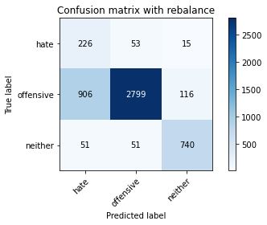

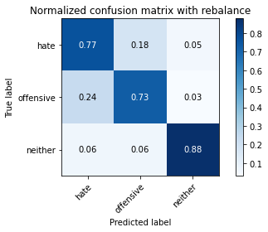

precision recall f1-score support

hate 0.19 0.77 0.31 294

offensive 0.96 0.73 0.83 3821

neither 0.85 0.88 0.86 842

accuracy 0.76 4957

macro avg 0.67 0.79 0.67 4957

weighted avg 0.90 0.76 0.81 4957

average eval_loss: 0.9151827075834116, accuracy: 0.7595319749848699

training 10 epoch...

29.184383869171143 seconds used......

10 training finished! average train loss: 0.022326455281009863

evaluating...

Confusion matrix, without normalization

[[ 235 45 14]

[ 904 2762 155]

[ 67 34 741]]

Normalized confusion matrix

[[0.79931973 0.15306122 0.04761905]

[0.23658728 0.72284742 0.0405653 ]

[0.07957245 0.04038005 0.88004751]]

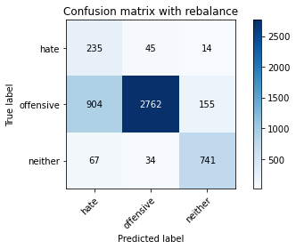

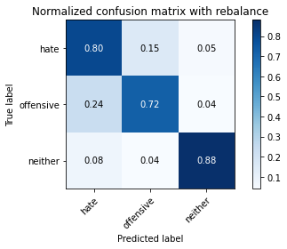

precision recall f1-score support

hate 0.19 0.80 0.31 294

offensive 0.97 0.72 0.83 3821

neither 0.81 0.88 0.85 842

accuracy 0.75 4957

macro avg 0.66 0.80 0.66 4957

weighted avg 0.90 0.75 0.80 4957

average eval_loss: 1.0658425152087734, accuracy: 0.7540851321363728

4 run

training 1 epoch...

29.249839305877686 seconds used......

1 training finished! average train loss: 0.5851466349865261

evaluating...

Confusion matrix, without normalization

[[ 229 34 31]

[ 894 2715 212]

[ 30 11 801]]

Normalized confusion matrix

[[0.77891156 0.11564626 0.10544218]

[0.23397016 0.71054698 0.05548286]

[0.03562945 0.01306413 0.95130641]]

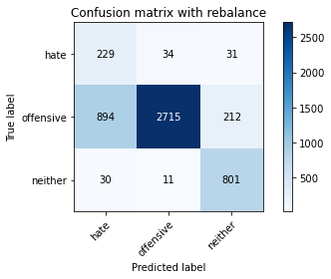

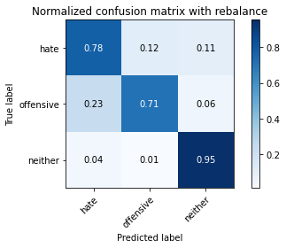

precision recall f1-score support

hate 0.20 0.78 0.32 294

offensive 0.98 0.71 0.83 3821

neither 0.77 0.95 0.85 842

accuracy 0.76 4957

macro avg 0.65 0.81 0.66 4957

weighted avg 0.90 0.76 0.80 4957

average eval_loss: 0.5468217490180847, accuracy: 0.7554972765785758

training 2 epoch...

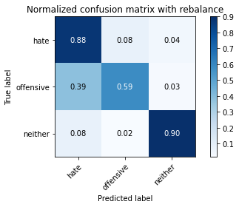

precision recall f1-score support

hate 0.14 0.88 0.25 294

offensive 0.98 0.59 0.74 3821

neither 0.87 0.90 0.88 842

accuracy 0.66 4957

macro avg 0.67 0.79 0.62 4957

weighted avg 0.91 0.66 0.73 4957

average eval_loss: 0.83186124920124, accuracy: 0.6582610449868872

training 5 epoch...

29.346136569976807 seconds used......

5 training finished! average train loss: 0.08236619539161305

evaluating...

Confusion matrix, without normalization

[[ 243 36 15]

[1088 2599 134]

[ 62 18 762]]

Normalized confusion matrix

[[0.82653061 0.12244898 0.05102041]

[0.28474221 0.68018843 0.03506935]

[0.0736342 0.02137767 0.90498812]]

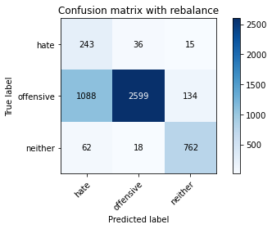

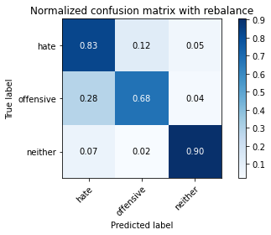

precision recall f1-score support

hate 0.17 0.83 0.29 294

offensive 0.98 0.68 0.80 3821

neither 0.84 0.90 0.87 842

accuracy 0.73 4957

macro avg 0.66 0.80 0.65 4957

weighted avg 0.91 0.73 0.78 4957

average eval_loss: 0.8830712645675146, accuracy: 0.7270526528142022

training 6 epoch...

29.32203507423401 seconds used......

6 training finished! average train loss: 0.06834982515024075

evaluating...

Confusion matrix, without normalization

[[ 241 42 11]

[ 889 2852 80]

[ 63 60 719]]

Normalized confusion matrix

[[0.81972789 0.14285714 0.03741497]

[0.23266161 0.74640147 0.02093693]

[0.07482185 0.07125891 0.85391924]]

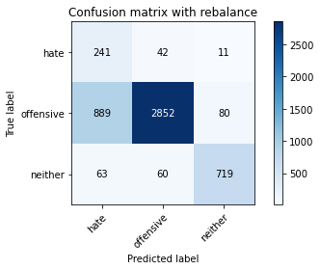

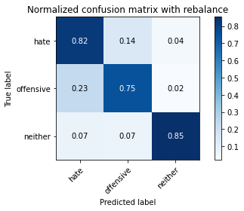

precision recall f1-score support

hate 0.20 0.82 0.32 294

offensive 0.97 0.75 0.84 3821

neither 0.89 0.85 0.87 842

accuracy 0.77 4957

macro avg 0.69 0.81 0.68 4957

weighted avg 0.91 0.77 0.82 4957

average eval_loss: 0.79328647227357, accuracy: 0.7690135162396611

training 7 epoch...

29.26347303390503 seconds used......

7 training finished! average train loss: 0.045471069665778185

evaluating...

Confusion matrix, without normalization

[[ 233 48 13]

[ 863 2897 61]

[ 61 74 707]]

Normalized confusion matrix

[[0.79251701 0.16326531 0.04421769]

[0.22585711 0.75817849 0.01596441]

[0.07244656 0.08788599 0.83966746]]

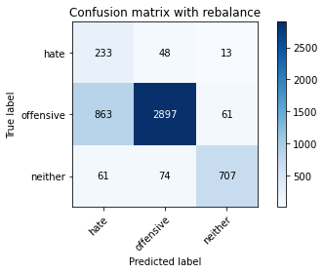

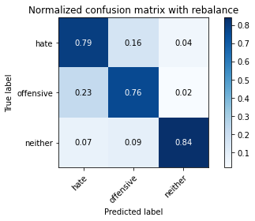

precision recall f1-score support

hate 0.20 0.79 0.32 294

offensive 0.96 0.76 0.85 3821

neither 0.91 0.84 0.87 842

accuracy 0.77 4957

macro avg 0.69 0.80 0.68 4957

weighted avg 0.91 0.77 0.82 4957

average eval_loss: 0.9259468739394159, accuracy: 0.7740568892475288

training 8 epoch...

29.206382274627686 seconds used......

8 training finished! average train loss: 0.037350118276663125

evaluating...

Confusion matrix, without normalization

[[ 222 55 17]

[ 786 2896 139]

[ 46 23 773]]

Normalized confusion matrix

[[0.75510204 0.18707483 0.05782313]

[0.20570531 0.75791678 0.03637791]

[0.05463183 0.02731591 0.91805226]]

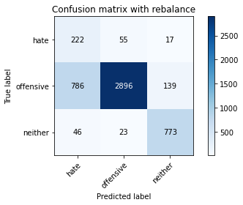

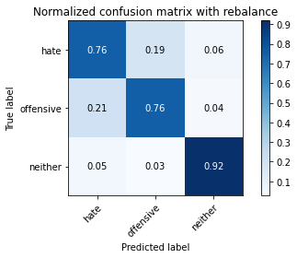

precision recall f1-score support

hate 0.21 0.76 0.33 294

offensive 0.97 0.76 0.85 3821

neither 0.83 0.92 0.87 842

accuracy 0.78 4957

macro avg 0.67 0.81 0.68 4957

weighted avg 0.90 0.78 0.82 4957

average eval_loss: 0.8060212336995098, accuracy: 0.7849505749445229

training 9 epoch...

29.385398626327515 seconds used......

9 training finished! average train loss: 0.035728889055909555

evaluating...

Confusion matrix, without normalization

[[ 232 49 13]

[ 861 2853 107]

[ 70 22 750]]

Normalized confusion matrix

[[0.78911565 0.16666667 0.04421769]

[0.22533368 0.74666318 0.02800314]

[0.08313539 0.02612827 0.89073634]]

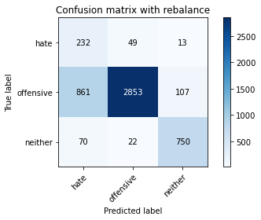

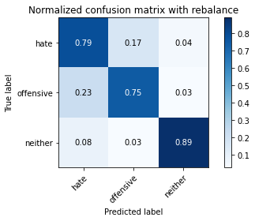

precision recall f1-score support

hate 0.20 0.79 0.32 294

offensive 0.98 0.75 0.85 3821

neither 0.86 0.89 0.88 842

accuracy 0.77 4957

macro avg 0.68 0.81 0.68 4957

weighted avg 0.91 0.77 0.82 4957

average eval_loss: 0.9584031125545622, accuracy: 0.7736534194068994

training 10 epoch...

29.29046940803528 seconds used......

10 training finished! average train loss: 0.03560116449616065

evaluating...

Confusion matrix, without normalization

[[ 212 56 26]

[ 705 2918 198]

[ 33 25 784]]

Normalized confusion matrix

[[0.72108844 0.19047619 0.08843537]

[0.18450667 0.76367443 0.0518189 ]

[0.0391924 0.02969121 0.93111639]]

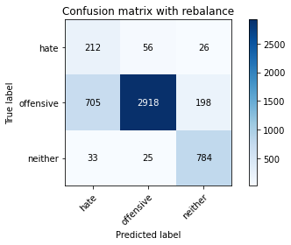

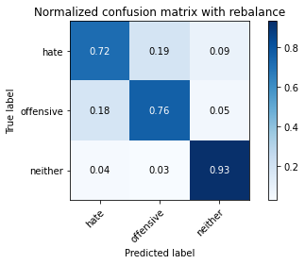

precision recall f1-score support

hate 0.22 0.72 0.34 294

offensive 0.97 0.76 0.86 3821

neither 0.78 0.93 0.85 842

accuracy 0.79 4957

macro avg 0.66 0.81 0.68 4957

weighted avg 0.90 0.79 0.82 4957

average eval_loss: 0.9615463178488426, accuracy: 0.7895904781117612

5 run

training 1 epoch...

29.156676054000854 seconds used......

1 training finished! average train loss: 0.5804832598619294

evaluating...

Confusion matrix, without normalization

[[ 251 15 28]

[1958 1682 181]

[ 62 5 775]]

Normalized confusion matrix

[[0.8537415 0.05102041 0.0952381 ]

[0.5124313 0.4401989 0.0473698 ]

[0.0736342 0.00593824 0.92042755]]

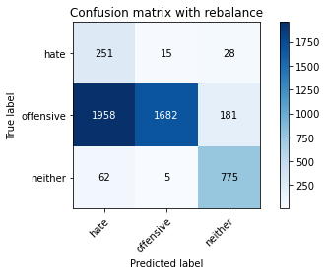

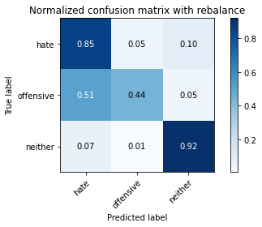

precision recall f1-score support

hate 0.11 0.85 0.20 294

offensive 0.99 0.44 0.61 3821

neither 0.79 0.92 0.85 842

accuracy 0.55 4957

macro avg 0.63 0.74 0.55 4957

weighted avg 0.90 0.55 0.63 4957

average eval_loss: 0.8490887942814058, accuracy: 0.5462981642122251

training 2 epoch...

28.176913738250732 seconds used......

2 training finished! average train loss: 0.31562746307480405

evaluating...

Confusion matrix, without normalization

[[ 260 19 15]

[1629 2086 106]

[ 84 10 748]]

Normalized confusion matrix

[[0.88435374 0.06462585 0.05102041]

[0.42632819 0.54593038 0.02774143]

[0.09976247 0.01187648 0.88836105]]

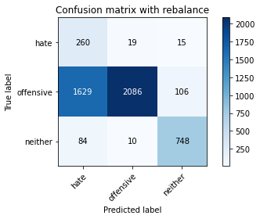

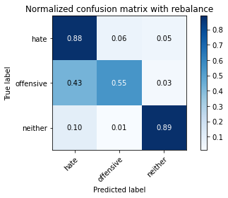

precision recall f1-score support

hate 0.13 0.88 0.23 294

offensive 0.99 0.55 0.70 3821

neither 0.86 0.89 0.87 842

accuracy 0.62 4957

macro avg 0.66 0.77 0.60 4957

weighted avg 0.91 0.62 0.70 4957

average eval_loss: 0.7584497520640012, accuracy: 0.6241678434537018

training 3 epoch...

28.147745847702026 seconds used......

3 training finished! average train loss: 0.19430949961581426

evaluating...

Confusion matrix, without normalization

[[ 257 22 15]

[1726 1962 133]

[ 59 12 771]]

Normalized confusion matrix

[[0.87414966 0.07482993 0.05102041]

[0.45171421 0.51347815 0.03480764]

[0.07007126 0.01425178 0.91567696]]

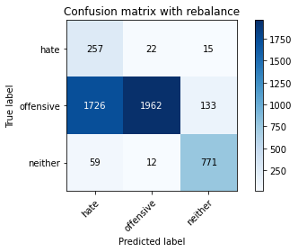

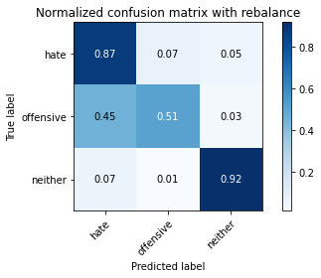

precision recall f1-score support

hate 0.13 0.87 0.22 294

offensive 0.98 0.51 0.67 3821

neither 0.84 0.92 0.88 842

accuracy 0.60 4957

macro avg 0.65 0.77 0.59 4957

weighted avg 0.91 0.60 0.68 4957

average eval_loss: 0.8449019643087541, accuracy: 0.6031874117409723

training 4 epoch...

28.131025314331055 seconds used......

4 training finished! average train loss: 0.12722333947643202

evaluating...

Confusion matrix, without normalization

[[ 244 29 21]

[1301 2346 174]

[ 49 11 782]]

Normalized confusion matrix

[[0.82993197 0.09863946 0.07142857]

[0.34048678 0.6139754 0.04553782]

[0.05819477 0.01306413 0.92874109]]

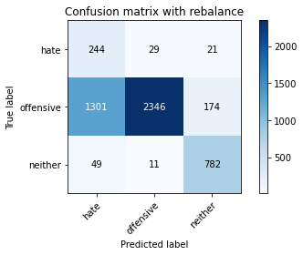

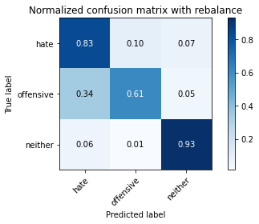

precision recall f1-score support

hate 0.15 0.83 0.26 294

offensive 0.98 0.61 0.76 3821

neither 0.80 0.93 0.86 842

accuracy 0.68 4957

macro avg 0.65 0.79 0.62 4957

weighted avg 0.90 0.68 0.74 4957

average eval_loss: 0.8355861377091177, accuracy: 0.6802501513011903

training 5 epoch...

28.049774646759033 seconds used......

5 training finished! average train loss: 0.08855331916503652

evaluating...

Confusion matrix, without normalization

[[ 236 42 16]

[ 983 2730 108]

[ 65 22 755]]

Normalized confusion matrix

[[0.80272109 0.14285714 0.05442177]

[0.2572625 0.71447265 0.02826485]

[0.07719715 0.02612827 0.89667458]]

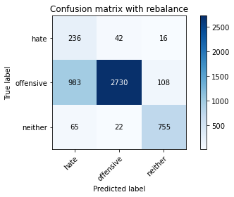

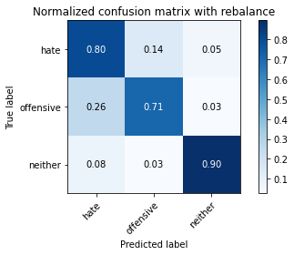

precision recall f1-score support

hate 0.18 0.80 0.30 294

offensive 0.98 0.71 0.83 3821

neither 0.86 0.90 0.88 842

accuracy 0.75 4957

macro avg 0.67 0.80 0.67 4957

weighted avg 0.91 0.75 0.80 4957

average eval_loss: 0.7508391630460298, accuracy: 0.7506556384910228

training 6 epoch...

28.044334411621094 seconds used......

6 training finished! average train loss: 0.08131487742992259

evaluating...

Confusion matrix, without normalization

[[ 241 40 13]

[1036 2666 119]

[ 87 34 721]]

Normalized confusion matrix

[[0.81972789 0.13605442 0.04421769]

[0.27113321 0.69772311 0.03114368]

[0.10332542 0.04038005 0.85629454]]

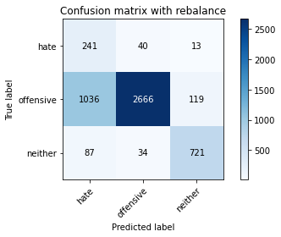

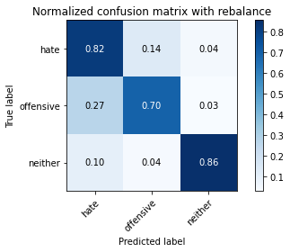

precision recall f1-score support

hate 0.18 0.82 0.29 294

offensive 0.97 0.70 0.81 3821

neither 0.85 0.86 0.85 842

accuracy 0.73 4957

macro avg 0.66 0.79 0.65 4957

weighted avg 0.90 0.73 0.79 4957

average eval_loss: 0.7408286707415697, accuracy: 0.7318942909017551

training 7 epoch...

28.019493103027344 seconds used......

7 training finished! average train loss: 0.04284772172717279

evaluating...

Confusion matrix, without normalization

[[ 240 42 12]

[ 937 2773 111]

[ 70 35 737]]

Normalized confusion matrix

[[0.81632653 0.14285714 0.04081633]

[0.24522376 0.72572625 0.02904999]

[0.08313539 0.0415677 0.87529691]]

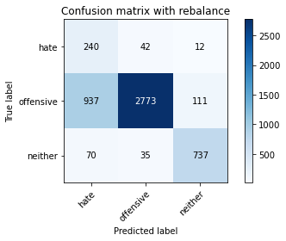

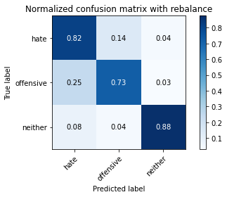

precision recall f1-score support

hate 0.19 0.82 0.31 294

offensive 0.97 0.73 0.83 3821

neither 0.86 0.88 0.87 842

accuracy 0.76 4957

macro avg 0.67 0.81 0.67 4957

weighted avg 0.91 0.76 0.81 4957

average eval_loss: 0.8830117948340147, accuracy: 0.7565059511801493

training 8 epoch...

28.096855640411377 seconds used......

8 training finished! average train loss: 0.02336853674179956

evaluating...

Confusion matrix, without normalization

[[ 238 42 14]

[ 949 2748 124]

[ 70 25 747]]

Normalized confusion matrix

[[0.80952381 0.14285714 0.04761905]

[0.2483643 0.71918346 0.03245224]

[0.08313539 0.02969121 0.8871734 ]]

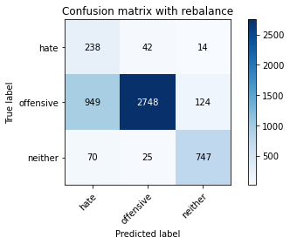

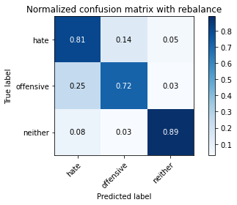

precision recall f1-score support

hate 0.19 0.81 0.31 294

offensive 0.98 0.72 0.83 3821

neither 0.84 0.89 0.87 842

accuracy 0.75 4957

macro avg 0.67 0.81 0.67 4957

weighted avg 0.91 0.75 0.80 4957

average eval_loss: 0.9991610859081359, accuracy: 0.7530764575347992

training 9 epoch...

28.091245412826538 seconds used......

9 training finished! average train loss: 0.016751138246972223

evaluating...

Confusion matrix, without normalization

[[ 228 47 19]

[ 891 2778 152]

[ 52 16 774]]

Normalized confusion matrix

[[0.7755102 0.15986395 0.06462585]

[0.23318503 0.72703481 0.03978016]

[0.06175772 0.01900238 0.9192399 ]]

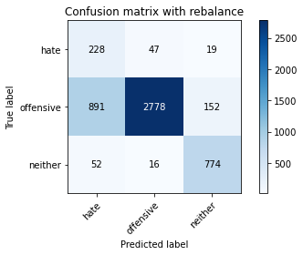

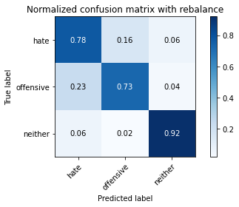

precision recall f1-score support

hate 0.19 0.78 0.31 294

offensive 0.98 0.73 0.83 3821

neither 0.82 0.92 0.87 842

accuracy 0.76 4957

macro avg 0.66 0.81 0.67 4957

weighted avg 0.90 0.76 0.81 4957

average eval_loss: 1.0352668921620916, accuracy: 0.7625579987895905

training 10 epoch...

28.2251935005188 seconds used......

10 training finished! average train loss: 0.03521071223621066

evaluating...

Confusion matrix, without normalization

[[ 228 50 16]

[ 749 2961 111]

[ 61 39 742]]

Normalized confusion matrix

[[0.7755102 0.17006803 0.05442177]

[0.19602198 0.77492803 0.02904999]

[0.07244656 0.04631829 0.88123515]]

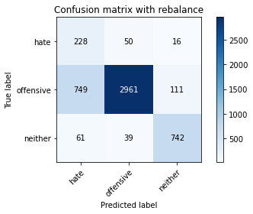

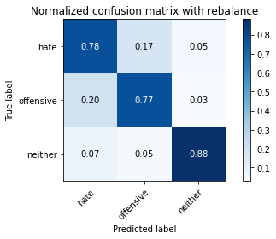

precision recall f1-score support

hate 0.22 0.78 0.34 294

offensive 0.97 0.77 0.86 3821

neither 0.85 0.88 0.87 842

accuracy 0.79 4957

macro avg 0.68 0.81 0.69 4957

weighted avg 0.91 0.79 0.83 4957

average eval_loss: 0.9076221858882608, accuracy: 0.7930199717571111