1 run

[1.2,0.6,1]

training 1 epoch...

29.95697832107544 seconds used......

1 training finished! average train loss: 0.644914540892456

evaluating...

Confusion matrix, without normalization

[[ 233 37 24]

[ 897 2782 142]

[ 55 13 774]]

Normalized confusion matrix

[[0.79251701 0.12585034 0.08163265]

[0.2347553 0.72808165 0.03716305]

[0.06532067 0.01543943 0.9192399 ]]

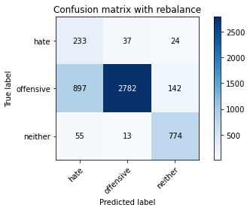

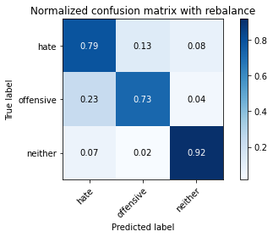

precision recall f1-score support

hate 0.20 0.79 0.32 294

offensive 0.98 0.73 0.84 3821

neither 0.82 0.92 0.87 842

accuracy 0.76 4957

macro avg 0.67 0.81 0.67 4957

weighted avg 0.91 0.76 0.81 4957

average eval_loss: 0.5578029932634484, accuracy: 0.7643736130724228

training 2 epoch...

29.240722179412842 seconds used......

2 training finished! average train loss: 0.3887593117025163

evaluating...

Confusion matrix, without normalization

[[ 226 47 21]

[ 732 2956 133]

[ 41 15 786]]

Normalized confusion matrix

[[0.76870748 0.15986395 0.07142857]

[0.19157289 0.77361947 0.03480764]

[0.04869359 0.01781473 0.93349169]]

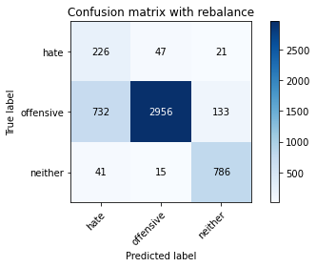

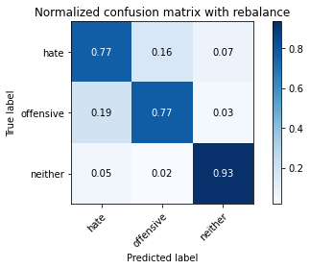

precision recall f1-score support

hate 0.23 0.77 0.35 294

offensive 0.98 0.77 0.86 3821

neither 0.84 0.93 0.88 842

accuracy 0.80 4957

macro avg 0.68 0.83 0.70 4957

weighted avg 0.91 0.80 0.84 4957

average eval_loss: 0.4465040080850163, accuracy: 0.8004841638087553

training 3 epoch...

29.21203088760376 seconds used......

3 training finished! average train loss: 0.2512700556183768

evaluating...

Confusion matrix, without normalization

[[ 247 34 13]

[1126 2572 123]

[ 60 15 767]]

Normalized confusion matrix

[[0.84013605 0.11564626 0.04421769]

[0.29468725 0.67312222 0.03219053]

[0.07125891 0.01781473 0.91092637]]

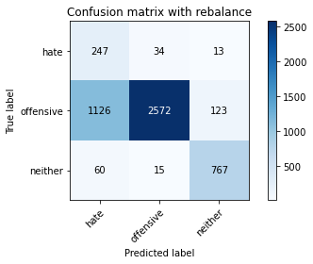

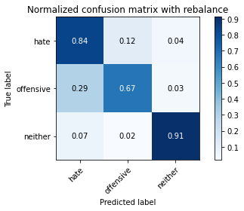

precision recall f1-score support

hate 0.17 0.84 0.29 294

offensive 0.98 0.67 0.80 3821

neither 0.85 0.91 0.88 842

accuracy 0.72 4957

macro avg 0.67 0.81 0.65 4957

weighted avg 0.91 0.72 0.78 4957

average eval_loss: 0.714294578489517, accuracy: 0.7234214242485374

training 4 epoch...

29.209216833114624 seconds used......

4 training finished! average train loss: 0.14596462891333634

evaluating...

Confusion matrix, without normalization

[[ 253 31 10]

[1306 2431 84]

[ 109 23 710]]

Normalized confusion matrix

[[0.86054422 0.10544218 0.03401361]

[0.34179534 0.63622088 0.02198377]

[0.12945368 0.02731591 0.8432304 ]]

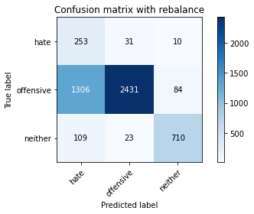

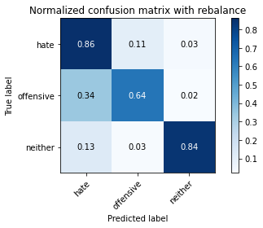

precision recall f1-score support

hate 0.15 0.86 0.26 294

offensive 0.98 0.64 0.77 3821

neither 0.88 0.84 0.86 842

accuracy 0.68 4957

macro avg 0.67 0.78 0.63 4957

weighted avg 0.91 0.68 0.76 4957

average eval_loss: 0.973485482255778, accuracy: 0.6846883195481138

training 5 epoch...

29.294915914535522 seconds used......

5 training finished! average train loss: 0.08742712051417047

evaluating...

Confusion matrix, without normalization

[[ 225 56 13]

[ 776 2946 99]

[ 62 35 745]]

Normalized confusion matrix

[[0.76530612 0.19047619 0.04421769]

[0.2030882 0.77100236 0.02590945]

[0.0736342 0.0415677 0.8847981 ]]

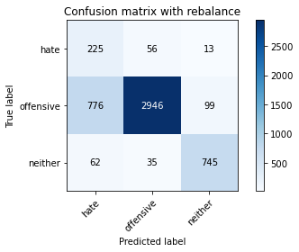

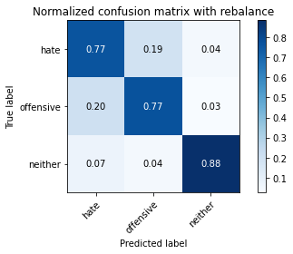

precision recall f1-score support

hate 0.21 0.77 0.33 294

offensive 0.97 0.77 0.86 3821

neither 0.87 0.88 0.88 842

accuracy 0.79 4957

macro avg 0.68 0.81 0.69 4957

weighted avg 0.91 0.79 0.83 4957

average eval_loss: 0.6469575010179993, accuracy: 0.7899939479523905

training 6 epoch...

29.198303937911987 seconds used......

6 training finished! average train loss: 0.057752047117380155

evaluating...

Confusion matrix, without normalization

[[ 235 45 14]

[ 840 2851 130]

[ 60 20 762]]

Normalized confusion matrix

[[0.79931973 0.15306122 0.04761905]

[0.21983774 0.74613975 0.03402251]

[0.07125891 0.02375297 0.90498812]]

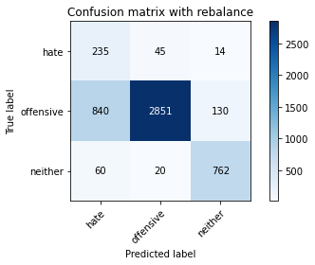

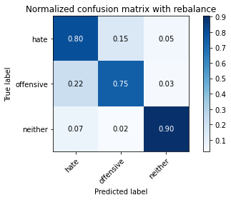

precision recall f1-score support

hate 0.21 0.80 0.33 294

offensive 0.98 0.75 0.85 3821

neither 0.84 0.90 0.87 842

accuracy 0.78 4957

macro avg 0.68 0.82 0.68 4957

weighted avg 0.91 0.78 0.82 4957

average eval_loss: 0.902626169214566, accuracy: 0.7762759733709905

training 7 epoch...

29.20504140853882 seconds used......

7 training finished! average train loss: 0.031003010310150944

evaluating...

Confusion matrix, without normalization

[[ 216 58 20]

[ 730 2946 145]

[ 45 23 774]]

Normalized confusion matrix

[[0.73469388 0.19727891 0.06802721]

[0.19104946 0.77100236 0.03794818]

[0.05344418 0.02731591 0.9192399 ]]

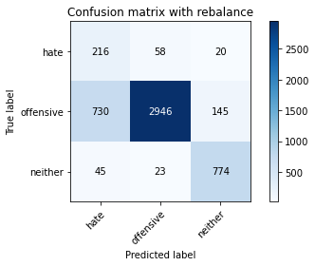

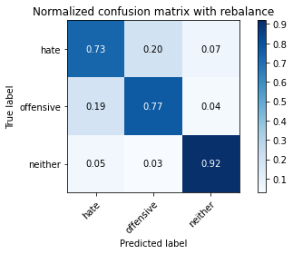

precision recall f1-score support

hate 0.22 0.73 0.34 294

offensive 0.97 0.77 0.86 3821

neither 0.82 0.92 0.87 842

accuracy 0.79 4957

macro avg 0.67 0.81 0.69 4957

weighted avg 0.90 0.79 0.83 4957

average eval_loss: 0.8673931525967594, accuracy: 0.7940286463586846

training 8 epoch...

29.221789121627808 seconds used......

8 training finished! average train loss: 0.023394762823965444

evaluating...

Confusion matrix, without normalization

[[ 219 60 15]

[ 685 3029 107]

[ 54 51 737]]

Normalized confusion matrix

[[0.74489796 0.20408163 0.05102041]

[0.17927244 0.79272442 0.02800314]

[0.06413302 0.06057007 0.87529691]]

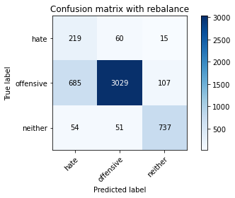

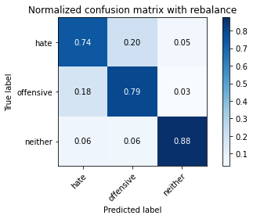

precision recall f1-score support

hate 0.23 0.74 0.35 294

offensive 0.96 0.79 0.87 3821

neither 0.86 0.88 0.87 842

accuracy 0.80 4957

macro avg 0.68 0.80 0.70 4957

weighted avg 0.90 0.80 0.84 4957

average eval_loss: 0.9345083158517692, accuracy: 0.8039136574541053

training 9 epoch...

29.21642279624939 seconds used......

9 training finished! average train loss: 0.011824236179590334

evaluating...

Confusion matrix, without normalization

[[ 231 48 15]

[ 904 2785 132]

[ 58 25 759]]

Normalized confusion matrix

[[0.78571429 0.16326531 0.05102041]

[0.23658728 0.72886679 0.03454593]

[0.06888361 0.02969121 0.90142518]]

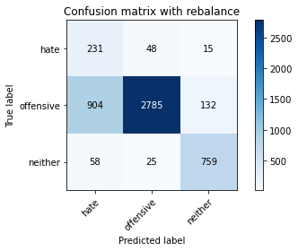

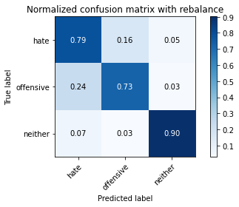

precision recall f1-score support

hate 0.19 0.79 0.31 294

offensive 0.97 0.73 0.83 3821

neither 0.84 0.90 0.87 842

accuracy 0.76 4957

macro avg 0.67 0.81 0.67 4957

weighted avg 0.90 0.76 0.81 4957

average eval_loss: 1.2561582478904916, accuracy: 0.7615493241880169

training 10 epoch...

29.2250657081604 seconds used......

10 training finished! average train loss: 0.0293772617405708

evaluating...

Confusion matrix, without normalization

[[ 231 48 15]

[ 897 2784 140]

[ 58 18 766]]

Normalized confusion matrix

[[0.78571429 0.16326531 0.05102041]

[0.2347553 0.72860508 0.03663962]

[0.06888361 0.02137767 0.90973872]]

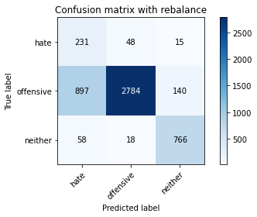

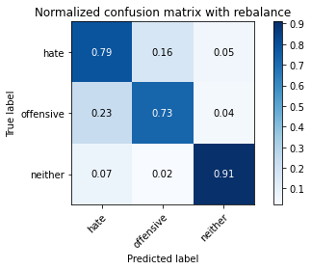

precision recall f1-score support

hate 0.19 0.79 0.31 294

offensive 0.98 0.73 0.83 3821

neither 0.83 0.91 0.87 842

accuracy 0.76 4957

macro avg 0.67 0.81 0.67 4957

weighted avg 0.91 0.76 0.81 4957

average eval_loss: 1.2204918233854245, accuracy: 0.762759733709905

2 run

training 1 epoch...

29.238210201263428 seconds used......

1 training finished! average train loss: 0.6532716732798961

evaluating...

Confusion matrix, without normalization

[[ 231 38 25]

[ 924 2760 137]

[ 53 10 779]]

Normalized confusion matrix

[[0.78571429 0.1292517 0.08503401]

[0.24182151 0.722324 0.03585449]

[0.06294537 0.01187648 0.92517815]]

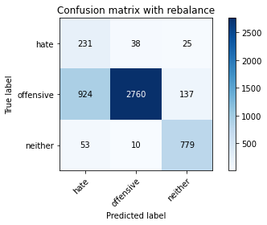

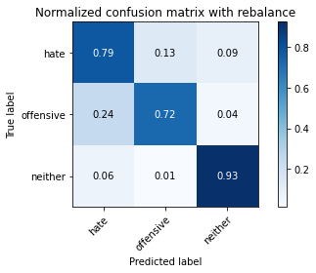

precision recall f1-score support

hate 0.19 0.79 0.31 294

offensive 0.98 0.72 0.83 3821

neither 0.83 0.93 0.87 842

accuracy 0.76 4957

macro avg 0.67 0.81 0.67 4957

weighted avg 0.91 0.76 0.81 4957

average eval_loss: 0.5945769180093081, accuracy: 0.7605406495864434

training 2 epoch...

29.188987255096436 seconds used......

2 training finished! average train loss: 0.3812794395183262

evaluating...

Confusion matrix, without normalization

[[ 250 31 13]

[1166 2545 110]

[ 85 8 749]]

Normalized confusion matrix

[[0.85034014 0.10544218 0.04421769]

[0.30515572 0.66605601 0.02878828]

[0.10095012 0.00950119 0.88954869]]

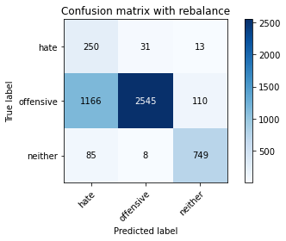

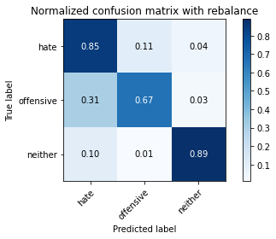

precision recall f1-score support

hate 0.17 0.85 0.28 294

offensive 0.98 0.67 0.79 3821

neither 0.86 0.89 0.87 842

accuracy 0.71 4957

macro avg 0.67 0.80 0.65 4957

weighted avg 0.91 0.71 0.78 4957

average eval_loss: 0.6949625519374686, accuracy: 0.7149485575953197

training 3 epoch...

29.1735782623291 seconds used......

3 training finished! average train loss: 0.24414588036070092

evaluating...

Confusion matrix, without normalization

[[ 244 36 14]

[1010 2675 136]

[ 78 11 753]]

Normalized confusion matrix

[[0.82993197 0.12244898 0.04761905]

[0.26432871 0.70007851 0.03559278]

[0.09263658 0.01306413 0.89429929]]

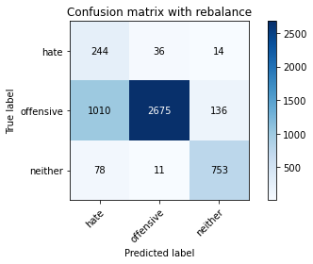

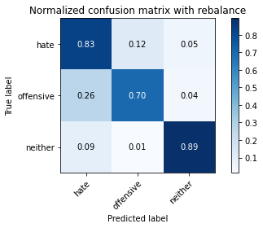

precision recall f1-score support

hate 0.18 0.83 0.30 294

offensive 0.98 0.70 0.82 3821

neither 0.83 0.89 0.86 842

accuracy 0.74 4957

macro avg 0.67 0.81 0.66 4957

weighted avg 0.91 0.74 0.79 4957

average eval_loss: 0.6040836864060932, accuracy: 0.7407706273956022

training 4 epoch...

29.177480220794678 seconds used......

4 training finished! average train loss: 0.14950371506400625

evaluating...

Confusion matrix, without normalization

[[ 250 32 12]

[1090 2648 83]

[ 92 32 718]]

Normalized confusion matrix

[[0.85034014 0.10884354 0.04081633]

[0.28526564 0.6930123 0.02172206]

[0.10926366 0.03800475 0.85273159]]

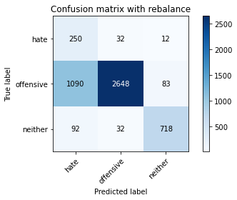

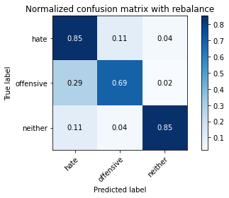

precision recall f1-score support

hate 0.17 0.85 0.29 294

offensive 0.98 0.69 0.81 3821

neither 0.88 0.85 0.87 842

accuracy 0.73 4957

macro avg 0.68 0.80 0.66 4957

weighted avg 0.91 0.73 0.79 4957

average eval_loss: 0.7291936090125912, accuracy: 0.7294734718579786

training 5 epoch...

29.18400287628174 seconds used......

5 training finished! average train loss: 0.0969424242948928

evaluating...

Confusion matrix, without normalization

[[ 251 31 12]

[1452 2294 75]

[ 128 36 678]]

Normalized confusion matrix

[[0.8537415 0.10544218 0.04081633]

[0.38000523 0.6003664 0.01962837]

[0.152019 0.04275534 0.80522565]]

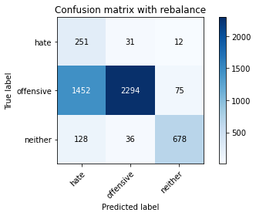

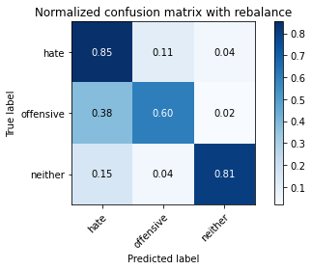

precision recall f1-score support

hate 0.14 0.85 0.24 294

offensive 0.97 0.60 0.74 3821

neither 0.89 0.81 0.84 842

accuracy 0.65 4957

macro avg 0.66 0.75 0.61 4957

weighted avg 0.91 0.65 0.73 4957

average eval_loss: 1.10000360525784, accuracy: 0.650191648174299

training 6 epoch...

29.179373741149902 seconds used......

6 training finished! average train loss: 0.059526627361828906

evaluating...

Confusion matrix, without normalization

[[ 225 57 12]

[ 702 2998 121]

[ 68 37 737]]

Normalized confusion matrix

[[0.76530612 0.19387755 0.04081633]

[0.18372154 0.78461136 0.0316671 ]

[0.0807601 0.04394299 0.87529691]]

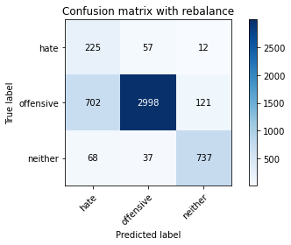

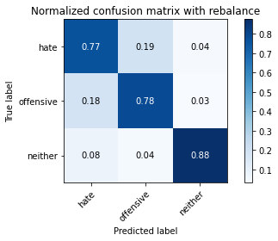

precision recall f1-score support

hate 0.23 0.77 0.35 294

offensive 0.97 0.78 0.87 3821

neither 0.85 0.88 0.86 842

accuracy 0.80 4957

macro avg 0.68 0.81 0.69 4957

weighted avg 0.90 0.80 0.84 4957

average eval_loss: 0.7540527889899339, accuracy: 0.7988702844462376

training 7 epoch...

29.192978858947754 seconds used......

7 training finished! average train loss: 0.030800032356892826

evaluating...

Confusion matrix, without normalization

[[ 236 46 12]

[ 932 2803 86]

[ 76 48 718]]

Normalized confusion matrix

[[0.80272109 0.15646259 0.04081633]

[0.24391521 0.7335776 0.0225072 ]

[0.09026128 0.05700713 0.85273159]]

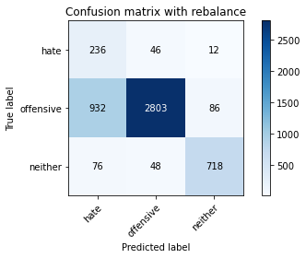

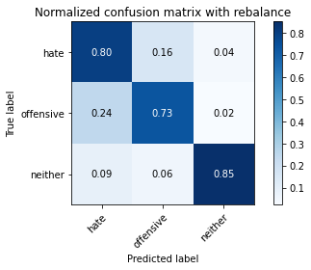

precision recall f1-score support

hate 0.19 0.80 0.31 294

offensive 0.97 0.73 0.83 3821

neither 0.88 0.85 0.87 842

accuracy 0.76 4957

macro avg 0.68 0.80 0.67 4957

weighted avg 0.91 0.76 0.81 4957

average eval_loss: 1.0159938410187381, accuracy: 0.7579180956223522

training 8 epoch...

29.242124319076538 seconds used......

8 training finished! average train loss: 0.02292732711355828

evaluating...

Confusion matrix, without normalization

[[ 227 53 14]

[ 835 2894 92]

[ 74 55 713]]

Normalized confusion matrix

[[0.77210884 0.18027211 0.04761905]

[0.21852918 0.75739335 0.02407747]

[0.08788599 0.06532067 0.84679335]]

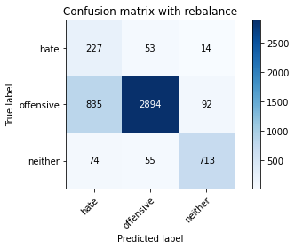

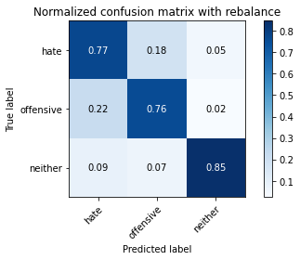

precision recall f1-score support

hate 0.20 0.77 0.32 294

offensive 0.96 0.76 0.85 3821

neither 0.87 0.85 0.86 842

accuracy 0.77 4957

macro avg 0.68 0.79 0.67 4957

weighted avg 0.90 0.77 0.82 4957

average eval_loss: 0.9869217219792547, accuracy: 0.7734516844865846

training 9 epoch...

29.19728994369507 seconds used......

9 training finished! average train loss: 0.01892777865229049

evaluating...

Confusion matrix, without normalization

[[ 220 58 16]

[ 721 3002 98]

[ 57 49 736]]

Normalized confusion matrix

[[0.74829932 0.19727891 0.05442177]

[0.18869406 0.7856582 0.02564774]

[0.06769596 0.05819477 0.87410926]]

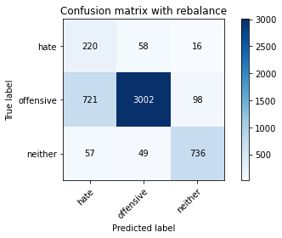

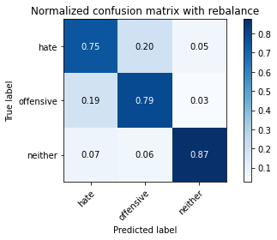

precision recall f1-score support

hate 0.22 0.75 0.34 294

offensive 0.97 0.79 0.87 3821

neither 0.87 0.87 0.87 842

accuracy 0.80 4957

macro avg 0.68 0.80 0.69 4957

weighted avg 0.90 0.80 0.84 4957

average eval_loss: 1.0226226854767095, accuracy: 0.7984668146056082

training 10 epoch...

29.18363118171692 seconds used......

10 training finished! average train loss: 0.007892775333916077

evaluating...

Confusion matrix, without normalization

[[ 219 60 15]

[ 801 2930 90]

[ 53 65 724]]

Normalized confusion matrix

[[0.74489796 0.20408163 0.05102041]

[0.20963099 0.76681497 0.02355404]

[0.06294537 0.07719715 0.85985748]]

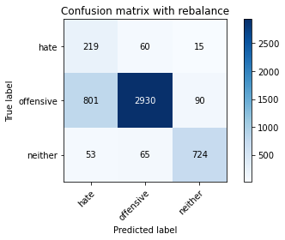

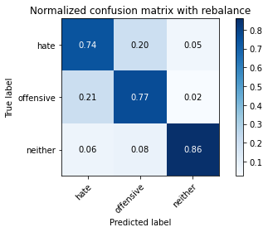

precision recall f1-score support

hate 0.20 0.74 0.32 294

offensive 0.96 0.77 0.85 3821

neither 0.87 0.86 0.87 842

accuracy 0.78 4957

macro avg 0.68 0.79 0.68 4957

weighted avg 0.90 0.78 0.82 4957

average eval_loss: 1.1479607618549057, accuracy: 0.7813193463788581

3 run

training 1 epoch...

29.24513530731201 seconds used......

1 training finished! average train loss: 0.6671437158396369

evaluating...

Confusion matrix, without normalization

[[ 226 37 31]

[ 789 2844 188]

[ 36 13 793]]

Normalized confusion matrix

[[0.76870748 0.12585034 0.10544218]

[0.20649045 0.74430777 0.04920178]

[0.04275534 0.01543943 0.94180523]]

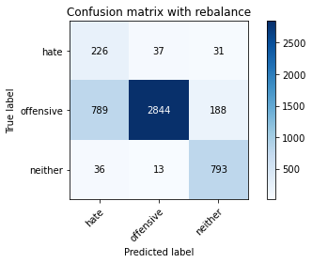

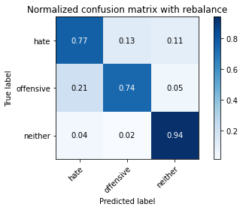

precision recall f1-score support

hate 0.22 0.77 0.34 294

offensive 0.98 0.74 0.85 3821

neither 0.78 0.94 0.86 842

accuracy 0.78 4957

macro avg 0.66 0.82 0.68 4957

weighted avg 0.90 0.78 0.82 4957

average eval_loss: 0.5310988322561306, accuracy: 0.7793019971757111

training 2 epoch...

29.182510137557983 seconds used......

2 training finished! average train loss: 0.38777858049374575

evaluating...

Confusion matrix, without normalization

[[ 239 39 16]

[ 917 2775 129]

[ 57 18 767]]

Normalized confusion matrix

[[0.81292517 0.13265306 0.05442177]

[0.23998953 0.72624967 0.0337608 ]

[0.06769596 0.02137767 0.91092637]]

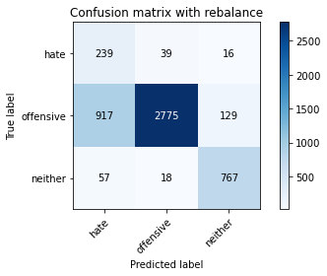

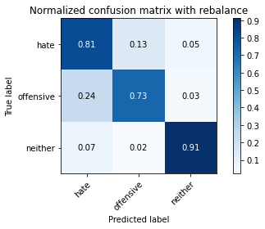

precision recall f1-score support

hate 0.20 0.81 0.32 294

offensive 0.98 0.73 0.83 3821

neither 0.84 0.91 0.87 842

accuracy 0.76 4957

macro avg 0.67 0.82 0.68 4957

weighted avg 0.91 0.76 0.81 4957

average eval_loss: 0.5385702462085793, accuracy: 0.7627597337099051

training 3 epoch...

29.19601798057556 seconds used......

3 training finished! average train loss: 0.2530716950215443

evaluating...

Confusion matrix, without normalization

[[ 245 42 7]

[ 980 2796 45]

[ 187 38 617]]

Normalized confusion matrix

[[0.83333333 0.14285714 0.02380952]

[0.25647736 0.73174562 0.01177702]

[0.22209026 0.04513064 0.7327791 ]]

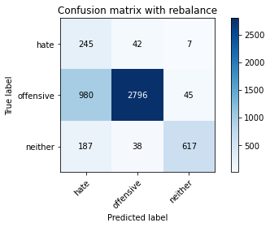

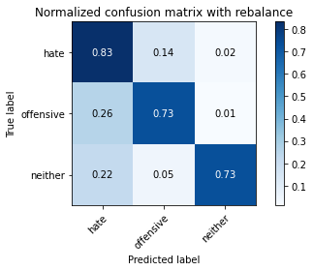

precision recall f1-score support

hate 0.17 0.83 0.29 294

offensive 0.97 0.73 0.84 3821

neither 0.92 0.73 0.82 842

accuracy 0.74 4957

macro avg 0.69 0.77 0.65 4957

weighted avg 0.92 0.74 0.80 4957

average eval_loss: 0.6332176568046692, accuracy: 0.7379463385111963

training 4 epoch...

29.181886672973633 seconds used......

4 training finished! average train loss: 0.1513263014695275

evaluating...

Confusion matrix, without normalization

[[ 231 47 16]

[1140 2523 158]

[ 62 28 752]]

Normalized confusion matrix

[[0.78571429 0.15986395 0.05442177]

[0.29835122 0.66029835 0.04135043]

[0.0736342 0.03325416 0.89311164]]

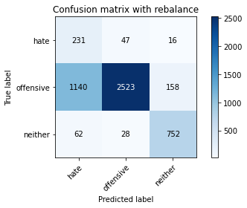

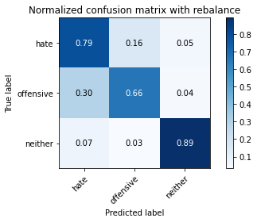

precision recall f1-score support

hate 0.16 0.79 0.27 294

offensive 0.97 0.66 0.79 3821

neither 0.81 0.89 0.85 842

accuracy 0.71 4957

macro avg 0.65 0.78 0.63 4957

weighted avg 0.90 0.71 0.77 4957

average eval_loss: 0.7537515622773959, accuracy: 0.7072826306233609

training 5 epoch...

29.150092363357544 seconds used......

5 training finished! average train loss: 0.10055035067319174

evaluating...

Confusion matrix, without normalization

[[ 226 54 14]

[ 723 2990 108]

[ 70 37 735]]

Normalized confusion matrix

[[0.76870748 0.18367347 0.04761905]

[0.18921748 0.78251767 0.02826485]

[0.08313539 0.04394299 0.87292162]]

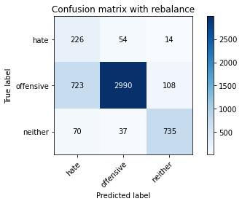

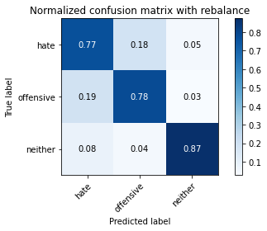

precision recall f1-score support

hate 0.22 0.77 0.34 294

offensive 0.97 0.78 0.87 3821

neither 0.86 0.87 0.87 842

accuracy 0.80 4957

macro avg 0.68 0.81 0.69 4957

weighted avg 0.91 0.80 0.84 4957

average eval_loss: 0.6192060808778831, accuracy: 0.7970546701634053

training 6 epoch...

29.186246156692505 seconds used......

6 training finished! average train loss: 0.06247855553387158

evaluating...

Confusion matrix, without normalization

[[ 228 49 17]

[ 772 2914 135]

[ 59 35 748]]

Normalized confusion matrix

[[0.7755102 0.16666667 0.05782313]

[0.20204135 0.76262758 0.03533107]

[0.07007126 0.0415677 0.88836105]]

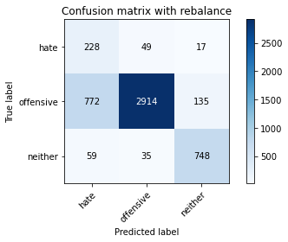

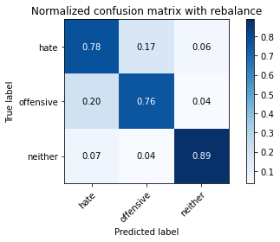

precision recall f1-score support

hate 0.22 0.78 0.34 294

offensive 0.97 0.76 0.85 3821

neither 0.83 0.89 0.86 842

accuracy 0.78 4957

macro avg 0.67 0.81 0.68 4957

weighted avg 0.90 0.78 0.82 4957

average eval_loss: 0.7530471121802205, accuracy: 0.7847488400242082

training 7 epoch...

29.153976917266846 seconds used......

7 training finished! average train loss: 0.038720650772008584

evaluating...

Confusion matrix, without normalization

[[ 210 66 18]

[ 556 3116 149]

[ 47 33 762]]

Normalized confusion matrix

[[0.71428571 0.2244898 0.06122449]

[0.14551165 0.81549333 0.03899503]

[0.05581948 0.0391924 0.90498812]]

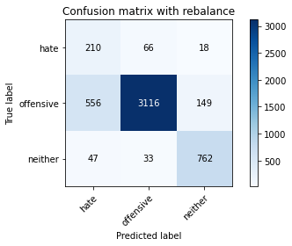

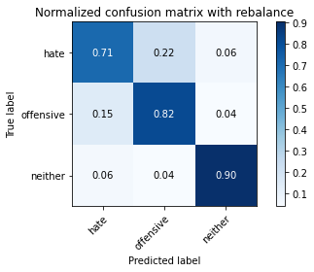

precision recall f1-score support

hate 0.26 0.71 0.38 294

offensive 0.97 0.82 0.89 3821

neither 0.82 0.90 0.86 842

accuracy 0.82 4957

macro avg 0.68 0.81 0.71 4957

weighted avg 0.90 0.82 0.85 4957

average eval_loss: 0.7466300918425869, accuracy: 0.8246923542465201

training 8 epoch...

29.21812915802002 seconds used......

8 training finished! average train loss: 0.020043103440327035

evaluating...

Confusion matrix, without normalization

[[ 219 61 14]

[ 676 3045 100]

[ 49 61 732]]

Normalized confusion matrix

[[0.74489796 0.20748299 0.04761905]

[0.17691704 0.7969118 0.02617116]

[0.05819477 0.07244656 0.86935867]]

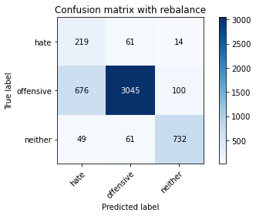

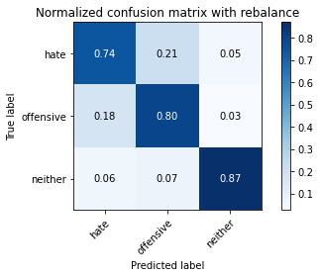

precision recall f1-score support

hate 0.23 0.74 0.35 294

offensive 0.96 0.80 0.87 3821

neither 0.87 0.87 0.87 842

accuracy 0.81 4957

macro avg 0.69 0.80 0.70 4957

weighted avg 0.90 0.81 0.84 4957

average eval_loss: 0.9296080048286146, accuracy: 0.8061327415775671

training 9 epoch...

29.210615634918213 seconds used......

9 training finished! average train loss: 0.020291990632693723

evaluating...

Confusion matrix, without normalization

[[ 202 77 15]

[ 503 3235 83]

[ 50 78 714]]

Normalized confusion matrix

[[0.68707483 0.26190476 0.05102041]

[0.13164093 0.84663701 0.02172206]

[0.05938242 0.09263658 0.847981 ]]

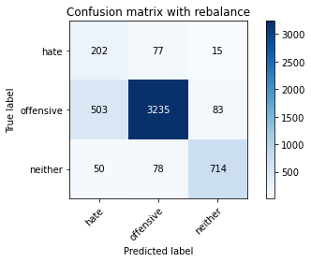

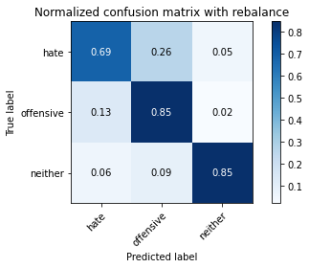

precision recall f1-score support

hate 0.27 0.69 0.39 294

offensive 0.95 0.85 0.90 3821

neither 0.88 0.85 0.86 842

accuracy 0.84 4957

macro avg 0.70 0.79 0.72 4957

weighted avg 0.90 0.84 0.86 4957

average eval_loss: 0.7679796748880988, accuracy: 0.8374016542263466

training 10 epoch...

29.168039083480835 seconds used......

10 training finished! average train loss: 0.01662312962907252

evaluating...

Confusion matrix, without normalization

[[ 249 35 10]

[1215 2517 89]

[ 96 46 700]]

Normalized confusion matrix

[[0.84693878 0.11904762 0.03401361]

[0.31797959 0.65872808 0.02329233]

[0.11401425 0.05463183 0.83135392]]

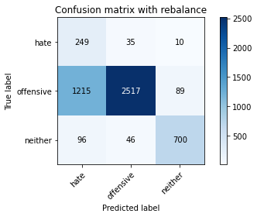

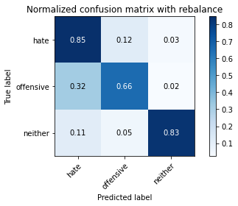

precision recall f1-score support

hate 0.16 0.85 0.27 294

offensive 0.97 0.66 0.78 3821

neither 0.88 0.83 0.85 842

accuracy 0.70 4957

macro avg 0.67 0.78 0.64 4957

weighted avg 0.91 0.70 0.77 4957

average eval_loss: 1.6025015080587999, accuracy: 0.6992132338107726

4 run

training 1 epoch...

29.424399375915527 seconds used......

1 training finished! average train loss: 0.63953877079208

evaluating...

Confusion matrix, without normalization

[[ 244 33 17]

[ 929 2787 105]

[ 84 13 745]]

Normalized confusion matrix

[[0.82993197 0.1122449 0.05782313]

[0.24313007 0.72939021 0.02747972]

[0.09976247 0.01543943 0.8847981 ]]

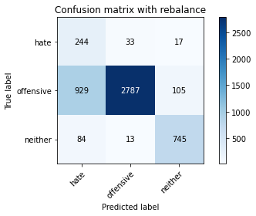

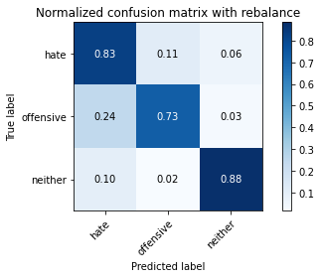

precision recall f1-score support

hate 0.19 0.83 0.31 294

offensive 0.98 0.73 0.84 3821

neither 0.86 0.88 0.87 842

accuracy 0.76 4957

macro avg 0.68 0.81 0.67 4957

weighted avg 0.92 0.76 0.81 4957

average eval_loss: 0.5508859424341109, accuracy: 0.7617510591083316

training 2 epoch...

29.29012179374695 seconds used......

4 training finished! average train loss: 0.149436372893247

evaluating...

Confusion matrix, without normalization

[[ 251 30 13]

[1225 2517 79]

[ 85 22 735]]

Normalized confusion matrix

[[0.8537415 0.10204082 0.04421769]

[0.3205967 0.65872808 0.02067522]

[0.10095012 0.02612827 0.87292162]]

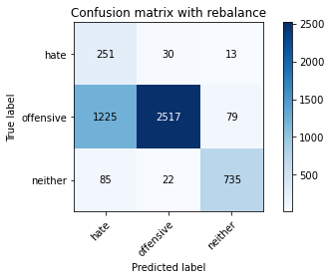

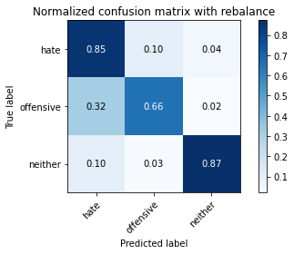

precision recall f1-score support

hate 0.16 0.85 0.27 294

offensive 0.98 0.66 0.79 3821

neither 0.89 0.87 0.88 842

accuracy 0.71 4957

macro avg 0.68 0.80 0.65 4957

weighted avg 0.92 0.71 0.77 4957

average eval_loss: 0.7229248146196047, accuracy: 0.7066774258624168

training 5 epoch...

29.31849980354309 seconds used......

5 training finished! average train loss: 0.08924319807641556

evaluating...

Confusion matrix, without normalization

[[ 226 47 21]

[ 827 2870 124]

[ 48 30 764]]

Normalized confusion matrix

[[0.76870748 0.15986395 0.07142857]

[0.21643549 0.75111227 0.03245224]

[0.05700713 0.03562945 0.90736342]]

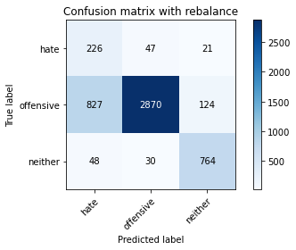

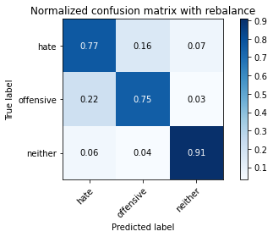

precision recall f1-score support

hate 0.21 0.77 0.32 294

offensive 0.97 0.75 0.85 3821

neither 0.84 0.91 0.87 842

accuracy 0.78 4957

macro avg 0.67 0.81 0.68 4957

weighted avg 0.91 0.78 0.82 4957

average eval_loss: 0.6691671193900308, accuracy: 0.778696792414767

training 6 epoch...

29.296921968460083 seconds used......

6 training finished! average train loss: 0.04825657408150752

evaluating...

Confusion matrix, without normalization

[[ 210 71 13]

[ 650 3085 86]

[ 58 51 733]]

Normalized confusion matrix

[[0.71428571 0.2414966 0.04421769]

[0.17011254 0.80738027 0.0225072 ]

[0.06888361 0.06057007 0.87054632]]

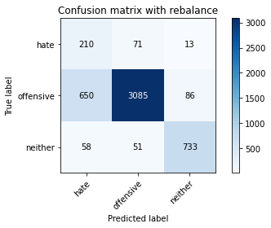

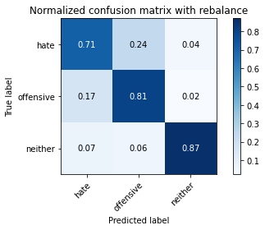

precision recall f1-score support

hate 0.23 0.71 0.35 294

offensive 0.96 0.81 0.88 3821

neither 0.88 0.87 0.88 842

accuracy 0.81 4957

macro avg 0.69 0.80 0.70 4957

weighted avg 0.90 0.81 0.85 4957

average eval_loss: 0.6842253397109979, accuracy: 0.8125882590276376

training 7 epoch...

29.263275861740112 seconds used......

7 training finished! average train loss: 0.027114445091720823

evaluating...

Confusion matrix, without normalization

[[ 210 59 25]

[ 618 3070 133]

[ 34 32 776]]

Normalized confusion matrix

[[0.71428571 0.20068027 0.08503401]

[0.16173776 0.80345459 0.03480764]

[0.04038005 0.03800475 0.9216152 ]]

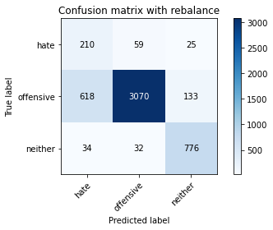

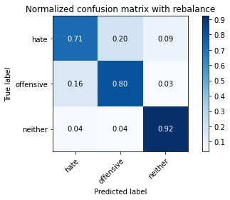

precision recall f1-score support

hate 0.24 0.71 0.36 294

offensive 0.97 0.80 0.88 3821

neither 0.83 0.92 0.87 842

accuracy 0.82 4957

macro avg 0.68 0.81 0.71 4957

weighted avg 0.90 0.82 0.85 4957

average eval_loss: 0.8265769663703395, accuracy: 0.8182368367964494

training 8 epoch...

29.303986072540283 seconds used......

8 training finished! average train loss: 0.019046280794158817

evaluating...

Confusion matrix, without normalization

[[ 198 61 35]

[ 667 2978 176]

[ 32 16 794]]

Normalized confusion matrix

[[0.67346939 0.20748299 0.11904762]

[0.17456163 0.77937713 0.04606124]

[0.03800475 0.01900238 0.94299287]]

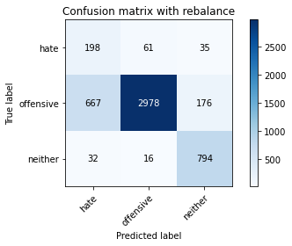

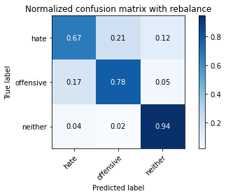

precision recall f1-score support

hate 0.22 0.67 0.33 294

offensive 0.97 0.78 0.87 3821

neither 0.79 0.94 0.86 842

accuracy 0.80 4957

macro avg 0.66 0.80 0.69 4957

weighted avg 0.90 0.80 0.83 4957

average eval_loss: 1.0100457223588526, accuracy: 0.8008876336493848

training 9 epoch...

29.29224681854248 seconds used......

9 training finished! average train loss: 0.01806636613556075

evaluating...

Confusion matrix, without normalization

[[ 216 62 16]

[ 705 3011 105]

[ 60 32 750]]

Normalized confusion matrix

[[0.73469388 0.21088435 0.05442177]

[0.18450667 0.78801361 0.02747972]

[0.07125891 0.03800475 0.89073634]]

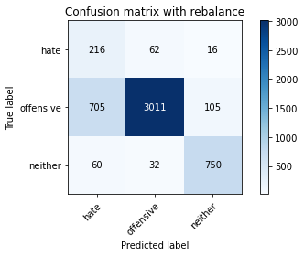

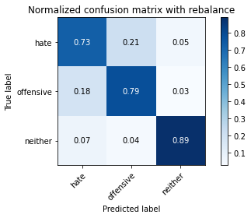

precision recall f1-score support

hate 0.22 0.73 0.34 294

offensive 0.97 0.79 0.87 3821

neither 0.86 0.89 0.88 842

accuracy 0.80 4957

macro avg 0.68 0.80 0.69 4957

weighted avg 0.91 0.80 0.84 4957

average eval_loss: 0.9888613349729923, accuracy: 0.8022997780915877

training 10 epoch...

29.37374973297119 seconds used......

10 training finished! average train loss: 0.016500811541537423

evaluating...

Confusion matrix, without normalization

[[ 231 43 20]

[ 833 2862 126]

[ 57 24 761]]

Normalized confusion matrix

[[0.78571429 0.1462585 0.06802721]

[0.21800576 0.74901858 0.03297566]

[0.06769596 0.02850356 0.90380048]]

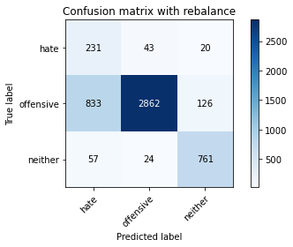

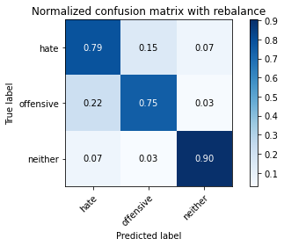

precision recall f1-score support

hate 0.21 0.79 0.33 294

offensive 0.98 0.75 0.85 3821

neither 0.84 0.90 0.87 842

accuracy 0.78 4957

macro avg 0.67 0.81 0.68 4957

weighted avg 0.91 0.78 0.82 4957

average eval_loss: 1.1367423281434081, accuracy: 0.7774863828928787

5 run

training 1 epoch...

29.25767230987549 seconds used......

1 training finished! average train loss: 0.6616729673934959

evaluating...

Confusion matrix, without normalization

[[ 220 39 35]

[ 801 2852 168]

[ 21 12 809]]

Normalized confusion matrix

[[0.74829932 0.13265306 0.11904762]

[0.20963099 0.74640147 0.04396755]

[0.02494062 0.01425178 0.9608076 ]]

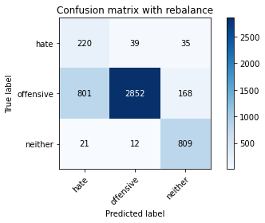

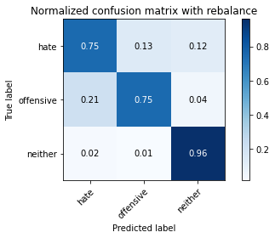

precision recall f1-score support

hate 0.21 0.75 0.33 294

offensive 0.98 0.75 0.85 3821

neither 0.80 0.96 0.87 842

accuracy 0.78 4957

macro avg 0.66 0.82 0.68 4957

weighted avg 0.91 0.78 0.82 4957

average eval_loss: 0.5242445719458403, accuracy: 0.7829332257413758

training 2 epoch...

29.19692850112915 seconds used......

2 training finished! average train loss: 0.37943533594496764

evaluating...

Confusion matrix, without normalization

[[ 242 37 15]

[1019 2641 161]

[ 51 13 778]]

Normalized confusion matrix

[[0.82312925 0.12585034 0.05102041]

[0.26668411 0.69118032 0.04213557]

[0.06057007 0.01543943 0.9239905 ]]

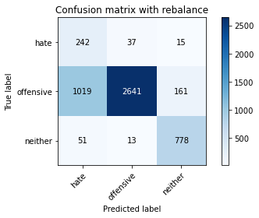

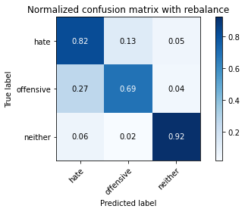

precision recall f1-score support

hate 0.18 0.82 0.30 294

offensive 0.98 0.69 0.81 3821

neither 0.82 0.92 0.87 842

accuracy 0.74 4957

macro avg 0.66 0.81 0.66 4957

weighted avg 0.91 0.74 0.79 4957

average eval_loss: 0.5658247782698562, accuracy: 0.7385515432721405

training 3 epoch...

29.18757152557373 seconds used......

3 training finished! average train loss: 0.24599702528280298

evaluating...

Confusion matrix, without normalization

[[ 233 47 14]

[ 759 2962 100]

[ 61 45 736]]

Normalized confusion matrix

[[0.79251701 0.15986395 0.04761905]

[0.1986391 0.77518974 0.02617116]

[0.07244656 0.05344418 0.87410926]]

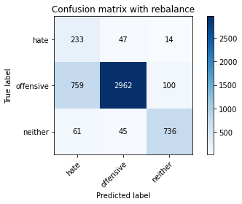

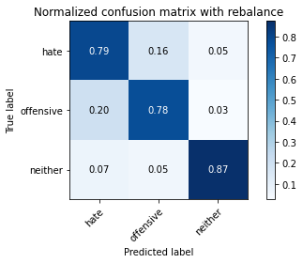

precision recall f1-score support

hate 0.22 0.79 0.35 294

offensive 0.97 0.78 0.86 3821

neither 0.87 0.87 0.87 842

accuracy 0.79 4957

macro avg 0.69 0.81 0.69 4957

weighted avg 0.91 0.79 0.83 4957

average eval_loss: 0.5324619233518118, accuracy: 0.7930199717571111

training 4 epoch...

29.210394620895386 seconds used......

4 training finished! average train loss: 0.16165330077995332

evaluating...

Confusion matrix, without normalization

[[ 240 42 12]

[ 837 2868 116]

[ 64 29 749]]

Normalized confusion matrix

[[0.81632653 0.14285714 0.04081633]

[0.2190526 0.75058885 0.03035854]

[0.0760095 0.03444181 0.88954869]]

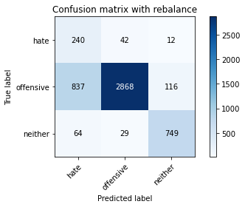

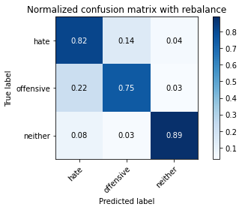

precision recall f1-score support

hate 0.21 0.82 0.33 294

offensive 0.98 0.75 0.85 3821

neither 0.85 0.89 0.87 842

accuracy 0.78 4957

macro avg 0.68 0.82 0.68 4957

weighted avg 0.91 0.78 0.82 4957

average eval_loss: 0.6357984598575821, accuracy: 0.7780915876538229

training 5 epoch...

29.206974983215332 seconds used......

5 training finished! average train loss: 0.09374974277932524

evaluating...

Confusion matrix, without normalization

[[ 245 39 10]

[1103 2625 93]

[ 78 32 732]]

Normalized confusion matrix

[[0.83333333 0.13265306 0.03401361]

[0.28866789 0.68699293 0.02433918]

[0.09263658 0.03800475 0.86935867]]

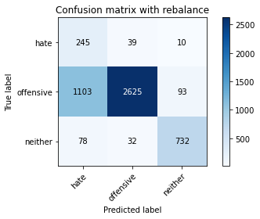

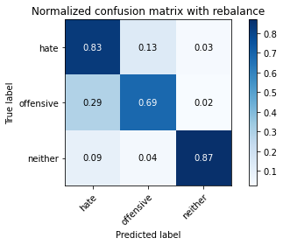

precision recall f1-score support

hate 0.17 0.83 0.28 294

offensive 0.97 0.69 0.81 3821

neither 0.88 0.87 0.87 842

accuracy 0.73 4957

macro avg 0.67 0.80 0.65 4957

weighted avg 0.91 0.73 0.79 4957

average eval_loss: 0.9375079166474601, accuracy: 0.7266491829735727

training 6 epoch...

29.23349928855896 seconds used......

6 training finished! average train loss: 0.06433298322099822

evaluating...

Confusion matrix, without normalization

[[ 223 52 19]

[ 806 2885 130]

[ 39 33 770]]

Normalized confusion matrix

[[0.7585034 0.17687075 0.06462585]

[0.21093954 0.75503795 0.03402251]

[0.04631829 0.0391924 0.91448931]]

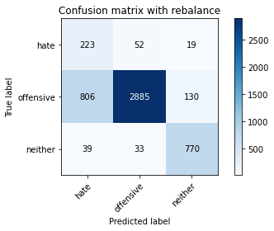

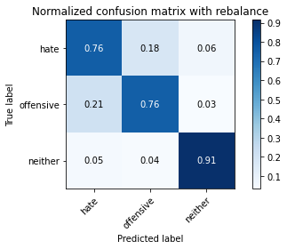

precision recall f1-score support

hate 0.21 0.76 0.33 294

offensive 0.97 0.76 0.85 3821

neither 0.84 0.91 0.87 842

accuracy 0.78 4957

macro avg 0.67 0.81 0.68 4957

weighted avg 0.90 0.78 0.82 4957

average eval_loss: 0.7810452751131849, accuracy: 0.7823280209804317

training 7 epoch...

29.316412925720215 seconds used......

7 training finished! average train loss: 0.035055011386264184

evaluating...

Confusion matrix, without normalization

[[ 230 52 12]

[ 901 2814 106]

[ 69 30 743]]

Normalized confusion matrix

[[0.78231293 0.17687075 0.04081633]

[0.23580215 0.73645643 0.02774143]

[0.08194774 0.03562945 0.8824228 ]]

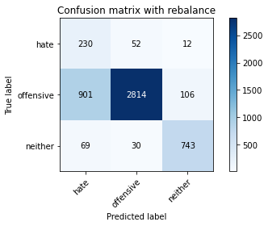

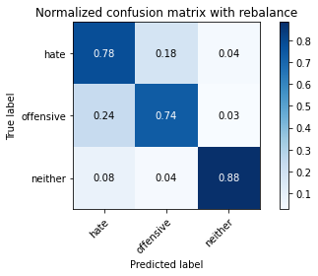

precision recall f1-score support

hate 0.19 0.78 0.31 294

offensive 0.97 0.74 0.84 3821

neither 0.86 0.88 0.87 842

accuracy 0.76 4957

macro avg 0.68 0.80 0.67 4957

weighted avg 0.91 0.76 0.81 4957

average eval_loss: 1.030554968383043, accuracy: 0.7639701432317935

training 8 epoch...

29.25785255432129 seconds used......

8 training finished! average train loss: 0.017290803427502992

evaluating...

Confusion matrix, without normalization

[[ 238 45 11]

[1012 2722 87]

[ 82 48 712]]

Normalized confusion matrix

[[0.80952381 0.15306122 0.03741497]

[0.26485213 0.71237896 0.02276891]

[0.09738717 0.05700713 0.8456057 ]]

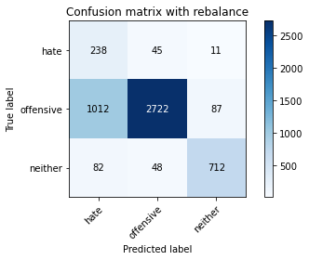

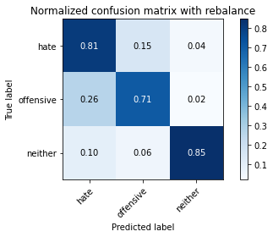

precision recall f1-score support

hate 0.18 0.81 0.29 294

offensive 0.97 0.71 0.82 3821

neither 0.88 0.85 0.86 842

accuracy 0.74 4957

macro avg 0.67 0.79 0.66 4957

weighted avg 0.91 0.74 0.80 4957

average eval_loss: 1.2299358415898056, accuracy: 0.7407706273956022

training 9 epoch...

29.228208303451538 seconds used......

9 training finished! average train loss: 0.02635752471444355

evaluating...

Confusion matrix, without normalization

[[ 210 58 26]

[ 526 3136 159]

[ 30 25 787]]

Normalized confusion matrix

[[0.71428571 0.19727891 0.08843537]

[0.1376603 0.82072756 0.04161214]

[0.03562945 0.02969121 0.93467933]]

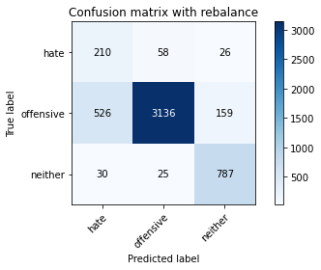

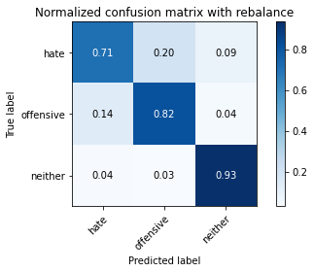

precision recall f1-score support

hate 0.27 0.71 0.40 294

offensive 0.97 0.82 0.89 3821

neither 0.81 0.93 0.87 842

accuracy 0.83 4957

macro avg 0.69 0.82 0.72 4957

weighted avg 0.90 0.83 0.86 4957

average eval_loss: 0.8666743147696252, accuracy: 0.8337704256606818

training 10 epoch...

29.20929789543152 seconds used......

10 training finished! average train loss: 0.030110574668485737

evaluating...

Confusion matrix, without normalization

[[ 204 74 16]

[ 559 3124 138]

[ 43 50 749]]

Normalized confusion matrix

[[0.69387755 0.25170068 0.05442177]

[0.14629678 0.81758702 0.0361162 ]

[0.05106888 0.05938242 0.88954869]]

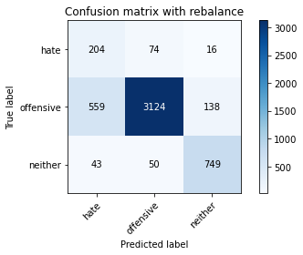

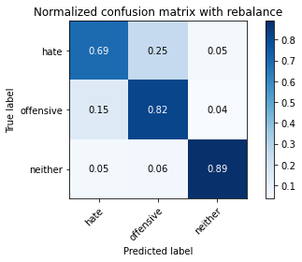

precision recall f1-score support

hate 0.25 0.69 0.37 294

offensive 0.96 0.82 0.88 3821

neither 0.83 0.89 0.86 842

accuracy 0.82 4957

macro avg 0.68 0.80 0.70 4957

weighted avg 0.90 0.82 0.85 4957

average eval_loss: 0.7908146184007262, accuracy: 0.8224732701230583