1,0.5,1

1 run......

Downloading: 100%

268M/268M [00:08<00:00, 32.5MB/s]

training 1 epoch...

60.411290884017944 seconds used......

1 training finished! average train loss: 0.7064130940220573

evaluating...

Confusion matrix, without normalization

[[ 87 45 58]

[ 60 286 69]

[ 73 22 618]]

Normalized confusion matrix

[[0.45789474 0.23684211 0.30526316]

[0.14457831 0.68915663 0.16626506]

[0.10238429 0.03085554 0.86676017]]

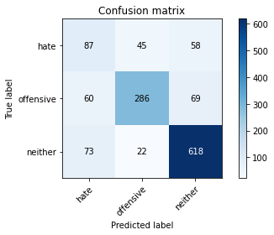

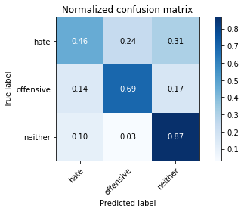

precision recall f1-score support

hate 0.40 0.46 0.42 190

offensive 0.81 0.69 0.74 415

neither 0.83 0.87 0.85 713

accuracy 0.75 1318

macro avg 0.68 0.67 0.67 1318

weighted avg 0.76 0.75 0.75 1318

average eval_loss: 0.5702243144765045, accuracy: 0.7518968133535661

training 2 epoch...

59.83920121192932 seconds used......

2 training finished! average train loss: 0.5022011415524916

evaluating...

Confusion matrix, without normalization

[[ 88 40 62]

[ 61 279 75]

[ 65 17 631]]

Normalized confusion matrix

[[0.46315789 0.21052632 0.32631579]

[0.14698795 0.67228916 0.18072289]

[0.0911641 0.02384292 0.88499299]]

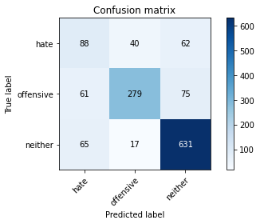

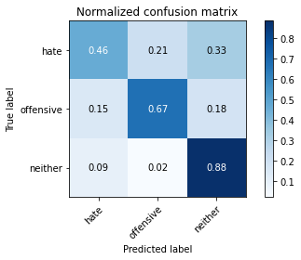

precision recall f1-score support

hate 0.41 0.46 0.44 190

offensive 0.83 0.67 0.74 415

neither 0.82 0.88 0.85 713

accuracy 0.76 1318

macro avg 0.69 0.67 0.68 1318

weighted avg 0.77 0.76 0.76 1318

average eval_loss: 0.5623362881667686, accuracy: 0.7572078907435509

training 3 epoch...

59.56183052062988 seconds used......

3 training finished! average train loss: 0.3438800586895509

evaluating...

Confusion matrix, without normalization

[[ 61 74 55]

[ 43 315 57]

[ 85 40 588]]

Normalized confusion matrix

[[0.32105263 0.38947368 0.28947368]

[0.10361446 0.75903614 0.1373494 ]

[0.11921459 0.05610098 0.82468443]]

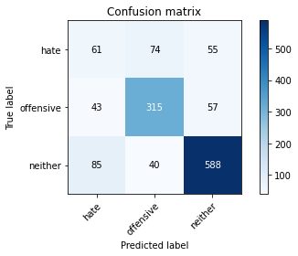

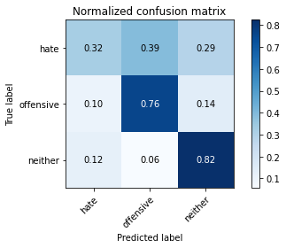

precision recall f1-score support

hate 0.32 0.32 0.32 190

offensive 0.73 0.76 0.75 415

neither 0.84 0.82 0.83 713

accuracy 0.73 1318

macro avg 0.63 0.63 0.63 1318

weighted avg 0.73 0.73 0.73 1318

average eval_loss: 0.6788129278204658, accuracy: 0.7314112291350531

training 4 epoch...

59.55301761627197 seconds used......

4 training finished! average train loss: 0.1791191533546556

evaluating...

Confusion matrix, without normalization

[[ 69 59 62]

[ 52 301 62]

[ 87 38 588]]

Normalized confusion matrix

[[0.36315789 0.31052632 0.32631579]

[0.1253012 0.7253012 0.14939759]

[0.12201964 0.05329593 0.82468443]]

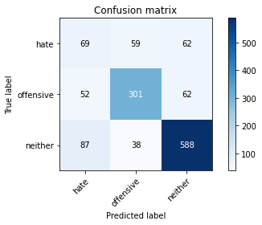

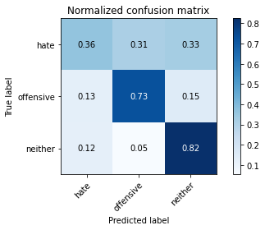

precision recall f1-score support

hate 0.33 0.36 0.35 190

offensive 0.76 0.73 0.74 415

neither 0.83 0.82 0.83 713

accuracy 0.73 1318

macro avg 0.64 0.64 0.64 1318

weighted avg 0.73 0.73 0.73 1318

average eval_loss: 0.8193429265961503, accuracy: 0.7268588770864947

training 5 epoch...

59.51683831214905 seconds used......

5 training finished! average train loss: 0.08038355572445488

evaluating...

Confusion matrix, without normalization

[[ 55 63 72]

[ 54 313 48]

[ 82 43 588]]

Normalized confusion matrix

[[0.28947368 0.33157895 0.37894737]

[0.13012048 0.75421687 0.11566265]

[0.11500701 0.06030856 0.82468443]]

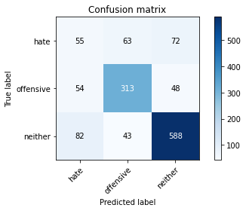

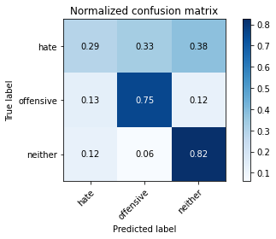

precision recall f1-score support

hate 0.29 0.29 0.29 190

offensive 0.75 0.75 0.75 415

neither 0.83 0.82 0.83 713

accuracy 0.73 1318

macro avg 0.62 0.62 0.62 1318

weighted avg 0.73 0.73 0.73 1318

average eval_loss: 0.9896187222365177, accuracy: 0.7253414264036419

training 6 epoch...

59.63485097885132 seconds used......

6 training finished! average train loss: 0.048615609248041765

evaluating...

Confusion matrix, without normalization

[[ 50 68 72]

[ 42 319 54]

[ 70 49 594]]

Normalized confusion matrix

[[0.26315789 0.35789474 0.37894737]

[0.10120482 0.7686747 0.13012048]

[0.09817672 0.0687237 0.83309958]]

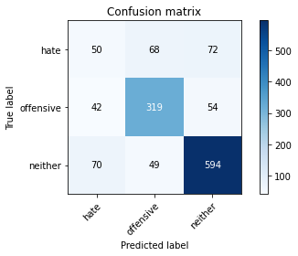

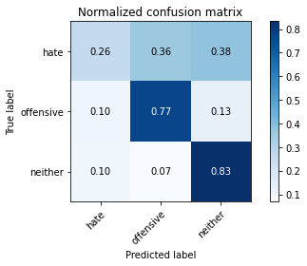

precision recall f1-score support

hate 0.31 0.26 0.28 190

offensive 0.73 0.77 0.75 415

neither 0.82 0.83 0.83 713

accuracy 0.73 1318

macro avg 0.62 0.62 0.62 1318

weighted avg 0.72 0.73 0.73 1318

average eval_loss: 1.1361962177536704, accuracy: 0.7306525037936267

training 7 epoch...

59.56027960777283 seconds used......

7 training finished! average train loss: 0.02955563828320671

evaluating...

Confusion matrix, without normalization

[[ 63 68 59]

[ 40 330 45]

[ 86 61 566]]

Normalized confusion matrix

[[0.33157895 0.35789474 0.31052632]

[0.09638554 0.79518072 0.10843373]

[0.12061711 0.085554 0.79382889]]

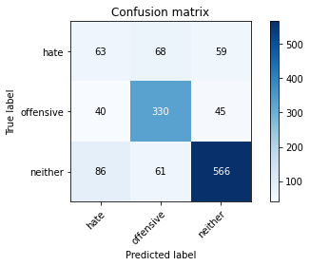

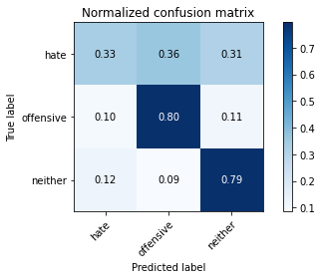

precision recall f1-score support

hate 0.33 0.33 0.33 190

offensive 0.72 0.80 0.76 415

neither 0.84 0.79 0.82 713

accuracy 0.73 1318

macro avg 0.63 0.64 0.64 1318

weighted avg 0.73 0.73 0.73 1318

average eval_loss: 1.2113137457406882, accuracy: 0.7276176024279211

training 8 epoch...

59.56702971458435 seconds used......

8 training finished! average train loss: 0.02057898894550321

evaluating...

Confusion matrix, without normalization

[[ 41 81 68]

[ 30 334 51]

[ 51 71 591]]

Normalized confusion matrix

[[0.21578947 0.42631579 0.35789474]

[0.07228916 0.80481928 0.12289157]

[0.07152875 0.09957924 0.82889201]]

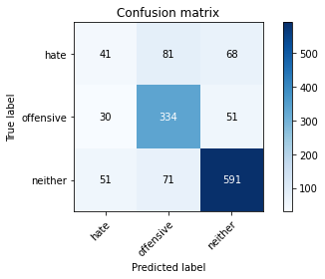

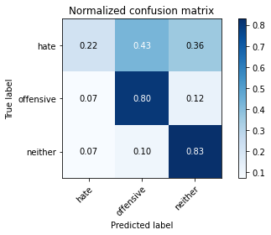

precision recall f1-score support

hate 0.34 0.22 0.26 190

offensive 0.69 0.80 0.74 415

neither 0.83 0.83 0.83 713

accuracy 0.73 1318

macro avg 0.62 0.62 0.61 1318

weighted avg 0.72 0.73 0.72 1318

average eval_loss: 1.4771802524725597, accuracy: 0.7329286798179059

training 9 epoch...

59.49737071990967 seconds used......

9 training finished! average train loss: 0.02175940867382451

evaluating...

Confusion matrix, without normalization

[[ 34 83 73]

[ 25 338 52]

[ 48 60 605]]

Normalized confusion matrix

[[0.17894737 0.43684211 0.38421053]

[0.06024096 0.81445783 0.1253012 ]

[0.06732118 0.08415147 0.84852735]]

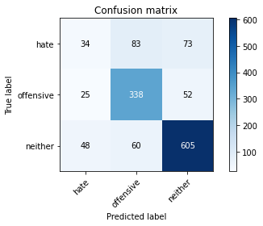

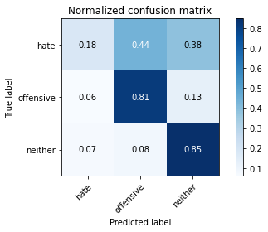

precision recall f1-score support

hate 0.32 0.18 0.23 190

offensive 0.70 0.81 0.75 415

neither 0.83 0.85 0.84 713

accuracy 0.74 1318

macro avg 0.62 0.61 0.61 1318

weighted avg 0.72 0.74 0.72 1318

average eval_loss: 1.4965526461601257, accuracy: 0.7412746585735963

training 10 epoch...

59.5701858997345 seconds used......

10 training finished! average train loss: 0.019692653742723366

evaluating...

Confusion matrix, without normalization

[[ 51 84 55]

[ 33 342 40]

[ 81 75 557]]

Normalized confusion matrix

[[0.26842105 0.44210526 0.28947368]

[0.07951807 0.82409639 0.09638554]

[0.11360449 0.10518934 0.78120617]]

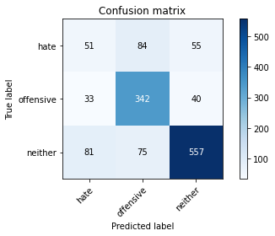

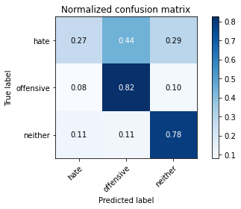

precision recall f1-score support

hate 0.31 0.27 0.29 190

offensive 0.68 0.82 0.75 415

neither 0.85 0.78 0.82 713

accuracy 0.72 1318

macro avg 0.62 0.62 0.62 1318

weighted avg 0.72 0.72 0.72 1318

average eval_loss: 1.5639819755698696, accuracy: 0.7207890743550834

2 run......

training 1 epoch...

59.592833518981934 seconds used......

1 training finished! average train loss: 0.6818911640481515

evaluating...

Confusion matrix, without normalization

[[ 43 48 99]

[ 19 268 128]

[ 8 16 689]]

Normalized confusion matrix

[[0.22631579 0.25263158 0.52105263]

[0.04578313 0.64578313 0.30843373]

[0.0112202 0.02244039 0.96633941]]

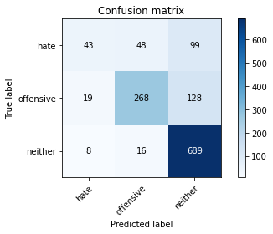

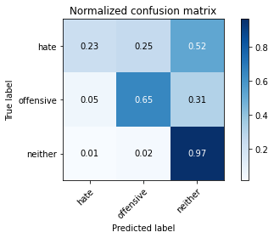

precision recall f1-score support

hate 0.61 0.23 0.33 190

offensive 0.81 0.65 0.72 415

neither 0.75 0.97 0.85 713

accuracy 0.76 1318

macro avg 0.72 0.61 0.63 1318

weighted avg 0.75 0.76 0.73 1318

average eval_loss: 0.5554179856271455, accuracy: 0.7587253414264037

training 2 epoch...

59.52641439437866 seconds used......

2 training finished! average train loss: 0.4870303984392773

evaluating...

Confusion matrix, without normalization

[[103 47 40]

[ 72 307 36]

[125 37 551]]

Normalized confusion matrix

[[0.54210526 0.24736842 0.21052632]

[0.17349398 0.73975904 0.08674699]

[0.17531557 0.05189341 0.77279102]]

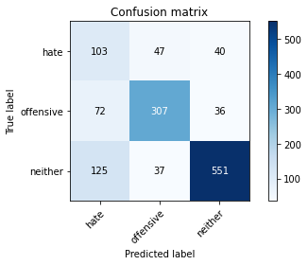

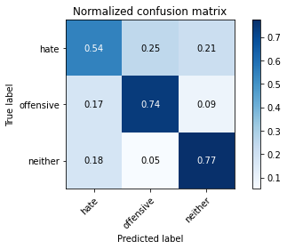

precision recall f1-score support

hate 0.34 0.54 0.42 190

offensive 0.79 0.74 0.76 415

neither 0.88 0.77 0.82 713

accuracy 0.73 1318

macro avg 0.67 0.68 0.67 1318

weighted avg 0.77 0.73 0.75 1318

average eval_loss: 0.6296089016126863, accuracy: 0.7291350531107739

training 3 epoch...

59.67206645011902 seconds used......

3 training finished! average train loss: 0.3269719950685447

evaluating...

Confusion matrix, without normalization

[[ 44 57 89]

[ 34 295 86]

[ 38 30 645]]

Normalized confusion matrix

[[0.23157895 0.3 0.46842105]

[0.08192771 0.71084337 0.20722892]

[0.05329593 0.04207574 0.90462833]]

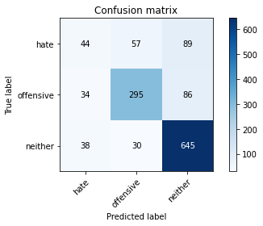

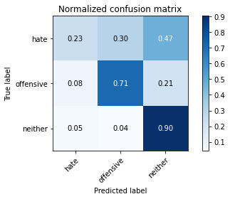

precision recall f1-score support

hate 0.38 0.23 0.29 190

offensive 0.77 0.71 0.74 415

neither 0.79 0.90 0.84 713

accuracy 0.75 1318

macro avg 0.65 0.62 0.62 1318

weighted avg 0.72 0.75 0.73 1318

average eval_loss: 0.69946924032587, accuracy: 0.7465857359635811

training 4 epoch...

59.475576877593994 seconds used......

4 training finished! average train loss: 0.18778638092970307

evaluating...

Confusion matrix, without normalization

[[ 69 50 71]

[ 68 285 62]

[ 94 30 589]]

Normalized confusion matrix

[[0.36315789 0.26315789 0.37368421]

[0.16385542 0.68674699 0.14939759]

[0.13183731 0.04207574 0.82608696]]

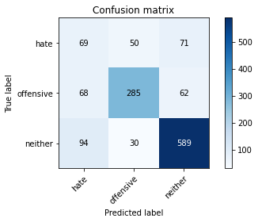

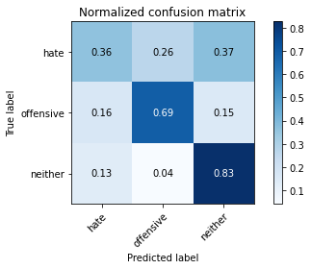

precision recall f1-score support

hate 0.30 0.36 0.33 190

offensive 0.78 0.69 0.73 415

neither 0.82 0.83 0.82 713

accuracy 0.72 1318

macro avg 0.63 0.63 0.63 1318

weighted avg 0.73 0.72 0.72 1318

average eval_loss: 0.8426584163398454, accuracy: 0.7154779969650986

training 5 epoch...

59.43993353843689 seconds used......

5 training finished! average train loss: 0.08864709690043872

evaluating...

Confusion matrix, without normalization

[[ 70 56 64]

[ 57 299 59]

[ 82 36 595]]

Normalized confusion matrix

[[0.36842105 0.29473684 0.33684211]

[0.1373494 0.72048193 0.14216867]

[0.11500701 0.05049088 0.8345021 ]]

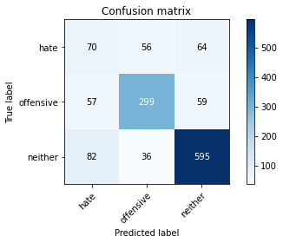

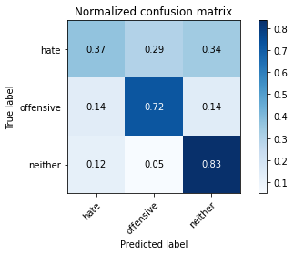

precision recall f1-score support

hate 0.33 0.37 0.35 190

offensive 0.76 0.72 0.74 415

neither 0.83 0.83 0.83 713

accuracy 0.73 1318

macro avg 0.64 0.64 0.64 1318

weighted avg 0.74 0.73 0.73 1318

average eval_loss: 0.9861772746750803, accuracy: 0.7314112291350531

training 6 epoch...

59.528088331222534 seconds used......

6 training finished! average train loss: 0.05034752243558283

evaluating...

Confusion matrix, without normalization

[[ 82 57 51]

[ 75 296 44]

[ 99 42 572]]

Normalized confusion matrix

[[0.43157895 0.3 0.26842105]

[0.18072289 0.71325301 0.1060241 ]

[0.13884993 0.05890603 0.80224404]]

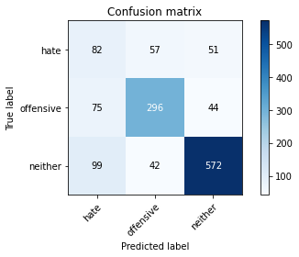

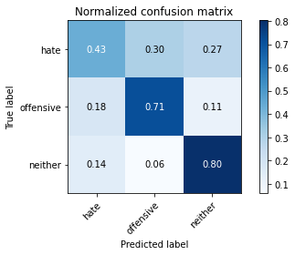

precision recall f1-score support

hate 0.32 0.43 0.37 190

offensive 0.75 0.71 0.73 415

neither 0.86 0.80 0.83 713

accuracy 0.72 1318

macro avg 0.64 0.65 0.64 1318

weighted avg 0.75 0.72 0.73 1318

average eval_loss: 1.1182597053773475, accuracy: 0.7207890743550834

training 7 epoch...

59.57888197898865 seconds used......

7 training finished! average train loss: 0.03928049224725162

evaluating...

Confusion matrix, without normalization

[[ 60 70 60]

[ 47 311 57]

[ 68 57 588]]

Normalized confusion matrix

[[0.31578947 0.36842105 0.31578947]

[0.11325301 0.74939759 0.1373494 ]

[0.09537167 0.0799439 0.82468443]]

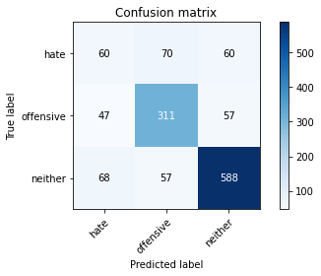

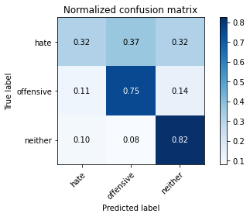

precision recall f1-score support

hate 0.34 0.32 0.33 190

offensive 0.71 0.75 0.73 415

neither 0.83 0.82 0.83 713

accuracy 0.73 1318

macro avg 0.63 0.63 0.63 1318

weighted avg 0.72 0.73 0.73 1318

average eval_loss: 1.1818393457568053, accuracy: 0.7276176024279211

training 8 epoch...

59.52441191673279 seconds used......

8 training finished! average train loss: 0.027762877109291203

evaluating...

Confusion matrix, without normalization

[[ 64 68 58]

[ 50 317 48]

[100 54 559]]

Normalized confusion matrix

[[0.33684211 0.35789474 0.30526316]

[0.12048193 0.76385542 0.11566265]

[0.14025245 0.07573633 0.78401122]]

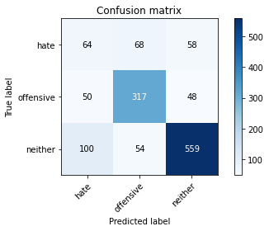

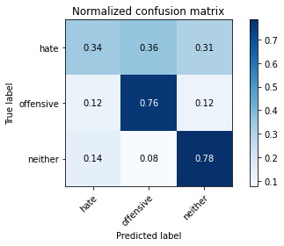

precision recall f1-score support

hate 0.30 0.34 0.32 190

offensive 0.72 0.76 0.74 415

neither 0.84 0.78 0.81 713

accuracy 0.71 1318

macro avg 0.62 0.63 0.62 1318

weighted avg 0.73 0.71 0.72 1318

average eval_loss: 1.4115328851974371, accuracy: 0.7132018209408194

training 9 epoch...

59.515615463256836 seconds used......

9 training finished! average train loss: 0.018555607962546426

evaluating...

Confusion matrix, without normalization

[[ 46 77 67]

[ 46 320 49]

[ 67 57 589]]

Normalized confusion matrix

[[0.24210526 0.40526316 0.35263158]

[0.11084337 0.77108434 0.11807229]

[0.09396914 0.0799439 0.82608696]]

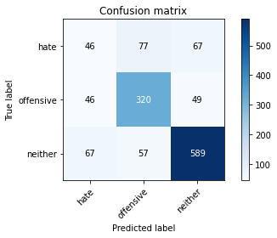

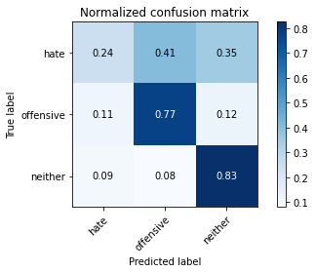

precision recall f1-score support

hate 0.29 0.24 0.26 190

offensive 0.70 0.77 0.74 415

neither 0.84 0.83 0.83 713

accuracy 0.72 1318

macro avg 0.61 0.61 0.61 1318

weighted avg 0.72 0.72 0.72 1318

average eval_loss: 1.479333955230135, accuracy: 0.7245827010622155

training 10 epoch...

59.46071410179138 seconds used......

10 training finished! average train loss: 0.022207566742938733

evaluating...

Confusion matrix, without normalization

[[ 53 67 70]

[ 44 309 62]

[ 69 43 601]]

Normalized confusion matrix

[[0.27894737 0.35263158 0.36842105]

[0.1060241 0.74457831 0.14939759]

[0.09677419 0.06030856 0.84291725]]

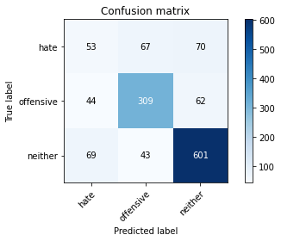

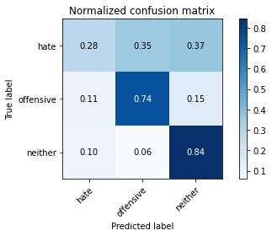

precision recall f1-score support

hate 0.32 0.28 0.30 190

offensive 0.74 0.74 0.74 415

neither 0.82 0.84 0.83 713

accuracy 0.73 1318

macro avg 0.63 0.62 0.62 1318

weighted avg 0.72 0.73 0.73 1318

average eval_loss: 1.3418256830085407, accuracy: 0.7306525037936267

3 run......

training 1 epoch...

59.46730613708496 seconds used......

1 training finished! average train loss: 0.6819520678879185

evaluating...

Confusion matrix, without normalization

[[ 92 46 52]

[ 70 292 53]

[ 96 26 591]]

Normalized confusion matrix

[[0.48421053 0.24210526 0.27368421]

[0.1686747 0.70361446 0.12771084]

[0.13464236 0.03646564 0.82889201]]

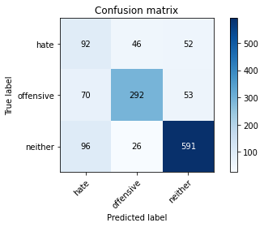

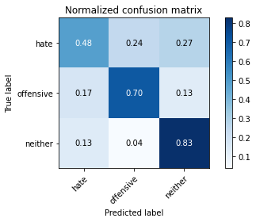

precision recall f1-score support

hate 0.36 0.48 0.41 190

offensive 0.80 0.70 0.75 415

neither 0.85 0.83 0.84 713

accuracy 0.74 1318

macro avg 0.67 0.67 0.67 1318

weighted avg 0.76 0.74 0.75 1318

average eval_loss: 0.5979329379218997, accuracy: 0.7397572078907435

training 2 epoch...

59.42155337333679 seconds used......

2 training finished! average train loss: 0.479701161689379

evaluating...

Confusion matrix, without normalization

[[ 61 58 71]

[ 36 314 65]

[ 49 37 627]]

Normalized confusion matrix

[[0.32105263 0.30526316 0.37368421]

[0.08674699 0.75662651 0.15662651]

[0.0687237 0.05189341 0.87938289]]

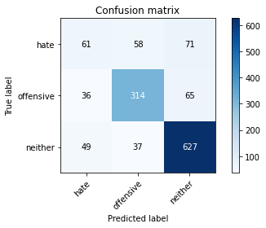

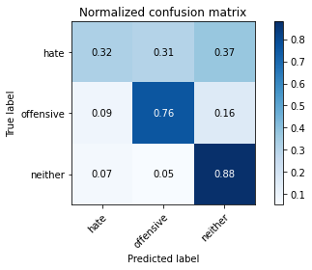

precision recall f1-score support

hate 0.42 0.32 0.36 190

offensive 0.77 0.76 0.76 415

neither 0.82 0.88 0.85 713

accuracy 0.76 1318

macro avg 0.67 0.65 0.66 1318

weighted avg 0.75 0.76 0.75 1318

average eval_loss: 0.5856784175742756, accuracy: 0.7602427921092565

training 3 epoch...

59.45397162437439 seconds used......

3 training finished! average train loss: 0.3238170504570007

evaluating...

Confusion matrix, without normalization

[[ 65 50 75]

[ 48 288 79]

[ 49 26 638]]

Normalized confusion matrix

[[0.34210526 0.26315789 0.39473684]

[0.11566265 0.6939759 0.19036145]

[0.0687237 0.03646564 0.89481066]]

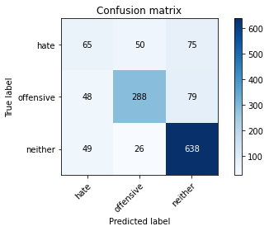

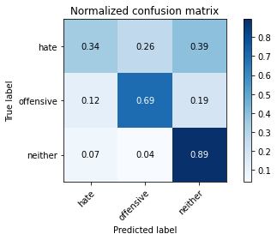

precision recall f1-score support

hate 0.40 0.34 0.37 190

offensive 0.79 0.69 0.74 415

neither 0.81 0.89 0.85 713

accuracy 0.75 1318

macro avg 0.67 0.64 0.65 1318

weighted avg 0.74 0.75 0.74 1318

average eval_loss: 0.6530233716422861, accuracy: 0.7518968133535661

training 4 epoch...

59.55943727493286 seconds used......

4 training finished! average train loss: 0.17722322110467675

evaluating...

Confusion matrix, without normalization

[[ 67 48 75]

[ 51 284 80]

[ 53 23 637]]

Normalized confusion matrix

[[0.35263158 0.25263158 0.39473684]

[0.12289157 0.68433735 0.19277108]

[0.0743338 0.03225806 0.89340813]]

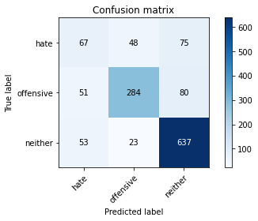

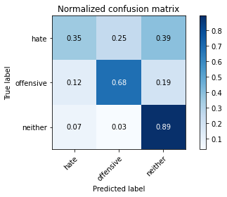

precision recall f1-score support

hate 0.39 0.35 0.37 190

offensive 0.80 0.68 0.74 415

neither 0.80 0.89 0.85 713

accuracy 0.75 1318

macro avg 0.67 0.64 0.65 1318

weighted avg 0.74 0.75 0.74 1318

average eval_loss: 0.8114190277728167, accuracy: 0.7496206373292867

training 5 epoch...

59.47372031211853 seconds used......

5 training finished! average train loss: 0.08879605594133451

evaluating...

Confusion matrix, without normalization

[[ 55 56 79]

[ 40 312 63]

[ 60 47 606]]

Normalized confusion matrix

[[0.28947368 0.29473684 0.41578947]

[0.09638554 0.75180723 0.15180723]

[0.08415147 0.06591865 0.84992987]]

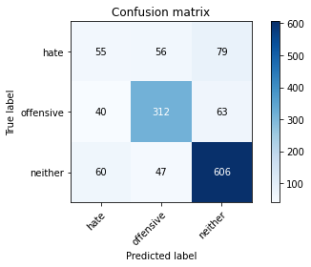

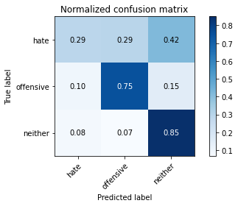

precision recall f1-score support

hate 0.35 0.29 0.32 190

offensive 0.75 0.75 0.75 415

neither 0.81 0.85 0.83 713

accuracy 0.74 1318

macro avg 0.64 0.63 0.63 1318

weighted avg 0.73 0.74 0.73 1318

average eval_loss: 0.9921467990586252, accuracy: 0.7382397572078907

training 6 epoch...

59.46758055686951 seconds used......

6 training finished! average train loss: 0.05936090749085204

evaluating...

Confusion matrix, without normalization

[[ 39 89 62]

[ 29 339 47]

[ 59 84 570]]

Normalized confusion matrix

[[0.20526316 0.46842105 0.32631579]

[0.06987952 0.81686747 0.11325301]

[0.08274895 0.11781206 0.79943899]]

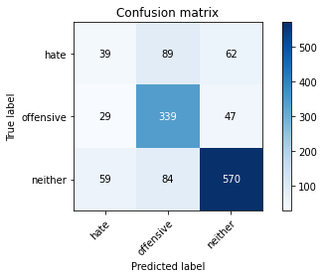

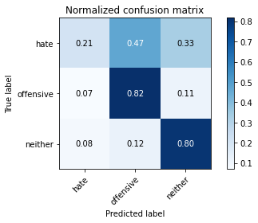

precision recall f1-score support

hate 0.31 0.21 0.25 190

offensive 0.66 0.82 0.73 415

neither 0.84 0.80 0.82 713

accuracy 0.72 1318

macro avg 0.60 0.61 0.60 1318

weighted avg 0.71 0.72 0.71 1318

average eval_loss: 1.30160700145996, accuracy: 0.7192716236722306

training 7 epoch...

59.5621063709259 seconds used......

7 training finished! average train loss: 0.03677259099733254

evaluating...

Confusion matrix, without normalization

[[ 54 76 60]

[ 37 327 51]

[ 68 66 579]]

Normalized confusion matrix

[[0.28421053 0.4 0.31578947]

[0.08915663 0.78795181 0.12289157]

[0.09537167 0.09256662 0.81206171]]

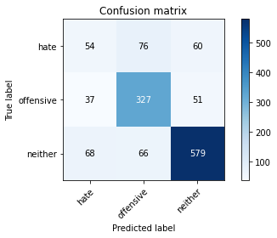

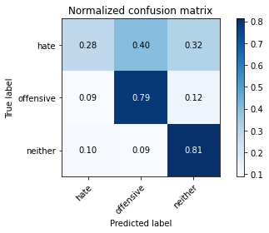

precision recall f1-score support

hate 0.34 0.28 0.31 190

offensive 0.70 0.79 0.74 415

neither 0.84 0.81 0.83 713

accuracy 0.73 1318

macro avg 0.63 0.63 0.62 1318

weighted avg 0.72 0.73 0.72 1318

average eval_loss: 1.2604778702511932, accuracy: 0.7283763277693475

training 8 epoch...

59.490944147109985 seconds used......

8 training finished! average train loss: 0.02636412034864241

evaluating...

Confusion matrix, without normalization

[[ 65 85 40]

[ 40 341 34]

[104 76 533]]

Normalized confusion matrix

[[0.34210526 0.44736842 0.21052632]

[0.09638554 0.82168675 0.08192771]

[0.14586255 0.10659187 0.74754558]]

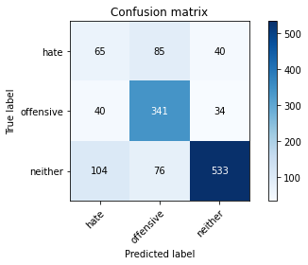

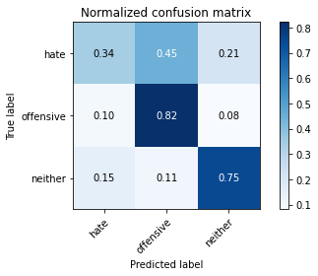

precision recall f1-score support

hate 0.31 0.34 0.33 190

offensive 0.68 0.82 0.74 415

neither 0.88 0.75 0.81 713

accuracy 0.71 1318

macro avg 0.62 0.64 0.63 1318

weighted avg 0.73 0.71 0.72 1318

average eval_loss: 1.4247920716350728, accuracy: 0.712443095599393

training 9 epoch...

59.49313735961914 seconds used......

9 training finished! average train loss: 0.020391944372783077

evaluating...

Confusion matrix, without normalization

[[ 49 76 65]

[ 36 325 54]

[ 65 61 587]]

Normalized confusion matrix

[[0.25789474 0.4 0.34210526]

[0.08674699 0.78313253 0.13012048]

[0.0911641 0.085554 0.82328191]]

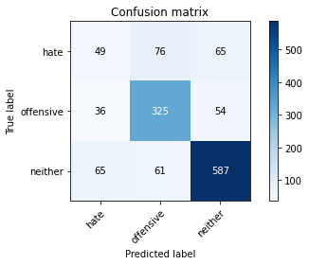

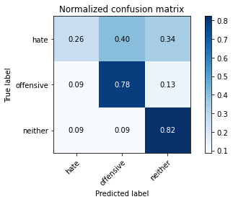

precision recall f1-score support

hate 0.33 0.26 0.29 190

offensive 0.70 0.78 0.74 415

neither 0.83 0.82 0.83 713

accuracy 0.73 1318

macro avg 0.62 0.62 0.62 1318

weighted avg 0.72 0.73 0.72 1318

average eval_loss: 1.334306925535202, accuracy: 0.7291350531107739

training 10 epoch...

59.4703414440155 seconds used......

10 training finished! average train loss: 0.016368786163961473

evaluating...

Confusion matrix, without normalization

[[ 75 58 57]

[ 66 297 52]

[ 80 46 587]]

Normalized confusion matrix

[[0.39473684 0.30526316 0.3 ]

[0.15903614 0.71566265 0.1253012 ]

[0.11220196 0.06451613 0.82328191]]

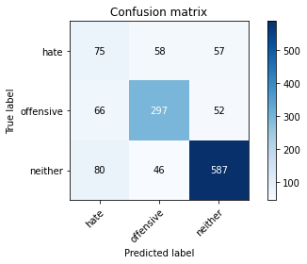

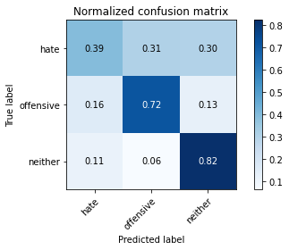

precision recall f1-score support

hate 0.34 0.39 0.36 190

offensive 0.74 0.72 0.73 415

neither 0.84 0.82 0.83 713

accuracy 0.73 1318

macro avg 0.64 0.64 0.64 1318

weighted avg 0.74 0.73 0.73 1318

average eval_loss: 1.299801933042931, accuracy: 0.7276176024279211

4 run......

training 1 epoch...

59.48211169242859 seconds used......

1 training finished! average train loss: 0.6900769512761723

evaluating...

Confusion matrix, without normalization

[[ 41 61 88]

[ 28 294 93]

[ 33 22 658]]

Normalized confusion matrix

[[0.21578947 0.32105263 0.46315789]

[0.06746988 0.70843373 0.22409639]

[0.04628331 0.03085554 0.92286115]]

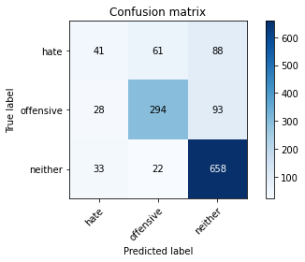

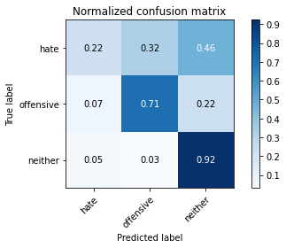

precision recall f1-score support

hate 0.40 0.22 0.28 190

offensive 0.78 0.71 0.74 415

neither 0.78 0.92 0.85 713

accuracy 0.75 1318

macro avg 0.66 0.62 0.62 1318

weighted avg 0.73 0.75 0.73 1318

average eval_loss: 0.5931914764823336, accuracy: 0.7534142640364189

training 2 epoch...

59.42715311050415 seconds used......

2 training finished! average train loss: 0.4854448218575933

evaluating...

Confusion matrix, without normalization

[[ 77 53 60]

[ 51 306 58]

[ 56 51 606]]

Normalized confusion matrix

[[0.40526316 0.27894737 0.31578947]

[0.12289157 0.7373494 0.13975904]

[0.07854137 0.07152875 0.84992987]]

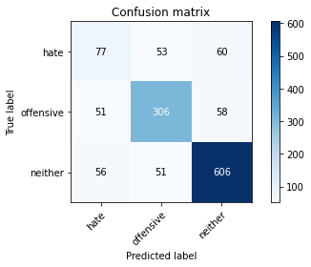

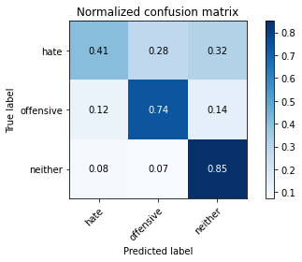

precision recall f1-score support

hate 0.42 0.41 0.41 190

offensive 0.75 0.74 0.74 415

neither 0.84 0.85 0.84 713

accuracy 0.75 1318

macro avg 0.67 0.66 0.67 1318

weighted avg 0.75 0.75 0.75 1318

average eval_loss: 0.5989525769696091, accuracy: 0.7503793626707133

training 3 epoch...

59.52976131439209 seconds used......

3 training finished! average train loss: 0.3399422837251967

evaluating...

Confusion matrix, without normalization

[[ 76 34 80]

[ 79 252 84]

[ 54 15 644]]

Normalized confusion matrix

[[0.4 0.17894737 0.42105263]

[0.19036145 0.60722892 0.20240964]

[0.07573633 0.02103787 0.90322581]]

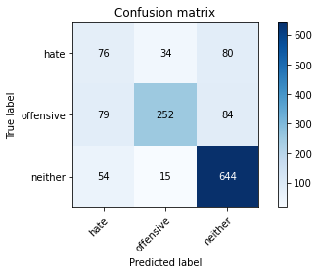

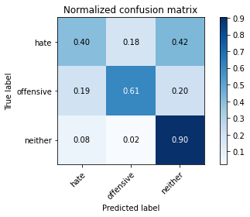

precision recall f1-score support

hate 0.36 0.40 0.38 190

offensive 0.84 0.61 0.70 415

neither 0.80 0.90 0.85 713

accuracy 0.74 1318

macro avg 0.67 0.64 0.64 1318

weighted avg 0.75 0.74 0.73 1318

average eval_loss: 0.6625358274940288, accuracy: 0.7374810318664643

training 4 epoch...

59.40441823005676 seconds used......

4 training finished! average train loss: 0.18579922693527556

evaluating...

Confusion matrix, without normalization

[[ 89 71 30]

[ 69 324 22]

[159 80 474]]

Normalized confusion matrix

[[0.46842105 0.37368421 0.15789474]

[0.16626506 0.78072289 0.05301205]

[0.2230014 0.11220196 0.66479663]]

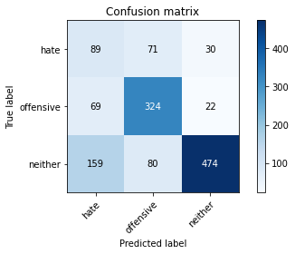

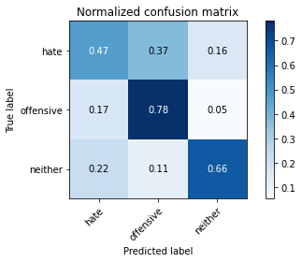

precision recall f1-score support

hate 0.28 0.47 0.35 190

offensive 0.68 0.78 0.73 415

neither 0.90 0.66 0.77 713

accuracy 0.67 1318

macro avg 0.62 0.64 0.61 1318

weighted avg 0.74 0.67 0.69 1318

average eval_loss: 1.093430883956678, accuracy: 0.6729893778452201

training 5 epoch...

59.461631298065186 seconds used......

5 training finished! average train loss: 0.09119176090356301

evaluating...

Confusion matrix, without normalization

[[ 62 64 64]

[ 58 316 41]

[ 93 58 562]]

Normalized confusion matrix

[[0.32631579 0.33684211 0.33684211]

[0.13975904 0.76144578 0.09879518]

[0.13043478 0.08134642 0.78821879]]

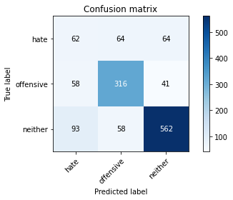

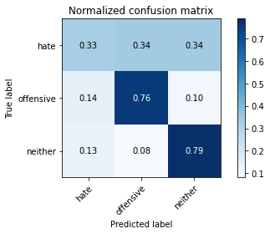

precision recall f1-score support

hate 0.29 0.33 0.31 190

offensive 0.72 0.76 0.74 415

neither 0.84 0.79 0.81 713

accuracy 0.71 1318

macro avg 0.62 0.63 0.62 1318

weighted avg 0.72 0.71 0.72 1318

average eval_loss: 1.1580380260041265, accuracy: 0.7132018209408194

training 6 epoch...

59.4381058216095 seconds used......

6 training finished! average train loss: 0.05363031164002181

evaluating...

Confusion matrix, without normalization

[[ 48 71 71]

[ 51 315 49]

[ 75 55 583]]

Normalized confusion matrix

[[0.25263158 0.37368421 0.37368421]

[0.12289157 0.75903614 0.11807229]

[0.10518934 0.07713885 0.81767181]]

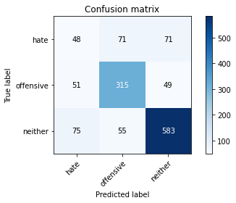

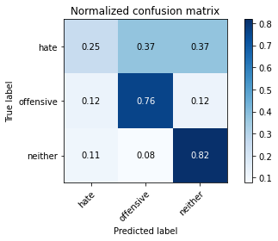

precision recall f1-score support

hate 0.28 0.25 0.26 190

offensive 0.71 0.76 0.74 415

neither 0.83 0.82 0.82 713

accuracy 0.72 1318

macro avg 0.61 0.61 0.61 1318

weighted avg 0.71 0.72 0.72 1318

average eval_loss: 1.2700425494800915, accuracy: 0.7177541729893778

training 7 epoch...

59.42645525932312 seconds used......

7 training finished! average train loss: 0.037402758073188706

evaluating...

Confusion matrix, without normalization

[[ 48 71 71]

[ 41 322 52]

[ 60 61 592]]

Normalized confusion matrix

[[0.25263158 0.37368421 0.37368421]

[0.09879518 0.77590361 0.1253012 ]

[0.08415147 0.085554 0.83029453]]

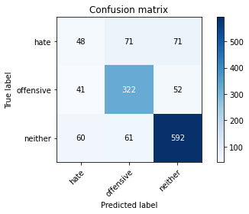

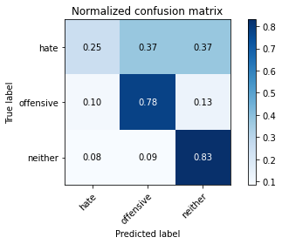

precision recall f1-score support

hate 0.32 0.25 0.28 190

offensive 0.71 0.78 0.74 415

neither 0.83 0.83 0.83 713

accuracy 0.73 1318

macro avg 0.62 0.62 0.62 1318

weighted avg 0.72 0.73 0.72 1318

average eval_loss: 1.2453035992203336, accuracy: 0.7298937784522003

training 8 epoch...

59.478238344192505 seconds used......

8 training finished! average train loss: 0.020625262198551684

evaluating...

Confusion matrix, without normalization

[[ 59 75 56]

[ 53 312 50]

[ 63 70 580]]

Normalized confusion matrix

[[0.31052632 0.39473684 0.29473684]

[0.12771084 0.75180723 0.12048193]

[0.08835905 0.09817672 0.81346424]]

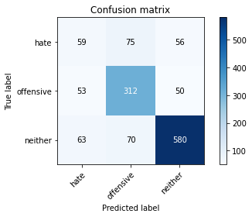

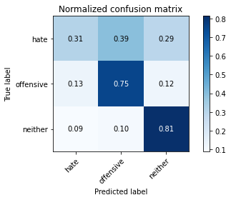

precision recall f1-score support

hate 0.34 0.31 0.32 190

offensive 0.68 0.75 0.72 415

neither 0.85 0.81 0.83 713

accuracy 0.72 1318

macro avg 0.62 0.63 0.62 1318

weighted avg 0.72 0.72 0.72 1318

average eval_loss: 1.4004919267061986, accuracy: 0.7215477996965098

training 9 epoch...

59.46267056465149 seconds used......

9 training finished! average train loss: 0.02164397162483841

evaluating...

Confusion matrix, without normalization

[[ 58 79 53]

[ 53 330 32]

[ 92 76 545]]

Normalized confusion matrix

[[0.30526316 0.41578947 0.27894737]

[0.12771084 0.79518072 0.07710843]

[0.12903226 0.10659187 0.76437588]]

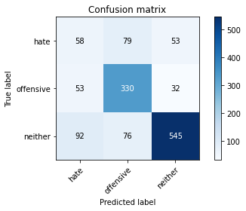

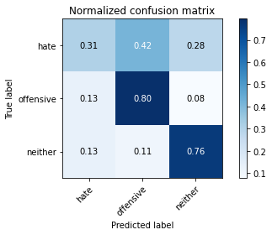

precision recall f1-score support

hate 0.29 0.31 0.30 190

offensive 0.68 0.80 0.73 415

neither 0.87 0.76 0.81 713

accuracy 0.71 1318

macro avg 0.61 0.62 0.61 1318

weighted avg 0.72 0.71 0.71 1318

average eval_loss: 1.523017434459744, accuracy: 0.7078907435508346

training 10 epoch...

59.49936389923096 seconds used......

10 training finished! average train loss: 0.015152951799708799

evaluating...

Confusion matrix, without normalization

[[ 34 100 56]

[ 25 351 39]

[ 49 102 562]]

Normalized confusion matrix

[[0.17894737 0.52631579 0.29473684]

[0.06024096 0.84578313 0.0939759 ]

[0.0687237 0.1430575 0.78821879]]

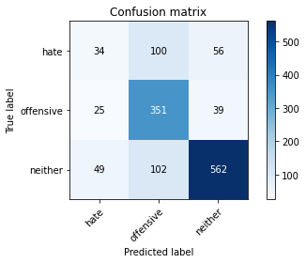

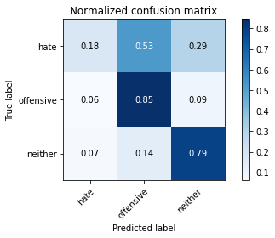

precision recall f1-score support

hate 0.31 0.18 0.23 190

offensive 0.63 0.85 0.73 415

neither 0.86 0.79 0.82 713

accuracy 0.72 1318

macro avg 0.60 0.60 0.59 1318

weighted avg 0.71 0.72 0.71 1318

average eval_loss: 1.7584723821192076, accuracy: 0.7185128983308042

5 run......

training 1 epoch...

59.524449825286865 seconds used......

1 training finished! average train loss: 0.6952872512015429

evaluating...

Confusion matrix, without normalization

[[ 47 72 71]

[ 24 307 84]

[ 44 28 641]]

Normalized confusion matrix

[[0.24736842 0.37894737 0.37368421]

[0.05783133 0.73975904 0.20240964]

[0.06171108 0.03927069 0.89901823]]

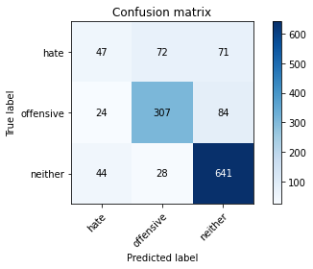

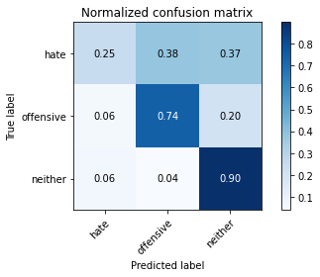

precision recall f1-score support

hate 0.41 0.25 0.31 190

offensive 0.75 0.74 0.75 415

neither 0.81 0.90 0.85 713

accuracy 0.75 1318

macro avg 0.66 0.63 0.63 1318

weighted avg 0.73 0.75 0.74 1318

average eval_loss: 0.5811064220739134, accuracy: 0.7549317147192717

training 2 epoch...

59.474886417388916 seconds used......

2 training finished! average train loss: 0.49897817339409484

evaluating...

Confusion matrix, without normalization

[[ 23 60 107]

[ 15 272 128]

[ 13 11 689]]

Normalized confusion matrix

[[0.12105263 0.31578947 0.56315789]

[0.03614458 0.65542169 0.30843373]

[0.01823282 0.01542777 0.96633941]]

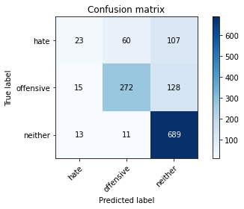

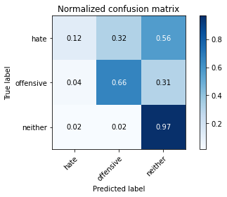

precision recall f1-score support

hate 0.45 0.12 0.19 190

offensive 0.79 0.66 0.72 415

neither 0.75 0.97 0.84 713

accuracy 0.75 1318

macro avg 0.66 0.58 0.58 1318

weighted avg 0.72 0.75 0.71 1318

average eval_loss: 0.5727038044821132, accuracy: 0.7465857359635811

training 3 epoch...

59.50565218925476 seconds used......

3 training finished! average train loss: 0.33956436948342755

evaluating...

Confusion matrix, without normalization

[[ 50 58 82]

[ 48 283 84]

[ 55 22 636]]

Normalized confusion matrix

[[0.26315789 0.30526316 0.43157895]

[0.11566265 0.68192771 0.20240964]

[0.07713885 0.03085554 0.89200561]]

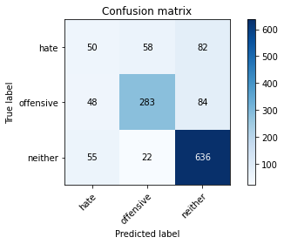

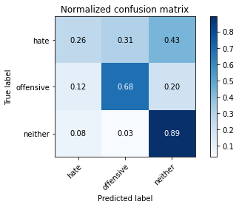

precision recall f1-score support

hate 0.33 0.26 0.29 190

offensive 0.78 0.68 0.73 415

neither 0.79 0.89 0.84 713

accuracy 0.74 1318

macro avg 0.63 0.61 0.62 1318

weighted avg 0.72 0.74 0.73 1318

average eval_loss: 0.6746227736725952, accuracy: 0.7352048558421851

training 4 epoch...

59.53602147102356 seconds used......

4 training finished! average train loss: 0.1713207579810511

evaluating...

Confusion matrix, without normalization

[[ 76 76 38]

[ 56 321 38]

[135 57 521]]

Normalized confusion matrix

[[0.4 0.4 0.2 ]

[0.13493976 0.77349398 0.09156627]

[0.18934081 0.0799439 0.73071529]]

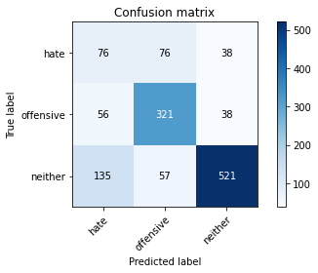

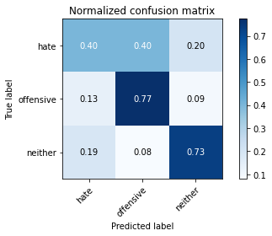

precision recall f1-score support

hate 0.28 0.40 0.33 190

offensive 0.71 0.77 0.74 415

neither 0.87 0.73 0.80 713

accuracy 0.70 1318

macro avg 0.62 0.63 0.62 1318

weighted avg 0.74 0.70 0.71 1318

average eval_loss: 1.0421091990940499, accuracy: 0.6965098634294385

training 5 epoch...

59.57241892814636 seconds used......

5 training finished! average train loss: 0.07917816783301532

evaluating...

Confusion matrix, without normalization

[[ 72 62 56]

[ 52 314 49]

[ 60 61 592]]

Normalized confusion matrix

[[0.37894737 0.32631579 0.29473684]

[0.1253012 0.75662651 0.11807229]

[0.08415147 0.085554 0.83029453]]

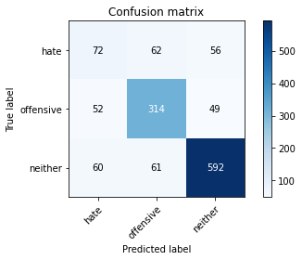

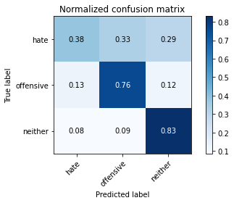

precision recall f1-score support

hate 0.39 0.38 0.39 190

offensive 0.72 0.76 0.74 415

neither 0.85 0.83 0.84 713

accuracy 0.74 1318

macro avg 0.65 0.66 0.65 1318

weighted avg 0.74 0.74 0.74 1318

average eval_loss: 1.0746950051098159, accuracy: 0.7420333839150227

training 6 epoch...

59.57556653022766 seconds used......

6 training finished! average train loss: 0.04968943450525826

evaluating...

Confusion matrix, without normalization

[[ 66 53 71]

[ 69 279 67]

[ 69 30 614]]

Normalized confusion matrix

[[0.34736842 0.27894737 0.37368421]

[0.16626506 0.67228916 0.16144578]

[0.09677419 0.04207574 0.86115007]]

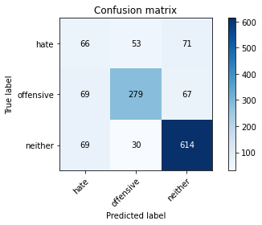

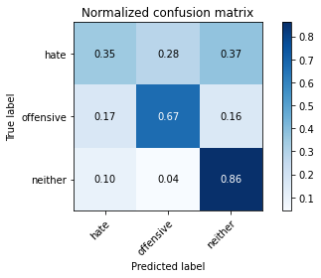

precision recall f1-score support

hate 0.32 0.35 0.34 190

offensive 0.77 0.67 0.72 415

neither 0.82 0.86 0.84 713

accuracy 0.73 1318

macro avg 0.64 0.63 0.63 1318

weighted avg 0.73 0.73 0.73 1318

average eval_loss: 1.1380636895244771, accuracy: 0.7276176024279211

training 7 epoch...

59.57214379310608 seconds used......

7 training finished! average train loss: 0.029534568476281657

evaluating...

Confusion matrix, without normalization

[[ 58 79 53]

[ 36 327 52]

[ 62 86 565]]

Normalized confusion matrix

[[0.30526316 0.41578947 0.27894737]

[0.08674699 0.78795181 0.1253012 ]

[0.08695652 0.12061711 0.79242637]]

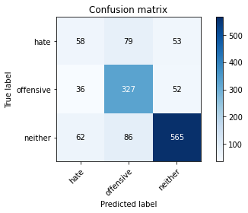

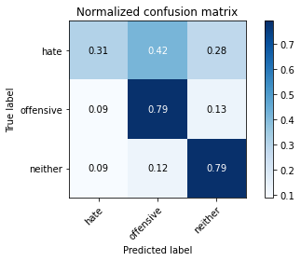

precision recall f1-score support

hate 0.37 0.31 0.34 190

offensive 0.66 0.79 0.72 415

neither 0.84 0.79 0.82 713

accuracy 0.72 1318

macro avg 0.63 0.63 0.62 1318

weighted avg 0.72 0.72 0.72 1318

average eval_loss: 1.400021030144258, accuracy: 0.7207890743550834

training 8 epoch...

59.4253876209259 seconds used......

8 training finished! average train loss: 0.030949805114174854

evaluating...

Confusion matrix, without normalization

[[ 71 81 38]

[ 58 328 29]

[112 89 512]]

Normalized confusion matrix

[[0.37368421 0.42631579 0.2 ]

[0.13975904 0.79036145 0.06987952]

[0.15708275 0.12482468 0.71809257]]

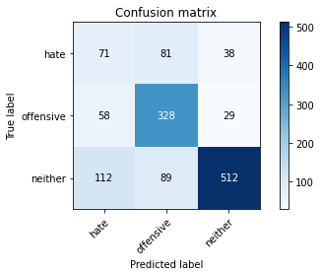

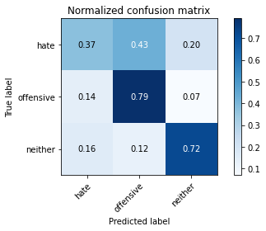

precision recall f1-score support

hate 0.29 0.37 0.33 190

offensive 0.66 0.79 0.72 415

neither 0.88 0.72 0.79 713

accuracy 0.69 1318

macro avg 0.61 0.63 0.61 1318

weighted avg 0.73 0.69 0.70 1318

average eval_loss: 1.5808414884588935, accuracy: 0.6911987860394537

training 9 epoch...

59.546306133270264 seconds used......

9 training finished! average train loss: 0.021266432814114854

evaluating...

Confusion matrix, without normalization

[[ 67 65 58]

[ 56 307 52]

[ 77 48 588]]

Normalized confusion matrix

[[0.35263158 0.34210526 0.30526316]

[0.13493976 0.73975904 0.1253012 ]

[0.10799439 0.06732118 0.82468443]]

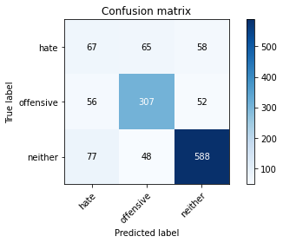

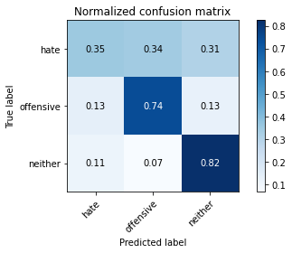

precision recall f1-score support

hate 0.34 0.35 0.34 190

offensive 0.73 0.74 0.74 415

neither 0.84 0.82 0.83 713

accuracy 0.73 1318

macro avg 0.64 0.64 0.64 1318

weighted avg 0.73 0.73 0.73 1318

average eval_loss: 1.3766990015001008, accuracy: 0.7298937784522003

training 10 epoch...

59.49349236488342 seconds used......

10 training finished! average train loss: 0.01843927689544878

evaluating...

Confusion matrix, without normalization

[[ 82 67 41]

[ 70 314 31]

[114 72 527]]

Normalized confusion matrix

[[0.43157895 0.35263158 0.21578947]

[0.1686747 0.75662651 0.0746988 ]

[0.1598878 0.10098177 0.73913043]]

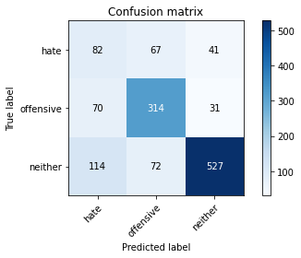

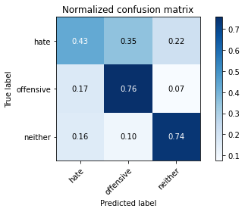

precision recall f1-score support

hate 0.31 0.43 0.36 190

offensive 0.69 0.76 0.72 415

neither 0.88 0.74 0.80 713

accuracy 0.70 1318

macro avg 0.63 0.64 0.63 1318

weighted avg 0.74 0.70 0.71 1318

average eval_loss: 1.6834190632357742, accuracy: 0.7003034901365706