1.5,0.5,1

1 run......

training 1 epoch...

59.51098871231079 seconds used......

1 training finished! average train loss: 0.7436285765333609

evaluating...

Confusion matrix, without normalization

[[130 35 25]

[127 267 21]

[204 23 486]]

Normalized confusion matrix

[[0.68421053 0.18421053 0.13157895]

[0.3060241 0.64337349 0.05060241]

[0.28611501 0.03225806 0.68162693]]

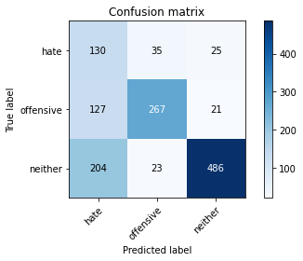

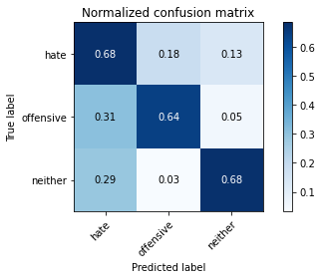

precision recall f1-score support

hate 0.28 0.68 0.40 190

offensive 0.82 0.64 0.72 415

neither 0.91 0.68 0.78 713

accuracy 0.67 1318

macro avg 0.67 0.67 0.63 1318

weighted avg 0.79 0.67 0.71 1318

average eval_loss: 0.7163523828441446, accuracy: 0.6699544764795144

training 2 epoch...

59.49654030799866 seconds used......

2 training finished! average train loss: 0.5320357480509714

evaluating...

Confusion matrix, without normalization

[[111 36 43]

[ 97 292 26]

[156 45 512]]

Normalized confusion matrix

[[0.58421053 0.18947368 0.22631579]

[0.23373494 0.70361446 0.0626506 ]

[0.21879383 0.0631136 0.71809257]]

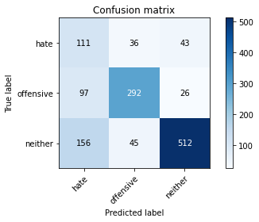

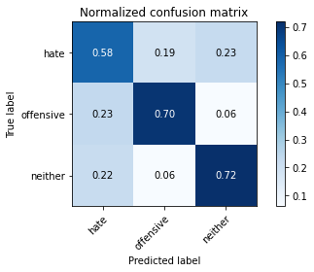

precision recall f1-score support

hate 0.30 0.58 0.40 190

offensive 0.78 0.70 0.74 415

neither 0.88 0.72 0.79 713

accuracy 0.69 1318

macro avg 0.66 0.67 0.64 1318

weighted avg 0.77 0.69 0.72 1318

average eval_loss: 0.7021426404967452, accuracy: 0.6942336874051593

training 3 epoch...

59.560202836990356 seconds used......

3 training finished! average train loss: 0.3575337130915035

evaluating...

Confusion matrix, without normalization

[[ 75 58 57]

[ 59 315 41]

[106 50 557]]

Normalized confusion matrix

[[0.39473684 0.30526316 0.3 ]

[0.14216867 0.75903614 0.09879518]

[0.1486676 0.07012623 0.78120617]]

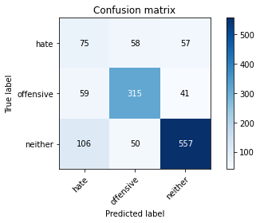

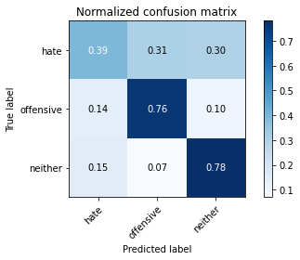

precision recall f1-score support

hate 0.31 0.39 0.35 190

offensive 0.74 0.76 0.75 415

neither 0.85 0.78 0.81 713

accuracy 0.72 1318

macro avg 0.64 0.64 0.64 1318

weighted avg 0.74 0.72 0.73 1318

average eval_loss: 0.8134833109198194, accuracy: 0.7185128983308042

training 4 epoch...

59.53324222564697 seconds used......

4 training finished! average train loss: 0.18566823449324477

evaluating...

Confusion matrix, without normalization

[[ 90 38 62]

[ 74 274 67]

[ 87 22 604]]

Normalized confusion matrix

[[0.47368421 0.2 0.32631579]

[0.17831325 0.66024096 0.16144578]

[0.12201964 0.03085554 0.84712482]]

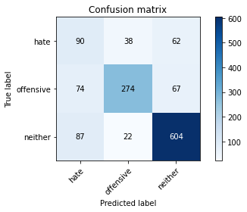

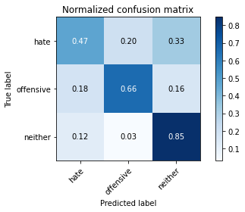

precision recall f1-score support

hate 0.36 0.47 0.41 190

offensive 0.82 0.66 0.73 415

neither 0.82 0.85 0.84 713

accuracy 0.73 1318

macro avg 0.67 0.66 0.66 1318

weighted avg 0.76 0.73 0.74 1318

average eval_loss: 0.8942946272365975, accuracy: 0.7344461305007587

training 5 epoch...

59.60875701904297 seconds used......

5 training finished! average train loss: 0.09827531265539372

evaluating...

Confusion matrix, without normalization

[[ 92 64 34]

[ 72 311 32]

[124 66 523]]

Normalized confusion matrix

[[0.48421053 0.33684211 0.17894737]

[0.17349398 0.74939759 0.07710843]

[0.17391304 0.09256662 0.73352034]]

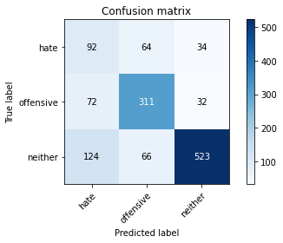

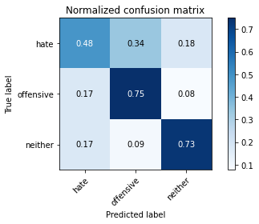

precision recall f1-score support

hate 0.32 0.48 0.38 190

offensive 0.71 0.75 0.73 415

neither 0.89 0.73 0.80 713

accuracy 0.70 1318

macro avg 0.64 0.66 0.64 1318

weighted avg 0.75 0.70 0.72 1318

average eval_loss: 1.2093690308657559, accuracy: 0.7025796661608498

training 6 epoch...

59.52619004249573 seconds used......

6 training finished! average train loss: 0.05283676063223869

evaluating...

Confusion matrix, without normalization

[[ 90 47 53]

[ 71 293 51]

[114 28 571]]

Normalized confusion matrix

[[0.47368421 0.24736842 0.27894737]

[0.17108434 0.7060241 0.12289157]

[0.1598878 0.03927069 0.80084151]]

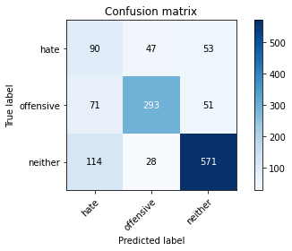

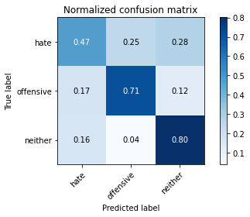

precision recall f1-score support

hate 0.33 0.47 0.39 190

offensive 0.80 0.71 0.75 415

neither 0.85 0.80 0.82 713

accuracy 0.72 1318

macro avg 0.66 0.66 0.65 1318

weighted avg 0.76 0.72 0.74 1318

average eval_loss: 1.2410377769759207, accuracy: 0.723823975720789

training 7 epoch...

59.52402639389038 seconds used......

7 training finished! average train loss: 0.033294072057800474

evaluating...

Confusion matrix, without normalization

[[ 59 73 58]

[ 51 315 49]

[ 90 46 577]]

Normalized confusion matrix

[[0.31052632 0.38421053 0.30526316]

[0.12289157 0.75903614 0.11807229]

[0.12622721 0.06451613 0.80925666]]

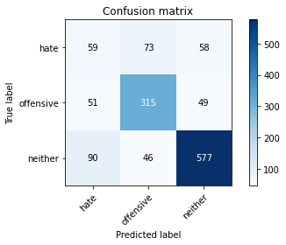

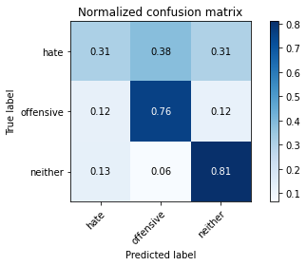

precision recall f1-score support

hate 0.29 0.31 0.30 190

offensive 0.73 0.76 0.74 415

neither 0.84 0.81 0.83 713

accuracy 0.72 1318

macro avg 0.62 0.63 0.62 1318

weighted avg 0.73 0.72 0.72 1318

average eval_loss: 1.4661175495747365, accuracy: 0.7215477996965098

training 8 epoch...

59.56514096260071 seconds used......

8 training finished! average train loss: 0.03178745165536053

evaluating...

Confusion matrix, without normalization

[[ 80 44 66]

[ 86 266 63]

[ 93 32 588]]

Normalized confusion matrix

[[0.42105263 0.23157895 0.34736842]

[0.20722892 0.64096386 0.15180723]

[0.13043478 0.04488079 0.82468443]]

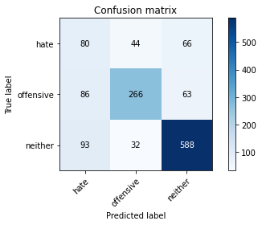

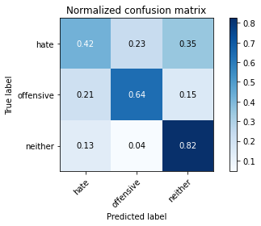

precision recall f1-score support

hate 0.31 0.42 0.36 190

offensive 0.78 0.64 0.70 415

neither 0.82 0.82 0.82 713

accuracy 0.71 1318

macro avg 0.64 0.63 0.63 1318

weighted avg 0.73 0.71 0.72 1318

average eval_loss: 1.375191294785702, accuracy: 0.708649468892261

training 9 epoch...

59.53515124320984 seconds used......

9 training finished! average train loss: 0.02491561936562489

evaluating...

Confusion matrix, without normalization

[[ 66 75 49]

[ 51 318 46]

[ 92 72 549]]

Normalized confusion matrix

[[0.34736842 0.39473684 0.25789474]

[0.12289157 0.76626506 0.11084337]

[0.12903226 0.10098177 0.76998597]]

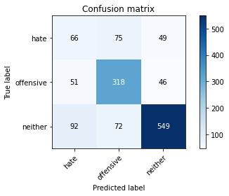

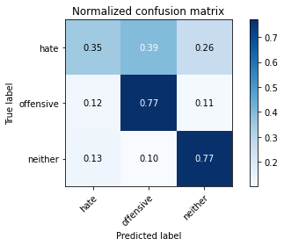

precision recall f1-score support

hate 0.32 0.35 0.33 190

offensive 0.68 0.77 0.72 415

neither 0.85 0.77 0.81 713

accuracy 0.71 1318

macro avg 0.62 0.63 0.62 1318

weighted avg 0.72 0.71 0.71 1318

average eval_loss: 1.5695084441791882, accuracy: 0.7078907435508346

training 10 epoch...

59.50482630729675 seconds used......

10 training finished! average train loss: 0.01898878292813606

evaluating...

Confusion matrix, without normalization

[[ 67 63 60]

[ 66 301 48]

[ 98 51 564]]

Normalized confusion matrix

[[0.35263158 0.33157895 0.31578947]

[0.15903614 0.7253012 0.11566265]

[0.13744741 0.07152875 0.79102384]]

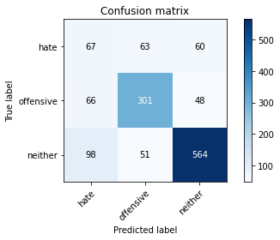

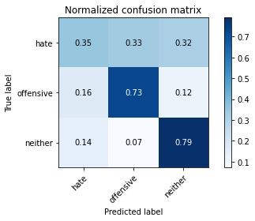

precision recall f1-score support

hate 0.29 0.35 0.32 190

offensive 0.73 0.73 0.73 415

neither 0.84 0.79 0.81 713

accuracy 0.71 1318

macro avg 0.62 0.62 0.62 1318

weighted avg 0.72 0.71 0.71 1318

average eval_loss: 1.539453755725514, accuracy: 0.7071320182094082

2 run......

training 1 epoch...

59.622127056121826 seconds used......

1 training finished! average train loss: 0.7530451679771597

evaluating...

Confusion matrix, without normalization

[[116 23 51]

[140 220 55]

[115 6 592]]

Normalized confusion matrix

[[0.61052632 0.12105263 0.26842105]

[0.3373494 0.53012048 0.13253012]

[0.16129032 0.00841515 0.83029453]]

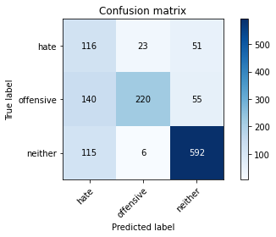

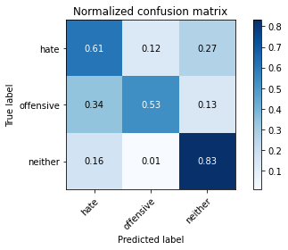

precision recall f1-score support

hate 0.31 0.61 0.41 190

offensive 0.88 0.53 0.66 415

neither 0.85 0.83 0.84 713

accuracy 0.70 1318

macro avg 0.68 0.66 0.64 1318

weighted avg 0.78 0.70 0.72 1318

average eval_loss: 0.6230591242060517, accuracy: 0.7040971168437026

training 2 epoch...

59.530362606048584 seconds used......

2 training finished! average train loss: 0.5269697099416093

evaluating...

Confusion matrix, without normalization

[[ 71 82 37]

[ 41 337 37]

[116 55 542]]

Normalized confusion matrix

[[0.37368421 0.43157895 0.19473684]

[0.09879518 0.81204819 0.08915663]

[0.16269285 0.07713885 0.7601683 ]]

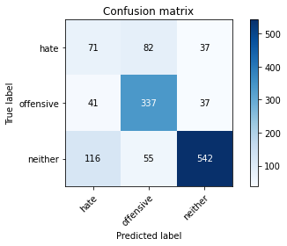

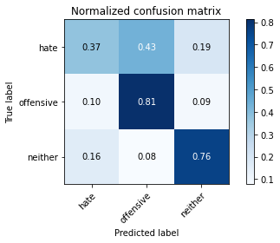

precision recall f1-score support

hate 0.31 0.37 0.34 190

offensive 0.71 0.81 0.76 415

neither 0.88 0.76 0.82 713

accuracy 0.72 1318

macro avg 0.63 0.65 0.64 1318

weighted avg 0.74 0.72 0.73 1318

average eval_loss: 0.7377729298490466, accuracy: 0.7207890743550834

training 3 epoch...

59.57107710838318 seconds used......

3 training finished! average train loss: 0.3496690024029125

evaluating...

Confusion matrix, without normalization

[[106 37 47]

[107 266 42]

[130 22 561]]

Normalized confusion matrix

[[0.55789474 0.19473684 0.24736842]

[0.25783133 0.64096386 0.10120482]

[0.18232819 0.03085554 0.78681627]]

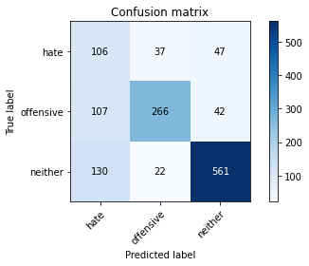

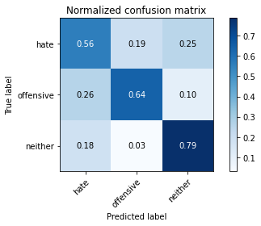

precision recall f1-score support

hate 0.31 0.56 0.40 190

offensive 0.82 0.64 0.72 415

neither 0.86 0.79 0.82 713

accuracy 0.71 1318

macro avg 0.66 0.66 0.65 1318

weighted avg 0.77 0.71 0.73 1318

average eval_loss: 0.7105860538554915, accuracy: 0.7078907435508346

training 4 epoch...

59.49768090248108 seconds used......

4 training finished! average train loss: 0.18734759664670989

evaluating...

Confusion matrix, without normalization

[[117 39 34]

[105 274 36]

[172 23 518]]

Normalized confusion matrix

[[0.61578947 0.20526316 0.17894737]

[0.25301205 0.66024096 0.08674699]

[0.24123422 0.03225806 0.72650771]]

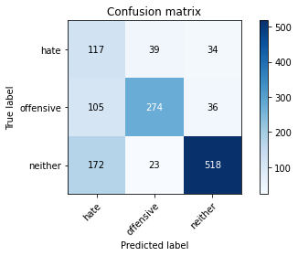

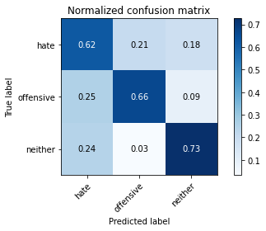

precision recall f1-score support

hate 0.30 0.62 0.40 190

offensive 0.82 0.66 0.73 415

neither 0.88 0.73 0.80 713

accuracy 0.69 1318

macro avg 0.66 0.67 0.64 1318

weighted avg 0.78 0.69 0.72 1318

average eval_loss: 0.9412421936338599, accuracy: 0.6896813353566009

training 5 epoch...

59.495864152908325 seconds used......

5 training finished! average train loss: 0.09567700530910357

evaluating...

Confusion matrix, without normalization

[[ 52 82 56]

[ 32 333 50]

[ 55 91 567]]

Normalized confusion matrix

[[0.27368421 0.43157895 0.29473684]

[0.07710843 0.80240964 0.12048193]

[0.07713885 0.12762973 0.79523142]]

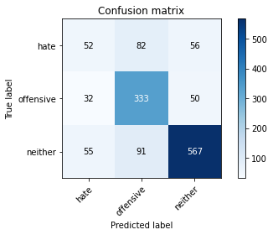

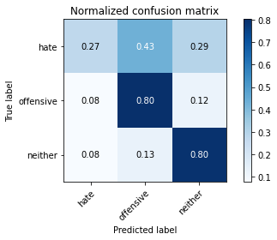

precision recall f1-score support

hate 0.37 0.27 0.32 190

offensive 0.66 0.80 0.72 415

neither 0.84 0.80 0.82 713

accuracy 0.72 1318

macro avg 0.62 0.62 0.62 1318

weighted avg 0.72 0.72 0.72 1318

average eval_loss: 1.2682983947522712, accuracy: 0.7223065250379362

training 6 epoch...

59.452765703201294 seconds used......

6 training finished! average train loss: 0.05047517020932653

evaluating...

Confusion matrix, without normalization

[[ 68 81 41]

[ 36 345 34]

[ 95 89 529]]

Normalized confusion matrix

[[0.35789474 0.42631579 0.21578947]

[0.08674699 0.8313253 0.08192771]

[0.13323983 0.12482468 0.74193548]]

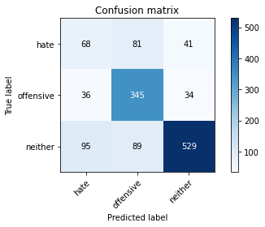

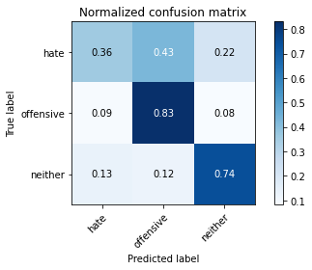

precision recall f1-score support

hate 0.34 0.36 0.35 190

offensive 0.67 0.83 0.74 415

neither 0.88 0.74 0.80 713

accuracy 0.71 1318

macro avg 0.63 0.64 0.63 1318

weighted avg 0.73 0.71 0.72 1318

average eval_loss: 1.4924081053697702, accuracy: 0.7147192716236722

training 7 epoch...

59.536839962005615 seconds used......

7 training finished! average train loss: 0.0386753493753283

evaluating...

Confusion matrix, without normalization

[[ 86 51 53]

[ 58 285 72]

[ 95 37 581]]

Normalized confusion matrix

[[0.45263158 0.26842105 0.27894737]

[0.13975904 0.68674699 0.17349398]

[0.13323983 0.05189341 0.81486676]]

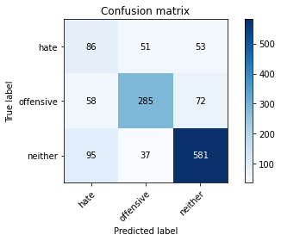

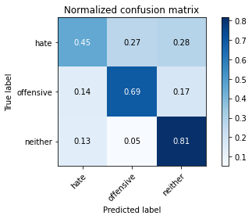

precision recall f1-score support

hate 0.36 0.45 0.40 190

offensive 0.76 0.69 0.72 415

neither 0.82 0.81 0.82 713

accuracy 0.72 1318

macro avg 0.65 0.65 0.65 1318

weighted avg 0.74 0.72 0.73 1318

average eval_loss: 1.2111121447700444, accuracy: 0.7223065250379362

training 8 epoch...

59.49577307701111 seconds used......

8 training finished! average train loss: 0.030486346160019325

evaluating...

Confusion matrix, without normalization

[[ 65 67 58]

[ 47 324 44]

[ 74 77 562]]

Normalized confusion matrix

[[0.34210526 0.35263158 0.30526316]

[0.11325301 0.78072289 0.1060241 ]

[0.10378682 0.10799439 0.78821879]]

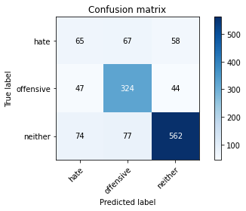

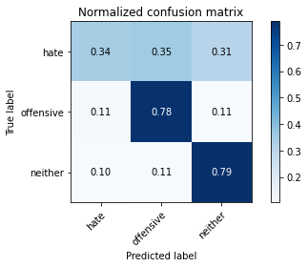

precision recall f1-score support

hate 0.35 0.34 0.35 190

offensive 0.69 0.78 0.73 415

neither 0.85 0.79 0.82 713

accuracy 0.72 1318

macro avg 0.63 0.64 0.63 1318

weighted avg 0.73 0.72 0.72 1318

average eval_loss: 1.3669680618878566, accuracy: 0.7215477996965098

training 9 epoch...

59.54582190513611 seconds used......

9 training finished! average train loss: 0.030246440610128707

evaluating...

Confusion matrix, without normalization

[[ 46 85 59]

[ 27 346 42]

[ 63 96 554]]

Normalized confusion matrix

[[0.24210526 0.44736842 0.31052632]

[0.06506024 0.83373494 0.10120482]

[0.08835905 0.13464236 0.7769986 ]]

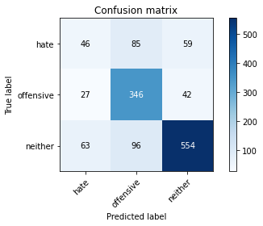

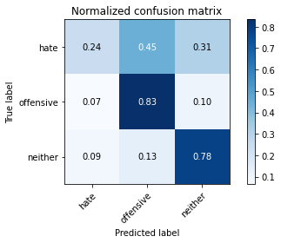

precision recall f1-score support

hate 0.34 0.24 0.28 190

offensive 0.66 0.83 0.73 415

neither 0.85 0.78 0.81 713

accuracy 0.72 1318

macro avg 0.61 0.62 0.61 1318

weighted avg 0.71 0.72 0.71 1318

average eval_loss: 1.8227727471879034, accuracy: 0.7177541729893778

training 10 epoch...

59.44516205787659 seconds used......

10 training finished! average train loss: 0.015992697215948613

evaluating...

Confusion matrix, without normalization

[[ 52 81 57]

[ 35 332 48]

[ 62 76 575]]

Normalized confusion matrix

[[0.27368421 0.42631579 0.3 ]

[0.08433735 0.8 0.11566265]

[0.08695652 0.10659187 0.80645161]]

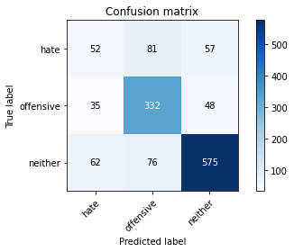

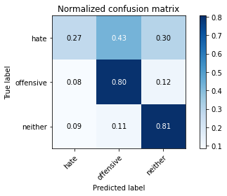

precision recall f1-score support

hate 0.35 0.27 0.31 190

offensive 0.68 0.80 0.73 415

neither 0.85 0.81 0.83 713

accuracy 0.73 1318

macro avg 0.62 0.63 0.62 1318

weighted avg 0.72 0.73 0.72 1318

average eval_loss: 1.7040546400980516, accuracy: 0.7276176024279211

3 run......

training 1 epoch...

59.42616081237793 seconds used......

1 training finished! average train loss: 0.7507385294545781

evaluating...

Confusion matrix, without normalization

[[ 66 62 62]

[ 55 313 47]

[ 62 42 609]]

Normalized confusion matrix

[[0.34736842 0.32631579 0.32631579]

[0.13253012 0.75421687 0.11325301]

[0.08695652 0.05890603 0.85413745]]

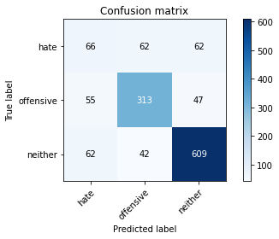

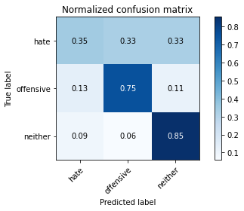

precision recall f1-score support

hate 0.36 0.35 0.35 190

offensive 0.75 0.75 0.75 415

neither 0.85 0.85 0.85 713

accuracy 0.75 1318

macro avg 0.65 0.65 0.65 1318

weighted avg 0.75 0.75 0.75 1318

average eval_loss: 0.6388983789718512, accuracy: 0.7496206373292867

training 2 epoch...

59.483036041259766 seconds used......

2 training finished! average train loss: 0.5376865506510843

evaluating...

Confusion matrix, without normalization

[[123 27 40]

[135 236 44]

[155 16 542]]

Normalized confusion matrix

[[0.64736842 0.14210526 0.21052632]

[0.3253012 0.5686747 0.1060241 ]

[0.2173913 0.02244039 0.7601683 ]]

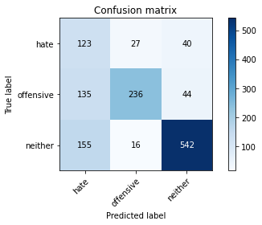

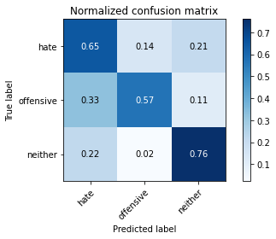

precision recall f1-score support

hate 0.30 0.65 0.41 190

offensive 0.85 0.57 0.68 415

neither 0.87 0.76 0.81 713

accuracy 0.68 1318

macro avg 0.67 0.66 0.63 1318

weighted avg 0.78 0.68 0.71 1318

average eval_loss: 0.6538468314842745, accuracy: 0.6836115326251897

training 3 epoch...

59.510119676589966 seconds used......

3 training finished! average train loss: 0.3495674242688851

evaluating...

Confusion matrix, without normalization

[[ 78 29 83]

[ 94 241 80]

[ 70 17 626]]

Normalized confusion matrix

[[0.41052632 0.15263158 0.43684211]

[0.22650602 0.58072289 0.19277108]

[0.09817672 0.02384292 0.87798036]]

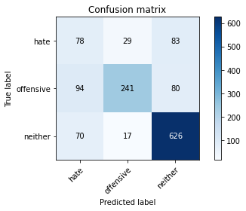

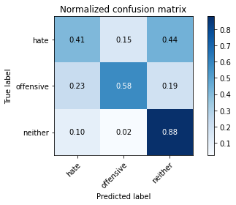

precision recall f1-score support

hate 0.32 0.41 0.36 190

offensive 0.84 0.58 0.69 415

neither 0.79 0.88 0.83 713

accuracy 0.72 1318

macro avg 0.65 0.62 0.63 1318

weighted avg 0.74 0.72 0.72 1318

average eval_loss: 0.7038316503167152, accuracy: 0.7169954476479514

training 4 epoch...

59.467557430267334 seconds used......

4 training finished! average train loss: 0.19117164107208903

evaluating...

Confusion matrix, without normalization

[[ 74 64 52]

[ 64 315 36]

[110 65 538]]

Normalized confusion matrix

[[0.38947368 0.33684211 0.27368421]

[0.15421687 0.75903614 0.08674699]

[0.1542777 0.0911641 0.7545582 ]]

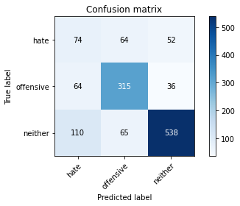

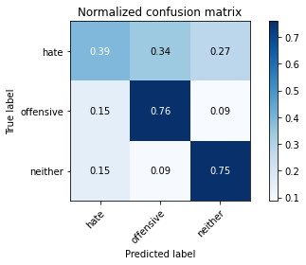

precision recall f1-score support

hate 0.30 0.39 0.34 190

offensive 0.71 0.76 0.73 415

neither 0.86 0.75 0.80 713

accuracy 0.70 1318

macro avg 0.62 0.63 0.62 1318

weighted avg 0.73 0.70 0.71 1318

average eval_loss: 0.9645200787168561, accuracy: 0.7033383915022762

training 5 epoch...

59.39641189575195 seconds used......

5 training finished! average train loss: 0.08443839680615135

evaluating...

Confusion matrix, without normalization

[[ 81 47 62]

[ 83 282 50]

[104 35 574]]

Normalized confusion matrix

[[0.42631579 0.24736842 0.32631579]

[0.2 0.67951807 0.12048193]

[0.14586255 0.04908836 0.80504909]]

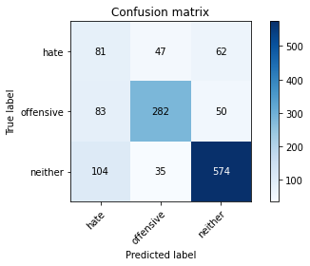

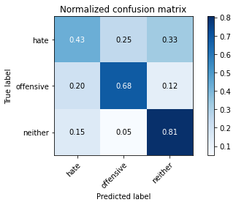

precision recall f1-score support

hate 0.30 0.43 0.35 190

offensive 0.77 0.68 0.72 415

neither 0.84 0.81 0.82 713

accuracy 0.71 1318

macro avg 0.64 0.64 0.63 1318

weighted avg 0.74 0.71 0.72 1318

average eval_loss: 1.1075071141575321, accuracy: 0.7109256449165402

training 6 epoch...

59.399359464645386 seconds used......

6 training finished! average train loss: 0.049413973293981554

evaluating...

Confusion matrix, without normalization

[[ 71 81 38]

[ 57 328 30]

[107 87 519]]

Normalized confusion matrix

[[0.37368421 0.42631579 0.2 ]

[0.1373494 0.79036145 0.07228916]

[0.15007013 0.12201964 0.72791024]]

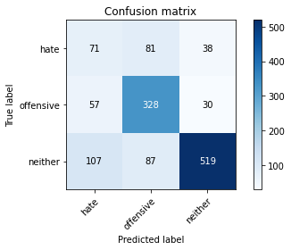

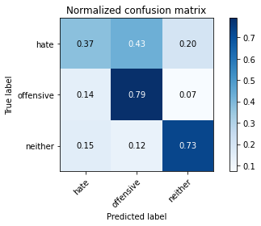

precision recall f1-score support

hate 0.30 0.37 0.33 190

offensive 0.66 0.79 0.72 415

neither 0.88 0.73 0.80 713

accuracy 0.70 1318

macro avg 0.62 0.63 0.62 1318

weighted avg 0.73 0.70 0.71 1318

average eval_loss: 1.4209224617842473, accuracy: 0.6965098634294385

training 7 epoch...

59.397595167160034 seconds used......

7 training finished! average train loss: 0.03637200893241573

evaluating...

Confusion matrix, without normalization

[[ 45 103 42]

[ 46 339 30]

[100 95 518]]

Normalized confusion matrix

[[0.23684211 0.54210526 0.22105263]

[0.11084337 0.81686747 0.07228916]

[0.14025245 0.13323983 0.72650771]]

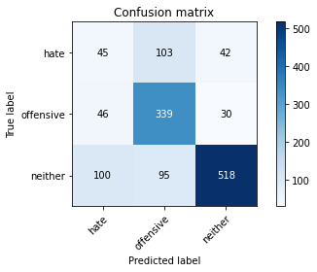

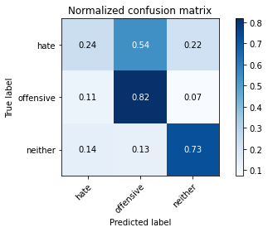

precision recall f1-score support

hate 0.24 0.24 0.24 190

offensive 0.63 0.82 0.71 415

neither 0.88 0.73 0.80 713

accuracy 0.68 1318

macro avg 0.58 0.59 0.58 1318

weighted avg 0.71 0.68 0.69 1318

average eval_loss: 1.5971911874684421, accuracy: 0.6843702579666161

training 8 epoch...

59.43236684799194 seconds used......

8 training finished! average train loss: 0.03577140731987046

evaluating...

Confusion matrix, without normalization

[[ 96 47 47]

[ 89 289 37]

[116 60 537]]

Normalized confusion matrix

[[0.50526316 0.24736842 0.24736842]

[0.21445783 0.69638554 0.08915663]

[0.16269285 0.08415147 0.75315568]]

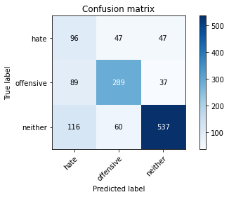

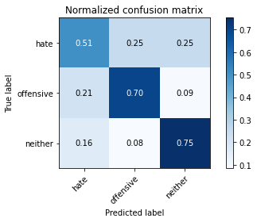

precision recall f1-score support

hate 0.32 0.51 0.39 190

offensive 0.73 0.70 0.71 415

neither 0.86 0.75 0.81 713

accuracy 0.70 1318

macro avg 0.64 0.65 0.64 1318

weighted avg 0.74 0.70 0.72 1318

average eval_loss: 1.3085180268143162, accuracy: 0.6995447647951442

training 9 epoch...

59.40495419502258 seconds used......

9 training finished! average train loss: 0.02320695688937452

evaluating...

Confusion matrix, without normalization

[[ 52 62 76]

[ 63 300 52]

[ 78 43 592]]

Normalized confusion matrix

[[0.27368421 0.32631579 0.4 ]

[0.15180723 0.72289157 0.1253012 ]

[0.10939691 0.06030856 0.83029453]]

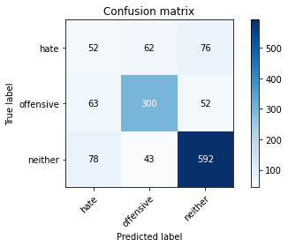

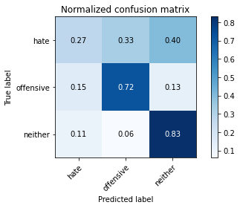

precision recall f1-score support

hate 0.27 0.27 0.27 190

offensive 0.74 0.72 0.73 415

neither 0.82 0.83 0.83 713

accuracy 0.72 1318

macro avg 0.61 0.61 0.61 1318

weighted avg 0.72 0.72 0.72 1318

average eval_loss: 1.4787090253649335, accuracy: 0.716236722306525

training 10 epoch...

59.38797903060913 seconds used......

10 training finished! average train loss: 0.024637128380444746

evaluating...

Confusion matrix, without normalization

[[ 67 82 41]

[ 50 339 26]

[113 103 497]]

Normalized confusion matrix

[[0.35263158 0.43157895 0.21578947]

[0.12048193 0.81686747 0.0626506 ]

[0.15848527 0.14446003 0.6970547 ]]

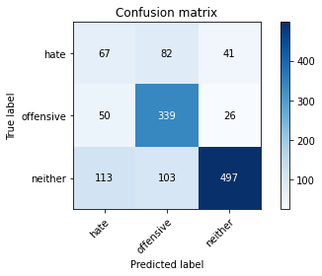

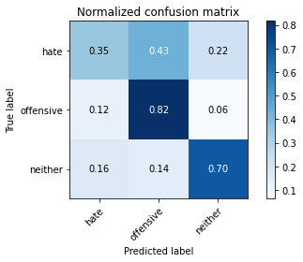

precision recall f1-score support

hate 0.29 0.35 0.32 190

offensive 0.65 0.82 0.72 415

neither 0.88 0.70 0.78 713

accuracy 0.69 1318

macro avg 0.61 0.62 0.61 1318

weighted avg 0.72 0.69 0.69 1318

average eval_loss: 1.8790818759889314, accuracy: 0.6851289833080425

4 run......

training 1 epoch...

59.53433394432068 seconds used......

1 training finished! average train loss: 0.7298513947224076

evaluating...

Confusion matrix, without normalization

[[ 76 43 71]

[ 50 274 91]

[ 49 21 643]]

Normalized confusion matrix

[[0.4 0.22631579 0.37368421]

[0.12048193 0.66024096 0.21927711]

[0.0687237 0.02945302 0.90182328]]

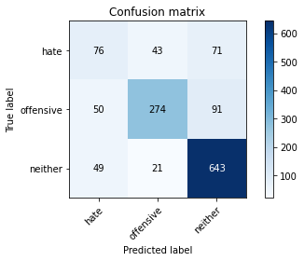

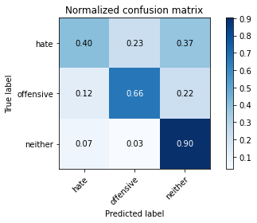

precision recall f1-score support

hate 0.43 0.40 0.42 190

offensive 0.81 0.66 0.73 415

neither 0.80 0.90 0.85 713

accuracy 0.75 1318

macro avg 0.68 0.65 0.66 1318

weighted avg 0.75 0.75 0.75 1318

average eval_loss: 0.6015039853977434, accuracy: 0.7534142640364189

training 2 epoch...

59.40650725364685 seconds used......

2 training finished! average train loss: 0.5315488571470434

evaluating...

Confusion matrix, without normalization

[[ 78 41 71]

[ 51 280 84]

[ 54 20 639]]

Normalized confusion matrix

[[0.41052632 0.21578947 0.37368421]

[0.12289157 0.6746988 0.20240964]

[0.07573633 0.02805049 0.89621318]]

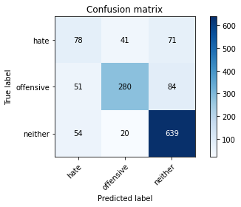

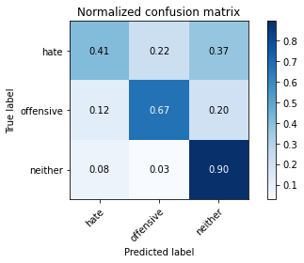

precision recall f1-score support

hate 0.43 0.41 0.42 190

offensive 0.82 0.67 0.74 415

neither 0.80 0.90 0.85 713

accuracy 0.76 1318

macro avg 0.68 0.66 0.67 1318

weighted avg 0.76 0.76 0.75 1318

average eval_loss: 0.6240681644641992, accuracy: 0.7564491654021245

training 3 epoch...

59.40491032600403 seconds used......

3 training finished! average train loss: 0.3469707888170061

evaluating...

Confusion matrix, without normalization

[[100 46 44]

[ 83 293 39]

[117 53 543]]

Normalized confusion matrix

[[0.52631579 0.24210526 0.23157895]

[0.2 0.7060241 0.0939759 ]

[0.16409537 0.0743338 0.76157083]]

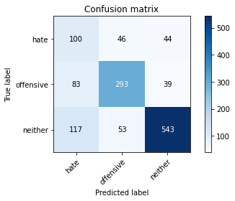

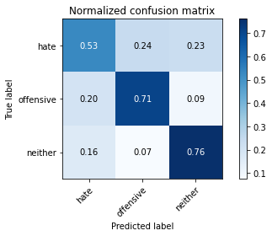

precision recall f1-score support

hate 0.33 0.53 0.41 190

offensive 0.75 0.71 0.73 415

neither 0.87 0.76 0.81 713

accuracy 0.71 1318

macro avg 0.65 0.66 0.65 1318

weighted avg 0.75 0.71 0.73 1318

average eval_loss: 0.8051851138924108, accuracy: 0.7101669195751138

training 4 epoch...

59.478495597839355 seconds used......

4 training finished! average train loss: 0.17888307513838464

evaluating...

Confusion matrix, without normalization

[[ 55 80 55]

[ 30 334 51]

[ 63 75 575]]

Normalized confusion matrix

[[0.28947368 0.42105263 0.28947368]

[0.07228916 0.80481928 0.12289157]

[0.08835905 0.10518934 0.80645161]]

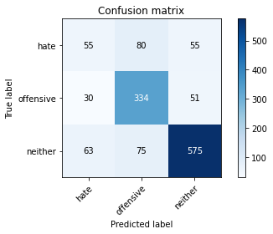

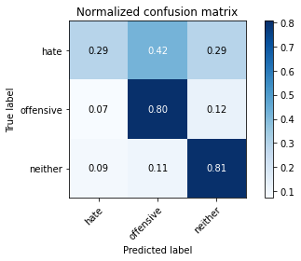

precision recall f1-score support

hate 0.37 0.29 0.33 190

offensive 0.68 0.80 0.74 415

neither 0.84 0.81 0.82 713

accuracy 0.73 1318

macro avg 0.63 0.63 0.63 1318

weighted avg 0.73 0.73 0.73 1318

average eval_loss: 1.100675457354748, accuracy: 0.7314112291350531

training 5 epoch...

59.41438364982605 seconds used......

5 training finished! average train loss: 0.08090426104820587

evaluating...

Confusion matrix, without normalization

[[ 68 67 55]

[ 55 319 41]

[ 83 59 571]]

Normalized confusion matrix

[[0.35789474 0.35263158 0.28947368]

[0.13253012 0.7686747 0.09879518]

[0.11640954 0.08274895 0.80084151]]

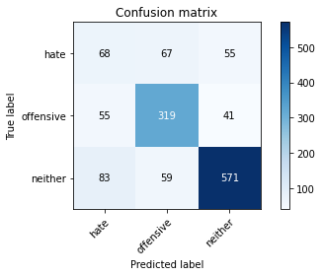

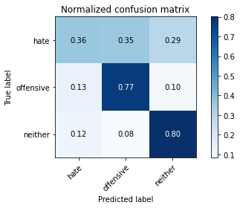

precision recall f1-score support

hate 0.33 0.36 0.34 190

offensive 0.72 0.77 0.74 415

neither 0.86 0.80 0.83 713

accuracy 0.73 1318

macro avg 0.63 0.64 0.64 1318

weighted avg 0.74 0.73 0.73 1318

average eval_loss: 1.2186135487122969, accuracy: 0.7268588770864947

training 6 epoch...

59.43809533119202 seconds used......

6 training finished! average train loss: 0.05151267192612233

evaluating...

Confusion matrix, without normalization

[[ 56 83 51]

[ 45 337 33]

[ 71 88 554]]

Normalized confusion matrix

[[0.29473684 0.43684211 0.26842105]

[0.10843373 0.81204819 0.07951807]

[0.09957924 0.12342216 0.7769986 ]]

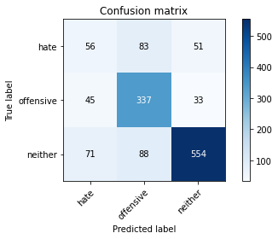

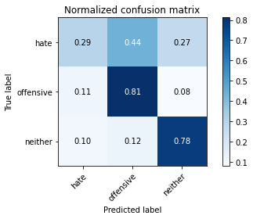

precision recall f1-score support

hate 0.33 0.29 0.31 190

offensive 0.66 0.81 0.73 415

neither 0.87 0.78 0.82 713

accuracy 0.72 1318

macro avg 0.62 0.63 0.62 1318

weighted avg 0.73 0.72 0.72 1318

average eval_loss: 1.4687733591505976, accuracy: 0.7185128983308042

training 7 epoch...

59.425588846206665 seconds used......

7 training finished! average train loss: 0.03690908599660774

evaluating...

Confusion matrix, without normalization

[[ 82 63 45]

[ 70 310 35]

[120 61 532]]

Normalized confusion matrix

[[0.43157895 0.33157895 0.23684211]

[0.1686747 0.74698795 0.08433735]

[0.16830295 0.085554 0.74614306]]

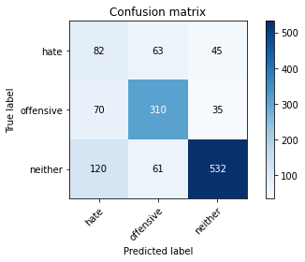

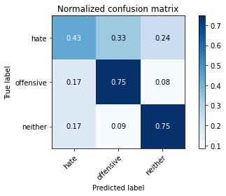

precision recall f1-score support

hate 0.30 0.43 0.35 190

offensive 0.71 0.75 0.73 415

neither 0.87 0.75 0.80 713

accuracy 0.70 1318

macro avg 0.63 0.64 0.63 1318

weighted avg 0.74 0.70 0.72 1318

average eval_loss: 1.356160911195206, accuracy: 0.701062215477997

training 8 epoch...

59.4629807472229 seconds used......

8 training finished! average train loss: 0.03127556135216516

evaluating...

Confusion matrix, without normalization

[[ 57 65 68]

[ 41 315 59]

[ 52 59 602]]

Normalized confusion matrix

[[0.3 0.34210526 0.35789474]

[0.09879518 0.75903614 0.14216867]

[0.07293128 0.08274895 0.84431978]]

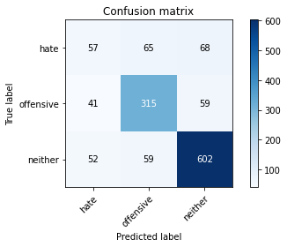

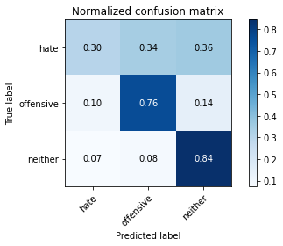

precision recall f1-score support

hate 0.38 0.30 0.34 190

offensive 0.72 0.76 0.74 415

neither 0.83 0.84 0.83 713

accuracy 0.74 1318

macro avg 0.64 0.63 0.64 1318

weighted avg 0.73 0.74 0.73 1318

average eval_loss: 1.5162887925451451, accuracy: 0.7389984825493171

training 9 epoch...

59.446462869644165 seconds used......

9 training finished! average train loss: 0.019079529474815487

evaluating...

Confusion matrix, without normalization

[[ 45 76 69]

[ 33 330 52]

[ 48 74 591]]

Normalized confusion matrix

[[0.23684211 0.4 0.36315789]

[0.07951807 0.79518072 0.1253012 ]

[0.06732118 0.10378682 0.82889201]]

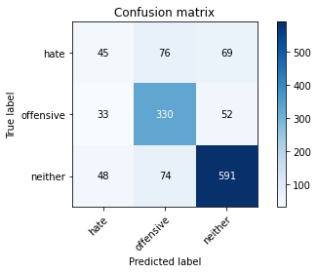

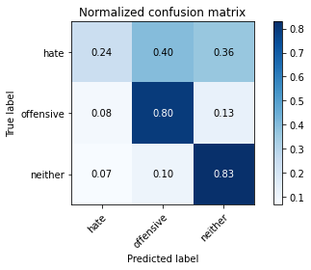

precision recall f1-score support

hate 0.36 0.24 0.28 190

offensive 0.69 0.80 0.74 415

neither 0.83 0.83 0.83 713

accuracy 0.73 1318

macro avg 0.62 0.62 0.62 1318

weighted avg 0.72 0.73 0.72 1318

average eval_loss: 1.7248580835082314, accuracy: 0.7329286798179059

training 10 epoch...

59.505244970321655 seconds used......

10 training finished! average train loss: 0.024040881698469588

evaluating...

Confusion matrix, without normalization

[[ 45 75 70]

[ 46 316 53]

[ 63 62 588]]

Normalized confusion matrix

[[0.23684211 0.39473684 0.36842105]

[0.11084337 0.76144578 0.12771084]

[0.08835905 0.08695652 0.82468443]]

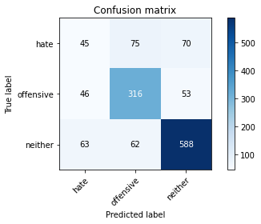

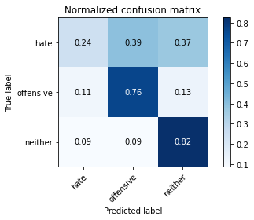

precision recall f1-score support

hate 0.29 0.24 0.26 190

offensive 0.70 0.76 0.73 415

neither 0.83 0.82 0.83 713

accuracy 0.72 1318

macro avg 0.61 0.61 0.61 1318

weighted avg 0.71 0.72 0.71 1318

average eval_loss: 1.7549099858963129, accuracy: 0.720030349013657

5 run......

training 1 epoch...

59.521069049835205 seconds used......

1 training finished! average train loss: 0.7421664462848143

evaluating...

Confusion matrix, without normalization

[[110 23 57]

[121 246 48]

[ 85 24 604]]

Normalized confusion matrix

[[0.57894737 0.12105263 0.3 ]

[0.29156627 0.59277108 0.11566265]

[0.11921459 0.03366059 0.84712482]]

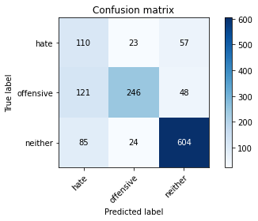

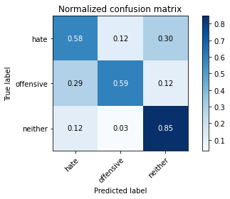

precision recall f1-score support

hate 0.35 0.58 0.43 190

offensive 0.84 0.59 0.69 415

neither 0.85 0.85 0.85 713

accuracy 0.73 1318

macro avg 0.68 0.67 0.66 1318

weighted avg 0.78 0.73 0.74 1318

average eval_loss: 0.6224811962156584, accuracy: 0.7283763277693475

training 2 epoch...

59.55974316596985 seconds used......

2 training finished! average train loss: 0.5248732201755046

evaluating...

Confusion matrix, without normalization

[[ 83 50 57]

[ 62 304 49]

[ 80 33 600]]

Normalized confusion matrix

[[0.43684211 0.26315789 0.3 ]

[0.14939759 0.73253012 0.11807229]

[0.11220196 0.04628331 0.84151473]]

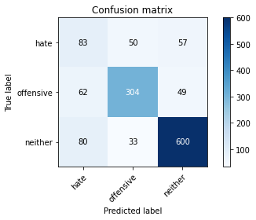

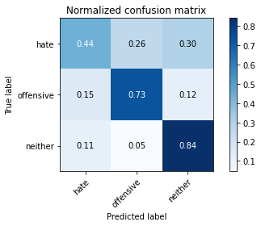

precision recall f1-score support

hate 0.37 0.44 0.40 190

offensive 0.79 0.73 0.76 415

neither 0.85 0.84 0.85 713

accuracy 0.75 1318

macro avg 0.67 0.67 0.67 1318

weighted avg 0.76 0.75 0.75 1318

average eval_loss: 0.6541074157664271, accuracy: 0.7488619119878603

training 3 epoch...

59.51103329658508 seconds used......

3 training finished! average train loss: 0.35056516114961017

evaluating...

Confusion matrix, without normalization

[[ 74 49 67]

[ 57 296 62]

[ 76 34 603]]

Normalized confusion matrix

[[0.38947368 0.25789474 0.35263158]

[0.1373494 0.71325301 0.14939759]

[0.10659187 0.04768583 0.8457223 ]]

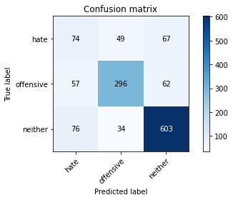

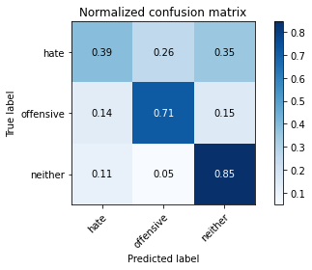

precision recall f1-score support

hate 0.36 0.39 0.37 190

offensive 0.78 0.71 0.75 415

neither 0.82 0.85 0.83 713

accuracy 0.74 1318

macro avg 0.65 0.65 0.65 1318

weighted avg 0.74 0.74 0.74 1318

average eval_loss: 0.7604640311363972, accuracy: 0.7382397572078907

training 4 epoch...

59.46178936958313 seconds used......

4 training finished! average train loss: 0.17661485236392102

evaluating...

Confusion matrix, without normalization

[[ 86 45 59]

[ 81 289 45]

[ 87 39 587]]

Normalized confusion matrix

[[0.45263158 0.23684211 0.31052632]

[0.19518072 0.69638554 0.10843373]

[0.12201964 0.05469846 0.82328191]]

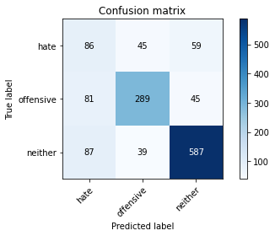

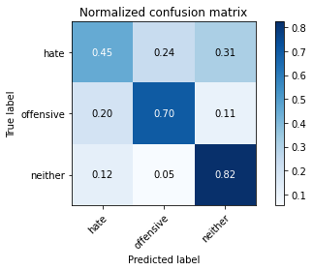

precision recall f1-score support

hate 0.34 0.45 0.39 190

offensive 0.77 0.70 0.73 415

neither 0.85 0.82 0.84 713

accuracy 0.73 1318

macro avg 0.65 0.66 0.65 1318

weighted avg 0.75 0.73 0.74 1318

average eval_loss: 0.8897787197069689, accuracy: 0.7298937784522003

training 5 epoch...

59.49945116043091 seconds used......

5 training finished! average train loss: 0.09237173258707944

evaluating...

Confusion matrix, without normalization

[[ 76 68 46]

[ 65 313 37]

[110 69 534]]

Normalized confusion matrix

[[0.4 0.35789474 0.24210526]

[0.15662651 0.75421687 0.08915663]

[0.1542777 0.09677419 0.74894811]]

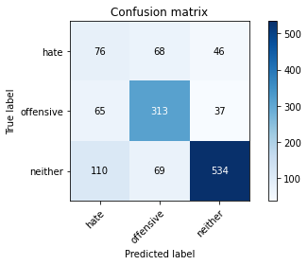

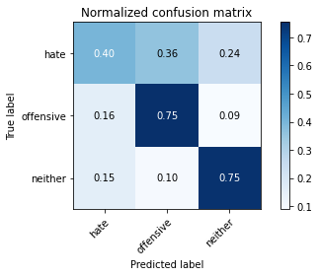

precision recall f1-score support

hate 0.30 0.40 0.34 190

offensive 0.70 0.75 0.72 415

neither 0.87 0.75 0.80 713

accuracy 0.70 1318

macro avg 0.62 0.63 0.62 1318

weighted avg 0.73 0.70 0.71 1318

average eval_loss: 1.1836223209446126, accuracy: 0.7003034901365706

training 6 epoch...

59.46339750289917 seconds used......

6 training finished! average train loss: 0.05634020868455991

evaluating...

Confusion matrix, without normalization

[[ 83 45 62]

[ 81 275 59]

[ 85 37 591]]

Normalized confusion matrix

[[0.43684211 0.23684211 0.32631579]

[0.19518072 0.6626506 0.14216867]

[0.11921459 0.05189341 0.82889201]]

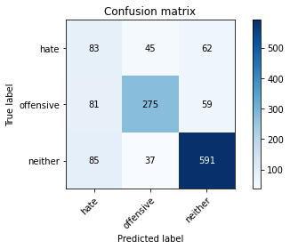

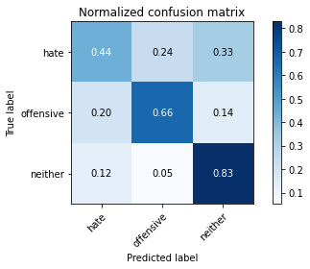

precision recall f1-score support

hate 0.33 0.44 0.38 190

offensive 0.77 0.66 0.71 415

neither 0.83 0.83 0.83 713

accuracy 0.72 1318

macro avg 0.64 0.64 0.64 1318

weighted avg 0.74 0.72 0.73 1318

average eval_loss: 1.1462483880194752, accuracy: 0.720030349013657

training 7 epoch...

59.542577028274536 seconds used......

7 training finished! average train loss: 0.037453171322968874

evaluating...

Confusion matrix, without normalization

[[ 53 71 66]

[ 37 323 55]

[ 44 68 601]]

Normalized confusion matrix

[[0.27894737 0.37368421 0.34736842]

[0.08915663 0.77831325 0.13253012]

[0.06171108 0.09537167 0.84291725]]

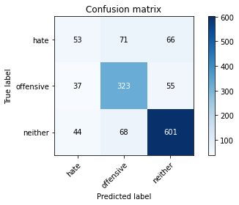

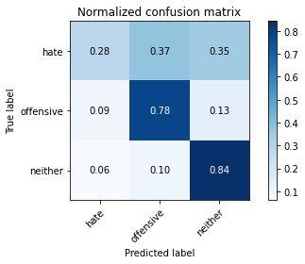

precision recall f1-score support

hate 0.40 0.28 0.33 190

offensive 0.70 0.78 0.74 415

neither 0.83 0.84 0.84 713

accuracy 0.74 1318

macro avg 0.64 0.63 0.63 1318

weighted avg 0.73 0.74 0.73 1318

average eval_loss: 1.4317027100107886, accuracy: 0.7412746585735963

training 8 epoch...

59.55401134490967 seconds used......

8 training finished! average train loss: 0.026151775057025425

evaluating...

Confusion matrix, without normalization

[[ 38 69 83]

[ 35 306 74]

[ 42 45 626]]

Normalized confusion matrix

[[0.2 0.36315789 0.43684211]

[0.08433735 0.7373494 0.17831325]

[0.05890603 0.0631136 0.87798036]]

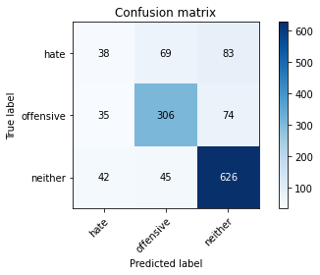

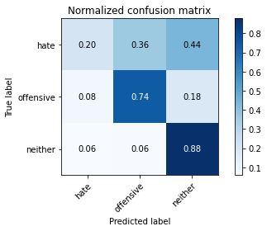

precision recall f1-score support

hate 0.33 0.20 0.25 190

offensive 0.73 0.74 0.73 415

neither 0.80 0.88 0.84 713

accuracy 0.74 1318

macro avg 0.62 0.61 0.61 1318

weighted avg 0.71 0.74 0.72 1318

average eval_loss: 1.5081497448863406, accuracy: 0.7359635811836115

training 9 epoch...

59.517059087753296 seconds used......

9 training finished! average train loss: 0.028348315969560646

evaluating...

Confusion matrix, without normalization

[[ 58 67 65]

[ 47 316 52]

[ 68 47 598]]

Normalized confusion matrix

[[0.30526316 0.35263158 0.34210526]

[0.11325301 0.76144578 0.1253012 ]

[0.09537167 0.06591865 0.83870968]]

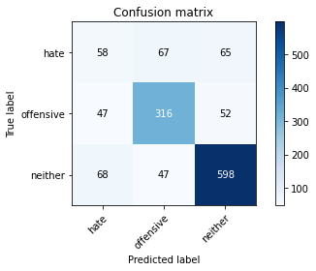

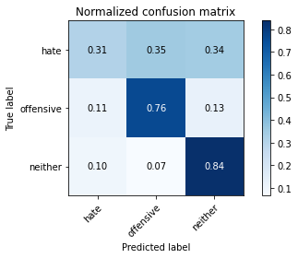

precision recall f1-score support

hate 0.34 0.31 0.32 190

offensive 0.73 0.76 0.75 415

neither 0.84 0.84 0.84 713

accuracy 0.74 1318

macro avg 0.64 0.64 0.64 1318

weighted avg 0.73 0.74 0.73 1318

average eval_loss: 1.579090029001236, accuracy: 0.7374810318664643

training 10 epoch...

59.52228784561157 seconds used......

10 training finished! average train loss: 0.02303396164114185

evaluating...

Confusion matrix, without normalization

[[ 61 67 62]

[ 54 314 47]

[ 69 57 587]]

Normalized confusion matrix

[[0.32105263 0.35263158 0.32631579]

[0.13012048 0.75662651 0.11325301]

[0.09677419 0.0799439 0.82328191]]

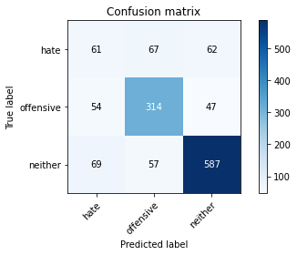

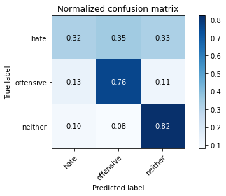

precision recall f1-score support

hate 0.33 0.32 0.33 190

offensive 0.72 0.76 0.74 415

neither 0.84 0.82 0.83 713

accuracy 0.73 1318

macro avg 0.63 0.63 0.63 1318

weighted avg 0.73 0.73 0.73 1318

average eval_loss: 1.5478125566785985, accuracy: 0.7298937784522003